Digital Signal Processing

Assignment 3

Made by: Habiba Gamal

900151007

Part 1:

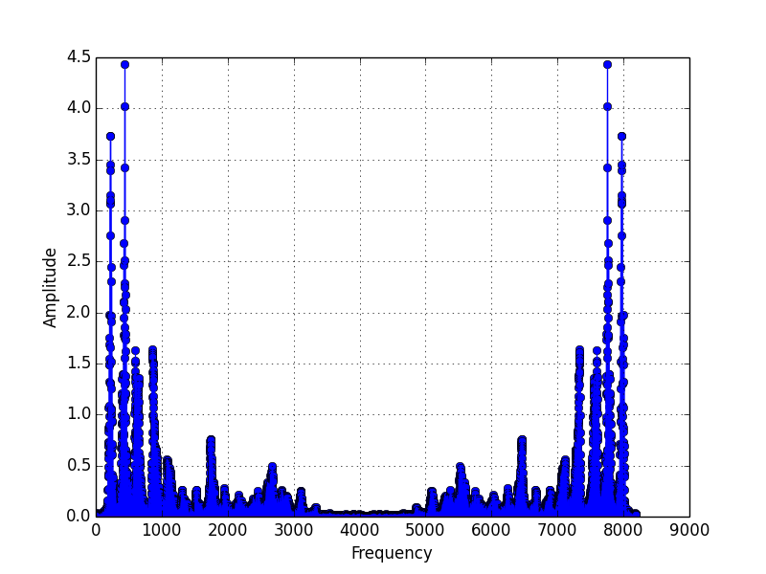

Figure 1.1: A plot of the magnitude of the FFT output of the audio signal

Part 2:

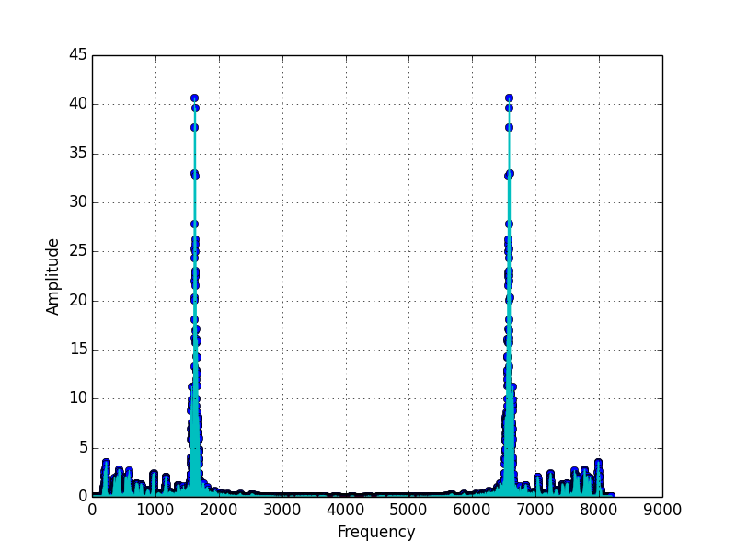

Figure 2.1: This is the magnitude of the audio signal with the whistle

How I implemented the filter?

* As shown in the figure above, the whistle frequency is from about 1500 to 1760 and from about 6500 to 6700.
* The filter suppresses these frequencies by being 0.01 at these frequencies and 1 otherwise.
* The suppressed frequencies are 0.01 rather than 0 to attenuate the whistle but leave the name kind of intact (not suppressed to zero at these frequencies)
* Then, the filter is multiplied by the fft output of the audio signal
* The multiplication output is inputted to the ifft. Its magnitude is shown in the graph below

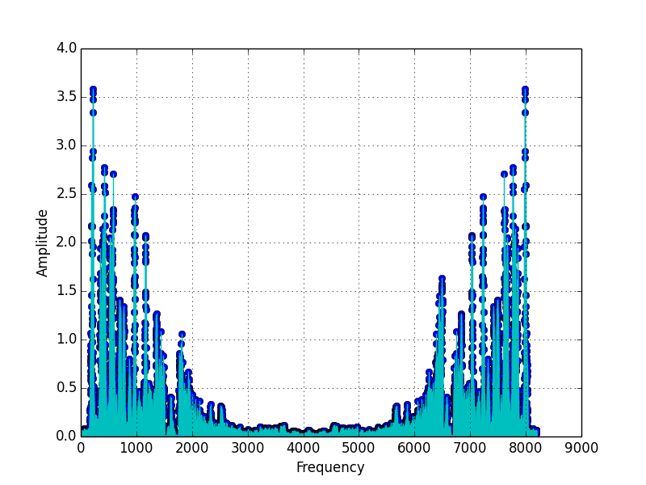

Figure 2.2: A plot of the magnitude of the output of the fft after being multiplied by the filter

As seen in the above figure, the amplitudes of the whistle frequencies were suppressed. The other frequencies were left intact.