1. **User Dashboard :**
2. Dashboard
3. Fast Access
4. Family Group/Profile
5. Messages
6. Benefits/Insurance Coverage
7. Files
8. Insurance Options
9. Payment
10. Report Claim

**A – Dashboard:**

Purpose/Goal - A user dashboard have current policy , policy products , payment summary of products (like – due date and next payment date ) , search , created reminders , broker contact details ,communication messages , recent proposals and recent enrollment kits.

Queries –

1. There is a search tab in dashboard so what we will search here and what we will do with that search results.
2. In communication messages tab what is the purpose of create post.
3. What is the purpose of recent proposals and recent enrollment kits tabs.

**B – Fast Access:**

Purpose/Goal – In Fast Access we have four parts Accounts,Policies,Bookmarks and Files. From Account part user can switch from good insured account to health shop account and vice versa. We will show user specific policies that he has acquired in policies section. In bookmarks section we will show user specific bookmarks .And in last section files we will show users specific files .

**C-Family Group/Profile:**

Purpose/Goal – Add\Edit Family Group and list of Particular User with their other group members that he (user) added to his group.

**D - Messages (Mail):**

Purpose/Goal – Send message and list of messages received (i.e. – Gmail).

**F - Benefits/Insurance Coverage:**

Purpose/Goal – Show Benefits and insurance coverage for specific product wise with filters customer name, insured number, policy number, effective from and effective to.

Queries – we need to show user taken policies benefits/coverage or overall policies benefits/coverage.

**G – Files:**

Purpose/Goal – Show list of files with user wise filter.

**H – Insurance Options**: Need to clarify.

**I – Payment:**

Purpose/Goal – Pay Policy premium amount and show list of payments done with user specific filter.

**J – Report Claim:**

Purpose/Goal – Show List of policies taken by user and claim report for particular policy with user specific filter.

1. **User Business:**
2. Dashboard
3. Fast Access
4. Employees
5. Messages
6. Benefits
7. Files
8. Timesheet
9. Insurance Options
10. Report Claim
11. Payment
12. Setting Products

**A – Dashboard:**

Purpose/Goal - A business dashboard have today attendance summary, employee summary ,attendance overview , search , created reminders , broker contact details ,communication messages , recent proposals and recent enrollment kits.

Queries –

Same as User Dashboard ((a) - Dashboard);

**B – Fast Access:**

Purpose/Goal – Same as User Dashboard.

**C –Employees:**

Purpose/Goal – Add/Edit employee and list of employees with filter by name and employee Number.

**D - Messages (Mail):**

Purpose/Goal – Send message and list of messages received (i.e. – Gmail).

**E - Benefits/Insurance Coverage:**

Purpose/Goal – Same as User Dashboard.

Queries – Same as User Dashboard..

**F – Files:**

Purpose/Goal – Add/Edit and show list of files with user wise filter and with share files option.

**G – Timesheet**: Need to clarify.

**H – Insurance Options:** Need to clarify.

**I – Payment:**

Purpose/Goal – Same as User Dashboard.

**J – Report Claim:**

Purpose/Goal – Same as User Dashboard.

**K –Settings Product:** Need to clarify.

1. **User Provider:**
2. Dashboard
3. Fast Access
4. Customers
5. Messages
6. Benefits
7. Files
8. Timesheet
9. Insurance Options
10. Payment
11. Report Claim
12. Setting Categories/Products/ Insurance

**A – Dashboard:**

Purpose/Goal - A Provider dashboard have today attendance summary, employee summary ,attendance overview , search , created reminders , broker contact details ,communication messages , recent proposals and recent enrollment kits.

Queries –

Same as User Dashboard ((a) - Dashboard);

**B – Fast Access:**

Purpose/Goal – Same as User Dashboard.

**C –Customers:**

In Customers tab there are 2 types of customers –

1. User Customer :

Purpose/Goal – Provider can see list of users customers add/edit and delete customer related to his (Provider) account.

1. Company Customers

Purpose/Goal – Provider can also see list of business customers add/edit and delete customer related to his (Provider) account.

**D - Messages (Mail):**

Purpose/Goal – Send message and list of messages received (i.e. – Gmail).

**E - Benefits/Insurance Coverage:**

Purpose/Goal – Same as User Dashboard.

Queries – Same as User Dashboard.

**F – Files:**

Purpose/Goal – Add/Edit and show list of files with user wise filter and with share files option.

**G – Timesheet:** Need to clarify.

**H – Insurance Options:** Need to clarify.

**I – Payment:**

Purpose/Goal – Same as User Dashboard.

**J – Report Claim:**

Purpose/Goal – Provider can create fields of create claim form and also can see list of report claims by user related to his (Provider) account.

**K –Settings Categories, Products and Insurance:**

Purpose/Goal – Provider can create/edit categories, products and insurance.

1. **User Admin:**
2. Dashboard
3. Fast Access
4. Customers/Book Of Business
5. Messages
6. Files
7. Business Timesheet
8. Payment
9. Reports
10. Directory
11. Ticket Management
12. Insurance Career Management
13. Settings
14. Users Center
15. Claim Management
16. Page Management
17. Site Management
18. Quote Management
19. **Dashboard:**

Purpose/Goal - A User dashboard have 3 sections Report, Individual and Business.

1. Report – Monthly Sales Report in the form of block chart. Vehicle Insurance total sales report in the form of block chart. Property Insurance total sales report by the property categories in the form of block chart. Business Insurance total sale report by business categories in the form of block chart. Products sales report by the categories wise in the form of circle chart. Top page report view only .View Per Country report views only. Claim report with total new request, total In-Progress and total Completed view only. Service Request Report with total new request, total In-Progress and total Completed view only. Ticket Incident Report with total new incident, total In-Progress, total Resolved and total closed view only. Ticket Change Request Report with total new request, total In-Progress, and total Completed view only. Number of API Access by users. Total Individual customers and total business customers.
2. Individual – Image Not Available.
3. Business – Image Not Available.
4. **Fast Access:**

Purpose/Goal – Same as User Dashboard.

1. **Customers/Book Of Business :**

In Customers/Book of business tab there are 2 types of customers –

1. User Customer :

Purpose/Goal – Admin can see list of users customers add/edit and delete customer related to his (Admin) account.

1. Company Customers

Purpose/Goal – Admin can also see list of business customers add/edit and delete customer related to his (Admin) account.

**D- Messages (Mail):**

Purpose/Goal – Send message and list of messages received (i.e. – Gmail).

**E – Files:**

Purpose/Goal – Add/Edit and show list of files with user wise filter and with share files option.

**F- Business Timesheet:**  Need to clarify.

**G- Payment:**

Purpose/Goal – Payment has 3 sections Payment Summary, Payment Processing and Payment Gateways.

1. Payment Summary – List of Payment Summary with filter policy holder, policy number and policy period.
2. Payment Processing – 2nd step will be process payment after selecting policy holder. In this admin can see payment details and can make payment processing.

Queries – Why Admin will make payment for policy.

1. Payment Gateways – Admin Can add different payment gateways credentials in this section.

**H- Reports:**

Purpose/Goal – Admin can manage (ADD, DELETE) customer, business, payment and sales report.

**I- Directory:**

Purpose/Goal – List of Site Users.

**J- Ticket Management:**

Purpose/Goal – Ticket Management has 4 sections Service Request, Incident Report, Change Request and Chat Request.

* 1. Service Request – List of Service Requests and resolution of this Service Request.
  2. Incident Report – List of Incident Report and resolution of this Incident Report.
  3. Change Request – List of Change Request and resolution of this Change Request.
  4. Chat Request -

1) Conversation – List of conversation with filter name, city, date, keyword, support, IP, Time

2) Support. – Image Not Available.

Queries – There is a column (assigned to) in all tickets resolution form so whom we will assign this ticket and for what purpose we are assigning to this ticket to him. And also who will create these tickets request .

**K-Insurance Career Management:** Need Clarification.

**L-Settings:**

Purpose/Goal – Settings has 4 sections Categories, Products, Insurance and Report Claim.

Queries – All 4 options are selected showing in image is it any type of step by step wise process.

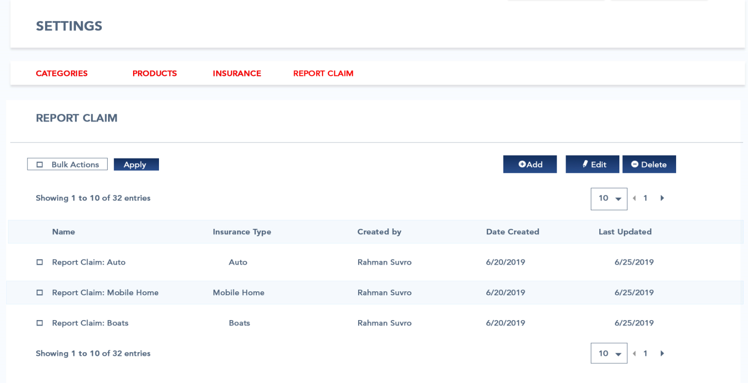

**M –User Center:**

Purpose/Goal – Show List, add/edit and deactivate user, change role of users, Invite User and Invite Broker.

**N –Claim Management:**

Purpose/Goal – Show List, search claim by filter, view claim and can change status of Claim report.

Queries – Image is missing (13.1) in User_Admin.

**O –Page Management:** Need Clarification.

**P –Site Management:**

Purpose/Goal – Admin can create a site for Agent Broker to showcase/sell products to users/customers that Broker has requested to admin.

Queries – Please get more details about this module from client.

**Q –Quote Management:**

Purpose/Goal – Quote Management has 4 sections Location, Products, Product Detail and Coverage option. I am assuming that it’s a step by step process for add product for quote at a particular location.

1. Location – List of locations will be show with products and can Add/Edit Details of Location. When Admin Add new Location for quote then next step will be Add Product.

Queries – If it’s a step by step process then what about when we need to add more products in a same place. To add more products in a same place then we must skip location step.

1. Products – At reaching this step admin will see list of Carrier Products table here admin can add product by clicking add button in table a box will appear below table which is a form to create product with location details , categories and product. After saving admin will jump to product details section.
2. Product Details – Admin will add product details for product that he has added previously.

Queries – Product Details Image is missing (16.3) in User_Admin folder.

1. Coverage Options – Admin will add product coverage option for product that he has added previously.

Queries – Need more details of this module.

1. **User Broker Agency:**
2. Dashboard
3. Fast Access
4. Customers/Book Of Business
5. Messages
6. Files
7. Business Timesheet
8. Payment
9. Reports
10. Directory
11. Ticket Management
12. User center
13. Claim Management
14. Agent /Broker Center.

**A-Dashboard:**

Purpose/Goal - A Broker Agency dashboard have 2 sections Individual and Business.

1. Business – Monthly Sales Report in the form of block chart. Vehicle Insurance total sales report in the form of block chart. Property Insurance total sales report by the property categories in the form of block chart. Business Insurance total sale report by business categories in the form of block chart. Products sales report by the categories wise in the form of circle chart. Number of Active Business Customers. Total sales and total Commision.
2. Individual – Image Not Available.

**B-Fast Access:**

Purpose/Goal – Same as User Dashboard.

**C-Customers/Book of Business:**

In Customers/Book of business tab there are 2 types of customers –

* 1. User Customer :

Purpose/Goal – Broker Agency can see list of users customers add/edit and delete customer related to his (Admin) account.

* 1. Business Customers

Purpose/Goal – Broker Agency can also see list of business customers add/edit and delete customer related to his (Broker Agency) account.

**D- Messages (Mail):**

Purpose/Goal – Send message and list of messages received (i.e. – Gmail).

**E – Files:**

Purpose/Goal – Add/Edit and show list of files with user wise filter and with share files option.

**F- Business Timesheet:**  Need to clarify.

**G- Payment:**

Purpose/Goal – Need to clarify.

**H- Reports:**

Purpose/Goal – Broker Agency can manage (ADD, DELETE) customer, business, payment and sales report.

**I- Directory:**

Purpose/Goal – List of Site Users.

**J- Ticket Management:**

Purpose/Goal – Ticket Management has 4 sections Service Request, Incident Report, Change Request and Chat Request.

* 1. Service Request – List of Service Requests and resolution of this Service Request.
  2. Incident Report – List of Incident Report and resolution of this Incident Report.
  3. Change Request – List of Change Request and resolution of this Change Request.
  4. Chat Request -

1) Conversation – List of conversation with filter name, city, date, keyword, support, IP, Time

2) Support. – Image Not Available.

Queries – There is a column (assigned to) in all tickets resolution form so whom we will assign this ticket and for what purpose we are assigning to this ticket to him. And also who will create these tickets request.

**K- User Center:**

Purpose/Goal – List of Users with change role and invite user’s option.

Queries – why Agency/broker will change users role.

**L- Claim Management:**

Purpose/Goal - User Broker Agency can apply for Claim for particular product and list of claim reported will be show in table and also can change Status of Claim reported.

Queries – Is User Broker Agency authorized for report claim or he can view and change status of reported claim from user.

**M- Agent/Broker Center:** Agent/Broker Center has 5 sub sections. Activities, Policies, Agents, Carriers and Commissions.

1. Activities -

Purpose/Goal – List of Activities for agents that he needs to follow.

Queries – To whom Agent Broker are assigning these activities.

1. Policies –
2. Business – Policies that has taken by User Business through this Agent/broker will be show in list with filter holder name, insured number, policy number, effective from and effective to. And can see details of payment details , payment history and files for this Business Policy.
3. Individual – Image is missing.
4. Agents –

Purpose/Goal – List of agents with agency name and other details of agents.

1. Agent/Agency details – Agent / Agency Full details .And can edit by User Agency/Broker.
2. Files – Files Added by these Agent/Agency.
3. Policies – Policies Done by this Agent/Agency.
4. Carrier Appointment – Need Clarification.
5. Access – Need Clarification (Image Not Found).

Queries – why particular broker agency is authorized to see others broker agency agents.

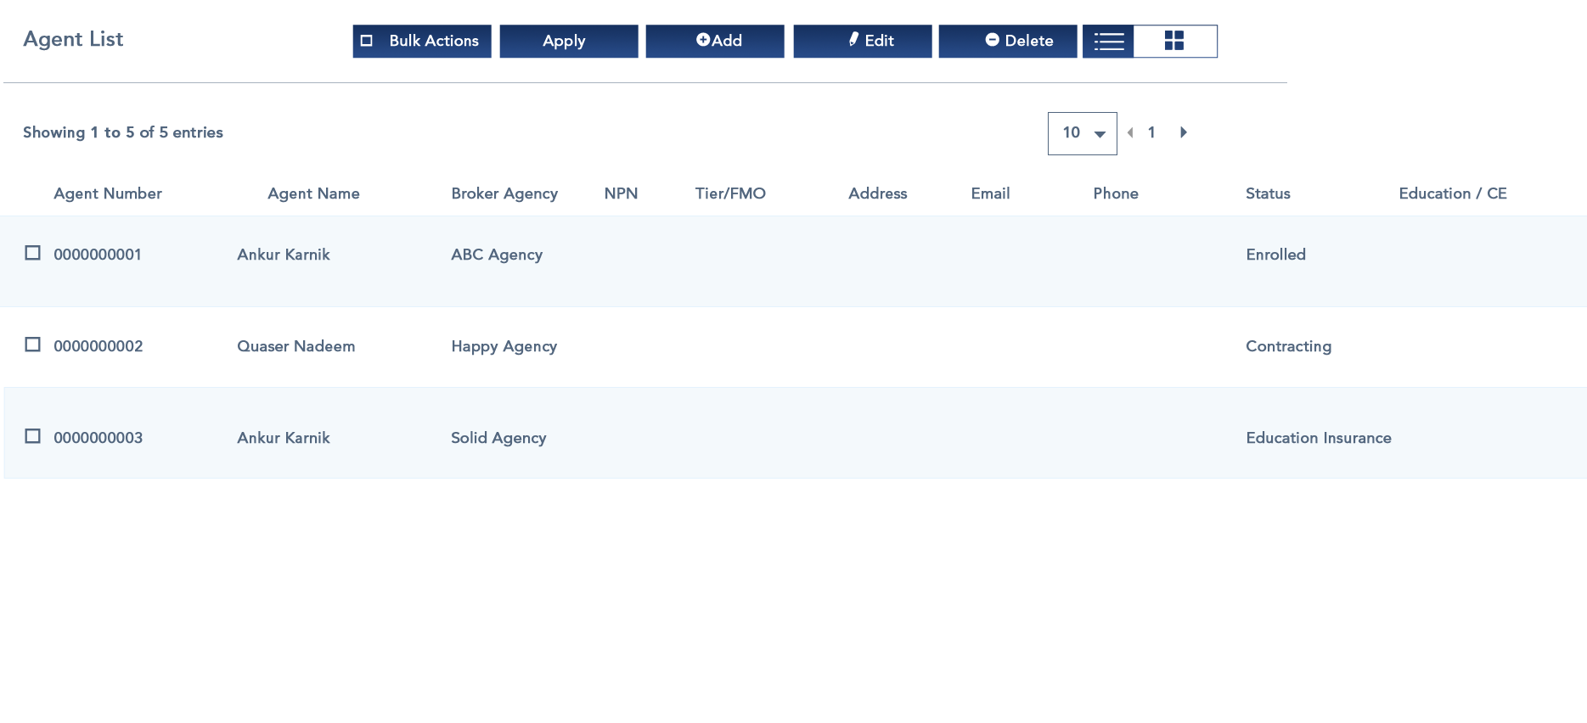

1. Carriers –

Purpose/Goal – List of Carriers with products they provide with search carrier filter.

1. Carrier Appointment – Need Clarification.
2. Career Access – Image Missing
3. Career Details – Image Missing.
4. Career Files – Image
5. Commissions – Image is missing.