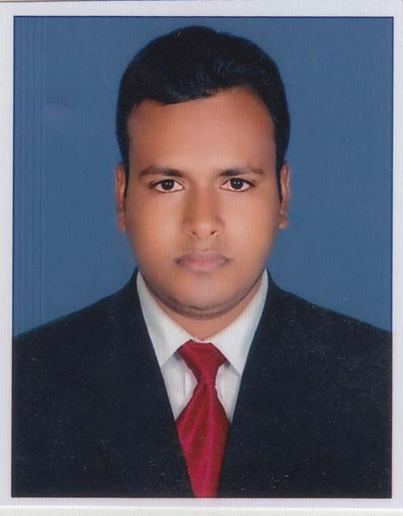
Habibur rahman
Mailing Address: Vatara mor, Vatara, Badda,
Gulshan, Dhaka- 1212.
Mob: 01933885872
E-Mail: contactme.hrhabib@gmail.com

---------------------------------------------------------------------------------------------------------------------

CAREER OBJECTIVE

To achieve a dynamic and challenging job where I can use my technical and interpersonal skills creativity and above all my learning experience in order to develop my career as well as to contribute in the welfare of the organization.

Academic Background

Honor’s (BSS)

Institution : Govt. Titumir College.Dhaka.
Subject : Economics
Result : on going

Higher Secondary Certificate (HSC):

College : Shaheed Ramiz Uddin Cantonment College,
Dhaka Cantonment, Dhaka.
Board : Dhaka
GPA : 4.50
Passing Year : 2014
Group : Humanities

Secondary School Certificate (SSC):

School : Ludhua Ahmadia (SM) Dhakil Madrasha.
Board : Madrasha
GPA : 4.88
Passing Year : 2012
Group : Humanities

Personal Skill

Training:
I have successfully completed Web Development Course from SoftTech-It Institute at Dhaka, Bangladesh.

And I have successfully completed National Certificate Course on Food & Beverage Production from National Hotel & Tourism Training Institute.

Industrial attachment:
I have successfully completed Industrial Attachment from SoftTech-It on Web Development. Uttara House Building, Dhaka, Bangladesh.

And I have successfully completed Industrial Attachment from Galesia Hotel & Resort Ltd. (House no-39, Road no-21, Banani, Dhaka-1213).

Experience:
I am working in different marketplaces such as Fiverr, Upwork, Freelancer.com & other marketplaces on Web Development, Web Design, Theme Development & WordPress Customization from last 3 years.

I worked at Lakeshore Hotel’s Gulshan from 15th March 2017 to 31st August 2021 as a Gym & Swimming Pool Attendant under Housekeeping Department.

Communication Skills:

Able to communicate English, Bangla. Fluent in writing English, Bangla.

Personal Information

Name : Habibur Rahman
Father’s name : Ab. Hannan
Mother’s name : Zasna Begum
Date of Birth : 6th May, 1997
Nationality : Bangladeshi (By Birth)
Religion : Islam
Home District : Chandpur
Marital Status : Unmarried
Blood Group : B+
Permanent Address : Vill-: Ludhua (Amtola), P.O:- Ludhua,
P.S:-Motlab (North), Dist:- Chandpur.

Why Me

- Able to work any type of Website.
- On Time Delivery.
- Good Communication.
- More Responsible.
- Organized and self-motivated.

Reference:

- MD: Tariqul Mawla Sujan 2. MD: Sharif Mollah
CEO & Founder Deputy General Manager
SoftTech-It Lakeshore Hotels Gulshan
Mob: +880 174548902 Mob: 01911426101

The above information is completed to the best of my knowledge.

Signature: ………………….
Date: .........../.........../............

