Personal Finance Data Analysis Project
A Complete End-to-End Data Analysis Workflow
Habib
April 2026
Tools Used: Microsoft Excel · MySQL Workbench · Power BI Desktop
Dataset Source: Kaggle — Synthetic Personal Finance Dataset

1. Introduction
This project presents a full end-to-end data analysis of a synthetic personal finance dataset sourced from Kaggle. The dataset contains 32,424 records and 19 original columns covering key financial attributes such as monthly income, savings, loan details, credit scores, and demographic information including age, gender, region, and employment status.

The goal of this project is to demonstrate a complete data analysis workflow using three professional tools: Microsoft Excel for data profiling and feature engineering, MySQL Workbench for structured querying and data cleaning, and Power BI for data visualization and insight presentation.

2. Methodology
This project followed a structured data analysis workflow consisting of four main phases:

Phase 1 — Data Profiling (Microsoft Excel)
All 19 columns were systematically reviewed. Data types were verified, unique values were counted for categorical columns, and missing values were checked using the COUNTBLANK function across all 32,424 rows. Zero missing values were found.

Phase 2 — Feature Engineering (Microsoft Excel)
Three new columns were created to enrich the dataset for deeper analysis: age_category, income_bracket, and loan_status_label.

Phase 3 — Data Cleaning and SQL Analysis (MySQL Workbench)
The enriched dataset was exported as CSV and imported into MySQL. Two corrupt values were identified and corrected using UPDATE queries. Six analytical queries were then written to extract insights across income, loans, credit scores, savings, and job titles.

Phase 4 — Data Visualization (Power BI)
Five interactive visuals were built from the raw dataset to communicate the key findings in a clear and professional format.

3. Data Profiling
Before any analysis was performed, a thorough data audit was conducted in Microsoft Excel. A dedicated sheet named data_profile was created to document the structure and quality of every column in the dataset.

The following was verified for each column: data type, example values, number of unique values, and missing value count. The COUNTBLANK function was applied across all 19 columns and returned zero missing values in every case. All data types were confirmed correct.

Two data quality issues were later discovered during SQL import: the letter A appeared in two numeric columns — loan_interest_rate_pct and debt_to_income_ratio. These were identified using a REGEXP query and corrected using UPDATE statements directly in MySQL Workbench.

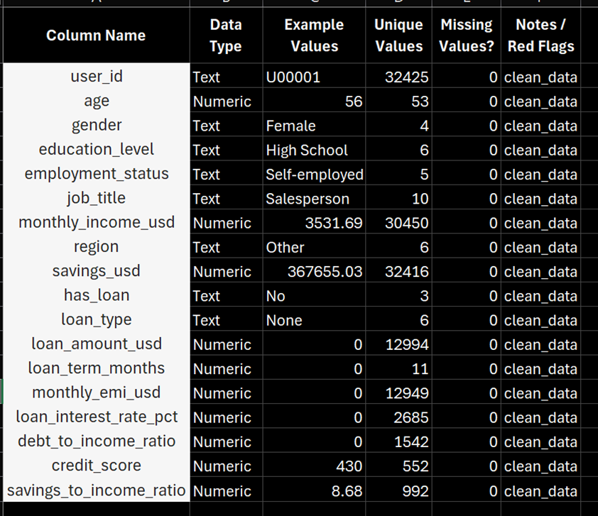

4. Feature Engineering
To enhance the analytical value of the dataset, three new columns were created in Microsoft Excel using IF formulas and applied across all 32,424 rows.

1. age_category
Customers were grouped into four age bands: Young Adult (18–25), Adult (26–40), Senior Adult (41–60), and Elderly (61+). This column allows age-based comparisons across income, savings, and loan behavior.

2. income_bracket
Monthly income was classified into four tiers: Low (below $3,000), Middle ($3,000–$6,000), Upper-Middle ($6,000–$10,000), and High (above $10,000). This column enables income-based segmentation across all financial metrics.

3. loan_status_label
The original has_loan column contained Yes/No values. This new column converted those values into descriptive labels — Has Loan and No Loan — for cleaner presentation in pivot tables and Power BI visuals.

Distribution: Adults represent the largest age group with 12,594 records. All four income brackets are nearly equal in size at approximately 8,100 records each. 12,995 people have an active loan while 19,429 do not.

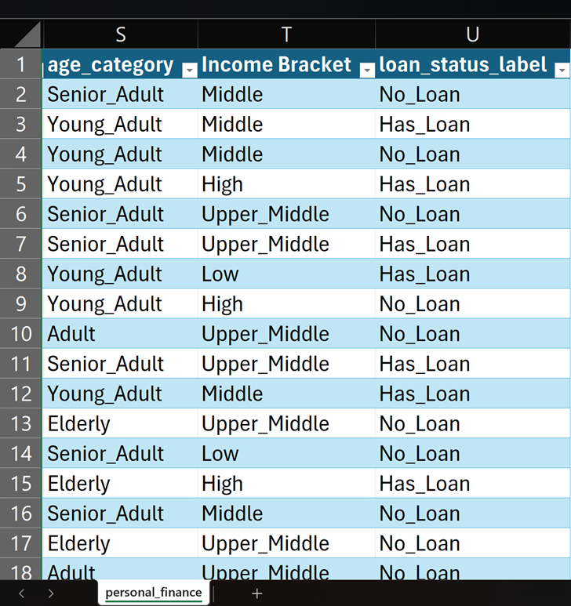

5. SQL Analysis
The enriched dataset was imported into MySQL Workbench and six analytical queries were executed to extract meaningful insights from the data.

Query 1 — Average Income by Education Level
[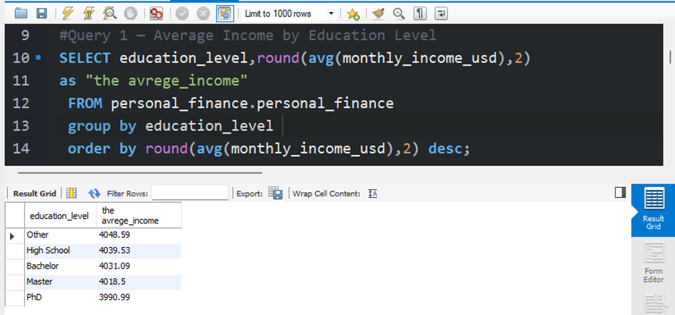]
Managers with a PhD earn the least on average at $3,990, while the Other education category earns the most at $4,048. The differences across all groups are minimal, which is consistent with synthetic data generation.

Query 2 — Loan Interest Rate by Employment Status
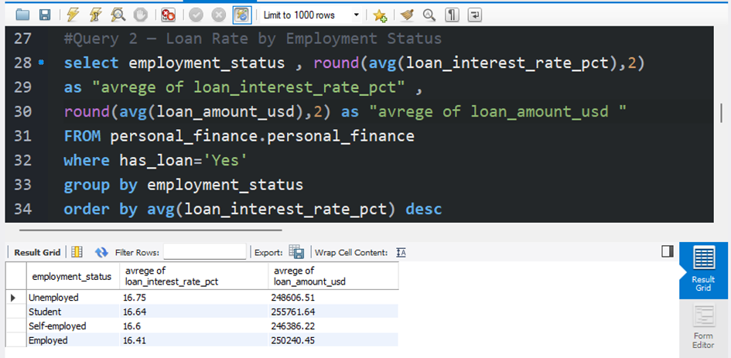
Among borrowers, unemployed individuals carry the highest average interest rate at 16.75%, while employed individuals carry the lowest at 16.41%. This reflects the higher lending risk associated with unstable income.

Query 3 — Credit Score by Region and Gender
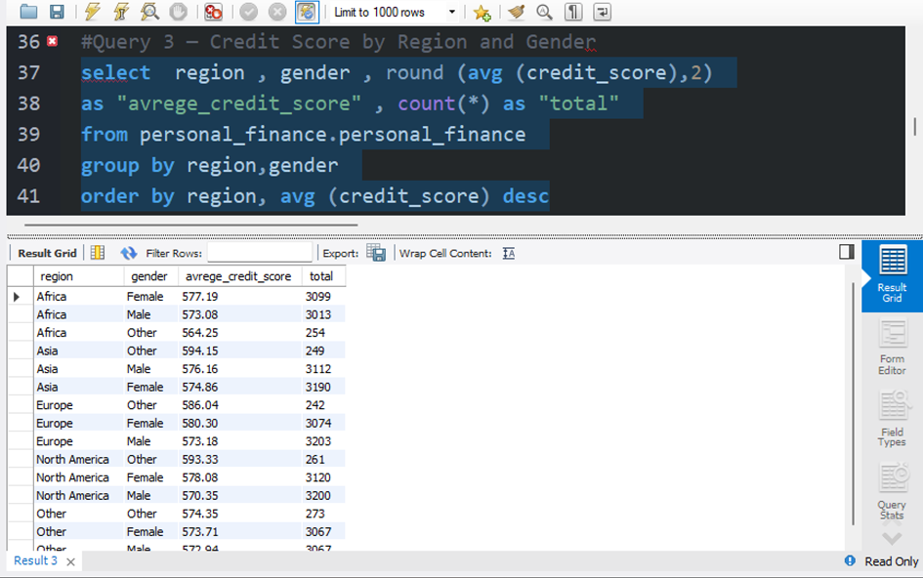
Credit scores are relatively consistent across all regions and gender groups, ranging between 564 and 594. This uniformity is expected in synthetic datasets.

Query 4 — Debt to Income Ratio by Age Group
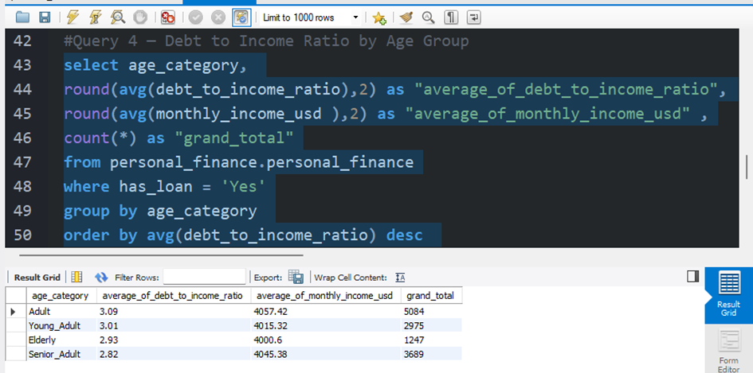
Adults carry the highest debt to income ratio at 3.09, reflecting peak borrowing years for mortgages and family expenses. Senior Adults carry the lowest at 2.82.

Query 5 — Savings Analysis by Income Bracket
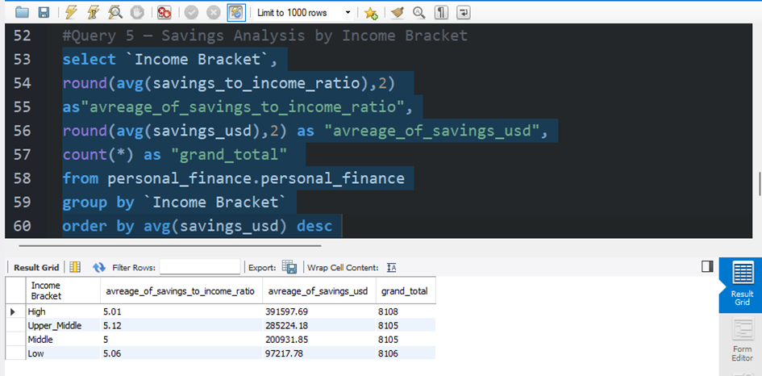
High income individuals save an average of $391,597 compared to $97,217 for low income individuals — nearly four times more in absolute terms. However the savings to income ratio remains consistent across all brackets at approximately 5.0.

Query 6 — Top 5 Job Titles by Average Income
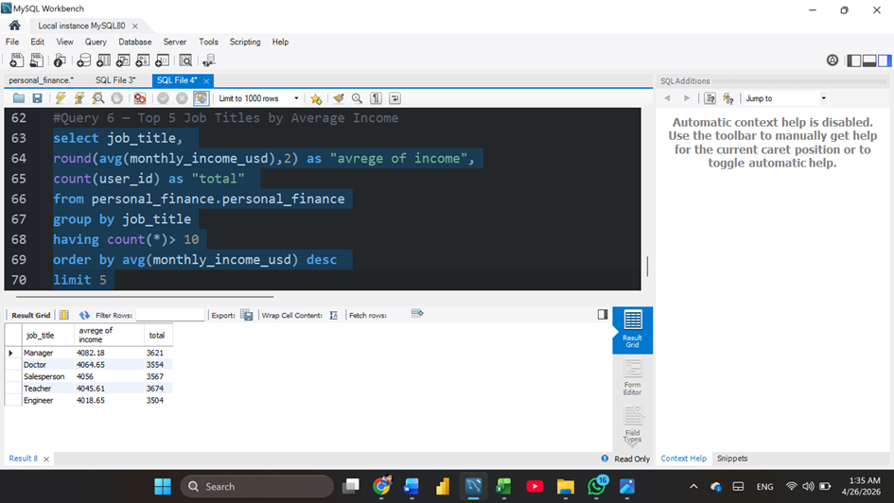
Managers earn the highest average monthly income at $4,082, followed by Doctors at $4,064. Engineers rank fifth at $4,018.

6. Data Visualization — Power BI Dashboard
Five visualizations were created in Power BI Desktop using the raw dataset to communicate the key findings in a clear and professional format.

Visual 1 — Average Income by Education Level
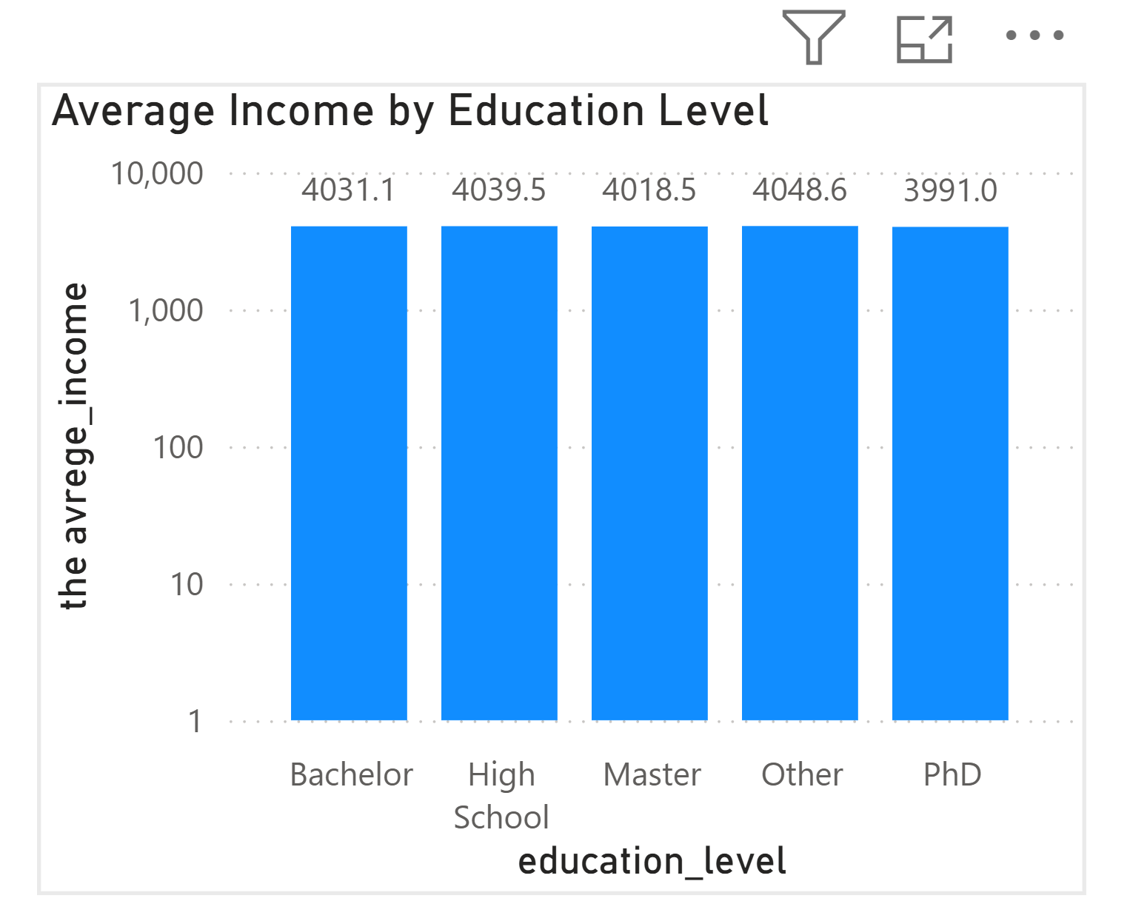
Income levels are nearly identical across all education groups, ranging from $3,990 for PhD holders to $4,048 for the Other category. This pattern reflects the synthetic nature of the dataset.

Visual 2 — Average Loan Interest Rate by Employment Status
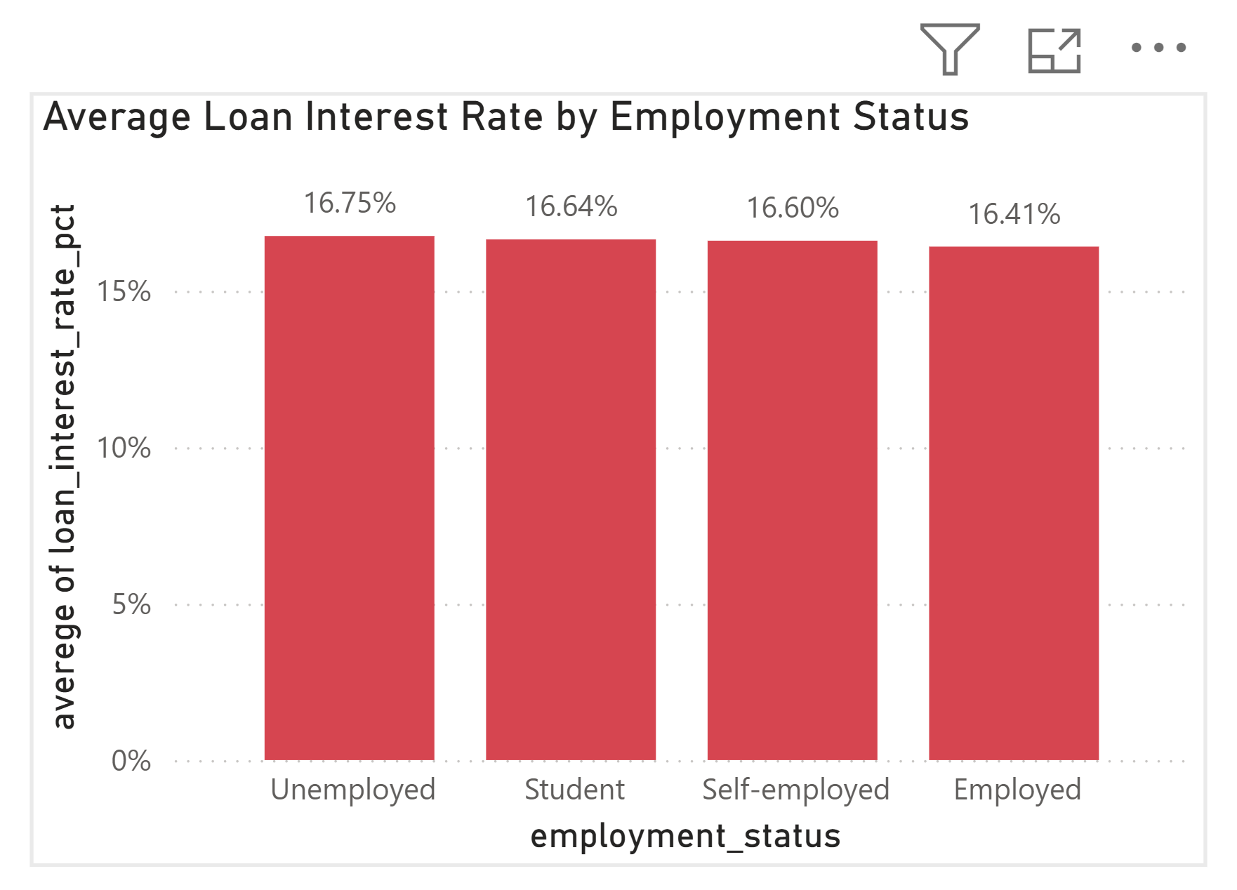
Unemployed borrowers face the highest interest rates at 16.75%, while employed borrowers receive the most favorable rates at 16.41%. Employment stability directly influences lending terms.

Visual 3 — Average Savings by Income Bracket
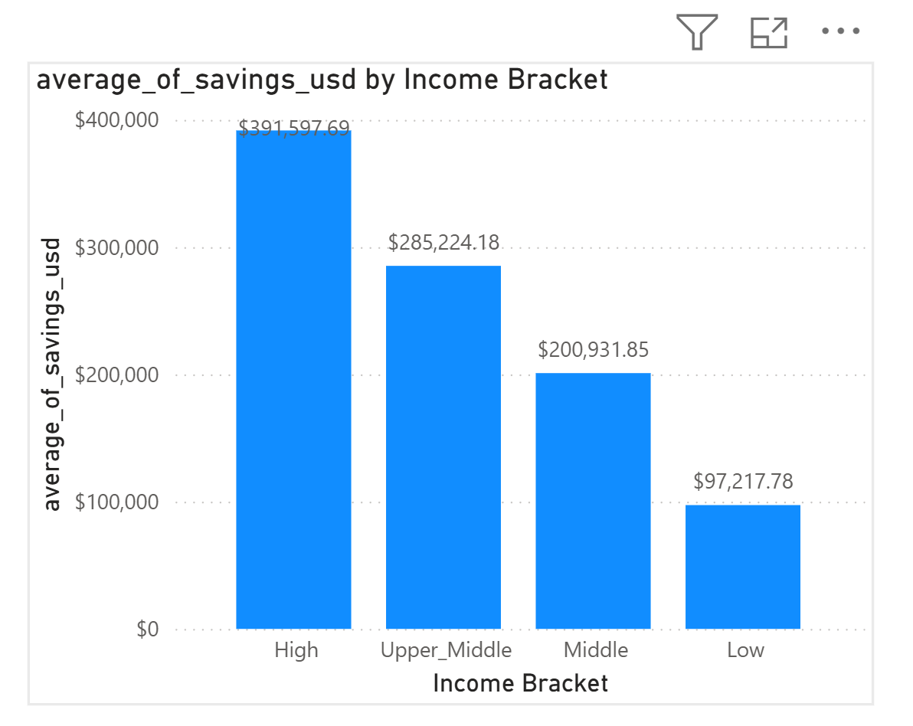
High income individuals save nearly four times more than low income individuals in absolute terms. This is the strongest and most intuitive insight in the entire project.

Visual 4 — Average Credit Score by Region
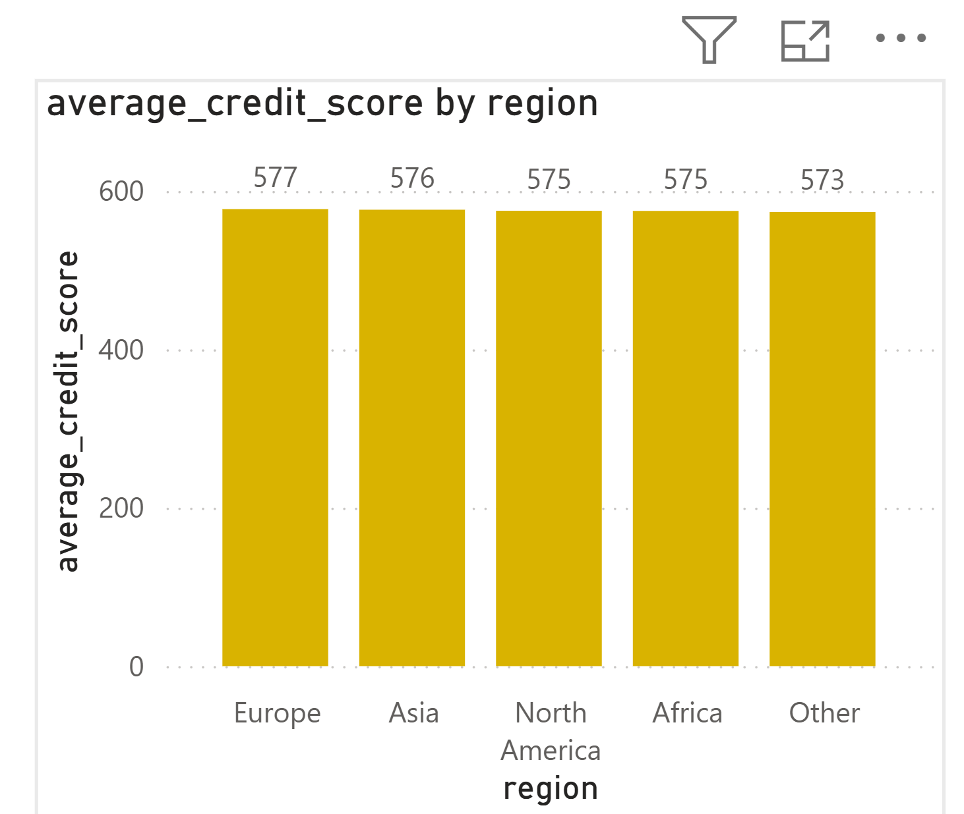
Credit scores are consistent across all global regions, ranging narrowly between 573 and 577. No single region demonstrates a significant credit advantage over others.

Visual 5 — Debt to Income Ratio by Age Group
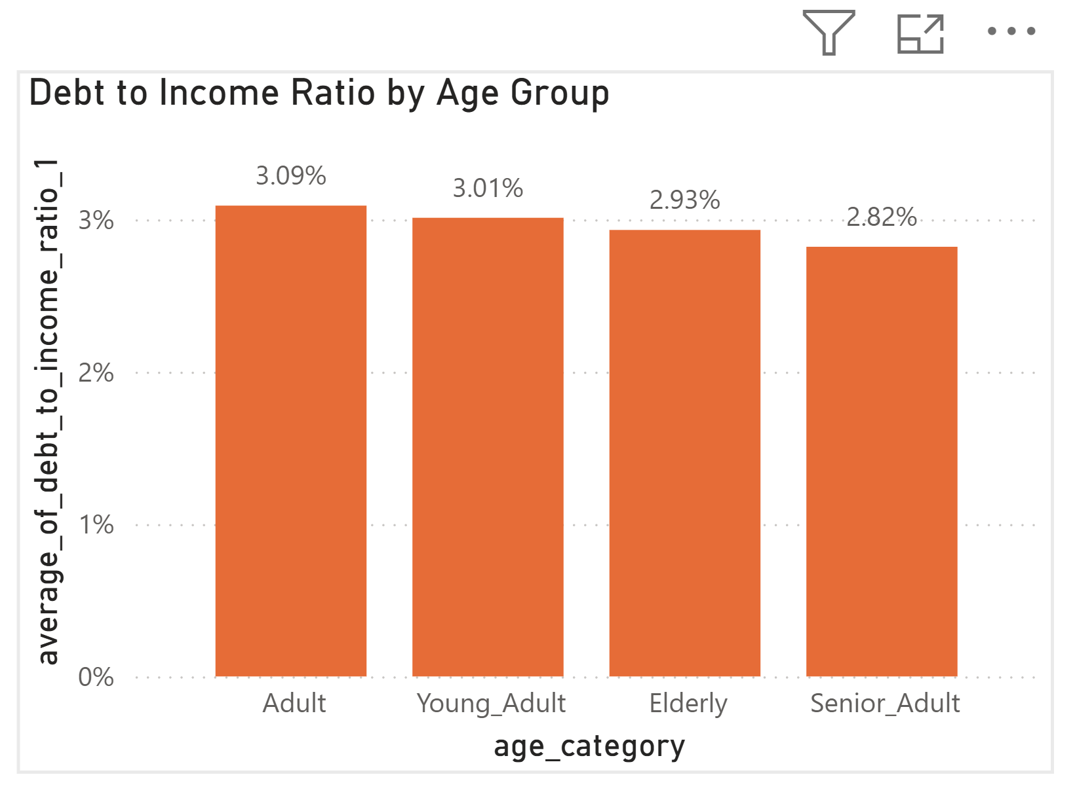
Adults carry the highest debt burden relative to income, while Senior Adults carry the least. This pattern aligns with real-world financial behavior where middle-aged individuals take on more debt for housing and family needs.

7. Conclusion
This project successfully demonstrated a complete end-to-end data analysis workflow using three industry-standard tools: Microsoft Excel, MySQL Workbench, and Power BI. The following key findings were drawn from the analysis of 32,424 personal finance records:

- Education level has minimal impact on average monthly income, with all groups earning between $3,990 and $4,048 per month.
- Unemployed individuals pay the highest loan interest rates at 16.75%, confirming that employment stability is a key factor in lending risk assessment.
- High income individuals save nearly four times more in absolute terms than low income individuals, though the savings to income ratio remains consistent at approximately 5.0 across all brackets.
- Credit scores are uniform across all regions and gender groups, ranging between 573 and 577, which limits geographic or demographic credit comparisons.
- Adults aged 26–40 carry the highest debt to income ratio at 3.09, reflecting peak borrowing years associated with mortgages, car loans, and family expenses.
- As a synthetic dataset, many findings show limited variation across groups. This project nonetheless demonstrates the ability to profile, clean, query, and visualize data professionally — skills directly applicable to real-world analytical roles.

Tools Used: Microsoft Excel · MySQL Workbench · Power BI Desktop
Dataset Source: Kaggle — Synthetic Personal Finance Dataset
Project Duration: 3 days — April 2026
By Habib Hajjioui
marrakech

