On-The-Job Training (OJT) Report on
OneStep Pharmacy E-commerce at
Shivapuri Secondary School, Maharajgunj, Kathmandu

A Report Submitted
In the Partial Fulfillment of the Requirement for the Degree
Computer Engineering under Technical and Vocational Stream
Secondary Level Education (Grade - 10)

Submitted By:
Shrawan Shah

Submitted To:
Department of Technical and Vocational Stream
National Examination Board, Sanothimi, Bhaktapur

Shrawan, 2083

CERTIFICATE OF APPROVAL
This is to certify that the On-the-Job Training (OJT) report entitled "OneStep Pharmacy E-commerce Platform" submitted by Mr. Shrawan Shah, a student of Grade 10 at Shivapuri Secondary School, is an authentic record of the work carried out by him under my supervision and guidance during the academic year 2082/83 B.S.
This project demonstrates the practical application of modern web development concepts including backend engineering with Django, frontend template design, database modeling, and secure user authentication for a functional pharmacy e-commerce platform. The work was performed as part of the Grade 10 Computer Engineering curriculum and reflects a high level of dedication and technical skill.
This report is approved for the partial fulfillment of the requirements for the Grade 10 level in the Computer Engineering program under the Technical Stream for the academic year 2082 B.S. and is accepted.

.........................
External Evaluator
IT Instructor
Maharajgunj, Kathmandu, Nepal

CERTIFICATE OF ON THE JOB TRAINING
This is to certify that Mr. Shrawan Shah, a student of Grade 10 at Shivapuri Secondary School, has successfully completed his On-the-Job Training (OJT) as part of the Computer Engineering curriculum under the Technical Stream for the academic year 2082 B.S.
During the training period, he was actively involved in the design and development of the project titled "OneStep Pharmacy E-commerce Platform." His work included practical implementation of modern technologies such as frontend development, backend system design using Django, and database management.
Throughout the training, he demonstrated a strong sense of responsibility, dedication, and eagerness to learn. He maintained good discipline and showed professional behavior during the entire training period.
We wish him success in his future academic and professional endeavors.

.........................
Supervisor
Er. Sagun Babu Adhikari
IT Instructor

DECLARATION
I, Shrawan Shah, a student of Grade 10, hereby declare that the OJT report entitled 'OneStep Pharmacy E-commerce Platform' submitted to the Department of Computer Engineering, Shivapuri Secondary School, is my original work.
I have followed all the institutional guidelines provided by the school and the National Education Board (NEB) during the preparation of this report.

.........................
Mr. Shrawan Shah
Shivapuri Secondary School
Maharajgunj-10, Kathmandu

PREFACE
The present report is the outcome of the On-the-Job Training (OJT) project titled 'OneStep Pharmacy - E-commerce Platform'. This report documents the entire journey of developing a functional pharmacy e-commerce website using the Django web framework, from initial planning and database design to frontend implementation and deployment.
This report is structured into five chapters. Chapter 1 provides an introduction to the project, its objectives, and scope. Chapter 2 describes the OJT workplace and context. Chapter 3 presents the technology stack and technical implementation in detail. Chapter 4 summarizes the learning and skills acquired during the OJT. Finally, Chapter 5 presents the conclusion, limitations, and recommendations for future enhancements.
Through this report, I aim to demonstrate the practical knowledge and hands-on experience gained during the OJT period, reflecting the skills required for a Grade 10 Computer Engineering student under the technical stream.

ACKNOWLEDGEMENT
This OJT report would not have been possible without the support and guidance of several individuals and institutions. First and foremost, I would like to express my sincere gratitude to my supervisor, Er. Sagun Babu Adhikari, for his invaluable guidance, continuous encouragement, and constructive feedback throughout the project duration.
I would also like to express my sincere gratitude to our respected Principal, Mrs. Sindhu Tuladha, for her valuable support and for providing the necessary infrastructure to carry out this project successfully.
I would also like to thank Shivapuri Secondary School for providing the technical infrastructure and a supportive environment that enabled me to work on this project effectively.
Finally, I extend my deepest gratitude to my parents and family for their constant support, motivation, and encouragement throughout my studies and during this OJT period.

TABLE OF CONTENTS
Topic Page No.
CERTIFICATE OF APPROVAL II
CERTIFICATE OF ON THE JOB TRAINING III
DECLARATION IV
PREFACE V
ACKNOWLEDGEMENT VI
TABLE OF CONTENTS VII
ABBREVIATIONS IX
Chapter: 1 Introduction 1
1.1 Project Overview 1
1.2 Problem Statement 1
1.3 Project Objectives 1
1.4 Project Scope 2
Chapter: 2 OJT Workplace & Context 3
Chapter: 3 Technology & Technical Implementation 4
3.1 Technology Stack 4
3.2 Backend Data Models 4
3.3 Visual Showcase & UI Analysis 5
3.3.1 Homepage / Landing Page 5
3.3.2 Featured Products Section 6
3.3.3 Product Catalog 6
3.3.4 User Authentication System 6
3.3.5 Order Placement & Tracking 7
3.3.6 Product Detail Page 7
3.3.7 Admin Dashboard 8
3.3.8 About Page & 3D Model Viewer 8
3.3.9 Responsive Design & Dark Mode 9
Chapter: 4 OJT Summary & Learning 10
4.1 Observations & Analysis 10
4.2 Technical Skills Acquired 10
Chapter: 5 Conclusion, Recommendation & Suggestion 11
5.1 Conclusion 11
5.2 Limitations 11
5.3 Future Enhancements 12
5.4 Recommendations 12
5.5 Suggestions 12
References 13

ABBREVIATIONS
OJT | On-the-Job Training
API | Application Programming Interface
ORM | Object-Relational Mapping
CSRF | Cross-Site Request Forgery
XSS | Cross-Site Scripting
HTTP | Hypertext Transfer Protocol
UI/UX | User Interface / User Experience

Chapter: 1 Introduction
1.1 Project Overview
OneStep Pharmacy is a modern, Django-based pharmacy e-commerce platform designed for managing medicines, customer orders, and user profiles through a clean and responsive web interface. The platform enables users to browse a catalog of pharmaceutical products, view detailed information about each medicine including price, stock status, and expiry date, and place orders directly from the product page.
The project was conceived as a Grade 10 OJT project to demonstrate how modern web technologies, particularly the Django web framework, can be used to create a functional and secure e-commerce application. The platform focuses on simplicity and usability, with an intuitive design that makes it accessible to users of all technical backgrounds.
1.2 Problem Statement
The traditional pharmacy experience often lacks transparency and convenience, presenting several challenges for both customers and pharmacy staff:
1. Limited Information Access: Customers often lack easy access to detailed medicine information such as prices, stock availability, and expiry dates without physically visiting the pharmacy.
2. Inconvenient Ordering: The process of ordering medicines can be time-consuming and inefficient, especially during busy hours or when customers need to check availability of specific medications.
3. Inefficient Management: Pharmacies may struggle with manual inventory tracking and order management, leading to stockouts or overstocking of certain medicines.
The OneStep Pharmacy platform aims to address these challenges by digitizing the pharmacy experience, making medicine information accessible online and streamlining the ordering process.
1.3 Project Objectives
The primary objectives of the OneStep Pharmacy project were:
• To build a secure backend using the Django web framework for managing products, users, and orders.
• To implement a user-friendly frontend using Django templates, HTML5, and custom CSS for a responsive design.
• To provide a product catalog with detailed medicine information including images, prices, stock levels, and expiry dates.
• To enable secure user authentication with registration, login, and logout functionality.
• To develop a simple order placement system allowing authenticated users to order medicines.
• To create an administrative dashboard for managing products, orders, and user profiles.
• To integrate an interactive 3D model viewer on the About page to showcase pharmaceutical models.
1.4 Project Scope
The project scope covers the end-to-end development of a functional pharmacy e-commerce platform, including product catalog browsing, user authentication (registration/login/logout), single-product ordering with quantity validation against available stock, order status tracking (Pending, Shipped, Delivered), and a full Django admin interface for managing products and orders. The platform also includes a responsive design with dark mode support and an About page featuring an interactive 3D model viewer.

Chapter: 2 OJT Workplace & Context
The On-the-Job Training (OJT) was conducted in the Computer Engineering Department of Shivapuri Secondary School, located in Maharajgunj, Kathmandu. The school provided a supportive learning environment with access to computer labs and internet facilities, enabling the practical implementation of the project.
The development of the OneStep Pharmacy platform followed a structured workflow based on iterative development principles. The project began with requirements gathering and system design, followed by backend development, frontend implementation, testing, and documentation. Regular consultations with the supervisor, Er. Sagun Babu Adhikari, helped ensure that the project met the required standards.
During the OJT, I gained valuable experience in full-stack web development using Django, Python, HTML, CSS, and JavaScript. I also learned important software engineering practices including version control with Git, database modeling, user authentication, and responsive design principles.

Chapter: 3 Technology & Technical Implementation
3.1 Technology Stack Details
The OneStep Pharmacy platform is built using the Django web framework version 6.0.5, which provides a robust and secure foundation for web application development. Django follows the Model-View-Template (MVT) architecture, which separates the data layer, business logic, and presentation layer for clean and maintainable code.
The frontend is built using Django template language with HTML5 and custom CSS. The styling is organized using CSS custom properties (variables) for consistent theming and dark mode support. The design is fully responsive, with a mobile hamburger menu for smaller screens, scroll-animated sections, and a gradient color scheme.
For 3D visualization, the platform integrates the <model-viewer> web component, loaded from a CDN, to display interactive 3D OBJ models of pharmaceutical shelves on the About page, with a texture image mapped onto the models.
3.2 Backend Data Models
The database backend is powered by SQLite, Django's default database engine, which provides a lightweight yet reliable data storage solution suitable for a prototype application. The backend architecture is centered around three key models:
Product Model: Stores medicine information including name, description, price, stock quantity, expiry date, and an image uploaded via the admin interface. Each product can be individually managed through the Django admin panel.
Order Model: Manages customer orders with fields for user reference, product selection, quantity ordered, order date, and delivery status (Pending, Shipped, Delivered). Orders are linked to both the User and Product models through foreign key relationships.
UserProfile Model: Extends the built-in Django User model with additional fields including a phone number and delivery address, allowing customers to provide necessary information for order fulfillment.
3.3 Visual Showcase & UI Analysis
The following sub-sections present each major module of the OneStep Pharmacy platform with annotated screenshots. Each component is analyzed in terms of its functionality, user interface design, and technical implementation.
3.3.1 Homepage / Landing Page
The OneStep Pharmacy landing page is designed for visual impact and clear navigation. The hero section features a gradient color scheme with a tagline and call-to-action button, immediately communicating the purpose of the platform. Below the hero, the page displays a section of featured medicines, a testimonials carousel showing user reviews, and a newsletter signup form in the footer.
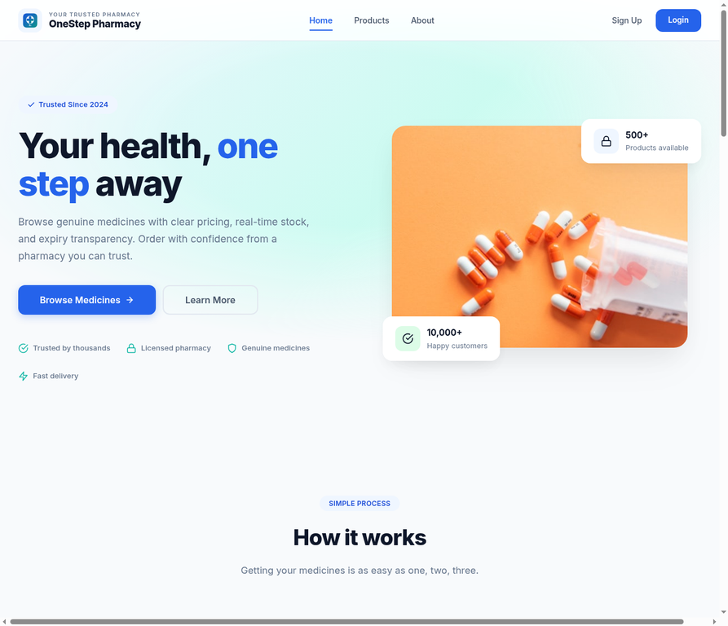
Figure 3.1: OneStep Pharmacy homepage showing hero section and featured products
3.3.2 Featured Products Section
The Featured Products section showcases six high-priority medicines in a responsive card grid layout. Each product card displays the product image, name, price, and a stock availability badge (green for "In Stock", red for "Out of Stock"). Users can click "View Details" to navigate to the product detail page or "Add to Cart" to initiate the order process. The grid adapts to different screen sizes, displaying four cards on desktop, two on tablets, and one on mobile devices.
3.3.3 Product Catalog
The product listing page provides a complete catalog of all available medicines, sorted with the newest products displayed first. Each product is shown in a card format with its image, name, price, and a brief description. The clean, organized layout makes it easy for users to browse through available medicines and quickly identify products of interest.
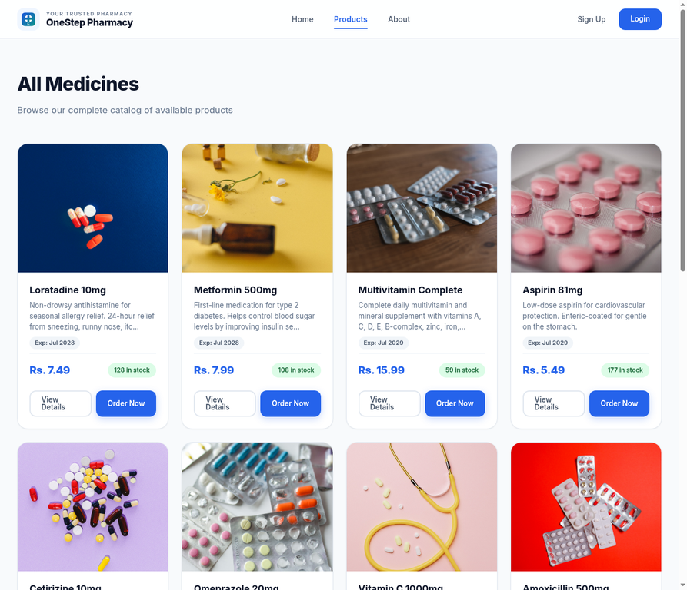
Figure 3.2: Product listing page showing the medicine catalog in card layout
3.3.4 User Authentication System
OneStep Pharmacy implements a complete user authentication system with registration, login, and logout functionality. New users can create an account by providing their username, email, password, and optional profile information including phone number and address. The system uses session-based authentication with Django's built-in authentication backend, CSRF protection tokens on all forms to prevent cross-site request forgery attacks, and HTTP-only cookies for secure session management. Authenticated users are identified by a personalized greeting in the navigation bar.
3.3.5 Order Placement & Tracking
The order placement system allows authenticated users to order medicines directly from the product detail page. When placing an order, users specify the desired quantity, which is validated against the available stock to prevent overselling. Once an order is placed, it is recorded in the database with a status of "Pending". Pharmacy staff can then update the order status through the admin dashboard to "Shipped" or "Delivered" as the order progresses. While the current implementation focuses on single-product orders, the database schema is designed to support more complex multi-item orders in future iterations.
3.3.6 Product Detail Page
The product detail page provides comprehensive information about a specific medicine. The page displays a large product image, the medicine name, price, a detailed description, current stock status, and expiry date. Authenticated users see an "Order Now" button with a quantity selector, allowing them to place an order immediately. The page also includes navigation links back to the product catalog, creating a seamless browsing experience.
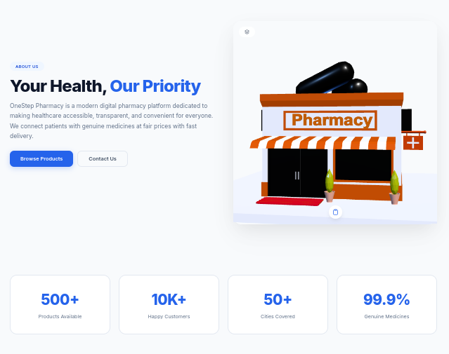
Figure 3.4: Product detail page showing medicine information and order button
3.3.7 Admin Dashboard
The Django admin interface provides a comprehensive management dashboard accessible at the /admin/ URL. Authorized staff can perform full CRUD (Create, Read, Update, Delete) operations on all products, manage customer orders and update their delivery status, view and manage user profiles, and monitor stock levels. The admin interface is automatically generated by Django based on the defined models, requiring minimal additional code while providing a powerful management tool.
3.3.8 About Page & 3D Model Viewer
The About page introduces the developer and features an interactive 3D model viewer that displays pharmaceutical shelf models. The viewer uses the <model-viewer> web component loaded from Google's CDN, supporting drag-to-rotate, scroll-to-zoom, and auto-rotate functionality. Users can switch between six different OBJ pharmacy models using numbered buttons below the viewer. A texture image (Resto.png) is mapped onto the models to provide a realistic appearance. The viewer wrapper uses CSS custom properties for consistent dark mode styling.
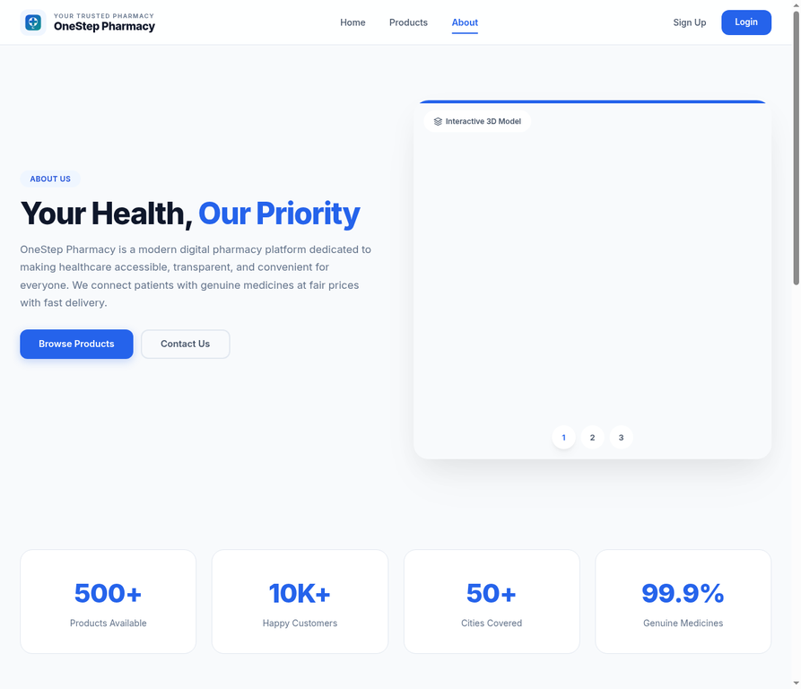
Figure 3.3: About page with interactive 3D model viewer
3.3.9 Responsive Design & Dark Mode
The platform is designed to be fully responsive across different device sizes. A mobile hamburger menu replaces the horizontal navigation bar on smaller screens, and product grids adjust their column count based on viewport width. The dark mode toggle, implemented using a JavaScript-controlled CSS class on the body element, switches between light and dark color schemes defined through CSS custom properties. The platform also includes scroll-triggered fade-in animations for visual appeal, implemented using the Intersection Observer API.

Chapter: 4 OJT Summary & Learning
4.1 Observations & Analysis
Throughout the OJT, I observed how modern web development frameworks like Django simplify complex development tasks by providing built-in solutions for common requirements such as user authentication, database management, and security. Django's "batteries-included" philosophy allowed me to focus on implementing application-specific features rather than reinventing foundational components.
The project also demonstrated the importance of security in web applications. During development, I implemented CSRF protection on all forms, used Django's built-in XSS filtering for template rendering, and applied session-based authentication to protect user accounts. These security measures are essential for any e-commerce platform handling user data and transactions.
4.2 Technical Skills Acquired
Working on OneStep Pharmacy, I have mastered several key skills:
• Backend Development with Django ORM: Creating models, managing database relationships, and performing CRUD operations using Django's Object-Relational Mapping system.
• Database Schema Design: Designing normalized database models with appropriate field types, relationships, and constraints for a pharmacy e-commerce application.
• User Authentication with Session Management: Implementing registration, login, logout, and session-based authentication using Django's built-in authentication system.
• Responsive Frontend with Custom CSS: Building responsive layouts using CSS Grid, Flexbox, media queries, and CSS custom properties for theming.
• 3D Web Integration with model-viewer: Embedding interactive 3D models in a web page using the <model-viewer> web component with OBJ file format support.
• Git Version Control: Using Git for source code management, tracking changes, and maintaining a clean development history.
• Vercel Deployment: Deploying the Django application to Vercel and configuring environment variables for production settings.

Chapter: 5 Conclusion, Recommendation & Suggestion
5.1 Conclusion
The OneStep Pharmacy project has successfully achieved its primary goal of building a functional, Django-based pharmacy e-commerce platform. The platform provides essential features including product catalog management, user authentication, order placement, and an administrative dashboard. Additionally, the integration of a 3D model viewer demonstrates the potential for interactive visualizations in educational and commercial contexts.
For a Grade 10 OJT project, OneStep Pharmacy represents a solid demonstration of fundamental web development skills. The project covers the full spectrum of web development from backend database design and API implementation to frontend template rendering and responsive styling. The experience gained during this project provides a strong foundation for future work in software development.
5.2 Limitations
Although the OneStep Pharmacy OJT project was highly beneficial, certain limitations were encountered during its development:
• Prototype Scope: The project was limited to a functional prototype; full production deployment with integrated payment gateways and SSL certificates was not implemented.
• No Shopping Cart: The current implementation supports only single-product ordering. A multi-item shopping cart with quantity management was not developed due to time constraints.
• No Payment Processing: The platform does not include any payment gateway integration. All orders are processed offline with cash-on-delivery or manual payment arrangements.
• No Order History: Users cannot view their past orders or track the status of current orders from their profile page.
• No Search or Filtering: The product catalog lacks search functionality and category-based filtering, requiring users to browse through all available products.
• No Reviews or Ratings: The platform does not include a customer review or rating system for medicines.
• Time Constraints: The limited OJT duration prevented the implementation of more advanced features and comprehensive testing.
5.3 Future Enhancements
The OneStep Pharmacy platform has strong potential for future development. The following enhancements are planned:
• Shopping Cart: Implementing a full shopping cart system that allows users to add multiple items, update quantities, and proceed to a consolidated checkout.
• Payment Gateway Integration: Integrating popular payment services like eSewa, Khalti, or Connect IPS to enable online payment processing.
• User Order History: Adding a dedicated order history page where users can view their past orders and track delivery status in real time.
• Search and Filtering: Implementing full-text search across product names and descriptions, along with category-based filtering and price range sorting.
• Review and Rating System: Allowing verified purchasers to leave reviews and ratings for medicines, building social proof and helping other customers make informed decisions.
• Email Notifications: Sending automated email confirmations for order placement and status updates.
• Inventory Alerts: Implementing automatic low-stock alerts for pharmacy staff to ensure timely restocking of medicines.
• Contact and Inquiry Page: Adding a contact form and chatbot integration for customer inquiries and support.
5.4 Recommendations
Based on the OJT experience with OneStep Pharmacy, the following recommendations are offered to improve future projects:
• Better Infrastructure: Schools should provide stable, high-speed internet and dedicated lab computers to support full-stack development and testing of web applications.
• Extended OJT Duration: Allocating more time for OJT would allow students to implement more advanced features, conduct thorough testing, and refine the user interface based on feedback.
• Regular Workshops: Conducting regular workshops on modern web technologies including Django, React, version control with Git, and cloud deployment would better prepare students for real-world development challenges.
5.5 Suggestions
From the OneStep Pharmacy OJT experience, the following suggestions are offered to future trainees and institutions:
• Start with a Clear Plan: Future trainees should begin their project with a clear requirement document and system design, ensuring that all features are well-understood before implementation begins.
• Maintain a Daily Logbook: Students should keep a daily development log to track progress, document bugs, and record learning experiences for future reference.
• Use Version Control from Day One: Adopting Git and GitHub from the very beginning of the project ensures clean commit history and facilitates collaboration.
• Be Honest About Scope: Students should honestly document the limitations and unfinished features of their project, as this demonstrates maturity and self-awareness.

References
1. Django Documentation: https://docs.djangoproject.com/en/6.0/
2. Python Documentation: https://docs.python.org/3/
3. Pillow (Python Imaging Library): https://pillow.readthedocs.io/
4. Google Model Viewer: https://modelviewer.dev/
5. W3Schools HTML & CSS Tutorials: https://www.w3schools.com/

