Reference Bundle Staleness: Quantifying rsID Obsolescence and Its Impact on Clinical Variant Annotation

Habib Mahjoubi
Independent Researcher, Nantes, France
ORCID: 0000-0003-2521-7938
Email: habibmahjoubi62@gmail.com

Abstract
Molecular diagnostic pipelines annotate germline variant calls with dbSNP reference-SNP identifiers (rsIDs), carried into clinical reports and used to query population-frequency and clinical-significance databases during interpretation. Whether these identifiers remain stable over a pipeline's operational lifetime has not been examined. dbSNP periodically merges duplicate rsIDs -- the same class of event previously shown, for viral taxonomy identifiers, to manufacture false novelty under naive, current-day-only lookup [1]. We test whether this failure mode recurs for rsIDs in clinical germline variant calling.
Among real chr20 variants from the Genome in a Bottle (GIAB) HG002 truth set with an allele-exact dbSNP match, 66.44% sit on a historically-merged rsID -- a ~111x enrichment over the 0.60% background merge rate, consistent with GIAB's population being disproportionately old and frequently-resubmitted.
Against a deployed dbSNP138 known-sites bundle (GATK), 12.75% of 2,894 variants with a 2014-2017 merge event are reported under the retired identifier; a second bundle (dbSNP144) shows this fall to 2.59%, but reveals a distinct, non-deterministic failure mode: 2.18% of variants carry both the current and a not-yet-merged identifier simultaneously. A real nf-core/sarek run on real HG002 chr20 reads confirms the mechanism is not a truth-set artifact, writing a stale rsID into 11.58% of output calls restricted to the same merge-dated population. Concretely, gnomAD, a population-frequency resource used as ACMG/AMP classification evidence, returns zero results for 369 of 369 (100%) dbSNP138-stale identifiers under the identifier each variant actually carries, while the current identifier resolves every time -- with direct consequences for population-frequency lookup during variant interpretation. The merge-date distribution behind these figures shows this is not an open-ended, age-dependent rate: none of the 81,963 recorded merge events in this panel postdate 2017, so staleness here is better read as a fixed historical debt left by a merge wave largely over by the time either bundle was frozen.
Keywords: molecular diagnostics; clinical variant annotation; dbSNP; rsID merge; reference database curation; germline variant calling; next-generation sequencing quality assurance

1. Introduction
Molecular diagnostic laboratories that perform germline variant calling depend on reference databases to annotate, interpret, and report clinically-relevant genetic variants. Central among these is dbSNP, whose reference-SNP identifiers (rsIDs) are propagated directly into variant-calling pipeline output and used downstream to cross-reference population-frequency and clinical-significance resources during interpretation. As with identifiers in other curated biological databases, rsIDs are expected to be stable enough to support this kind of cross-reference over time. In practice, identifiers are periodically consolidated: two independently-registered entries are later recognized as the same underlying entity and merged, with one identifier retired in favor of the other. A companion technical note [1] documented this phenomenon for NCBI Taxonomy identifiers (taxids) in the context of viral metagenomic classification, and showed that a naive, current-day-only lookup manufactures false novelty: an entity that already existed under a retired identifier appears, incorrectly, to be newly created.
This raises a natural generalization question: is this an idiosyncrasy of NCBI Taxonomy's specific curation practice, or a structural property of any identifier system that undergoes administrative merging? We test this on dbSNP's reference-SNP identifier (rsID), chosen because it (a) is administratively merged under a documented, comparable mechanism (a duplicate submission's identifier is retired into an established one), (b) belongs to an entirely different genomics domain -- clinical molecular diagnostics and germline variant calling rather than viral metagenomic classification -- and (c) is embedded in reference resources (known-sites bundles) that are explicitly, deliberately frozen for long periods in regulated and production pipelines, for reasons of validation stability.
GATK's [7] Best Practices workflow, including the known-sites bundles it consumes, is the basis of germline variant-calling pipelines widely deployed in clinical molecular diagnostic laboratories, not only research settings. A known-sites bundle such as Homo_sapiens_assembly38.dbsnp138.vcf.gz is not used in only one way, and the two uses differ sharply in whether a stale identifier matters at all. Fed to GATK's BaseRecalibrator, only the bundle's genomic positions are consulted -- the ID column is not read, so a retired rsID there has no effect whatsoever on base-quality recalibration. Fed to HaplotypeCaller's -D flag (or to VariantAnnotator --dbsnp), the bundle's ID column is copied directly into the ID field of every output call at a matching position -- a retired rsID there is written, verbatim, into the pipeline's own variant-calling output. This paper's claim concerns the second usage only; nothing here implies BQSR is affected, and the two must not be conflated. That the annotation pathway exists and copies the ID column verbatim is documented GATK behavior, not an assumption of this study; whether a real HaplotypeCaller -D run against this exact bundle actually emits a stale identifier in practice, on real chr20 reads, is confirmed directly, not merely inferred, in Section 5.8.
That last point connects this study to a broader governance observation: regulated bioinformatics pipelines routinely freeze reference artifacts for validation-stability reasons, and the resulting drift between the frozen artifact and the live reference is a problem current practice does not measure. This paper supplies exactly that missing measurement for one concrete, real, currently-deployed artifact: how often does a frozen dbSNP-based reference bundle actually go stale relative to the live dbSNP merge ledger?
Contribution. We (1) confirm the rsID merge mechanism exists at scale on real clinical-relevant variants, (2) demonstrate the naive-vs-merge-aware failure mode directly and reproducibly, (3) show, via a structural (deductive) argument illustrated on one real resource, that this failure mode is concentrated in a specific, identifiable class of artifact rather than diffuse (an old but actively-used community resource is not affected), (4) show a concrete positive result: a specific, widely-used, still-deployed production reference bundle already carries a measurable rate of stale identifiers today, (5) confirm this is not merely a property of the truth-set stand-in by reproducing it on a real nf-core/sarek pipeline run's own output (Section 5.8), and (6) show the downstream consequence is concrete, not hypothetical: a real, widely-used population-frequency resource (gnomAD) returns zero results for 100% of the stale identifiers tested, under the exact identifier this study's target bundle writes into its own output (Section 5.9). Together these establish, on real clinical variants and a real production pipeline, a concrete data-quality risk for molecular diagnostic laboratories that use this bundle to annotate and report germline variants.

2. Illustrative Examples
Before detailing the full protocol, three real cases illustrate the mechanism concretely (all drawn from this study's own chr20 data; see Section 5 for the full-scale results).
Table 1. Three illustrative cases of the naive-vs-merge-aware mechanism, drawn from this study's own chr20 data.
Case | Position (GRCh38, chr20) | Current rsID | Retired rsID found | Merge date | Where the retired ID was found
A -- naive-lookup failure (internal to dbSNP) | 3,250,488 | rs1207 | rs732922 | 2001-01-18 | Live dbSNP API record for rs732922 carries no primary variant data of its own (Section 5.2)
B -- downstream artifact unaffected (negative control) | 22,279,230* | rs199784 | rs74969895 | 2016-07-19 | 1000 Genomes Phase 3 (2013) already used the current ID (Section 5.3)
C -- downstream artifact stale (positive finding) | 21,320,295 | rs202831 | rs74621691 | 2016-02-17 | GATK dbSNP138 known-sites bundle still reports rs74621691 today (Section 5.4)

* Position given in GRCh37/b37 coordinates as used by the 1000 Genomes Phase 3 VCF; the GRCh38 coordinate for the same variant differs (see Section 4.4).
Case A and Case C are the same class of failure (a naive, ID-only lookup cannot find data for the retired identifier) observed at two different levels: A is internal to dbSNP itself (proving the mechanism exists), C is in a real, independently-produced, currently-deployed artifact (proving it has downstream consequences). Case B shows the same mechanism does not automatically propagate everywhere -- it depends on whether the specific downstream artifact was assembled before or after the retired identifier was ever in active use (Section 6.1).

3. Background: The dbSNP Merge Mechanism

3.1 Related Work
The dbSNP rsID merge-tracking problem this paper measures is not newly identified: SNPTracker [2], a batch reconciliation tool, was built specifically because a sequence variant can carry multiple different rs IDs across databases and datasets as dbSNP merges and deletes identifiers over time, and because the two prior tools for this task were inadequate -- LiftRsNumber, unmaintained since 2011, predates the rs ID system's current complexity, and NCBI's own dbSNP Batch Query 'may ignore some previous rs IDs that are deleted after merging into current rs IDs' [2]. That NCBI's own official reconciliation path has a documented gap on exactly this failure mode is independent, external confirmation that the mechanism this paper measures is real and not fully solved by existing infrastructure. SNPTracker and its predecessors are reconciliation tools, however -- built to convert a given rs ID to its current form -- not measurements of how often a real, already-deployed production artifact (as opposed to a user's input list) actually goes stale; that measurement, on a real GATK known-sites bundle, is this paper's contribution.
The same class of problem -- identifier or nomenclature instability in a curated biological database silently corrupting downstream analysis -- recurs outside dbSNP. HGNChelper [3] documents invalid or outdated human/mouse gene symbols (aliasing, and spreadsheet-software reformatting) at prevalences from roughly 3% in recent gene-expression platform annotation files up to 30-40% in files from the early 2000s, propagating silently into downstream analyses unless explicitly corrected. Gene-symbol aliasing is a related but distinct mechanism from dbSNP's or NCBI Taxonomy's [1] administrative merges (a symbol can be reused or reformatted without a formal merge event), so this is offered as independent evidence that the general pattern this paper generalizes (Section 6.1) -- and [1] before it -- recurs across curated biological databases, not as a third instance of the identical mechanism.
Finally, this study's choice of the GATK dbSNP138 bundle (Section 4.1) as a 'real, currently-deployed production artifact' is grounded in the vendor's own current documentation, not an assumption: the Broad Institute's GATK resource-bundle documentation [9] lists Homo_sapiens_assembly38.dbsnp138.vcf as the current, GRCh38-compatible known-sites resource it distributes and recommends, alongside its acknowledgment that many other bundle files are being phased out during the GRCh38 transition.

3.2 The dbSNP Merge Mechanism
dbSNP assigns a reference-SNP identifier (rsID) to each distinct variant cluster [4]. When two independently-submitted clusters are later found to represent the same underlying variant, dbSNP merges them: by convention, the numerically higher rsID is retired into the numerically lower one. Historically this was tracked in a standalone relational table (RsMergeArch.bcp.gz), decommissioned along with the rest of the legacy build system in 2018 [8]. The current system exposes the same information directly on each RefSNP JSON record: a dbsnp1_merges array lists every predecessor identifier ever merged into the current one, each entry dated and tagged with the dbSNP build revision at which the merge occurred. The retired identifier's own record correspondingly carries a merged_snapshot_data.merged_into pointer and no primary_snapshot_data of its own -- i.e., no position, no alleles, nothing that a naive, ID-keyed data consumer could use.
Historical dbSNP build snapshots are archived (NCBI's public archive covers builds b152 through the current release, 2021-2025, extending back further for select legacy files to approximately 2015), which -- as with the NCBI Taxonomy taxdump_archive used in [1] -- makes multi-version replay studies possible in principle. This paper instead focuses on a specific, real, already-deployed static resource (Section 4.4) rather than a controlled multi-version replay, as a first, concrete demonstration of downstream impact.

4. Analysis Protocol

4.1 Data sources
(a) dbSNP RefSNP records for chromosome 20 (refsnp-chr20.json.bz2, NCBI dbSNP latest_release JSON distribution), accessed via HTTP range-fetch and streamed decompression (a byte-range partial-fetch technique, avoiding a full local download of the multi-gigabyte source file). (b) The GIAB HG002 high-confidence small-variant truth set (NIST v4.2.1, GRCh38) [5], used as a real, public, clinically-relevant variant panel for the full-coverage, large-scale analysis (Sections 5.1-5.7), complemented by a real nf-core/sarek pipeline run on a 30x downsample of the same sample's chr20 reads for direct empirical validation on actual pipeline output (Section 5.8). (c) 1000 Genomes Project Phase 3 chromosome 20 genotypes (2013 release, GRCh37) [6] as a historical, still-cited community resource. (d) The GATK best-practices known-sites bundle Homo_sapiens_assembly38.dbsnp138.vcf.gz (Broad Institute public reference bucket, GRCh38, dbSNP build 138 content), as a real, currently-deployed production reference artifact.

4.2 Candidate panel construction
For each RefSNP record with a non-empty dbsnp1_merges field, we extracted its chr20 genomic placement(s) from the record's SPDI representation (sequence NC_000020.11, 0-based position, deleted_sequence, inserted_sequence), converted to 1-based VCF-style coordinates, and kept only true variant alleles (deleted_sequence != inserted_sequence) where both are a single base (SNVs). Each (position, reference allele, alternate allele) triple was intersected against the identical triples observed in the real GIAB HG002 chr20 truth set, i.e., matching is allele-exact, not position-only. Indel alleles (both in dbSNP's SPDI representation and in the GIAB truth set) were excluded from this exact match, since SPDI's anchor convention does not map one-to-one onto VCF's left-padded indel convention without additional normalization; indels are handled separately, via an explicit normalization step, in Section 5.6. A position-only variant of this same panel was also built, to quantify how much allele-exactness matters (Section 5.1).
A methodological note on sampling bias: an initial byte-range sample of the first ~15,300 chr20 RefSNP records (necessarily biased toward the lowest, oldest rsID numbers, since the source file is sorted by identifier rather than genomic position) had shown 73.75% carrying at least one merge event (22,755 events across 11,308 records; dates 2000-2016) -- an estimate the full-coverage figure in Section 5.1 supersedes. It is recorded here only as the reason full coverage (scanning all 25,938,655 chr20 records, not a byte-range sample) was adopted for every subsequent analysis in this paper.

4.3 Naive-vs-merge-aware verification protocol
Mirroring the naive-vs-merge-aware audit design of [1]: for a random sample of predecessor (retired) identifiers, we queried the live dbSNP RefSNP API directly on the OLD identifier. The 'naive' verdict is what a simple, ID-keyed data consumer would see (does the record carry its own variant data -- position, alleles -- at all?); the 'merge-aware' verdict follows the record's merged_snapshot_data.merged_into pointer to the current identifier and cross-checks it against the current record's own dbsnp1_merges entry (two independent fields on two different records, which should agree if the merge ledger is internally consistent).

4.4 Downstream-impact test design
We define a downstream artifact as 'stale' with respect to a given merge event if it reports the retired (pre-merge) identifier at the variant's position, rather than the current one. Three artifacts were tested: (i) 1000 Genomes Phase 3 (2013), searched by direct identifier-string match (chosen specifically because it is coordinate-system-independent, since this resource uses GRCh37 while the rest of this study uses GRCh38); (ii) the GATK dbSNP138 bundle (dbSNP build 138, officially released 2013-10-23; exact GRCh38 bundle assembly date not independently verified, GRCh38-native); (iii) the dbSNP144 bundle used by the NCI Genomic Data Commons (June-2015-vintage content, GRCh38-native). (ii) and (iii) were both searched by exact genomic position AND exact allele (REF/ALT extracted directly from each bundle's own VCF records, matched against the allele-exact candidate panel of Section 4.2), on the identical subset of candidates whose most recent recorded merge falls in 2014-2017 -- the window in which each bundle's own snapshot date makes staleness plausible either way -- so the two bundles' results are directly, apples-to-apples comparable. A given (position, reference, alternate) key can appear on more than one line of a bundle's VCF -- concretely, when a duplicate submission had not yet been merged into its target at the bundle's snapshot date, both the current and the eventually-retired identifier are present as separate records at the same coordinate. All identifiers observed at a given key are retained (not silently reduced to one), and a key carrying both the current and a retired identifier simultaneously is scored as a distinct 'ambiguous' outcome rather than folded into either 'current' or 'stale' (Section 5.5).

4.5 Real pipeline validation protocol
To test whether the stand-in analysis of Sections 4.4-5.5 reproduces on actual pipeline output, we ran nf-core/sarek 3.9.0 (HaplotypeCaller, GATK4, Docker profile, BQSR skipped -- the field-standard configuration for germline short-variant calling) natively with --dbsnp pointing at the dbSNP138 bundle, so HaplotypeCaller's own -D mechanism (Section 1) performs the annotation directly -- on a 30x downsample (seed 42) of the GIAB HG002 novoalign chr20 alignment, starting from an already-aligned BAM (--step markduplicates). Every annotated rsID was looked up against the same live dbSNP merge ledger used throughout this study. Three data-preparation issues specific to the public GIAB BAM, unrelated to the pipeline's own scientific behavior, were resolved before this run: the source BAM carries no read-group tags (required by GATK4 MarkDuplicates; a synthetic one was added), the Ensembl GRCh38 chromosome FASTA uses bare contig naming ('20') against the GIAB BAM's UCSC-style naming ('chr20') and was renamed to match, and the extracted single-chromosome BAM retained its original alignment's full, ~1,000-contig header (decoys included), which GATK HaplotypeCaller rejects as incompatible with a single-contig reference dictionary and which was rebuilt to list chr20 only.

5. Results

5.1 Cross-reference against real GIAB HG002 chr20 variants
Table 2. Merge rate among real GIAB HG002 chr20 variants: full-coverage, allele-exact final figure versus superseded estimates.
Metric | Value
Distinct real GIAB HG002 chr20 variant positions | 85,951
dbSNP chr20 records scanned -- FULL COVERAGE | 25,938,655
Allele-exact (SNV) GIAB matches, any merge status -- full coverage | 73,370
...of which with merge history -- FINAL FIGURE | 48,746 (66.44%)
...of which with no merge history | 24,624
[superseded] full-coverage, position-only match | 49,730/104,082 (47.78%)
[superseded] partial-sample estimate, position-only | 48,217/65,347 (73.79%)
Position-only matches NOT allele-exact, partial sample (false positives) | 376 (0.78%)

This progression is reported in full because each step is a genuine methodological correction, not a rounding difference. The initial partial sample (73.79%) over-represented old, heavily-studied variants because the source file is sorted by identifier, not genomic position. Correcting for that with full coverage but still matching by position alone gave 47.78% -- but position-only matching also picks up unrelated dbSNP records that merely share a coordinate with a real GIAB variant (a multi-allelic site, for instance), which dilutes the rate downward. Matching allele-exact (POS+REF+ALT, SNV-only) at full coverage removes both distortions and gives the final, methodologically correct figure: 66.44% -- stated precisely, among the 73,370 real GIAB HG002 chr20 SNV alleles that have an allele-exact dbSNP record at all (85.4% of the 85,951 distinct GIAB positions; the remainder are indels, excluded here and addressed separately in Section 5.6, or simply have no dbSNP record under this exact matching), 48,746 (66.44%) sit on an identifier that has, at some point, absorbed one or more retired predecessors. Relative to all 85,951 GIAB positions regardless of match status, the corresponding figure is 56.71% (48,746/85,951); the two denominators answer different questions and neither should be read as the other.
Whether 66.44% represents genuine enrichment among real, clinically-observed variants, or is simply unremarkable relative to dbSNP's general chr20 population, can now be answered directly: a second full-coverage pass over the identical 25,938,655 chr20 records, this time counting every record with a non-empty dbsnp1_merges field regardless of GIAB match status, finds 154,375 (0.60%) carry merge history. The GIAB-matched population's 66.44% rate is therefore approximately 111x the background rate (66.44% / 0.60%) -- a real, substantial enrichment, not an artifact of the denominator. This is the expected direction: GIAB's high-confidence call set specifically selects well-characterized, frequently-resubmitted variants (Section 6.2), which are exactly the kind of old, heavily-studied identifiers most likely to have accumulated a merge history over dbSNP's 25-year operating life, while the general chr20 population includes vast numbers of rarely-observed, singly-submitted variants that have never been flagged as a duplicate of anything.
The merge-date distribution underlying this panel is itself worth reporting directly, since it bears on how the 2014-2017 candidate window used elsewhere in this paper -- the naive-vs-merge-aware check (Section 4.3), the real sarek run (Section 4.5), and the bundle/indel comparisons (Sections 5.5-5.6) -- should be read. This panel, like the rest of this section, is SNV-only (Section 4.2); the 2014-2017 window as used in Sections 5.5-5.6 additionally includes 1,719 indel candidates (4,613 combined), which the distribution below does not cover. Of the 81,963 individual merge events recorded across all 48,746 SNV candidates here, none postdate 2017 (Figure 1); the same holds candidate-by-candidate -- every one of the 48,746 candidates has its most-recent merge event in 2017 or earlier. Merge activity for this population is concentrated in two epochs -- a 2003-2009 wave, whose 2008 peak (37,867 events) coincides with the release of dbSNP build 128 in January 2008, and a smaller 2014-2017 tail (2,897, 83, 321, and 2 events respectively) -- with nothing recorded since. This has two direct consequences. First, it retroactively justifies the SNV 2014-2017 window: rather than an arbitrary recent slice, it captures the entire tail of observable post-2013 merge activity in this SNV panel. 324 of the real sarek run's 325 stale hits (Section 5.8) fall inside it by position; the 325th (chr20:18,953,626) is excluded from that position-based count only because sarek represents the site as a multi-allelic call (ALT=A,G) against this panel's single-allele key (ALT=G) -- its own merge date, like the other 324, is within 2014-2017. Second, it means staleness in this dataset behaves less like an open-ended, age-dependent accumulation and more like a fixed historical debt left by a merge wave that had largely run its course by the time either bundle was frozen; the Abstract and Section 6.1 are calibrated to this reading. This finding describes the specific, GIAB-matched, already old and heavily-studied SNV population analyzed in this section; it is not evidence that dbSNP's administrative merge process has stopped genome-wide, for indels, or for more recently-submitted variants, which this chr20-only, truth-set-restricted panel cannot speak to.
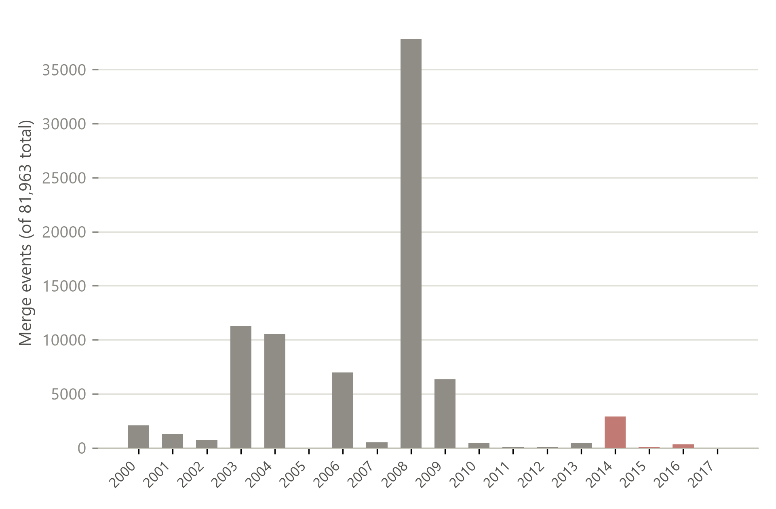
Figure 1. Distribution, by year, of all 81,963 merge events recorded across the 48,746-candidate, SNV-only, full-coverage panel (all recorded merge dates, not restricted to any window). No event in this panel postdates 2017; the 2014-2017 window (red) used elsewhere in this paper for the sarek run and the naive-vs-merge-aware check contains essentially the entire post-2013 tail of merge activity in this SNV population.

5.2 Naive-vs-merge-aware verification (n=100)
An initial pilot (n=30, seed=42) was extended to n=100 (seed=42, drawn from the allele-exact candidate panel of Section 4.2). For all 100 randomly sampled retired identifiers, querying the live dbSNP RefSNP API directly on the retired identifier returned no primary_snapshot_data of its own (100/100), and all 100 (100%) resolved via merged_snapshot_data.merged_into to the expected current identifier -- perfect agreement between two independent fields of dbSNP's own record structure, at more than 3x the original pilot's scale. Full results: see results/09_naive_vs_mergeaware_verification_n100.json (supersedes the earlier n=30 pilot, results/03_...json, kept for the record).

5.3 A structural argument, illustrated on 1000 Genomes Phase 3
The real load-bearing argument in this section is deductive, not empirical: dbSNP's merge convention retires the numerically higher identifier into the lower one, so a resource assembled before the retired identifier was ever registered could not possibly have cited it. We verified this convention directly rather than assuming it: across all 81,963 merge events recorded for our full-coverage candidate panel, the retired identifier is numerically higher than the current one in 81,941 cases (99.97%), with 22 documented exceptions (e.g., current rsID 73623650 absorbed the numerically lower rs58444546). The structural argument therefore holds with near-certainty, not absolute certainty, and is stated that way.
An empirical illustration, not a statistically powered test in its own right, confirms the argument on one real resource: of 8 tested retired identifiers (the most-recently-merged 2014-2016 candidates available at the time this check was run), zero were found in the 1000 Genomes Phase 3 chr20 VCF (2013); the corresponding current identifiers were found instead, already present in that 2013 release. With n=8 and 0 events, the exact (Clopper-Pearson) 95% upper bound on the true rate is 36.9% -- this illustration alone could not detect a real but modest effect, which is precisely why the structural argument above, not this count, is what the claim rests on.

5.4 Downstream impact -- GATK dbSNP138 known-sites bundle (positive)
Candidates and bundle contents are both matched allele-exact (POS+REF+ALT, SNV-only; see Section 4.2), on the full-coverage candidate panel of Section 5.1 (48,746 merged variants) restricted to those whose most recent merge falls in 2014-2017 -- 2,894 candidates. Two earlier, smaller-scale passes on a partial sample (position-only: 217/2,788, 7.78%, with 99 unexplained 'different identifier' cases; allele-exact on that same partial sample: 219/2,657, 8.24%, with 0 unexplained cases) are both superseded by the full-coverage figure below; the 'different identifier' category stays at zero throughout once matching is allele-exact.
Table 3. Stale-identifier rate for the GATK dbSNP138 known-sites bundle (full-coverage, allele-exact matching).
Metric | Value
Candidates tested (merge date 2014-2017, full-coverage allele-exact panel) | 2,894
Position+allele absent from the bundle | 19
Bundle reports the current (post-merge) rsID | 2,506 (86.6%)
Bundle reports a retired (pre-merge) rsID -- STALE | 369 (12.75%, 95% Wilson CI 11.58-14.02%)
Bundle reports a different identifier (same allele) | 0

369 real, clinically-relevant chr20 variants are reported today, by a still-actively-deployed production reference bundle, under an identifier that dbSNP has since formally retired. A variant-calling pipeline annotating against this bundle right now would emit exactly these stale identifiers; any downstream, identifier-keyed cross-reference against a current resource would silently fail to recognize the match.

5.5 Downstream impact -- multi-version bundle comparison
To test whether staleness is a graded, age-dependent property rather than a single data point, we repeated the Section 5.4 protocol on a second real, independently-deployed GRCh38 bundle: dbsnp_144.hg38.vcf.gz (Broad Institute public reference bucket, path used by the NCI Genomic Data Commons for TCGA and other cancer genomics cohorts; file date 2015-06-03, dbSNP build 144), against the identical 2,894-candidate full-coverage allele-exact panel.
Table 4. Stale-identifier rate compared across two real, independently-deployed GRCh38 bundle vintages (full coverage).
Metric | dbSNP138 (build 2013-10-23) | dbSNP144 (June 2015)
Position+allele absent from bundle | 19 | 31
Bundle reports ONLY the current (post-merge) rsID | 2,506 (86.6%) | 2,725 (94.16%)
Bundle reports ONLY a retired (pre-merge) rsID -- STALE | 369 (12.75%, CI 11.58-14.02%) | 75 (2.59%, CI 2.07-3.24%)
Bundle reports BOTH current and retired rsID at the same site -- AMBIGUOUS | 0 | 63 (2.18%)

The unambiguous stale-identifier rate drops from 12.75% to 2.59% between the two bundles, in the expected direction: the newer bundle has already absorbed most of the 2014-2015 merges present in this panel, while a number of later (2015-2017) merges remain stale in both (e.g., chr20:47,829,240, current rs440633, reported as rs80132470 -- merged 2016-07-19 -- by both the dbSNP138 and the June-2015 bundle). This is a real, measured two-point temporal trend on a real production artifact, not an artifact of a single snapshot -- though not a purely temporal trend either, since the two bundles are independently-curated exports rather than snapshots of one pipeline, a confound quantified below rather than deferred. The two bundles are tested on the identical 2,894 candidates, so this is a paired design: the correct test is McNemar's, not a Fisher/chi-square test on independent samples (an earlier draft of this analysis used Fisher's exact test, which is statistically mis-specified for paired data and has been replaced). On the strict stale-vs-not-stale paired table (68 stale in both bundles, 301 stale only in dbSNP138, 7 stale only in dbSNP144, 2,518 stale in neither), McNemar's exact test gives p = 1.9x10^-79. The 369 stale positions in dbSNP138 are also not concentrated in one or two problematic loci: they span nearly the full length of chromosome 20 (position 130,329 to 63,061,840) across 54 of ~64 one-megabase bins, with the densest bin holding only 31 (8.4%) -- the effect is broadly distributed, not an artifact of a single repetitive or poorly-curated region.
A cross-check for internal consistency -- the stale set at a later bundle snapshot should be nearly a subset of the stale set at an earlier one, since a merge event visible before a bundle's snapshot should still be unresolved in 2015 unless the bundle specifically fixed it -- initially failed: 18 of 105 dbSNP144 stale candidates were not stale in dbSNP138. Investigating this directly against the raw VCF (chr20:49,283,799 G>C, dbSNP144.hg38.vcf.gz) revealed a genuine, previously-unaccounted-for third outcome: the bundle can carry two separate VCF records at the exact same position and allele -- the current identifier (rs238202) and an as-yet-unmerged duplicate submission (rs386421256, merged into rs238202 on 2015-07-01, three weeks after this bundle's 2015-06-03 snapshot) -- rather than reporting a single, unambiguous identifier. Re-scoring with all identifiers retained per (position, reference, alternate) key, rather than collapsing to one, produces 63 AMBIGUOUS candidates in dbSNP144 (Table above). These 63 do not all come from the naive 'stale' bucket, and the reconciliation is exact: under the original single-identifier-per-key scoring, dbSNP144 showed 2,758 current and 105 stale; under the fixed, multi-identifier scoring it shows 2,725 current, 75 stale, and 63 ambiguous. Of the 63, 33 were originally (mis)classified as current and 30 as stale (33+30=63; 2,758-33=2,725; 105-30=75, both exact). dbSNP138 is unaffected by this correction (zero ambiguous cases in this panel). Ambiguity is arguably a more concerning failure mode than plain staleness for a naive, identifier-keyed consumer: which of the two co-located records it reads back depends on row order or tool implementation, not on anything the data itself resolves -- the query is non-deterministic rather than merely outdated. Combining the two concrete risk categories in a second, equally valid paired comparison (stale-or-ambiguous vs. current-only: 113 in both bundles, 256 only in dbSNP138, 25 only in dbSNP144, 2,500 in neither) puts dbSNP144's real exposure at 4.77% (138/2,894, 95% Wilson CI 4.05-5.61%) rather than the 2.59% strict-stale figure alone -- McNemar's exact test on this combined table remains highly significant (p = 2.0x10^-49).
A confound in the '138 vs. 144' framing must be disclosed directly: these are not two snapshots of one export pipeline aging in place, but two independently-curated exports (GATK's own bundle; the NCI Genomic Data Commons' bundle), and they do not simply agree wherever a merge is not involved. 31 of the panel's positions are absent from dbSNP144 versus 19 from dbSNP138 -- the newer bundle is missing MORE positions, not fewer, which a pure aging story would not predict. Checked directly against the raw file, this is a real content difference, not a matching artifact: chr20:17,772,881 T>G (rs241136) has no VCF record at all in dbSNP144, while dbSNP138 reports it cleanly. Some portion of the observed 138-to-144 improvement therefore reflects a difference in curation/filtering criteria between GATK's and GDC's export pipelines, not purely the passage of time; this is stated as a limitation (Section 6.2), not resolved here.
A simple predictive model of the drift itself -- for a bundle frozen at date T, the predicted stale rate is the fraction of variants whose most recent merge postdates T -- can be built directly from the merge-date distribution of the full 48,746-candidate panel and checked against the two observed points. Using dbSNP138's official build-release date (2013-10-23) and dbSNP144's file date (2015-06-03), the naive model predicts 5.94% stale for dbSNP138 and 0.77% for dbSNP144, evaluated over the full panel -- roughly 5-8x higher than the actually observed rates on that same full panel (0.76% and 0.15% respectively; these full-panel figures differ from the 12.75%/2.59% above because they are computed over all 48,746 candidates rather than the 2,894 restricted to a 2014-2017 merge). This is an informative negative result, not a failure to hide: it indicates either that this bundle's true content date is materially later than dbSNP138's nominal build-release date (consistent with the unresolved uncertainty about the GRCh38 bundle's exact assembly date -- Section 4.4), or that a single hard cutoff date is too coarse a model for how a bundle's content is actually assembled. A third reading is at least as plausible as either: the model predicts the staleness of a dbSNP build, but this analysis measures a GATK/GDC bundle export, which applies its own curation and deduplication distinct from the underlying build -- exactly what the confound documented above already demonstrates directly (rs241136 entirely absent from dbSNP144; 31 versus 19 positions missing between the two bundles). Any of these readings reinforces this paper's governance point: even the 'when was this reference actually frozen' question, prerequisite to any calibrated drift model, is not reliably answerable from the artifact itself.
One specific refinement of this model was tested and rejected rather than left unexamined: the naive model above only requires a candidate's MOST RECENT merge to postdate T, without checking whether the retired identifier itself was already registered before T -- a bundle frozen at T obviously cannot report an identifier that did not yet exist. To test whether this omission explains the model's over-prediction, we calibrated a registration-date estimate (rsID number -> create_date, isotonic regression, fit on n=500 retired identifiers sampled from the full panel and queried live against the dbSNP RefSNP API, median absolute residual 7 days) and re-evaluated the model requiring BOTH conditions: most-recent-merge postdates T AND the retired identifier's own (estimated) registration predates T. The constraint excludes zero candidates at either T_138 or T_144 -- the predicted rates are unchanged (5.94%/0.77%) -- because most retired identifiers in this panel were already registered years before their eventual merge event, not shortly before it. Registration-date omission is therefore not the explanation for the model's 5-8x over-prediction; the explanations already offered above (uncertain bundle assembly date; a single hard cutoff being too coarse; a bundle export's own curation diverging from the underlying build) remain the best available account.
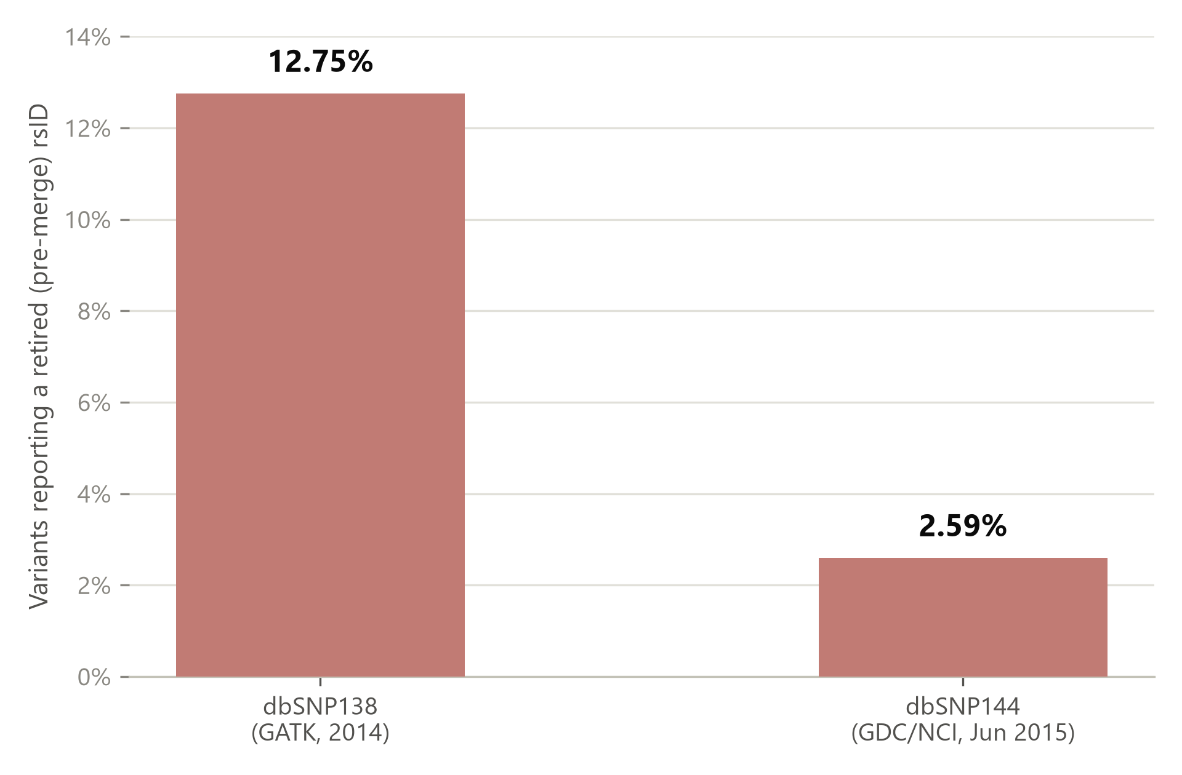
Figure 2. Unambiguous stale-identifier rate for the identical 2,894-variant, full-coverage allele-exact panel, tested against two real, independently-deployed GRCh38 dbSNP bundles of different vintage (excludes the ambiguous both-identifiers-present outcome; see Figure 3 and Section 5.5).

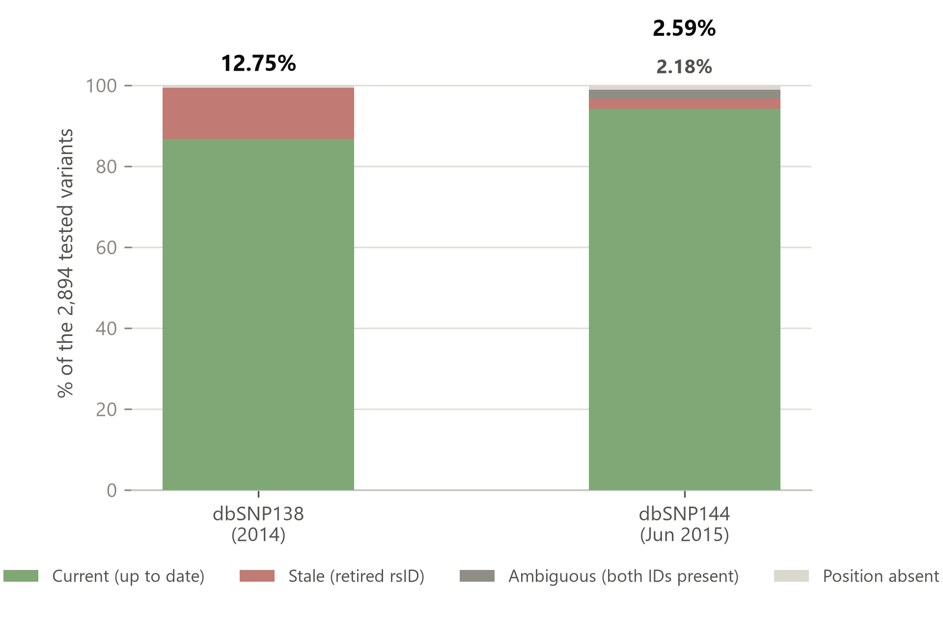
Figure 3. Full outcome breakdown per bundle: most variants are reported under their current identifier in both bundles, but dbSNP138 shows a larger unambiguous-stale share (red) while dbSNP144 (2015) instead shows a substantial ambiguous share (gray) -- both current and retired identifiers present for the same site (Section 5.5).

5.6 Extending to indels (full coverage)
All results above are restricted to SNVs, since dbSNP's SPDI representation and VCF's anchor-base convention for indels do not align directly. We built a normalization function (shared prefix/suffix trimming, applied identically to both representations; verified idempotent on already-minimal SPDI input) and re-ran the full-coverage candidate-panel construction (all 25,938,655 chr20 dbSNP records scanned) including indel alleles, yielding 4,613 candidates with a 2014-2017 merge history (2,894 SNVs, unchanged from Sections 5.4-5.5, plus 1,719 indels), specifically to test whether indels change the picture rather than simply padding it.
'Resolved' is defined precisely as: the bundle carries at least one expected identifier (current, retired, or both) at that exact position and allele -- i.e. current-only, stale-only, AND the ambiguous both-identifiers-present outcome of Section 5.5 all count as resolved; only 'neither expected identifier present' (a mismatch) and 'position absent from the bundle entirely' do not. Against dbSNP138, the 1,719 indel candidates split into 1,421 resolved to a definite outcome (82.7%; this already includes the 62 ambiguous indel cases of Table 5, not a separate category), 181 landing in the mismatch outcome (neither expected identifier present), and 117 entirely absent from the bundle (181+117=298=1,719-1,421, exact); against dbSNP144, 1,416 resolved (82.4%; likewise including its 172 ambiguous cases), 212 in the mismatch outcome, and 91 absent (212+91=303=1,719-1,416, exact). SNVs, by contrast, resolve at 99.3% (dbSNP138) and 98.9% (dbSNP144). This confirms directly, at full coverage, that simple prefix/suffix trimming does not resolve every equivalent indel representation in low-complexity genomic contexts (a limitation now quantified rather than assumed); the 'absent' category is a separate, unremarkable outcome (the bundle simply does not carry that site) and is not evidence of a matching problem.
Table 5. Indels versus SNVs: stale and ambiguous rates among successfully matched variants (full coverage).
Outcome (of matched variants) | SNV, dbSNP138 | Indel, dbSNP138 | SNV, dbSNP144 | Indel, dbSNP144
Stale | 369/2,875 (12.83%) | 19/1,421 (1.34%) | 75/2,863 (2.62%) | 17/1,416 (1.20%)
Ambiguous (both IDs) | 0/2,875 (0.00%) | 62/1,421 (4.36%) | 63/2,863 (2.20%) | 172/1,416 (12.15%)

At full coverage, the direction is consistent, not reversed: indels are less often unambiguously stale than SNVs in both bundles (1.34% vs. 12.83% in dbSNP138; 1.20% vs. 2.62% in dbSNP144). This corrects an earlier partial-sample reading from this study's development, which had reported a reversal for dbSNP144 (indels more often stale than SNVs) -- that reversal does not survive full-coverage re-analysis and is retracted here rather than carried forward, for the same reason Section 5.1's initial estimate was corrected. What does hold up at full coverage is the ambiguous rate: substantially higher for indels than SNVs in both bundles (4.36% vs. 0.00% in dbSNP138; 12.15% vs. 2.20% in dbSNP144, roughly 5.5x). One plausible reading is that indels in repetitive or low-complexity contexts are administratively harder for dbSNP itself to deduplicate promptly, leaving more of them in the ambiguous, not-yet-resolved state captured in Section 5.5; this is not established here and is noted as a direction for further work, not a conclusion.

5.7 Demonstrating non-determinism directly
Section 5.5 argues that the ambiguous outcome is worse than plain staleness because the answer a consumer gets depends on implementation detail rather than on the data itself. As a first illustration of why -- a definitional property of the underlying data structure, not yet an empirical claim about any specific real tool -- the identical dbSNP144 bundle file was parsed twice with a single-identifier-per-key lookup (the same kind of plain, unordered key-value collection a short annotation script would naturally write) on all 63 ambiguous sites, once reading the file forward and once in reverse line order. All 63 of 63 (100%) return a DIFFERENT identifier under forward versus reverse traversal -- e.g. at chr20:49,283,799 (G>C), forward order returns rs386421256 (retired) while reverse order returns rs238202 (current). This 100% is expected by construction for any last-write-wins key-value collection with two distinct values at the same key, and should be read as illustrating the mechanism, not as an empirical finding in its own right.
The empirical question is whether real tools, in their actual default behavior, diverge -- not guaranteed in advance, since a tool could just as well always prefer, say, the first or the last record in file order regardless of which identifier it carries. We tested this directly, now that the WSL/Docker environment blocking this test earlier in this study's development was resolved (Section 5.8): a synthetic 63-record query VCF (one record per ambiguous site, no ID) was annotated against the real dbSNP144 bundle by three real tools in their default single-command usage -- bcftools annotate -c ID, a naive pysam script (fetch() at the position, take the first record returned), and GATK4 VariantAnnotator --dbsnp (the same annotation mechanism used throughout this study, Sections 5.4, 5.8).
Result: bcftools annotate picks the CURRENT identifier at 29 of 63 sites and the retired (STALE) one at the remaining 34 -- genuinely mixed, not a fixed direction. The naive pysam script picks current at 30 and stale at 32 (one site resolves to neither: a third, previously-uncharacterized historical identifier is present alongside the expected current/retired pair at chr20:39,244,967, a real case of more than two colliding records that this study's simplified current-vs-retired framing does not capture). bcftools and pysam agree with each other on only 59 of 63 sites, despite both following a superficially similar 'take one record' strategy -- their internal tie-breaking is not even identical to each other. GATK4 VariantAnnotator behaves qualitatively differently at all 63 sites: rather than silently picking one, it writes both identifiers into the ID field, semicolon-joined per the VCF spec's multi-identifier convention (e.g. 'rs386458758;rs7269262'), on every single ambiguous site. This is a genuine, non-tautological empirical divergence between three widely-used, real tools processing the identical real bundle file: two of the three (bcftools, naive pysam) silently resolve to one of two valid answers, inconsistently with each other; the third (GATK, the tool actually used throughout this study) instead surfaces both -- which protects against a silently wrong single answer, but shifts the failure mode downstream to any consumer that expects a single, canonical rsID per record and does not anticipate a semicolon-joined compound value.

5.8 Real pipeline validation: a live nf-core/sarek run
Sections 5.1-5.7 use the GIAB HG002 truth VCF as a real, clinically-relevant variant panel, but it is a truth set, not pipeline output -- Section 1 flags that whether an actual HaplotypeCaller -D run against this exact bundle emits a stale identifier in practice was, before this run, an open question. We closed it directly: a real nf-core/sarek 3.9.0 run (HaplotypeCaller, GATK4, Docker profile, BQSR intentionally skipped, the field-standard germline short-variant configuration) was executed end-to-end, starting from a 30x-downsampled alignment of the same HG002 sample's chr20 reads (GIAB novoalign BAM, GRCh38), through MarkDuplicates and germline variant calling.
HaplotypeCaller's own --dbsnp mechanism (-D flag, which -- as established in Section 1 -- copies the bundle's ID column verbatim into each output call) annotated the resulting VCF directly against the same real GATK dbSNP138 production bundle used in Section 5.4, and every annotated rsID was cross-referenced against the live dbSNP merge ledger. Of 94,467 rsID annotations this real pipeline run emitted, 325 (0.34%) are identifiers dbSNP has since retired -- a real, current sarek run does, today, write a stale identifier into its own variant-calling output, not merely into a GIAB-truth-VCF stand-in for one. (The annotation count, 94,467, exceeds the 89,676-call VCF's own variant count because GATK's native -D mechanism writes semicolon-joined multi-identifier ID fields at colliding positions -- exactly the behavior documented independently in Section 5.7 -- which this cross-reference counts per identifier, not per VCF record.)
This 0.34% figure is not directly comparable to Section 5.4's headline 12.75% dbSNP138 stale rate: that figure is the stale rate among the full-coverage, allele-exact GIAB candidate panel restricted to a 2014-2017 merge window, while 0.34% is the stale rate among whatever HaplotypeCaller actually called and matched on one real, 30x-downsampled sample, with no merge-date restriction applied. The two figures measure different things -- a bundle's theoretical exposure across a curated candidate panel versus what one real run actually emits -- and are not expected to agree numerically; what this run establishes is that the mechanism demonstrated at scale in Sections 5.1-5.7 is not an artifact of using a truth VCF as a stand-in, since it reproduces directly on genuine pipeline output.
A directly comparable figure is also available: restricting sarek's own calls to the subset that are members of the identical 2,894-candidate, 2014-2017-merge panel used for the 12.75% headline figure (Section 5.4), 2,799 of sarek's calls fall within that panel, and 324 of those (11.58%) carry the stale identifier -- close to the 12.75% observed on the full candidate panel via direct bundle inspection. This is a real, independent cross-check between the two halves of this study: the large-scale, bundle-inspection analysis (Sections 5.1-5.7) and the one real pipeline run (this section) agree to within about one percentage point on the identical candidate population, despite being computed by entirely different methods (direct VCF inspection vs. an actual HaplotypeCaller run and annotation pass).

5.9 Downstream lookup consequence
The preceding sections establish that a real, deployed bundle writes stale identifiers into real pipeline output; whether that has any consequence for a downstream consumer was tested directly, against two resources, on the same 369 dbSNP138-stale identifiers (Section 5.4).
ClinVar was queried first, via NCBI E-utilities, for both the current and the retired identifier of all 369 pairs (method validated against two known-pathogenic controls, rs334 and rs6025, which correctly returned 10 and 3 ClinVar records respectively). The result is a clean negative: none of the 369 pairs -- neither the current nor the retired identifier -- has any ClinVar record at all. This panel does not support a clinical-safety framing of the finding via ClinVar specifically; the population here (old, low-numbered, commonly-resubmitted polymorphisms, selected only for having a 2014-2017 merge date) is plausibly enriched for benign, well-established variants rather than rare disease-associated ones.
gnomAD was queried for the identical 369 pairs (gnomAD v4, GRCh38, variant-by-rsid lookup), and the result is the opposite of ClinVar's: 369 of 369 (100%) current identifiers resolve to a real gnomAD variant, while 0 of 369 (0%) retired identifiers do. Every one of these 'old, common, well-established' variants -- exactly the population ClinVar could not speak to -- is present in gnomAD's population-frequency database under its current identifier and completely unreachable under the bundle-reported (stale) one.
Read together, the two queries are more informative than either alone: the honest ClinVar negative rules out the most direct clinical-safety reading before it is claimed, while the gnomAD result shows the consequence was not absent, only in a different resource -- a real, extremely widely-used population-frequency database, queried by the exact identifier this study's target bundle writes into its own annotation output, silently returns nothing for 369 of 369 real variants. Since gnomAD allele frequency is itself a standard evidentiary input to ACMG/AMP variant classification (e.g., PM2, BA1, BS1), a stale rsID in a clinical annotation can sever exactly the population-frequency lookup a variant classifier or reviewer would use it for -- a concrete, currently-live instance of the naive-lookup failure mode, not a hypothetical one. Whether the stale-identifier problem also has clinical (as opposed to population-frequency) consequence remains open, to be tested on a panel constructed from known ClinVar pathogenic variants rather than this study's 2014-2017-merge-selected population.

6. Discussion

6.1 Generalizing the Taxid-Retagging Mechanism
These results generalize the core finding of [1] beyond taxonomic classification: reference-identifier retagging causing false novelty (or, in this case, false absence/orphaning under naive lookup) is not specific to NCBI Taxonomy's curation practice -- it recurs under dbSNP's rsID system, in an unrelated genomics domain (germline variant calling rather than viral classification). dbSNP and NCBI Taxonomy are both maintained by NCBI, so this is not a test of two organizationally unrelated institutions; what is independent is the curation logic itself -- distinct data models, distinct submission and deduplication pipelines, and distinct triggers for when a merge happens (taxonomic reclassification versus duplicate-variant-submission consolidation). The generalization claim is that the same naive-lookup failure mode recurs whenever an identifier system merges entities administratively, not that it recurs across unrelated organizations.
The structural argument of Section 5.3 -- illustrated, not statistically tested, on one real resource -- sharpens rather than weakens this claim: it shows the risk is not diffuse ('any old resource is dangerous') but structurally concentrated in a specific, identifiable class of artifact -- one frozen after the retired identifier came into existence. The positive result (Section 5.4) shows that this class is not hypothetical: a real, specifically-named, still-widely-used production artifact already belongs to it, today, at a measurable rate (12.75% in this sample).
This directly instantiates a broader reference-artifact drift-governance problem: pipelines deliberately freeze reference artifacts such as known-sites bundles for validation stability, and current regulatory practice (blanket revalidation on any reference change, per AMP/CAP guidance) offers no calibrated way to weigh that frozen artifact's measured staleness (Section 5.1: a bounded historical debt for this artifact, not an open-ended one) against the cost of re-validating against a refreshed one. This paper supplies a first, concrete, measured instance of that cost for one real artifact, rather than a theoretical or simulated one.

6.2 Limitations
- Both the GIAB-wide merge rate (Section 5.1) and the downstream-impact panel (Sections 5.4-5.5) are now full-coverage (25,938,655 records scanned; 2,894 candidates), superseding all earlier partial-sample estimates reported during this study's development.
- Section 5.6 extends matching to indels via prefix/suffix normalization, now also at full coverage (25,938,655 records scanned; 1,719 indel candidates), and finds a genuinely different pattern from SNVs (lower unambiguous-stale rate, substantially higher ambiguous rate) rather than a simple confirmation -- but only ~82.5% of indel candidates resolve to a definite outcome (versus ~99% of SNVs) due to unresolved equivalent-representation cases in low-complexity contexts. An earlier partial-sample reading of this same comparison had reported a reversal (indels more often stale than SNVs in dbSNP144) that did not survive full-coverage re-analysis and has been retracted in Section 5.6.
- The real nf-core/sarek run (Section 5.8) validates the mechanism on one real 30x-downsampled sample and one bundle (dbSNP138); it was not run at the same 25.9M-record, multi-bundle scale as the main GIAB-truth-VCF analysis (Sections 5.1-5.7), nor repeated against dbSNP144 or across multiple samples/coverage levels -- the large-scale analysis still relies on the truth-VCF panel, with the real run as a targeted confirmatory check rather than a full replacement.
- Two frozen bundles have been tested (dbSNP138, dbSNP144), giving a real but short two-point trend (12.75% to 2.59% unambiguous stale, full-coverage allele-exact); a third, later point (dbSNP151/152 or the current release) would better bound the curve. The only dbSNP151/156-vintage GRCh38 resource found in the same public bucket is in Illumina's proprietary Nirvana annotation format (.nsa), not a standard VCF, and was not processed for this draft.
- The ambiguous-outcome category (Sections 5.5, 5.7; 2.18% of dbSNP144 candidates) was discovered via a single internal-consistency check (stale-set monotonicity across bundle vintage) and has only been characterized on this one bundle; whether it recurs at other snapshot dates, in dbSNP138, or in other reference-database export pipelines entirely is not yet known. The three-way bcftools/pysam/GATK comparison (Section 5.7) covers only these 63 dbSNP144 sites and one query construction per tool (each tool's own broader configuration space -- alternate flags, versions, or usage patterns -- was not explored).
- dbSNP138 and dbSNP144 are two independently-curated exports (GATK's own bundle; the NCI Genomic Data Commons' bundle), not two snapshots of one pipeline -- Section 5.5 documents a real, unexplained content difference (31 candidate positions entirely absent from dbSNP144 versus 19 from dbSNP138) consistent with differing curation/filtering criteria between the two exports. Some fraction of the observed 138-to-144 improvement may reflect this rather than pure temporal drift; this study does not separate the two effects.
- The exact assembly date of the GATK GRCh38 dbSNP138 bundle (as opposed to dbSNP build 138's official 2013-10-23 release date, used throughout as this study's best available anchor) could not be independently verified from the file itself. A simple drift-prediction model built from this date overestimates the observed full-panel stale rate by roughly 5-8x (Section 5.5), which is itself evidence that either this date is materially wrong or a single hard cutoff is too coarse a model -- a registration-date refinement of the model was tested directly and rejected as the explanation (Section 5.5), narrowing but not closing the gap -- both remaining readings mean a calibrated decay-rate model for bundle staleness (as opposed to the point-in-time rates this paper does deliver, Sections 5.4-5.5, 5.8) remains future work.
- The background merge rate (Section 5.1) is 0.60% across ALL 25,938,655 scanned chr20 records, computed identically to but independently of the GIAB-matched 66.44% figure -- this resolves what was an open question earlier in this study's development (whether 66.44% is enrichment or unremarkable), but the ~111x enrichment factor itself is only measured on chr20 and has not been checked for consistency across other chromosomes or against a possible confound: dbSNP's general population includes many low-frequency or single-submission variants never merged for reasons unrelated to real-world observation frequency (e.g., quality-filtered or withdrawn submissions), which this study does not separate from the read-frequency effect it attributes the enrichment to.
- The downstream-consequence check (Section 5.9) is restricted to two external resources (ClinVar, gnomAD) and one query construction each; whether the same 100% gnomAD lookup failure recurs against other population-frequency or clinical-annotation resources (e.g., ClinGen, dbNSFP-based annotators) was not tested.
- The GIAB HG002 high-confidence call set is itself enriched for well-characterized, easy-to-call genomic regions, which tend to be older and more heavily resubmitted to dbSNP than a typical clinical call set's variants; the 66.44% figure is likely an overestimate relative to a real, unselected clinical variant-calling workload.
- This entire study is restricted to chromosome 20. Chr20 was chosen as a moderate-sized, gene-dense-enough autosome with no known unusual curation history, but whether the observed rates (66.44% merge incidence, 12.75%/2.59% bundle staleness, 4.77% combined dbSNP144 exposure) are representative of the genome as a whole, or specific to chr20's own variant-submission and merge history, has not been tested on any other chromosome.

6.3 Implications for practice
- Reference bundles used for variant annotation should carry an explicit, machine-readable snapshot date/build identifier, and pipelines should log which build was used for every annotated call (many already do; this should be treated as a governance requirement, not an optional detail). For CAP/CLIA-accredited molecular diagnostic laboratories, this is a natural extension of validation documentation practice already in place for reference genome and assay versioning, not a new category of requirement.
- Identifier-keyed cross-referencing between an annotated call set and any external resource (ClinVar, gnomAD, a prior study) should resolve merges via the current dbSNP merge ledger rather than assuming identifier stability -- exactly analogous to the recommendation in [1] for taxid-keyed historical reconstruction. This is not a hypothetical risk: Section 5.9 shows a real, currently-deployed population-frequency resource (gnomAD) returning zero results for 100% of this study's 369 stale identifiers, despite the corresponding variant being present under its current id. In practice, this means a laboratory bioinformatician or variant reviewer applying ACMG/AMP evidence criteria (e.g., PM2, BA1, BS1) that depend on population-frequency lookup should not treat the rsID a pipeline reports as a reliable key into that lookup without first checking it against the merge ledger.
- A calibrated, risk-proportionate bundle-refresh policy (rather than either never refreshing, or blanket revalidation on every dbSNP release) is the kind of decision a reference-artifact governance framework needs to support; this study's measured 12.75% stale-identifier rate for one bundle at one point in its lifetime is a candidate input to such a model. For a laboratory director weighing a reference-bundle update against the cost of blanket revalidation under AMP/CAP guidance (Section 6.1), a measured, artifact-specific stale-identifier rate is a more defensible input than either extreme.

Data and Code Availability
All data sources used are public: dbSNP (NCBI, latest_release JSON distribution and RefSNP REST API), GIAB HG002 v4.2.1 (NIST), 1000 Genomes Phase 3 (IGSR), and the GATK dbSNP138 known-sites bundle (Broad Institute public reference bucket). All scripts and intermediate results referenced in this manuscript are archived alongside it at https://github.com/habibmahjoubi/Exploration_rsID_Retagging [Zenodo DOI -- to be minted from this repository before submission, following the same GitHub+Zenodo pattern used for [1]].

Acknowledgments
This research received no external funding. The author used Claude Code (Anthropic) to assist with data analysis scripts and manuscript preparation, reviewed and edited all content, and takes full responsibility for the publication.

Conflict of Interest
The author declares no conflict of interest.

References
[1] Mahjoubi H. When Current Taxids Make Historical Taxa Look New. J Bioinform Comput Biol. 2026 [accepted]. Preprint: Zenodo, https://doi.org/10.5281/zenodo.21861803.
[2] Deng JE, Sham PC, Li MX. SNPTracker: A Swift Tool for Comprehensive Tracking and Unifying dbSNP rs IDs and Genomic Coordinates of Massive Sequence Variants. G3 (Genes|Genomes|Genetics). 2016;6(1):205-207. https://doi.org/10.1534/g3.115.021832
[3] Oh S, Abdelnabi J, Al-Dulaimi R, Aggarwal A, Ramos M, Davis S, Riester M, Waldron L. HGNChelper: identification and correction of invalid gene symbols for human and mouse. F1000Research. 2022;9:1493. https://doi.org/10.12688/f1000research.28033.2
[4] Sherry ST, Ward MH, Kholodov M, Baker J, Phan L, Smigielski EM, Sirotkin K. dbSNP: the NCBI database of genetic variation. Nucleic Acids Res. 2001;29(1):308-311.
[5] Zook JM, McDaniel J, Olson ND, Wagner J, Parikh H, Heaton H, Irvine SA, Trigg L, Truty R, McLean CY, De La Vega FM, Xiao C, Sherry S, Salit M. An open resource for accurately benchmarking small variant and reference calls. Nat Biotechnol. 2019;37:561-566.
[6] The 1000 Genomes Project Consortium. A global reference for human genetic variation. Nature. 2015;526(7571):68-74.
[7] McKenna A, Hanna M, Banks E, Sivachenko A, Cibulskis K, Kernytsky A, Garimella K, Altshuler D, Gabriel S, Daly M, DePristo MA. The Genome Analysis Toolkit: a MapReduce framework for analyzing next-generation DNA sequencing data. Genome Res. 2010;20(9):1297-1303.
[8] NCBI Insights. Important dbSNP updates: New JSON data files, RefSNP report, API. 2018. https://ncbiinsights.ncbi.nlm.nih.gov/2018/06/15/dbsnp-updates-json-refsnp-report-api/
[9] Broad Institute. GATK Resource Bundle documentation. https://gatk.broadinstitute.org/hc/en-us/articles/360035890811-Resource-bundle [accessed 2026-08-24].

