TYPO.CO, ONLINE PC GAME STORE

User Manual

Version 1.0

Table of Contents

1. Home Page 1

2. Member Profile 2

3. Administrator 3-9

4. User 10-15

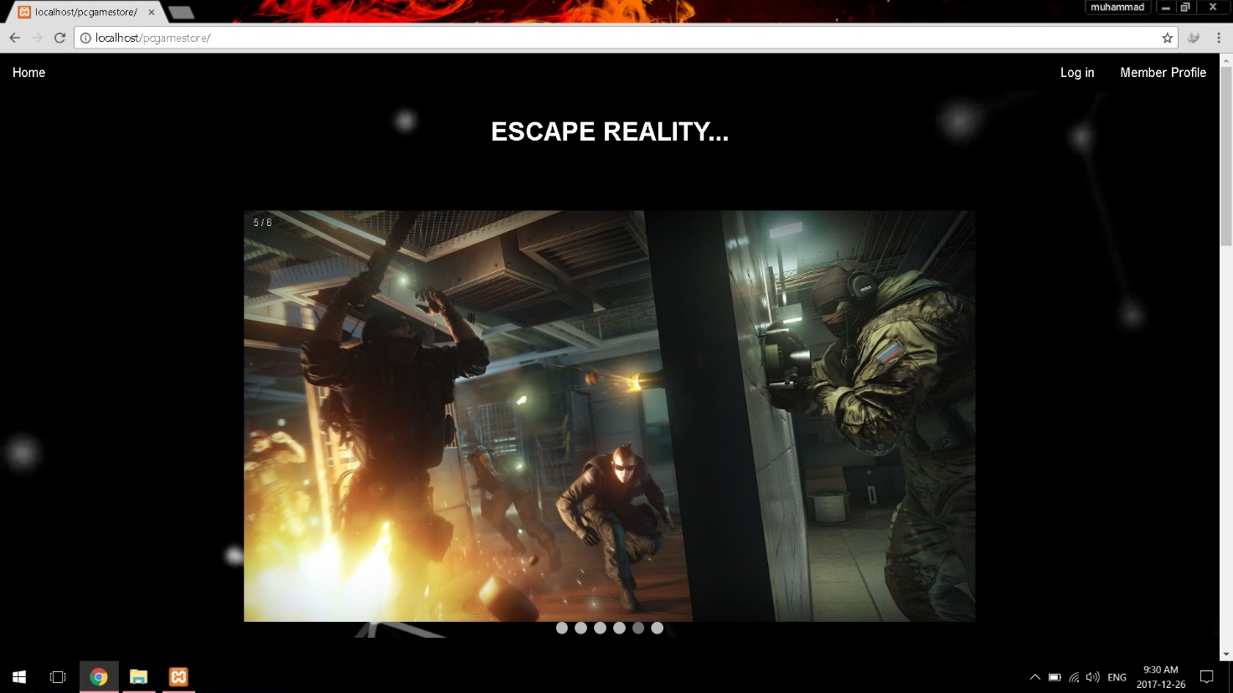HOME PAGE

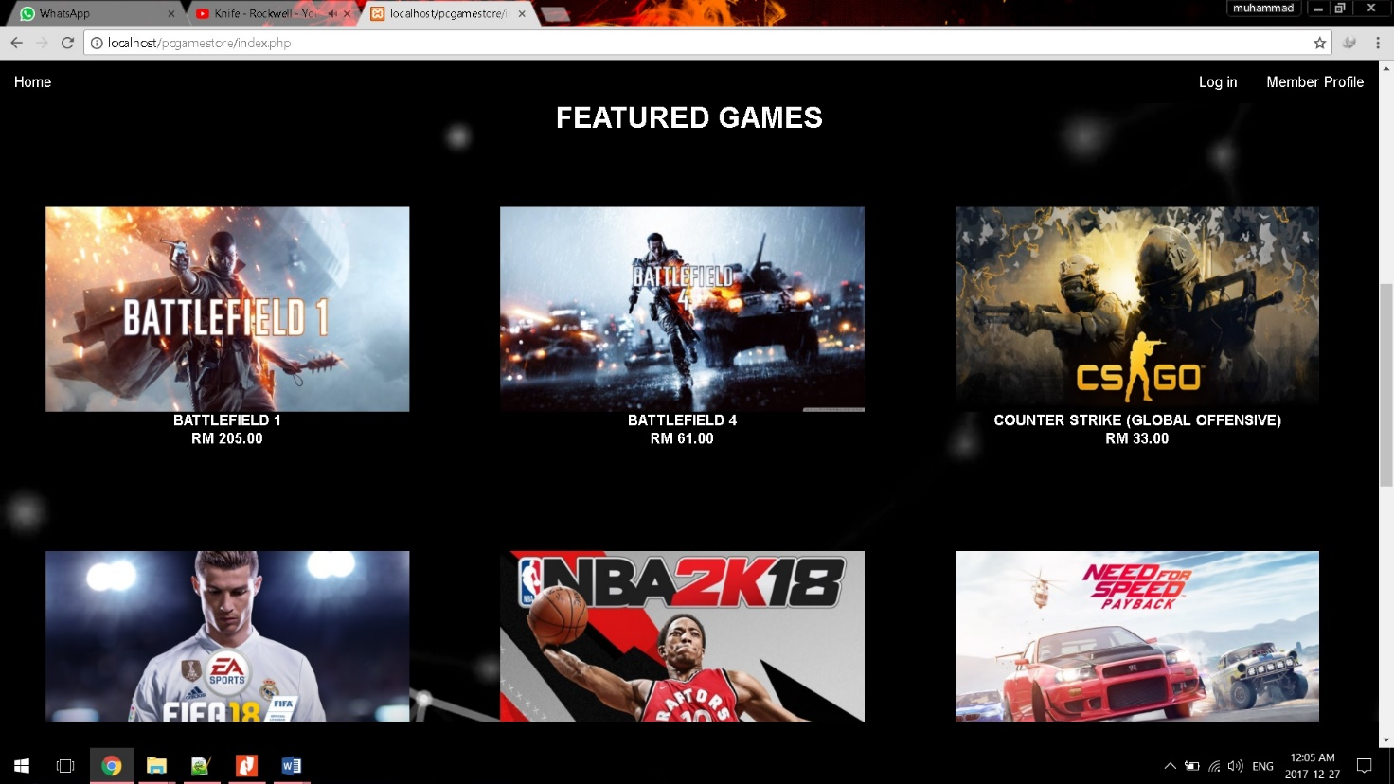

1. **Index.php** as **Home Page** for both user and administrator.
2. Slide show is for **in game** pictures.
3. **Log in** button is for log in to the system between user and administrator.
4. **Member Profile** button is to view all member group’s information.

Member Profile

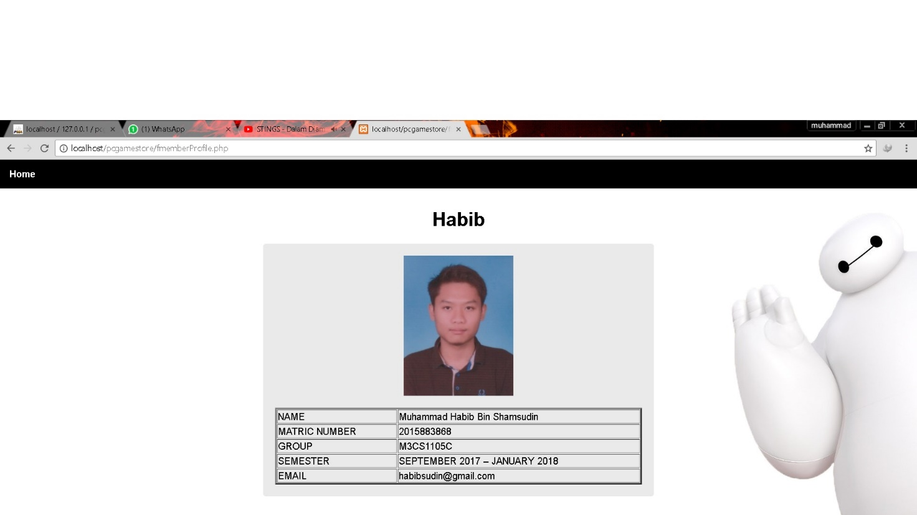

1. **Member Profile** page view all group member’s information in a table.

ADMINSTRATOR

Adminstrator Login

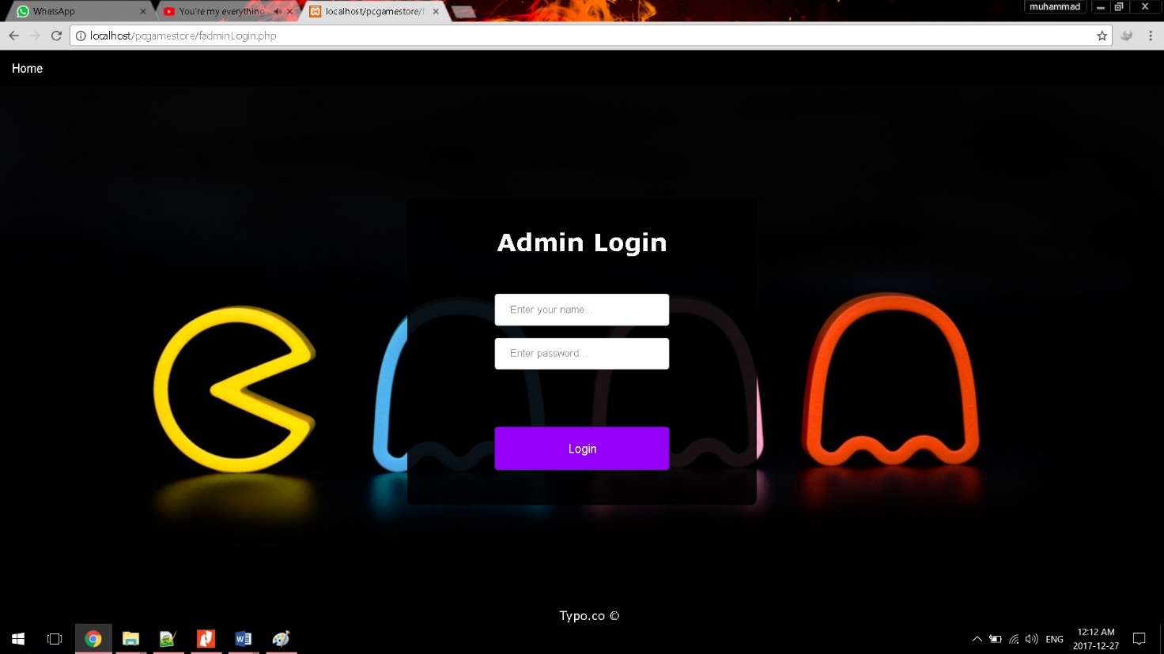

* Admin login interface.
* Insert admin username and password.

Administrator Home

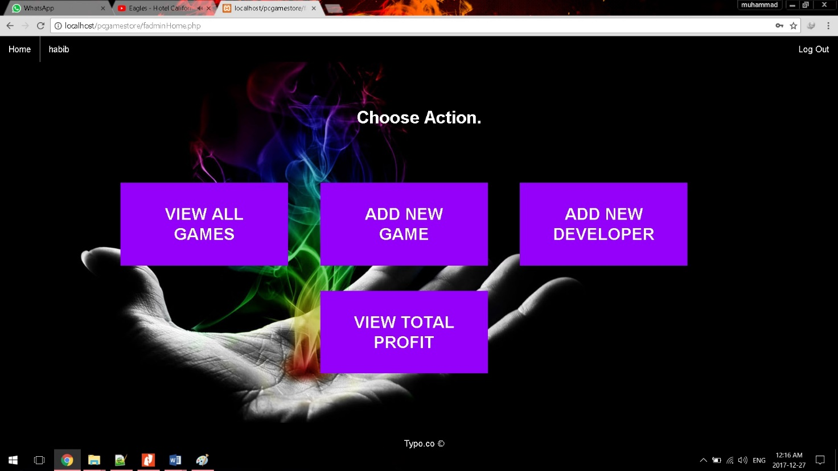

Admin home have 10 buttons.

* **Home** button is to go to home page.
* **View All Games** button is to view all games and their details that available.
* **Add New Game** button is to add a new game to the store.
* **Add New Developer** button is to add new developer to developer table.
* **View Total Profit** button is to view total profit for all games that has been sold.
* **Log Out** button is to log out current admin and end administrator session.

View All Games Details

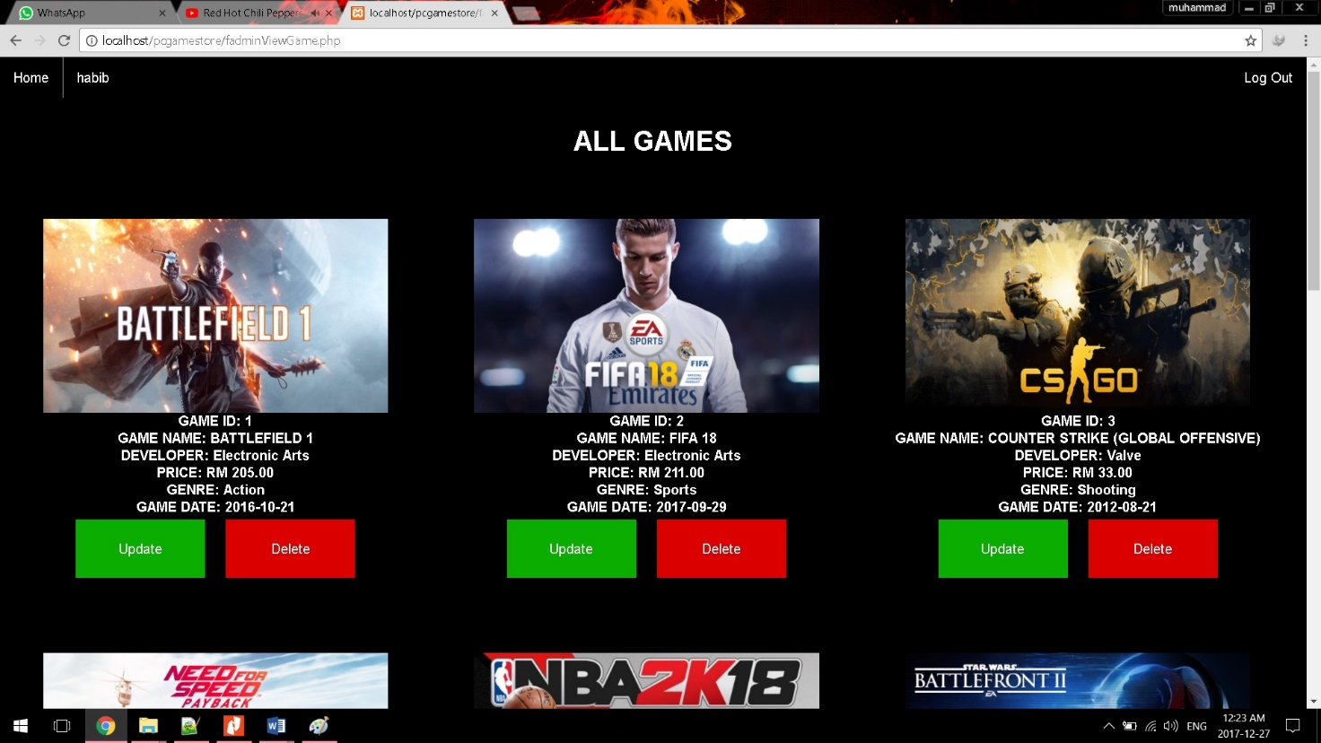

It shows list of games and their details. Games view consist of several buttons.

1. From **Home** page, administrator will have to click on **View All Games** button.
2. Administrator will be navigated to **View All Games** page.
3. **Update** button is to update selected game from table.
4. **Delete** button is to delete selected game from table.

Update Game Details

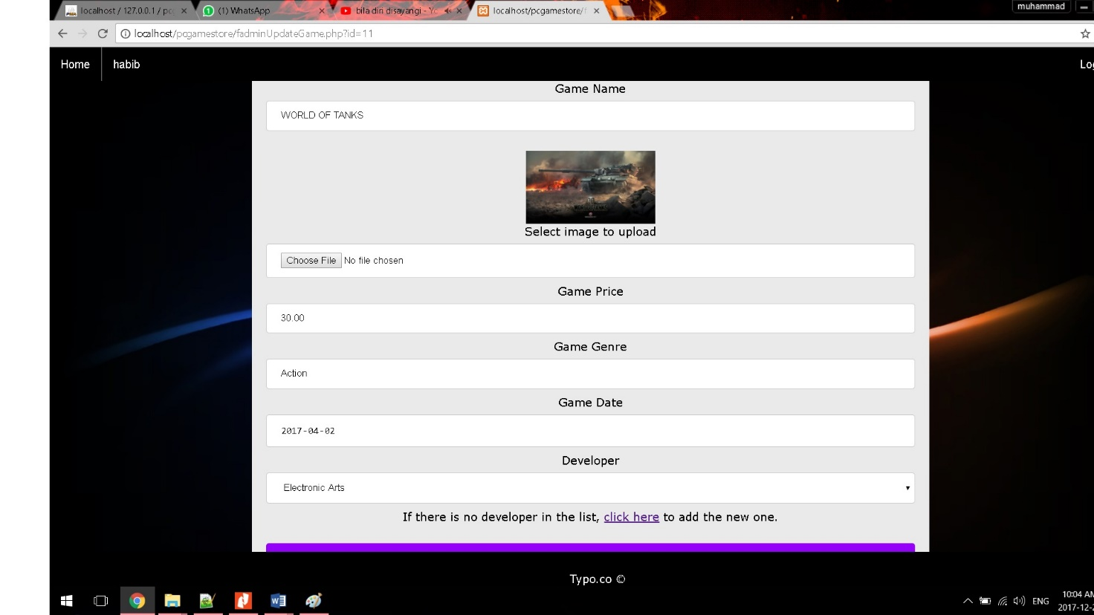

1. From **View All Games** page, administrator will have to click on **Update** button.
2. Administrator will be navigated to **Update Game** form.
3. Enter all details of the game that you want to change.
4. Click submit to update the game.
5. If the developer of the game is not on the list, administrator need to click **Add New Developer** hyperlink to add the new one.

Add New Game

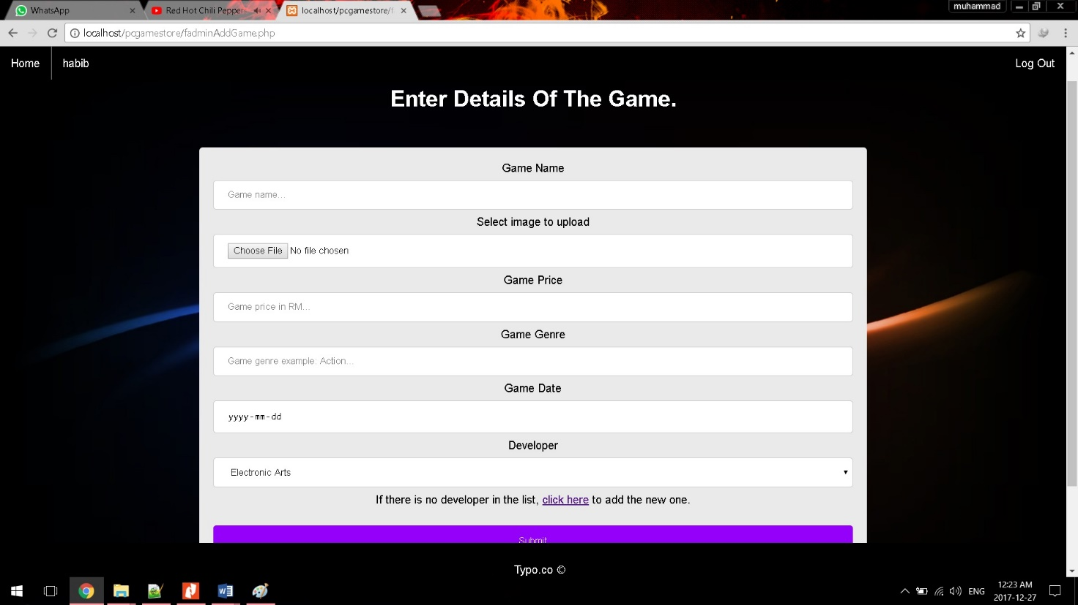

1. From **Home** page, administrator will have to click on **Add New Game** button.
2. Administrator will be navigated to add new game form.
3. Administrator need to enter the details of the game incuding image for the game. The image need to be landscape and recommended ratio is 16:9.
4. If the developer of the game is not on the list, administrator need to click **Add New Developer** hyperlink to add the new one.
5. Administrator need to click the submit button to add the game to games table.

Add New Developer

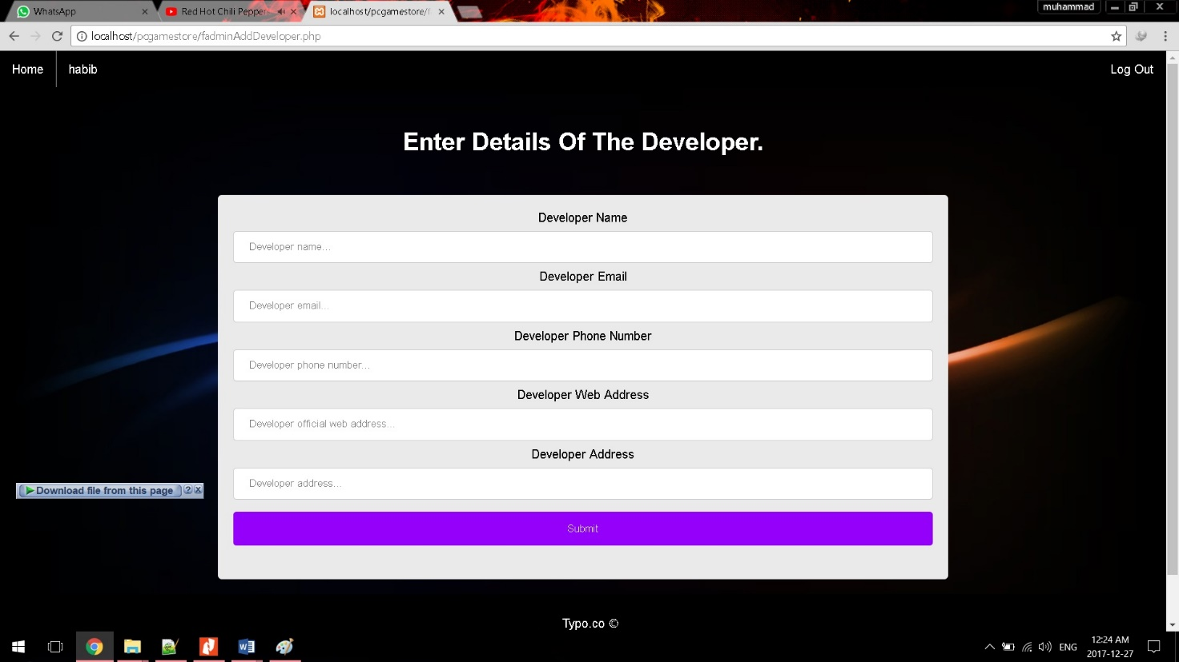

1. From **Home** page, administrator will have to click on **Add New Developer** button or **click here** hyperlink to add the new developer.
2. Administrator will be navigated to add new developer form.
3. Administrator need to enter the details of the developer.
4. Administrator need to click the submit button to add the new developer detail to developer table.

View Total Profit

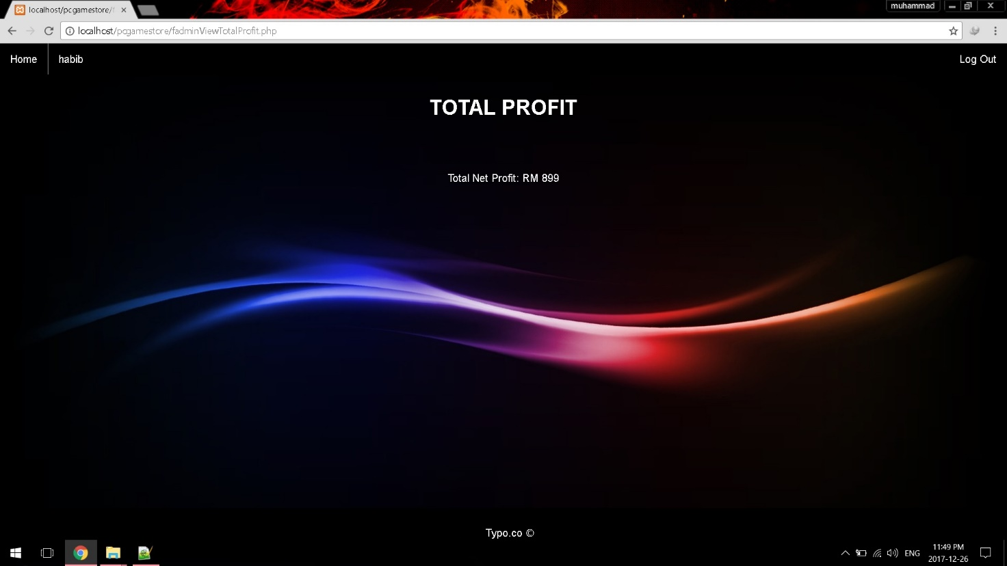

1. From **Home** page, administrator will have to click on **View Total Profit** button.
2. It will display the total profit for all games that has been sold.

USER

User Login

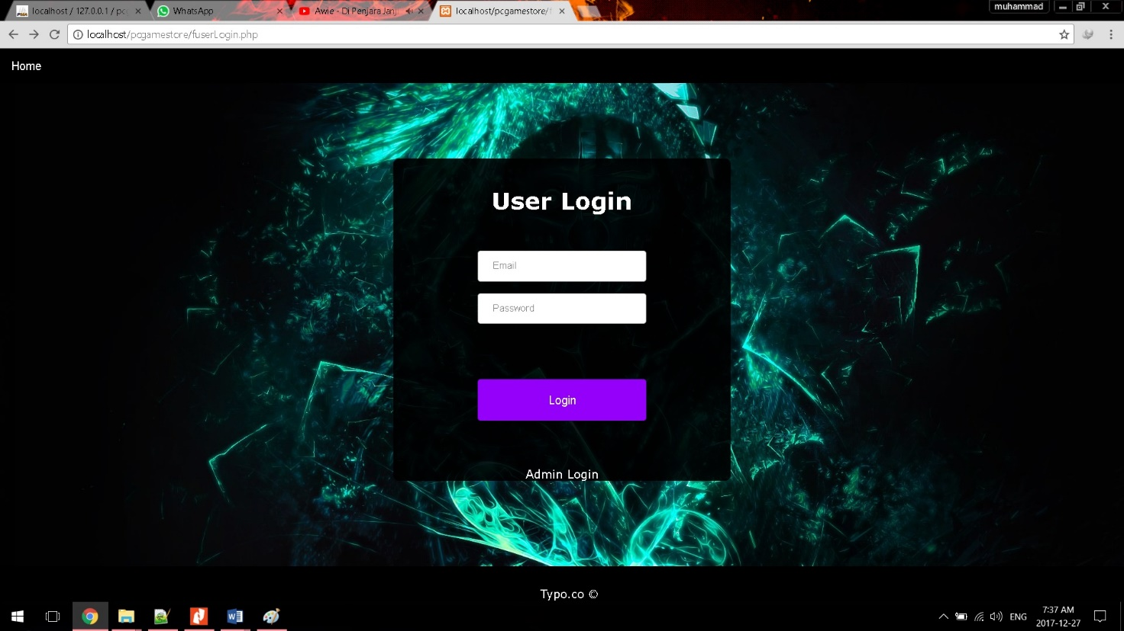

* User login interface.
* Insert user email and password.

User Home

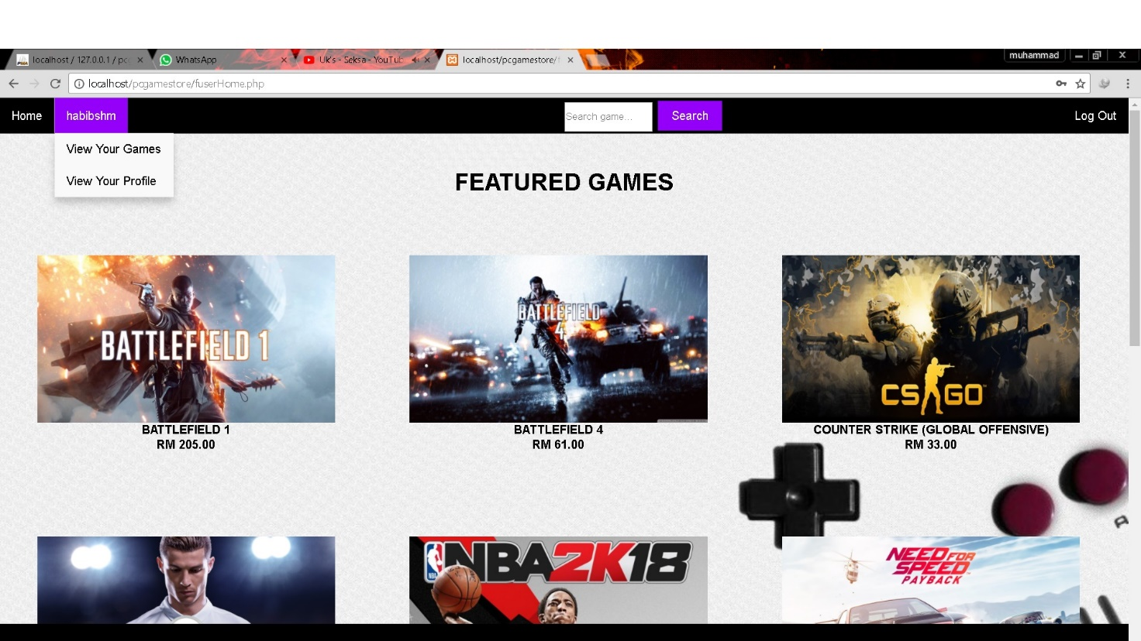

User homepage has several buttons available.

1. Click **Any Pictures** to buy the game.
2. On **habibshm** (username) dropdown, **View Your Games** button is to view all user’s games.
3. On **habibshm** (username) dropdown, **View Your Profile** button is to view user’s information and user can update their information.
4. On **search game** text field, just type the game that user want to search and click button **Search** to search the game.
5. Click **Log out** button to log out of the system.

Payment Page

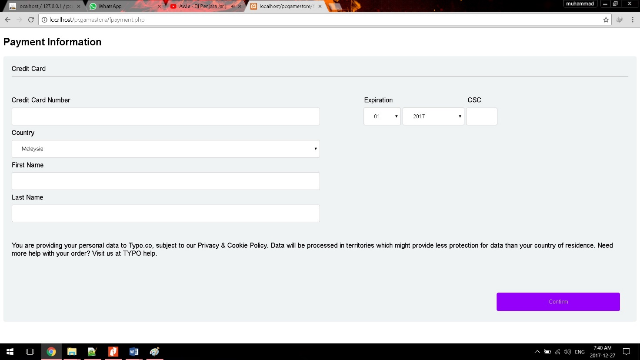

1. Enter all credit card information.
2. Click **Confirm** button to continue.

User View Games

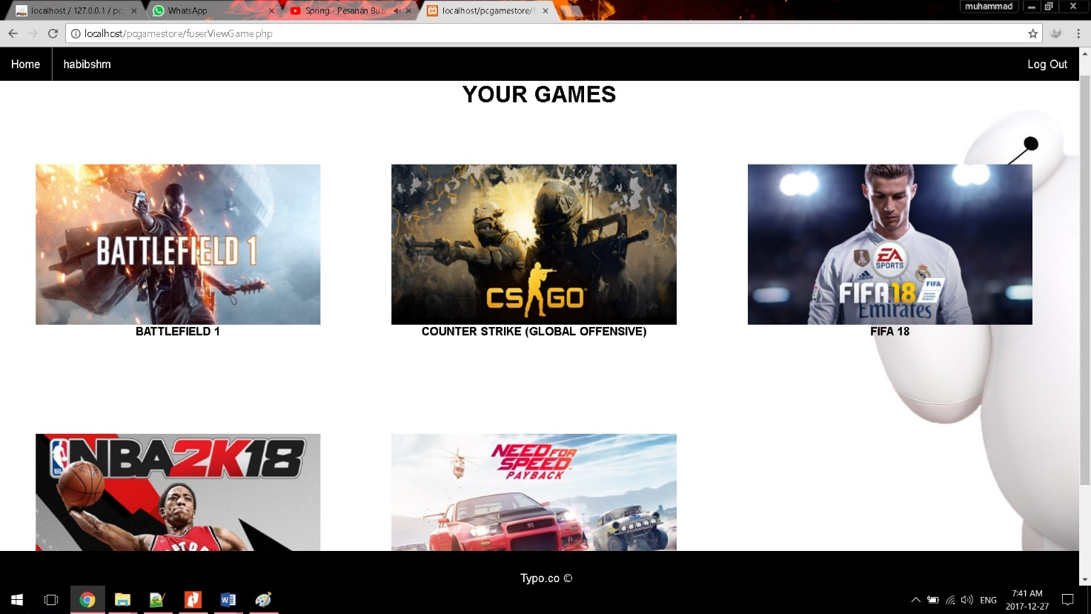

1. User View Game will show all user’s games including the one user’s just bought.
2. Click **Home** button to go back to user home page.
3. Click **Log out** button to log out of the system.

User View Profile

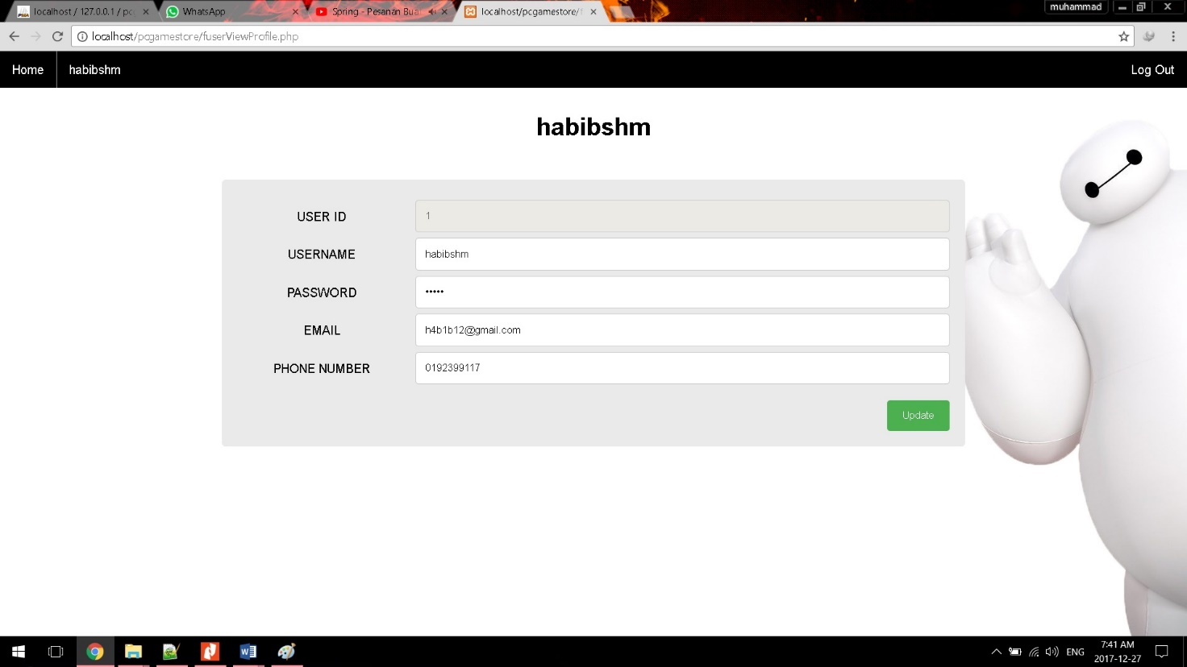

1. User View Profile page will view all user’s information and user can edit their information if they want to.
2. Click **Update** button if user want to update their information.
3. Click **Home** button to go back to user home page.
4. Click **Log out** button to log out of the system.

User Search Game

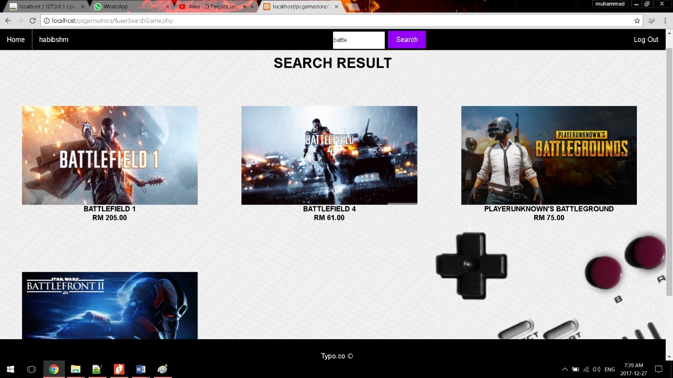

1. Search page will view all games that user enter in the search text field.
2. It will show any game that have the search word.
3. Click **Home** button to go back to user home page.
4. Click **Log out** button to log out of the system.