1 Create stock and save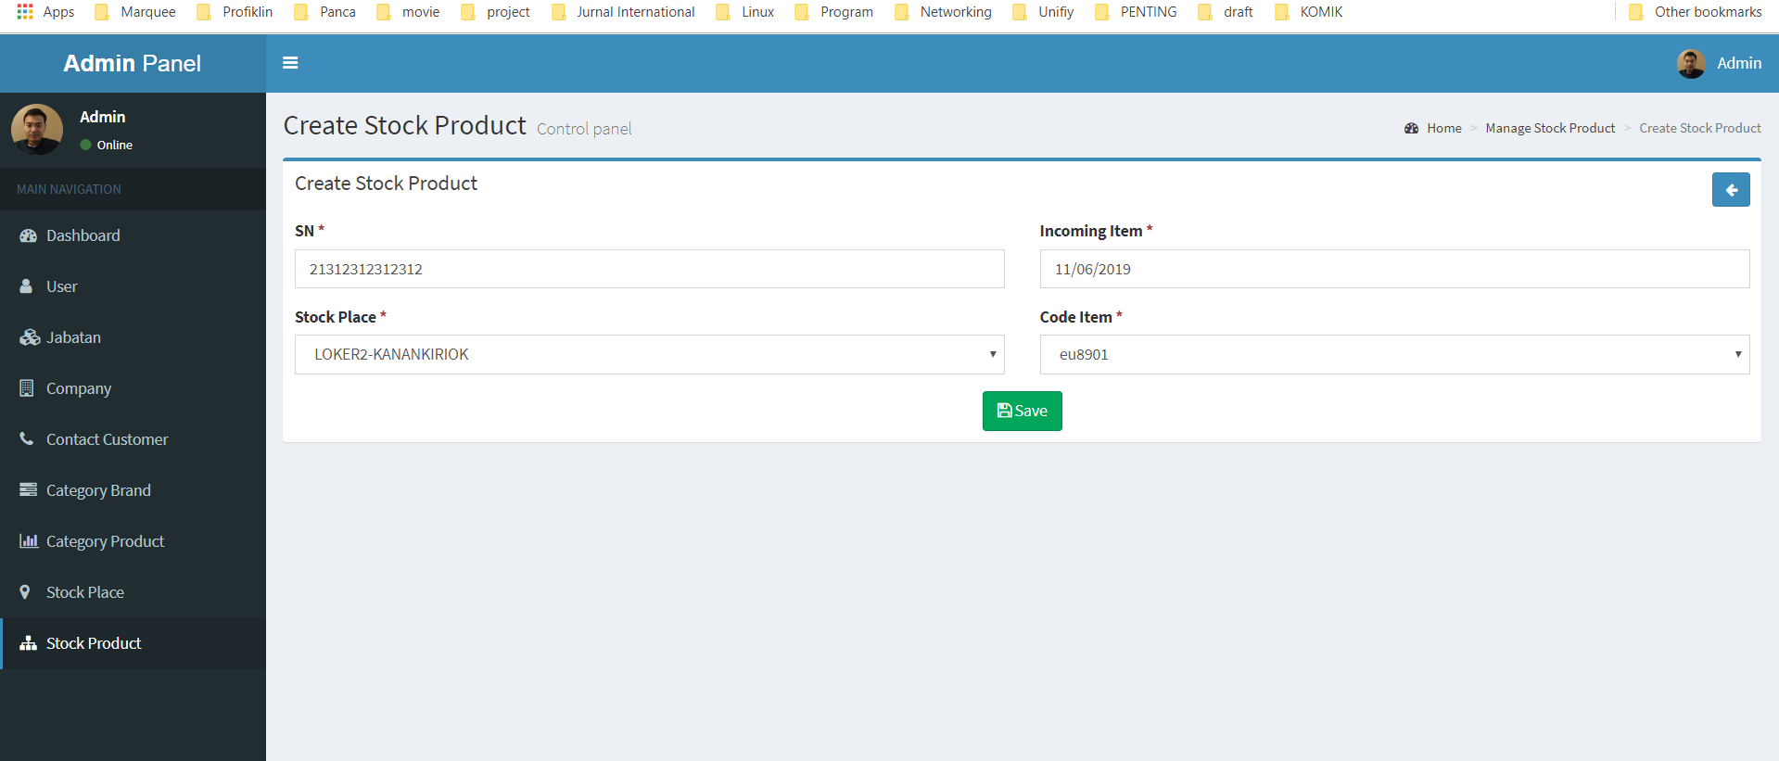

Error got this :

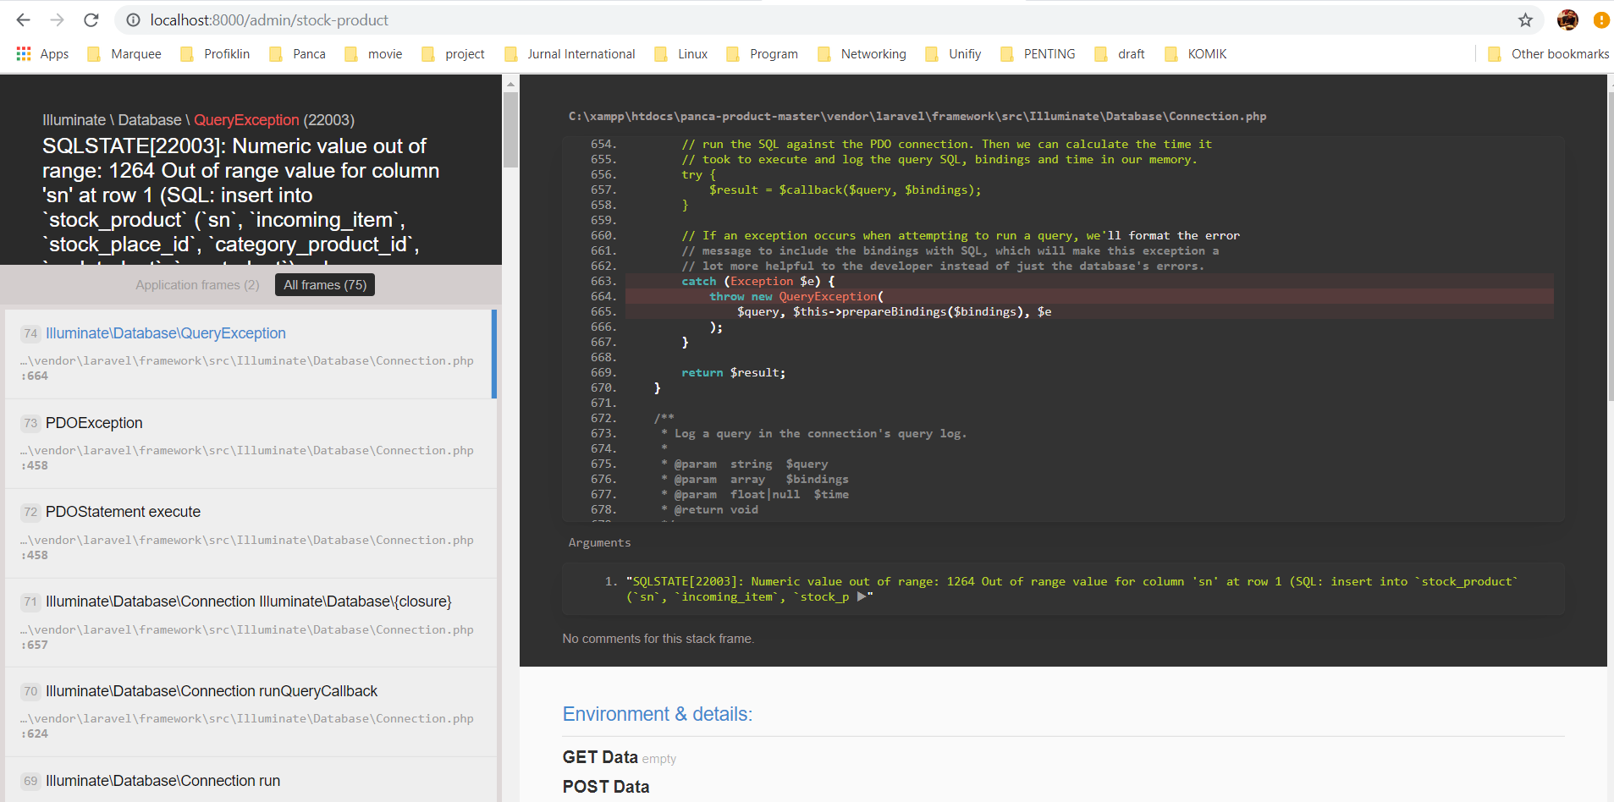

2. Create contact Customer ==> Please add feature : I can select and search the Company name form, because there will be more data so it is difficult to find 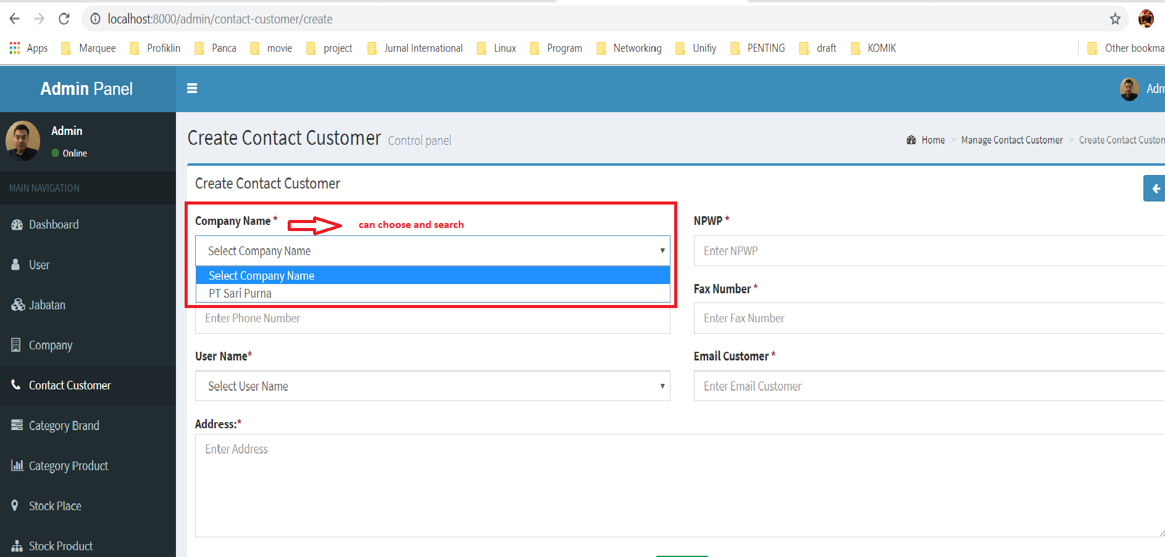

3. Create Stock Product 🡺 Please add feature : I can select and search the Company name form, because there will be more data so it is difficult to find 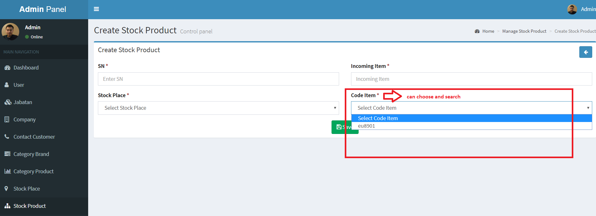

4. Please check again excel final design => List Product does not yet exist

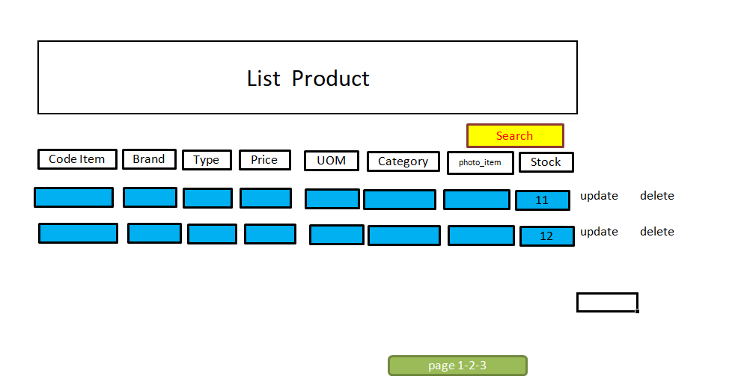

**Note :** Stock is the amount of sn on the same item code found on the Stock Product menu

5. Create Contact Number : Please change mandatory validate

