Spatio-Temporal Patterns of Satellite-Observed Air Pollutants and Their Relationship With Land Surface Temperature Over Bangladesh in 2025: A Google Earth Engine–Based Assessment
[Author names to be added]
[Affiliations to be added]
Corresponding author: [name and e-mail address to be added]
Abstract
Bangladesh is among the most polluted countries in the world, yet its ground monitoring network is sparse and largely urban. This study provides a national-scale, satellite-based assessment of air pollutants and land surface temperature (LST) for 2025 and examines how they are related across space and seasons. Seven Sentinel-5P TROPOMI products (CH₄, HCHO, O₃, UV aerosol index [UVAI], NO₂, CO and SO₂), MODIS aerosol optical depth (AOD) and MODIS day and night LST were quality-controlled and composited in Google Earth Engine. Relationships were analysed on a 0.05° grid (n = 4,901 cells) using correlation, regression, principal component analysis and geographically weighted regression (GWR), and satellite values were compared with measurements from 16 ground stations. AOD and CO declined from west to east, whereas NO₂, CH₄, HCHO and the surface urban heat island (up to 3.7 °C) peaked over the Dhaka conurbation. NO₂, CO, SO₂ and AOD were highest in winter and the pre-monsoon season and lowest during the monsoon. Annual daytime LST was positively correlated with CH₄ (r = 0.48), NO₂ (0.36), SO₂ (0.31) and HCHO (0.30), but single pollutants explained at most 23% of its variance; three principal components explained 74.9% of the total variance. The relationships reversed between seasons: the correlation between AOD and daytime LST was −0.52 in winter and 0.29 in the monsoon. GWR raised the explained variance of LST from 0.24 to more than 0.91, indicating strong spatial non-stationarity, with CH₄ the most frequently significant local predictor. Station PM_{2.5} correlated with AOD (r = 0.50) and UVAI (r = 0.72), and every station exceeded the World Health Organization guideline and the national standard. The results identify persistent multi-pollutant hotspots and show that pollutant–temperature relationships in a monsoon delta are seasonal and spatially variable, with implications for air quality and urban heat management.
Keywords: air pollution; land surface temperature; Sentinel-5P TROPOMI; MODIS; Google Earth Engine; geographically weighted regression; urban heat island; Bangladesh

1. Introduction
Ambient air pollution is one of the leading environmental risks to human health worldwide (GBD 2019 Risk Factors Collaborators, 2020; Lelieveld et al., 2015). The burden is particularly heavy in South Asia, and Bangladesh has repeatedly been ranked among the most polluted countries in the world. Raza et al. (2022) reported that Bangladesh was ranked the most polluted country between 2018 and 2021 and that air pollution was the second-largest risk factor for death and disability in the country in 2019. In 2024 the national annual mean PM_{2.5} concentration was 78 µg m⁻³, the second highest in the world and more than 15 times the World Health Organization (WHO) annual guideline of 5 µg m⁻³ (IQAir, 2025; World Health Organization, 2021). More than 235,000 deaths in Bangladesh were attributed to air pollution in 2021 (Health Effects Institute, 2024). With a population of about 170 million (Bangladesh Bureau of Statistics, 2023), a very large number of people are therefore exposed to air that does not meet either international guidelines or national standards.
The sources of this pollution are diverse. Particulate matter in and around Dhaka originates from brick kilns, vehicles, road and construction dust, industry and biomass burning (Begum et al., 2013; Guttikunda et al., 2013), and concentrations exceed national standards for about half of the year, with a peak in the dry months (Khan et al., 2023). Local emissions are compounded by regional transport: fine particulate matter builds up across the Indo-Gangetic Plain towards winter under stagnant conditions, a shallow boundary layer and weak winds (Ojha et al., 2020), and aerosol optical depth over Bangladesh is highest in the west and declines towards the south-east (Zaman et al., 2021), with a significant increase between 2003 and 2020 (Ali et al., 2022). Bangladesh is also an important source region for methane, where rice cultivation and monsoon flooding make a large contribution (Subramanian et al., 2026; Zhang et al., 2020).
Routine monitoring cannot capture this variability. The Department of Environment (DoE) operates a limited number of continuous air monitoring stations, almost all of them in cities, which leaves most of the country unobserved. Satellite remote sensing offers a consistent alternative. The TROPOspheric Monitoring Instrument (TROPOMI) on board Sentinel-5 Precursor (Sentinel-5P) provides daily global observations of trace gases and aerosol indices at a spatial resolution of a few kilometres (Veefkind et al., 2012), the MODIS Multi-Angle Implementation of Atmospheric Correction (MAIAC) algorithm delivers aerosol optical depth (AOD) at 1 km (Lyapustin et al., 2018), and MODIS land surface temperature (LST) products describe the thermal state of the surface by day and by night (Wan, 2014). Cloud platforms such as Google Earth Engine (GEE) make it practical to process these archives at national scale (Gorelick et al., 2017; Tamiminia et al., 2020).
Several recent studies have used Sentinel-5P data in Bangladesh. Shobnom et al. (2023) mapped NO₂ over Dhaka and its surroundings and linked high columns to population density and built-up land. Rahman et al. (2025) analysed CO, NO₂, SO₂ and O₃ over Dhaka for 2020–2024 and found that CO, NO₂ and SO₂ peaked in the cooler, drier months. Acharjee et al. (2026) profiled five pollutants across all 64 districts for 2020–2024 and identified a Dhaka–Gazipur–Munshiganj–Narayanganj cluster with the highest NO₂ and CH₄ levels. These studies describe pollutant distributions, but they do not relate them to the thermal environment of the surface.
Air pollution and surface temperature are physically linked. Urban and industrial areas are both emission sources and heat sources, so pollutants and the surface urban heat island (UHI) tend to coincide (Peng et al., 2012; Voogt & Oke, 2003; Zhou et al., 2019). Aerosols also modify the surface energy balance: they reduce incoming solar radiation during the day (Ramanathan et al., 2001) and increase downward longwave radiation at night, which strengthens the nocturnal UHI (Cao et al., 2016). In Bangladesh, the daytime surface UHI of Dhaka averaged 2.74 °C over 2000–2019 and has been increasing (Dewan et al., 2021), and UHI intensity has risen in most major districts (Rahman et al., 2022). The joint behaviour of LST and pollutants has been examined with Sentinel-5P and MODIS data in Egypt (Sameh et al., 2026), Pakistan (Munawar et al., 2026), Iran (Asghari Beirami et al., 2025), the Philippines (Broqueza et al., 2024) and Kenya (Mwangi, 2024). These studies cover a single city or province, and most rely on global correlation or regression, which assumes that one relationship holds everywhere.
Three gaps remain. First, to our knowledge, no study has examined the relationship between satellite-observed pollutants and LST for the whole of Bangladesh. Second, the monsoon climate causes long periods of cloud cover and a strong seasonal cycle in both pollution and temperature, so relationships estimated from annual means may hide opposing seasonal behaviour. Third, satellite column quantities are rarely compared with the ground measurements that are available in the country. This study addresses these gaps by adapting the framework of Sameh et al. (2026) to the national scale of Bangladesh for 2025, extending it with additional pollutants, seasonal analysis and a comparison with ground stations. The specific objectives are to: (a) produce quality-controlled monthly, seasonal and annual maps of eight atmospheric variables and of day and night LST; (b) quantify surface UHI intensity; (c) characterise seasonal and daily variability; (d) evaluate the relationships between LST and pollutants using correlation, regression and principal component analysis (PCA) at annual and seasonal scales; (e) identify spatially varying relationships with geographically weighted regression (GWR); and (f) compare the satellite observations with DoE station measurements and with air quality standards.

2. Study Area
Bangladesh lies between approximately 20.6° and 26.6° N and 88.0° and 92.7° E and covers about 147,570 km² of the Ganges–Brahmaputra–Meghna delta, bordered by India, Myanmar and the Bay of Bengal (Figure 1). Most of the country is a low-lying alluvial plain. The main exceptions are the forested Chittagong Hill Tracts in the south-east, the low hills of Sylhet in the north-east and the Sundarbans mangrove forest in the south-west. The climate is tropical monsoonal and is conventionally divided into four seasons: a cool, dry winter (December–February), a hot pre-monsoon season (March–May), the south-west monsoon (June–September), which brings most of the annual rainfall, and a short post-monsoon transition (October–November) (Shahid, 2010). The country has a population of about 170 million (Bangladesh Bureau of Statistics, 2023). The Dhaka conurbation, including the adjoining industrial districts of Gazipur and Narayanganj, is by far the largest urban and industrial centre, followed by the port city of Chattogram.
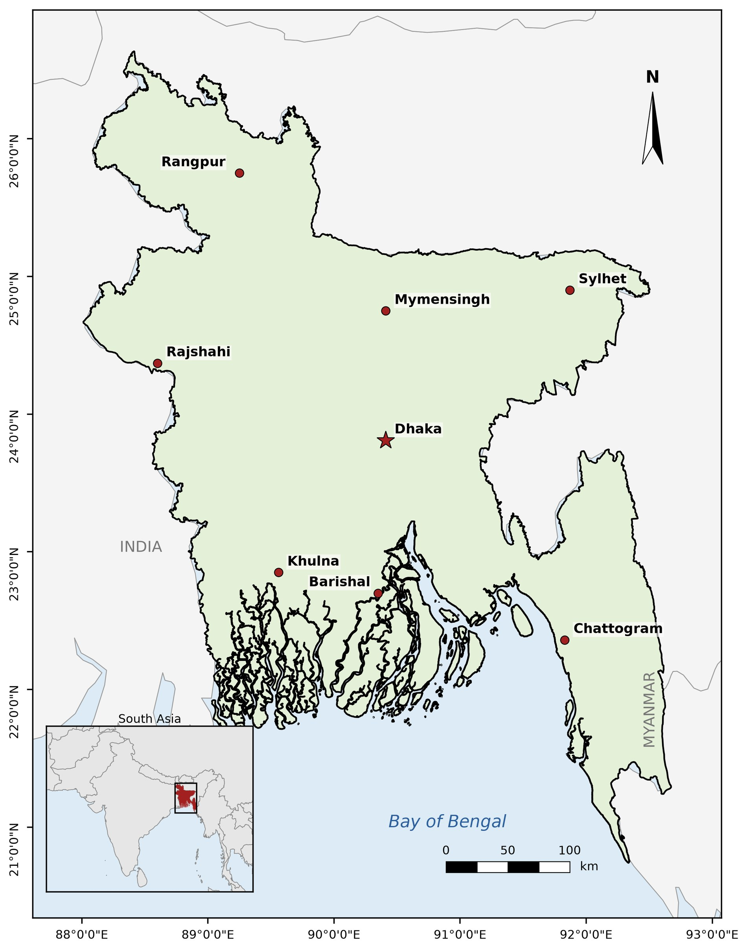
Figure 1. Study area. Bangladesh with its administrative divisions and divisional headquarters (Dhaka is shown as a star) and its location in South Asia (inset).

3. Data and Methods
The workflow is summarised in Figure 2. Satellite data were processed in GEE (Gorelick et al., 2017), and mapping and statistical analyses were carried out in Python using the rasterio, geopandas, pandas, SciPy, matplotlib and mgwr libraries (Oshan et al., 2019). All data refer to the period from 1 January to 31 December 2025.

3.1 Satellite Data
Table 1 lists the datasets.
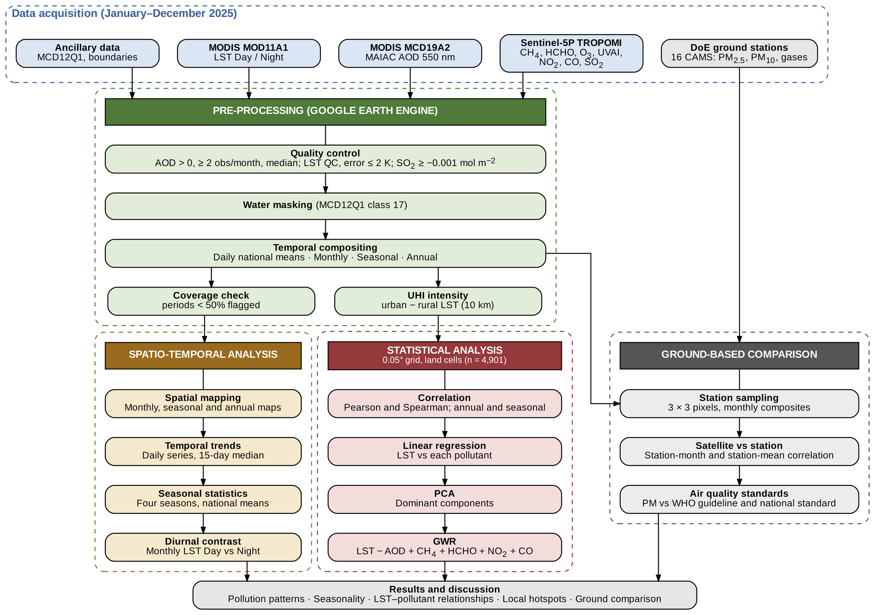
Figure 2. Workflow of the study, from data acquisition and pre-processing in Google Earth Engine to the spatio-temporal analysis, the statistical analysis and the comparison with ground stations.
Seven Sentinel-5P TROPOMI offline (OFFL) Level-3 products were used as provided in the GEE catalogue: the column-averaged dry-air mixing ratio of CH₄ (Lorente et al., 2021), the tropospheric column of HCHO (De Smedt et al., 2018), the total column of O₃ (Garane et al., 2019), the UV aerosol index (UVAI; Torres et al., 1998), the tropospheric column of NO₂ (van Geffen et al., 2022), the total column of CO (Landgraf et al., 2016) and the total column of SO₂ (Theys et al., 2017). The GEE Level-3 products are already filtered with the quality thresholds recommended for each species. AOD at 550 nm was taken from the MODIS MCD19A2 Collection 6.1 product (Lyapustin et al., 2018), which has been evaluated over South Asia (Mhawish et al., 2019). Daytime and nighttime LST were taken from the MODIS Terra MOD11A1 Collection 6.1 product (Wan, 2014). The MODIS MCD12Q1 land cover product (Sulla-Menashe et al., 2019) was used to identify urban land and water.

3.2 Ground-Based Data
Monthly air quality statistics were extracted from the monthly monitoring reports of the DoE for 2025 (Department of Environment, 2025). The reports give, for 16 continuous air monitoring stations (CAMS), the monthly mean concentration and the percentage of valid data (data capture) for PM_{2.5}, PM₁₀, NO₂, SO₂, CO and O₃. Reports were available for 11 months; the report for May could not be obtained.
Table 1. Satellite and ground-based datasets used in the study (1 January to 31 December 2025).
Product | Variable (unit) | Native resolution | Composite | Reference
Sentinel-5P TROPOMI OFFL L3 | CH₄, column-averaged dry-air mixing ratio (ppb) | 5.5 × 7 km | Mean | Lorente et al. (2021)
Sentinel-5P TROPOMI OFFL L3 | HCHO, tropospheric column (mol m⁻²) | 5.5 × 3.5 km | Mean | De Smedt et al. (2018)
Sentinel-5P TROPOMI OFFL L3 | O₃, total column (DU) | 5.5 × 3.5 km | Mean | Garane et al. (2019)
Sentinel-5P TROPOMI OFFL L3 | UV aerosol index (unitless) | 5.5 × 3.5 km | Mean | Torres et al. (1998)
Sentinel-5P TROPOMI OFFL L3 | NO₂, tropospheric column (µmol m⁻²) | 5.5 × 3.5 km | Mean | van Geffen et al. (2022)
Sentinel-5P TROPOMI OFFL L3 | CO, total column (mol m⁻²) | 5.5 × 7 km | Mean | Landgraf et al. (2016)
Sentinel-5P TROPOMI OFFL L3 | SO₂, total column (µmol m⁻²) | 5.5 × 3.5 km | Mean | Theys et al. (2017)
MODIS MCD19A2 (MAIAC), C6.1 | AOD at 550 nm (unitless) | 1 km | Median | Lyapustin et al. (2018)
MODIS MOD11A1, C6.1 | LST, day and night (°C) | 1 km | Mean | Wan (2014)
MODIS MCD12Q1 | Land cover (urban and water classes) | 500 m | – | Sulla-Menashe et al. (2019)
DoE monthly reports | PM_{2.5}, PM₁₀, NO₂, SO₂, CO and O₃ at 16 stations | Point | Monthly mean | Department of Environment (2025)
Note. TROPOMI resolutions are given at nadir. OFFL = offline processing stream; L3 = Level 3; C6.1 = Collection 6.1; DoE = Department of Environment.
Three stations are located in Dhaka, two in Chattogram and one each in Gazipur, Narayanganj, Savar, Narsingdi, Mymensingh, Cumilla, Sylhet, Khulna, Rajshahi, Barishal and Rangpur. Only station-months with at least 50% data capture were used.

3.3 Pre-Processing and Quality Control
All products were clipped to the national boundary and composited to monthly and annual values. TROPOMI variables were averaged over all valid observations in each period. For SO₂, values below −0.001 mol m⁻² were removed before averaging, because strongly negative columns represent retrieval noise. For AOD, non-positive values were removed, a pixel was retained in a month only if it had at least two valid observations, and the median was used instead of the mean to limit the influence of residual cloud contamination. Because MAIAC retrievals over inland water are unreliable, pixels classified as water in MCD12Q1 were masked. For LST, only observations flagged as good quality, or as other quality with an LST error of 2 K or less, were retained, and values were converted to degrees Celsius. All rasters were exported in geographic coordinates (EPSG:4326) at approximately 1 km resolution.
Monsoon cloud removes a large share of the optical and thermal observations. All monthly maps were retained, but the spatial coverage of each month was computed as the percentage of pixels with a valid value among all pixels observed at least once during the year, and months with less than 50% coverage were flagged as having insufficient data. O₃ was converted from mol m⁻² to Dobson units (1 DU = 4.4615 × 10⁻⁴ mol m⁻²), and NO₂ and SO₂ are reported in µmol m⁻².
Particulate matter was not estimated from AOD. The reference study derived PM_{2.5} and PM₁₀ from AOD using empirical relationships calibrated in other regions (Sameh et al., 2026). Such relationships depend on aerosol type, humidity and the vertical distribution of aerosols and cannot be transferred to Bangladesh without local calibration. AOD and UVAI were therefore analysed directly as indicators of the aerosol load, and their relationship with measured PM was examined separately (Section 3.7).

3.4 Urban Heat Island Intensity
Surface UHI intensity was calculated from the annual daytime LST composite as the difference between the LST of each pixel and the mean LST of the rural pixels within a 10 km radius, where rural pixels are those classified neither as urban nor as water in MCD12Q1. This follows the urban–rural contrast that is widely used in surface UHI studies (Peng et al., 2012; Zhou et al., 2019), but uses a local rural reference so that regional temperature gradients across the country do not appear as heat islands. Water pixels were masked.

3.5 Temporal and Seasonal Analysis
Daily national means were computed for every variable. For AOD, NO₂, CO and SO₂, days on which less than 50% of the country was observed were excluded, because national means based on a few cloud-free pixels are not representative. Days deviating by more than three robust standard deviations (1.4826 times the median absolute deviation) from a 15-day running median were removed as outliers, a filter of the Hampel type (Hampel, 1974), and the 15-day running median was used as the smoothed series. Seasonal composites were calculated for each pixel as the mean of the monthly composites of the season, for winter (January, February and December 2025), pre-monsoon (March–May), monsoon (June–September) and post-monsoon (October–November). National seasonal means and standard deviations were derived from these composites.

3.6 Statistical Analysis
The variables have different native resolutions, so all rasters were aggregated by averaging onto a common grid of 0.05° (about 5.5 km), which is close to the TROPOMI footprint. Water was removed from the MODIS variables before aggregation, and only cells with at least 50% land were retained. Cells with valid annual values for all variables formed the analysis sample (n = 4,901).
Pearson and Spearman correlation coefficients were calculated among LST Day, LST Night, UHI and the eight atmospheric variables. Because the observations are spatially autocorrelated, the effective sample size is much smaller than the number of cells and significance levels are overstated (Clifford et al., 1989); p values are reported for completeness, but the interpretation is based on the size of the coefficients. Following Sameh et al. (2026), simple ordinary least squares (OLS) regressions of LST Day and LST Night on each pollutant were fitted. The correlation analysis was repeated for each season using the seasonal composites, with cells retained pairwise.
PCA was applied to the correlation matrix of ten standardised variables. UHI was excluded because it is derived from LST Day. Components with an eigenvalue greater than one were retained (Jolliffe & Cadima, 2016; Kaiser, 1960).
Global regression assumes that the relationship between LST and the pollutants is the same everywhere. GWR relaxes this assumption by fitting a separate regression at each location, weighting neighbouring observations by distance (Fotheringham et al., 2002). LST Day and LST Night were modelled as functions of standardised AOD, CH₄, HCHO, NO₂ and CO, using an adaptive bi-square kernel, great-circle distances and a bandwidth selected by minimising the corrected Akaike information criterion (AICc) (Oshan et al., 2019). UVAI was excluded because it overlaps with AOD, total-column O₃ because it is dominated by the stratosphere, and SO₂ because of its low signal-to-noise ratio. The variance inflation factors (VIF) of the predictors ranged from 2.0 to 3.6, below the commonly used threshold of 5 (O’Brien, 2007). The significance of local coefficients was assessed with t values corrected for multiple testing (da Silva & Fotheringham, 2016). To test the sensitivity of the results to the choice of aerosol indicator, a second model was fitted with UVAI in place of AOD.

3.7 Comparison With Ground Stations
For each station, the satellite value of each month was taken as the mean of the 3 × 3 pixels of the monthly composite centred on the station. Station PM_{2.5} and PM₁₀ were compared with AOD, station PM_{2.5} with UVAI, and station NO₂, SO₂, CO and O₃ with the corresponding TROPOMI columns. Agreement was measured with Pearson and Spearman coefficients at two levels: across all station-months, which reflects mainly the shared seasonal cycle, and across station means, which reflects spatial agreement. The mean PM_{2.5} and PM₁₀ concentrations of each station were compared with the annual WHO air quality guideline levels of 5 and 15 µg m⁻³ (World Health Organization, 2021) and with the annual national standards of 35 and 50 µg m⁻³ (Ministry of Environment, Forest and Climate Change, 2022). Satellite columns were not compared with these limits, because the guidelines apply to surface concentrations.

4. Results

4.1 Data Availability
UVAI, NO₂, SO₂, CO, HCHO and O₃ had almost complete coverage in every month (Table 2). CH₄, AOD and LST were strongly affected by monsoon cloud. CH₄ coverage fell to 15% in June, was close to zero in July and August and recovered to only 25% in September. AOD coverage dropped to 11% in July and 25% in August, daytime LST to 32% and 47%, and nighttime LST to 30% and 15%. These months are flagged in all figures and tables, and their national means should be read with caution, because the pixels that were observed are spatially clustered.
Table 2. Monthly spatial coverage of each variable in 2025 (%).
Month | AOD | UVAI | NO₂ | SO₂ | CO | CH₄ | HCHO | O₃ | LST Day | LST Night
Jan | 100 | 100 | 100 | 100 | 100 | 99 | 100 | 100 | 100 | 100
Feb | 100 | 100 | 100 | 100 | 100 | 100 | 100 | 100 | 100 | 100
Mar | 100 | 100 | 100 | 100 | 100 | 99 | 100 | 100 | 100 | 100
Apr | 99 | 100 | 100 | 100 | 100 | 95 | 100 | 100 | 100 | 100
May | 93 | 100 | 100 | 100 | 100 | 53 | 100 | 100 | 100 | 100
Jun | 62 | 100 | 100 | 100 | 100 | 15* | 100 | 100 | 96 | 90
Jul | 11* | 100 | 99 | 99 | 100 | 0* | 99 | 100 | 32* | 30*
Aug | 25* | 100 | 100 | 100 | 100 | 0* | 100 | 100 | 47* | 15*
Sep | 89 | 100 | 100 | 100 | 100 | 25* | 100 | 100 | 99 | 89
Oct | 100 | 100 | 100 | 100 | 100 | 90 | 100 | 100 | 100 | 100
Nov | 100 | 100 | 100 | 100 | 100 | 99 | 100 | 100 | 100 | 100
Dec | 100 | 100 | 100 | 100 | 100 | 99 | 100 | 100 | 100 | 100
Note. Coverage is the percentage of pixels with a valid value among all pixels observed at least once in 2025. * Coverage below 50% (flagged as insufficient data).

4.2 Annual Spatial Patterns
The annual statistics of all variables on the analysis grid are summarised in Table 3, and the annual maps of the aerosol indicators, NO₂ and SO₂ are shown in Figure 3. Median AOD had a marked west–east gradient (Figure 3a). The highest values, about 0.55–0.67, occurred in the north-western and western districts that adjoin the Indo-Gangetic Plain, and the lowest, about 0.16–0.29, in the Sylhet region and the Chittagong Hill Tracts. On the analysis grid, mean AOD was 0.58 west of 89.5° E and 0.24 east of 91° E. A faint straight diagonal discontinuity crossing central Bangladesh was traced to the MAIAC product and is treated as a retrieval artefact. UVAI was negative everywhere on the annual scale (Figure 3b), with the least negative values over Dhaka, in the north-west and along the Jamuna and Padma rivers. The river signal most likely reflects bright sandbars and water surfaces and not absorbing aerosols.
Table 3. Descriptive statistics of the annual values on the 0.05° analysis grid (n = 4,901 land cells).
Variable | Unit | M | SD | Minimum | Maximum
AOD | – | 0.425 | 0.145 | 0.149 | 0.707
UVAI | index | −0.410 | 0.069 | −0.598 | −0.134
NO₂ | µmol m⁻² | 36.6 | 18.9 | 16.4 | 188.6
SO₂ | µmol m⁻² | 83.4 | 26.9 | 11.0 | 192.4
CO | mol m⁻² | 0.0423 | 0.0015 | 0.0363 | 0.0455
CH₄ | ppb | 1946.6 | 15.3 | 1877.3 | 2015.3
HCHO | ×10⁻⁴ mol m⁻² | 2.04 | 0.19 | 1.51 | 2.66
O₃ | DU | 276.7 | 1.8 | 271.8 | 280.5
LST Day | °C | 25.72 | 0.71 | 23.50 | 30.61
LST Night | °C | 19.91 | 0.79 | 17.99 | 23.61
UHI | °C | 0.01 | 0.28 | −1.41 | 3.74
Note. AOD is the annual median; all other variables are annual means. UHI = surface urban heat island intensity.
NO₂ gave the clearest picture of anthropogenic emissions (Figure 3c). The tropospheric column over the Dhaka conurbation reached 189 µmol m⁻² on the analysis grid, about five times the national mean of 36.6 µmol m⁻². Secondary maxima were visible over Chattogram and several other cities, and along the western border near Chapainawabganj. SO₂ was noisy at the pixel scale, as expected for a weak absorber (Figure 3d), but the annual mean still showed elevated values in the south-west, where the highest cells reached about 190 µmol m⁻², around Dhaka and along the western border.
CH₄ and HCHO also peaked over Dhaka and its surroundings (Figures 4a and 4b). CH₄ reached about 2,000 ppb there, against a national mean of 1,947 ppb, and was lowest over the Sundarbans and the Chittagong Hill Tracts. HCHO was additionally elevated along the western border. CO declined from west to east, with the highest columns along the south-western and western borders (Figure 4c). Narrow north–south bands in the CO map follow the satellite ground track and are a known feature of the TROPOMI CO product (Borsdorff et al., 2019). Total-column O₃ varied by less than 9 DU across the country and followed a smooth north–south gradient (Figure 4d), which is consistent with a column dominated by the stratosphere (Garane et al., 2019).
Daytime LST was highest across the west-central plains, in the Dhaka conurbation and on the south-central coastal islands, and lowest over the Sylhet wetlands, the Sundarbans and the Chittagong Hill Tracts (Figure 5a). The night pattern was different (Figure 5b): the south-west, Dhaka and the river corridors were warmest, and the north-west was coolest. Mean UHI intensity was close to zero by construction, but individual cells reached 3.7 °C in central Dhaka and 2.7 °C in Chattogram (Figure 5c). Within the Dhaka area (90.30–90.55° E, 23.65–23.95° N), the mean UHI intensity was 0.85 °C and the mean daytime LST was 27.5 °C, compared with a national mean of 25.7 °C.
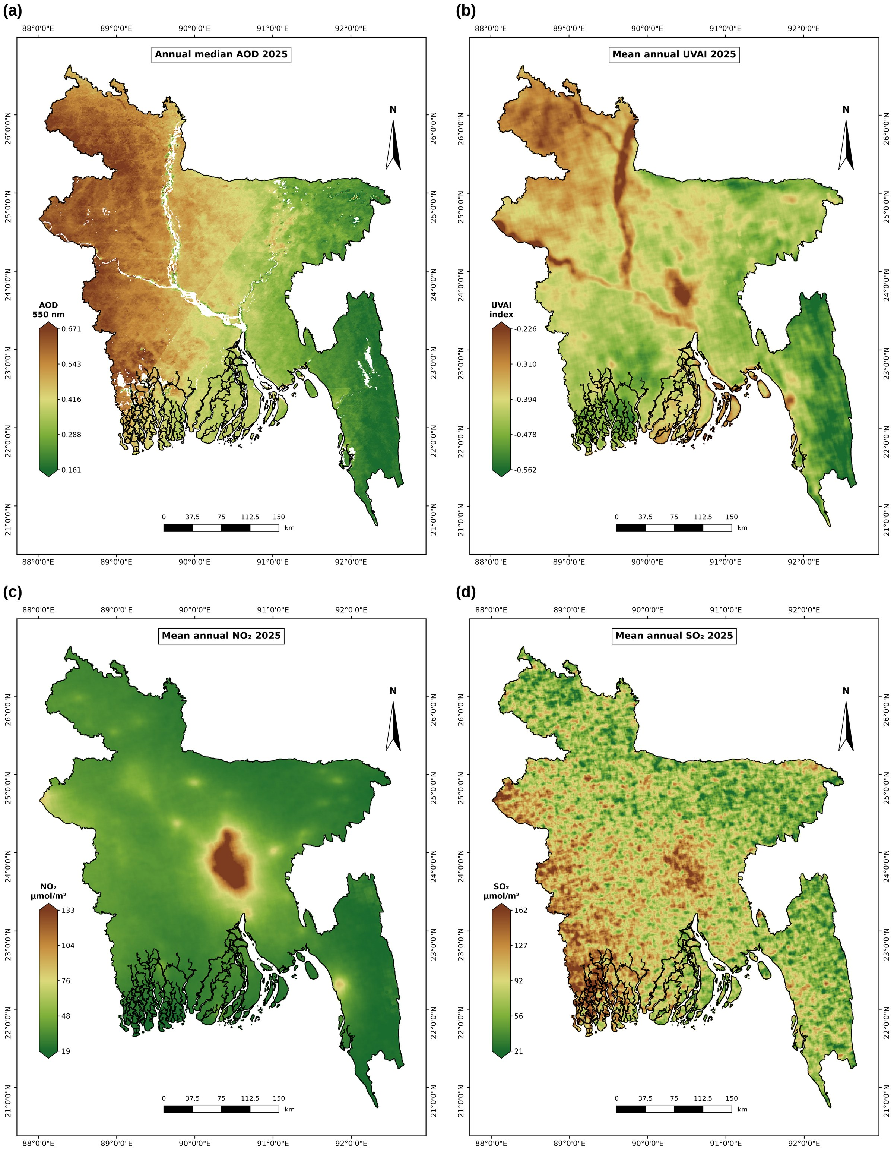
Figure 3. Annual maps for 2025 of (a) median AOD at 550 nm (inland water masked), (b) mean UVAI, (c) mean tropospheric NO₂ column and (d) mean SO₂ column.

4.3 Seasonal and Temporal Variation
All variables had a pronounced seasonal cycle (Table 4; Figure 6). NO₂ was highest in winter (42.6 µmol m⁻²) and lowest in the monsoon (24.5 µmol m⁻²).
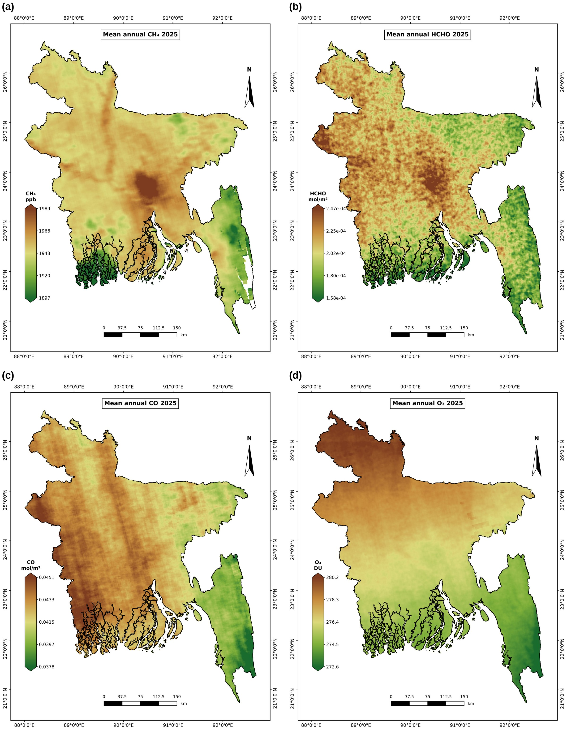
Figure 4. Annual maps for 2025 of (a) mean column-averaged CH₄, (b) mean tropospheric HCHO column, (c) mean CO column and (d) mean total O₃ column.
CO and SO₂ were highest in the pre-monsoon season and winter and fell sharply in the monsoon; the monsoon mean of CO was 27% lower than the pre-monsoon mean. AOD was highest in the pre-monsoon season (0.57) and winter (0.51) and lowest after the monsoon (0.29).
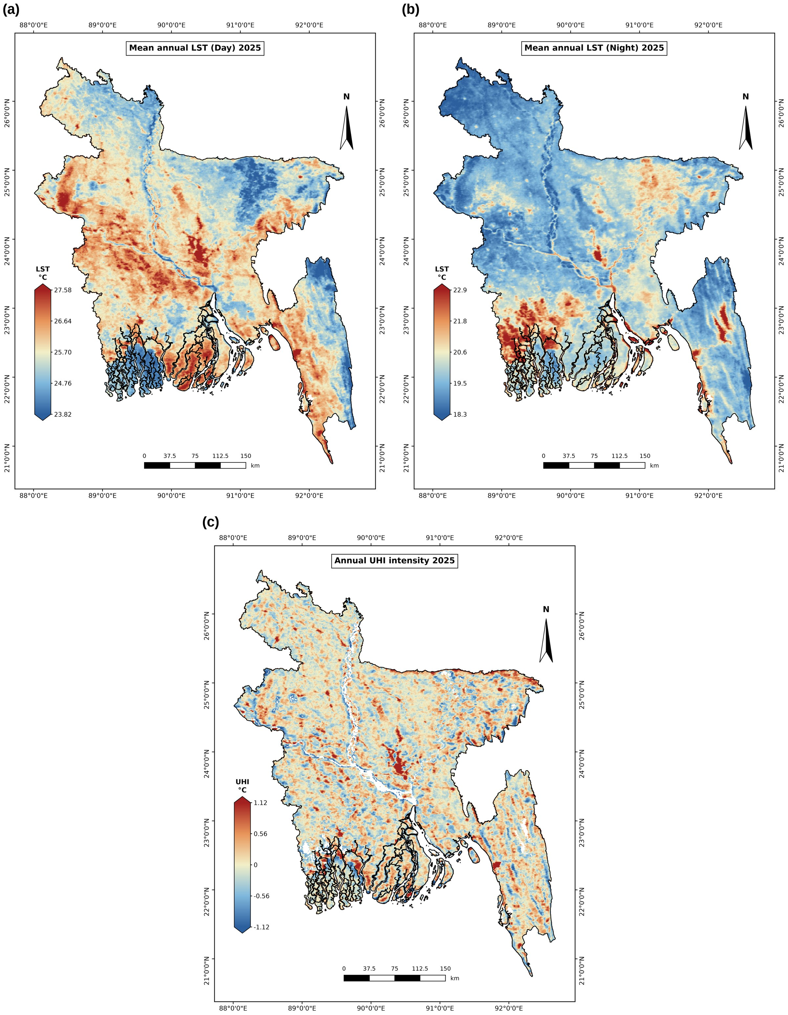
Figure 5. Annual maps for 2025 of (a) mean daytime LST, (b) mean nighttime LST and (c) surface UHI intensity, calculated as daytime LST minus the mean rural LST within 10 km (water masked).
UVAI was close to zero in winter and strongly negative during the monsoon (−0.78), when clouds strongly affect the index (Kooreman et al., 2020). HCHO peaked in the pre-monsoon season, and total-column O₃ rose from 264 DU in winter to 292 DU in the pre-monsoon season. CH₄ was highest in the monsoon and post-monsoon seasons, but the monsoon value is based on only 32% of the country.
Table 4. Seasonal national means (± standard deviation across pixels) in 2025.
Variable | Unit | Winter (Dec–Feb) | Pre-monsoon (Mar–May) | Monsoon (Jun–Sep) | Post-monsoon (Oct–Nov)
AOD | – | 0.51 ± 0.18 | 0.57 ± 0.14 | 0.37 ± 0.21 | 0.29 ± 0.12
UVAI | index | −0.05 ± 0.13 | −0.25 ± 0.09 | −0.78 ± 0.07 | −0.43 ± 0.08
NO₂ | µmol m⁻² | 42.6 ± 27.7 | 36.1 ± 14.3 | 24.5 ± 9.3 | 32.2 ± 21.5
SO₂ | µmol m⁻² | 97.6 ± 54.6 | 136.7 ± 54.0 | 15.3 ± 29.3 | 26.1 ± 41.5
CO | mol m⁻² | 0.0462 ± 0.0023 | 0.0482 ± 0.0013 | 0.0350 ± 0.0017 | 0.0375 ± 0.0021
CH₄ | ppb | 1945 ± 16 | 1934 ± 19 | 1966 ± 31* | 1964 ± 22
HCHO | ×10⁻⁴ mol m⁻² | 1.93 ± 0.24 | 2.38 ± 0.30 | 1.73 ± 0.31 | 1.96 ± 0.30
O₃ | DU | 264.1 ± 2.5 | 291.8 ± 2.6 | 279.7 ± 0.9 | 263.9 ± 1.5
LST Day | °C | 22.2 ± 1.0 | 28.6 ± 1.4 | 28.4 ± 1.5 | 26.4 ± 0.7
LST Night | °C | 16.7 ± 1.3 | 23.4 ± 0.9 | 26.4 ± 1.1 | 22.7 ± 1.1
Note. Winter combines January, February and December 2025. * Spatial coverage below 50%.
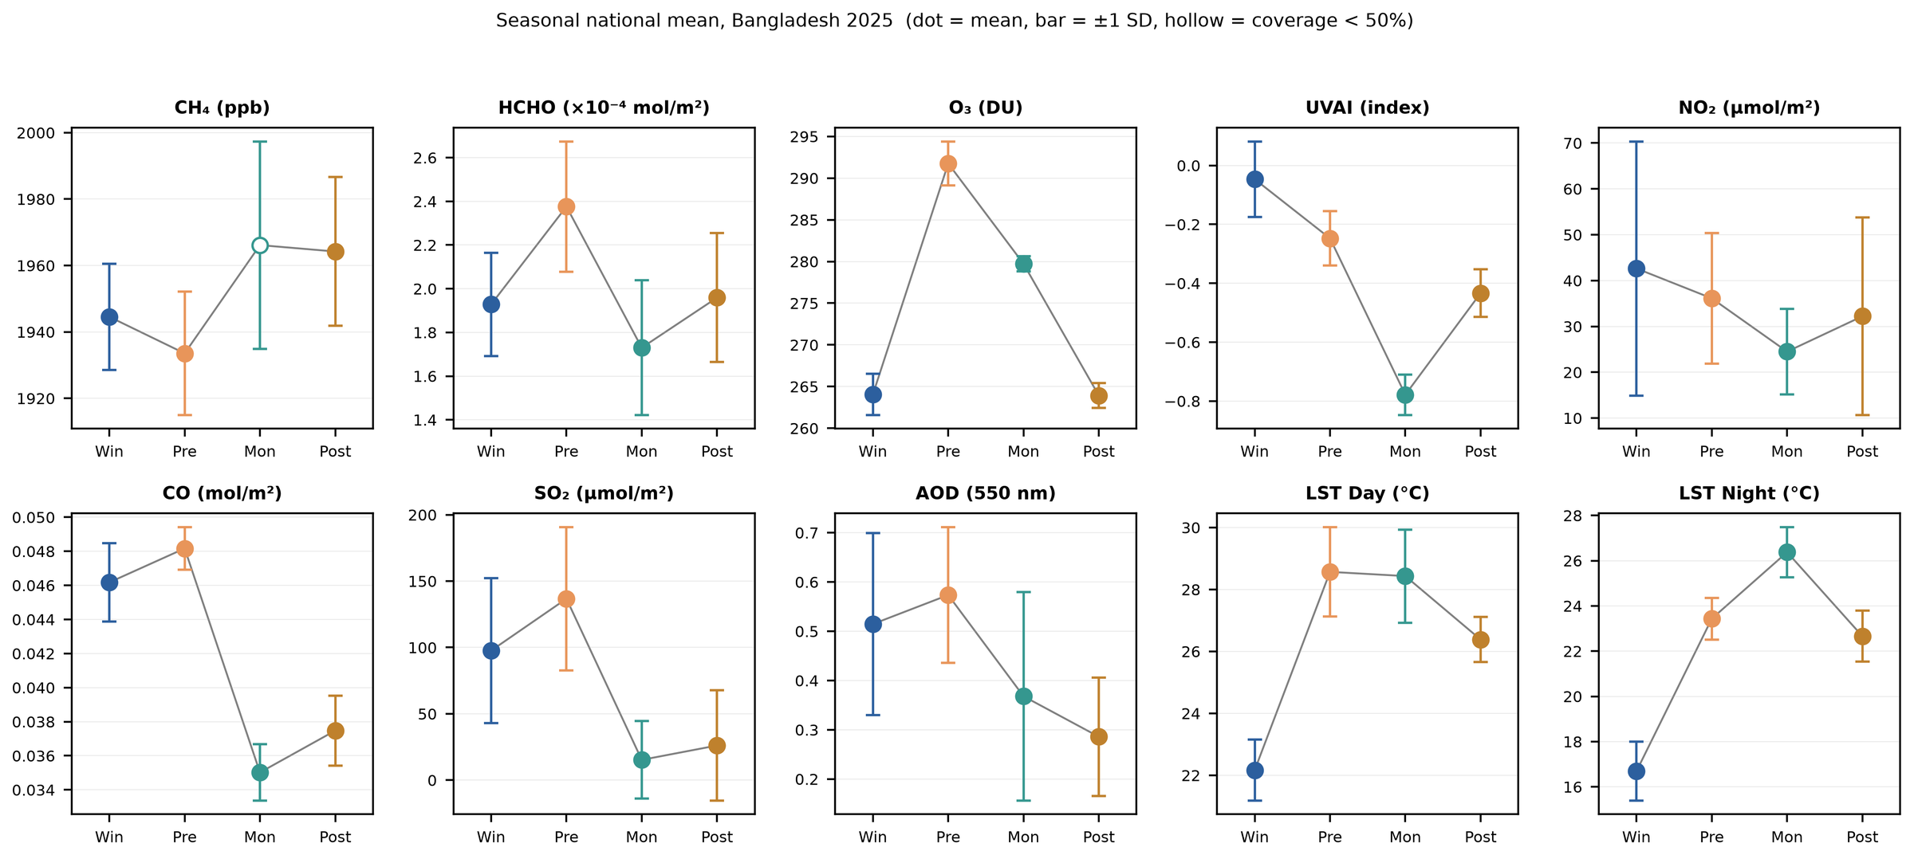
Figure 6. Seasonal national means for 2025 (dots) with ±1 standard deviation across pixels (bars). Win = winter, Pre = pre-monsoon, Mon = monsoon, Post = post-monsoon. The hollow marker indicates spatial coverage below 50%.
The spatial patterns changed with season as well. The Dhaka NO₂ hotspot was present in every season but was largest and most intense in winter and after the monsoon, and weakest during the monsoon (Figure 7). AOD was high over most of the country in winter and the pre-monsoon season, with the west–east gradient most pronounced in winter, and was low everywhere after the monsoon (Figure 8). Monthly maps of all variables are provided in the Supplementary Material (Figures S1–S10), and the monthly national means in Table S1.
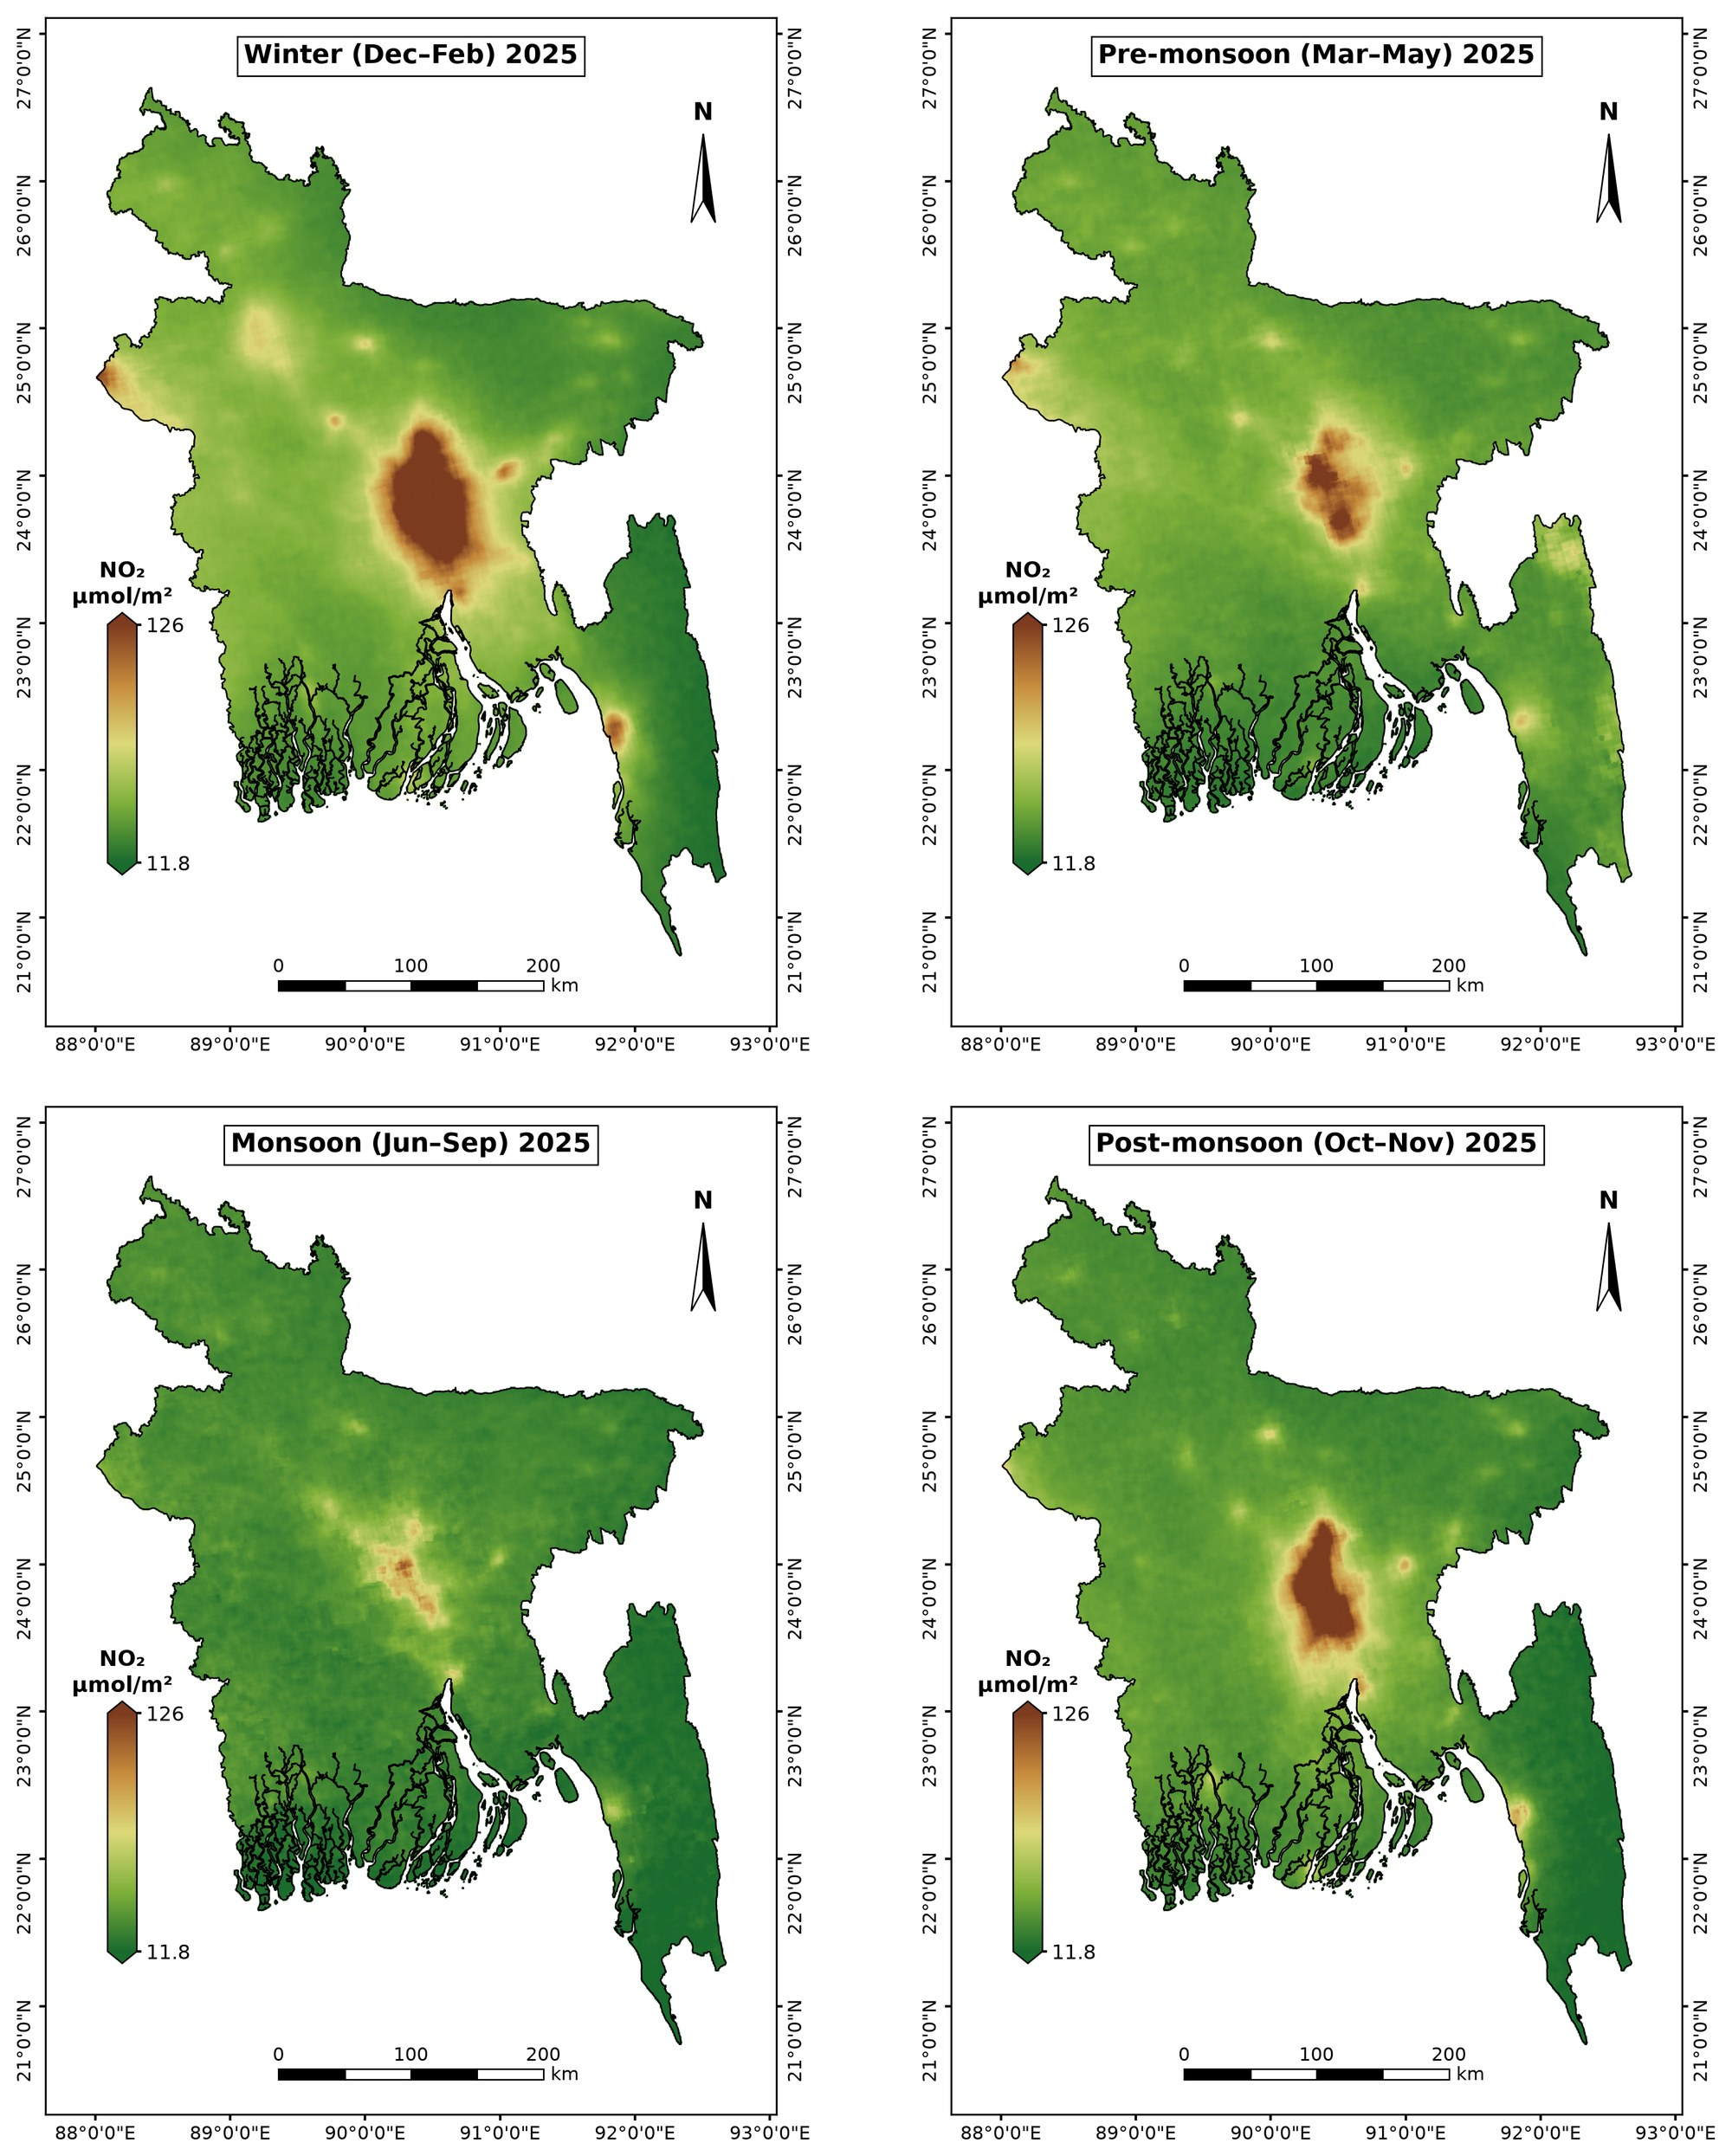
Figure 7. Seasonal mean tropospheric NO₂ column in 2025. All panels share one colour scale.
The daily national series confirm this behaviour (Figure 9). AOD reached its maximum in late January, during the winter haze season, and its minimum in September. NO₂ was highest from January to March, declined to a minimum in August and recovered from October onwards. CO remained high until April and dropped sharply between May and June, with the onset of the monsoon. O₃ showed the smoothest cycle, with a broad maximum in April–May and a minimum in December. After quality filtering, between 165 (AOD) and 364 (UVAI) days were available per variable.
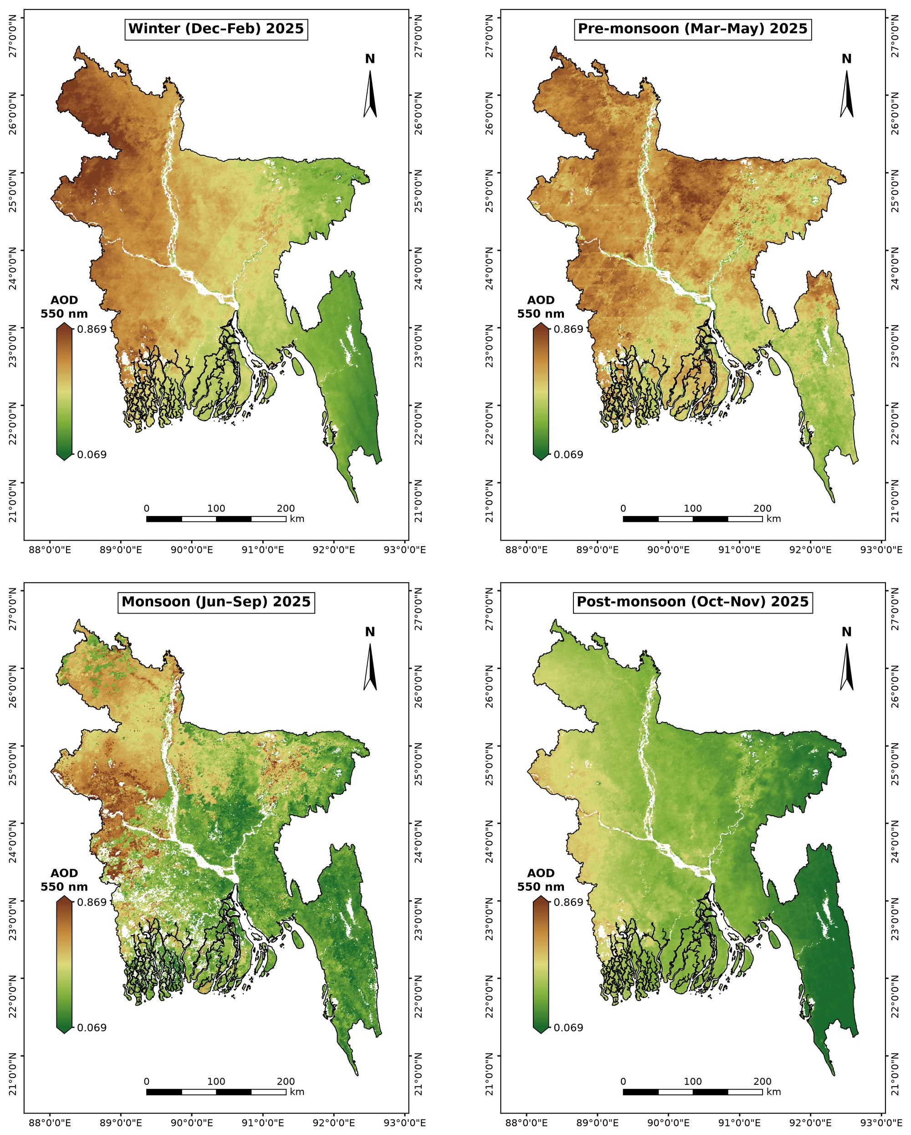
Figure 8. Seasonal AOD at 550 nm in 2025 (inland water masked). All panels share one colour scale.
Monthly mean daytime LST rose from 21.2 °C in January to a maximum of 29.6 °C in May, whereas nighttime LST continued to rise into the monsoon and peaked at 26.8 °C in September (Figure 10). The difference between day and night therefore narrowed from about 5.5 °C in winter to 0.8 °C in August, when persistent cloud and high humidity suppress both daytime heating and nocturnal cooling.

4.4 Correlation Analysis
Pearson and Spearman coefficients were similar (Figure 11), which indicates that the relationships are not driven by a few extreme cells.
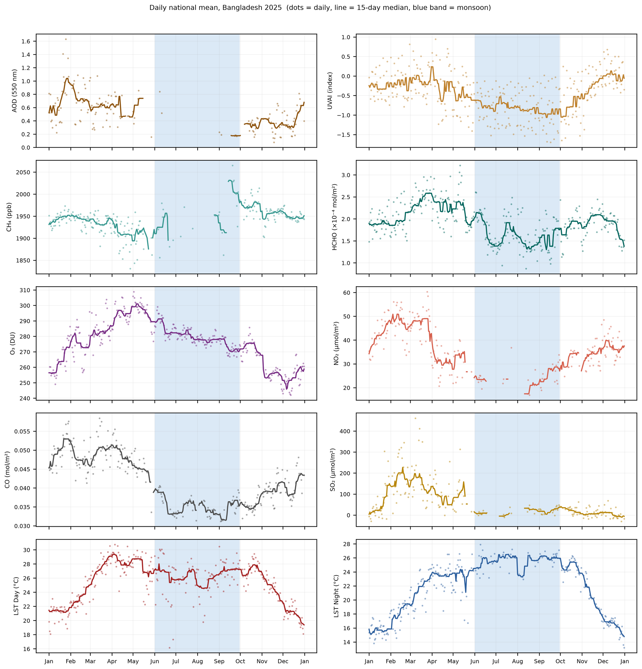
Figure 9. Daily national means in 2025. Dots are daily values after outlier removal, lines are 15-day running medians, and the shaded band marks the monsoon (June–September). AOD, NO₂, CO and SO₂ are restricted to days with at least 50% spatial coverage.
Annual daytime LST was positively correlated with CH₄ (r = 0.48), NO₂ (0.36), SO₂ (0.31), HCHO (0.30), CO (0.24), UVAI (0.22) and AOD (0.17), and weakly negatively with O₃ (−0.14). Nighttime LST behaved differently: it was negatively correlated with O₃ (−0.39), UVAI (−0.29), HCHO (−0.23) and AOD (−0.18), positively with SO₂ (0.22), and essentially uncorrelated with CH₄, NO₂ and CO. UHI intensity correlated with daytime LST (0.51), from which it is derived, but only weakly with NO₂ (0.16) and CH₄ (0.15).
The pollutants were strongly correlated with one another. The highest coefficients were found for AOD and CO (0.79), UVAI and O₃ (0.71), AOD and O₃ (0.69), AOD and UVAI (0.66), CH₄ and NO₂ (0.64), HCHO and NO₂ (0.62), and HCHO and CH₄ (0.61).
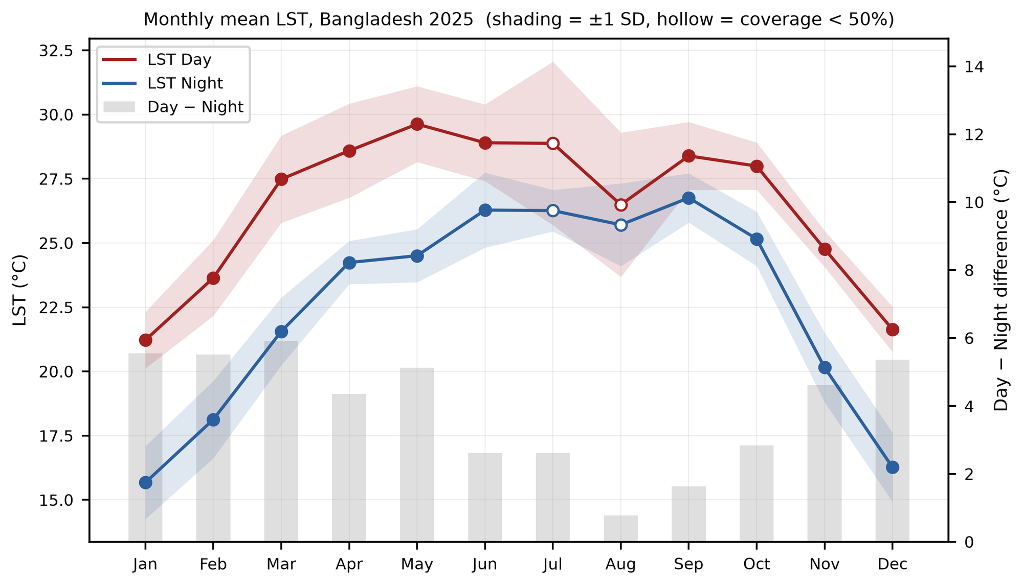
Figure 10. Monthly national mean daytime and nighttime LST in 2025 (shading: ±1 standard deviation; hollow markers: spatial coverage below 50%) and the day–night difference (grey bars, right axis).
Two groups can be distinguished: variables that follow the regional west–east and north–south gradients (AOD, CO, UVAI and O₃), and variables that are concentrated around urban and industrial centres (NO₂, CH₄ and HCHO).

4.5 Regression Analysis
Single pollutants explained only a small to moderate share of the spatial variation of LST (Table 5; Figure 12). CH₄ was the strongest single predictor of daytime LST (R² = 0.23), followed by NO₂ (0.13), SO₂ (0.09) and HCHO (0.09). O₃ was the strongest single predictor of nighttime LST (R² = 0.15); all other nighttime relationships had R² below 0.10. The slopes are statistically significant because of the large sample, but the low explained variance shows that LST is controlled by several factors together, including land cover, surface moisture and urban form, and not by any single pollutant.

4.6 Principal Component Analysis
Three components had eigenvalues greater than one and together explained 74.9% of the total variance (Table 6; Figure 13). The first component (42.8%) is a general pollution factor, with high positive loadings on HCHO (0.85), AOD (0.81), UVAI (0.78), CO (0.78), CH₄ (0.70), O₃ (0.65) and NO₂ (0.61). It shows that the most polluted parts of the country are affected by several pollutants at the same time. The second component (19.2%) contrasts O₃ (0.68) with SO₂ (−0.62), nighttime LST (−0.58), daytime LST (−0.51) and NO₂ (−0.47); it separates the latitudinal ozone gradient from the warm, combustion-influenced areas of the south and centre. The third component (13.0%) has moderate loadings of opposite sign on CO, SO₂, AOD and nighttime LST (0.42 to 0.49) and on CH₄, NO₂ and daytime LST (−0.35 to −0.47), and distinguishes the regional aerosol and CO burden from locally concentrated emissions.
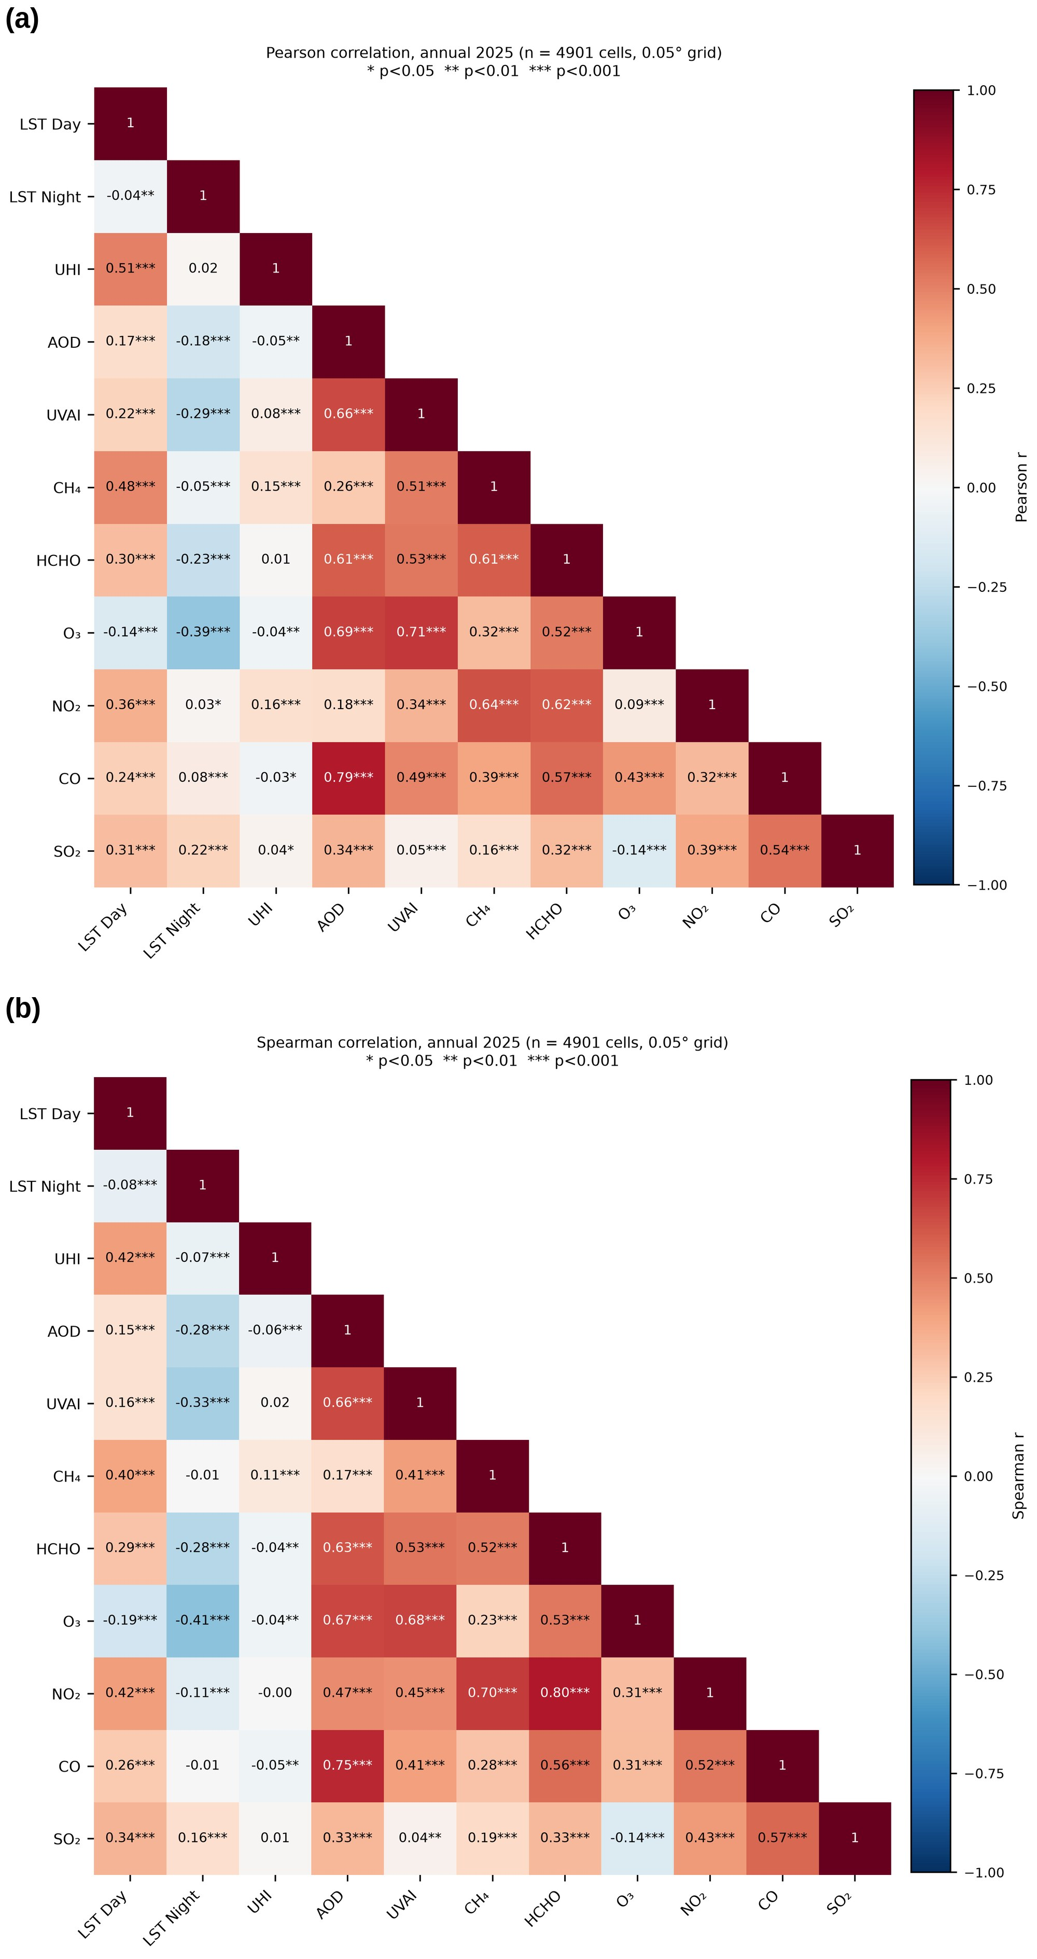
Figure 11. (a) Pearson and (b) Spearman correlation matrices of the annual variables on the 0.05° grid (n = 4,901 cells). * p < 0.05. ** p < 0.01. *** p < 0.001.
Table 5. Simple linear regression of annual LST (°C) on each atmospheric variable (n = 4,901).
Response | Predictor (unit) | Slope | Intercept | r | R²
LST Day | AOD | 0.861 | 25.36 | 0.175 | 0.030
LST Night | AOD | −1.003 | 20.33 | −0.184 | 0.034
LST Day | UVAI | 2.252 | 26.64 | 0.219 | 0.048
LST Night | UVAI | −3.277 | 18.56 | −0.289 | 0.083
LST Day | CH₄ (ppb) | 0.0224 | −17.80 | 0.480 | 0.231
LST Night | CH₄ (ppb) | −0.0027 | 25.14 | −0.052 | 0.003
LST Day | HCHO (×10⁻⁴ mol m⁻²) | 1.174 | 23.33 | 0.305 | 0.093
LST Night | HCHO (×10⁻⁴ mol m⁻²) | −0.967 | 21.88 | −0.228 | 0.052
LST Day | O₃ (DU) | −0.0577 | 41.69 | −0.144 | 0.021
LST Night | O₃ (DU) | −0.171 | 67.11 | −0.386 | 0.149
LST Day | NO₂ (µmol m⁻²) | 0.0134 | 25.23 | 0.356 | 0.127
LST Night | NO₂ (µmol m⁻²) | 0.0012 | 19.86 | 0.028 | 0.001
LST Day | CO (mol m⁻²) | 115.7 | 20.82 | 0.240 | 0.058
LST Night | CO (mol m⁻²) | 44.7 | 18.02 | 0.084 | 0.007
LST Day | SO₂ (µmol m⁻²) | 0.0082 | 25.04 | 0.308 | 0.095
LST Night | SO₂ (µmol m⁻²) | 0.0066 | 19.36 | 0.224 | 0.050
Note. All slopes are significant at p < 0.001 except LST Night on NO₂ (p = 0.047). Significance levels are overstated because of spatial autocorrelation.

4.7 Seasonal Correlation
The relationships between LST and the pollutants were not stable through the year (Figure 14). In winter, daytime LST was negatively correlated with AOD (r = −0.52), O₃ (−0.50) and CO (−0.34), and positively with CH₄ (0.34). In the pre-monsoon season, the correlations with AOD (−0.35) and O₃ (−0.57) remained negative. During and after the monsoon the signs reversed: daytime LST was positively correlated with CO (0.51), HCHO (0.50), NO₂ (0.43), O₃ (0.41) and AOD (0.29) in the monsoon, and with CH₄ (0.58), NO₂ (0.51), HCHO (0.44) and CO (0.36) after the monsoon. Nighttime LST followed the same pattern, with strongly negative winter correlations with O₃ (−0.56), AOD (−0.52) and UVAI (−0.52) and positive monsoon correlations with O₃ (0.39), HCHO (0.38) and CO (0.32). The annual coefficients reported in Section 4.4 are therefore averages of opposing seasonal relationships.

4.8 Geographically Weighted Regression
GWR performed much better than the corresponding global models (Table 7). The global OLS models explained 24.0% of the variance of daytime LST and 23.5% of that of nighttime LST. With an AICc-optimised adaptive bandwidth of 53 neighbouring cells, equivalent to a radius of about 22 km, GWR raised R² to 0.913 and 0.925, respectively, and the mean local R² was 0.64. The relationship between LST and the pollutants is therefore strongly non-stationary across Bangladesh.
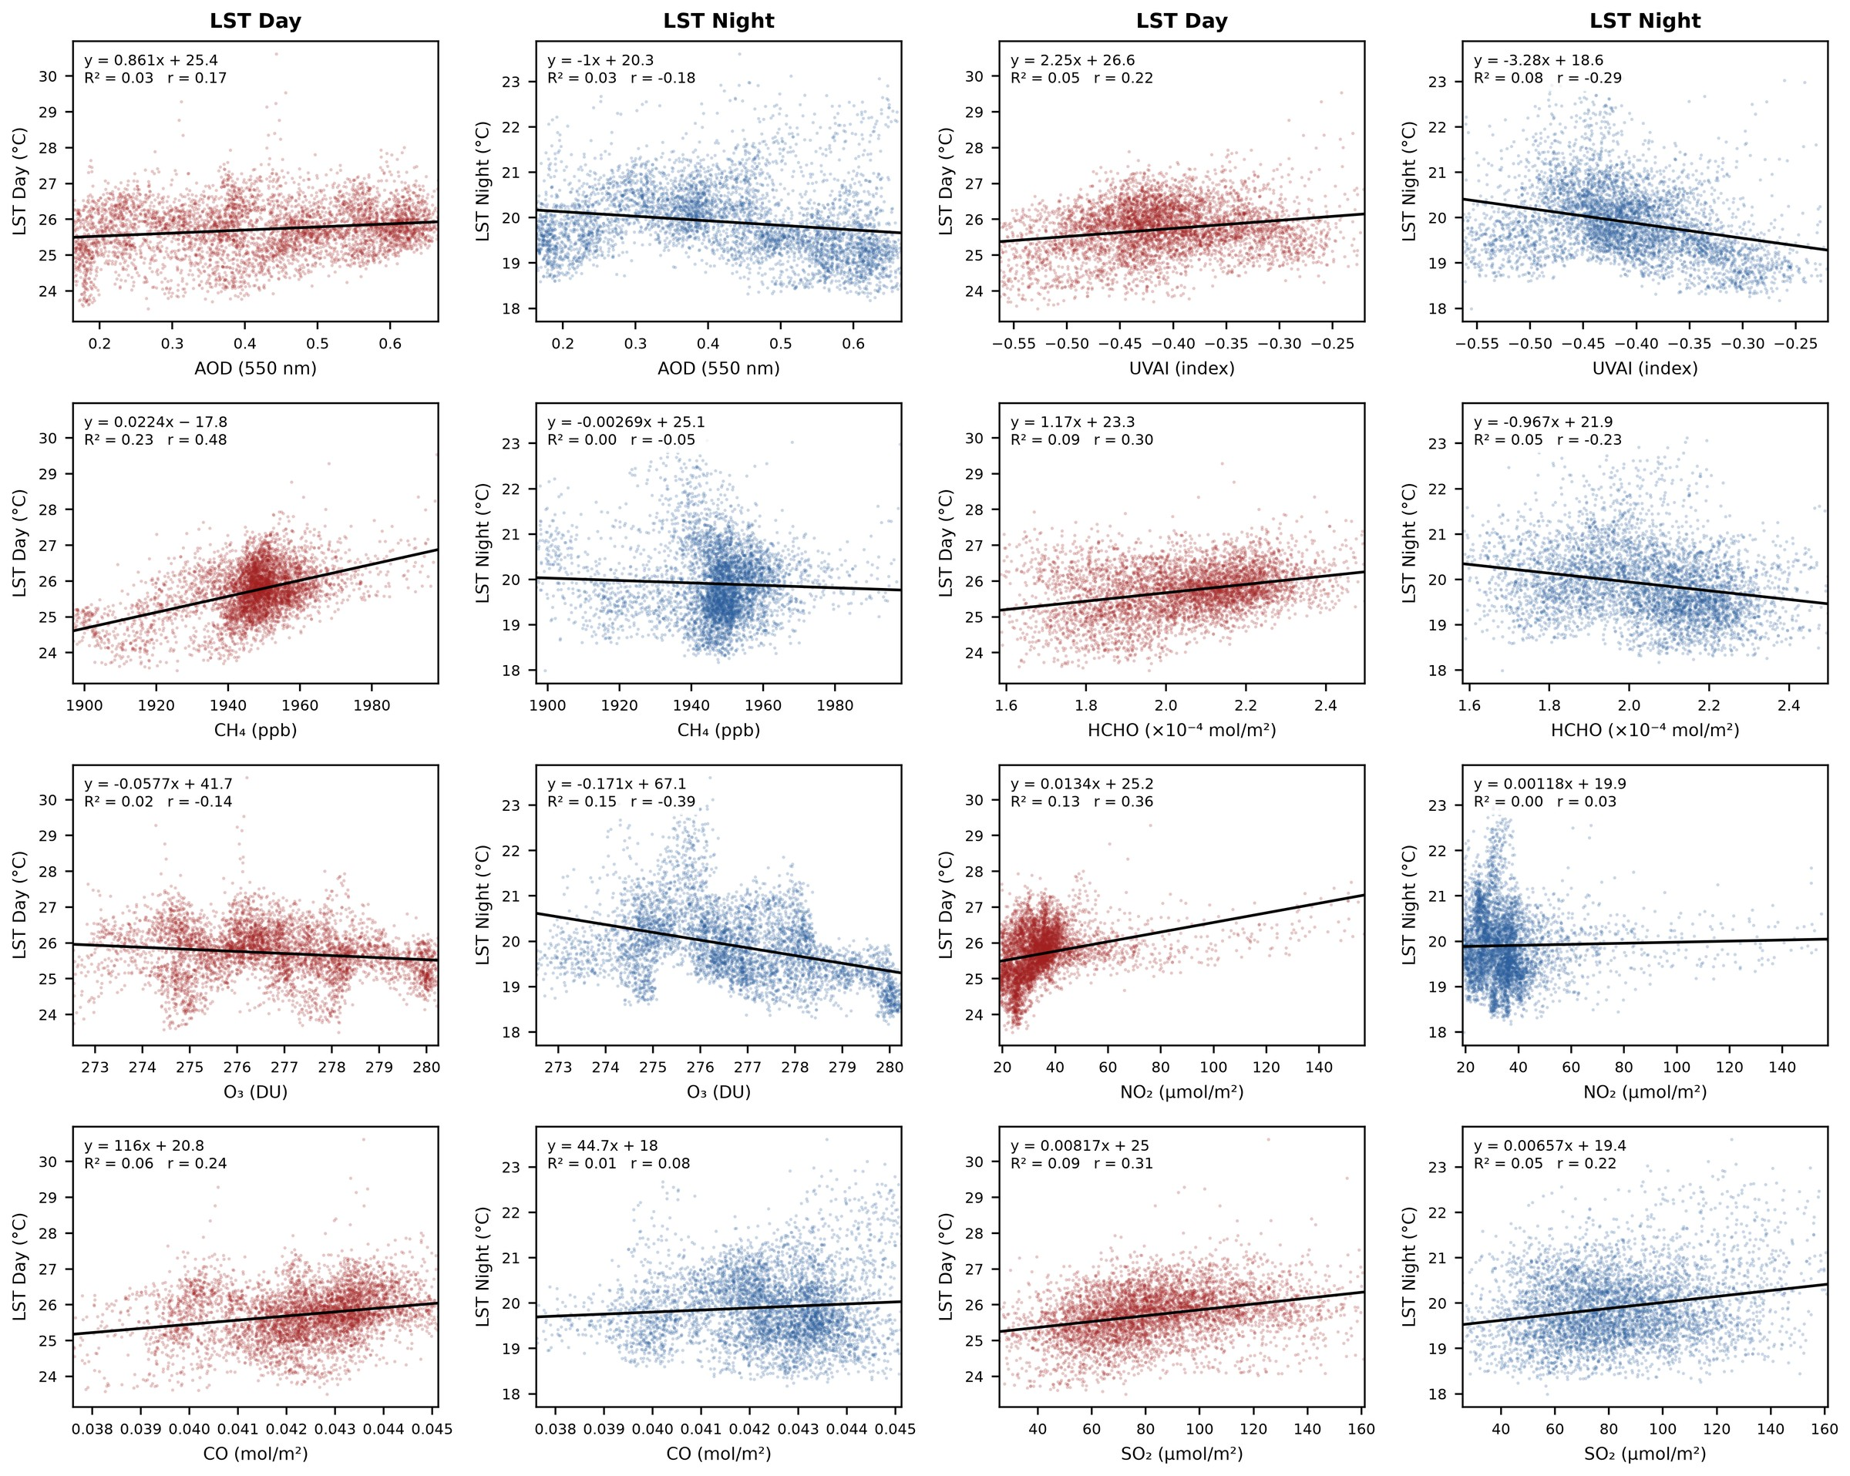
Figure 12. Linear regression of annual daytime LST (red) and nighttime LST (blue) on each pollutant (n = 4,901 cells). Lines are ordinary least squares fits.
Table 6. Eigenvalues, explained variance and loadings of the first three principal components.
 | PC1 | PC2 | PC3
Eigenvalue | 4.28 | 1.92 | 1.30
Variance explained (%) | 42.8 | 19.2 | 13.0
Cumulative variance (%) | 42.8 | 61.9 | 74.9
LST Day | 0.41 | −0.51 | −0.35
LST Night | −0.21 | −0.58 | 0.42
AOD | 0.81 | 0.26 | 0.43
UVAI | 0.78 | 0.35 | −0.10
CH₄ | 0.70 | −0.24 | −0.47
HCHO | 0.85 | −0.03 | −0.13
O₃ | 0.65 | 0.68 | 0.07
NO₂ | 0.61 | −0.47 | −0.35
CO | 0.78 | −0.12 | 0.49
SO₂ | 0.41 | −0.62 | 0.45
Note. Loadings are correlations between the variables and the components. Loadings with an absolute value of 0.50 or more are in bold.
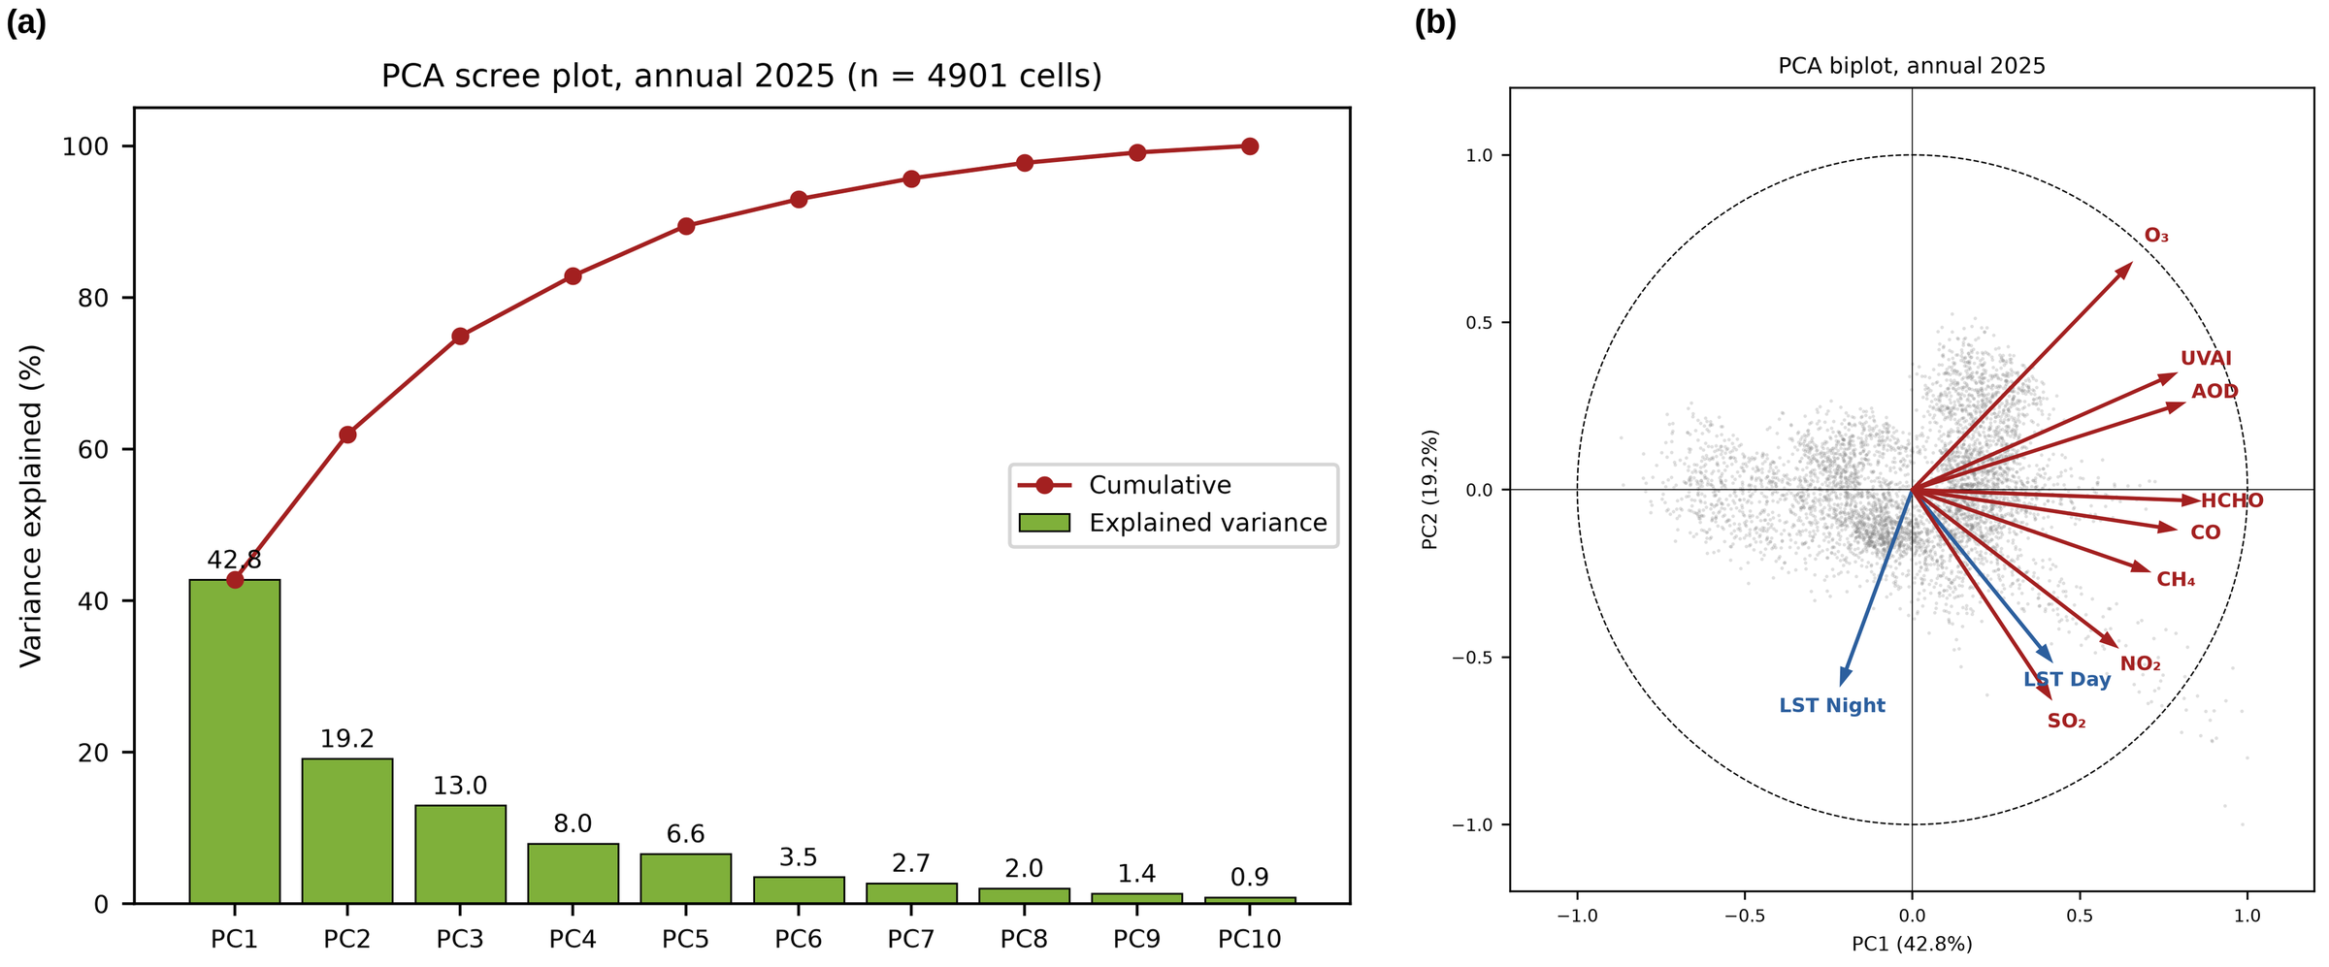
Figure 13. Principal component analysis of ten standardised annual variables: (a) explained and cumulative variance and (b) biplot of the first two components, with variable loadings shown as arrows and cell scores as grey points.
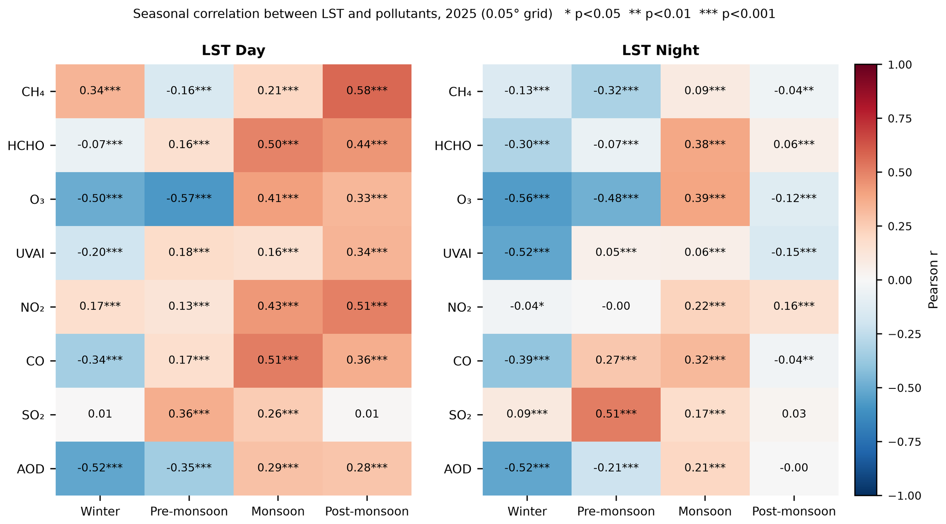
Figure 14. Seasonal Pearson correlation between LST and the atmospheric variables on the 0.05° grid in 2025. * p < 0.05. ** p < 0.01. *** p < 0.001.
Table 7. Comparison of the global ordinary least squares (OLS) models and the geographically weighted regression (GWR) models (n = 4,901).
Model | Response | Bandwidth (cells) | OLS R² | GWR R² | GWR adj. R² | AICc | Mean local R²
Main (AOD) | LST Day | 53 | 0.240 | 0.913 | 0.890 | 4583.7 | 0.64
Main (AOD) | LST Night | 53 | 0.235 | 0.925 | 0.904 | 3910.9 | 0.64
Check (UVAI) | LST Day | 53 | 0.241 | 0.919 | 0.897 | 4244.8 | 0.66
Check (UVAI) | LST Night | 53 | 0.257 | 0.926 | 0.906 | 3806.0 | 0.65
Note. Main model: LST ~ AOD + CH₄ + HCHO + NO₂ + CO. Check model: UVAI in place of AOD. All variables were standardised. AICc = corrected Akaike information criterion.
CH₄ was the most frequently significant local predictor (Table 8). For daytime LST, its coefficient was significant in 31.8% of cells and almost always positive, with the largest values in the west, in the north-east and across the southern coastal districts (Figure 15). NO₂ was significant in 12.6% of cells, AOD in 10.8% and CO in 7.9%, each with coefficients of both signs, and HCHO in only 2.2%. For nighttime LST (Figure 16), the CH₄ coefficient was significant in 27.3% of cells but almost always negative, whereas AOD was significant in 15.1% of cells and predominantly positive (13.7%), mainly in the south-west and along the south-eastern coast. NO₂ was significant in 14.5% of cells and CO in 9.5%.
Table 8. Percentage of cells with a significant local GWR coefficient for each predictor.
Model | Response | AOD or UVAI | CH₄ | HCHO | NO₂ | CO
Main | LST Day | 10.8 (6.0 / 4.8) | 31.8 (31.1 / 0.7) | 2.2 (0.5 / 1.8) | 12.6 (7.9 / 4.8) | 7.9 (4.5 / 3.4)
Main | LST Night | 15.1 (13.7 / 1.4) | 27.3 (2.6 / 24.7) | 3.2 (2.5 / 0.6) | 14.5 (9.6 / 4.9) | 9.5 (4.9 / 4.6)
Check | LST Day | 13.0 (9.9 / 3.1) | 28.7 (27.8 / 0.9) | 3.5 (0.8 / 2.7) | 12.7 (6.9 / 5.8) | 7.6 (4.0 / 3.6)
Check | LST Night | 15.4 (12.2 / 3.1) | 25.4 (2.2 / 23.1) | 3.6 (2.6 / 1.0) | 10.5 (5.8 / 4.7) | 8.6 (4.3 / 4.3)
Note. Main = model with AOD; Check = model with UVAI in place of AOD. Values are the percentage of cells that are significant after correction for multiple testing; the percentages with positive and negative coefficients are given in parentheses (positive / negative).
Replacing AOD with UVAI changed the results very little. R² was 0.919 for daytime LST and 0.926 for nighttime LST, the bandwidth was unchanged, and the shares of significant cells for CH₄, NO₂, CO and HCHO differed by no more than four percentage points from the main model. UVAI itself was significant in 13.0% of cells for daytime LST and 15.4% for nighttime LST, similar to AOD. The conclusions therefore do not depend on the choice of aerosol indicator.

4.9 Comparison With Ground Stations
Satellite aerosol indicators tracked ground-level particulate matter moderately well (Table 9; Figure 17). Across station-months, station PM_{2.5} correlated with AOD (r = 0.50) and more strongly with UVAI (r = 0.72), and station PM₁₀ correlated with AOD (r = 0.60). The relationships also held across station means (r = 0.51 to 0.71), which shows that AOD and UVAI reproduce part of the spatial contrast between cities and not only the seasonal cycle. The scatter is nevertheless large: in winter, when the boundary layer is shallow, stations recorded very high PM_{2.5} at moderate AOD.
For the gases, the agreement was weaker. Station NO₂ was moderately correlated with the tropospheric NO₂ column across station-months (r = 0.41), but not across station means. The correlations for SO₂ (0.27) and CO (0.17) were weak, and there was no relationship between surface O₃ and the total O₃ column (0.07), as expected for a column dominated by the stratosphere.
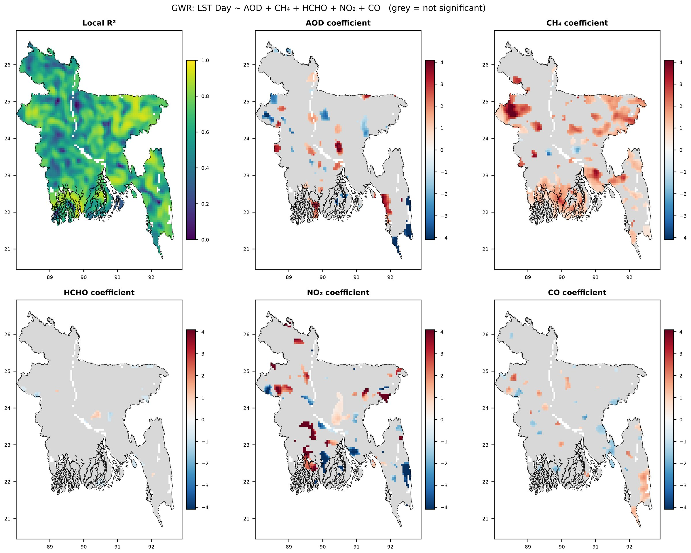
Figure 15. GWR results for daytime LST: local R² and local standardised coefficients of AOD, CH₄, HCHO, NO₂ and CO. Grey cells are not significant after correction for multiple testing.
Mean PM_{2.5} at the 16 stations ranged from 39.8 µg m⁻³ in Barishal to 141.0 µg m⁻³ in Narayanganj (Table 10). Every station exceeded the WHO annual guideline, by a factor of 8 to 28, and the national annual standard, by a factor of 1.1 to 4.0. Mean PM₁₀ at the 15 stations with data ranged from 70.1 to 234.6 µg m⁻³, and all stations exceeded both limits. These means are based on the months with sufficient data, which differ between stations, so values for stations with few valid months are weighted towards the dry season.

5. Discussion

5.1 Pollution Hotspots and Their Likely Sources
Two spatial regimes emerge from the maps and from the PCA. The first is regional. AOD, CO and, to a lesser extent, UVAI decline from west to east, with the highest values in the districts adjoining the Indo-Gangetic Plain. This agrees with earlier satellite and ground-based studies, which found the highest aerosol loads in the west of Bangladesh and a decline towards the south-east (Zaman et al., 2021), and with the build-up of fine particulate matter across the Indo-Gangetic Plain in the cool season (Ojha et al., 2020).
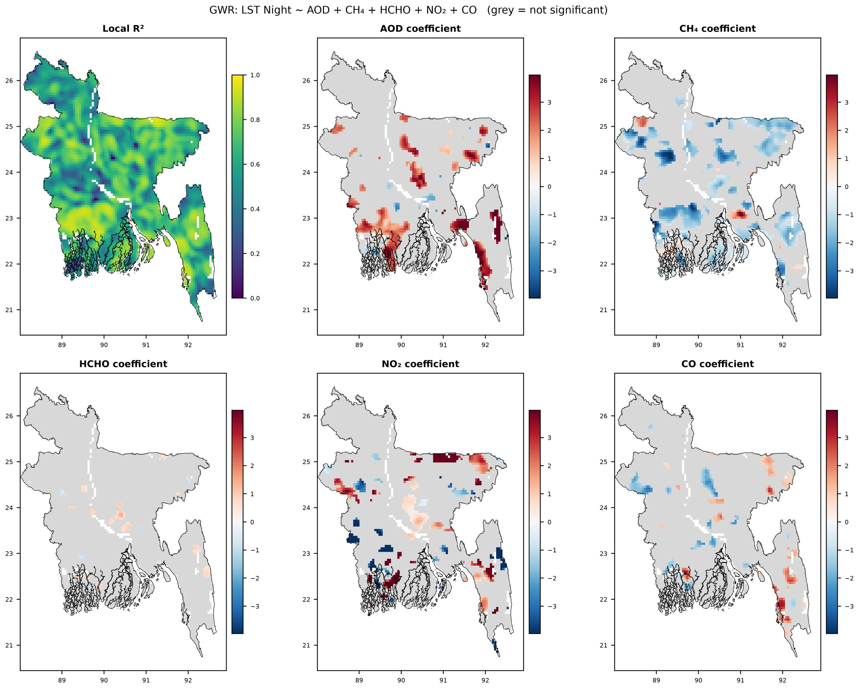
Figure 16. GWR results for nighttime LST: local R² and local standardised coefficients of AOD, CH₄, HCHO, NO₂ and CO. Grey cells are not significant after correction for multiple testing.
Table 9. Correlation between monthly station measurements and satellite values at the station locations in 2025.
 |  | Station-months |  |  |  | Station means
Station variable | Satellite variable | n | r | p | ρ | n | r | p
PM_{2.5} | AOD | 132 | 0.50 | < 0.001 | 0.54 | 16 | 0.51 | 0.046
PM₁₀ | AOD | 103 | 0.60 | < 0.001 | 0.65 | 15 | 0.62 | 0.013
PM_{2.5} | UVAI | 155 | 0.72 | < 0.001 | 0.75 | 16 | 0.71 | 0.002
NO₂ | NO₂ column | 117 | 0.41 | < 0.001 | 0.46 | 15 | 0.12 | 0.673
SO₂ | SO₂ column | 134 | 0.27 | 0.002 | 0.23 | 15 | −0.11 | 0.696
CO | CO column | 128 | 0.17 | 0.056 | 0.21 | 15 | 0.50 | 0.059
O₃ | O₃ total column | 127 | 0.07 | 0.407 | 0.10 | 16 | −0.10 | 0.716
Note. r = Pearson coefficient; ρ = Spearman coefficient. Station-months with less than 50% data capture were excluded. Satellite values are means of 3 × 3 pixels of the monthly composites.
CO has an atmospheric lifetime of weeks to months, so its distribution reflects regional transport more than local emissions, which explains its close association with AOD (r = 0.79).
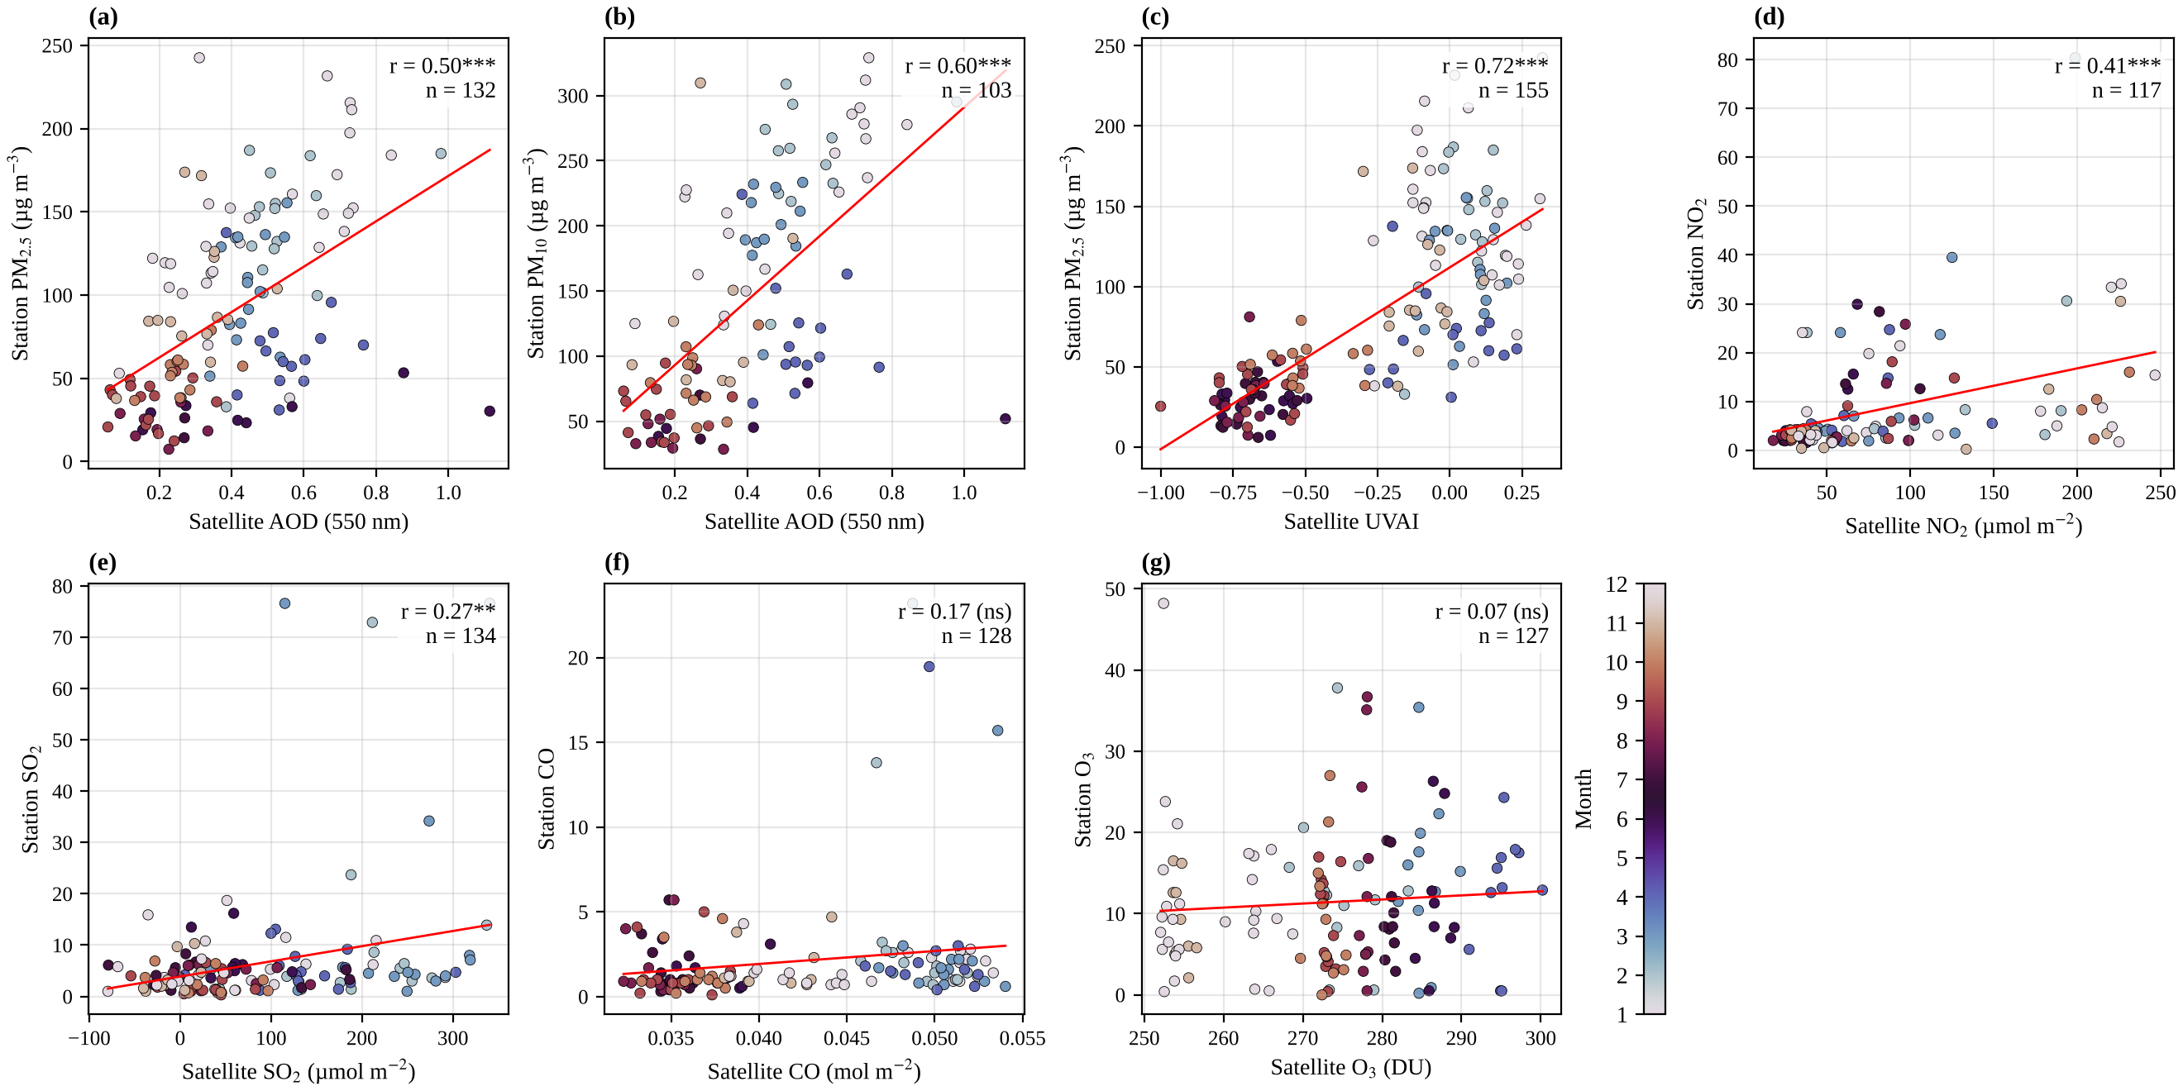
Figure 17. Monthly station measurements against satellite values at the station locations in 2025: (a) PM_{2.5} and AOD, (b) PM₁₀ and AOD, (c) PM_{2.5} and UVAI, (d) NO₂, (e) SO₂, (f) CO and (g) O₃. Colours indicate the month; lines are least squares fits. Gaseous pollutants at the stations are in the units reported by the Department of Environment. ** p < 0.01. *** p < 0.001. ns = not significant.
Table 10. Mean PM_{2.5} and PM₁₀ concentrations at the Department of Environment stations in 2025 and their ratio to the WHO guideline and the national standard.
 | PM_{2.5} |  |  |  | PM₁₀
Station | Mean (µg m⁻³) | Months | × WHO | × BD | Mean (µg m⁻³) | Months | × WHO | × BD
Agrabad, Chattogram | 122.1 | 4 | 24.4 | 3.5 | 234.6 | 3 | 15.6 | 4.7
BARC Farmgate, Dhaka | 73.0 | 11 | 14.6 | 2.1 | 133.5 | 10 | 8.9 | 2.7
Barishal | 39.8 | 10 | 8.0 | 1.1 | – | – | – | –
Cumilla | 68.3 | 11 | 13.7 | 2.0 | 79.5 | 8 | 5.3 | 1.6
Darus-Salam, Dhaka | 98.8 | 8 | 19.8 | 2.8 | 145.3 | 5 | 9.7 | 2.9
DoE Agargaon, Dhaka | 77.1 | 11 | 15.4 | 2.2 | 143.3 | 11 | 9.6 | 2.9
Gazipur | 99.2 | 6 | 19.8 | 2.8 | 129.2 | 9 | 8.6 | 2.6
Khulna | 60.6 | 11 | 12.1 | 1.7 | 111.1 | 11 | 7.4 | 2.2
Mymensingh | 91.5 | 11 | 18.3 | 2.6 | 161.6 | 11 | 10.8 | 3.2
Narayanganj | 141.0 | 6 | 28.2 | 4.0 | 190.8 | 2 | 12.7 | 3.8
Narsingdi | 81.4 | 11 | 16.3 | 2.3 | 70.1 | 6 | 4.7 | 1.4
Rajshahi | 96.4 | 11 | 19.3 | 2.8 | 149.2 | 11 | 9.9 | 3.0
Rangpur | 108.2 | 11 | 21.6 | 3.1 | 133.2 | 10 | 8.9 | 2.7
Savar | 84.1 | 11 | 16.8 | 2.4 | 157.6 | 7 | 10.5 | 3.2
Sylhet | 50.1 | 11 | 10.0 | 1.4 | 114.4 | 11 | 7.6 | 2.3
TV Station, Chattogram | 69.9 | 11 | 14.0 | 2.0 | 72.7 | 8 | 4.8 | 1.5
Note. Means are calculated over the months with at least 50% data capture (number given under Months); the report for May was not available. × WHO = ratio to the WHO annual guideline level (5 µg m⁻³ for PM_{2.5} and 15 µg m⁻³ for PM₁₀). × BD = ratio to the national annual standard (35 and 50 µg m⁻³). Because the means do not cover a full year, the ratios are indicative.
The second regime is local. NO₂ has a lifetime of only a few hours and therefore stays close to its combustion sources. Its column over the Dhaka conurbation was about five times the national mean, in line with the Dhaka–Gazipur–Narayanganj hotspot reported from earlier Sentinel-5P analyses (Acharjee et al., 2026; Shobnom et al., 2023). HCHO and CH₄ peaked in the same area. Elevated HCHO over a megacity points to the oxidation of anthropogenic volatile organic compounds, in addition to the biogenic and biomass-burning sources that dominate regionally (Hoque et al., 2022; Surl et al., 2018). The urban CH₄ enhancement is consistent with emissions from waste, wastewater and gas distribution, superimposed on the large rice and wetland source of the delta (Subramanian et al., 2026; Zhang et al., 2020); source attribution, however, is beyond what the column data alone can support. The clustering of brick kilns around Dhaka (Guttikunda et al., 2013) may contribute to the SO₂ and aerosol signals in the centre of the country. The SO₂ maximum in the south-west should be interpreted cautiously, because TROPOMI SO₂ has a low signal-to-noise ratio for weak sources (Fioletov et al., 2020) and retrievals near the coast and over mangrove forest may be affected by surface conditions.

5.2 Seasonality
The seasonal cycle is controlled by the monsoon. In winter, low rainfall, weak winds and a shallow boundary layer allow pollutants to accumulate, and seasonal sources such as brick kilns and biomass burning are active; in the monsoon, frequent rain removes aerosols and soluble gases and clean marine air is advected from the Bay of Bengal. The winter and pre-monsoon maxima of NO₂, CO, SO₂ and AOD found here agree with the dry-season peaks reported for Dhaka from satellite data (Rahman et al., 2025) and from DoE measurements (Khan et al., 2023), and with the spring and winter aerosol maxima over Bangladesh (Ali et al., 2022). The pre-monsoon maximum of HCHO coincides with the highest temperatures and with the biomass-burning season in South Asia, both of which increase the production of HCHO (Hoque et al., 2022; Surl et al., 2018). The spring maximum of total-column O₃ is a feature of the stratospheric column and not of surface ozone. The apparent monsoon maximum of CH₄ rests on very few observations; inverse modelling indicates a strong monsoon influence on South Asian methane emissions (Subramanian et al., 2026), but the TROPOMI coverage in this study is too limited to confirm it.

5.3 Relationship Between Land Surface Temperature and Pollutants
On the annual scale, daytime LST was positively associated with the urban group of pollutants (CH₄, NO₂ and HCHO). The most plausible explanation is a common cause. Built-up and industrial land is warmer during the day because of its low vegetation cover and high heat storage (Peng et al., 2012; Zhou et al., 2019), and the same land emits pollutants; neither variable needs to drive the other. The negative annual correlations of nighttime LST with O₃, UVAI and AOD largely reflect geography: the north-west of the country is both the coolest region at night and the region with the highest aerosol load and total ozone.
The seasonal analysis shows that these annual relationships conceal a reversal of sign. In winter, the most polluted north-western districts are also the coolest, which produces negative correlations between LST and AOD, CO and O₃. A direct radiative contribution is physically plausible, because a thick aerosol layer reduces the solar radiation reaching the surface (Ramanathan et al., 2001), but the present data cannot separate this effect from the regional temperature gradient. During and after the monsoon, the regional aerosol gradient weakens and the urban signal dominates, so that warmer cells are also more polluted. This reversal has a practical consequence: studies that report a single annual coefficient between LST and a pollutant, as is common in this literature, may obtain results that depend on the mix of seasons in the data.
The GWR results add a spatial dimension. Explained variance increased from about 0.24 to more than 0.9 when the coefficients were allowed to vary in space, and the local coefficients of several pollutants took both signs. AOD had a predominantly positive local association with nighttime LST, particularly in the south-west and along the south-eastern coast. This is consistent with the enhancement of downward longwave radiation by aerosols at night (Cao et al., 2016), although the local coefficients are associations and not estimates of a causal effect. The contrast between the positive daytime and negative nighttime coefficients of CH₄ suggests that CH₄ acts mainly as a marker of land cover: areas with high CH₄, such as cities and intensively cultivated land, are warm during the day, whereas wet and irrigated land cools less at night than its surroundings.

5.4 Comparison With Previous Studies
Table 11 compares the main findings with those of related studies. The signs of the annual relationships between daytime LST and CH₄, UVAI, HCHO and O₃ agree with those reported by Sameh et al. (2026) for Sharkia Governorate in Egypt, but the coefficients are considerably smaller (for example, 0.48 against 0.86 for CH₄). This is expected. The Egyptian study covered a single governorate with a clear contrast between an industrial south and an agricultural north, whereas the present study covers an entire country with heterogeneous land cover, a monsoon climate and strong regional gradients that are unrelated to local emissions. Weak global relationships between LST and CO, NO₂ and SO₂ were also reported for Metro Manila (Broqueza et al., 2024), and stronger relationships in the most urbanised cities of Pakistan (Munawar et al., 2026). The UHI intensity obtained here for Dhaka, 0.85 °C on average over the conurbation and up to 3.7 °C in the urban core at 0.05° resolution, is of the same order as the daytime surface UHI of 2.74 °C reported by Dewan et al. (2021).
Table 11. Comparison of the main findings with those of related studies.
Study | Area, period and data | Main finding | Comparison with this study
Sameh et al. (2026) | Sharkia Governorate, Egypt, 2024; Sentinel-5P, MODIS AOD and LST | LST correlated with CH₄ (0.86), UVAI (0.89), HCHO (0.43) and O₃ (−0.79); local GWR R² above 0.8 in hotspots | Same signs, weaker coefficients (0.48, 0.22, 0.30 and −0.14); mean local R² of 0.64
Munawar et al. (2026) | Four cities, Pakistan, 2018–2023; Sentinel-5P NO₂, CO and O₃ | Strongest links between LST and pollutants in the most urbanised cities | Consistent: positive associations concentrated around urban centres
Broqueza et al. (2024) | Metro Manila, Philippines, 2019–2023; Sentinel-5P CO, NO₂ and SO₂, MODIS LST | Weak links between LST and CO and NO₂; almost none with SO₂ | Consistent: single pollutants explain at most 23% of the variance of LST
Rahman et al. (2025) | Dhaka, 2020–2024; Sentinel-5P CO, NO₂, SO₂ and O₃ | CO, NO₂ and SO₂ peak in the cooler, drier months; O₃ peaks in May | Consistent: winter and pre-monsoon maxima; O₃ maximum in May
Acharjee et al. (2026) | 64 districts, Bangladesh, 2020–2024; Sentinel-5P | Highest NO₂ and CH₄ in the Dhaka–Gazipur–Munshiganj–Narayanganj cluster | Consistent: NO₂ and CH₄ maxima over the Dhaka conurbation
Zaman et al. (2021) | Six cities, Bangladesh; AERONET and MODIS AOD | Highest AOD in the west, declining from north-west to south-east | Consistent: mean AOD of 0.58 in the west and 0.24 in the east
Dewan et al. (2021) | Five cities, Bangladesh, 2000–2019; MODIS LST | Mean daytime surface UHI intensity of 2.74 °C in Dhaka | Comparable: 0.85 °C over the conurbation, up to 3.7 °C in the core
Cao et al. (2016) | Cities in China; satellite data and modelling | Haze strengthens the nighttime UHI by increasing downward longwave radiation | Consistent with predominantly positive local coefficients of AOD for nighttime LST
Note. Coefficients are Pearson correlation coefficients with daytime LST unless stated otherwise.

5.5 Implications
Three implications follow for air quality management. First, the Dhaka conurbation is a persistent hotspot for NO₂, HCHO, CH₄ and surface heat in every season, so measures directed at transport, industry, brick manufacturing and waste in this area would address several problems at the same time. Second, the regional gradient of AOD and CO indicates that a substantial part of the aerosol burden in the western districts is linked to the wider Indo-Gangetic Plain, which calls for regional cooperation in addition to national measures. Third, the comparison with DoE stations shows that satellite AOD and UVAI carry useful information on particulate pollution in areas without monitors, but that they cannot replace surface measurements. Extending the monitoring network beyond the main cities, particularly to the north-west and south-west, would allow satellite products to be calibrated locally.

5.6 Limitations
Several limitations should be kept in mind. First, all satellite variables are column-integrated or optical quantities and not surface concentrations. They cannot be compared directly with air quality standards, and their relationship with surface concentrations varies with boundary-layer height, humidity and aerosol type; TROPOMI tropospheric NO₂ is also known to be biased low under polluted conditions (Verhoelst et al., 2021). Second, total-column O₃ is dominated by the stratosphere, so its associations with LST and other pollutants should not be interpreted in terms of surface photochemistry. Third, cloud removes most CH₄, AOD and LST retrievals between June and September, and LST is available only under clear sky; annual and monsoon values are therefore biased towards cloud-free conditions. Fourth, some features are retrieval artefacts: a diagonal discontinuity in annual AOD, elevated UVAI over bright river surfaces, along-track striping in CO and pixel-scale noise in SO₂.
Fifth, the analysis is cross-sectional and covers a single year, so the relationships describe spatial association in 2025 and not causation or long-term behaviour. Sixth, spatial autocorrelation inflates the significance of global correlations and regressions (Clifford et al., 1989), and effect sizes should be emphasised over p values. Seventh, the optimal GWR bandwidth of 53 neighbours is small relative to the number of parameters, so the high R² values partly reflect local overfitting, and local coefficients can be unstable where predictors are collinear (Wheeler & Tiefelsdorf, 2005). The coefficient maps and the shares of significant cells are more informative than the overall fit, and multiscale GWR, which allows each predictor its own bandwidth (Fotheringham et al., 2017), should be tested in future work. Finally, the ground comparison is limited to 16 urban stations and 11 months, the pollutants are compared in different physical units, and station means are based on unequal numbers of months.

6. Conclusions
This study presents, to our knowledge, the first national-scale assessment of the relationship between satellite-observed air pollutants and land surface temperature over Bangladesh, based on Sentinel-5P TROPOMI and MODIS data for 2025 processed in Google Earth Engine. The main conclusions are as follows.
- Air pollution over Bangladesh has two spatial components: a regional west–east gradient in AOD and CO, linked to the Indo-Gangetic Plain, and local hotspots of NO₂, HCHO and CH₄ centred on the Dhaka conurbation, where the surface urban heat island also reaches its maximum of 3.7 °C.
- NO₂, CO, SO₂ and AOD are highest in winter and the pre-monsoon season and lowest during the monsoon. Monsoon cloud severely limits CH₄, AOD and LST observations from June to September.
- On the annual scale, daytime LST is positively correlated with CH₄, NO₂, SO₂ and HCHO, but single pollutants explain no more than 23% of its spatial variance. Three principal components explain 74.9% of the total variance and separate a general pollution factor from regional and local patterns.
- The relationships between LST and pollutants change sign between seasons, from negative in winter to positive during and after the monsoon for AOD, CO and O₃. Annual coefficients alone are therefore misleading in a monsoon climate.
- GWR raises the explained variance of LST from 0.24 to more than 0.9 and shows that the relationships are spatially non-stationary, with CH₄ the most frequently significant local predictor. The high overall fit should be interpreted with caution because of the small bandwidth.
- Satellite AOD and UVAI are moderately correlated with PM_{2.5} measured at DoE stations (r = 0.50 and 0.72), and all stations exceed the WHO guideline and the national standard for PM_{2.5} and PM₁₀.
Future work should extend the analysis to several years to separate persistent patterns from interannual variability, include land cover, vegetation and meteorological variables as predictors, apply multiscale GWR, and use the DoE station data to calibrate satellite-based estimates of surface particulate matter for Bangladesh.

Author Contributions
[To be completed by the authors.]

Funding
[To be completed by the authors. If none: This research received no specific grant from any funding agency in the public, commercial or not-for-profit sectors.]

Data Availability
All satellite data used in this study are openly available through the Google Earth Engine data catalogue. The Google Earth Engine and Python scripts, the derived tables and the figures are available from the corresponding author on reasonable request and will be released in a public repository on publication. The ground-based data were obtained from the monthly air quality reports of the Department of Environment, Bangladesh.

Declaration of Competing Interest
The authors declare that they have no known competing financial interests or personal relationships that could have appeared to influence the work reported in this paper.

Declaration of Generative AI Use
[To be completed by the authors in line with the policy of the target journal.]

Acknowledgements
The authors thank the European Space Agency and the Copernicus programme for the Sentinel-5P data, NASA for the MODIS products, Google for access to Earth Engine, and the Department of Environment, Government of Bangladesh, for the air quality monitoring reports. [Further acknowledgements to be added by the authors.]

References
Acharjee, B., Abdullah, M., Hasan, M., Roy, H., Fahim, T. T., & Rahman, M. M. (2026). Spatiotemporal analysis and machine learning-based profiling of atmospheric pollutants using Sentinel-5P TROPOMI satellite data at tier-two administrative units in Bangladesh. Journal of Science, 46(1), 1–28. https://doi.org/10.59185/jos.v46i1.425
Ali, M. A., Bilal, M., Wang, Y., Qiu, Z., Nichol, J. E., Mhawish, A., de Leeuw, G., Zhang, Y., Shahid, S., Almazroui, M., Islam, M. N., Rahman, M. A., Mondol, S. K., Tiwari, P., & Khedher, K. M. (2022). Spatiotemporal changes in aerosols over Bangladesh using 18 years of MODIS and reanalysis data. Journal of Environmental Management, 315, Article 115097. https://doi.org/10.1016/j.jenvman.2022.115097
Asghari Beirami, B., Shobairi, S. O. R., Gulahmadov, N., Hotam, P., & Farhod, N. (2025). Assessing the impact of urbanization on air pollution and land surface temperature using remote sensing data in Google Earth Engine: A case study of Tehran Province (2018–2022). Ecological Questions, 36(4), 83–97. https://doi.org/10.12775/EQ.2025.038
Bangladesh Bureau of Statistics. (2023). Population and housing census 2022: National report (Vol. 1). Statistics and Informatics Division, Ministry of Planning, Government of the People’s Republic of Bangladesh.
Begum, B. A., Hopke, P. K., & Markwitz, A. (2013). Air pollution by fine particulate matter in Bangladesh. Atmospheric Pollution Research, 4(1), 75–86. https://doi.org/10.5094/APR.2013.008
Borsdorff, T., aan de Brugh, J., Schneider, A., Lorente, A., Birk, M., Wagner, G., Kivi, R., Hase, F., Feist, D. G., Sussmann, R., Rettinger, M., Wunch, D., Warneke, T., & Landgraf, J. (2019). Improving the TROPOMI CO data product: Update of the spectroscopic database and destriping of single orbits. Atmospheric Measurement Techniques, 12, 5443–5455. https://doi.org/10.5194/amt-12-5443-2019
Broqueza, M. J., Cruz, L. M., Mana-ay, M., Jamboy, A. M., & Ramos, R. V. (2024). GIS-based regression analysis of air quality and land surface temperature in Metro Manila airsheds. The International Archives of the Photogrammetry, Remote Sensing and Spatial Information Sciences, XLVIII-4/W8-2023, 77–83. https://doi.org/10.5194/isprs-archives-XLVIII-4-W8-2023-77-2024
Cao, C., Lee, X., Liu, S., Schultz, N., Xiao, W., Zhang, M., & Zhao, L. (2016). Urban heat islands in China enhanced by haze pollution. Nature Communications, 7, Article 12509. https://doi.org/10.1038/ncomms12509
Clifford, P., Richardson, S., & Hémon, D. (1989). Assessing the significance of the correlation between two spatial processes. Biometrics, 45(1), 123–134. https://doi.org/10.2307/2532039
da Silva, A. R., & Fotheringham, A. S. (2016). The multiple testing issue in geographically weighted regression. Geographical Analysis, 48(3), 233–247. https://doi.org/10.1111/gean.12084
Department of Environment. (2025). Monthly air quality monitoring reports, January–December 2025. Ministry of Environment, Forest and Climate Change, Government of the People’s Republic of Bangladesh.
De Smedt, I., Theys, N., Yu, H., Danckaert, T., Lerot, C., Compernolle, S., Van Roozendael, M., Richter, A., Hilboll, A., Peters, E., Pedergnana, M., Loyola, D., Beirle, S., Wagner, T., Eskes, H., van Geffen, J., Boersma, K. F., & Veefkind, P. (2018). Algorithm theoretical baseline for formaldehyde retrievals from S5P TROPOMI and from the QA4ECV project. Atmospheric Measurement Techniques, 11(4), 2395–2426. https://doi.org/10.5194/amt-11-2395-2018
Dewan, A., Kiselev, G., Botje, D., Mahmud, G. I., Bhuian, M. H., & Hassan, Q. K. (2021). Surface urban heat island intensity in five major cities of Bangladesh: Patterns, drivers and trends. Sustainable Cities and Society, 71, Article 102926. https://doi.org/10.1016/j.scs.2021.102926
Fioletov, V., McLinden, C. A., Griffin, D., Theys, N., Loyola, D. G., Hedelt, P., Krotkov, N. A., & Li, C. (2020). Anthropogenic and volcanic point source SO₂ emissions derived from TROPOMI on board Sentinel-5 Precursor: First results. Atmospheric Chemistry and Physics, 20, 5591–5607. https://doi.org/10.5194/acp-20-5591-2020
Fotheringham, A. S., Brunsdon, C., & Charlton, M. (2002). Geographically weighted regression: The analysis of spatially varying relationships. Wiley.
Fotheringham, A. S., Yang, W., & Kang, W. (2017). Multiscale geographically weighted regression (MGWR). Annals of the American Association of Geographers, 107(6), 1247–1265. https://doi.org/10.1080/24694452.2017.1352480
Garane, K., Koukouli, M.-E., Verhoelst, T., Lerot, C., Heue, K.-P., Fioletov, V., Balis, D., Bais, A., Bazureau, A., Dehn, A., Goutail, F., Granville, J., Griffin, D., Hubert, D., Keppens, A., Lambert, J.-C., Loyola, D., McLinden, C., Pazmino, A., . . . Zimmer, W. (2019). TROPOMI/S5P total ozone column data: Global ground-based validation and consistency with other satellite missions. Atmospheric Measurement Techniques, 12(10), 5263–5287. https://doi.org/10.5194/amt-12-5263-2019
GBD 2019 Risk Factors Collaborators. (2020). Global burden of 87 risk factors in 204 countries and territories, 1990–2019: A systematic analysis for the Global Burden of Disease Study 2019. The Lancet, 396(10258), 1223–1249. https://doi.org/10.1016/S0140-6736(20)30752-2
Gorelick, N., Hancher, M., Dixon, M., Ilyushchenko, S., Thau, D., & Moore, R. (2017). Google Earth Engine: Planetary-scale geospatial analysis for everyone. Remote Sensing of Environment, 202, 18–27. https://doi.org/10.1016/j.rse.2017.06.031
Guttikunda, S. K., Begum, B. A., & Wadud, Z. (2013). Particulate pollution from brick kiln clusters in the Greater Dhaka region, Bangladesh. Air Quality, Atmosphere & Health, 6(2), 357–365. https://doi.org/10.1007/s11869-012-0187-2
Hampel, F. R. (1974). The influence curve and its role in robust estimation. Journal of the American Statistical Association, 69(346), 383–393. https://doi.org/10.1080/01621459.1974.10482962
Health Effects Institute. (2024). State of global air 2024: Special report. Health Effects Institute. https://www.stateofglobalair.org
Hoque, H. M. S., Sudo, K., Irie, H., Damiani, A., Naja, M., & Fatmi, A. M. (2022). Multi-axis differential optical absorption spectroscopy (MAX-DOAS) observations of formaldehyde and nitrogen dioxide at three sites in Asia and comparison with the global chemistry transport model CHASER. Atmospheric Chemistry and Physics, 22(18), 12559–12589. https://doi.org/10.5194/acp-22-12559-2022
IQAir. (2025). 2024 world air quality report: Region and city PM_{2.5} ranking. IQAir.
Jolliffe, I. T., & Cadima, J. (2016). Principal component analysis: A review and recent developments. Philosophical Transactions of the Royal Society A: Mathematical, Physical and Engineering Sciences, 374(2065), Article 20150202. https://doi.org/10.1098/rsta.2015.0202
Kaiser, H. F. (1960). The application of electronic computers to factor analysis. Educational and Psychological Measurement, 20(1), 141–151. https://doi.org/10.1177/001316446002000116
Khan, R. H., Quayyum, Z., & Rahman, S. (2023). A quantitative assessment of natural and anthropogenic effects on the occurrence of high air pollution loading in Dhaka and neighboring cities and health consequences. Environmental Monitoring and Assessment, 195(12), Article 1509. https://doi.org/10.1007/s10661-023-12046-3
Kooreman, M. L., Stammes, P., Trees, V., Sneep, M., Tilstra, L. G., de Graaf, M., Stein Zweers, D. C., Wang, P., Tuinder, O. N. E., & Veefkind, J. P. (2020). Effects of clouds on the UV Absorbing Aerosol Index from TROPOMI. Atmospheric Measurement Techniques, 13, 6407–6426. https://doi.org/10.5194/amt-13-6407-2020
Landgraf, J., aan de Brugh, J., Scheepmaker, R., Borsdorff, T., Hu, H., Houweling, S., Butz, A., Aben, I., & Hasekamp, O. (2016). Carbon monoxide total column retrievals from TROPOMI shortwave infrared measurements. Atmospheric Measurement Techniques, 9(10), 4955–4975. https://doi.org/10.5194/amt-9-4955-2016
Lelieveld, J., Evans, J. S., Fnais, M., Giannadaki, D., & Pozzer, A. (2015). The contribution of outdoor air pollution sources to premature mortality on a global scale. Nature, 525(7569), 367–371. https://doi.org/10.1038/nature15371
Lorente, A., Borsdorff, T., Butz, A., Hasekamp, O., aan de Brugh, J., Schneider, A., Wu, L., Hase, F., Kivi, R., Wunch, D., Pollard, D. F., Shiomi, K., Deutscher, N. M., Velazco, V. A., Roehl, C. M., Wennberg, P. O., Warneke, T., & Landgraf, J. (2021). Methane retrieved from TROPOMI: Improvement of the data product and validation of the first 2 years of measurements. Atmospheric Measurement Techniques, 14, 665–684. https://doi.org/10.5194/amt-14-665-2021
Lyapustin, A., Wang, Y., Korkin, S., & Huang, D. (2018). MODIS Collection 6 MAIAC algorithm. Atmospheric Measurement Techniques, 11(10), 5741–5765. https://doi.org/10.5194/amt-11-5741-2018
Mhawish, A., Banerjee, T., Sorek-Hamer, M., Lyapustin, A., Broday, D. M., & Chatfield, R. (2019). Comparison and evaluation of MODIS Multi-angle Implementation of Atmospheric Correction (MAIAC) aerosol product over South Asia. Remote Sensing of Environment, 224, 12–28. https://doi.org/10.1016/j.rse.2019.01.033
Ministry of Environment, Forest and Climate Change. (2022). Air pollution (control) rules, 2022. Government of the People’s Republic of Bangladesh.
Munawar, S., Miandad, M., Khan, M. A., Bajwa, N., Basharat, M., & Chohan, A. (2026). Impact assessment of land surface temperature on air pollution and smog formation in major cities of Pakistan using Google Earth Engine. Ecological Questions, 37(1), 1–22. https://doi.org/10.12775/EQ.2026.012
Mwangi, P. (2024). Evaluating the spatio-temporal distribution of nitrogen dioxide, land surface temperature and NDVI in Nairobi City County. ISPRS Annals of the Photogrammetry, Remote Sensing and Spatial Information Sciences, X-3-2024, 237–244. https://doi.org/10.5194/isprs-annals-X-3-2024-237-2024
O’Brien, R. M. (2007). A caution regarding rules of thumb for variance inflation factors. Quality & Quantity, 41(5), 673–690. https://doi.org/10.1007/s11135-006-9018-6
Ojha, N., Sharma, A., Kumar, M., Girach, I., Ansari, T. U., Sharma, S. K., Singh, N., Pozzer, A., & Gunthe, S. S. (2020). On the widespread enhancement in fine particulate matter across the Indo-Gangetic Plain towards winter. Scientific Reports, 10, Article 5862. https://doi.org/10.1038/s41598-020-62710-8
Oshan, T. M., Li, Z., Kang, W., Wolf, L. J., & Fotheringham, A. S. (2019). mgwr: A Python implementation of multiscale geographically weighted regression for investigating process spatial heterogeneity and scale. ISPRS International Journal of Geo-Information, 8(6), Article 269. https://doi.org/10.3390/ijgi8060269
Peng, S., Piao, S., Ciais, P., Friedlingstein, P., Ottle, C., Bréon, F.-M., Nan, H., Zhou, L., & Myneni, R. B. (2012). Surface urban heat island across 419 global big cities. Environmental Science & Technology, 46(2), 696–703. https://doi.org/10.1021/es2030438
Rahman, M. M., Kamruzzaman, M., Faridatul, M. I., & Szabó, G. (2025). Spatiotemporal dynamics of urban air pollution in Dhaka City (2020–2024) using time-series Sentinel-5P satellite images and Google Earth Engine (GEE). Environments, 12(8), Article 274. https://doi.org/10.3390/environments12080274
Rahman, M. N., Rony, M. R. H., Jannat, F. A., Pal, S. C., Islam, M. S., Alam, E., & Islam, A. R. M. T. (2022). Impact of urbanization on urban heat island intensity in major districts of Bangladesh using remote sensing and geo-spatial tools. Climate, 10(1), Article 3. https://doi.org/10.3390/cli10010003
Ramanathan, V., Crutzen, P. J., Kiehl, J. T., & Rosenfeld, D. (2001). Aerosols, climate, and the hydrological cycle. Science, 294(5549), 2119–2124. https://doi.org/10.1126/science.1064034
Raza, W. A., Mahmud, I., & Rabie, T. S. (2022). Breathing heavy: New evidence on air pollution and health in Bangladesh. World Bank. https://doi.org/10.1596/978-1-4648-1919-3
Sameh, S., Zaki, A., Elsaka, B., Beshr, A. A. A., & Shehata, A. G. (2026). Air pollution mapping and monitoring using Sentinel-5P data and Google Earth Engine. The Egyptian Journal of Remote Sensing and Space Sciences, 29(1), 158–178. https://doi.org/10.1016/j.ejrs.2026.01.008
Shahid, S. (2010). Recent trends in the climate of Bangladesh. Climate Research, 42(3), 185–193. https://doi.org/10.3354/cr00889
Shobnom, N., Hossain, M. S., & Roni, R. (2023). Monitoring spatiotemporal changes of NO₂ using TROPOMI and Sentinel-5 images for Dhaka city and its surrounding areas of Bangladesh. Journal of Air Pollution and Health, 8(3), 269–284. https://doi.org/10.18502/japh.v8i3.13785
Subramanian, R., Thompson, R. L., Vojta, M., Schneising, O., & Stohl, A. (2026). Strong monsoon influence on South Asian methane emissions in 2020 revealed by a Bayesian inversion constrained by satellite observations. Atmospheric Chemistry and Physics, 26, 9757–9777. https://doi.org/10.5194/acp-26-9757-2026
Sulla-Menashe, D., Gray, J. M., Abercrombie, S. P., & Friedl, M. A. (2019). Hierarchical mapping of annual global land cover 2001 to present: The MODIS Collection 6 Land Cover product. Remote Sensing of Environment, 222, 183–194. https://doi.org/10.1016/j.rse.2018.12.013
Surl, L., Palmer, P. I., & González Abad, G. (2018). Which processes drive observed variations of HCHO columns over India? Atmospheric Chemistry and Physics, 18, 4549–4566. https://doi.org/10.5194/acp-18-4549-2018
Tamiminia, H., Salehi, B., Mahdianpari, M., Quackenbush, L., Adeli, S., & Brisco, B. (2020). Google Earth Engine for geo-big data applications: A meta-analysis and systematic review. ISPRS Journal of Photogrammetry and Remote Sensing, 164, 152–170. https://doi.org/10.1016/j.isprsjprs.2020.04.001
Theys, N., De Smedt, I., Yu, H., Danckaert, T., van Gent, J., Hörmann, C., Wagner, T., Hedelt, P., Bauer, H., Romahn, F., Pedergnana, M., Loyola, D., & Van Roozendael, M. (2017). Sulfur dioxide retrievals from TROPOMI onboard Sentinel-5 Precursor: Algorithm theoretical basis. Atmospheric Measurement Techniques, 10(1), 119–153. https://doi.org/10.5194/amt-10-119-2017
Torres, O., Bhartia, P. K., Herman, J. R., Ahmad, Z., & Gleason, J. (1998). Derivation of aerosol properties from satellite measurements of backscattered ultraviolet radiation: Theoretical basis. Journal of Geophysical Research: Atmospheres, 103(D14), 17099–17110. https://doi.org/10.1029/98JD00900
van Geffen, J., Eskes, H., Compernolle, S., Pinardi, G., Verhoelst, T., Lambert, J.-C., Sneep, M., ter Linden, M., Ludewig, A., Boersma, K. F., & Veefkind, J. P. (2022). Sentinel-5P TROPOMI NO₂ retrieval: Impact of version v2.2 improvements and comparisons with OMI and ground-based data. Atmospheric Measurement Techniques, 15(7), 2037–2060. https://doi.org/10.5194/amt-15-2037-2022
Veefkind, J. P., Aben, I., McMullan, K., Förster, H., de Vries, J., Otter, G., Claas, J., Eskes, H. J., de Haan, J. F., Kleipool, Q., van Weele, M., Hasekamp, O., Hoogeveen, R., Landgraf, J., Snel, R., Tol, P., Ingmann, P., Voors, R., Kruizinga, B., . . . Levelt, P. F. (2012). TROPOMI on the ESA Sentinel-5 Precursor: A GMES mission for global observations of the atmospheric composition for climate, air quality and ozone layer applications. Remote Sensing of Environment, 120, 70–83. https://doi.org/10.1016/j.rse.2011.09.027
Verhoelst, T., Compernolle, S., Pinardi, G., Lambert, J.-C., Eskes, H. J., Eichmann, K.-U., Fjæraa, A. M., Granville, J., Niemeijer, S., Cede, A., Tiefengraber, M., Hendrick, F., Pazmiño, A., Bais, A., Bazureau, A., Boersma, K. F., Bognar, K., Dehn, A., Donner, S., . . . Zehner, C. (2021). Ground-based validation of the Copernicus Sentinel-5P TROPOMI NO₂ measurements with the NDACC ZSL-DOAS, MAX-DOAS and Pandonia global networks. Atmospheric Measurement Techniques, 14(1), 481–510. https://doi.org/10.5194/amt-14-481-2021
Voogt, J. A., & Oke, T. R. (2003). Thermal remote sensing of urban climates. Remote Sensing of Environment, 86(3), 370–384. https://doi.org/10.1016/S0034-4257(03)00079-8
Wan, Z. (2014). New refinements and validation of the collection-6 MODIS land-surface temperature/emissivity product. Remote Sensing of Environment, 140, 36–45. https://doi.org/10.1016/j.rse.2013.08.027
Wheeler, D., & Tiefelsdorf, M. (2005). Multicollinearity and correlation among local regression coefficients in geographically weighted regression. Journal of Geographical Systems, 7(2), 161–187. https://doi.org/10.1007/s10109-005-0155-6
World Health Organization. (2021). WHO global air quality guidelines: Particulate matter (PM_{2.5} and PM₁₀), ozone, nitrogen dioxide, sulfur dioxide and carbon monoxide. World Health Organization. https://apps.who.int/iris/handle/10665/345329
Zaman, S. U., Pavel, M. R. S., Joy, K. S., Jeba, F., Islam, M. S., Paul, S., Bari, M. A., & Salam, A. (2021). Spatial and temporal variation of aerosol optical depths over six major cities in Bangladesh. Atmospheric Research, 262, Article 105803. https://doi.org/10.1016/j.atmosres.2021.105803
Zhang, G., Xiao, X., Dong, J., Xin, F., Zhang, Y., Qin, Y., Doughty, R. B., & Moore, B., III. (2020). Fingerprint of rice paddies in spatial–temporal dynamics of atmospheric methane concentration in monsoon Asia. Nature Communications, 11, Article 554. https://doi.org/10.1038/s41467-019-14155-5
Zhou, D., Xiao, J., Bonafoni, S., Berger, C., Deilami, K., Zhou, Y., Frolking, S., Yao, R., Qiao, Z., & Sobrino, J. A. (2019). Satellite remote sensing of surface urban heat islands: Progress, challenges, and perspectives. Remote Sensing, 11(1), Article 48. https://doi.org/10.3390/rs11010048

Supplementary Material
Table S1. Monthly national mean values in 2025 derived from the monthly composites.
Month | AOD | UVAI | NO₂ | SO₂ | CO | CH₄ | HCHO | O₃ | LST Day | LST Night
Jan | 0.62 | −0.19 | 43.2 | 71.4 | 0.0499 | 1946.4 | 1.92 | 264.3 | 21.2 | 15.7
Feb | 0.60 | −0.07 | 46.5 | 179.5 | 0.0473 | 1942.6 | 2.01 | 274.5 | 23.6 | 18.1
Mar | 0.48 | −0.06 | 46.6 | 203.3 | 0.0505 | 1938.6 | 2.48 | 285.0 | 27.5 | 21.6
Apr | 0.58 | −0.15 | 32.0 | 113.7 | 0.0490 | 1931.9 | 2.31 | 294.9 | 28.6 | 24.2
May | 0.67 | −0.54 | 29.8 | 93.2 | 0.0450 | 1927.7 | 2.34 | 295.3 | 29.6 | 24.5
Jun | 0.66 | −0.74 | 23.9 | 16.0 | 0.0371 | 1959.7* | 1.97 | 286.8 | 28.9 | 26.3
Jul | 0.28* | −0.75 | 25.5 | 0.1 | 0.0341 | n/a | 1.80 | 280.9 | 28.9* | 26.3*
Aug | 0.19* | −0.81 | 22.1 | 21.0 | 0.0339 | n/a | 1.47 | 277.9 | 26.5* | 25.7*
Sep | 0.21 | −0.81 | 26.6 | 24.1 | 0.0350 | 1971.3* | 1.69 | 273.3 | 28.4 | 26.8
Oct | 0.28 | −0.66 | 30.4 | 24.8 | 0.0353 | 1977.1 | 1.91 | 273.0 | 28.0 | 25.2
Nov | 0.29 | −0.21 | 34.0 | 27.4 | 0.0397 | 1953.8 | 2.01 | 254.9 | 24.8 | 20.2
Dec | 0.32 | 0.12 | 38.2 | 41.9 | 0.0413 | 1944.9 | 1.85 | 253.4 | 21.6 | 16.3
Note. Units: NO₂ and SO₂ in µmol m⁻²; CO in mol m⁻²; CH₄ in ppb; HCHO in 10⁻⁴ mol m⁻²; O₃ in DU; LST in °C. * Spatial coverage below 50%. n/a = not available (coverage below 1%).
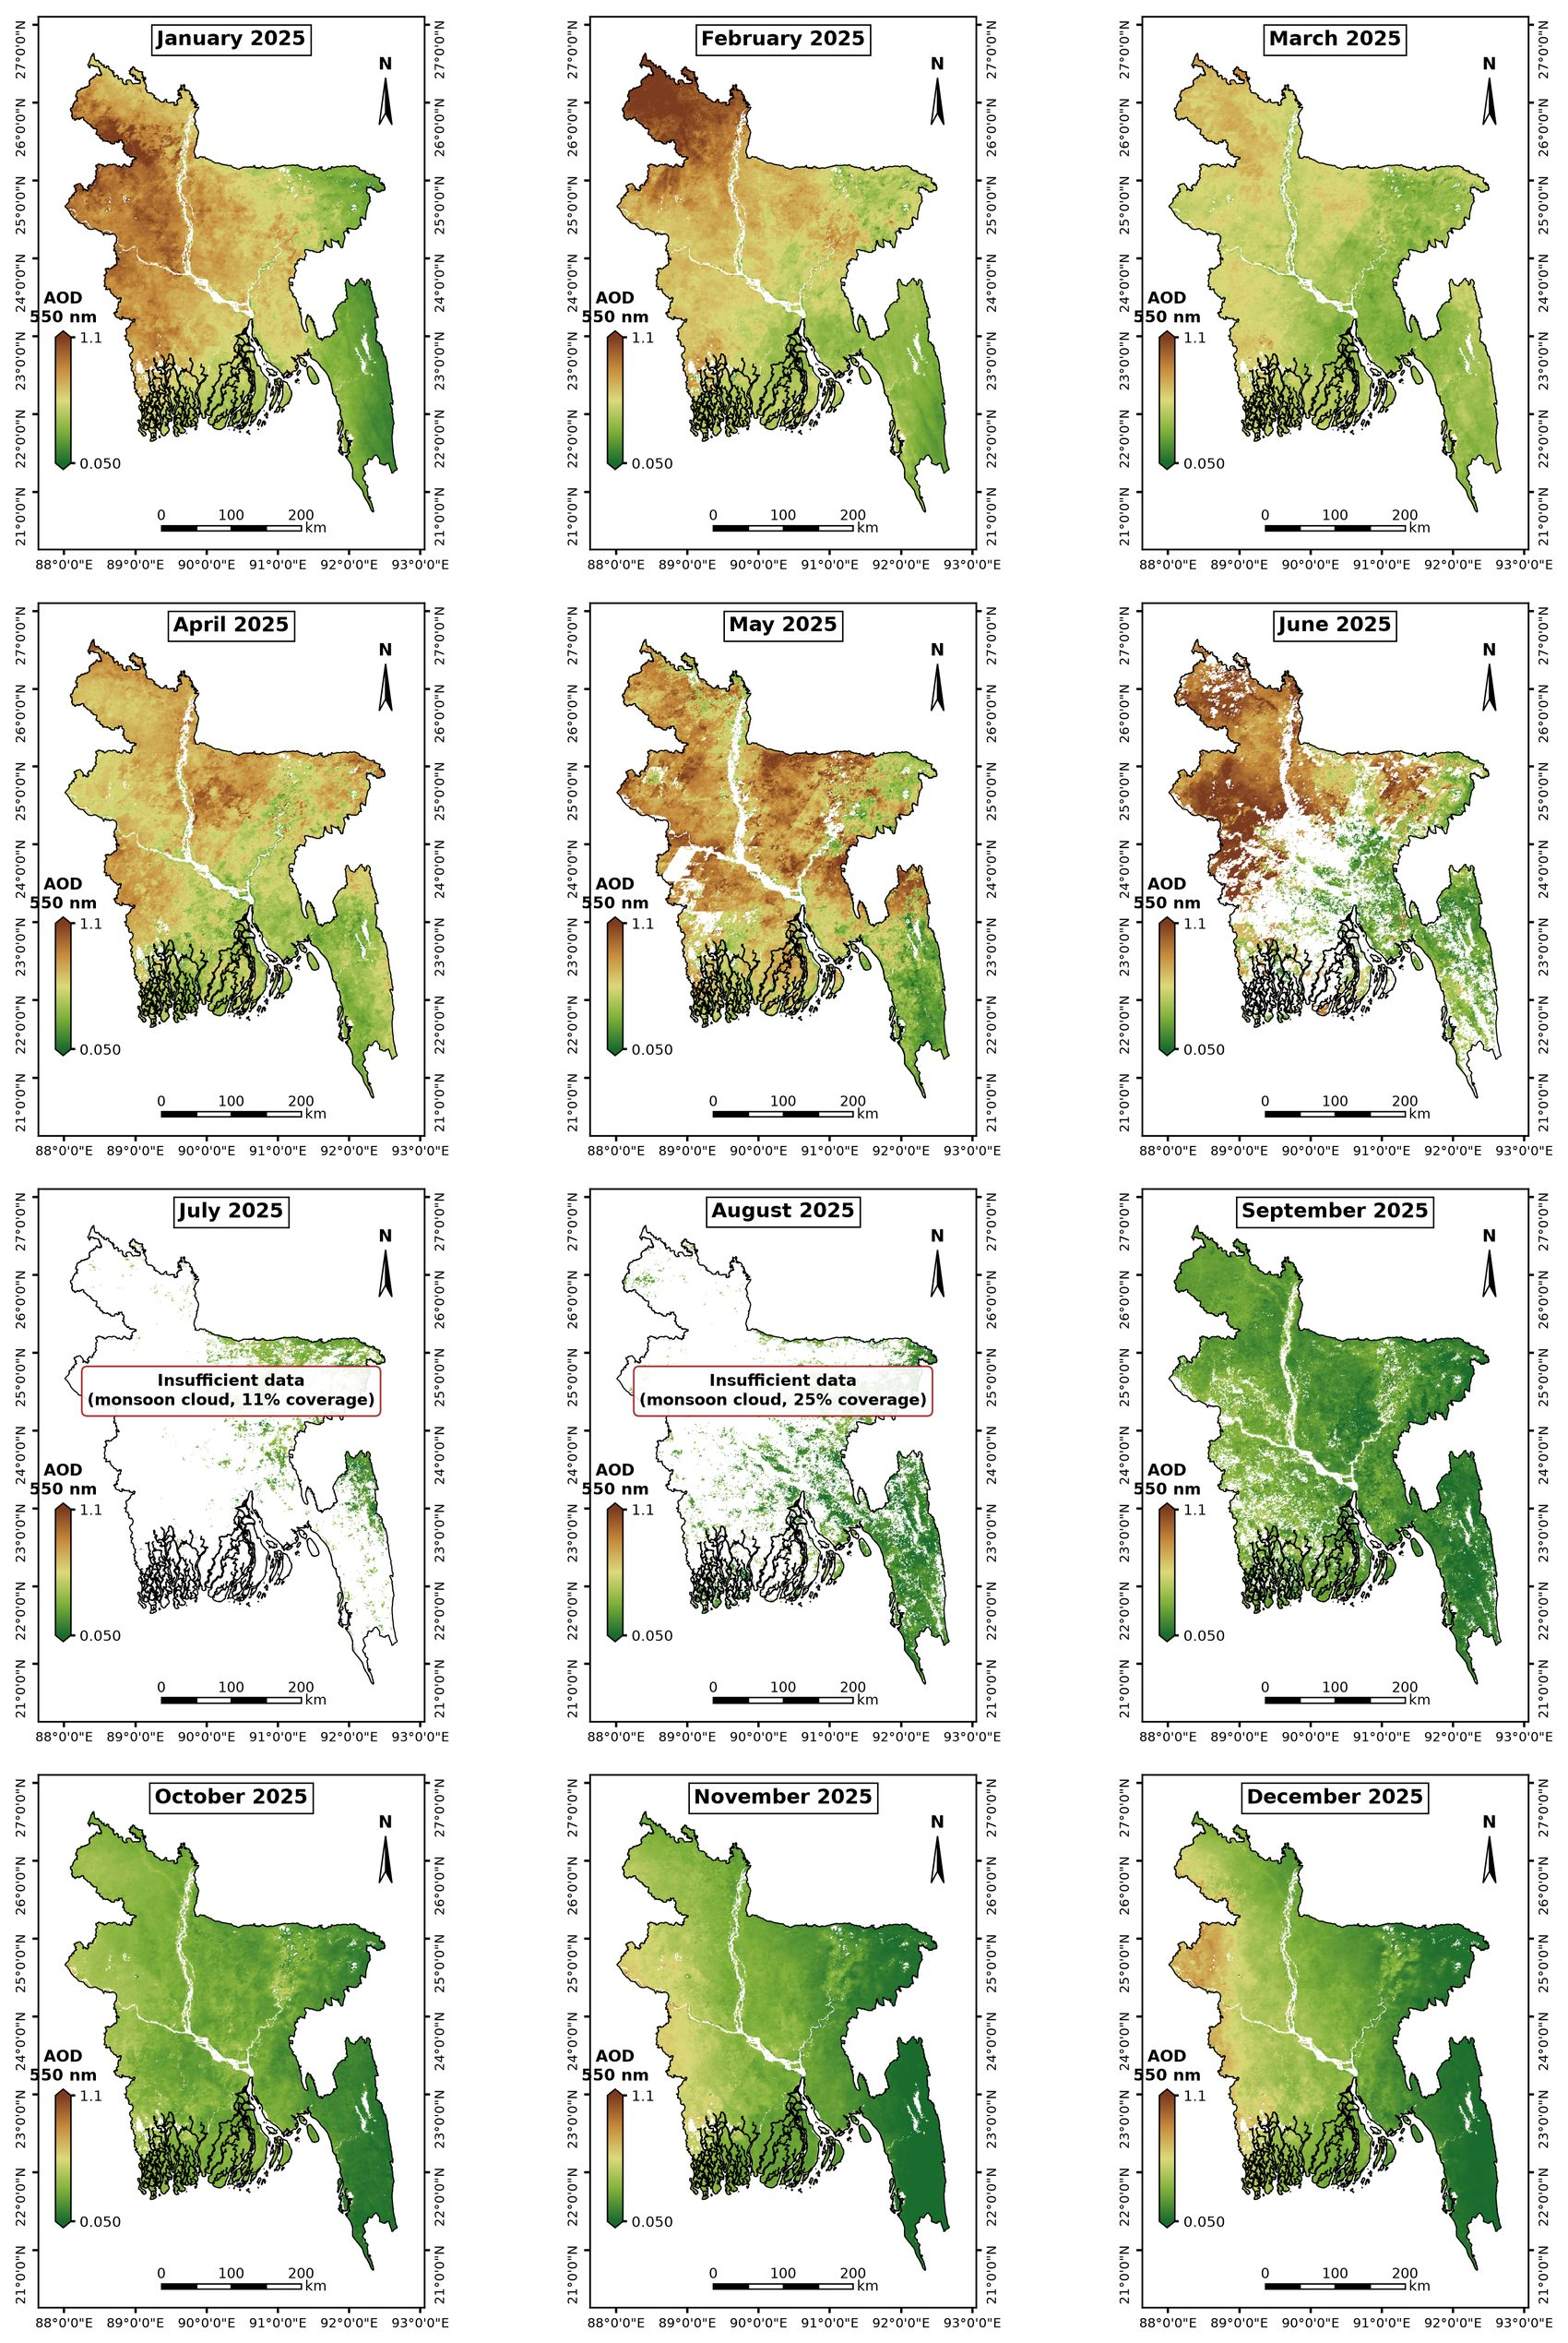
Figure S1. Monthly maps of AOD at 550 nm (median; inland water masked) over Bangladesh in 2025. All panels share one colour scale. Months with spatial coverage below 50% are labelled as having insufficient data.
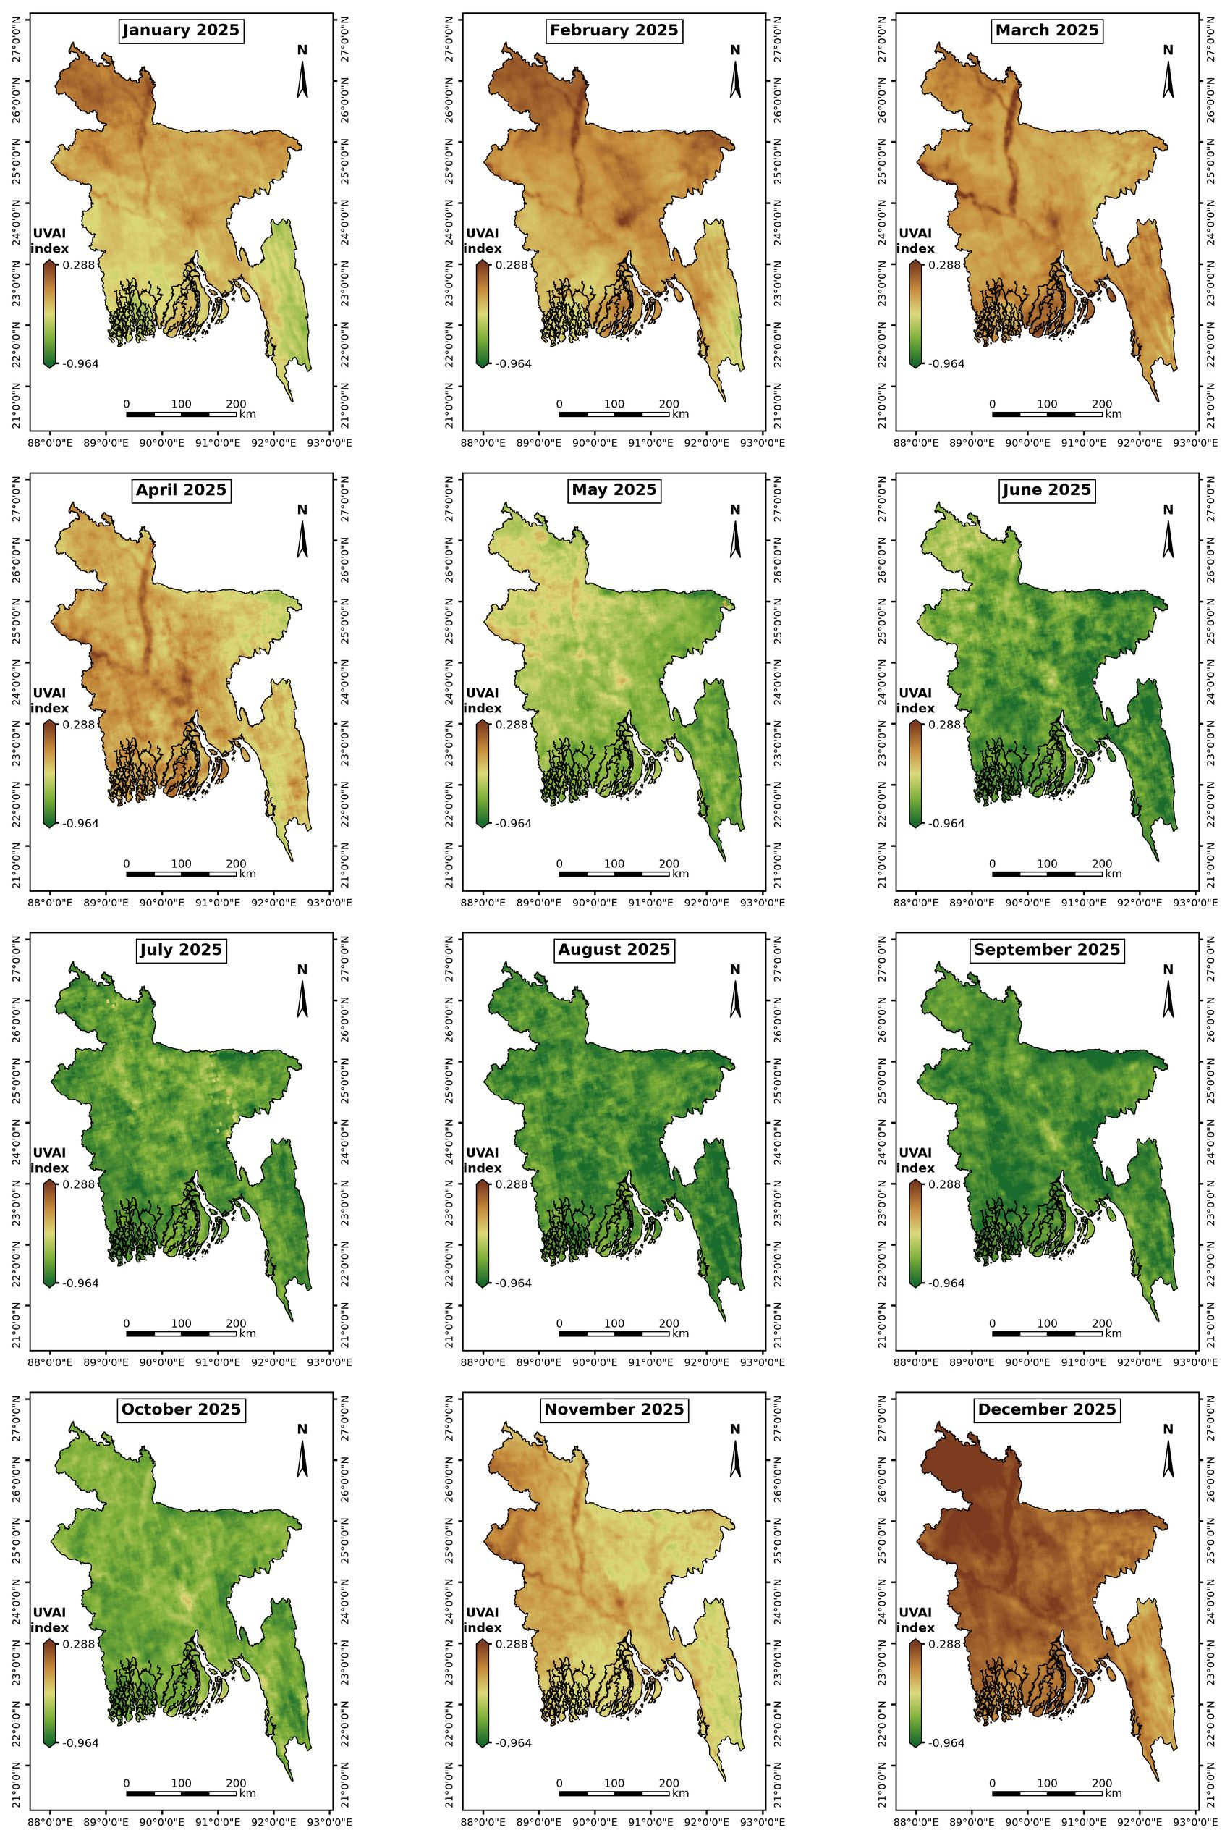
Figure S2. Monthly maps of UV aerosol index over Bangladesh in 2025. All panels share one colour scale. Months with spatial coverage below 50% are labelled as having insufficient data.
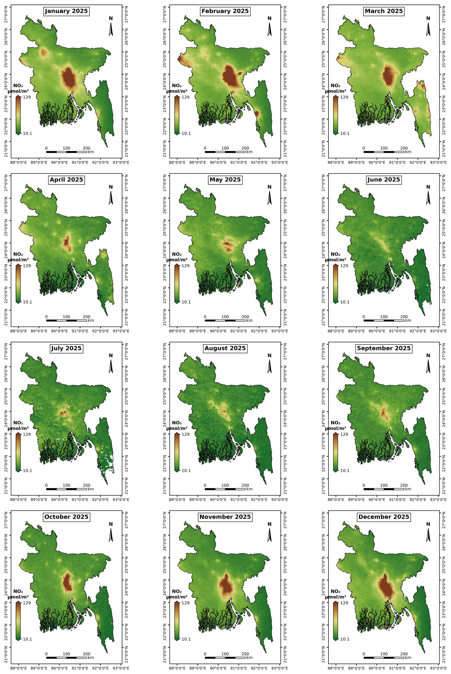
Figure S3. Monthly maps of tropospheric NO₂ column over Bangladesh in 2025. All panels share one colour scale. Months with spatial coverage below 50% are labelled as having insufficient data.
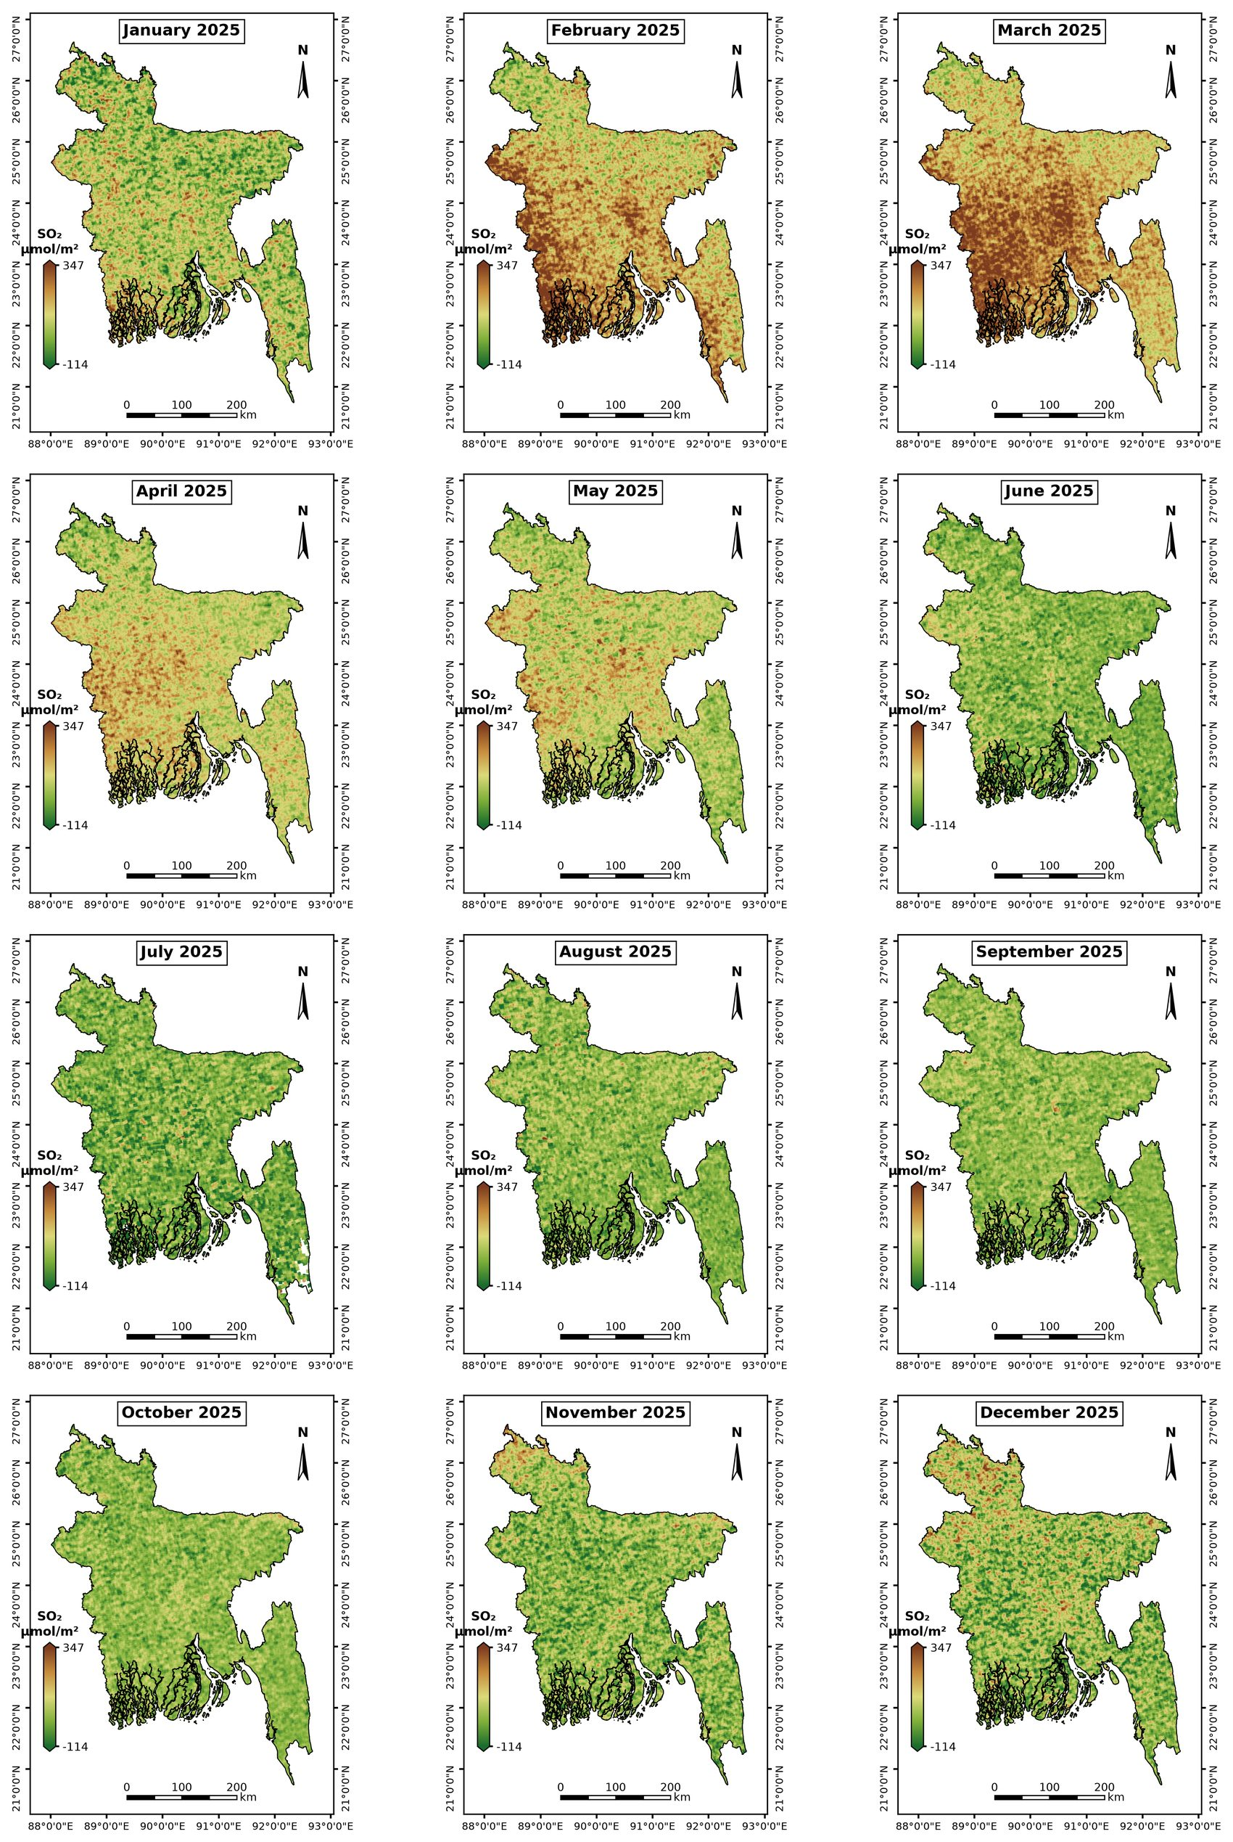
Figure S4. Monthly maps of SO₂ column over Bangladesh in 2025. All panels share one colour scale. Months with spatial coverage below 50% are labelled as having insufficient data.
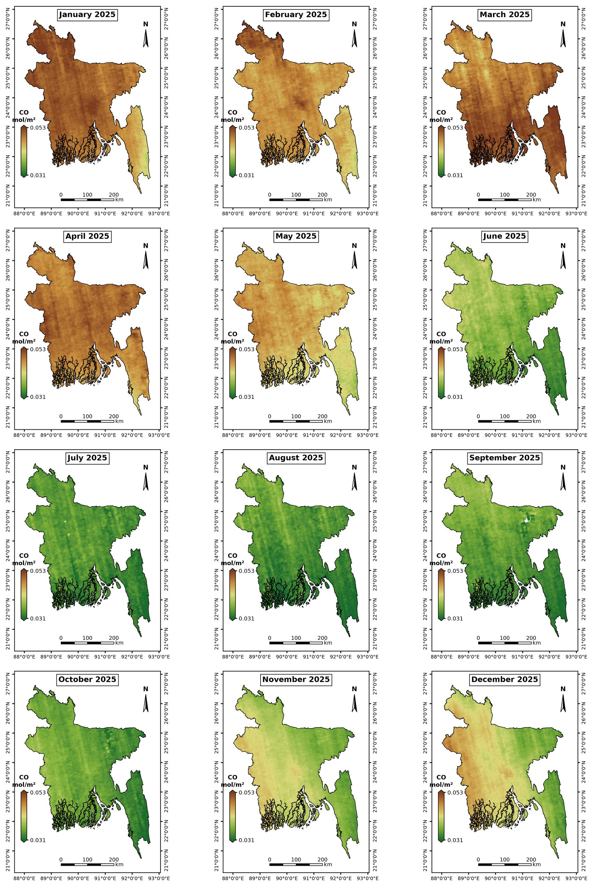
Figure S5. Monthly maps of CO column over Bangladesh in 2025. All panels share one colour scale. Months with spatial coverage below 50% are labelled as having insufficient data.
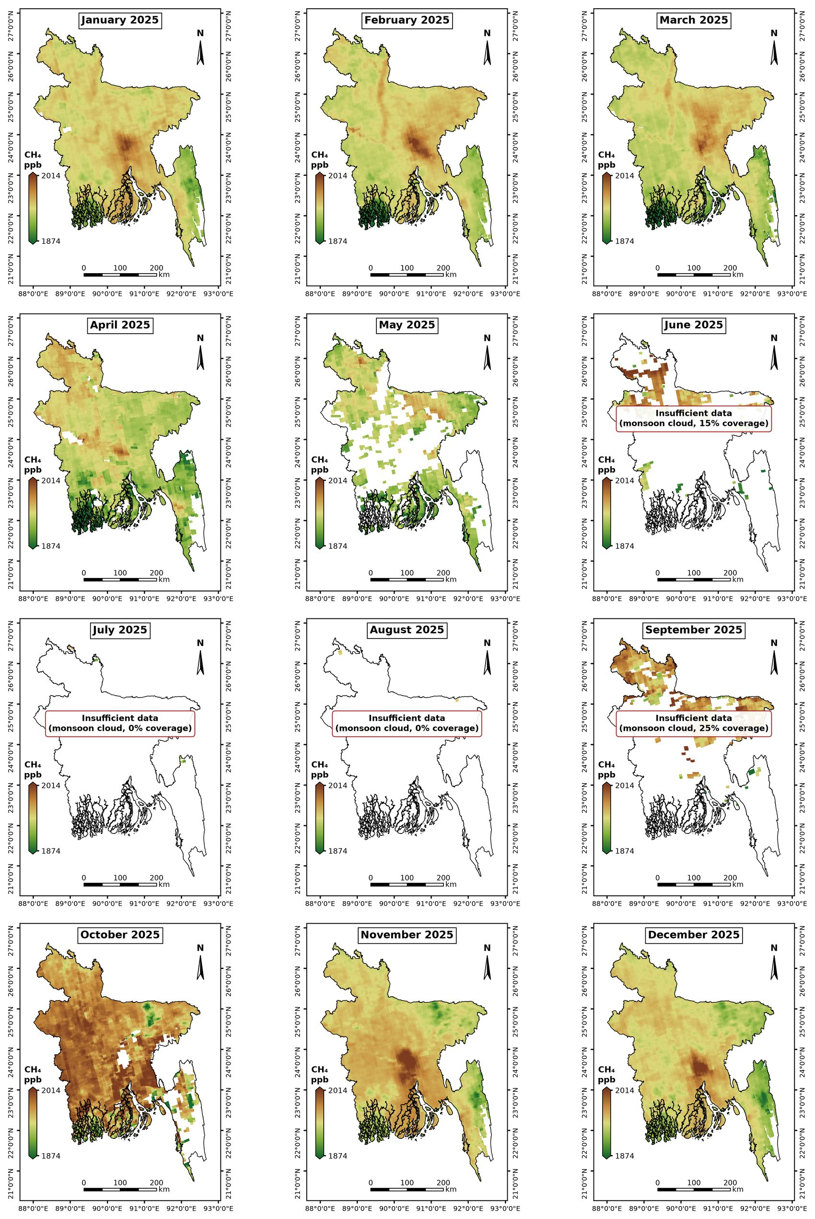
Figure S6. Monthly maps of column-averaged CH₄ over Bangladesh in 2025. All panels share one colour scale. Months with spatial coverage below 50% are labelled as having insufficient data.
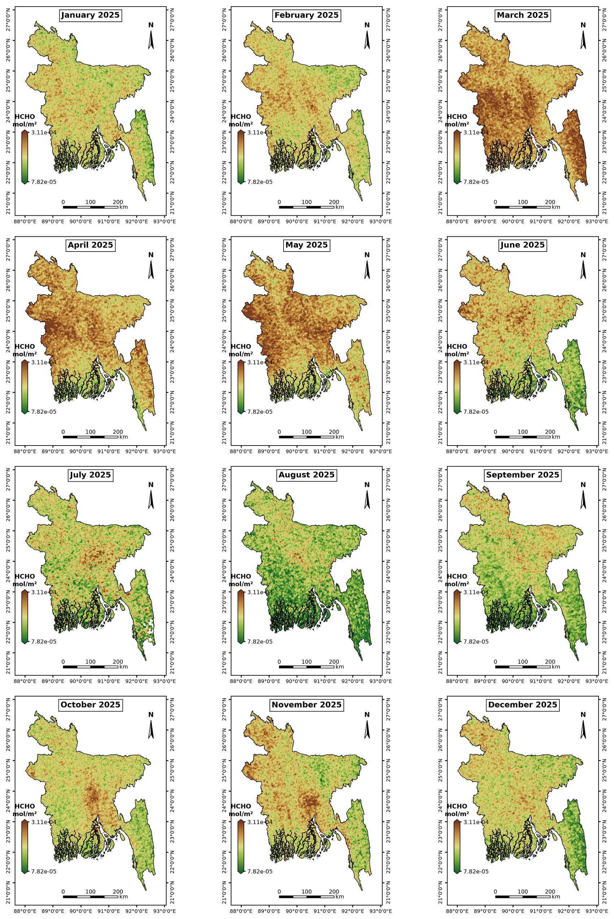
Figure S7. Monthly maps of tropospheric HCHO column over Bangladesh in 2025. All panels share one colour scale. Months with spatial coverage below 50% are labelled as having insufficient data.
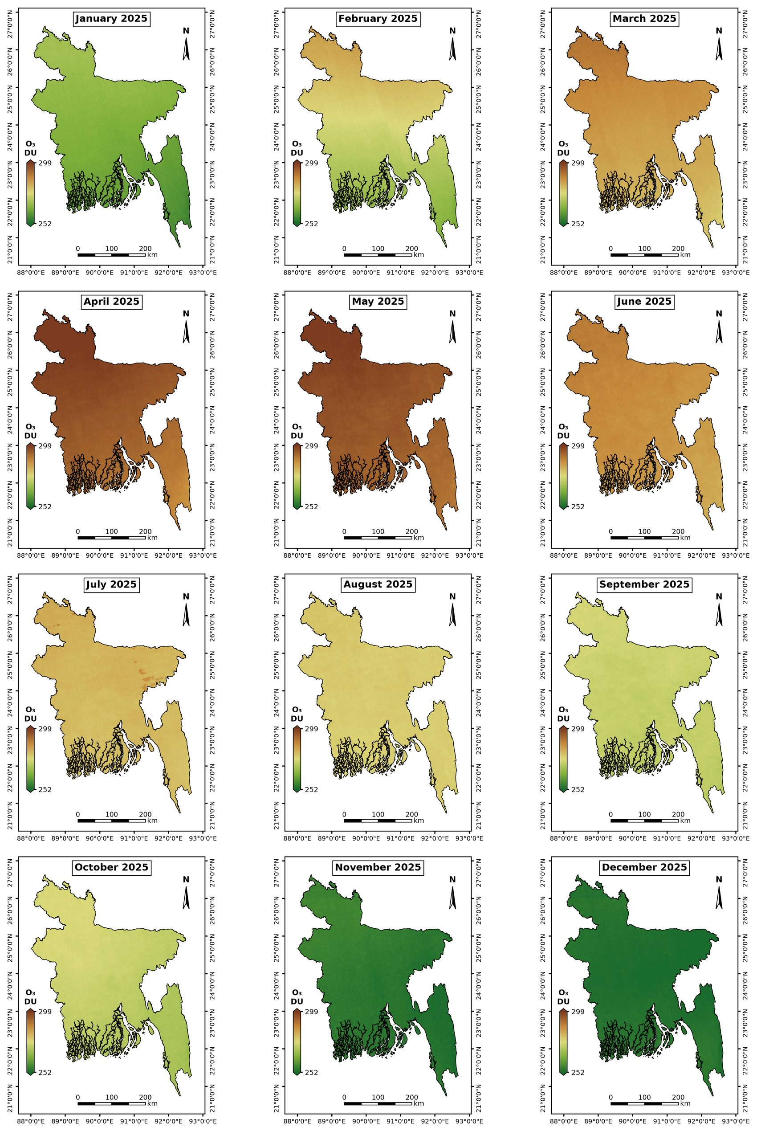
Figure S8. Monthly maps of total O₃ column over Bangladesh in 2025. All panels share one colour scale. Months with spatial coverage below 50% are labelled as having insufficient data.
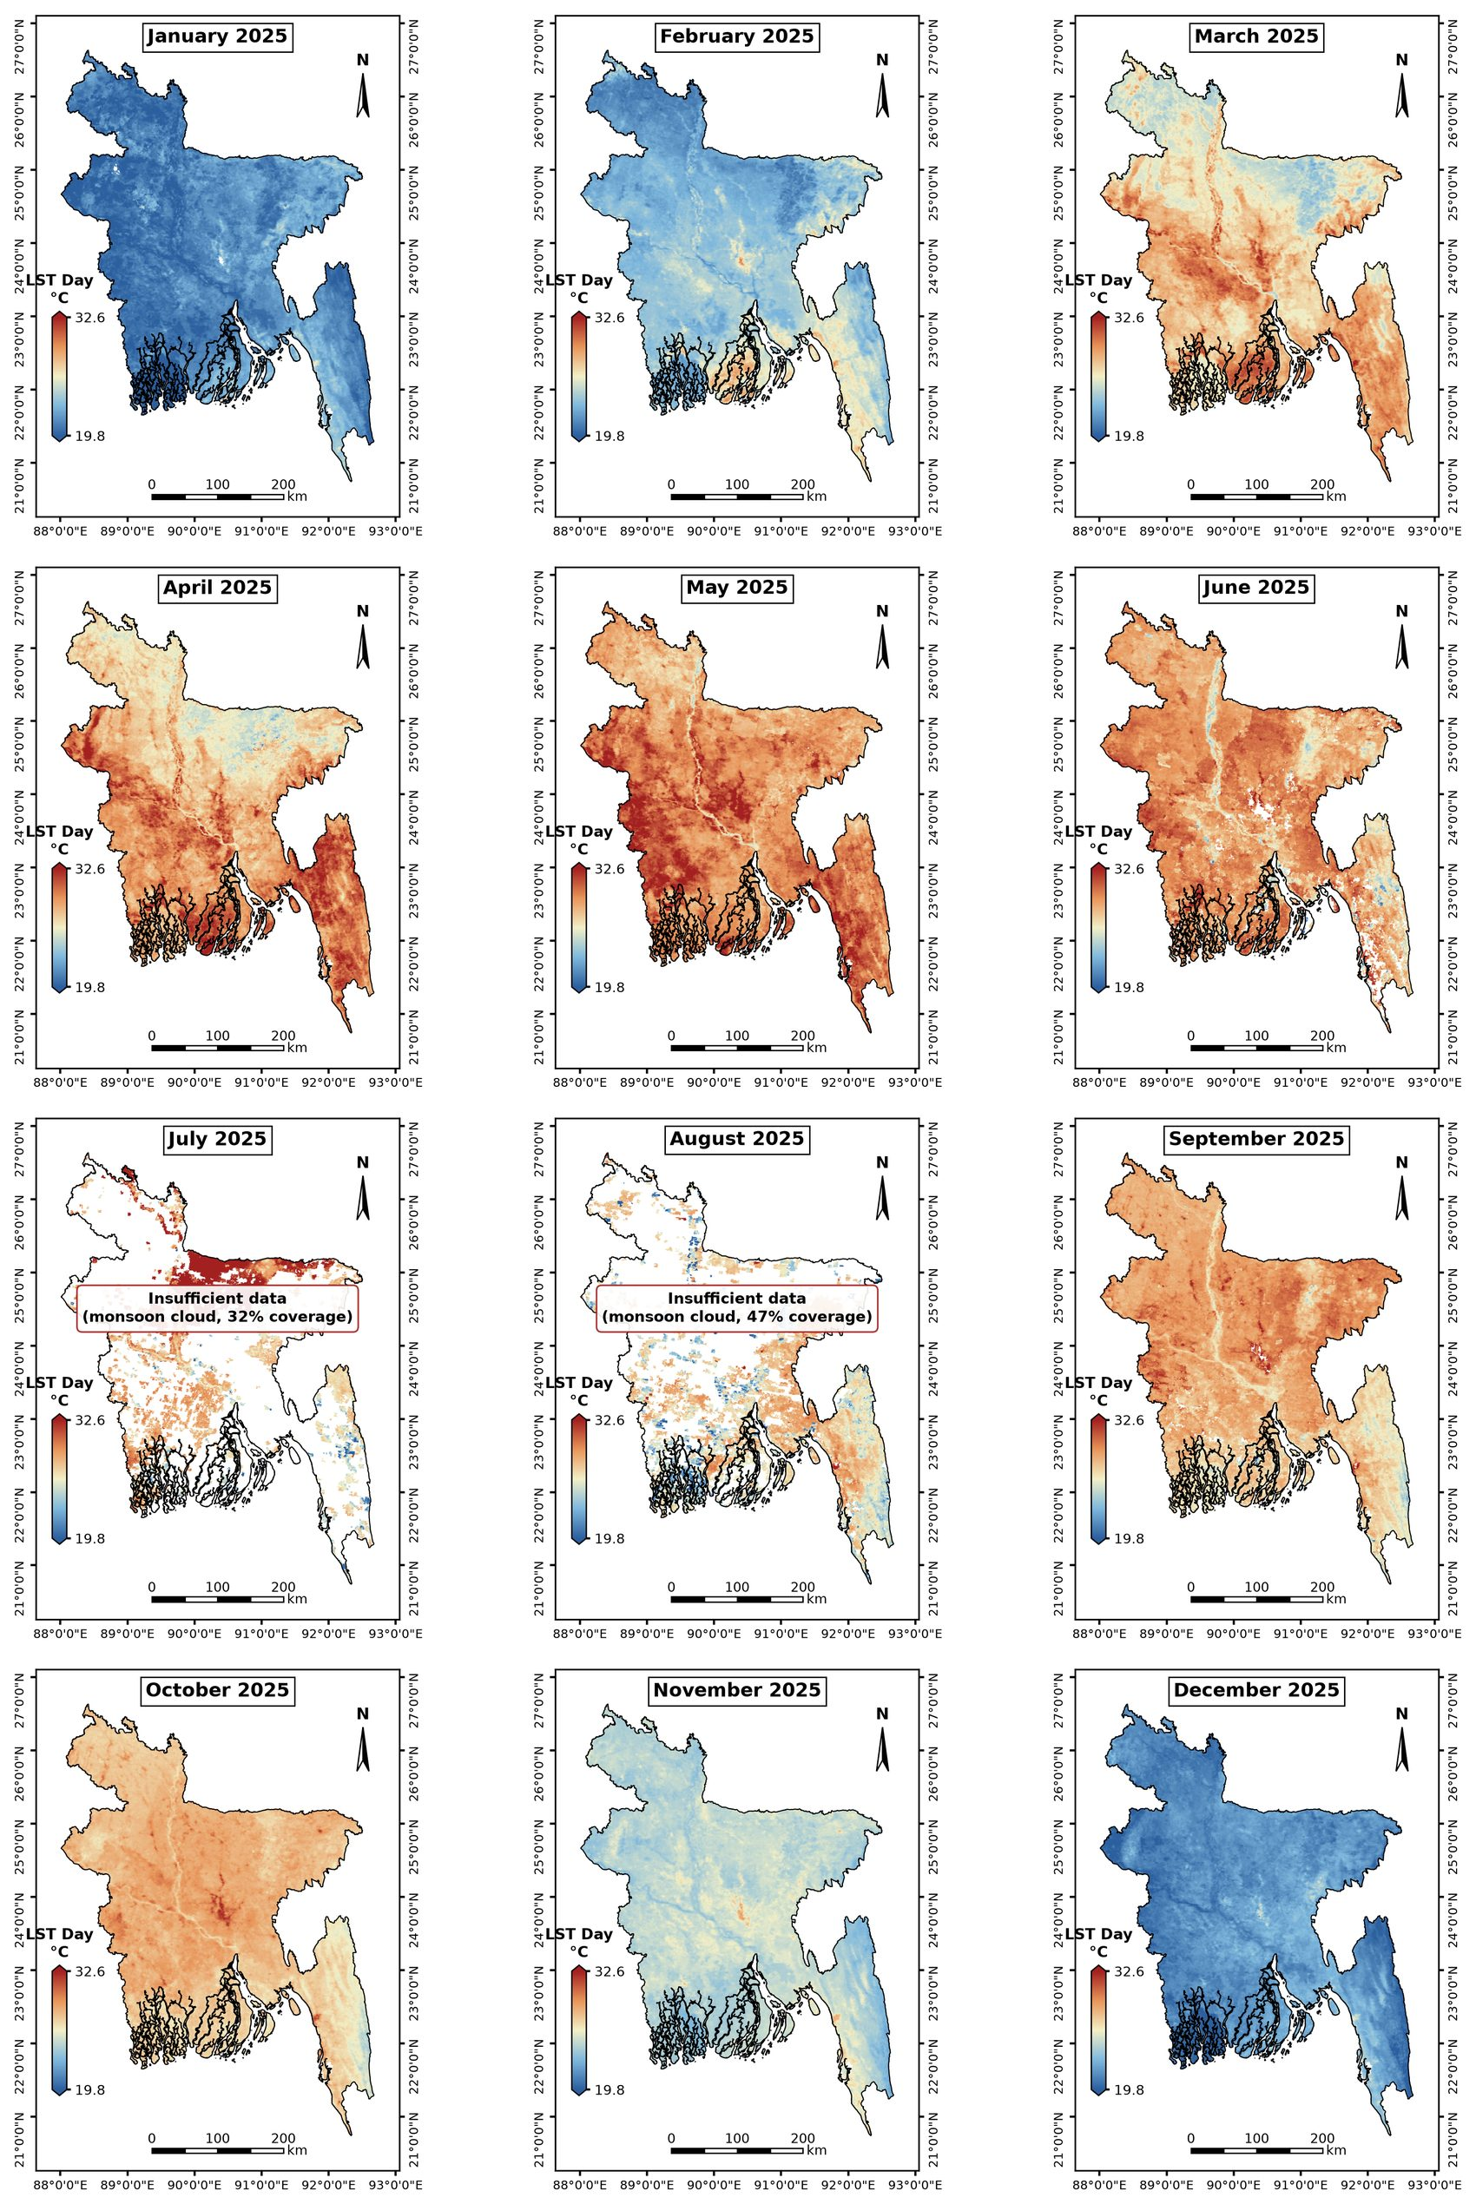
Figure S9. Monthly maps of daytime LST over Bangladesh in 2025. All panels share one colour scale. Months with spatial coverage below 50% are labelled as having insufficient data.
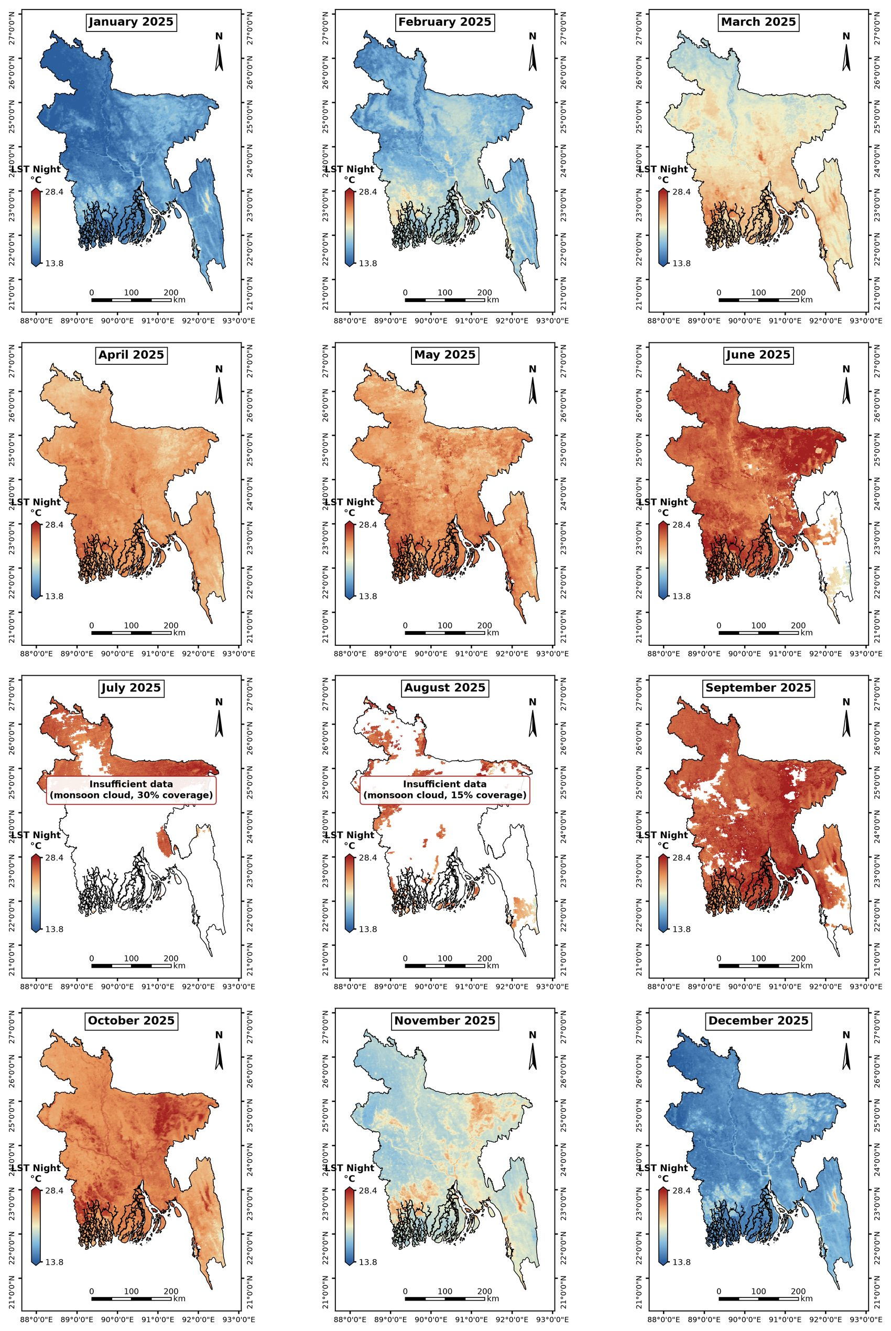
Figure S10. Monthly maps of nighttime LST over Bangladesh in 2025. All panels share one colour scale. Months with spatial coverage below 50% are labelled as having insufficient data.

