Satellite-Based Assessment of Air Pollutants and Land Surface Temperature over Bangladesh, 2025
Progress Report: Data Processing, Mapping and Statistical Analysis
Prepared by: Md. Habibullah Masbah
Prepared for: Air Pollution Research Team
Date: 23 September 2026
Status: Working draft for internal review

Executive Summary
This report documents all work completed to date on the Bangladesh adaptation of the satellite-based air pollution and land surface temperature (LST) framework of Sameh et al. [1]. Using Google Earth Engine (GEE) [2] and Python, twelve months of 2025 data from Sentinel-5P TROPOMI (CH₄, HCHO, O₃, UVAI) [3–6], MODIS MAIAC aerosol optical depth (AOD) [7] and MODIS LST [8] were quality-controlled, composited and mapped for the whole of Bangladesh. The complete processing chain, from data export to multivariate and local spatial statistics, has now been executed and all figures have been regenerated from the final exports.
The main outcomes are as follows:
- Mapping: 7 monthly panels (84 maps) and 8 annual maps were produced with shared colour scales, water masking for AOD, and explicit flagging of months with less than 50% valid coverage.
- Spatial pattern: a persistent west–east aerosol gradient (annual AOD 0.15–0.71; highest in the north-west) and a pronounced Dhaka hotspot visible in CH₄, HCHO, UVAI, nighttime LST and urban heat island (UHI) intensity (up to 3.7 °C at 0.05° resolution).
- Seasonality: pollutant loads peak in the dry and pre-monsoon seasons (AOD peak in late January; HCHO in March; O₃ in May) and are strongly reduced during the monsoon; the diurnal LST range falls from about 5.5 °C in winter to below 1 °C in August.
- Statistics (n = 4,901 cells): daytime LST correlates positively with CH₄ (r = 0.48), HCHO (0.30), UVAI (0.22) and AOD (0.17), whereas nighttime LST correlates negatively with the pollutants (O₃ r = −0.39). PCA extracted two components (68.4% of variance): a combined pollution factor and a daytime-heat/CH₄ factor.
- GWR: local models raised explained variance from R² = 0.23 (OLS) to 0.90 for daytime LST and from 0.07 to 0.91 for nighttime LST, confirming strong spatial non-stationarity; CH₄ is the dominant local daytime predictor and AOD shows mostly positive local effects at night.
Several methodological decisions require confirmation by the team, most importantly the replacement of PM_{2.5}/PM₁₀ by AOD and the replacement of the originally planned WHO guideline comparison, which is not valid for satellite column quantities (Section 7).

1. Introduction and Objectives
Sameh et al. [1] combined Sentinel-5P, MODIS MCD19A2 and MOD11A1 data within GEE to analyse the spatio-temporal interaction between LST and air pollutants in Sharkia Governorate, Egypt, using correlation, regression, principal component analysis (PCA) and geographically weighted regression (GWR). The present study transfers this framework to the national scale of Bangladesh for the year 2025, with methodological refinements required by the monsoon climate, the much larger study area and the lack of local calibration data for particulate matter.
The specific objectives are to: (i) produce quality-controlled monthly and annual maps of atmospheric pollutants and LST; (ii) quantify surface UHI intensity; (iii) characterise seasonal and daily variability; (iv) evaluate global relationships between LST and pollutants through correlation, regression and PCA; and (v) identify spatially varying relationships and local hotspots with GWR.

2. Study Area
Bangladesh (approximately 20.6–26.6° N, 88.0–92.7° E; about 147,570 km²) occupies the Ganges–Brahmaputra–Meghna delta between India, Myanmar and the Bay of Bengal (Figure 1). The climate is tropical monsoonal, with a dry winter (December–February), a hot pre-monsoon season (March–May), the south-west monsoon (June–September) and a short post-monsoon transition (October–November). Persistent monsoon cloud strongly limits optical and thermal satellite retrievals between June and September, which directly affects data availability in this study (Section 4.1). The country combines one of the world's densest megacities (Dhaka), extensive agricultural plains, the Sylhet haor wetlands, the Sundarbans mangrove forest and the forested Chittagong Hill Tracts.
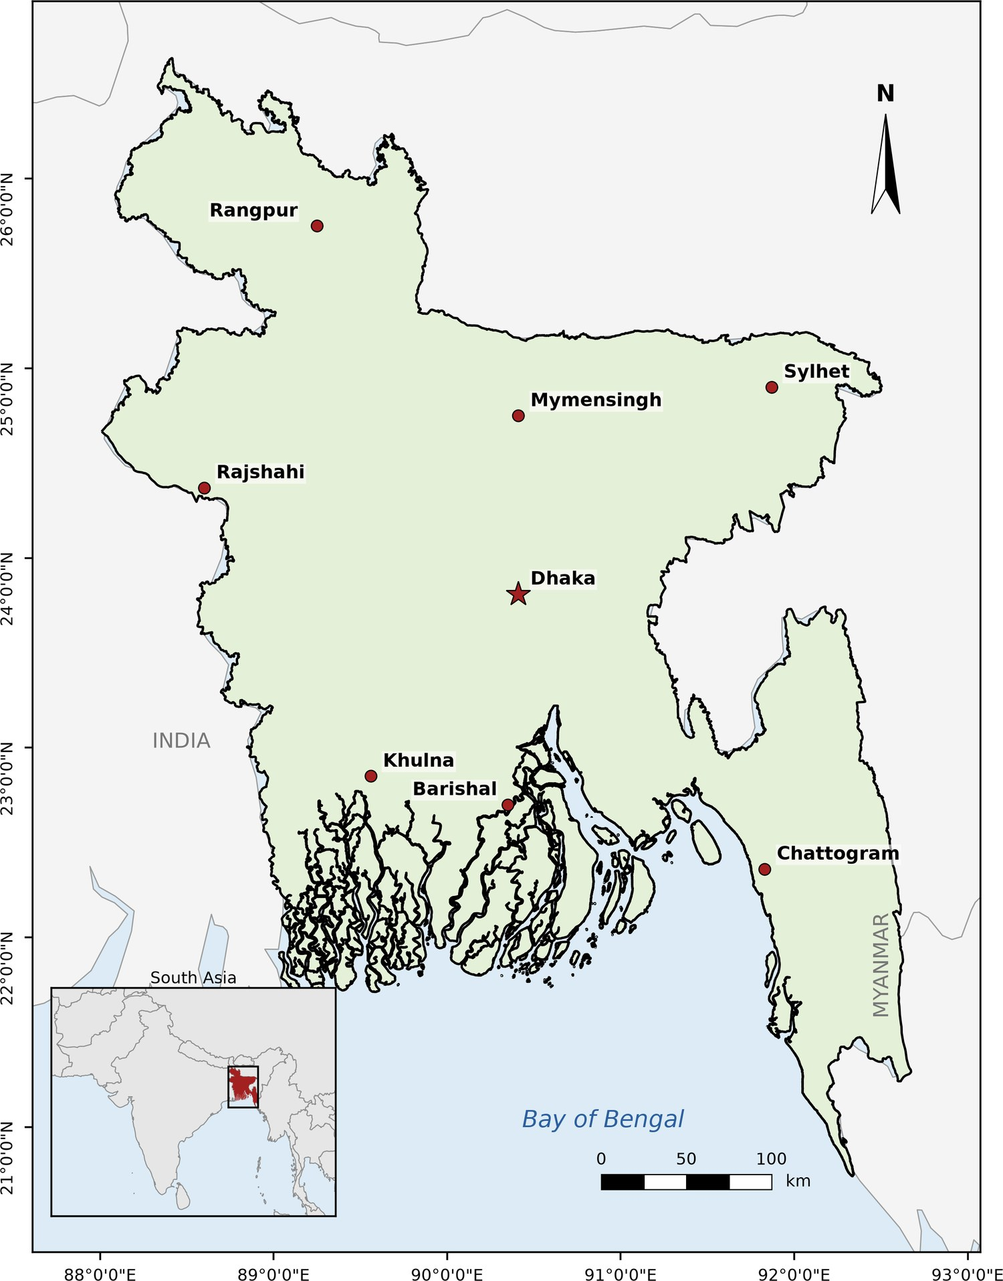
Figure 1. Study area: Bangladesh with the eight divisional headquarters (Dhaka shown as a star) and its location in South Asia (inset). Neighbouring country boundaries from Natural Earth (1:50 m).

3. Data and Methods
The overall workflow is summarised in Figure 2. All satellite processing was performed in GEE; mapping and statistical analyses were carried out in Python (rasterio, geopandas, pandas, SciPy, matplotlib and mgwr [15]).
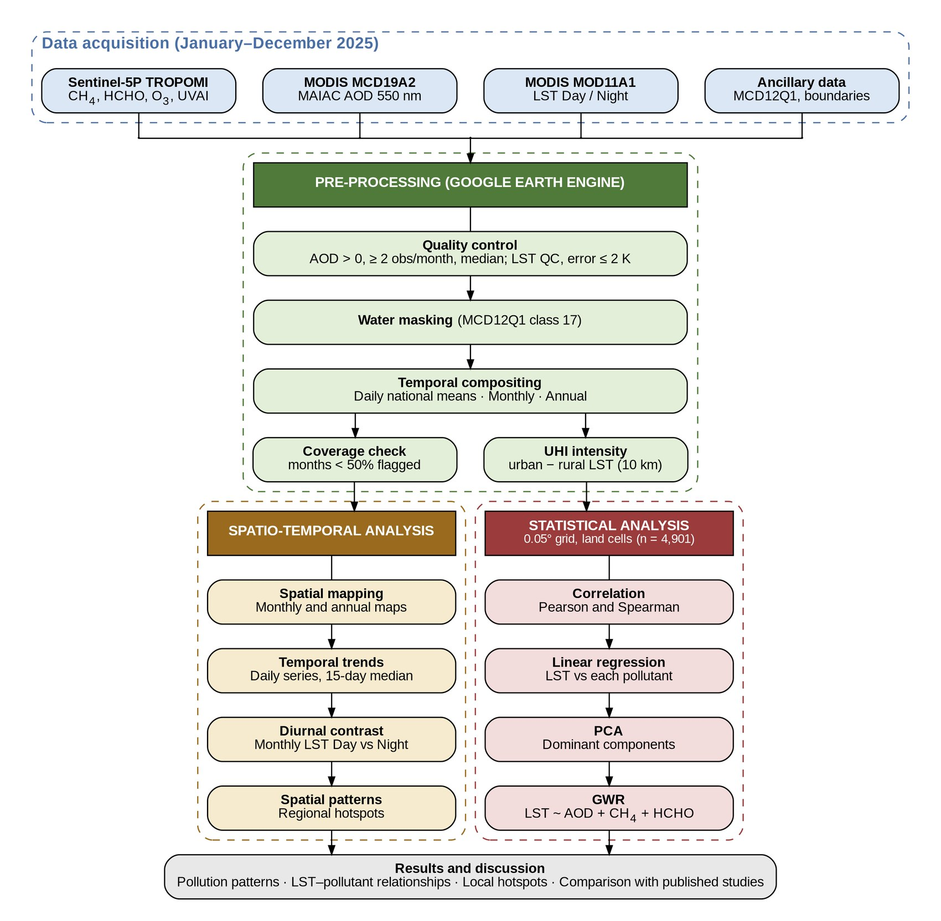
Figure 2. Methodological workflow of the study, from data acquisition through pre-processing in Google Earth Engine to spatio-temporal and statistical analyses.

3.1 Datasets
Table 1. Satellite and ancillary datasets used (1 January – 31 December 2025).
Product | Variable(s) | Native resolution | Export scale | Reference
Sentinel-5P TROPOMI OFFL L3 | CH₄ (dry-air mixing ratio, ppb) | ~5.5 × 7 km | 1,113 m | [3, 4]
Sentinel-5P TROPOMI OFFL L3 | HCHO tropospheric column (mol m⁻²) | ~5.5 × 3.5 km | 1,113 m | [3, 5]
Sentinel-5P TROPOMI OFFL L3 | O₃ total column (mol m⁻² → DU) | ~5.5 × 3.5 km | 1,113 m | [3, 19]
Sentinel-5P TROPOMI OFFL L3 | UV Aerosol Index (UVAI) | ~5.5 × 3.5 km | 1,113 m | [3, 6]
MODIS MCD19A2 (MAIAC, C6.1) | AOD at 550 nm | 1 km | 1,000 m | [7]
MODIS MOD11A1 (C6.1) | LST Day / Night (°C) | 1 km | 1,000 m | [8]
MODIS MCD12Q1 | Land cover (IGBP; urban = 13, water = 17) | 500 m | – | [9]
GEE asset / Natural Earth | National boundary; neighbouring countries | Vector | – | –

3.2 Pre-processing and Quality Control
An exploratory phase (script test-gee.js) evaluated data coverage, quality masks, mean versus median compositing, minimum-observation rules and alternative particulate matter sources. The resulting decisions (Table 2) were implemented in the final export script (for_all_Pollutants_GEE_script.js), which produced, for each variable, a 12-band monthly composite, an annual composite and a daily national-mean time series, as well as the annual UHI raster and a monthly coverage table. All rasters were exported in EPSG:4326 with a no-data value of −9999.
Table 2. Methodological issues identified during development and the adopted solutions.
Issue | Adopted solution
Monsoon cloud gaps (most severe for CH₄) | Keep all 12 monthly maps; months with < 50% valid pixels are labelled “Insufficient data (monsoon cloud)”
AOD outliers and zero-value pixels | Mask AOD ≤ 0; require ≥ 2 observations per pixel per month; use median compositing
AOD over inland water (unreliable MAIAC retrievals) | Mask MCD12Q1 water (class 17) from AOD; rivers and lakes shown as no-data
No quality filter on LST | Retain only good/other-quality pixels with LST error ≤ 2 K (QC bits)
PM_{2.5}/PM₁₀ derived from AOD with regressions calibrated outside Bangladesh | No usable 2025 ground data (OpenAQ, CAMS, US Embassy); PM dropped and AOD analysed directly (pending team confirmation)
UHI defined as pixel minus national mean | UHI = pixel LST − mean rural LST within 10 km (urban and water excluded from the rural reference; water masked)
Monthly maps with independent colour scales | One shared colour scale per variable (1st–99th percentile of all monthly pixels)
AOD daily export timed out as a single task | Split into 12 monthly export tasks and merged in Python
Coverage table computed at 5 km overestimated patchy months | Coverage recomputed from raster pixels (valid pixels / pixels observed at least once)

UHI intensity was computed from the annual daytime LST composite as the difference between each pixel and the mean LST of non-urban, non-water pixels within a 10 km circular neighbourhood, following the urban–rural contrast concept widely used in surface UHI studies [10].

3.3 Mapping
Monthly panels (A4, 4 × 3 layout) and single annual maps were produced for all variables, with graticules in degrees–minutes–seconds, a north arrow, a scale bar and a colour bar. O₃ was converted from mol m⁻² to Dobson Units (1 DU = 4.4615 × 10⁻⁴ mol m⁻²). Annual AOD is shown as a median composite, all other variables as means; UHI uses a zero-centred diverging scale.

3.4 Temporal Analysis
Daily national means were plotted for each variable. For AOD, only days with ≥ 50% spatial coverage were retained (171 of 365 days). Because cloudy days observed over only a few pixels produce unrepresentative national means, outlier days deviating by more than three robust standard deviations (1.4826 × MAD) from a 15-day running median were removed (a Hampel-type filter [16]), and a 15-day running median was used as the smoothed series. Monthly national means and standard deviations were computed directly from the monthly rasters, together with the day–night LST contrast.

3.5 Statistical Analysis
For all statistical analyses, the annual rasters were aggregated by averaging onto a common 0.05° grid (~5.5 km, close to the TROPOMI footprint), which harmonises the different native resolutions and reduces pixel-level noise. A land mask derived from the water-masked AOD layer was applied to the MODIS-based variables before aggregation, and only cells with ≥ 50% land were retained. Cells valid for all eight variables formed the analysis sample (n = 4,901).
- Correlation: Pearson and Spearman coefficients among LST Day, LST Night, UHI, AOD, UVAI, CH₄, HCHO and O₃. Because spatial autocorrelation inflates the effective sample size, p-values are reported for completeness but interpretation focuses on effect size [11].
- Regression: simple ordinary least squares (OLS) regression of LST Day and LST Night on each pollutant, following [1].
- PCA: performed on the correlation matrix of seven standardised variables (UHI excluded because it is derived from LST Day). Components were retained using the Kaiser criterion (eigenvalue > 1) [12, 13].
- GWR: LST Day and LST Night were modelled as functions of standardised AOD, CH₄ and HCHO using an adaptive bi-square kernel, great-circle distances and an AICc-optimised bandwidth [14, 15]. UVAI and O₃ were excluded to limit local collinearity (UVAI largely duplicates AOD; total-column O₃ is dominated by the stratosphere and a latitudinal gradient). Global VIFs of the retained predictors were 1.63–2.41. Local significance was assessed with multiple-testing-corrected t-values [18].

4. Results

4.1 Data Availability
TROPOMI HCHO, O₃ and UVAI achieved near-complete monthly coverage throughout the year, whereas CH₄, AOD and LST were severely affected by monsoon cloud (Table 3). CH₄ was entirely unavailable in July and August and below 25% in June and September; AOD fell to 11% in July and 25% in August; nighttime LST dropped to 15% in August. These months are flagged in all monthly figures and their national means should be interpreted with caution, because the observed pixels are spatially clustered (for example, September CH₄ is dominated by the northern districts).
Table 3. Monthly spatial coverage (% of pixels observed at least once in 2025). Values below 50% (bold) are flagged as insufficient data.
Month | AOD | UVAI | CH₄ | HCHO | O₃ | LST Day | LST Night
Jan | 100 | 100 | 99 | 100 | 100 | 100 | 100
Feb | 100 | 100 | 100 | 100 | 100 | 100 | 100
Mar | 100 | 100 | 99 | 100 | 100 | 100 | 100
Apr | 99 | 100 | 95 | 100 | 100 | 100 | 100
May | 93 | 100 | 53 | 100 | 100 | 100 | 100
Jun | 62 | 100 | 15 | 100 | 100 | 96 | 90
Jul | 11 | 100 | 0 | 99 | 100 | 32 | 30
Aug | 25 | 100 | 0 | 100 | 100 | 47 | 15
Sep | 89 | 100 | 25 | 100 | 100 | 99 | 89
Oct | 100 | 100 | 90 | 100 | 100 | 100 | 100
Nov | 100 | 100 | 99 | 100 | 100 | 100 | 100
Dec | 100 | 100 | 99 | 100 | 100 | 100 | 100

4.2 Annual Spatial Patterns
Annual pollutant distributions are shown in Figure 3 and summarised at the 0.05° analysis scale in Table 4. Median AOD displayed a marked west–east gradient: the highest loads (≈ 0.55–0.67) occurred across the north-western and western districts adjoining the Indo-Gangetic Plain, while the Sylhet region and the Chittagong Hill Tracts showed the cleanest conditions (≈ 0.16–0.29). A faint straight diagonal discontinuity crossing central Bangladesh was traced to the MAIAC product rather than to observation density and is treated as a retrieval artefact.
CH₄, HCHO and UVAI all exhibited a distinct maximum over Dhaka and its surroundings (≈ 90.4–90.6° E, 23.7–23.9° N), with CH₄ reaching ≈ 1,990 ppb. HCHO was also elevated along the western border, and UVAI was high along the Jamuna and Padma river corridors, most likely reflecting bright sandbar and water surfaces rather than absorbing aerosols. The Sundarbans and the Chittagong Hill Tracts recorded the lowest CH₄ and HCHO values. Total-column O₃ varied within only ≈ 272–280 DU and followed a smooth north–south gradient, consistent with its stratospheric dominance [19].
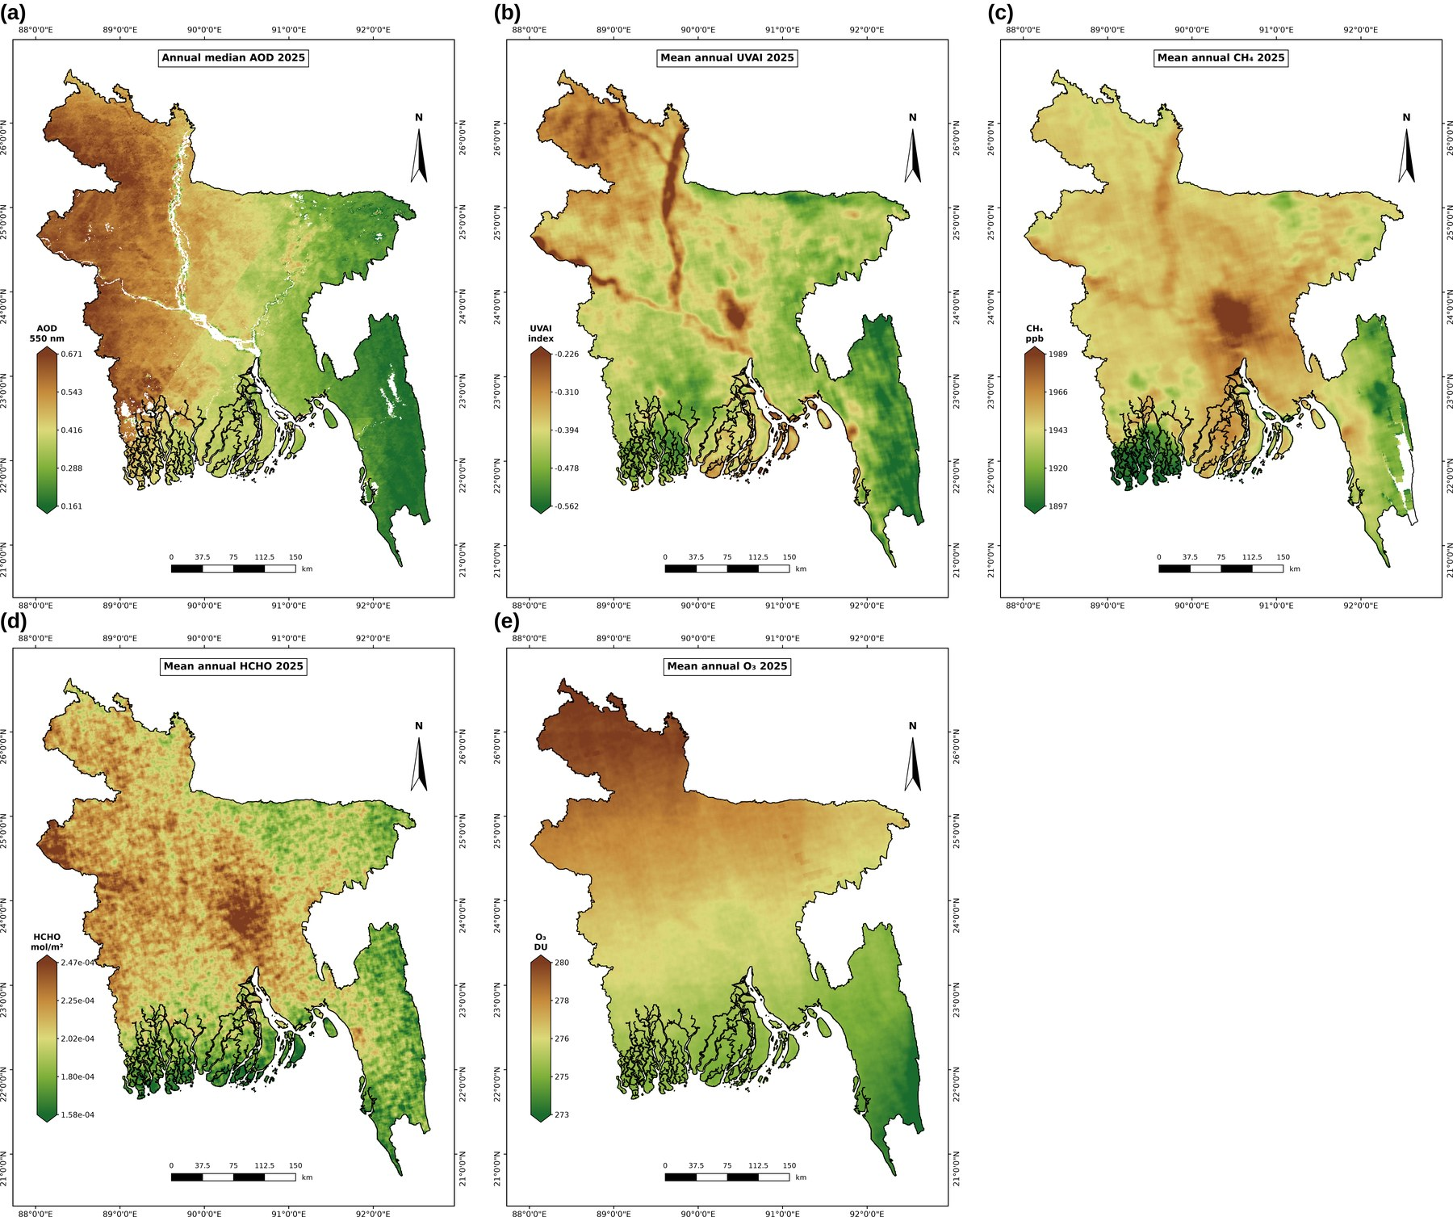
Figure 3. Annual 2025 maps of (a) median AOD at 550 nm, (b) mean UVAI, (c) mean CH₄, (d) mean tropospheric HCHO and (e) mean total-column O₃. Water bodies are masked in (a).
Daytime LST (Figure 4a) was highest across the west-central plains, the Dhaka agglomeration and the south-central coastal islands, and lowest over the Sylhet haor wetlands, the Sundarbans and the forested Chittagong Hill Tracts. At night (Figure 4b) the pattern changed: the south-west (Khulna–Satkhira, where aquaculture ponds retain heat), Dhaka and the river corridors were warmest, while the north-west was coolest. UHI intensity (Figure 4c) averaged close to zero nationally but reached up to 3.7 °C at the 0.05° scale, with the strongest and most extensive positive anomaly over Dhaka and smaller hotspots at other urban centres.
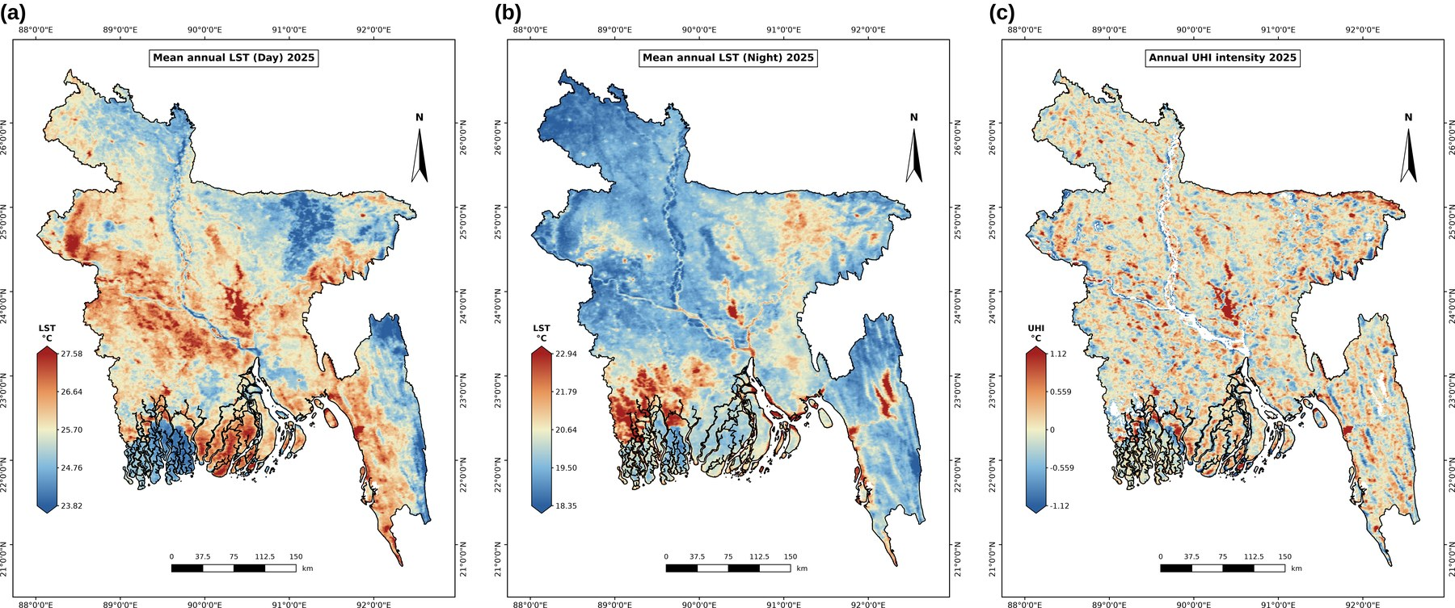
Figure 4. Annual 2025 maps of (a) mean daytime LST, (b) mean nighttime LST and (c) surface UHI intensity (urban minus rural LST within 10 km; water masked).
Table 4. Descriptive statistics of annual values on the common 0.05° grid (n = 4,901 land cells).
Variable | Unit | Mean | SD | Min | Max
AOD | – | 0.425 | 0.145 | 0.149 | 0.707
UVAI | index | −0.410 | 0.069 | −0.598 | −0.134
CH₄ | ppb | 1946.6 | 15.3 | 1877.3 | 2015.3
HCHO | ×10⁻⁴ mol m⁻² | 2.04 | 0.19 | 1.51 | 2.66
O₃ | DU | 276.7 | 1.8 | 271.8 | 280.5
LST Day | °C | 25.72 | 0.71 | 23.50 | 30.61
LST Night | °C | 19.91 | 0.79 | 17.99 | 23.61
UHI | °C | 0.01 | 0.28 | −1.41 | 3.74

4.3 Monthly and Seasonal Patterns
National monthly means (Table 5; monthly maps in Appendix A, Figures A1–A7) reveal a strong seasonal cycle. AOD remained high from January to June (0.48–0.67) and fell to ≈ 0.19–0.29 during and after the monsoon, although the low July–August values are based on limited coverage. HCHO peaked in March (2.48 × 10⁻⁴ mol m⁻²), coinciding with the pre-monsoon biomass-burning and high-temperature period, and reached its minimum in August. Total-column O₃ increased from ≈ 264 DU in January to ≈ 295 DU in April–May before declining to ≈ 253 DU in December. UVAI was highest in the dry season (maximum in December) and lowest during the monsoon. CH₄ showed its highest values in September–October, but these estimates are biased toward the northern districts that were observable.
Table 5. National monthly mean values in 2025 derived from the monthly composites (* coverage < 50%).
Month | AOD | UVAI | CH₄ (ppb) | HCHO (×10⁻⁴) | O₃ (DU) | LST Day (°C) | LST Night (°C)
Jan | 0.62 | −0.19 | 1946.4 | 1.92 | 264.3 | 21.2 | 15.7
Feb | 0.60 | −0.08 | 1942.6 | 2.01 | 274.5 | 23.6 | 18.1
Mar | 0.48 | −0.06 | 1938.6 | 2.48 | 285.0 | 27.5 | 21.6
Apr | 0.58 | −0.15 | 1931.9 | 2.31 | 294.9 | 28.6 | 24.2
May | 0.67 | −0.54 | 1927.7 | 2.34 | 295.3 | 29.6 | 24.5
Jun | 0.66 | −0.74 | 1959.7* | 1.97 | 286.8 | 28.9 | 26.3
Jul | 0.28* | −0.75 | n/a* | 1.80 | 280.9 | 28.9* | 26.3*
Aug | 0.19* | −0.81 | n/a* | 1.47 | 277.9 | 26.5* | 25.7*
Sep | 0.21 | −0.81 | 1971.3* | 1.69 | 273.3 | 28.4 | 26.8
Oct | 0.28 | −0.66 | 1977.1 | 1.91 | 273.0 | 28.0 | 25.2
Nov | 0.29 | −0.21 | 1953.8 | 2.01 | 254.9 | 24.8 | 20.2
Dec | 0.32 | 0.12 | 1944.9 | 1.85 | 253.4 | 21.6 | 16.3
CH₄ values for July and August are not reported because coverage was 0% (the few residual pixels are not representative).

4.4 Temporal Trends
The daily national series (Figure 5) confirm the seasonal behaviour. AOD reached its annual maximum in late January (15-day median ≈ 1.0), reflecting the winter haze season, and dropped to ≈ 0.2 in September. UVAI and HCHO were elevated in the dry and pre-monsoon seasons and suppressed during the monsoon by wet deposition and cloud. O₃ showed the clearest cycle, with a broad spring maximum near 300 DU and a December minimum near 250 DU. Between 165 (AOD) and 364 (UVAI) valid days were available per variable after quality filtering.
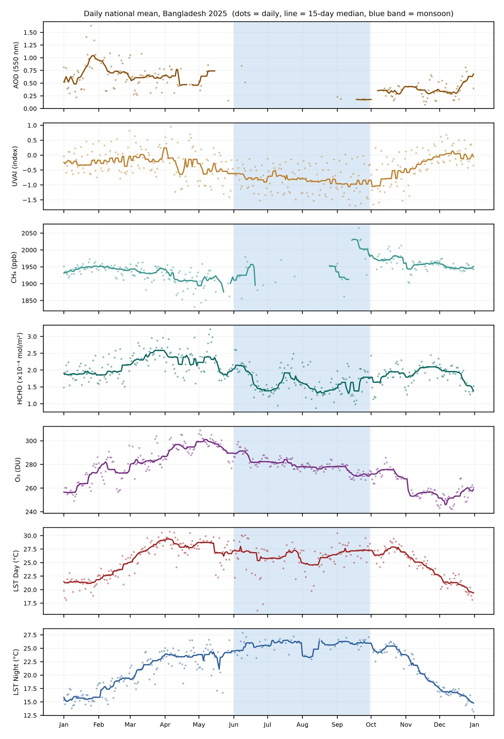
Figure 5. Daily national mean values in 2025 for all variables (dots: daily values after outlier removal; line: 15-day running median; blue band: monsoon, June–September). AOD is restricted to days with ≥ 50% spatial coverage.
Monthly mean LST (Figure 6) rose from 21.2 °C (day) and 15.7 °C (night) in January to a daytime maximum of 29.6 °C in May, while nighttime LST continued to rise into the monsoon and peaked at 26.8 °C in September. Consequently, the day–night contrast narrowed from ≈ 5.5 °C in December–February to ≈ 2.6 °C in June–July and only 0.8 °C in August, a consequence of persistent cloud cover and high humidity that suppress daytime heating and nocturnal cooling.
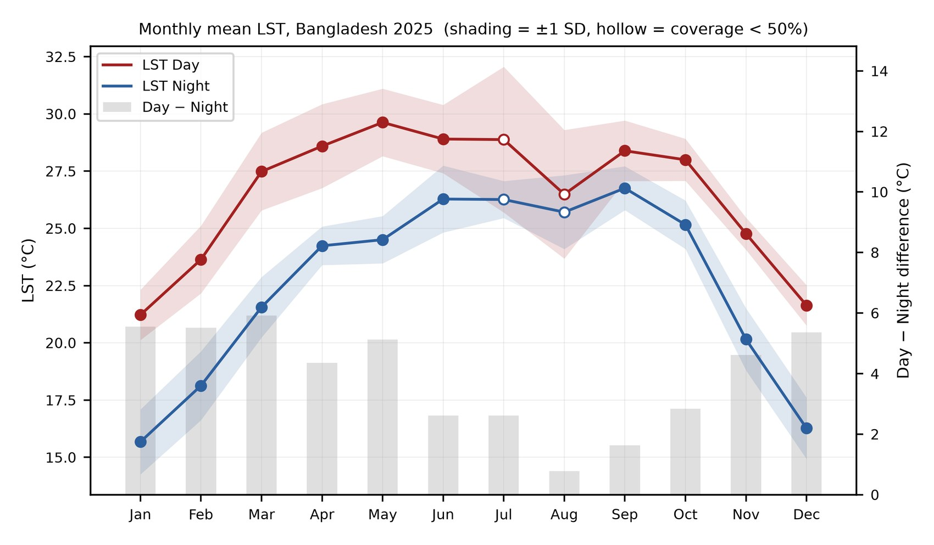
Figure 6. Monthly national mean LST Day and LST Night in 2025 (shading: ±1 SD; hollow markers: coverage < 50%) and the day–night difference (grey bars, right axis).

4.5 Correlation Analysis
Pearson and Spearman coefficients were consistent (Figure 7; Table 6), indicating that the relationships are not driven by outliers. Daytime LST was positively associated with CH₄ (r = 0.48), HCHO (0.30), UVAI (0.22) and AOD (0.17), and negatively with O₃ (−0.14). In contrast, nighttime LST was negatively associated with O₃ (−0.39), UVAI (−0.29), HCHO (−0.23) and AOD (−0.18). The pollutants were strongly inter-correlated, particularly UVAI–O₃ (0.71), AOD–O₃ (0.69), AOD–UVAI (0.66), HCHO–CH₄ (0.61) and HCHO–AOD (0.61), reflecting the co-location of multiple pollutants in the north-west and around Dhaka. The strong association of O₃ with the other pollutants is at least partly a shared latitudinal gradient rather than a chemical link. As expected, UHI correlated with LST Day (0.51), from which it is derived.
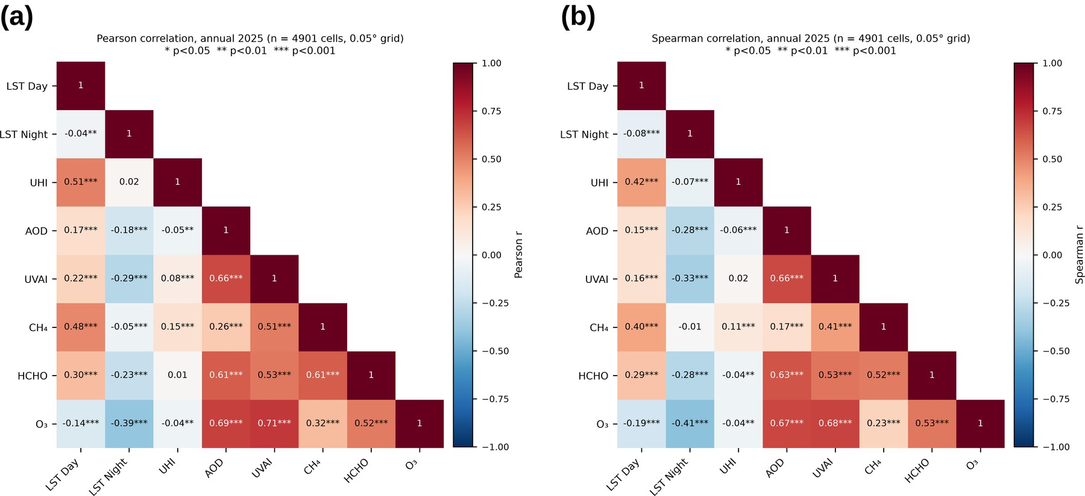
Figure 7. (a) Pearson and (b) Spearman correlation matrices of annual variables on the 0.05° grid (n = 4,901; p < 0.05, p < 0.01, ** p < 0.001).
Table 6. Pearson correlation coefficients among annual variables (n = 4,901). All coefficients are significant at p < 0.01 except those marked ns.
 | LST Day | LST Night | UHI | AOD | UVAI | CH₄ | HCHO | O₃
LST Day | 1
LST Night | −0.04 | 1
UHI | 0.51 | 0.02^{ns} | 1
AOD | 0.17 | −0.18 | −0.05 | 1
UVAI | 0.22 | −0.29 | 0.08 | 0.66 | 1
CH₄ | 0.48 | −0.05 | 0.15 | 0.26 | 0.51 | 1
HCHO | 0.30 | −0.23 | 0.01^{ns} | 0.61 | 0.53 | 0.61 | 1
O₃ | −0.14 | −0.39 | −0.04 | 0.69 | 0.71 | 0.32 | 0.52 | 1

4.6 Regression Analysis
Simple linear regressions (Figure 8; Table 7) show that individual pollutants explain only a small to moderate share of the spatial variation in LST. CH₄ was the strongest single predictor of daytime LST (R² = 0.23), followed by HCHO (0.09); O₃ was the strongest single predictor of nighttime LST (R² = 0.15). All other relationships had R² < 0.10. Although all slopes are statistically significant owing to the large sample, the low explained variance indicates that LST is governed by the combined effect of several factors, including land cover, surface moisture and urban form, rather than by any single pollutant.
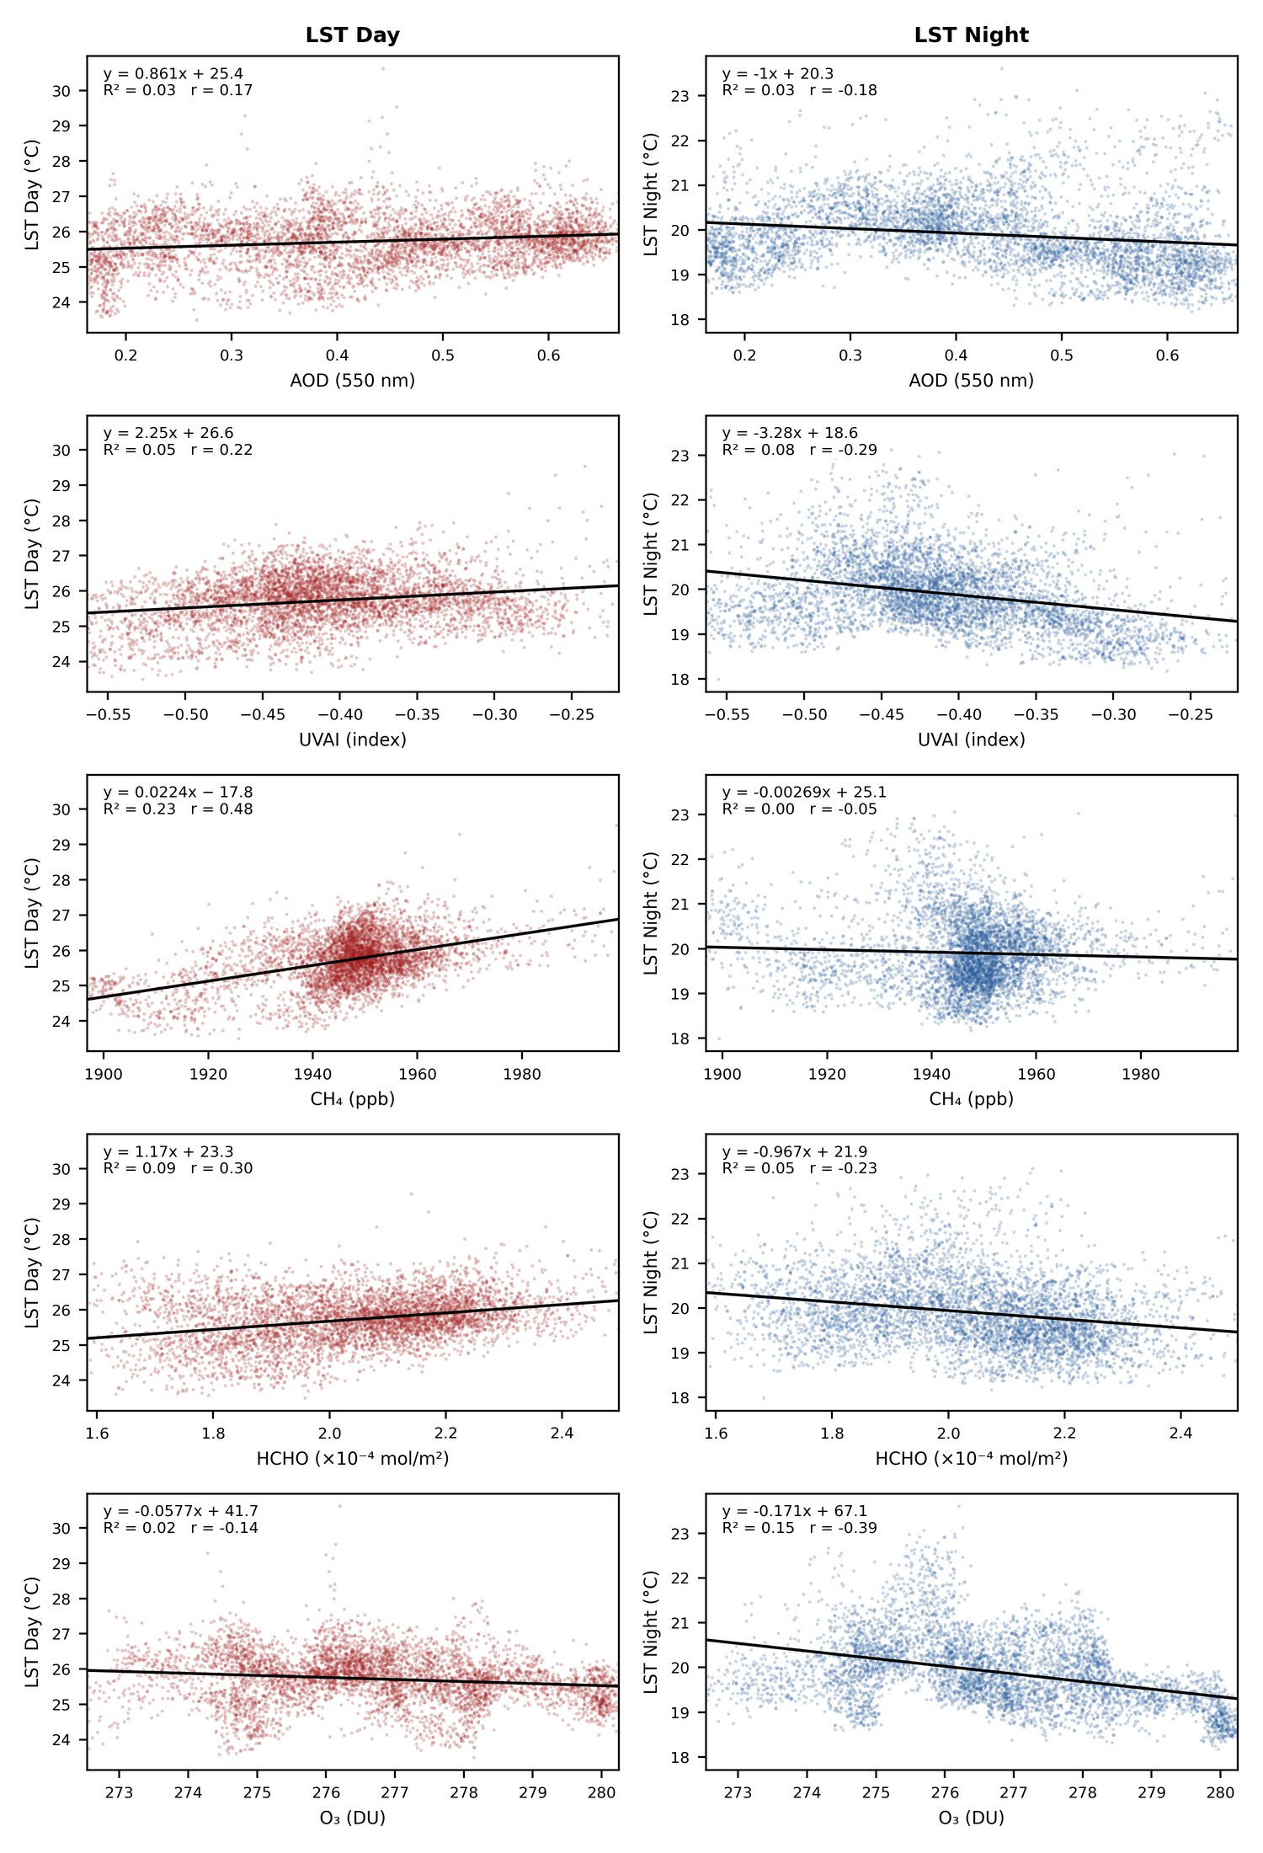
Figure 8. Linear regression of annual LST Day (left) and LST Night (right) on each pollutant (n = 4,901 cells). Lines show OLS fits; equations, R² and r are given in each panel.
Table 7. Simple OLS regression of LST on individual pollutants (n = 4,901; all p < 0.001).
Response | Predictor | Slope | Intercept | r | R²
LST Day | AOD | 0.861 | 25.36 | 0.175 | 0.030
LST Day | UVAI | 2.252 | 26.64 | 0.219 | 0.048
LST Day | CH₄ (ppb) | 0.0224 | −17.80 | 0.480 | 0.231
LST Day | HCHO (×10⁻⁴) | 1.174 | 23.33 | 0.305 | 0.093
LST Day | O₃ (DU) | −0.0577 | 41.69 | −0.144 | 0.021
LST Night | AOD | −1.003 | 20.33 | −0.184 | 0.034
LST Night | UVAI | −3.277 | 18.56 | −0.289 | 0.083
LST Night | CH₄ (ppb) | −0.0027 | 25.14 | −0.052 | 0.003
LST Night | HCHO (×10⁻⁴) | −0.967 | 21.88 | −0.228 | 0.052
LST Night | O₃ (DU) | −0.171 | 67.11 | −0.386 | 0.149

4.7 Principal Component Analysis
Two components had eigenvalues above one and jointly explained 68.4% of the total variance (Figure 9; Table 8). PC1 (48.4%) is a combined pollution factor with high positive loadings on UVAI (0.86), HCHO (0.82), AOD (0.80), O₃ (0.80) and CH₄ (0.66), confirming that the most polluted areas are affected by several pollutants simultaneously. PC2 (20.0%) is a daytime-heat factor dominated by LST Day (0.80) together with CH₄ (0.55) and contrasted with O₃ (−0.49). PC3 (12.3%, eigenvalue 0.86) is essentially a nighttime LST factor (0.83). The biplot shows the pollutant vectors clustered together and nighttime LST opposing them, consistent with the negative correlations reported above.
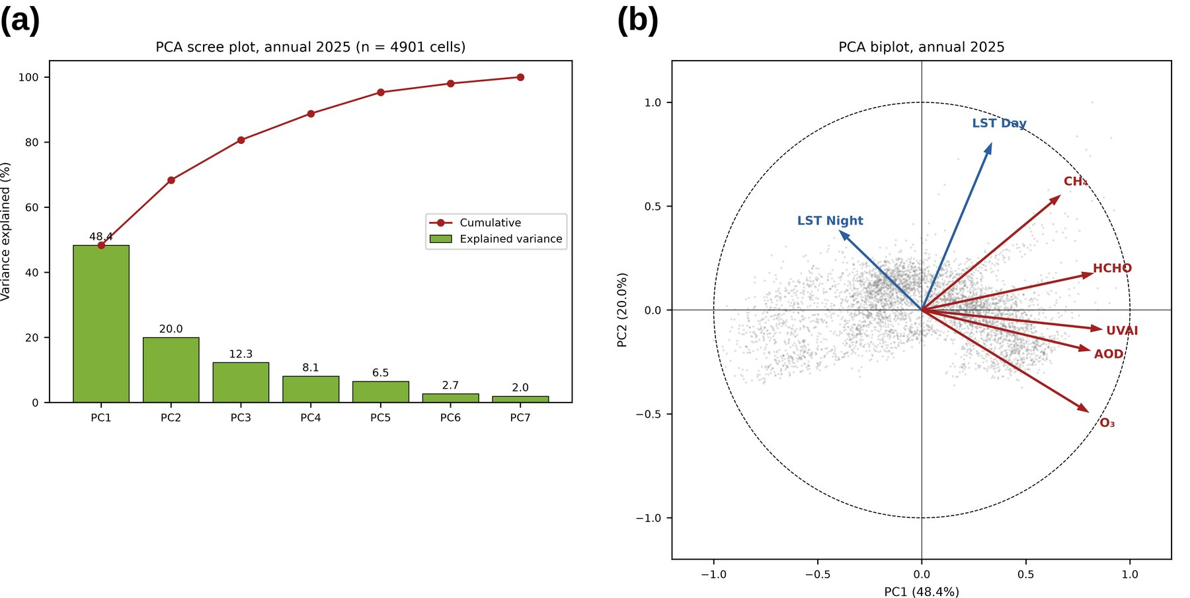
Figure 9. PCA of seven standardised annual variables: (a) scree plot of explained and cumulative variance; (b) biplot of PC1 versus PC2 showing variable loadings (arrows) and cell scores (grey points).
Table 8. PCA eigenvalues, explained variance and loadings of the first three components.
 | PC1 | PC2 | PC3
Eigenvalue | 3.39 | 1.40 | 0.86
Variance explained (%) | 48.4 | 20.0 | 12.3
Cumulative (%) | 48.4 | 68.4 | 80.7
LST Day | 0.33 | 0.80 | −0.28
LST Night | −0.39 | 0.38 | 0.83
AOD | 0.80 | −0.19 | 0.26
UVAI | 0.86 | −0.09 | 0.07
CH₄ | 0.66 | 0.55 | 0.02
HCHO | 0.82 | 0.18 | 0.06
O₃ | 0.80 | −0.49 | 0.11
Loadings are correlations between variables and components; |loading| ≥ 0.5 in bold. PC1–PC7 values are provided in pca_variance_2025.csv and pca_loadings_2025.csv.

4.8 Geographically Weighted Regression
GWR substantially outperformed the corresponding global OLS models (Table 9), raising R² from 0.23 to 0.90 for daytime LST and from 0.07 to 0.91 for nighttime LST, with AICc-optimised adaptive bandwidths of 49 neighbours (≈ 20 km). This confirms that the relationships between LST and pollutants are strongly non-stationary across Bangladesh.
For daytime LST (Figure 10), CH₄ was the dominant local predictor, significant in 35% of cells and almost exclusively positive (34%), with the largest coefficients in the west, around Dhaka and in parts of the north-east and south. AOD was significant in 11% of cells with mixed signs, and HCHO in only 5%. For nighttime LST (Figure 11), AOD was significant in 16% of cells, predominantly positive (13%), particularly in the south-west and along the south-east coast, consistent with the long-wave warming effect of aerosols at night [17]. CH₄ was significant in 29% of cells but mostly negative (25%), whereas HCHO was rarely significant (6%).
Table 9. Comparison of global OLS and GWR models (predictors: standardised AOD, CH₄ and HCHO; n = 4,901).
Response | Bandwidth (neighbours) | OLS R² | GWR R² | GWR adj. R² | AICc | Significant cells: AOD / CH₄ / HCHO
LST Day | 49 | 0.234 | 0.899 | 0.878 | 4646.9 | 11% / 35% / 5%
LST Night | 49 | 0.065 | 0.909 | 0.891 | 4133.1 | 16% / 29% / 6%

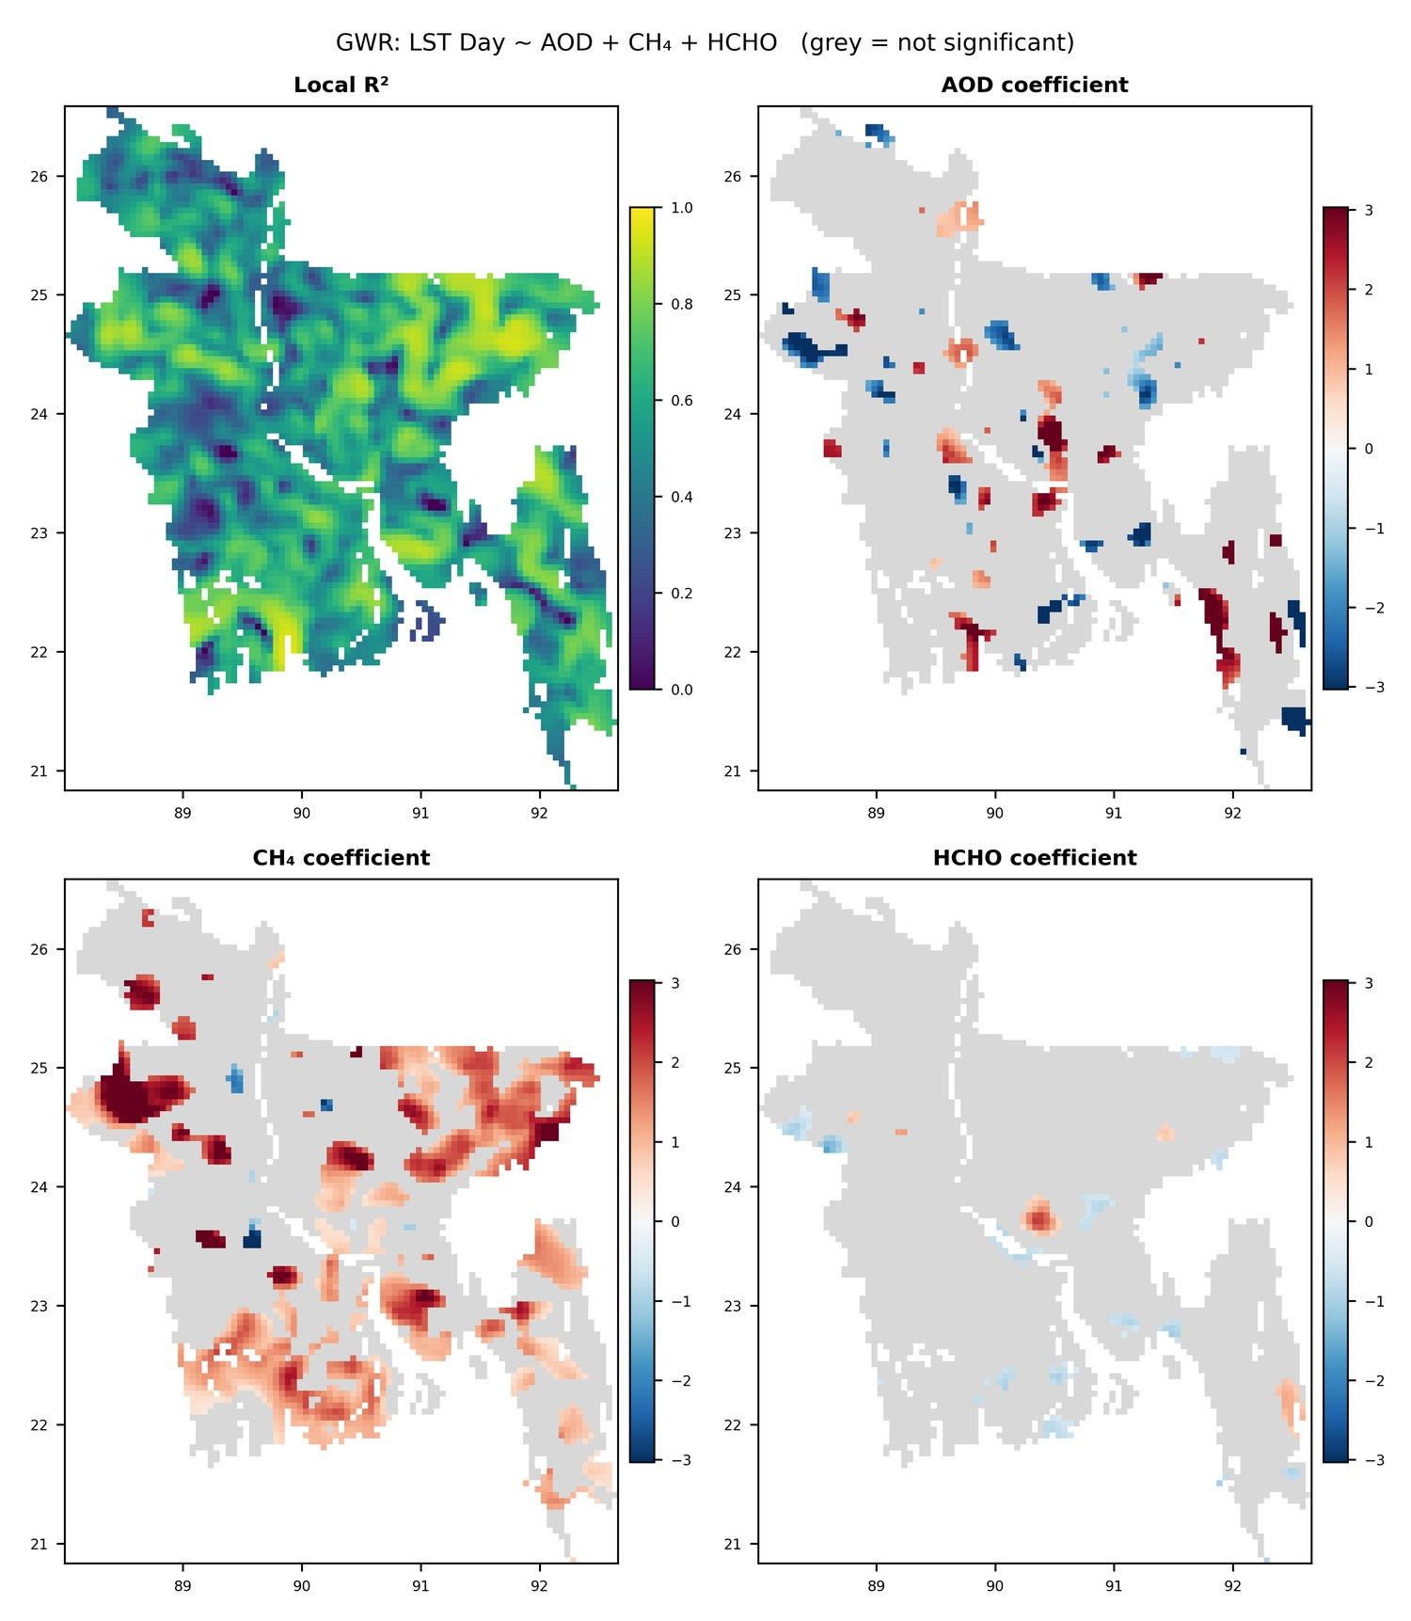
Figure 10. GWR results for daytime LST: local R² and local standardised coefficients of AOD, CH₄ and HCHO. Grey cells are not significant after multiple-testing correction.
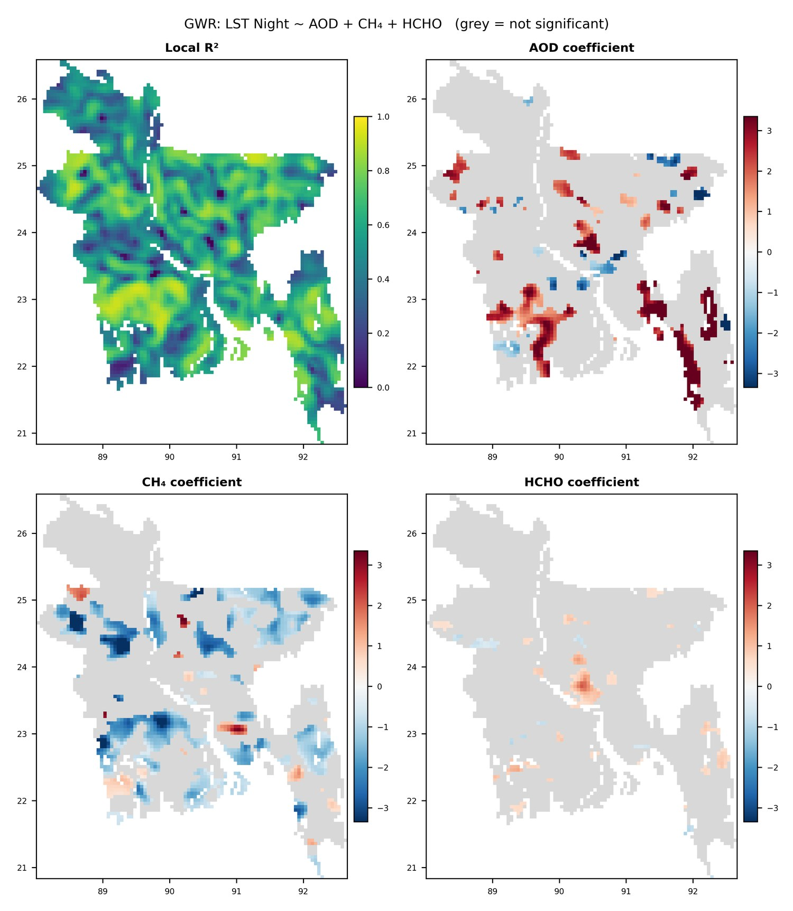
Figure 11. GWR results for nighttime LST: local R² and local standardised coefficients of AOD, CH₄ and HCHO. Grey cells are not significant after multiple-testing correction.

5. Discussion and Limitations
The results demonstrate that the Sameh et al. [1] framework can be transferred to the national scale, while revealing behaviour specific to a monsoonal deltaic country. The contrasting signs of the day and night relationships are physically plausible: polluted, densely built-up areas are hotter during the day, whereas aerosol-rich air reduces incoming solar radiation and alters nocturnal cooling [17]. The Dhaka region emerges consistently as a multi-pollutant and thermal hotspot, and the western border districts reflect transboundary aerosol transport from the Indo-Gangetic Plain. The following limitations must be acknowledged:
- Column versus surface quantities: all pollutant variables are column-integrated or optical quantities, not surface concentrations; they cannot be compared directly with ambient air quality standards such as the WHO guidelines [20], which define limits only for surface PM, O₃, NO₂, SO₂ and CO.
- Total-column O_{3}: dominated by the stratosphere and a latitudinal gradient; its associations with LST and other pollutants should not be interpreted as surface photochemistry.
- Monsoon sampling bias: cloud removes most CH₄, AOD and LST retrievals in June–September, and clear-sky compositing biases LST and annual means toward dry-season conditions.
- Retrieval artefacts: a diagonal discontinuity in annual MAIAC AOD and elevated UVAI along bright river corridors are attributed to retrieval characteristics.
- Spatial autocorrelation: inflates the significance of correlations and regressions [11]; effect sizes, not p-values, should be emphasised.
- GWR bandwidth: the small optimal bandwidth (49 neighbours) may partly overfit local variation; the high GWR R² should be reported with caution and the coefficient maps emphasised. Multiscale GWR could be tested.
- Particulate matter: PM_{2.5}/PM₁₀ were not estimated because no locally calibrated AOD–PM relationship was available for 2025; AOD is used as the aerosol indicator.

6. Outputs and Reproducibility
All scripts and outputs have been uploaded to the shared Google Drive. Table 10 lists every script used and the outputs it produces.
Table 10. Inventory of scripts and outputs.
Script | Environment | Purpose | Main outputs
test-gee.js | GEE | Exploratory tests of coverage, QC masks, compositing and UHI methods | Console statistics (no exports)
for_all_Pollutants_GEE_script.js | GEE | Final export of monthly/annual rasters, UHI, coverage and daily means | 15 rasters, coverage CSV, daily CSVs (BD_AQ_2025)
AOD_daily_fix_GEE.js | GEE | AOD daily means as 12 monthly tasks (timeout fix) | AOD_daily_2025_M01–M12.csv
AOD_check | GEE | Visual check of AOD observation count and water mask | Map layers (no exports)
merge_aod_daily.py | Python | Merge monthly AOD CSVs | AOD_daily_2025.csv
panel_map.py | Python | Monthly 4 × 3 panels with pixel-based coverage flags | 7 panel figures (84 maps)
annual_map.py | Python | Annual maps | 8 annual maps
temporal_trends.py | Python | Daily trends and monthly LST day/night | 2 figures, daily and monthly summary CSVs
correlation_matrix.py | Python | 0.05° gridding, land mask, correlation | Pixel table, Pearson/Spearman matrices and heatmaps
regression_plots.py | Python | OLS LST vs pollutants | Scatter figure and regression table
pca_analysis.py | Python | PCA | Scree plot, biplot, variance, loadings and scores
gwr_analysis.py | Python | GWR for LST Day and Night | Coefficient maps, cell-level CSVs, summary
study_area_map.py | Python | Study area map with inset | Study area figure
Flowchart (Graphviz) | – | Methodology diagram | PNG (600 dpi) and vector PDF

7. Pending Decisions and Next Steps
Table 11. Items requiring team input and planned next steps.
No. | Item | Proposal / status
1 | Replacement of PM_{2.5}/PM₁₀ by AOD | Proposed; awaiting confirmation
2 | WHO guideline comparison | Not valid for satellite column data; proposed replacement by a comparison with published satellite studies for Bangladesh, India and Egypt [1]
3 | GWR predictor set (AOD, CH₄, HCHO) | Proposed; alternatives: add UVAI, or test multiscale GWR
4 | Administrative divisions (adm1) for the study area map | Shapefile needed from the boundary dataset
5 | Additional pollutants (e.g. NO₂, CO, SO₂) | Optional; would align with related studies
6 | Seasonal (rather than annual) statistics | Optional extension
7 | Target journal and figure format requirements | Needed before manuscript preparation
8 | Manuscript drafting (methods and results) | Next step after decisions 1–7

References
[1] Sameh, S., Zaki, A., Elsaka, B., Beshr, A.A.A., Shehata, A.G. (2026). Air pollution mapping and monitoring using Sentinel-5P data and Google Earth Engine. The Egyptian Journal of Remote Sensing and Space Sciences (in press). https://www.sciencedirect.com/science/article/pii/S1110982326000086
[2] Gorelick, N., Hancher, M., Dixon, M., Ilyushchenko, S., Thau, D., Moore, R. (2017). Google Earth Engine: Planetary-scale geospatial analysis for everyone. Remote Sensing of Environment, 202, 18–27.
[3] Veefkind, J.P., et al. (2012). TROPOMI on the ESA Sentinel-5 Precursor: A GMES mission for global observations of the atmospheric composition for climate, air quality and ozone layer applications. Remote Sensing of Environment, 120, 70–83.
[4] Lorente, A., et al. (2021). Methane retrieved from TROPOMI: improvement of the data product and validation of the first 2 years of measurements. Atmospheric Measurement Techniques, 14, 665–684.
[5] De Smedt, I., et al. (2018). Algorithm theoretical baseline for formaldehyde retrievals from S5P TROPOMI and from the QA4ECV project. Atmospheric Measurement Techniques, 11, 2395–2426.
[6] Torres, O., Bhartia, P.K., Herman, J.R., Ahmad, Z., Gleason, J. (1998). Derivation of aerosol properties from satellite measurements of backscattered ultraviolet radiation: Theoretical basis. Journal of Geophysical Research, 103(D14), 17099–17110.
[7] Lyapustin, A., Wang, Y., Korkin, S., Huang, D. (2018). MODIS Collection 6 MAIAC algorithm. Atmospheric Measurement Techniques, 11, 5741–5765.
[8] Wan, Z. (2014). New refinements and validation of the collection-6 MODIS land-surface temperature/emissivity product. Remote Sensing of Environment, 140, 36–45.
[9] Friedl, M., Sulla-Menashe, D. (2019). MCD12Q1 MODIS/Terra+Aqua Land Cover Type Yearly L3 Global 500m SIN Grid V006. NASA EOSDIS Land Processes DAAC. https://doi.org/10.5067/MODIS/MCD12Q1.006
[10] Peng, S., et al. (2012). Surface urban heat island across 419 global big cities. Environmental Science & Technology, 46(2), 696–703.
[11] Clifford, P., Richardson, S., Hémon, D. (1989). Assessing the significance of the correlation between two spatial processes. Biometrics, 45(1), 123–134.
[12] Jolliffe, I.T., Cadima, J. (2016). Principal component analysis: a review and recent developments. Philosophical Transactions of the Royal Society A, 374, 20150202.
[13] Kaiser, H.F. (1960). The application of electronic computers to factor analysis. Educational and Psychological Measurement, 20(1), 141–151.
[14] Fotheringham, A.S., Brunsdon, C., Charlton, M. (2002). Geographically Weighted Regression: The Analysis of Spatially Varying Relationships. Wiley, Chichester.
[15] Oshan, T.M., Li, Z., Kang, W., Wolf, L.J., Fotheringham, A.S. (2019). mgwr: A Python implementation of multiscale geographically weighted regression for investigating process spatial heterogeneity and scale. ISPRS International Journal of Geo-Information, 8(6), 269.
[16] Hampel, F.R. (1974). The influence curve and its role in robust estimation. Journal of the American Statistical Association, 69(346), 383–393.
[17] Ramanathan, V., Crutzen, P.J., Kiehl, J.T., Rosenfeld, D. (2001). Aerosols, climate, and the hydrological cycle. Science, 294(5549), 2119–2124.
[18] da Silva, A.R., Fotheringham, A.S. (2016). The multiple testing issue in geographically weighted regression. Geographical Analysis, 48(3), 233–247.
[19] Garane, K., et al. (2019). TROPOMI/S5P total ozone column data: global ground-based validation and consistency with other satellite missions. Atmospheric Measurement Techniques, 12, 5263–5287.
[20] World Health Organization (2021). WHO Global Air Quality Guidelines: Particulate Matter (PM2.5 and PM10), Ozone, Nitrogen Dioxide, Sulfur Dioxide and Carbon Monoxide. WHO, Geneva.

Appendix A. Monthly Maps
Monthly composites for January–December 2025. All panels of a variable share one colour scale (1st–99th percentile of all monthly pixels). Months with less than 50% valid coverage are labelled “Insufficient data (monsoon cloud)”, with the percentage computed from the raster pixels.
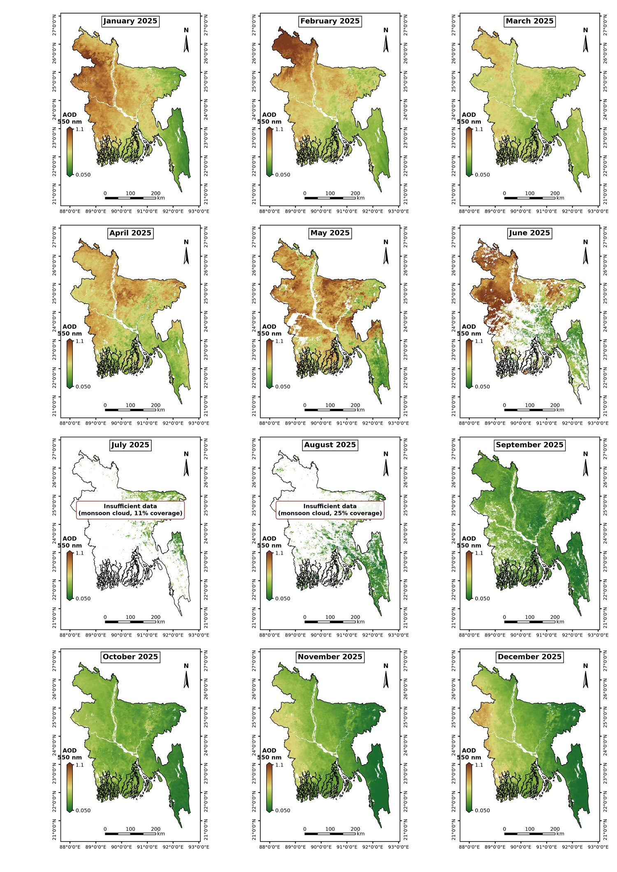
Figure A1. Monthly maps of AOD at 550 nm (median; water masked), Bangladesh 2025.

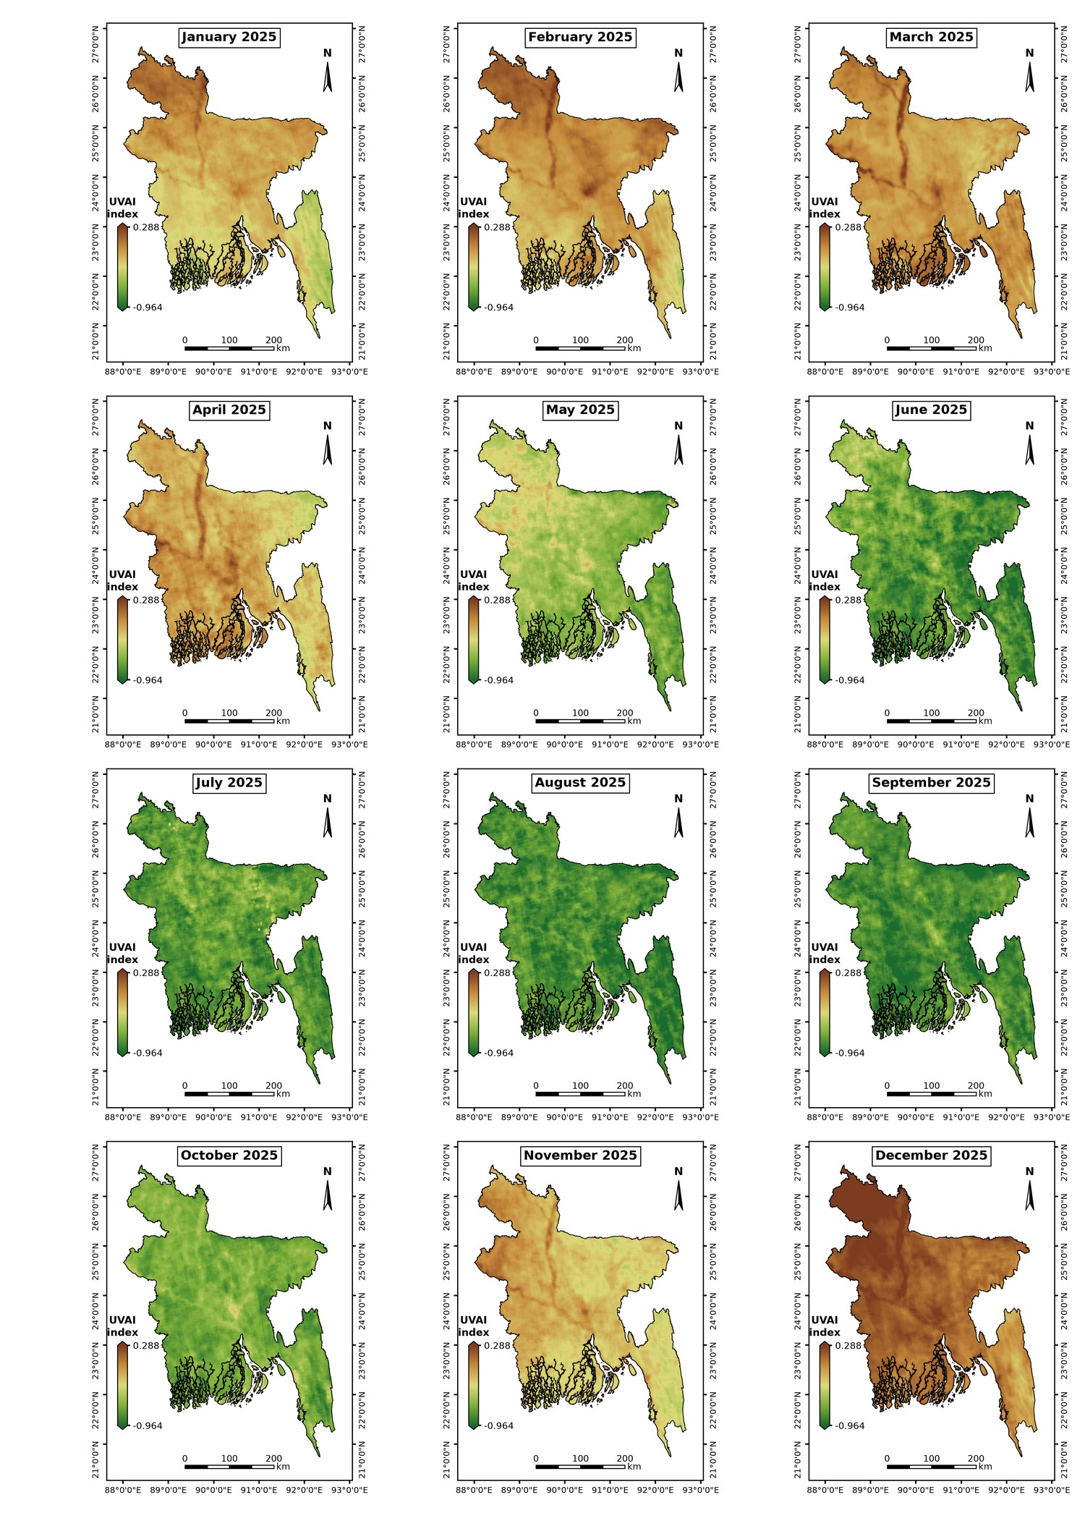
Figure A2. Monthly maps of UV Aerosol Index, Bangladesh 2025.
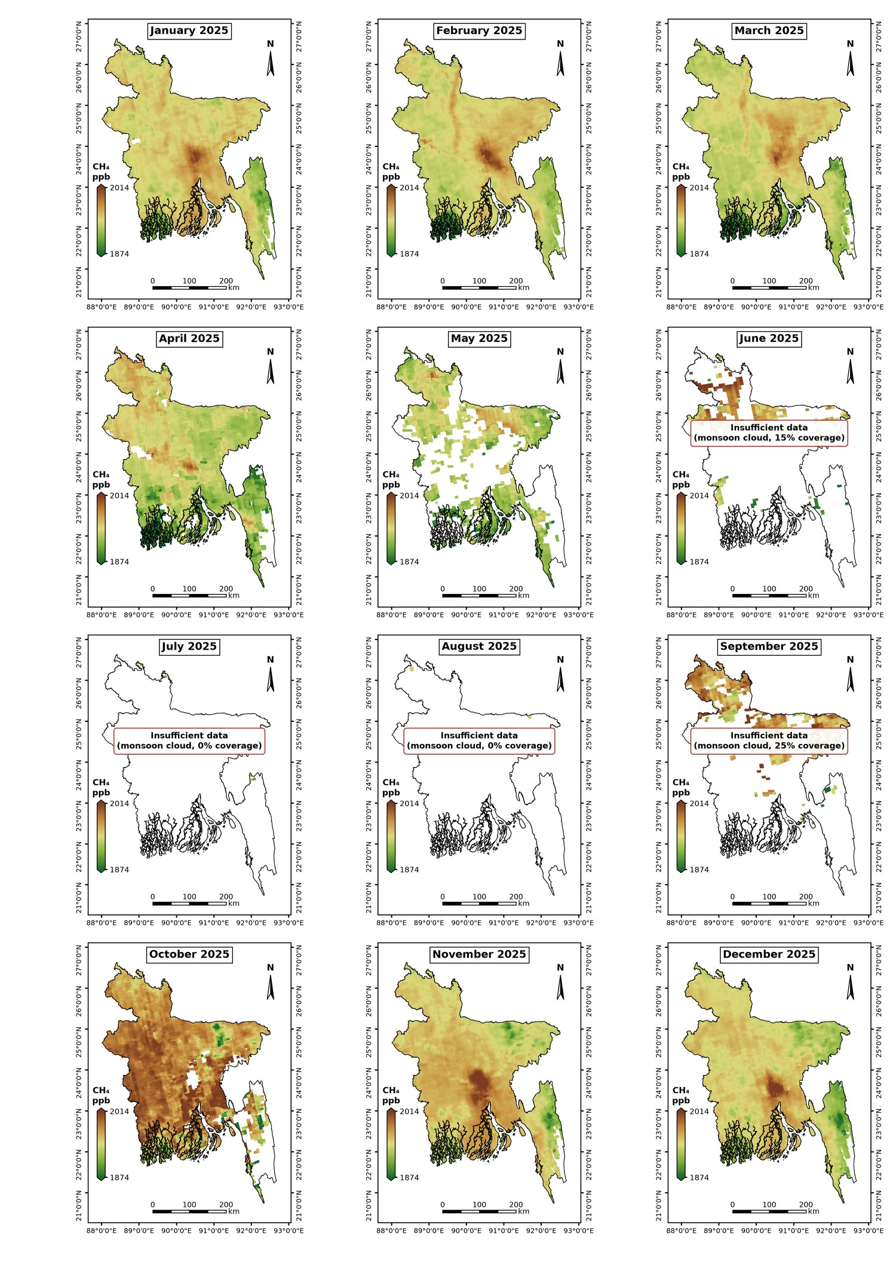
Figure A3. Monthly maps of CH₄ (ppb), Bangladesh 2025.

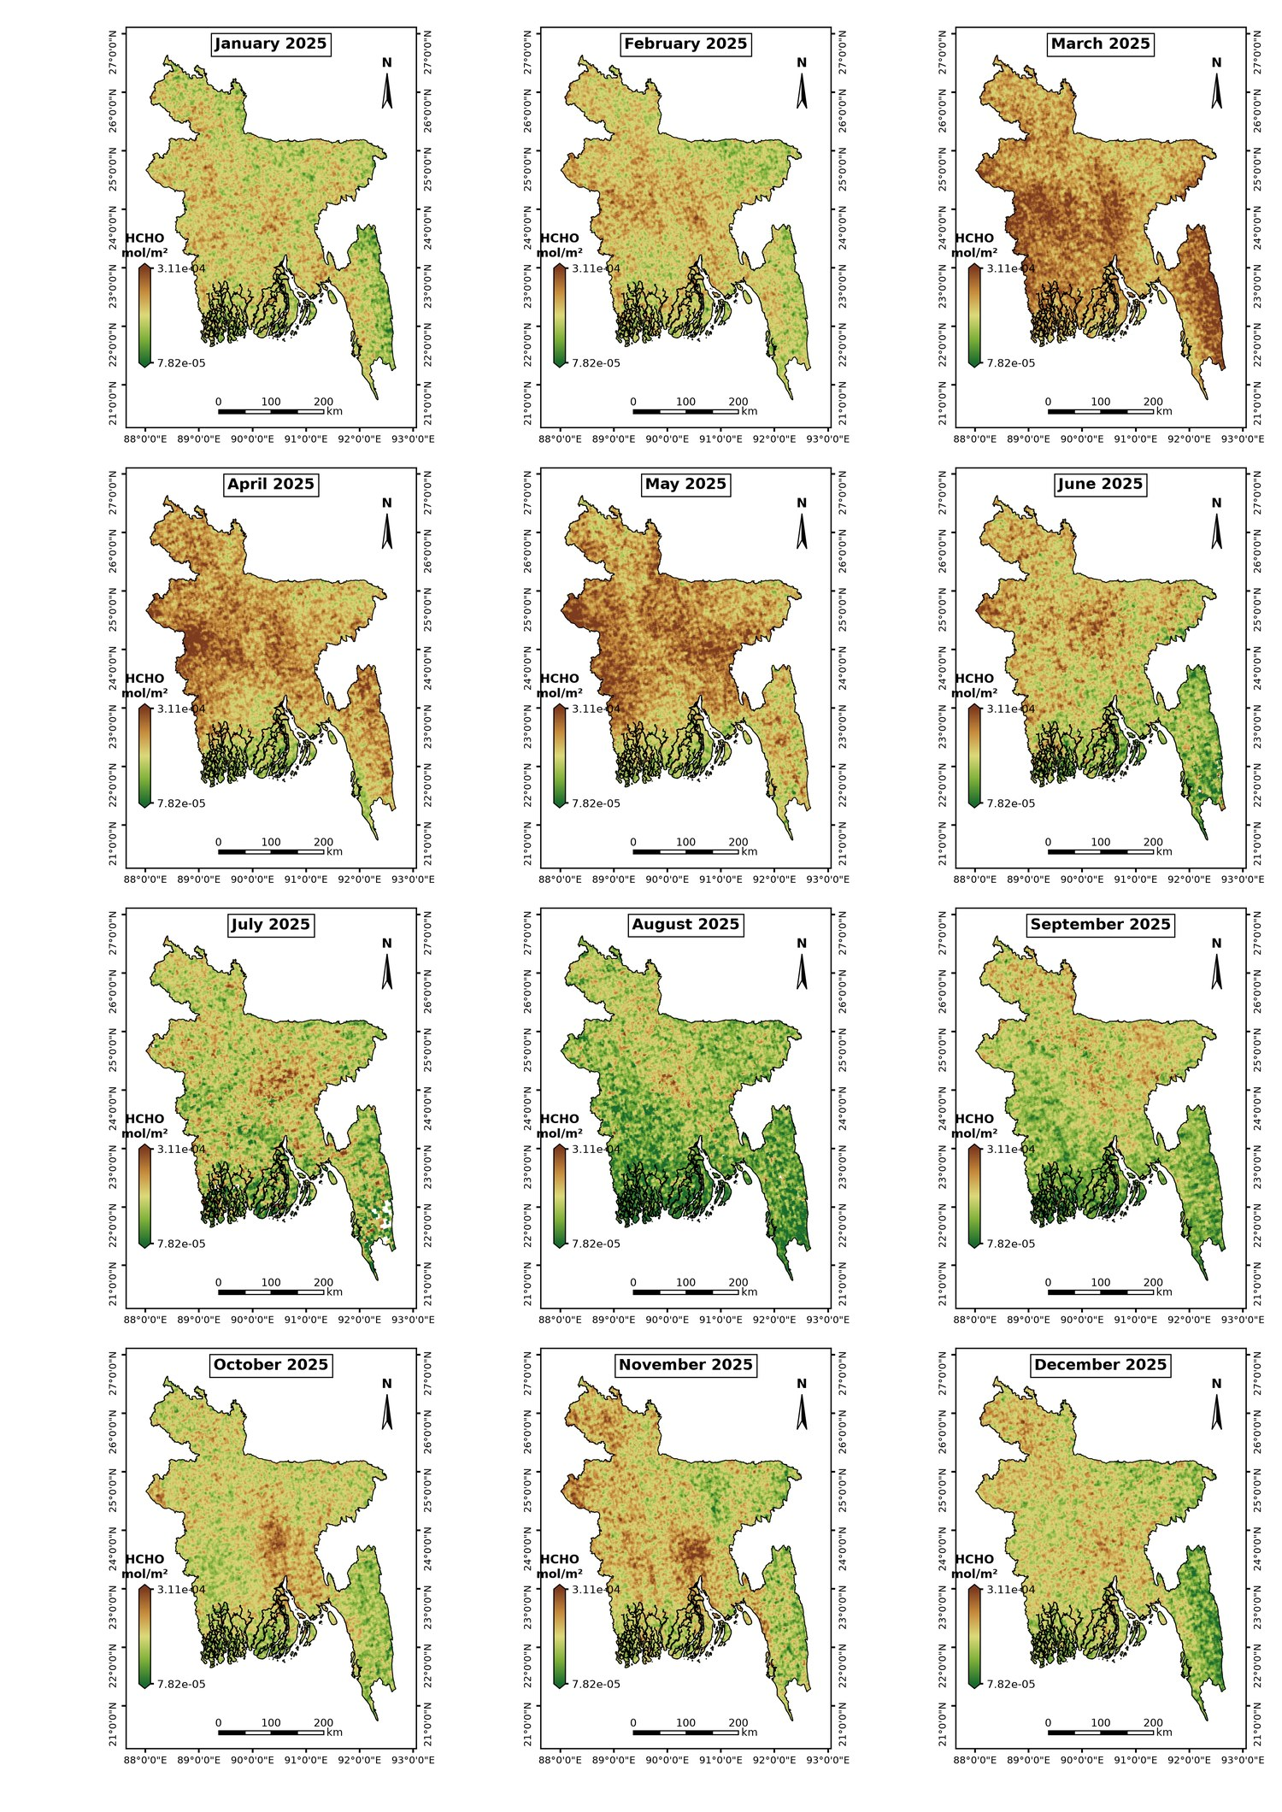
Figure A4. Monthly maps of tropospheric HCHO (mol m⁻²), Bangladesh 2025.
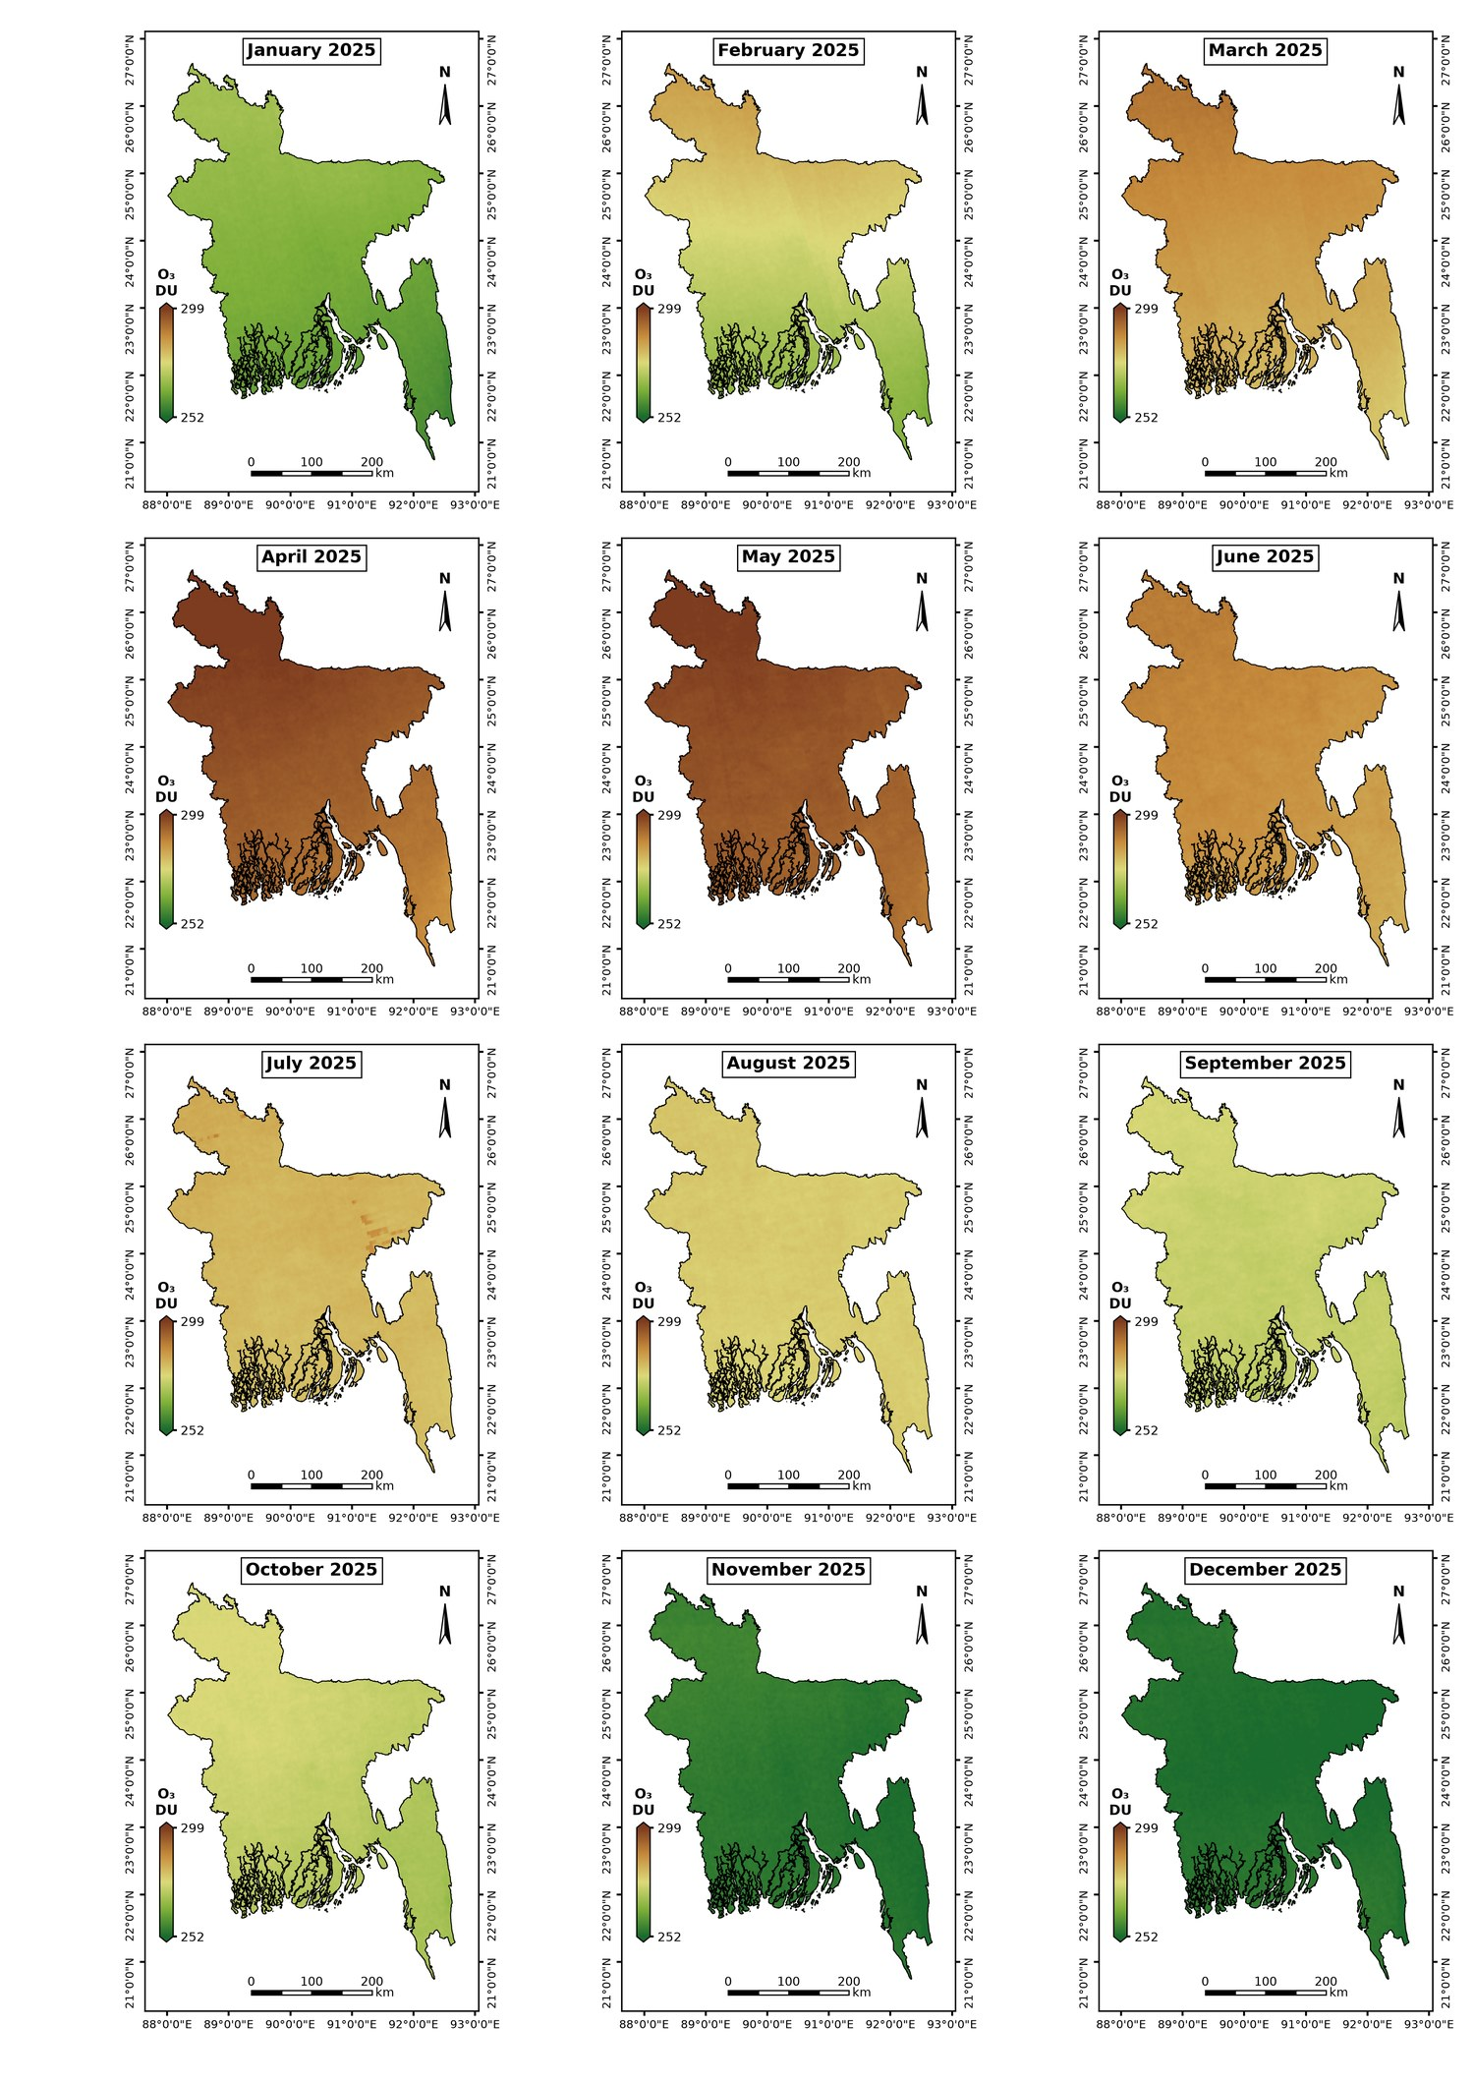
Figure A5. Monthly maps of total-column O₃ (DU), Bangladesh 2025.

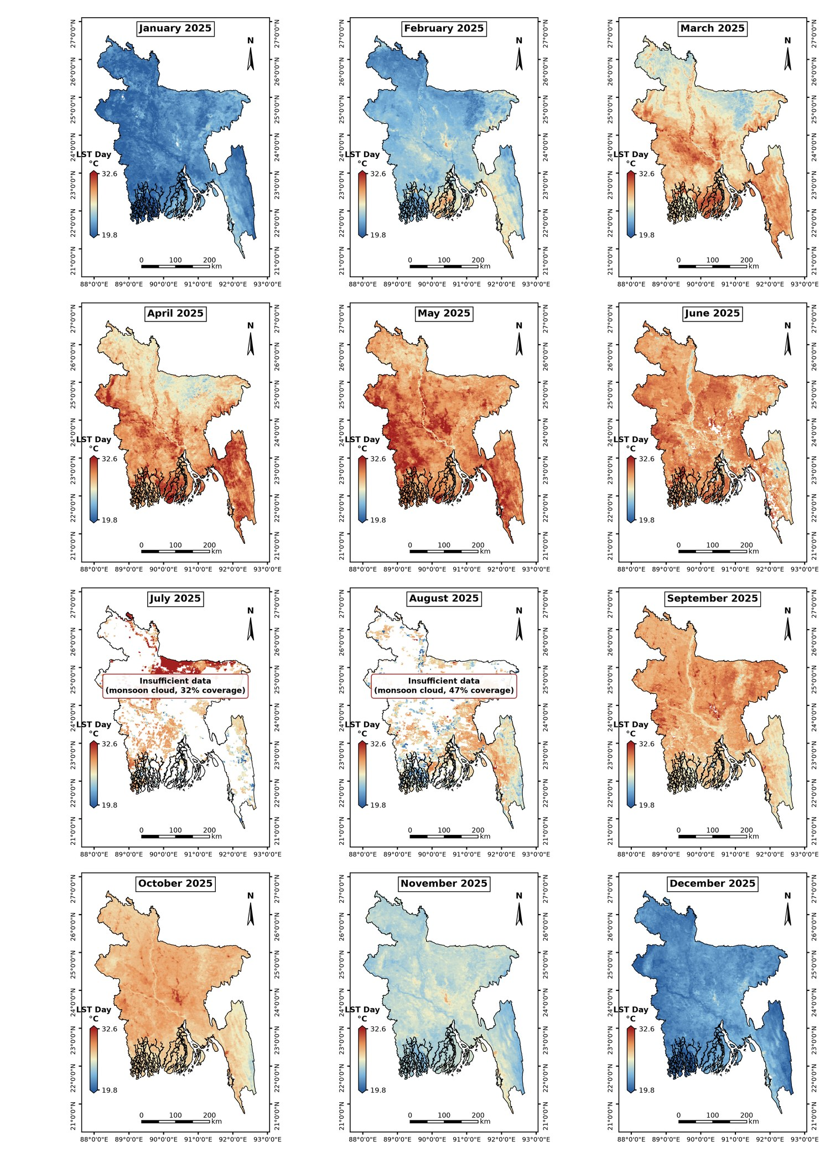
Figure A6. Monthly maps of daytime LST (°C), Bangladesh 2025.

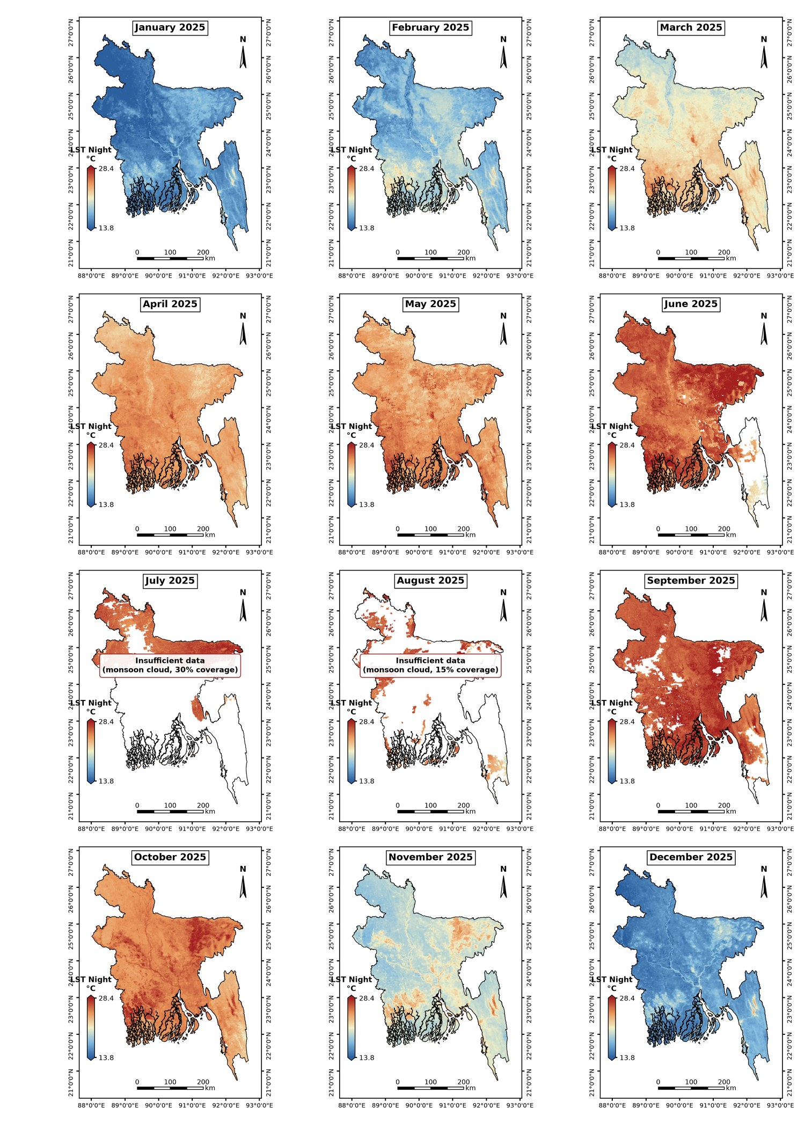
Figure A7. Monthly maps of nighttime LST (°C), Bangladesh 2025.

