WayAbroad
The Autonomous Gateway to Studying Abroad

Business Plan
An AI-powered admissions platform replacing the traditional study-abroad agency
Team 6
Firdavs Tursunov | Chief Executive Officer
Habibullo Chutboev | Chief Technology Officer
Amarbat Otgonbat | Chief Financial Officer
Mikhail Li | Chief Operating Officer
Sunnatjon Jabborov | Chief Product Officer
Jasmina Bakhronova | Chief Marketing Officer
Technology Innovation & Entrepreneurship • Spring 2026
May 2026

Table of Contents

(In Word, select all and press F9 to populate page numbers.)

1. Executive Summary
Every year, millions of students decide to build their futures in a country that is not their own. For most of them, the hardest part is not the studying — it is getting in. The path from “I want to study abroad” to “I have an acceptance letter” runs through a maze of universities, deadlines, document requirements, scholarship rules and visa procedures that almost no eighteen-year-old can navigate alone. Into that gap stepped the recruitment agency, an intermediary that charges families between USD 500 and USD 3,000 to do paperwork a motivated student could, in principle, do themselves. The agency model is opaque, expensive and slow, and it has barely changed in twenty years.
WayAbroad replaces that intermediary with software. We are building the first end-to-end, AI-driven admissions platform that takes a student from profile to enrollment without a human agent in the loop. A student enters their grades, language scores and budget; our recommendation engine returns a ranked shortlist of universities with a transparent admission-probability score; our document engine drafts the statement of purpose, study plan and personal statement; and a step-by-step dashboard walks the student through uploading, applying, tracking and ultimately enrolling — with every cost shown up front and no hidden fees. The student pays nothing for the core journey. Universities, who today spend heavily and inefficiently to recruit international students, pay us for qualified applicants and confirmed enrollments.
We are launching in South Korea, one of the fastest-growing study destinations in Asia and a market where mid-tier universities are actively competing for international enrollment. Korea gives us a focused, winnable beachhead with clear demand and willing institutional payers. From there, our roadmap extends to Japan and the broader Asia-bound student corridor, and ultimately to a global platform serving students wherever they want to go.
Our revenue model is a hybrid of per-lead fees and enrollment-success fees from partner universities, supplemented by premium student services and ancillary partnerships in housing, insurance and fintech. We project revenue of roughly USD 0.70 million in Year 1, USD 2.5 million in Year 2 and USD 6.9 million in Year 3, reaching operating profitability during Year 2. To fund the launch and the first eighteen months of growth, we are raising a seed round of USD 750,000, which sits inside a USD 1.0 million capitalisation that also includes founder capital and Korean government start-up grants.
WayAbroad is led by a six-person founding team spanning product, engineering, operations, finance and marketing. The opportunity is large, the problem is real and painful, and the timing — mature language models, digital-native students and universities under enrollment pressure — has never been better. This plan sets out how we intend to capture it.

2. Company Overview
WayAbroad is an education-technology company headquartered in Incheon, South Korea, founded in 2026 by a team of six. The company operates a software-as-a-service platform that connects internationally mobile students with universities and automates the application process that has traditionally been handled by recruitment agencies. WayAbroad is incorporated as a private limited company and intends to register within South Korea’s K-Startup ecosystem to access grant and accelerator support.
The company exists because the international-education market is enormous yet still runs on manual, relationship-driven recruitment. Universities depend on a fragmented web of regional agents; students depend on word of mouth and expensive consultants. WayAbroad’s thesis is simple: almost everything an agent does — matching, advising, drafting and tracking — is structured, repeatable work that modern AI can do faster, cheaper and more transparently. By owning the digital relationship with the student and selling qualified demand to universities, WayAbroad becomes the default front door to studying abroad rather than one more agency among thousands.
At launch, WayAbroad focuses on inbound applicants to South Korean universities, with a particular emphasis on the mid-tier institutions that most need help attracting international students. The longer-term vision is a single platform on which any student, anywhere, can discover, apply to and enroll in any university abroad — with WayAbroad as the trusted, intelligent layer in between.

3. Mission and Vision Statements

Mission
To make studying abroad accessible, transparent and affordable by giving every student a free, intelligent guide that replaces the costly and opaque agency model with software they can trust.

Vision
A world in which a student’s ambition — not their access to an agent, an advisor or a budget — determines where they can study. WayAbroad aims to be the global operating system for international admissions: the single platform students open when they decide to study abroad, and the channel universities rely on to find the right applicants.

Core Values
- Transparency first. We show real costs, real probabilities and real status. No hidden fees, no inflated promises.
- Student-aligned. Students never pay for the core journey; our incentives are tied to getting them admitted, not to extracting fees.
- Intelligence with accountability. We use AI to do more for students, but every recommendation is explainable and every document is reviewable.
- Built to scale. Every feature is designed to work for one student or one million, across one country or fifty.

4. Problem Statement and Market Need
Studying abroad is a high-stakes, low-information decision, and the people making it are usually doing it for the first and only time. A prospective student faces three compounding problems.
First, discovery is broken. There are thousands of universities and tens of thousands of programs, each with different requirements, deadlines and scholarship rules. Students cannot realistically compare them, so they fall back on whatever a friend, a forum or an agent happens to recommend — which is rarely the best fit for their profile or budget.
Second, the process is intimidating and manual. A single application can require a statement of purpose, a study plan, a personal statement, transcripts, language certificates, financial proof and a visa file, each formatted differently for each institution. Students miss deadlines, submit weak essays and abandon applications halfway through. This is precisely the friction that agencies monetise.
Third, the incumbent solution is expensive and opaque. Traditional agencies charge families USD 500 to USD 3,000 per student, frequently while also collecting commissions from universities — a double-dip the student never sees. Costs are vague, timelines are hidden, and the student has little visibility into where their application actually stands. Trust is low and complaints are common.
The market need, therefore, is for a transparent, low-cost, guided path to enrollment that does the hard work for the student and shows them exactly what is happening at every step. On the other side of the same transaction, universities — especially mid-tier institutions competing for tuition-paying international students — need a more efficient, measurable channel than the scattered agent networks they rely on today. WayAbroad is built to serve both needs with a single platform.

5. Product or Service Description
WayAbroad is a web and mobile platform that guides a student through the entire admissions journey. Five connected modules turn what is today a stressful, agent-mediated process into a transparent, self-service experience.

5.1 AI Application Assistant
The student enters their academic record (GPA), language scores (IELTS, TOPIK or equivalent) and budget. The assistant returns a ranked shortlist of universities and programs matched to that profile, together with realistic scholarship prospects. Instead of guessing, the student starts from a curated, data-driven set of options.

5.2 Admission Probability Engine
Our headline feature scores each recommended program with a clear admission probability — for example, “72% likelihood of admission to Inha University.” The score is generated from historical admission patterns, program selectivity and the student’s profile, and it is presented with the factors that drive it so students understand how to improve their odds. This converts anxiety into informed strategy and is the feature judges, students and partners remember.

5.3 Auto-Document Generator
This is where WayAbroad replaces the bulk of an agency’s value. Based on the student’s profile and target program, the system drafts a tailored Statement of Purpose, Personal Statement and Study Plan, which the student can edit and refine. What used to take an agency hours of paid work — the single most valuable thing they sell — becomes an instant, editable draft the student owns.

5.4 Step-by-Step Smart Dashboard
Rather than a list of instructions, the dashboard is an interactive, mission-style tracker: upload passport, complete the auto-filled application form, submit to the university, prepare for interview. Each step is clearly defined, pre-filled where possible and checked off as it is completed, so the student always knows exactly what to do next.

5.5 Real-Time Tracking and Cost Transparency
Students see live application status — “documents received,” “under review,” “interview required” — instead of waiting in the dark as they do with agencies. A built-in cost engine breaks down tuition, dormitory fees, visa costs and living expenses for each option, so families can plan with full visibility and no surprises.

5.6 Technology
The platform is built on a modern cloud stack with large-language-model services powering the document generator and an AI advisory chatbot trained on Korean university admissions. The probability engine combines a rules-based eligibility layer with a statistical model refined as enrollment outcomes accumulate — a data advantage that compounds with every application processed and is difficult for a late entrant to replicate.

6. Industry and Market Analysis
International higher education is a large and structurally growing industry. Globally, the number of internationally mobile students has climbed past six million and continues to rise as middle-class families across Asia, Central Asia and Africa pursue foreign credentials. South Korea has positioned itself as a deliberate beneficiary of this trend: government policy actively targets a substantial increase in international enrollment, and universities — facing a sharp domestic demographic decline — are under real pressure to recruit abroad. For our beachhead, that combination of policy tailwind and institutional urgency is close to ideal.
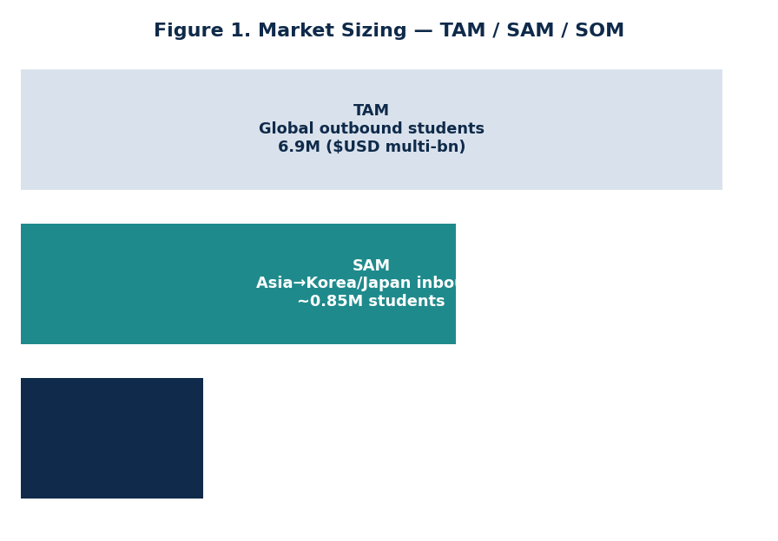
Figure 1. Market sizing — total, serviceable and obtainable markets.
We frame our opportunity in three layers. The total addressable market is the global pool of internationally mobile students, a multi-billion-dollar recruitment economy. Our serviceable available market is the cohort of students bound for South Korea and, in the next phase, Japan — on the order of several hundred thousand applicants annually. Our serviceable obtainable market is the share we can realistically capture as platform users within three years: a target of roughly 60,000 registered students by Year 3, of whom a growing fraction convert into university enrollments.

6.1 Industry Forces
Applying Porter’s framework clarifies why this market is attractive for a software entrant. The threat of new entrants is moderate: building a credible probability engine and university partnerships takes time and data, which creates a defensible head start. Supplier power — here, the universities — is real but declining, because demographic pressure makes institutions more eager for qualified applicants than students are for any single school. Buyer power among students is high in the sense that they can walk away, which is exactly why a free, superior product wins them. Substitutes — doing it yourself, or using an agency — are weak: one is overwhelming, the other is expensive and opaque. Rivalry exists among agencies and a handful of portals, but none combine free guidance, document automation and probability scoring in one place.
The decisive industry trends all point our way: the maturation of generative AI makes high-quality document automation possible for the first time; students are digital-native and expect self-service; and universities are increasingly willing to pay for measurable, performance-based recruitment instead of opaque agent commissions. WayAbroad is built precisely at the intersection of these three shifts.

7. Target Audience and Customer Segmentation
WayAbroad serves a two-sided market. On one side are students, our users and the source of demand; on the other are universities, our paying customers. Within each side we focus tightly at launch.
Segment | Profile | Why they choose WayAbroad
Primary students | Undergraduate and master’s applicants from Central Asia, Southeast Asia and the CIS region aiming for Korea; price-sensitive, digitally fluent, first-generation international applicants | Free, guided, transparent alternative to a USD 1,000+ agency
Secondary students | Domestic students in Korea and elsewhere planning a later move to Japan or the West | Single trusted platform across destinations
Primary universities | Mid-tier Korean institutions actively recruiting international, tuition-paying students | Qualified, measurable applicant flow at lower cost than agents
Ancillary partners | Student housing, insurance and fintech providers targeting newly admitted students | High-intent audience at the moment of enrollment
Table 1. Customer segmentation across both sides of the platform.
Our initial wedge is the price-sensitive, ambitious student from Central Asia and Southeast Asia heading to a mid-tier Korean university — a student for whom a USD 1,000 agency fee is a genuine barrier and for whom transparency and free guidance are powerful draws. These students are also highly networked: they share recommendations within tight communities, which makes word-of-mouth growth fast and cheap once trust is established. On the paying side, we concentrate on mid-tier universities first, because they have the strongest need for international enrollment and the least leverage to ignore a new, performance-based channel.

8. Competitive Analysis
The competitive field divides into three groups: traditional recruitment agencies, online study-abroad portals and aggregators, and the do-it-yourself path. None offers what WayAbroad does — a free, AI-guided, end-to-end journey with transparent costs and admission probability — in a single product.
Capability | Agencies | Online portals | Do-it-yourself | WayAbroad
Cost to student | USD 500–3,000 | Low / ads | Free | Free
AI document drafting | No | No | No | Yes
Admission probability | Guess | No | No | Yes
Cost transparency | Low | Partial | Self-research | Full
Real-time tracking | Hidden | Limited | None | Live
Scalability | Low | Medium | n/a | High
Table 2. Competitive comparison across the study-abroad landscape.
Agencies remain our most direct competitor because they own the status quo and the trust of parents. Our answer is not to undercut their price but to remove it entirely for students while delivering a better experience, and to fund the business from the university side instead. Portals and aggregators generate leads but stop short of guiding the student through application and enrollment; we go all the way to the acceptance letter. The do-it-yourself path is free but overwhelming, and it is exactly the friction our product eliminates.
Our durable advantages are threefold: a proprietary admission-probability model that improves with every outcome we observe; a document-automation engine that delivers an agency’s most valuable service instantly and for free; and a two-sided network in which more students attract more universities and more universities make the platform more useful to students. These compound over time and are difficult for a late entrant or a legacy agency to copy.

9. Marketing and Branding Strategy
WayAbroad’s brand promise is captured in one line: the autonomous gateway to studying abroad. The positioning is deliberately not “a cheaper agency” but “the platform that makes agencies unnecessary.” Everything in the brand — a clean, trustworthy visual identity, transparent language and a confident, student-first tone — reinforces the message that WayAbroad is on the student’s side.

9.1 Acquisition Channels
Because our core users are digitally native and tightly networked, our growth strategy is built around organic and community-led channels supplemented by targeted paid acquisition:
- Community and referral. In-product referral rewards and ambassador programs in source-country student communities, where a single trusted recommendation travels fast.
- Content and search. SEO-optimised guides on “how to study in Korea,” scholarship explainers and free probability checks that draw high-intent students and rank for the queries they actually type.
- Social and short-form video. Localised content on the platforms each source market uses, featuring real admission stories and the probability engine in action.
- University co-marketing. Joint campaigns with partner universities that want visibility with qualified applicants, which lowers our acquisition cost while serving the paying customer.

9.2 Funnel and Trust
The free probability check is our top-of-funnel hook: a student arrives, enters a profile and immediately receives a personalised result and shortlist, with no payment and no sign-up friction. From there, the dashboard and document generator convert curiosity into committed applications. Trust — the scarce resource in this market — is earned through transparency: published costs, visible application status and verified university partners. As outcomes accumulate, success stories become our most persuasive marketing asset.

10. Operational Plan
WayAbroad operates as a lean, software-first company. Day-to-day operations fall into four areas: product and engineering, which build and maintain the platform and AI models; university partnerships, which sign and service institutional customers and integrate their requirements; student success, which provides light-touch support and quality review of AI-generated documents; and growth, which runs acquisition and brand. Most of the value chain — matching, drafting, tracking — is automated, so headcount scales far more slowly than user volume.

10.1 How the Platform Runs
A typical cycle works as follows. A student completes their profile and receives recommendations and a probability score in minutes. They generate and refine their documents, then submit applications through the dashboard. WayAbroad routes qualified applications to partner universities through agreed channels, tracks status back to the student, and records the eventual outcome. Each confirmed enrollment triggers a success fee, and each qualified application a lead fee. Human staff intervene only for edge cases, premium consulting and quality assurance — keeping marginal cost per student low.

10.2 Milestones
Phase | Timeline | Key milestones
Build | Q3–Q4 2026 | Launch MVP; sign first 8–12 Korean university partners; first 1,000 student profiles
Validate | 2027 | Scale to 25,000 students and 30+ partners; reach operating breakeven; launch premium tier
Expand | 2028 | Enter Japan; 60,000 students; broaden ancillary partnerships; prepare Series A
Scale | 2029+ | Multi-region global platform; deepen data moat; pursue international expansion
Table 3. Operational roadmap and milestones.

11. Management and Organizational Structure
WayAbroad is led by six co-founders whose responsibilities map cleanly onto the company’s functional needs. The team combines technical depth, operational discipline and market-side understanding of the very students the platform serves — several founders have themselves navigated international admissions, which is a meaningful source of product insight.
Founder | Role | Responsibility
Firdavs Tursunov | CEO | Vision, fundraising, university partnerships and overall strategy
Habibullo Chutboev | CTO | Platform architecture, AI models and the probability engine
Amarbat Otgonbat | CFO | Financial planning, unit economics, grants and investor relations
Mikhail Li | COO | Operations, student success and partnership delivery
Sunnatjon Jabborov | CPO | Product design, user experience and the document generator
Jasmina Bakhronova | CMO | Brand, growth marketing and community
Table 4. Founding team and responsibilities.
In the first year the team stays deliberately small, supplemented by a handful of engineers, a partnerships manager and part-time student-success staff. As the company scales we will add a head of data to strengthen the probability model, regional partnership leads for new markets, and an advisory board drawn from international-education and SaaS backgrounds. Equity is shared among the founders with a standard vesting schedule, and an option pool is reserved for early hires.

12. Revenue Model and Pricing Strategy
WayAbroad is free for students by design. We monetise the value we create for universities and the convenience we offer at the moment of enrollment. The model has four streams, anchored by a hybrid university fee that mirrors how the industry already pays for recruitment — but on transparent, performance-based terms.
Stream | Pricing | Rationale
University lead fee | USD 30–34 per qualified applicant | Universities pay for measurable, pre-qualified demand
Enrollment success fee | USD 800–950 per confirmed enrollment | Performance-based; far below an agent’s cost per student
Premium student services | USD 99–149 per student | Optional advanced essay editing and 1-on-1 consulting
Ancillary partnerships | Referral / placement fees | Housing, insurance and fintech reaching high-intent students
Table 5. Revenue streams and pricing logic.
The hybrid university fee is central. A single international student represents USD 20,000–40,000 of tuition over a degree, so a university that pays USD 30 for a qualified lead and USD 800–950 on successful enrollment is acquiring a highly profitable customer at a fraction of the lifetime value — and at a lower, more measurable cost than traditional agents. For students, keeping the core journey free removes the single largest barrier to adoption and is the foundation of the trust the brand depends on. Premium services and ancillary partnerships then layer incremental margin on top of a user base we acquired without charging them.

13. Financial Projections and Funding Requirements
Our projections are built bottom-up from the unit economics above: registered students, the share that become qualified leads, the share that convert to enrollment, and the four revenue streams. They are deliberately conservative on conversion and realistic on cost, and they show a business that approaches breakeven in Year 1, turns profitable in Year 2 and scales strongly into Year 3.
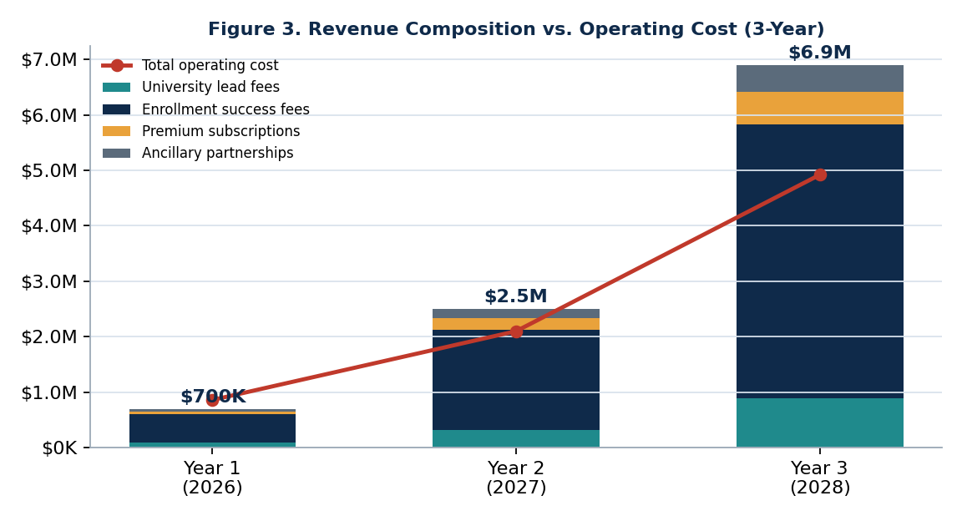
Figure 3. Three-year revenue composition versus total operating cost.

13.1 Three-Year Projection
Metric (USD) | Year 1 (2026) | Year 2 (2027) | Year 3 (2028)
Registered students | 8,000 | 25,000 | 60,000
Confirmed enrollments | 600 | 2,000 | 5,200
University lead fees | 90,000 | 320,000 | 884,000
Enrollment success fees | 510,000 | 1,800,000 | 4,940,000
Premium services | 51,600 | 208,500 | 596,000
Ancillary partnerships | 48,000 | 180,000 | 480,000
Total revenue | 699,600 | 2,508,500 | 6,900,000
Total operating cost | 860,000 | 2,100,000 | 4,920,000
Net income | (160,400) | 408,500 | 1,980,000
Table 6. Summary three-year financial projection.

13.2 Start-up Costs
The capital required to launch and reach validation is modest by software standards because the product, not headcount, does the work. Estimated start-up costs over the first year total USD 500,000:
Start-up cost item | Amount (USD) | Share
Product & platform development (MVP) | 120,000 | 24%
AI model integration & data | 60,000 | 12%
Initial marketing & launch | 90,000 | 18%
Working capital reserve | 150,000 | 30%
Legal, incorporation, IP & compliance | 35,000 | 7%
Branding & website | 25,000 | 5%
Office & equipment (lean) | 20,000 | 4%
Total start-up costs | 500,000 | 100%
Table 7. Estimated first-year start-up costs.

13.3 Funding Requirement and Sources
WayAbroad is raising a seed round of USD 750,000, which together with founder capital, friends-and-family contributions and Korean government start-up grants forms a USD 1.0 million capitalisation. This funds the eighteen-month path to profitability with a comfortable buffer, covering product development, the launch marketing push and the Year 1 operating burn before enrollment revenue compounds.
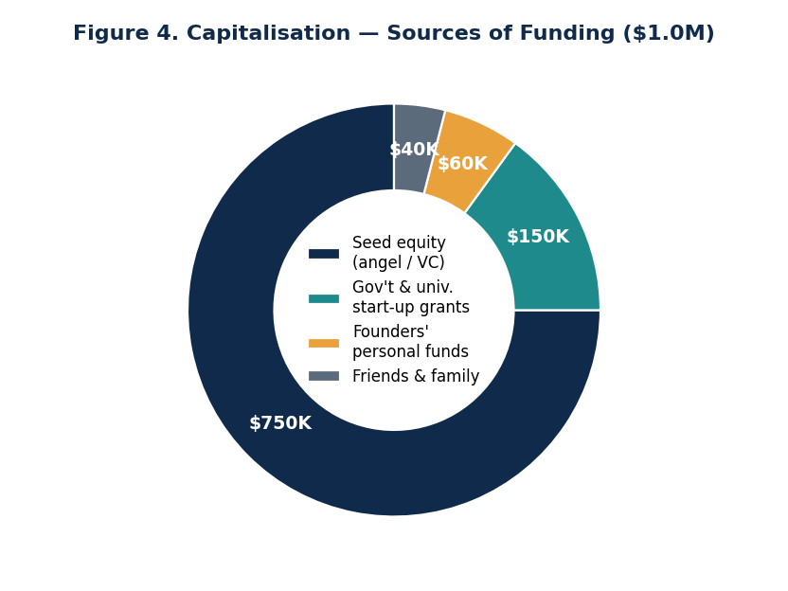
Figure 4. Sources of funding across the USD 1.0M capitalisation.
Source of funding | Amount (USD) | Type
Seed equity (angel / VC) | 750,000 | Equity
Government & university start-up grants | 150,000 | Grant
Founders’ personal funds & sweat equity | 60,000 | Personal
Friends & family | 40,000 | Personal
Total capitalisation | 1,000,000
Table 8. Projected sources of funding.
The seed equity is offered at terms implying a pre-money valuation in the region of USD 4.5–5.0 million, consistent with an early-stage two-sided marketplace in a large market with a working product and signed launch partners. Government grants are non-dilutive and align well with Korea’s policy goal of growing international enrollment, making them a natural and credible part of our stack.

14. Growth Strategy and Future Expansion
Our growth follows a focused, three-stage path that protects the quality of the early experience while building toward a global platform. Stage one is to win Korea: dominate the inbound-to-Korea corridor by signing mid-tier universities and building a loyal student base whose success stories fuel referral growth. Concentrating here lets us perfect the product, prove the unit economics and accumulate the outcome data that sharpens our probability engine.
Stage two is regional expansion into Japan and adjacent destinations that share the same structural conditions — demographic decline, government appetite for international students and a fragmented agency layer ripe for disruption. Because the platform and AI infrastructure are destination-agnostic, each new corridor reuses the same engine with localised content and partnerships, so expansion is largely a go-to-market exercise rather than a rebuild.
Stage three is the global vision: a single platform on which a student anywhere can discover, apply to and enroll in a university anywhere. At that scale, the data moat becomes formidable — a probability engine trained on millions of real outcomes is something no agency and no late entrant can match. Adjacent revenue opportunities (student finance, relocation, alumni services) open naturally once we own the enrollment relationship. This expansion will be supported by a planned Series A once the Japan corridor is validated.

15. Risk Analysis and Mitigation
A clear-eyed view of the risks is part of why we are confident in the plan. The most material risks, and our responses, are summarised below, followed by a SWOT overview.
Risk | Impact | Mitigation
University adoption is slow | Limits the revenue side of the marketplace | Start with mid-tier institutions with the highest recruitment need; performance-based pricing lowers their risk of trying us
AI-generated documents lack quality or authenticity | Erodes student trust and university confidence | Human quality review, editable drafts, and clear positioning as a drafting aid, not a ghostwriter
Probability scores are inaccurate early on | Damages the headline feature’s credibility | Present scores with confidence ranges; refine continuously as real outcomes accumulate
Regulatory / visa policy changes | Could affect demand in a corridor | Diversify across destinations; maintain compliance and policy monitoring
Incumbents react competitively | Competitive pressure on growth | Move fast on the data moat and two-sided network that are hard to copy
Table 9. Principal risks and mitigations.

15.1 SWOT Analysis
Strengths | Weaknesses
• Free-to-student model removes the biggest adoption barrier  • Proprietary probability engine and document automation  • Lean, scalable, software-first cost structure | • Early-stage brand with limited trust to start  • Dependence on signing enough university partners  • Unproven probability model until data accumulates
Opportunities | Threats
• Korea’s policy push and demographic-driven recruitment need  • Maturing AI makes automation newly possible  • Large, fragmented global market open to disruption | • Agencies or portals copying features  • Visa or regulatory shifts in key corridors  • AI policy changes affecting document generation
Table 10. SWOT analysis.

16. Conclusion
Studying abroad is one of the most consequential decisions a young person makes, and for too long it has been gatekept by an expensive, opaque intermediary. WayAbroad removes that gatekeeper. By giving students a free, intelligent, transparent path from profile to enrollment — and by selling the qualified demand we create to the universities that need it — we align our success with the student’s success and build a business with attractive, compounding economics.
The market is large and growing, the timing is right, and our beachhead in Korea is focused and winnable. With a working product, a clear monetisation model, a committed founding team and a USD 750,000 seed round, WayAbroad is positioned to become the default front door to international education — first in Korea, then across Asia, and ultimately worldwide. We invite partners and investors to help us build it.

17. References
Barringer, B. R., & Ireland, R. D. (2019). Entrepreneurship: Successfully Launching New Ventures (6th ed.). Pearson.
Kim, V. (2026). Technology Innovation & Entrepreneurship — Course Materials, Chapters 1–11. Inha University.
OECD. (2024). Education at a Glance 2024: International Student Mobility. OECD Publishing.
UNESCO Institute for Statistics. (2024). Global Flow of Tertiary-Level Students. UNESCO.
Korean Ministry of Education. (2023). Study Korea 300K Project: Plan to Attract International Students.
Institute of International Education. (2024). Project Atlas: Global Student Mobility Trends.
Porter, M. E. (2008). The Five Competitive Forces That Shape Strategy. Harvard Business Review.
Osterwalder, A., & Pigneur, Y. (2010). Business Model Generation. John Wiley & Sons.

18. Appendix

Appendix A — Key Operating Assumptions
Assumption | Value used in model
Profile-to-qualified-lead rate | ~37–43%
Lead-to-enrollment conversion | 7–9%
Average lead fee | USD 30–34
Average enrollment success fee | USD 800–950
Premium attach rate | ~5–7% of students
Operating breakeven | During Year 2 (2027)
Table A1. Core assumptions underlying the financial model.

Appendix B — Business Model Canvas (Summary)
Building block | WayAbroad | Notes
Value proposition | Free, AI-guided, transparent path to enrollment | Students; universities get qualified demand
Customer segments | Outbound students; mid-tier universities | Two-sided market
Channels | Web/mobile app, SEO, community, co-marketing | Digital-first
Revenue streams | Lead + enrollment fees, premium, ancillary | Hybrid model
Key resources | Probability engine, document AI, partnerships | Data moat
Cost structure | Engineering, AI/cloud, marketing, G&A | Lean, scalable
Table A2. Business model canvas summary.

Appendix C — Glossary
SOP — Statement of Purpose. TOPIK — Test of Proficiency in Korean. TAM/SAM/SOM — Total / Serviceable Available / Serviceable Obtainable Market. CAC — Customer Acquisition Cost. LTV — Lifetime Value. SaaS — Software as a Service.

