Power BI: Theoretical Questions and Answers
1. Power BI’da visual nima?
Visual — ma’lumotlarni grafik, jadval, diagramma yoki boshqa ko‘rinishda aks ettiruvchi element.
2. Dashboard va report o‘rtasidagi farq nimada?
Dashboard — bir nechta muhim ma’lumotlarni bitta sahifada ko‘rsatadi. Report esa bir yoki bir nechta sahifadan iborat batafsil tahlildir.
3. Qaysi holatda Table visual ishlatiladi?
Ma’lumotlarni satr va ustunlar ko‘rinishida batafsil ko‘rsatish kerak bo‘lganda ishlatiladi.
4. Qaysi holatda Bar chart ishlatiladi?
Kategoriyalar yoki qiymatlarni bir-biri bilan taqqoslash kerak bo‘lganda ishlatiladi.
5. Slicer nima va nima uchun ishlatiladi?
Slicer — ma’lumotlarni tanlangan qiymat bo‘yicha filtrlash uchun ishlatiladigan interaktiv filter.
6. Visual ichida filter qilish qanday ishlaydi?
Filter tanlanganda visual faqat belgilangan shartga mos ma’lumotlarni ko‘rsatadi.
7. Measure vizuallarda qanday rol o‘ynaydi?
Measure hisoblangan natijalarni, masalan Total Sales yoki Average Sales qiymatlarini visualda ko‘rsatadi.
8. Nima uchun DAX visual bilan birga ishlatiladi?
DAX yordamida Measure va hisob-kitoblar yaratiladi, natijalar esa visual orqali ko‘rsatiladi.
9. Aggregation (SUM, AVERAGE) visualda qanday ishlaydi?
SUM qiymatlarni yig‘adi, AVERAGE esa ularning o‘rtacha qiymatini hisoblaydi.
10. Cross-filtering nima?
Cross-filtering — bitta visualdagi ma’lumot tanlanganda boshqa vizuallarning ham shu tanlov asosida filtrlanishidir.

2. DAX Tasks
Calculated Column
1. FullLocation ustuni yarating:
City & " - " & RoadName
Quyidagi kod orqali “FullLocation” nomli yangi ustun yaratildi.
FullLocation = traffic_congestion_data[City] & " - " & traffic_congestion_data[RoadName]
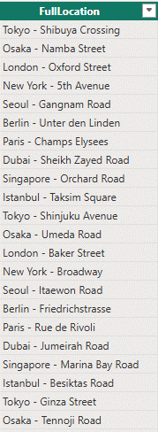
2. Year ustuni yarating:
YEAR(Date)
Year ustunini yaratish kodi: Year = YEAR(traffic_congestion_data[Date])
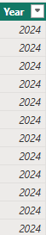
3. Month ustuni yarating:
MONTH(Date)
Year ustunini yaratish kodi:
Month = MONTH(traffic_congestion_data[Date])
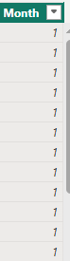
4. VehicleType ustunini katta harfga o‘tkazing
VehicleType_Upper = UPPER(traffic_congestion_data[VehicleType])
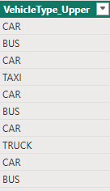
5. RoadName uzunligini hisoblang
RoadName_Length = LEN(traffic_congestion_data[RoadName])
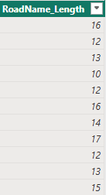

6. Traffic category ustuni yarating:
agar CongestionLevel = "High" bo‘lsa → "High Traffic", aks holda "Normal"
Traffic_Category =
IF(
traffic_congestion_data[CongestionLevel] = "High",
"High Traffic",
"Normal"
)
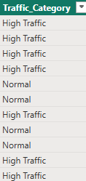

Measure
7. Total TrafficVolume measure yarating
Total TrafficVolume = SUM(traffic_congestion_data[TrafficVolume])
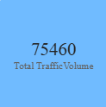
8. Average Speed measure yarating
Average Speed = AVERAGE(traffic_congestion_data[AverageSpeed])
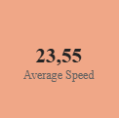
9. Total SignalDelay measure yarating
Total SignalDelay = SUM(traffic_congestion_data[SignalDelay])
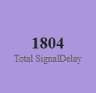
10. Record count measure yarating
Record count = COUNTROWS(traffic_congestion_data)
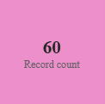
11. Max CongestionIndex measure yarating
Max CongestionIndex = MAX(traffic_congestion_data[CongestionIndex])
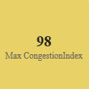
12. Min CongestionIndex measure yarating
Min CongestionIndex = MIN(traffic_congestion_data[CongestionIndex])
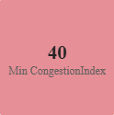

3. Visual Tasks
1. Table visual yarating:
o City
o RoadName
o TrafficVolume
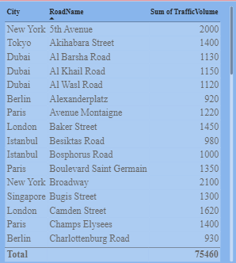
2. Bar chart yarating:
o Axis: City
o Values: Total TrafficVolume
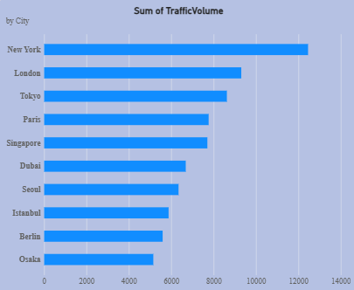
3. Column chart yarating:
o Axis: VehicleType
o Values: Total TrafficVolume
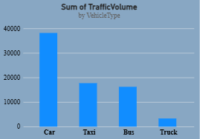
4. Line chart yarating:
o Axis: Date
o Values: Total TrafficVolume
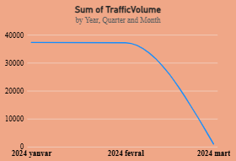
5. Card visual yarating:
o Total TrafficVolume
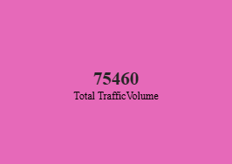
6. Pie chart yarating:
o Legend: CongestionLevel
o Values: TrafficVolume
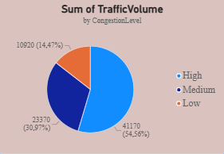
7. Slicer qo‘shing:
o City
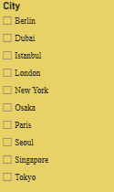
8. Slicer qo‘shing:
o VehicleType
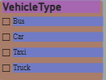
9. Visual’lar o‘zaro qanday bog‘lanishini kuzating (cross-filtering)
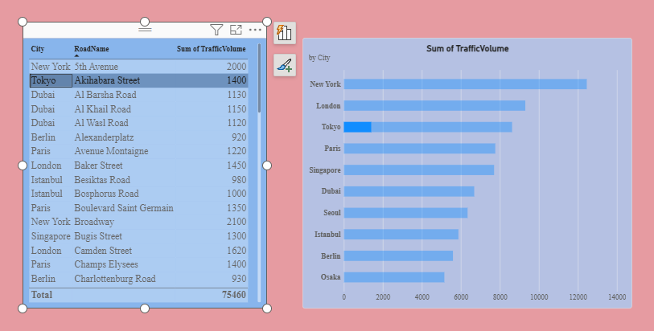
10. Vizualni formatlang:
• Title qo‘shing
• Ranglarni o‘zgartiring
• Data labels yoqing
Har bir vizualga ranglar, title va data labelslar mos ravishda shakllantirilgan.

