[Date]

Advanced programing in C++

Assignment 06th July 2023

|  |  |
| --- | --- |
| Group Member | Reg. Number |
| NDAYISHIMIYE Habibu | 222005474 |
| UWABABYEYI MBABAZI Aline | 222009293 |
| IRADUKUNDA Bonheur | 222005615 |
|  |  |
|  |  |
|  |  |
|  |  |

QUESTION1 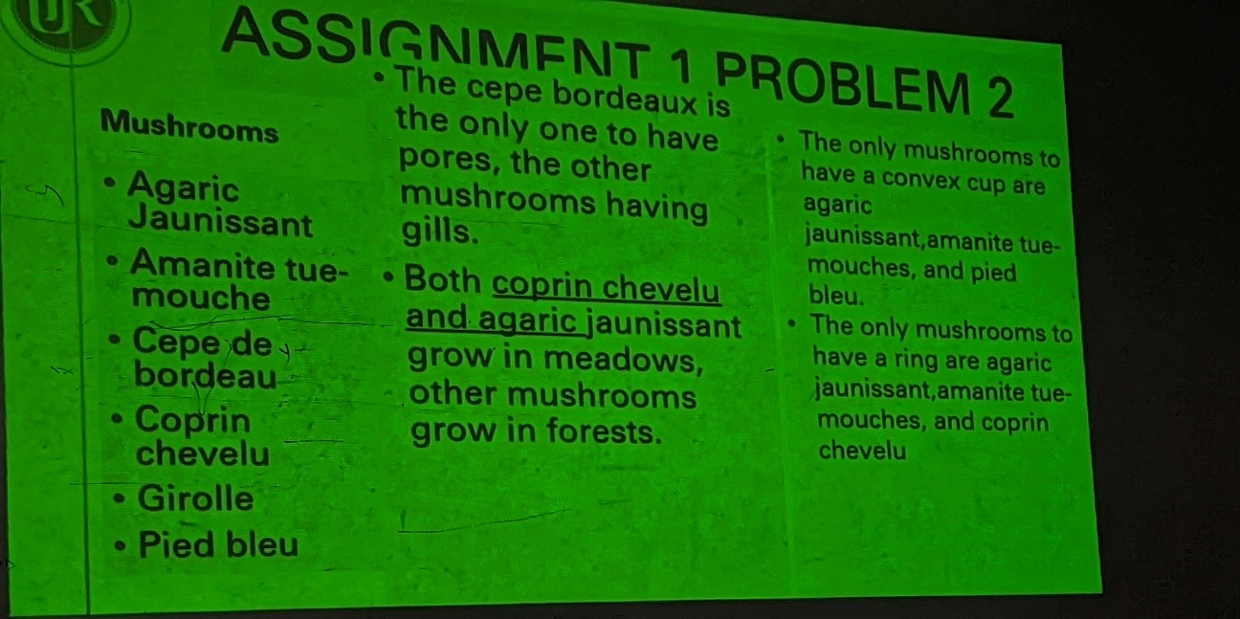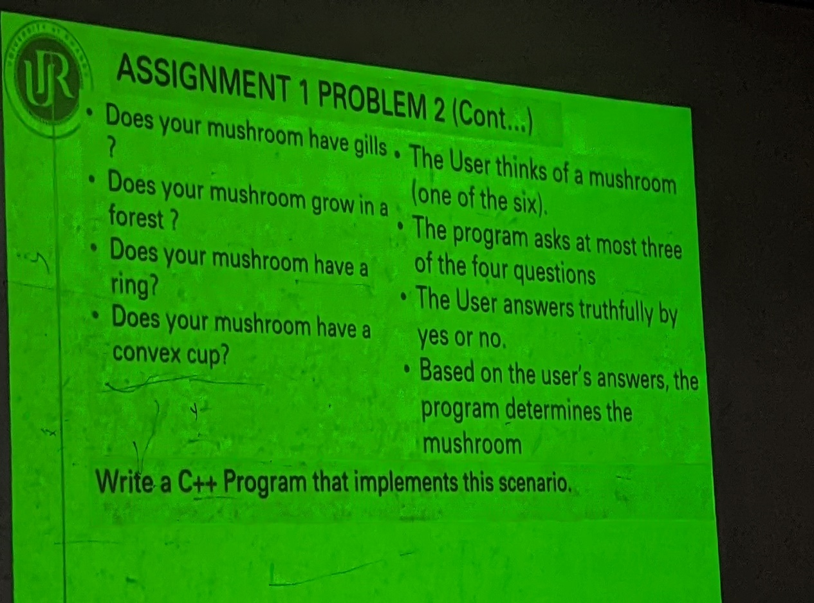

**ANSWERS**

**Problem analysis**

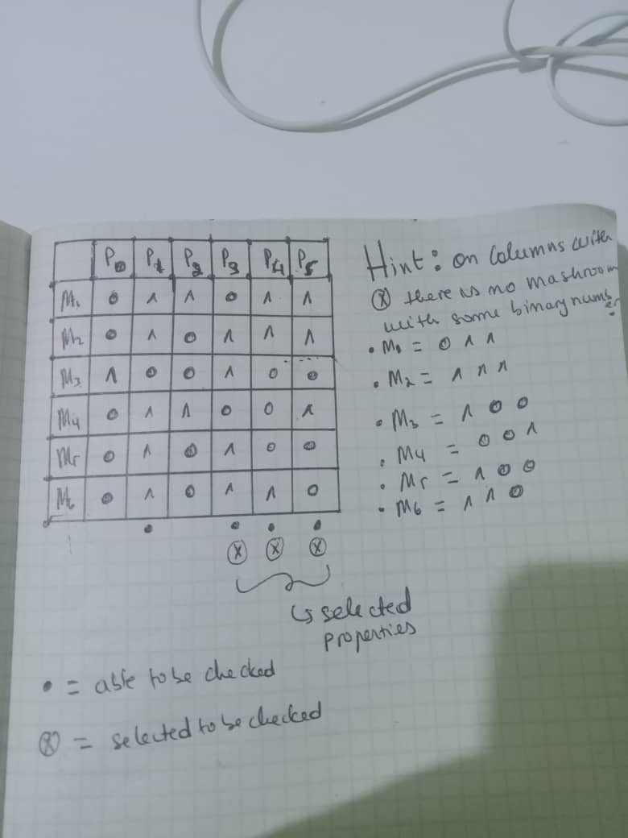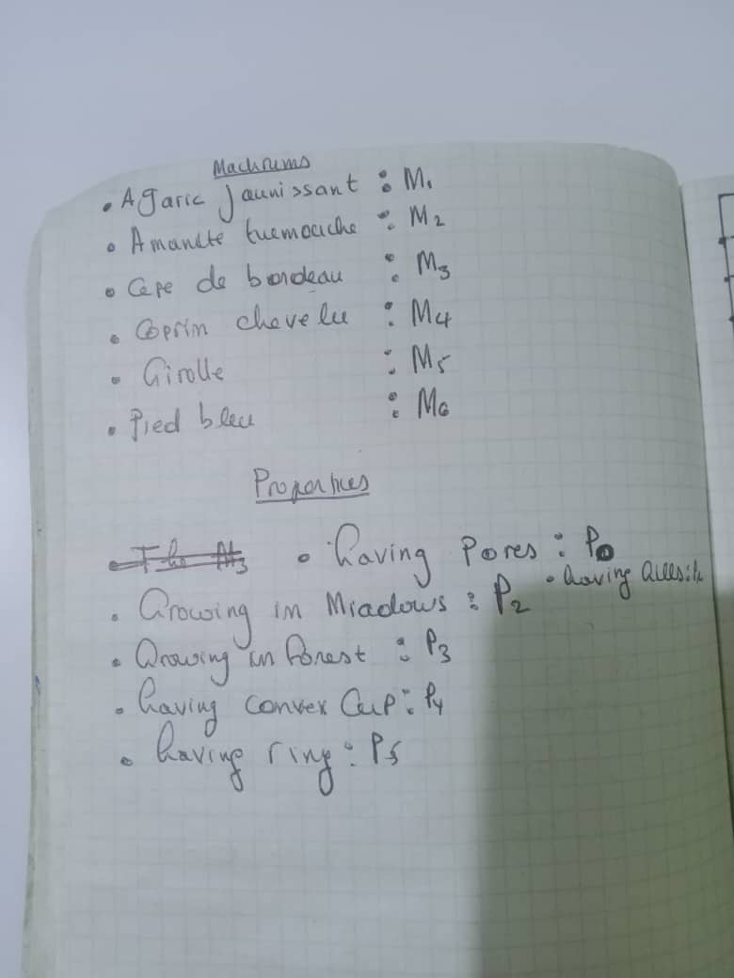

CODES

//AGARIC JAUNISSANT:-GILLS->MEADOWS(NO FOREST)->COMVEX CUP ->RING

//AMANITE TUEMOUCHE:-GILLS->FOREST->COMVEX CUP ->RING

//CEPE DE BORDEAU:-PORES(NO GILLS)->FOREST->(NO COMVEX CUP) ->(NO RING)

//COPRIN CHEVELU:-GILLS->MEADOWS(NO FOREST)->(NO COMVEX CUP) ->RING

//GIROLLE:-GILLS->FORESTS->(NO COMVEX CUP)->(NO RING)

//PIED BLEU:-GILLS->FOREST-> COMVEX CUP->(NO RING)

#include<iostream>

using namespace std;

int main(){

char gills, forest, ring, comvex_cup;

cout<<"----- please enter y for yes and n for no ------- \n \n";

cout<<"does your mushrooom have gills :\n";

cin>>gills;

cout<<"does your mushroom grow in forest ?: \n";

cin>> forest;

cout<<"does your mushroom have a ring ?: \n";

cin>> ring;

if(gills =='y'&&forest =='y'&&ring =='y'){

cout<<"your mushroom is: AMANITE TUEMOUCHE";

}

else if(gills == 'y'&&forest == 'n'&&ring =='y'){

cout<<"your mushroom is : AGARIC JAUNISSANT";

}

else if(gills =='n'&&forest =='y'&&ring =='n'){

cout<<"your mushroom is : CEPE DE BORDEAU";

}

else if(gills =='y'&&forest =='y'&&ring =='n'){

cout<<"does your mushroom have comvex cup? : \n";

cin>> comvex_cup;

if(comvex_cup =='y') cout<<"your mushrooom is: GIROLLE ";

else if(comvex_cup =='n')

cout<<" your mushroom is : PIED BLEU";

}

else if (gills!='y'||gills!='n'||forest!='n'||forest!='y'||

ring!='n'||ring!='y'){

cout<<" answer must be only either y or n !!\n";

}

return 0;

}

QUESTION 2

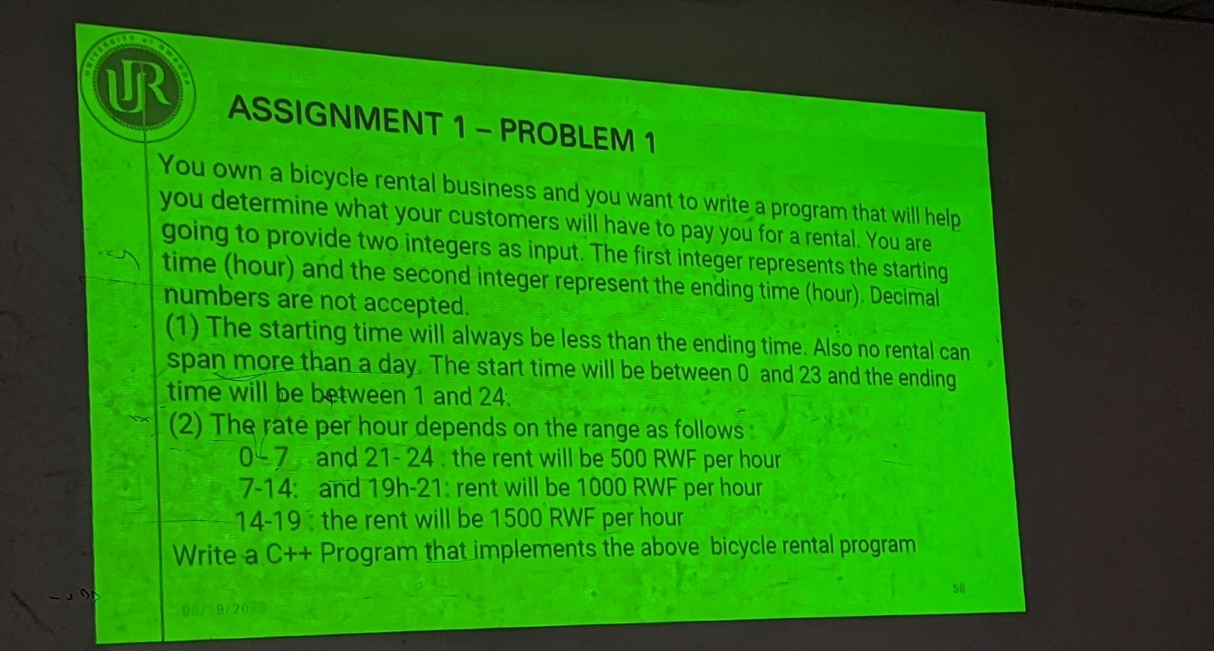

ANSWER

Problem analysis

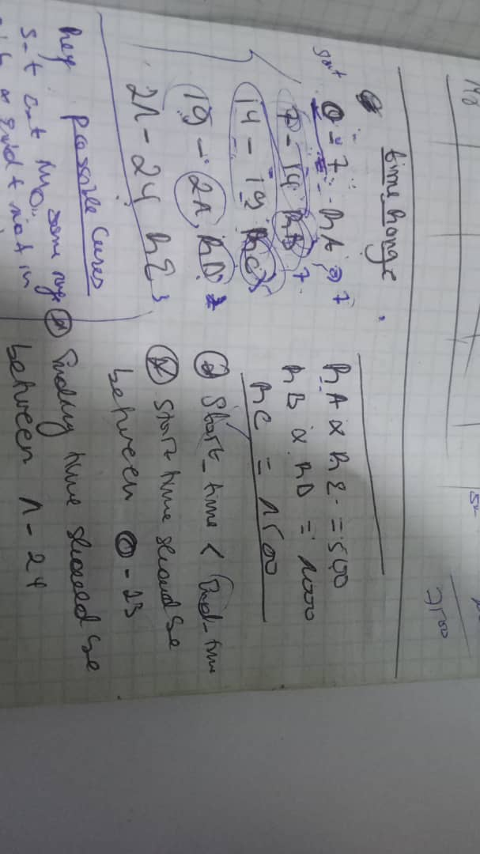

CODES

#include<iostream>

using namespace std;

int main(){

int start_time,end_time,used_time,sum;

cout<<"please enter start time and end time respectivery"<<endl;

cin>>start_time>>end_time;

used_time = end_time - start_time;

if(0 <=start_time && start_time < 24 && 0 < end_time && end_time <= 24 && start_time < end_time){

if(start_time >= 0 && end_time < 7){

sum+= (end_time - start_time) * 500;

}

if(start_time>=0 && start_time < 7 && end_time >=7){

sum+= (7 - start_time)*500;

}

if(start_time >= 7 && end_time < 14){

sum+= (end_time - start_time) * 1000;

}

if(start_time<=7 && end_time >14){

sum+= 1000*7;

}

if(start_time>=7 && start_time < 14 && end_time >=14){

sum+= (14 - start_time)*1000;

}

if(start_time<7 && end_time > 7 && end_time <14){

sum+= (end_time - 7)*1000;

}

if(start_time >= 14 && end_time < 19){

sum+= (end_time - start_time) * 1500;

}

if(start_time<=14 && end_time >19){

sum+= 1500*5;

}

if(start_time>=14 && start_time < 19 && end_time >=19){

sum+= (19 - start_time)*1500;

}

if(start_time<14 && end_time > 14 && end_time <19){

sum+= (end_time - 14)*1500;

}

if(start_time >= 19 && end_time < 21){

sum+= (end_time - start_time) * 1000;

}

if(start_time<=19 && end_time >21){

sum+= 1000*2;

}

if(start_time>=19 && start_time < 21 && end_time >=21){

sum+= (21 - start_time)*1000;

}

if(start_time<19 && end_time > 19 && end_time <21){

sum+= (end_time - 19)*1000;

}

if(start_time >= 21 && end_time < 24){

sum+= (end_time - start_time) * 500;

}

// if(start_time<=21 && end_time >24){

// sum+= 500*7;

// }

if(start_time>=21 && start_time < 24 && end_time >=24){

sum+= (24 - start_time)*500;

}

if(start_time<21 && end_time > 21 && end_time <24){

sum+= (end_time - 21)*500;

}

cout<<"you should pay "<<sum<<" rwf"<<endl;

}else{

cout<<"INVARID INPUT, try again."<<endl;

}

}