**Detecting COVID-19 with Chest X-Ray**

***A Report submitted***

***in partial fulfillment for the Degree of***

**Bachelor of Technology**

**in**

**Computer Engineering**

***By***

**Habibur Rahman 17BCS071**

**Khan Mohd Arquam 17BCS008**

**Saman Rashid 17BCS094**

**Department of Computer Engineering, F/O Engineering & Technology, Jamia Millia Islamia,**

**New Delhi –110025**

**2020-2021**

# CERTIFICATE

This is to certify that the project report entitled **COVID-19 Detection using Chest X-Ray Images** submitted by **Khan Mohd Arquam, Habibur Rahman, Saman Rashid** to the Department of Computer Engineering, F/O Engineering & Technology, Jamia Millia Islamia New Delhi – 110025 in partial fulfillment for the award of the degree of B. Tech in (Computer Engineering) is a bona fide record of project work carried out by him/her under my/our supervision. The contents of this report, in full or in parts, have not been submitted to any other Institution or University for the award of any degree.

<Signature>

Dr. Sarfaraz Masood,

Supervisor,

Department of Computer Engineering

New Delhi Counter signature of HOD with seal

July. 2021

# DECLARATION

I declare that this project report titled COVID-19 Detection using Chest X-Ray Images submitted in partial fulfillment of the degree of B. Tech in (Computer Engineering) is a record of original work carried out by me under the supervision of Dr. Sarfaraz Masood and has not formed the basis for the award of any other degree, in this or any other Institution or University. In keeping with the ethical practice in reporting scientific information, due acknowledgements have been made wherever the findings of others have been cited.

<Signature> <Signature> <Signature>

Khan Mohd Arquam, Habibur Rahman, Saman Rashid,

17BCS008 17BCS071 17BCS094

New Delhi-110025

07/07/2021

# ACKNOWLEDGMENTS

We take this opportunity to thank Dr. Tanvir Ahmad, Dr. Bashir Alam, Dr. Sarfaraz Masood, and other faculty members of the Department of Computer Engineering, Jamia Millia Islamia who helped in preparing the guidelines

.

We extend our sincere thanks to all members Department of Computer Engineering family including the teaching and non-teaching staff and also fellow students for the completion of this document on the project report format guidelines.

Khan Mohd Arquam Habibur Rahman Saman Rashid

# ABSTRACT

COVID-19 continues to cause catastrophic effects on the lives of people throughout the world. To combat this disease, it's necessary to screen the affected patients with a fast, cheap and effective way. One of the foremost viable steps towards achieving this goal is through radiological examination, Chest X-ray, being the foremost easily available and least expensive option. In this project report, we have proposed a Deep Convolutional Neural Network (CNN)- based solution which may help detect the COVID-19 positive patients using chest X-Ray images. Multiple state-of-the-art CNN models which are renowned for image classification tasks- DenseNet201, Resnet50V2, and InceptionV3, are adopted with in the proposed work. They have been trained individually to perform independent predictions. Then the models are combined, employing a new method of weighted average ensembling technique, to predict a category value. To check the efficacy of the answer, we've used publicly available chest X-ray images of COVID positive and COVID negative cases. Since COVID-19 is a novel disease, the data available for the same is quite less. 3600 images of COVID positive patients and 3600 images of COVID negative people (including Viral Pneumonia patients) are divided into training (2800 positive and 2800 negative cases), test (400 positive and 400 negative cases) and validation (400 positive and 400 negative cases) sets. The proposed ensembled model gave a classification accuracy of 98% which is above the state-of-the-art CNN models. Also, we have used Grad-CAM visualization to highlight the important regions in the image on which the prediction was based. We have also developed a web based GUI application for public use. This web based application may be used on any computer/device by any medical/non-medical personnel to detect COVID positive patients using Chest X-Ray images within seconds.

**LIST OF FIGURES**

|  |  |  |
| --- | --- | --- |
| **Fig. No.** | **Description** | **Page No.** |
| 1 | Densenet201 architecture | 17 |
| 2 | Architecture of InceptionV3 | 17 |
| 3 | Inception modules | 18 |
| 4 | A ResNet residual block | 19 |
| 5 | Complete diagram describing the proposed approach | 20 |
| 6 | Four sample images from the dataset of which all are COVID positive | 24 |
| 7 | Four sample images from the dataset of which all are of healthy people (normal) | 25 |
| 8 | Four sample images from the dataset of which all are of Viral Pneumonia patients. | 26 |
| 9 | Visualization of the Validation Losses of the Densenet201 model | 28 |
| 10 | Visualization of the Validation Losses of the InceptionV3 model | 29 |
| 11 | Visualization of the Validation Losses of the ResNet50V2 model | 29 |
| 12 | Visualization of the Validation Losses of the all three models | 30 |
| 13 | Visualization of the Validation Accuracies of the three models | 30 |
| 14 | A Sample Image after Grad-CAM implementation | 34 |
| 15 | A screenshot of the Web based GUI | 35 |

**LIST OF TABLES**

|  |  |  |
| --- | --- | --- |
| **Table No.** | **Description** | **Page No.** |
| 1 | Validation Losses and Validation Accuracies of the three individual models | 28 |
| 2 | Test Accuracies of the three models | 31 |
| 3 | Weights assigned to the three models | 31 |
| 4 | Classification Report of the Final Model | 32 |
| 5 | Comparison of accuracies with some of the previous work | 33 |

**ABBREVIATIONS/NOMENCLATURE/NOTATIONS**

|  |  |
| --- | --- |
| **Abbreviation /Nomenclature/ Notation** | **Description** |
| SARS-CoV-2 | Severe Acute Respiratory Syndrome Coronavirus 2 |
| RT-PCR | Real-time Transcription- Polymerase Chain Reaction |
| CNN | Convolutional Neural Networks |
| CXR | Chest X-Ray |
| CV | Computer Vision |
| Grad-CAM | Gradient-weighted Class Activation Mapping |
| GUI | Graphical User Interface |
| CT scan | Computed Tomography scan |
| MRI | Magnetic Resonance Imaging |
| PET scan | Positron Emission Tomography scan |

**TABLE OF CONTENTS**

|  |  |
| --- | --- |
| DESCRIPTION | PAGE NO. |
| CERTIFICATE | 1 |
| DECALARATION | 2 |
| ACKNOWLEDGEMENTS | 3 |
| ABSTRACT | 4 |
| LIST OF FIGURES | 5 |
| LIST OF TABLES | 6 |
| ABBREAVIATIONS/NOMENCLATURE/NOTATIONS | 6 |
| 1. INTRODUCTION | 8 |
| 2. LITERATURE REVIEW | 12 |
| 3. PROPOSED METHOD AND EXPLANATION | 15 |
| 3.1 Proposed Methodology | 16 |
| 3.2 Models Used | 16 |
| 3.2.1 Densenet201 | 16 |
| 3.2.2 InceptionV3 | 17 |
| 3.2.3 ResNet50V2 | 18 |
| 3.3 The Ensembled Model | 19 |
| 3.4 Grad-CAM Visualization | 21 |
| 4. EXPERIMENTAL RESULTS | 22 |
| 4.1 Dataset Description | 23 |
| 4.1.1 Dataset Samples | 24 |
| 4.2 Data Preparation | 26 |
| 4.3 Tools Used | 27 |
| 4.4 Training the Models | 27 |
| 4.4.1 Training Results | 27 |
| 4.4.2 Training Visualization | 28 |
| 4.5 Testing the Models | 31 |
| 4.5.1 Test Results | 31 |
| 4.5.2 Weights Assigned to the Models | 31 |
| 4.6 Final Model Results | 32 |
| 4.6.1 Performance Metrics | 32 |
| 4.6.2 Accuracy of Final Model | 32 |
| 4.6.3 Confusion Matrix | 33 |
| 4.6.4 A brief comparison with some of the other works | 33 |
| 4.7 Implementation of Grad-CAM | 34 |
| 4.8 Web based GUI | 35 |
| 5. CONCLUSION AND FUTURE SCOPES | 36 |
| 5.1 Conclusion | 37 |
| 5.2 Future Scope | 37 |
| REFERENCES | 38 |

# Chapter 1

# Introduction

The outbreak of SARS-CoV-2, a transmissible disease also known as COVID-19, in 2019 has caused destruction all over the world. A recently discovered coronavirus is the primary cause of COVID-19. The outbreak, which began in December 2019 in the city of Wuhan, China very quickly turned into a pandemic due to its highly contagious nature. SARS-CoV-2 stands for Severe Acute Respiratory Syndrome Coronavirus 2.

A family of hundreds of viruses, Coronaviruses (CoV) usually infect wild animals like chickens, bats, camels, cats, etc. However, these viruses can mutate within the animal’s body, thus enabling them to transmit this deadly virus inside their body to other species (in this case, human beings) thus leading to an epidemic. It has also been observed that this deadly virus is actually attacking the human respiratory system, varying from the common cold to more deadly diseases like Middle East Respiratory Syndrome (MERS) and Severe Acute Respiratory Syndrome (SARS).

COVID-19 has very hard-to-detect symptoms. In some cases, the affected person may not show any symptoms at all but can infect other people. However, it is not as severe as SARS and MERS. Fever, dry cough, and fatigue are some of the common symptoms found in COVID-19 affected patients. Other symptoms that are not so common in nature are headaches, nasal congestion, sore throat, loss of taste and smell, conjunctivitis, and discoloration of fingers or toes. Mostly, the old and infirm people having other underlying medical issues such as asthma, diabetes, high blood pressure, heart and lung problems, or cancer have a much higher chance of developing severe illness. However, a perfectly healthy person can also get infected with the virus and get seriously ill.

Even in the highly developed first world countries, the healthcare system has come to the brink of collapse because of the ever increasing demand for intensive care units (ICU) beds and highly sophisticated machines like ventilators. Only some patients, that too with much severe infection were able to get access to the Intensive care units. With more than 185 million confirmed cases and around 4 million fatalities in more than 200 countries, as of 6th July 2021, COVID-19 continues to ravage across the world. The first noticeable outbreaks (the first wave) in Europe and North America were seen in April 2020, but as soon as they began to wane, greater number of cases began to pop up in South America and Asia. India has been engulfed with COVID cases in recent months (the second wave). Also, an incoming third wave has also been predicted to arrive soon.

Apart from this, COVID-19 has brought the global economy to a standstill. The damage caused to the economies throughout the world is huge. It is also considered the biggest economic shock in the past few decades. According to latest data, the service and the travel industry have been hit the hardest. Every country in the world has seen huge disruptions in Tourism and global trade. India witnessed a negative GDP growth for the first time ever in 2020. The outbreak has also caused a recession that may cause an ever-lasting damage through investor fears, lower and lower investment, a removal of human capital, and also destruction of global trade and supply linkages.

The upper and lower respiratory specimens of the patients are used for the detection of COVID-19 with the help of RT-PCR (Real-time transcription-polymerase chain reaction) tests. The quantity of the testing kits and access to them have been low ever since the beginning of the pandemic. Also, there are questions over the stability and reproducibility of these kits. These factors play a huge and determinant role in the accuracy of test results. The accuracy of the kits has been found to be only 80% in several places. Hence, tests has to be repeated several times before the a case can be confirmed. This has worsened the problem of shortage of kits. Even the quality of these kits have been questioned from time to time .

With the help of the ever improving field of artificial intelligence and machine learning, X-ray images of the chest (Lungs X-ray) can be used to detect COVID-19. One of the most reliable and important parts of machine learning is deep learning. It is based on extracting features and thus classifies images which are then applied in detecting objects, which in our case is the classification of Chest X-rays. Machine learning and deep learning are now considered the established fields in applying AI to mine, analyze, and recognize patterns from huge chunks of data .

In this modern era of AI, AI can detect COVID-19 in patients, thus making it easier to separate patients who have been infected for faster and better treatment. The infections present in the lungs of the patient can be scanned with the help of Chest X-rays. In fact, Chest X-rays are a much quicker, simpler, economical, and less harmful way of testing patients and thus should be used. Since the fatalities have been increasing during the pandemic, All countries/states must implement Chest X-rays. Even though this technological advancement looks very helpful, the images of different types of pneumonia are similar and overlap with other infectious and inflammatory lung diseases making it difficult to distinguish between COVID-19 from other viral cases of pneumonia .

In this project, a model to predict the COVID-19 cases has been created using Convolutional Neural Network (CNN) based on Chest X-ray images. Using the training data, CNN helps in the extraction of the features by enhancing low-light images. In the initial days of a COVID-19 infection, bilateral distribution of patchy shadows and ground-glass opacity has been observed which are similar to the viral pneumonia symptoms with some minor differences . The CNN model can identify unique features which are difficult for recognition by human beings. After training the model on the dataset, performance of this classification model is evaluated on the test dataset using a Confusion Matrix.

# Chapter 2

# LITERATURE REVIEW

# 

In recent times, medical diagnosis has often depended upon Computer Vision (CV). Medical branches like dermatology, orthopedics, etc. that require visual checks have often been on the receiving end of Computer Vision advancements. Computer vision has been used as a tool to diagnose skin abnormalities which can be a proactive detector of skin cancer. It has also been used for the detection of tissues inside one’s body. It is also been used in ophthalmology to diagnose different diseases. Its success is reflected by its ever-increasing usage in medical surgeries and operations. Modern medical imaging techniques like Computed Tomography scan (CT scan), Magnetic Resonance Imaging (MRI), Positron Emission Tomography scan (PET scan), Ultrasound and Chest X-Ray (CXR) images, all use Computer Vision.

It is known that the analysis of the presence of viruses in the human body can improved using medical imaging. In many different works, Pneumonia has been detected using novel deep learning-based techniques [3, 16]. Apart from this, thoracic diseases [21, 23, 29], skin cancer [1], hemorrhage[8], etc. have also been detected using deep learning. A lot of these works have yielded much better results when compared to traditional methods.

A convolutional neural network (CNN) model has also been created to detect COVID-19 positive cases using CT scan images in a work by Singh et al. [25]. Other than this, there are many different research works to identify COVID-19 virus in the lungs of human beings with the help of a CT scan [5, 13, 24, 25, 31]. A self-supervised Artificial Intelligence model has also been developed for the diagnosis of the COVID-19 virus in the lungs of human beings using CT scan images, with an accuracy of 89%. This model was developed by Yan et al. [31] and is also capable of multi-tasking. Shan et. al. [24]. Li et al. [13] have done an automatic segmentation and quantification of the lungs in a fully automatic framework to identify the presence COVID infected lungs from chest CT scan images and differentiated it from other lung diseases. However, it was proposed by Ng et al. [18] and Huang et al. [9] that Chest X-Ray images are better and more efficient in handling the task of COVID-19 detection because they yield much better and more accurate results. This is also supported by the fact that X-Ray machines are available more widely across the world and are more budget-friendly in terms of maintenance.

Even in the field of detection of COVID-19 cases using Chest X-Ray images [2, 6, 10, 12, 14, 15, 17, 19, 20, 28]. Makris et al.[15] has used the transfer learning approach with the Inception-V3 network to classify Chest X-Ray images of normal people, viral pneumonia patients and COVID-19 patients. The work by Mangal et al. [16] uses the DenseNet with ChexNet architecture to differentiate between Chest X-Ray images of normal people (healthy), bacterial and viral pneumonia patients and COVID-19 patients. A combination of two models- Xception and ResNet50V2 has been used by Rahimzadeh et al. [20] for the same task. The ResNet architecture has been used to classify viral pneumonia images and COVID-19 images by Xu et al. [30]. Since data of COVID-19 positive patients is scarce, this problem of classification is considered quite challenging. However, a major work undertaken by Waheed et al.[27] will artificially generate data of COVID-19 positive cases. This will enable much more accurate models to be developed.

Another significant contribution has been made by Wang et al. [28]. Here, a novel custom architecture known as COVIDNet has been developed. This architecture classifies between COVID-19, Normal, and Viral Pneumonia patients’ Chest X-Ray images. This state-of-the-art model has achieved a classification accuracy of 94%, which is far better than the PCR tests.

Since, almost all the work till now related to COVID-19 detection from Chest X-Ray images have been done using one deep learning model at a time. Very few work has been done on combination of models to increase their capability and power of detection. Ensemble Learning is a technique wherein we combine the results of multiple models to generate a more accurate result. Previous works on Ensemble Learning with Deep Neural Networks have proved that the models have achieved much better performance when ensembled. This technique also helps avoid the issue of overfitting [26]. The work proposed in [7], has used the generated probabilities to generate weights. The weighted average is applied among the models. This weighted average method yields much better results than that by normal average method or that by majority voting based method. The work by Cheng et al. [11], compares the performance of the different ensembling techniques in Convolutional Neural Networks (CNN) like majority voting, unweighted average, Bayes Optimal Classifier, and Super Learner.

In our project, we have proposed a new methodology to detect COVID-19 positive patients using Chest X-Ray images by ensembling three modern CNN models- DenseNet201, InceptionV3, and Resnet50V2. In addition to this, we have also used Grad-CAM visualization to highlight the areas of the image which were important in predicting the class. We have also created a web-based GUI for public use.

# Chapter 3

# PROPOSED METHOD AND EXPLANATION

# 3.1 Proposed Methodology:

We propose an ensemble model to achieve a more efficient solution to the problem of Chest X-Ray image classification into COVID-19 positive and COVID-19 negative classes.

We all like to hear different opinions from different sources before taking major decisions in our lives. This is because different opinions help us analyze the situation in a much better way. It also often leads to the correct decision. Similarly, using multiple state-of-the-art Convolutional Neural Networks models allow us to get a better result when compared to an individual model. Hence, we used an ensembled model in this project. All the three models have been trained well enough to make predictions on their own with great accuracy and efficiency. Further, the models were combined using the weighted average ensembling technique to predict the output. This technique would enable an even better and more accurate model. We combine the models- Densenet201, InceptionV3, ResNet50V2 to create an ensemble model.

**3.2 Models Used**

**3.2.1 Densenet201**

Dense Convolution Network or DenseNet, is a type of Convolutional Neural Network that utilizes dense connections between layers, through Dense Blocks, where all layers are connected (with matching feature-map sizes) directly with each other. Each layer obtains additional inputs from all preceding layers and passes on its own feature-maps to all subsequent layers to preserve the feed-forward nature. This helps to strengthen feature propagation and encourages feature reuse. As shown in Fig. 1, it requires comparatively fewer parameters than similar types of traditional CNN.

The Densenet201 model is a convolutional neural network that is among one of the DenseNet group of models designed to perform image classification. DenseNet201 is 201 layers deep. Fig. 1 shows the architecture of Densenet201.

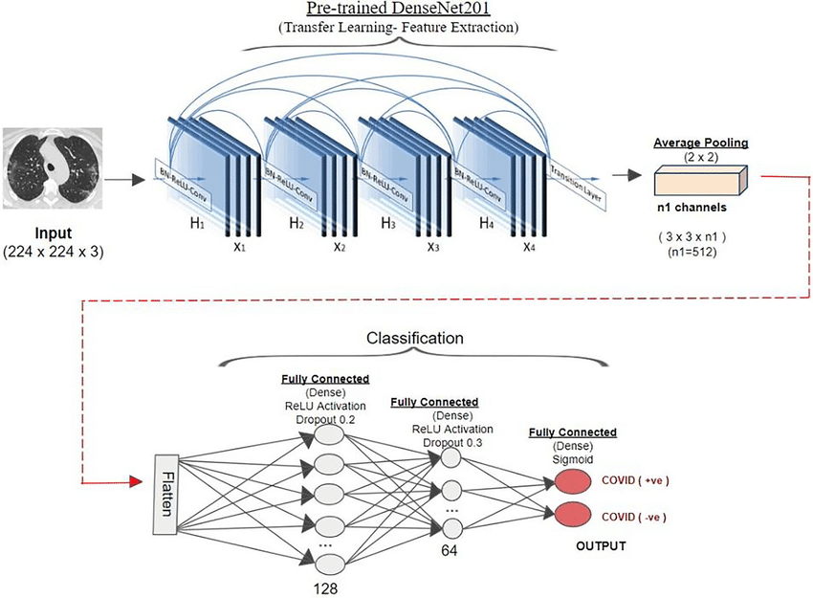

Fig. 1: Densenet201 architecture

**3.2.2 InceptionV3**

InceptionV3 is a widely-used image recognition model that has been shown to attain greater than 78.1% accuracy on the ImageNet dataset. The model is the culmination of many ideas developed by multiple researchers over the years. It is based on the original paper: "Rethinking the Inception Architecture for Computer Vision" by Szegedy et. al. [4] Fig. 2 shows the architecture of InceptionV3.

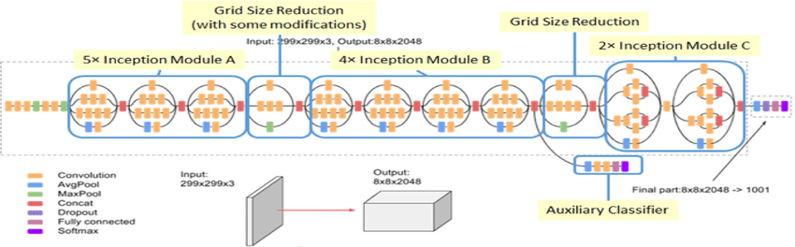

Fig. 2: Architecture of InceptionV3

The model itself is made up of symmetric and asymmetric building blocks, including convolutions, average pooling, max pooling, concats, dropouts, and fully connected layers. Batchnorm is used extensively throughout the model and applied to activation inputs. Loss is computed via Softmax.

InceptionV3 has a 48-layer deep architecture consisting of 11 inception modules. As a means of regularization, before a fully connected layer, a dropout of 0.6 is added. Fig. 3 shows each of the 11 inception modules.

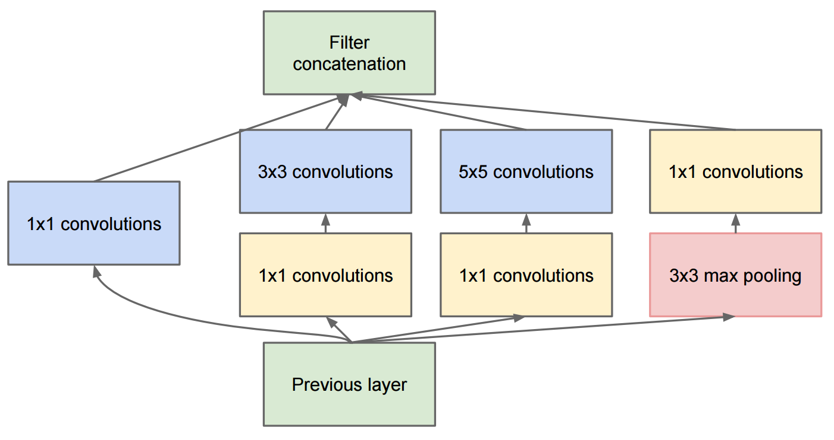

Fig. 3: Inception modules

**3.2.3 ResNet50V2**

ResNet50V2, is a contemporary convolutional network which is easier to train than any other deep convolutional neural networks, yields greater accuracy and converges faster. It also addresses the vanishing or exploding gradient problems by the use of “residual blocks” in the architecture. In a residual network, multiple residual blocks stacked up one after another. Each residual block, as shown in Fig. 4, is formed of short-cut connections skipping one or more layers. In ResNet50, 3-layer residual blocks are used.

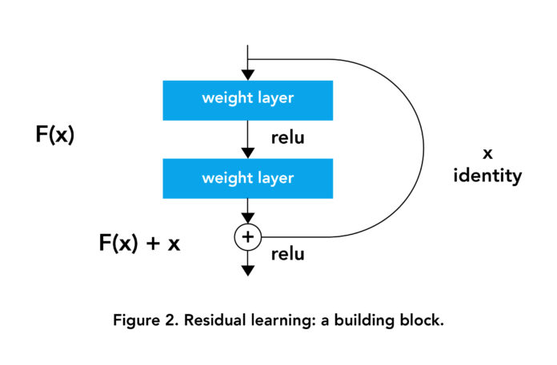

Fig. 4: A ResNet residual block.

**3.3 The Ensembled Model**

The most important feature of this proposed approach is that we have used an ensembling technique which is based on the concept of weighted average. This technique helps us combine different CNN models in a more effective and efficient way. Hence, suppose if one of the models is giving better results than the other two models and has higher accuracy, then it is given a higher weight so that it has a higher weightage in predicting the final output. Assuming the accuracy percentage of the ith model as ai , the error is (100 – ai).

We define a factor ki as below:

di = 100 – ai --------(1)

D = ∑di2 ------------(2)

ki = di2/D ------------(3)

Weight of the ith  network is defined as:

**wi = (1/ ki2)/( ∑(1/ ki2)) -----(4)**

Suppose the outputs from the neural networks are of the form [p0, p1], where p0 is the probability of Class 0 (COVID-19 positive) and p1 is the probability of Class 1 (COVID-19 negative). Let the outputs from the three CNN models be [p01, p11], [p02, p12], [p03, p13] for models 1, 2 and 3 respectively.

Let the weights calculated using the proposed method mentioned in equation (4) be [w1, w2, w3] for the models 1, 2, and 3 respectively.

Then the weighted average is calculated as:

**Average =**

**[(w1×p01+w2×p02+w3×p03)/(w1+w2+w3), (w1×p11+w2×p12+w3×p13)/ (w1+w2+w3)]**

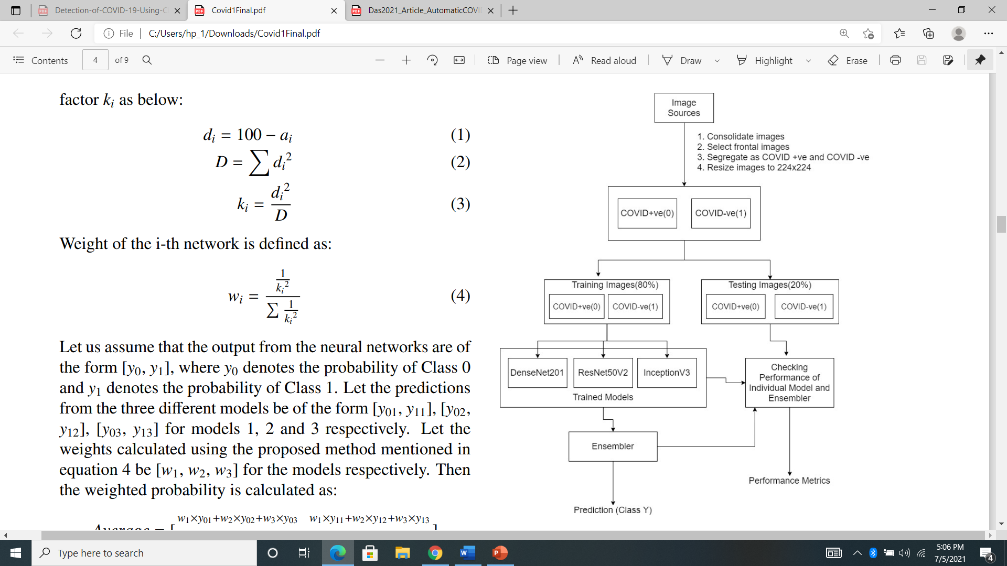

Fig. 5: Complete diagram describing the proposed approach.

**3.4 Grad-CAM visualization:**

Even though deep learning has allowed achieving high levels of accuracy in image classification, object detection, and image segmentation, one of their biggest problems is model interpretability, a core component in model understanding and model debugging.

Selvaraju et al. [22] created Gradient-weighted Class Activation Mapping, or more simply, Grad-CAM which enables us to visually debug our models and properly understand where it’s looking in an image.

Grad-CAM uses the gradients of any target concept flowing into the final convolutional layer to produce a coarse localization map highlighting the important regions in the image for predicting the concept.

Using Grad-CAM, we can visually validate where our network is looking, verifying that it is indeed looking at the correct patterns in the image and activating around those patterns.

# Chapter 4

# EXPERIMENTAL RESULTS

# 4.1 Dataset Description

The dataset used for this project consists:

1. 3600 images Chest X-Ray images of COVID-19 patients.
2. 3600 images Chest X-Ray images of healthy people and viral Pneumonia patients(300 images).

* For training, 2800 COVID-19 positive and 2800 COVID-19 negative images were used.
* For validation, 400 COVID-19 positive and 400 COVID-19 negative images were used.
* For testing, 400 COVID-19 positive and 400 COVID-19 negative images were used.

# 4.1.1 Dataset Samples

Here are few samples images from the dataset used for this project:

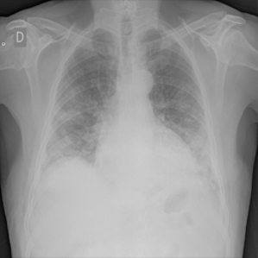 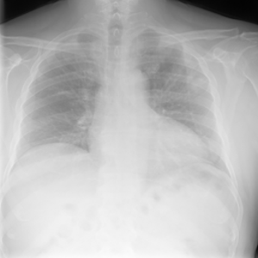

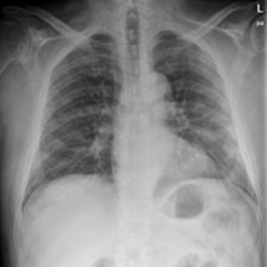 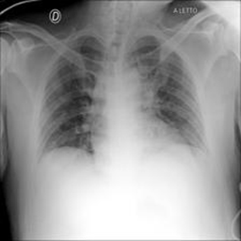

Fig. 6: Four sample images from the dataset of which all are COVID positive

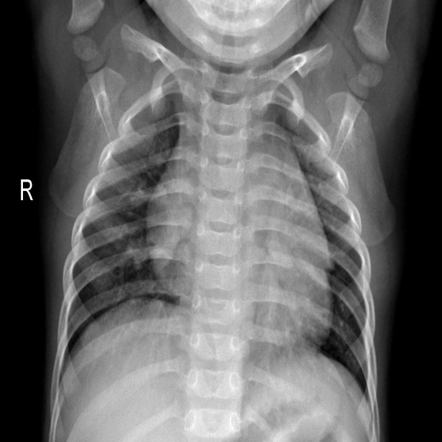 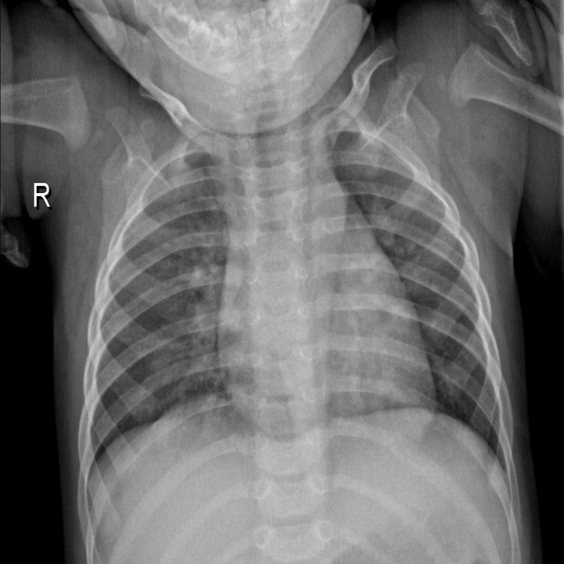

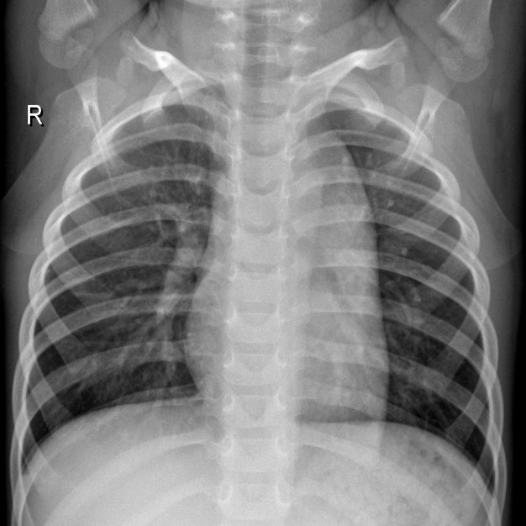 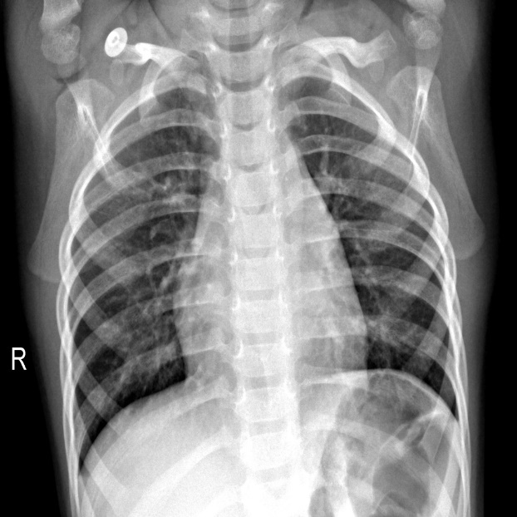

Fig. 7: Four sample images from the dataset of which all are of healthy people (normal)

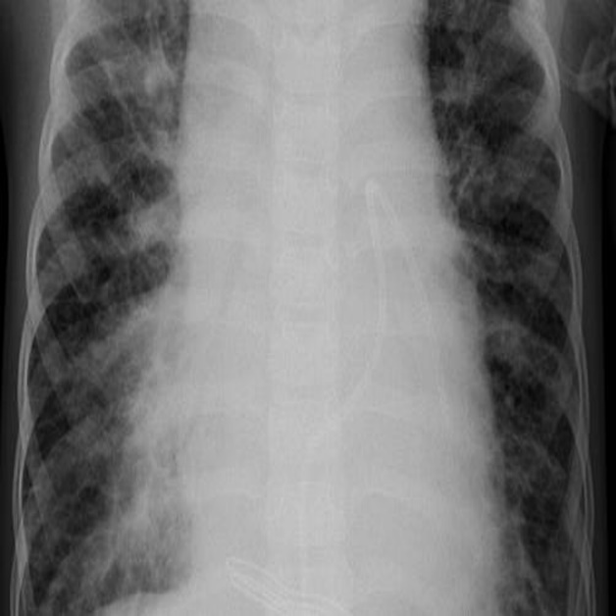 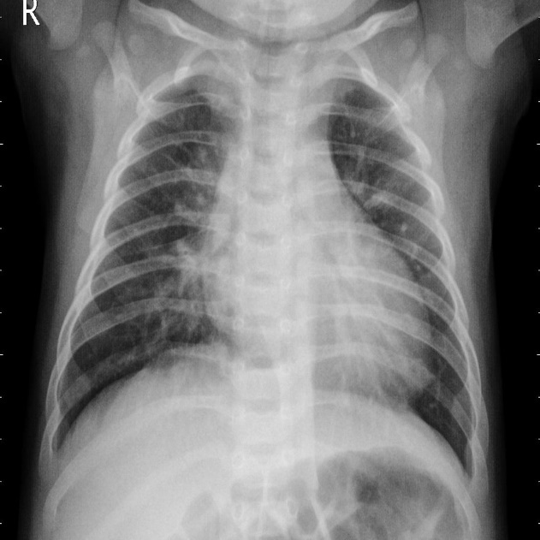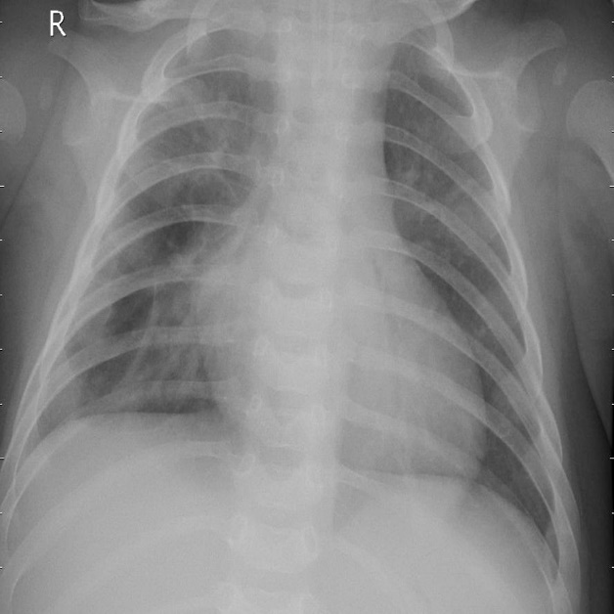 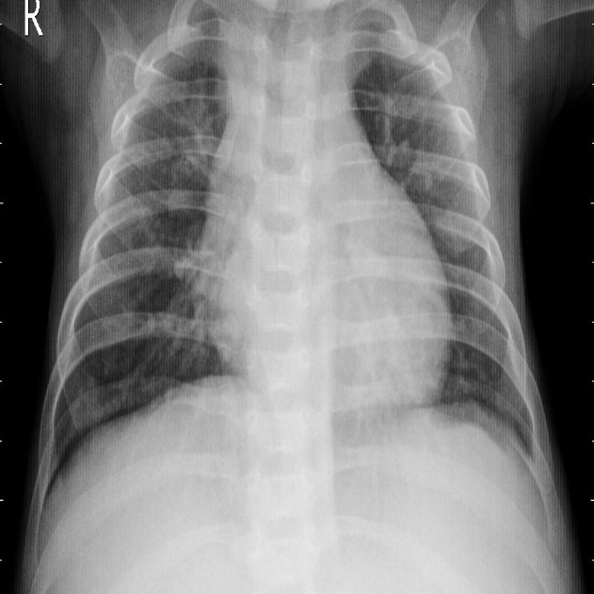

Fig. 8: Four sample images from the dataset of which all are of Viral Pneumonia patients.

## 4.2 Data Preparation

The images from the dataset were first normalized and resized into 224×224 shaped images. Then the images are randomly shuffled and divided into training, validation and testing data. Then the images and their respective class labels were converted into Numpy format. The training data has 5600 images where 2800 images are for COVID-19 positive (Class 0) and 2800 images are for COVID-19 negative (Class 1). The validation data and the testing data has 800 images each where 400 images are for COVID-19 positive (Class 0) and 400 images for COVID-19 negative (Class 1). It is ensured that if a patient has multiple images, they do not overlap in different sets. In case the same patient’s images are kept in two different sets, we may get wrong results due to the overlap.

## 4.3 Tools Used

The models were trained in the Google Colaboratory environment. The GPU used was Tesla K80 12GB GDDR5 VRAM. Python 3.7 was used as the programming language. For the implementation of CNN, the deep learning library of TensorFlow 2.2.0 along with the Keras library was used.

## 4.4 Training the Models

All the three models (Densenet201, InceptionV3, Resnet50V2) were trained for 30 epochs each. To prevent overfitting, the models were validated on the validation dataset after each epoch. Early stopping callbacks were also placed with the condition to minimize validation losses. The value of patience was set to 10 epochs. Early stopping enables the system to stop the training process prematurely if there is no significant improvement in the model. After the training process, all the models were saves as h5 files.

### 4.4.1 Training Results

The Densenet201 model was trained first. It yielded the lowest validation loss value of **0.1124** after 6 epochs. The validation accuracy was **0.9688**. Hence, due to early stopping, it stops after 16 epochs as it fails to improve upon the results fetched in the 6th epoch.

Next, the InceptionV3 model is trained. It yields the lowest validation loss value of **0.061** after 10 epochs. The validation accuracy was **0.9800**. Hence, due to early stopping, it stops after 20 epochs as it fails to improve upon the results fetched in the 10th epoch.

Lastly, the ResNet50V2 model is trained. It yields the lowest validation loss value of **0.1209** after 29 epochs. The validation accuracy was **0.9638**.However, since we train each model for only 30 epochs, early stopping does not happen here, it stops after 30 epochs as it reaches it epoch limit.

|  |  |  |
| --- | --- | --- |
| **Model Name** | **Final Validation Loss** | **Final Validation Accuracy** |
| **Densenet201** | 0.1124 | 0.9688 |
| **InceptionV3** | 0.0610 | 0.9800 |
| **ResNet50V2** | 0.1209 | 0.9638 |

## Table 1: Validation Losses and Validation Accuracies of the three individual models

### 4.4.2 Training Visualization

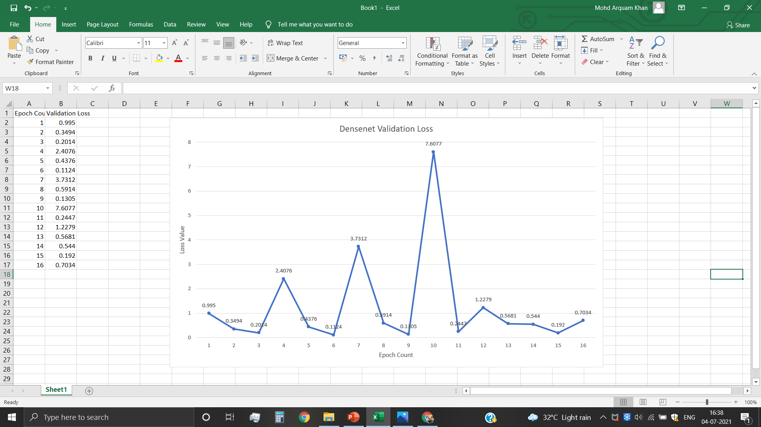

Fig. 9: Visualization of the Validation Losses of the Densenet201 model

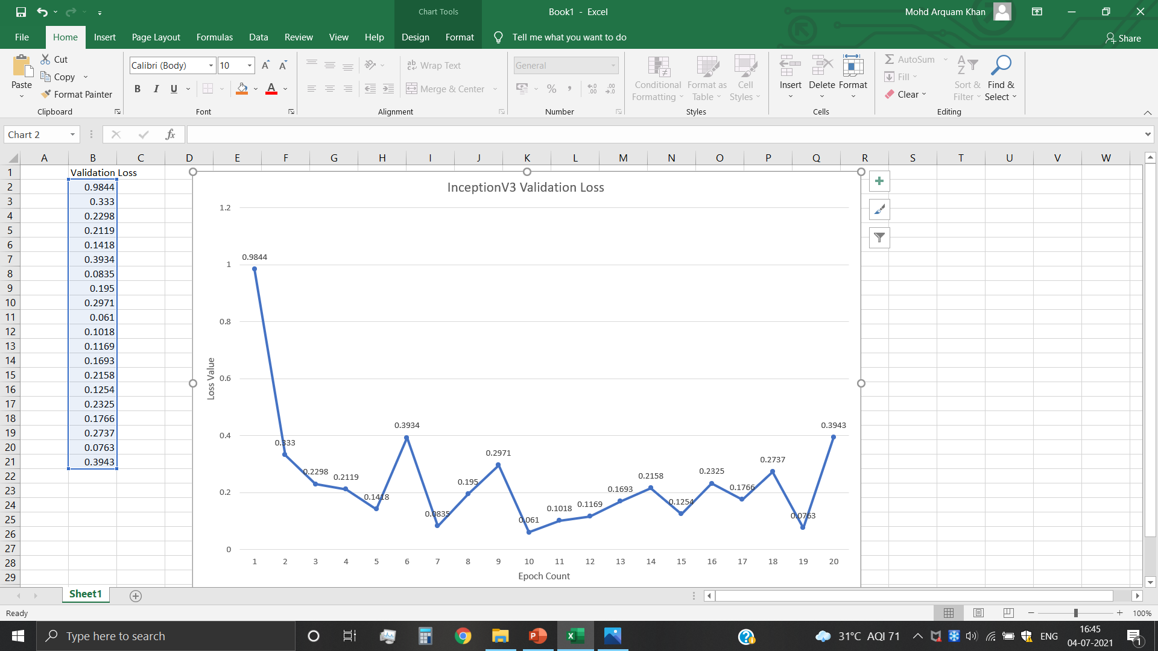

Fig. 10: Visualization of the Validation Losses of the InceptionV3 model

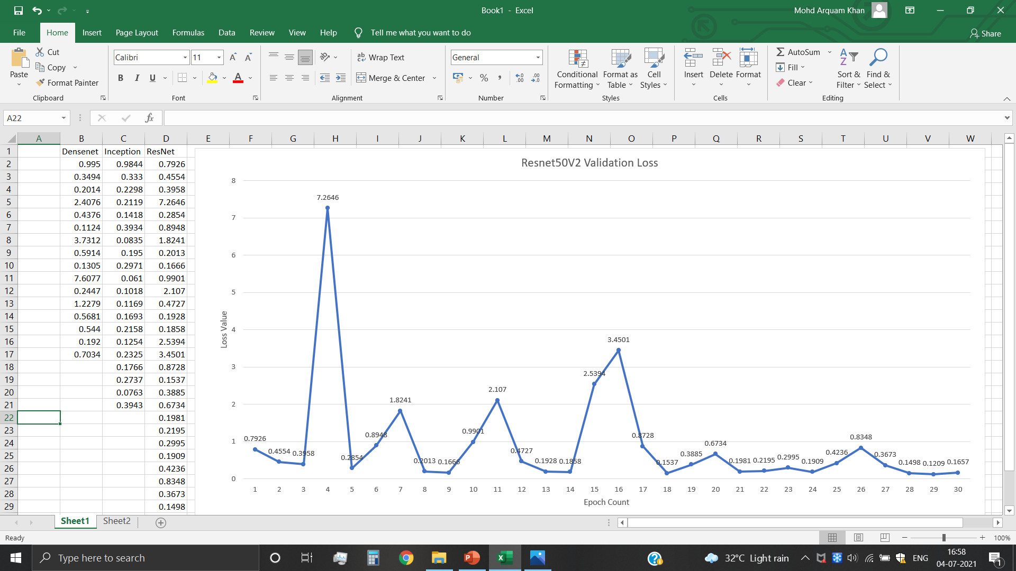

Fig. 11: Visualization of the Validation Losses of the ResNet50V2 model

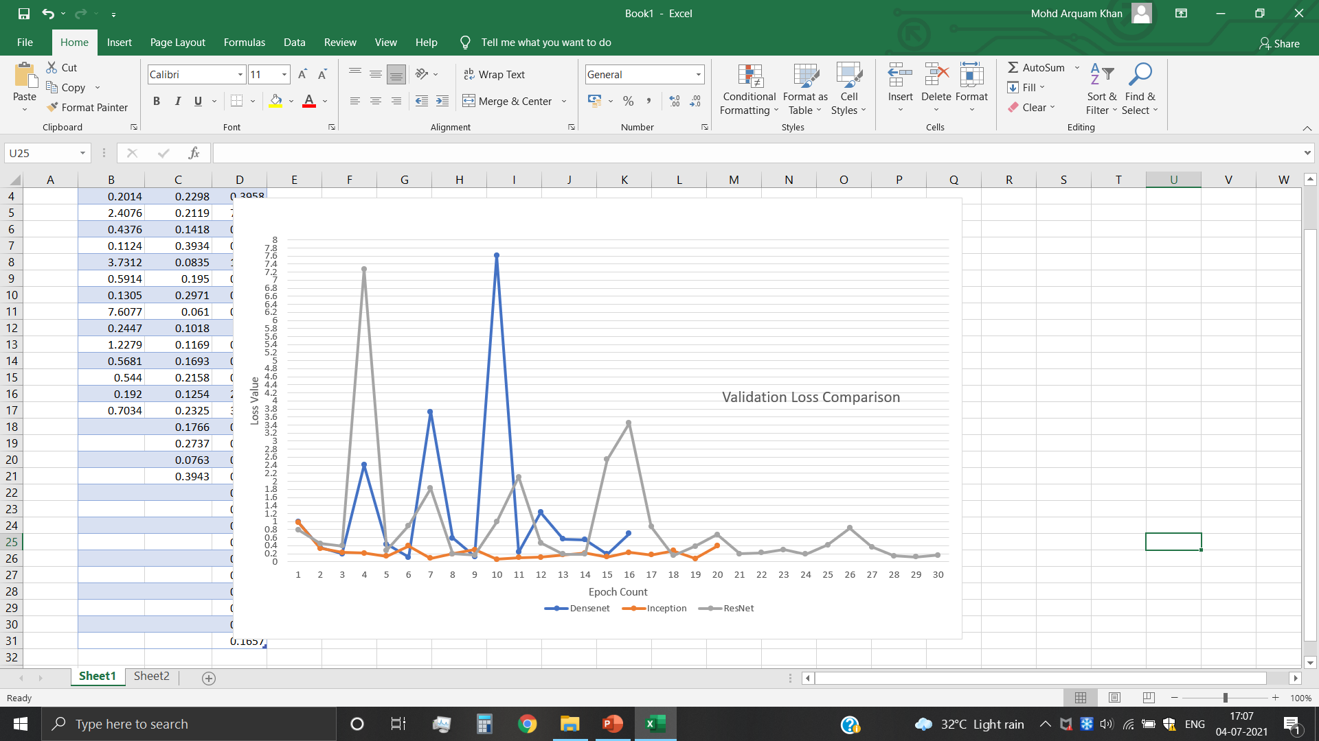

Fig. 12: Visualization of the Validation Losses of the all three models

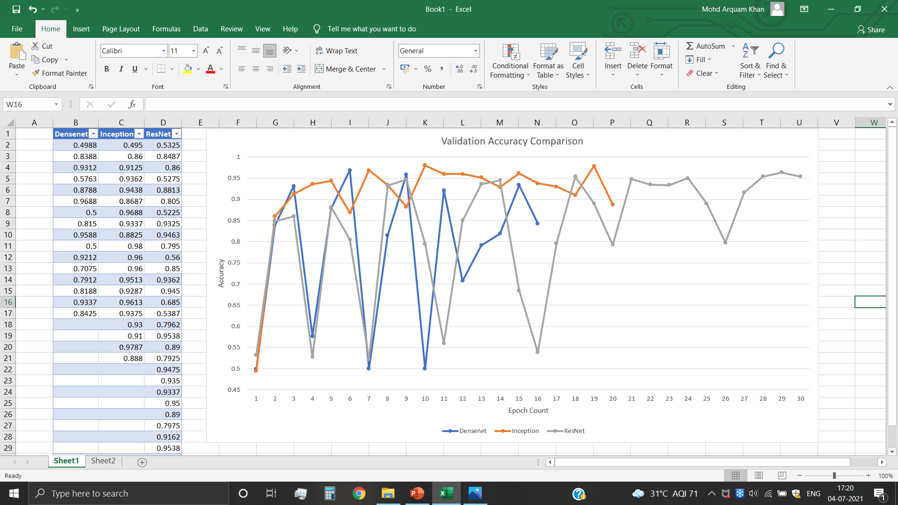

Fig. 13: Visualization of the Validation Accuracies of the three models

## 4.5 Testing the Models

The three models were tested on the test dataset. The following results were achieved.

**4.5.1 Test Results**

|  |  |
| --- | --- |
| Model | Test Accuracy |
| Densenet201 | 0.9638 |
| InceptionV3 | 0.9675 |
| Resnet50V2 | 0.9700 |

Table 2: Test Accuracies of the three models

**4.5.2 Weights Assigned to the Models**

Using the test accuracies, we calculate the weights assigned to the three models:

|  |  |  |
| --- | --- | --- |
| Densenet201 | InceptionV3 | ResNet50V2 |
| 0.2137 | 0.3307 | 0.4555 |

Table 3: Weights assigned to the three models

## 4.6 Final Model Results

## 4.6.1 Performance Metrics

To evaluate the performance of the proposed approach, the metrics adopted are classification accuracy, sensitivity and F1-score, measured as follows:

**Classification accuracy = (TP+TN)/(TP+TN+FP+FN)**

**Sensitivity = (TP)/(TP+FN)**

**F1 Score = (2 × Sensitivity × Precision)/(Sensitivity + Precision)**

where TP stands for True Positive, FP for False Positive, FN for False Negative and TN for True Negative.

In a confusion matrix, the COVID-19 positive cases that are correctly classified by the model are termed as True Positive and incorrectly classified as COVID-19 negative are termed as False Positive. Similarly, COVID-19 negative subjects classified correctly are termed as True Negative and incorrectly classified as COVID-19 positive are termed as False Negative.

### 4.6.2 Accuracy of Final Model

The final model yielded an accuracy of **98%** with an average precision of 0.98, and average recall of 0.98, and an average F1-Score of 0.98

|  |  |  |  |  |
| --- | --- | --- | --- | --- |
|  | Precision | Recall | F1-Score | Support |
| COVID-19 Positive | 0.97 | 0.99 | 0.98 | 400 |
| COVID-19 Negative | 0.99 | 0.97 | 0.98 | 400 |

Table 4: Classification Report of the Final Model

**4.6.3 Confusion Matrix**

The model correctly predicts 397 out of 400 COVID-19 positive cases, and 387 out of 400 COVID-19 negative cases.

|  |  |  |
| --- | --- | --- |
|  | **Predicted Positive** | **Predicted Negative** |
| **Actual Positive** | 397 | 3 |
| **Actual Negative** | 13 | 387 |

Confusion Matrix of the Final Model

**4.6.4 A brief comparison with some of the other works**

|  |  |  |
| --- | --- | --- |
| Article | Algorithm/Technique | Accuracy |
| Ozturk et al. (2020) | DarkNet | 87.02% |
| Panwar et al. (2020) | nCOVnet | 88.10% |
| Wang et al. (2020) | COVID-Net | 93.30% |
| Abbas et al. (2020) | DeTraC | 95.12% |
| Asnaoui et al.(2020) | VGG16, VGG19, Inception_V3, Xception | 96.61% |
| Our model (2020) | **Ensemble of Densenet201, InceptionV3, and ResNet50V2** | **98.00%** |

Table 5: Comparison of accuracies with some of the previous work

## 4.7 Implementation of Grad-CAM

Grad-CAM was used to visually validate where our model is looking for the classification task and thus verifying that it is indeed looking at the correct patterns in the image and activating around those patterns.

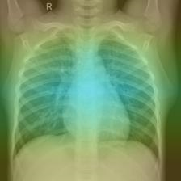

Fig. 14: A Sample Image after Grad-CAM implementation

## 4.8 Web based GUI

Finally, a web based GUI was created to enable medical personnel to screen COVID-19 positive cases thus preventing further transmission of the deadly virus.

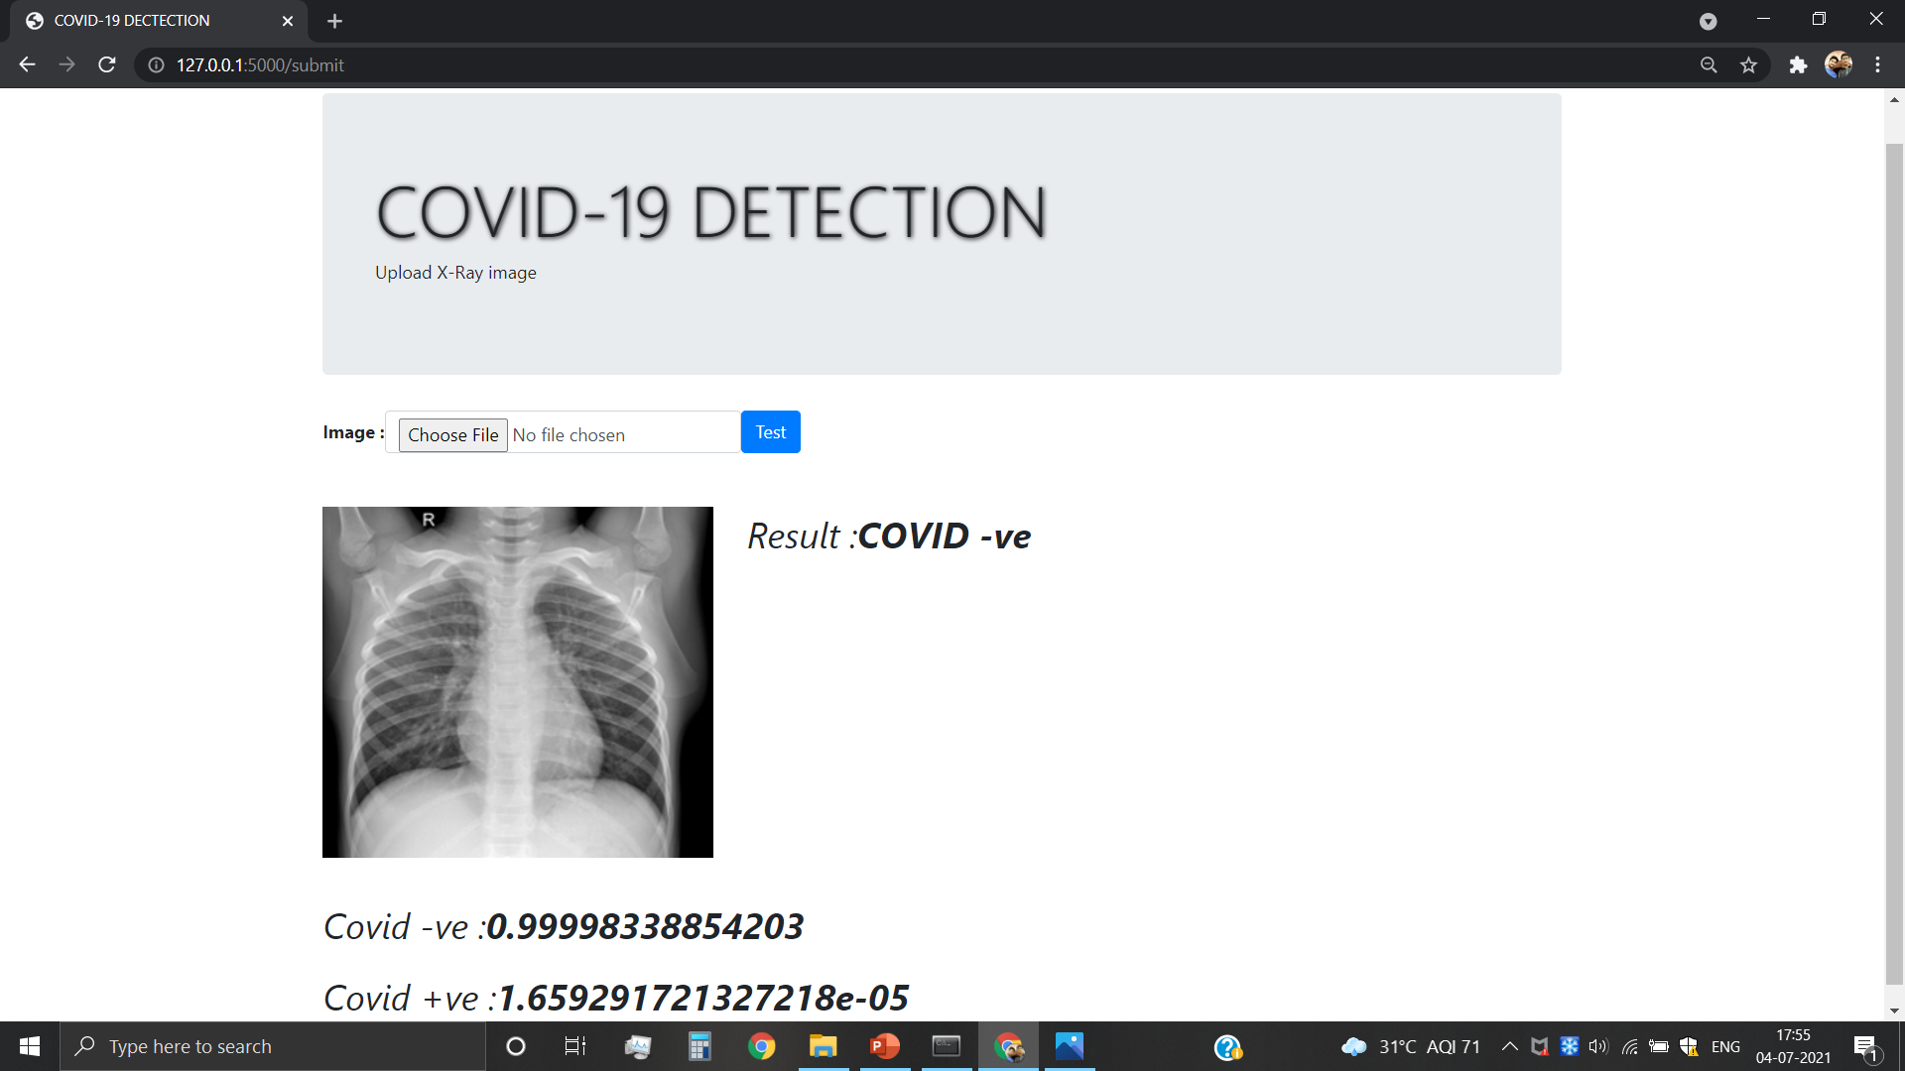

Fig. 15: A screenshot of the Web based GUI

# Chapter 5

# CONCLUSION AND FUTURE SCOPES

# 5.1 Conclusion

As we know that timely detection of COVID positive patients is vital to avoiding further transmission of the disease and keeping it under control. This project enables the detection of COVID-19 cases in a efficient, pragmatic, and economical way. In this project, we used three modern deep learning models and ensembled them. Thus the proposed model achieved a classification accuracy of 98%. Most importantly, the model has a sensitivity of over 99% i.e. out of 400 COVID positive patients, 397 can correctly detected. Also, the implementation of Grad-CAM will enable a visual validation of the model. The GUI interface will help frontline workers to detect COVID cases with ease and without contact within a few seconds. Thus, we can conclude that this project will be of great use to the society.

# 5.2 Future Scopes

Every single COVID case that goes undetected can cause major harm to the society. There have been cases where a few infected people have gone on to infect thousands. The patient may keep on spreading the virus without knowing about his condition. Hence, even though an accuracy of 98% has been achieved, we still need a better and more efficient model. As more and more data becomes available, we can expect better models as Deep Learning thrives as the amount of data increases. Also, as more and more research is conducted on the coronavirus, we can hope for a breakthrough in COVID-19 detection.

# REFERENCES

1. Andre E, Brett K, Roberto A et al (2017)- Dermatologist-level classifcation of skin cancer with deep neural networks. Nature 542(7639):115–118

2. Apostolopoulos ID, Bessiana T (2020)- COVID-19: automatic detection from X-ray images utilizing transfer learning with convolutional neural networks. Phys Eng Sci Med, pp 1–6

3. Chouhan V, Singh S, Khamparia A, Gupta D, Tiwari P, Moreira C, Damaeviuus R, Albuquerque V (2020)- A novel transfer learning based approach for pneumonia detection in chest X-ray images. Appl Sci 10:559

4. Christian Szegedy, Vincent Vanhoucke, Sergey Ioffe, Jonathon Shlens, Zbigniew Wojna- Rethinking the Inception Architecture for Computer Vision

5. Dansana D, Kumar R, Bhattacharjee A, Hemanth DJ, Gupta D, Khanna A, Castillo O (2020)- Early diagnosis of COVID-19-affected patients based on X-ray and computed tomography images using deep learning algorithm. Soft Comput, pp 1–9

6. Duran-Lopez L, Dominguez-Morales JP, Corral-Jaime J, VicenteDiaz S, Linares-Barranco A (2020)- COVID-XNet: a custom deep learning system to diagnose and locate COVID-19 in chest X-ray images. Appl Sci 10(16):5683

7. Frazao X, Alexandre LA (2014)- Weighted convolutional neural network ensemble. In: Iberoamerican Congress on pattern recognition, Springer, Cham

8. Grewal M, Srivastava MM, Kumar P, Varadarajan S (2017)- Radiologist level accuracy using deep learning for hemorrhage detection in CT scans. arXiv:1710.04934

9. Huang C et al (2020)- Clinical features of patients infected with 2019 novel coronavirus in Wuhan, China. Lancet 395:497–506.

10. Jain R, Gupta M, Taneja S, Hemanth DJ (2020)- Deep learning based detection and analysis of COVID-19 on chest X-ray images. Appl Intell, pp 1–11.

11. Ju C, Bibaut A, van der Laan M (2018)- The relative performance of ensemble methods with deep convolutional neural networks for image classifcation. J Appl Stat 45(15):2800–2818

12. Khan AI, Shah J, Bhat M (2020)- CoroNet: a deep neural network for detection and diagnosis of COVID-19 from chest x-ray images. Comput Methods Programs Biomed 196:105581.

13. Li L, Qin L, Xu Z, Yin Y, Wang X, Kong B, Bai J, Lu Y, Fang Z, Song Q, Cao K, Liu D, Wang G, Xu Q, Fang X, Zhang S, Xia J, Xia J (2020)- Artifcial intelligence distinguishes COVID-19 from community acquired pneumonia on chest CT Radiology

14. Mahmud T, Rahman MA, Fattah SA (2020)- CovXNet: a multidilation convolutional neural network for automatic COVID-19 and other pneumonia detection from chest X-ray images with transferable multi-receptive feature optimization. Comput Biol Med 122:103869

15. Makris A, Kontopoulos I, Tserpes K (2020)- COVID-19 detection from chest X-ray images using deep learning and convolutional neural networks. medRxiv.

16. Mangal A, Kalia S, Rajgopal H, Rangarajan K, Namboodiri V, Banerjee S, Arora C (2020)- COVIDAID: COVID-19 detection using chest X-ray. arXiv:2004.09803

17. Minaee S, Kafeh R, Sonka M, Yazdani S, Souf GJ (2020)- DeepCOVID: predicting COVID-19 from chest X-ray images using deep transfer learning. Med Image Anal 65:101794

18. Ng M-Y, Lee EY, Yang J, Yang F, Li X, Wang H, Lui M-MS, Lo CS-Y, Leung B, Khong P-L, Hui CK-M, Yuen K-Y, Kuo MD (2020)- Imaging prole of the COVID-19 infection radiologic endings and literature review. Radiol Cardiothorac Image 2(1):e200034.

19. Ozturk T, Talo M, Yildirim EA, Baloglu UB, Yildirim O, Acharya UR (2020)- Automated detection of COVID-19 cases using deep neural networks with X-ray images. Comput Biol Med 121:103792

20. Rahimzadeh M, Attar A (2020)- A modifed deep convolutional neural network for detecting COVID-19 and pneumonia from chest X-ray images based on the concatenation of Xception and ResNet50V2. Inf Med Unlock 19:100360

21. Rajpurkar P, Irvin J, Zhu K, Yang B, Mehta H, Duan T, Ding D, Bagul A, Langlotz C, Shpanskaya K, et al (2017)- Chexnet: radiologist-level pneumonia detection on chest x-rays with deep learning. arXiv preprint arXiv:1711.05225

22. Ramprasaath R. Selvaraju, Michael Cogswell, Abhishek Das, Ramakrishna Vedantam, Devi Parikh, Dhruv Batra- Grad-CAM: Visual Explanations from Deep Networks via Gradient-based Localization

23. Ranjan E, Paul S, Kapoor S, Kar A, Sethuraman R, Sheet D (2018)- Jointly learning convolutional representations to compress radiological images and classify thoracic diseases in the compressed domain. Proceedings of the 11th Indian Conference on computer vision, graphics and image processing

24. Shan F, Gao Y, Wang J, Shi W, Shi N, Han M, Xue Z, Shen D, Shi Y (2020)- Lung infection quantifcation of COVID-19 in CT images with deep learning. arXiv:2003.04655

25. Singh D, Kumar V, Vaishali, Kaur M (2020)- Classifcation of COVID-19 patients from chest CT images using multi-objective diferential evolution based convolutional neural networks. Eur J Clin Microbiol Infect Dis 39:1379–1389

26. Tao S (2019)- Deep neural network ensembles. arXiv:1904.05488

27. Waheed A, Goyal M, Gupta D, Khanna A, Al-Turjman F, Pinheiro PR (2020)- COVIDGAN: data augmentation using auxiliary classifer GAN for improved COVID-19 detection. IEEE Access 8:91916–91923

28. Wang L, Lin ZQ, Wong A (2020)- COVID-Net: a tailored deep convolutional neural network design for detection of COVID-19 cases from chest X-ray images. Scientifc Reports, Vol. 10

29. Wang X, Peng Y, Lu L, Lu Z, Bagheri M, Summers RM (2017)- Chestx-ray8: hospital-scale chest x-ray database and benchmarks on weakly-supervised classifcation and localization of common thorax diseases. In: Proceedings of the IEEE Conference on computer vision and pattern recognition, pp 3462–3471

30. Xu X, Jiang X, Ma C, Du P, Li X, Lv S, Y L, Chen Y, Su J, Lang G, Li Y, Zhao H, Xu K, Ruan L, Wu W (2020)- Deep learning system to screen Coronavirus disease 2019 pneumonia. arXiv: 2002.09334

31. Yan Q, Wang B, Gong D, Luo C, Zhao W, Shen J, Shi Q, Jin S, Zhang L, You Z (2020)- COVID-19 Chest CT image segmentation—a deep convolutional neural network solution. arXiv:2004.10987

- Dataset Source: https://www.kaggle.com/tawsifurrahman/covid19-radiography-database