Complier Design Lab Assignment

CEN-692

Submitted By: Submitted To:

Habibur Rahman Mr. Shahzad Alam

17BCS071

**B-Tech VIth Semester ( Computer Science )**

Department of Computer Engineering,

Faculty of Engineering and Technology,

Jamia Millia Islamia ,

New Delhi

Session: 2019-20

|  |  |
| --- | --- |
| **Index** | |
| **1.** | **Write a program to find out the FIRST & FOLLOW values for a given Context Free Grammar. The program should read the C.F.G. from a file.** |
| **2.** | **Write a program that verifies whether a given CFG is suitable for LL(1) parsing or not. If not then the program should convert the given CFG to a form which is suitable for the LL parsing.** |
| **3.** | **Write a program in C to generate SLR parse table from CFG grammar.** |
| **4.** | **Write a program to find the Leaders and Basic Blocks for a Three Address Code given through a file.** |

**Question 1 ) Write a program to find out the FIRST & FOLLOW values for a given Context Free Grammar. The program should read the C.F.G. from a file.**

import java.io.File;

import java.io.FileNotFoundException;

import java.util.ArrayList;

import java.util.Arrays;

import java.util.HashMap;

import java.util.Scanner;

public class firstFollow {

public static void main(String[] args) throws FileNotFoundException {

hrkhan();

File file = new File("first.txt");

Scanner s = new Scanner(file) ;

int non_terminal = Integer.parseInt(s.nextLine());

HashMap<String , String[]> map = new HashMap<>();

String[] terminal = new String[non_terminal];

for (int i = 0; i <non_terminal ; i++) {

String str = s.nextLine();

String[] str_split = str.split("-->" );

String[] terminal_str = str_split[1].split("/");

//System.out.println(Arrays.toString(terminal_str));

map.put(str_split[0] , terminal_str) ;

terminal[i] = str_split[0];

}

HashMap<String , ArrayList<String> > first = new HashMap<>();

HashMap<String , ArrayList<String> > follow = new HashMap<>();

System.out.println("First of All non-Terminal ");

first_func(map , first,terminal);

System.out.println("Follow of all non-Terminal ");

follow_func(map ,first ,terminal , follow);

}

public static void follow_func(HashMap<String, String[]> map, HashMap<String, ArrayList<String>> first, String[] terminal, HashMap<String, ArrayList<String>> follow) {

for (int i = 0; i <terminal.length ; i++) {

String str = terminal[i] ;

int j = 0 ;

ArrayList<String> follow_str = new ArrayList<>();

if(i==0)

{

follow_str.add("$") ;

}

for (int k = 0; k <map.size(); k++) {

String st[] = map.get(terminal[k]);

for (int l = 0; l <st.length ; l++) {

if(st[l].contains(terminal[i]))

{

int m = st[l].indexOf(terminal[i] , 0 );

if(m + 1< st[l].length())

{

if (map.containsKey(st[l].charAt(m+1) + ""))

{

if(!map.get(terminal[k]).equals(st[l].charAt(m+1) + ""))

{

ArrayList<String> ft = first.get(st[l].charAt(m+1) + "") ;

for (String sttt:ft) {

if (!follow_str.contains(sttt)) {

if (sttt.equals("#"))

{

ArrayList<String> ff = follow.get(terminal[k]);

for (String epl:ff) {

if (!follow_str.contains(epl)) {

follow_str.add(epl);

}

}

}

else

{

follow_str.add(sttt);

}

}

}

}

}

else

{

follow_str.add(st[l].charAt(m+1) + "") ;

}

}

else

{

if (map.containsKey(st[l].charAt(m) + ""))

{

if(!terminal[k].equals(st[l].charAt(m) + ""))

{

ArrayList<String> ft = follow.get(terminal[k]);

for (String sttt:ft) {

if (!follow_str.contains(sttt)) {

follow_str.add(sttt);

}

}

}

}

}

}

}

}

follow.put(terminal[i] , follow_str) ;

System.out.println("follow ( " + terminal[i] + " ) = " + follow_str);

}

}

private static void hrkhan() {

System.out.println("\nName :- Habiburrahman \nRollno 17BCS071 \nB-Tech Computer Engineering \n");

}

public static void first_func(HashMap<String, String[]> map, HashMap<String, ArrayList<String>> first, String[] terminal){

for (int i = 0; i <terminal.length ; i++) {

String str = terminal[i];

ArrayList<String> first_str = new ArrayList<>();

String[] st = map.get(str);

int j = 0 ;

while(j < st.length)

{

if(map.containsKey(st[j].charAt(0) + ""))

{

st = map.get(st[j].charAt(0) + "") ;

}

else

{

first_str.add(st[j].charAt(0) + "");

j++ ;

}

}

st = map.get(str);

first.put(terminal[i] , first_str) ;

}

for (int i = 0; i <first.size() ; i++) {

System.out.println("first( " +terminal[i] + " ) = " + first.get(terminal[i]));

}

}

}

Output: -

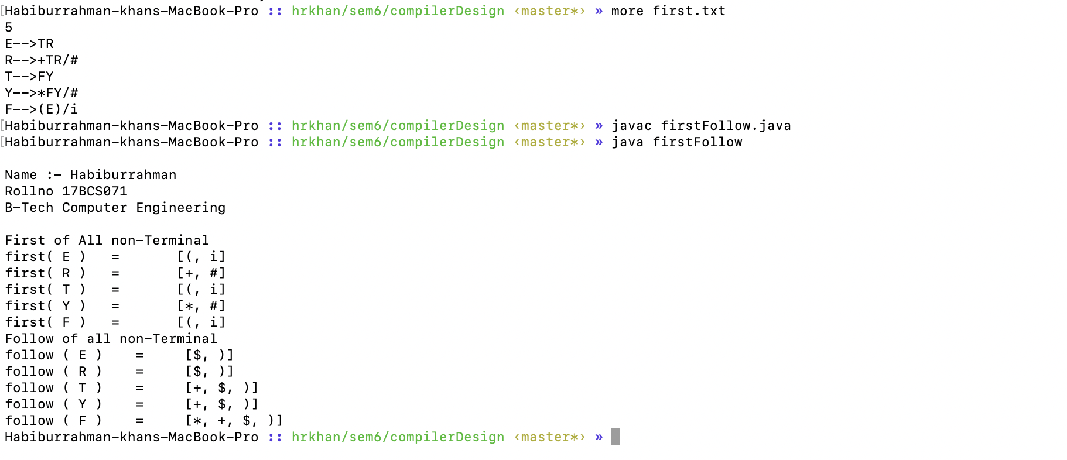

**Question 2 ) Write a program that verifies whether a given CFG is suitable for LL(1) parsing or not. If not then the program should convert the given CFG to a form which is suitable for the LL parsing.**

import java.io.File;

import java.io.FileNotFoundException;

import java.util.ArrayList;

import java.util.Arrays;

import java.util.HashMap;

import java.util.Scanner;

public class checkLL1 {

public static void main(String[] args) throws FileNotFoundException {

hrkhan();

File file = new File("cfg");

Scanner s = new Scanner(file) ;

HashMap<String , String[]> map = new HashMap<>();

HashMap<String , String[]> leftRecursion = new HashMap<>();

HashMap<String , String[]> leftFactoring = new HashMap<>();

int i =0 ;

while (s.hasNextLine())

{

String str = s.nextLine() ;

String[] str_split = str.split("-->" );

String[] terminal_str = str_split[1].split("/");

//System.out.println(Arrays.toString(terminal_str));

map.put(str_split[0] , terminal_str) ;

}

String[] non_terminal = new String[map.size()];

for (String str: map.keySet()

) {

non_terminal[i++] = str ;

}

boolean lr = checkLeftRecursion(map , non_terminal , leftRecursion);

boolean lf = checkLeftfactoring(map , non_terminal , leftFactoring);

if (lr && lf)

{

System.out.println("CFG is valid for LL1");

}

else

{

System.out.println("CFG is Not valid for LL1");

System.out.println("the CFG suitable for LL parsing ");

}

for (String st : map.keySet()) {

System.out.print(st + " --> ");

for (String ss : map.get(st)) {

System.out.print(ss + " / ");

}

System.out.println();

}

}

private static boolean checkLeftfactoring(HashMap<String, String[]> map, String[] non_terminal, HashMap<String, String[]> leftFactoring) {

int w = (int) 'W';

HashMap<String , Boolean> del = new HashMap<>();

for (String str: map.keySet()) {

String stt = map.get(str)[0];

for (int i = 1; i < map.get(str).length; i++) {

stt = commonPrefix(stt , map.get(str)[i]);

}

String alpha = stt.length()!=map.get(str)[0].length() ? stt:"";

if (alpha.length()!=0)

{

del.put(str , true);

ArrayList<String> beeta = new ArrayList<>();

ArrayList<String> gamma = new ArrayList<>();

for (int i = 0; i <map.get(str).length ; i++) {

if (map.get(str)[i].contains(alpha))

{

int m = map.get(str)[i].indexOf(alpha , 0);

beeta.add(map.get(str)[i].substring(m+1));

}

else

{

gamma.add(map.get(str)[i]);

}

}

String[] beeta_ = new String[beeta.size()];

String[] gamma_ = new String[gamma.size() + 1 ];

gamma_[0] = alpha + (char)w ;

for (int j = 1; j < gamma_.length; j++) {

gamma_[j] = gamma.get(j-1);

}

for (int j = 0; j <beeta.size() ; j++) {

beeta_[j] = beeta.get(j);

}

leftFactoring.put(str , gamma_ );

leftFactoring.put((char)w+"" , beeta_);

w++;

}

}

for (String de:del.keySet()) {

if (map.containsKey(de))

{

map.remove(de);

}

}

for (String sr : leftFactoring.keySet()) {

map.put(sr , leftFactoring.get(sr));

}

if (del.size()==0)

{

System.out.println("No Factoring (Non - Deterministic Grammar) in the production After Left Recursion removing ");

return true;

}

else

{

return false ;

}

}

static String commonPrefix(String str1, String str2) {

String result = "";

int n1 = str1.length(), n2 = str2.length();

if (str1.charAt(0)!=str2.charAt(0))

return str1 ;

// Compare str1 and str2

for (int i = 0, j = 0; i <= n1 - 1 && j <= n2 - 1; i++, j++) {

if (str1.charAt(i) != str2.charAt(j)) {

break;

}

result += str1.charAt(i);

}

return (result);

}

private static boolean checkLeftRecursion(HashMap<String, String[]> map, String[] non_terminal , HashMap<String , String[]> leftRe) {

int p = 80 ;

HashMap<String , Boolean> del = new HashMap<>();

for (String str: map.keySet()) {

for (int i = 0; i < map.get(str).length ; i++) {

if(map.get(str)[i].charAt(0) == str.charAt(0))

{

System.out.println(" Left Recursion found in the production " +str +"-->" + Arrays.toString(map.get(str)));

del.put(str , true);

ArrayList<String> alpha = new ArrayList<>();

ArrayList<String> beeta = new ArrayList<>();

for (String ab:map.get(str)) {

if (ab.charAt(0) == str.charAt(0))

{

alpha.add(ab.substring(1));

}

else

{

beeta.add(ab);

}

}

String[] beeta_ = new String[beeta.size()];

String[] alpha_ = new String[alpha.size() + 1];

for (int j = 0; j <beeta.size() ; j++) {

beeta_[j] = beeta.get(j)+(char)p;

}

for (int j = 0; j <alpha.size() ; j++) {

alpha_[j] = alpha.get(j)+(char)p;

}

alpha_[alpha.size()] = "#" ;

leftRe.put(str,beeta_);

leftRe.put((char)p + "" ,alpha_ ) ;

p++;

}

break;

}

}

for (String de:del.keySet()) {

if (map.containsKey(de))

{

map.remove(de);

}

}

for (String sr : leftRe.keySet()) {

map.put(sr , leftRe.get(sr));

}

if (del.size()==0)

{

System.out.println("No Left Recursion in the production ");

return true;

}

else

{

return false ;

}

}

private static void hrkhan() {

System.out.println("\nName :- Habiburrahman \nRollno 17BCS071 \nB-Tech Computer Engineering \n");

}

}

Output:-

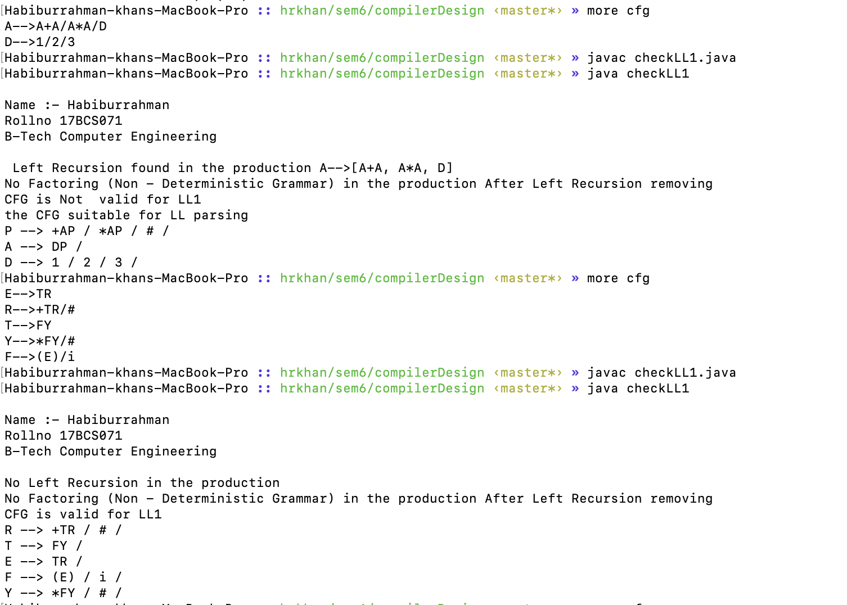

**Question 3 ) Write a program in C to generate SLR parse table from CFG grammar.**

#include <stdio.h>

#include <string.h>

#include <ctype.h>

int i2,j2,i,j,k,m2=0,n=0,o,p,ns=0,tn=0,rr=0,ch=0;

char read[15][10],gl[15],gr[15][10],temp,templ[15],tempr[15][10],*ptr,temp2[5],dfa[15][15];

char variables[15]={'\0'}, terminals[15]={'\0'};

char slr[15][15][10]={'\0'};

char foll[10];

int len_var, len_ter;

struct states

{

char lhs[15],rhs[15][10];

int n;

}I[15];

void follow(char c);

void first(char c);

int compstruct(struct states s1,struct states s2)

{

int t;

if(s1.n!=s2.n)

return 0;

if( strcmp(s1.lhs,s2.lhs)!=0 )

return 0;

for(t=0;t<s1.n;t++)

if( strcmp(s1.rhs[t],s2.rhs[t])!=0 )

return 0;

return 1;

}

void hrkhan()

{

printf("Name: Habiburrahman\n");

printf("Rollno : 17BCS071\n");

printf("B-Tech Computer Enigeering \n");

}

void moreprod()

{

int r,s,t,l1=0,rr1=0;

char *ptr1,read1[15][10];

for(r=0;r<I[ns].n;r++)

{

ptr1=strchr(I[ns].rhs[l1],'.');

t=ptr1-I[ns].rhs[l1];

if( t+1==strlen(I[ns].rhs[l1]) )

{

l1++;

continue;

}

temp=I[ns].rhs[l1][t+1];

l1++;

for(s=0;s<rr1;s++)

if( temp==read1[s][0] )

break;

if(s==rr1)

{

read1[rr1][0]=temp;

rr1++;

}

else

continue;

for(s=0;s<n;s++)

{

if(gl[s]==temp)

{

I[ns].rhs[I[ns].n][0]='.';

I[ns].rhs[I[ns].n][1]='\0';

strcat(I[ns].rhs[I[ns].n],gr[s]);

I[ns].lhs[I[ns].n]=gl[s];

I[ns].lhs[I[ns].n+1]='\0';

I[ns].n++;

}

}

}

}

void canonical(int l)

{

int t1;

char read1[15][10],rr1=0,*ptr1;

for(i=0;i<I[l].n;i++)

{

temp2[0]='.';

ptr1=strchr(I[l].rhs[i],'.');

t1=ptr1-I[l].rhs[i];

if( t1+1==strlen(I[l].rhs[i]) )

continue;

temp2[1]=I[l].rhs[i][t1+1];

temp2[2]='\0';

for(j=0;j<rr1;j++)

if( strcmp(temp2,read1[j])==0 )

break;

if(j==rr1)

{

strcpy(read1[rr1],temp2);

read1[rr1][2]='\0';

rr1++;

}

else

continue;

for(j=0;j<I[0].n;j++)

{

ptr=strstr(I[l].rhs[j],temp2);

if( ptr )

{

templ[tn]=I[l].lhs[j];

templ[tn+1]='\0';

strcpy(tempr[tn],I[l].rhs[j]);

tn++;

}

}

for(j=0;j<tn;j++)

{

ptr=strchr(tempr[j],'.');

p=ptr-tempr[j];

tempr[j][p]=tempr[j][p+1];

tempr[j][p+1]='.';

I[ns].lhs[I[ns].n]=templ[j];

I[ns].lhs[I[ns].n+1]='\0';

strcpy(I[ns].rhs[I[ns].n],tempr[j]);

I[ns].n++;

}

moreprod();

for(j=0;j<ns;j++)

{

if( compstruct(I[ns],I[j])==1 )

{

I[ns].lhs[0]='\0';

for(k=0;k<I[ns].n;k++)

I[ns].rhs[k][0]='\0';

I[ns].n=0;

dfa[l][j]=temp2[1];

break;

}

}

if(j<ns)

{

tn=0;

for(j=0;j<15;j++)

{

templ[j]='\0';

tempr[j][0]='\0';

}

continue;

}

dfa[l][j]=temp2[1];

printf("\n\nI%d :",ns);

for(j=0;j<I[ns].n;j++)

printf("\n\t%c -> %s",I[ns].lhs[j],I[ns].rhs[j]);

//getch();

ns++;

tn=0;

for(j=0;j<15;j++)

{

templ[j]='\0';

tempr[j][0]='\0';

}

}

}

void extract_var_char(){

for (i=0;i<n;i++){

if (gl[i] >= 'A' && gl[i] <= 'Z'){

if (!strchr(variables,gl[i]))

sprintf(variables,"%s%c",variables,gl[i]);

}

for (j=0;j<strlen(gr[i]);j++){

if (gr[i][j] < 'A' || gr[i][j] > 'Z'){

if (!strchr(terminals,gr[i][j]))

sprintf(terminals,"%s%c",terminals,gr[i][j]);

}

}

}

strcat(terminals,"$");

printf ("Variables : %s\nTerminals : %s\n",variables,terminals);

}

void display_slr(){

printf("\n\t\tSLR(1) Table...\n\n\t");

for (i=0;i<len_ter;i++)

printf("%c\t",terminals[i]);

for (i=0;i<len_var;i++)

printf("%c\t",variables[i]);

printf("\n");

for (i=0;i<ns;i++){

printf("I%d\t",i);

for (j=0;j<len_var+len_ter;j++)

printf("%s\t",slr[i][j]);

printf("\n");

}

}

int main()

{

hrkhan();

FILE *f;

int l;

//clrscr();

for(i=0;i<15;i++)

{

I[i].n=0;

I[i].lhs[0]='\0';

I[i].rhs[0][0]='\0';

dfa[i][0]='\0';

}

f=fopen("grammar.txt","r");

while(!feof(f))

{

fscanf(f,"%c",&gl[n]);

fscanf(f,"%s\n",gr[n]);

n++;

}

printf("\tGiven Grammar...\n");

for(i=0;i<n;i++)

printf("\t\t%c -> %s\n",gl[i],gr[i]);

I[0].lhs[0]='Z';

strcpy(I[0].rhs[0],".S");

I[0].n++;

l=0;

for(i=0;i<n;i++)

{

temp=I[0].rhs[l][1];

l++;

for(j=0;j<rr;j++)

if( temp==read[j][0] )

break;

if(j==rr)

{

read[rr][0]=temp;

rr++;

}

else

continue;

for(j=0;j<n;j++)

{

if(gl[j]==temp)

{

I[0].rhs[I[0].n][0]='.';

strcat(I[0].rhs[I[0].n],gr[j]);

I[0].lhs[I[0].n]=gl[j];

I[0].n++;

}

}

}

ns++;

printf("\n\tCanonicals...\n");

printf("\nI%d :\n",ns-1);

for(i=0;i<I[0].n;i++)

printf("\t%c -> %s\n",I[0].lhs[i],I[0].rhs[i]);

for(l=0;l<ns;l++){

canonical(l);

}

/////////////Construction of SLR(1) Table/////////////////

int t,tempo;

extract_var_char();

len_var = strlen(variables);

len_ter = strlen(terminals);

int columns = len_var + len_ter;

for (i=0;i<ns;i++){

for (j=0;j<ns;j++){

if (dfa[i][j] != '\0'){

if (strchr(terminals,dfa[i][j])){

sprintf(slr[i][strchr(terminals,dfa[i][j])-terminals],"s%d",j);

}

else if (strchr(variables,dfa[i][j])){

sprintf(slr[i][len_ter+strchr(variables,dfa[i][j])-variables],"%d",j);

}

}

}

for (j=0;j<I[i].n;j++){

int temp_ind = strlen(I[i].rhs[j])-1; // to make the 1st state that end with "S." accept.

if (I[i].rhs[j][temp_ind] == '.'){

if (I[i].rhs[j][temp_ind-1] == 'S' && i==1)

sprintf(slr[i][strchr(terminals,'$')-terminals],"accept");

else{

follow(I[i].lhs[j]);

int ha,prod_num,tempo_store;

for (ha=0;gl[ha]!='\0';ha++){

if (strncmp(gr[ha],I[i].rhs[j],temp_ind)==0)

prod_num = ha + 1;

}

for (ha=0; ha<m2 ; ha++){

tempo_store = strchr(terminals,foll[ha])-terminals;

if (strlen(slr[i][tempo_store]) > 0){

if (slr[i][tempo_store][0] == 's')

printf("\nSR-Conflict occurred....\n");

else

printf("\nRR-Conflict occurred....\n");

}

else

sprintf(slr[i][tempo_store],"r%d",prod_num);

}

m2=0;

}

}

}

}

display_slr();

return 0 ;

}

void follow(char c){

if(gl[0]==c)

foll[m2++]='$';

for(i2=0;i2<n;i2++){

for(j2=0;j2<strlen(gr[i2]);j2++){

if(gr[i2][j2]==c){

if(gr[i2][j2+1]!='\0')

first(gr[i2][j2+1]);

if(gr[i2][j2+1]=='\0'&&c!=gl[i2])

follow(gl[i2]);

}

}

}

}

void first(char c){

int k;

if(!(isupper(c)))

foll[m2++]=c;

for(k=0;k<n;k++){

if(gl[k]==c){

if(gr[k][0]=='$')

follow(gl[i2]);

else if(islower(gr[k][0]))

foll[m2++]=gr[k][0];

else

first(gr[k][0]);

}

}

}

Output:-

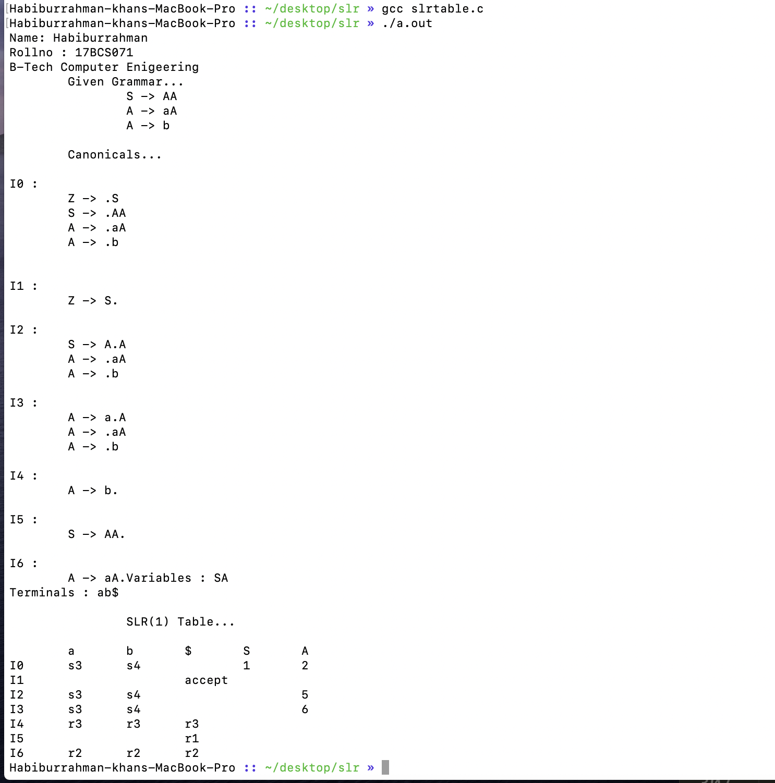

**Question 4 ) Write a program to find the Leaders and Basic Blocks for a Three Address Code given through a file.**

import java.io.File;

import java.io.FileNotFoundException;

import java.util.*;

public class leaderBasicBlocks {

public static void main(String[] args) throws FileNotFoundException {

File file = new File("leaderbasicblockinput") ;

hrkhan();

Scanner s = new Scanner(file);

HashMap<Integer , String> input = new HashMap<>();

HashMap<Integer , String> leader = new HashMap<>();

HashMap<Integer , ArrayList<String>> basic = new HashMap<>();

int i =1 ;

while (s.hasNextLine())

{

String str = s.nextLine() ;

input.put(i++ , str);

}

leader_func(input, leader);

basicblocksfunc(input , leader , basic);

}

private static void basicblocksfunc(HashMap<Integer, String> input, HashMap<Integer, String> leader, HashMap<Integer, ArrayList<String>> basic) {

Set<Integer> linenos = leader.keySet() ;

int[] lineno = new int[linenos.size()];

int j = 0 ;

for (int i : linenos) {

lineno[j] = i ;

j++;

}

Arrays.sort(lineno);

j = 1;

for (int i = 0; i <lineno.length-1; i++) {

ArrayList<String> basicstr = new ArrayList<>();

for (int k = lineno[i]; k <lineno[i+1]; k++) {

basicstr.add(input.get(k));

}

basic.put(j++ , basicstr);

}

ArrayList<String> basicstr = new ArrayList<>();

for (int k = lineno[lineno.length -1 ]; k < input.size()+1; k++) {

basicstr.add(input.get(k));

}

basic.put(j++ , basicstr);

for (int i : basic.keySet()) {

ArrayList<String> showoutput = basic.get(i) ;

System.out.println("Basic blocks no " + i + " ");

for (String st:

showoutput) {

System.out.println(st);

}

}

}

private static void leader_func(HashMap<Integer, String> input, HashMap<Integer, String> leader) {

leader.put(1 , input.get(1)) ;

for (int i = 1; i <=input.size(); i++) {

if (input.get(i).contains("goto"))

{

int m = input.get(i).indexOf("(");

int n = input.get(i).indexOf(")");

int line_no = Integer.parseInt(input.get(i).substring(m+1 , n));

leader.put(line_no , input.get(line_no));

if (input.containsKey(i+1) )

{

leader.put(i+1, input.get(i+1));

}

}

}

for (int i : leader.keySet()) {

System.out.println("leaders line no " + i + " " + leader.get(i));

}

}

private static void hrkhan() {

System.out.println("\nName :- Habiburrahman \nRollno 17BCS071 \nB-Tech Computer Engineering \n");

}

}

Output :-

