Tables and Figures for the MangoLeafVarietyBD Dataset

This document contains all tables and figures used in the manuscript.

Table 1: Comparison of MangoLeafVarietyBD with existing Bangladeshi datasets.
Mango Dataset | Number of Classes | Total Raw Images | Resolution | Geographical Coverage
BDMANGO [2] | 6 | 837 | 640 x 480 px | Dhaka, Bangladesh
MangoLeafVarietyBD | 8 | 2,744 | Up to  4000 x 3000 px | Thakurgaon & Savar, Bangladesh

Table 2: A quick look at the mango leaf variety dataset.
Data type | Raw field-captured mango leaf images (original resolution; no resizing applied in dataset)
Data Format | Images are JPG.
Total images | 2,744 raw images.
Number of classes/varieties | Total of eight classes (Amrupali, Banana, Bandigori, Himsagar, Surjapuri, Harivanga, Kacha Mitha, and Brunei King).
Distribution of original images | Amrupali: 308 images, Banana: 351 images, Bandigori: 332 images, Himsagar: 341 images, Surjapuri: 370 images, Harivanga: 366 images, Kacha Mitha: 376 images, and Brunei King: 300 images.
Acquisition method | Snapping of the samples was done on white background using two mobile phones after sample collection and the two sides of a leaf were captured to have an in-depth picture.
Data source locations | Thakurgaon District and Daffodil International University, Savar, Dhaka.
Where applicable | The dataset can be used in classifying the mango leaf varieties, image classification, phenotyping of plants, and agricultural studies that use machine learning.

Table 3: Architecture-Specific Hyperparameters Used for Model Training
Model | Learning Rate | Dropout | Weight Decay | Label Smoothing
ViT-B16 | $$2× {10}^{-4}$$ | 0.8 | 0.50 | 0.50
DenseNet121 | $$1.4 × {10}^{-3}$$ | 0.8 | 0.50 | 0.50
GhostNetV2 | $$5 × {10}^{-5}$$ | 0.8 | 0.30 | 0.40
ResNet18 | $$1 × {10}^{-4}$$ | 0.0 | 0.00 | 0.00

Table 4: Benchmark Performance of Deep Learning Models on the MangoLeafVarietyBD Test Set (N = 1,921)
Model | Test Accuracy | Precision (Weighted) | Recall (Weighted) | F1-Score (Weighted) | Latency (ms) | Throughput (FPS)
ViT-B16 | 0.9755 | 0.9762 | 0.9755 | 0.9756 | 13.6739 | ~73.13
DenseNet121 | 0.9558 | 0.9565 | 0.9558 | 0.9558 | 3.5861 | ~278.85
GhostNetV2 | 0.9474 | 0.9482 | 0.9474 | 0.9474 | 1.5566 | ~642.42
ResNet18 | 0.9391 | 0.9417 | 0.9391 | 0.9394 | 1.4083 | ~710.07

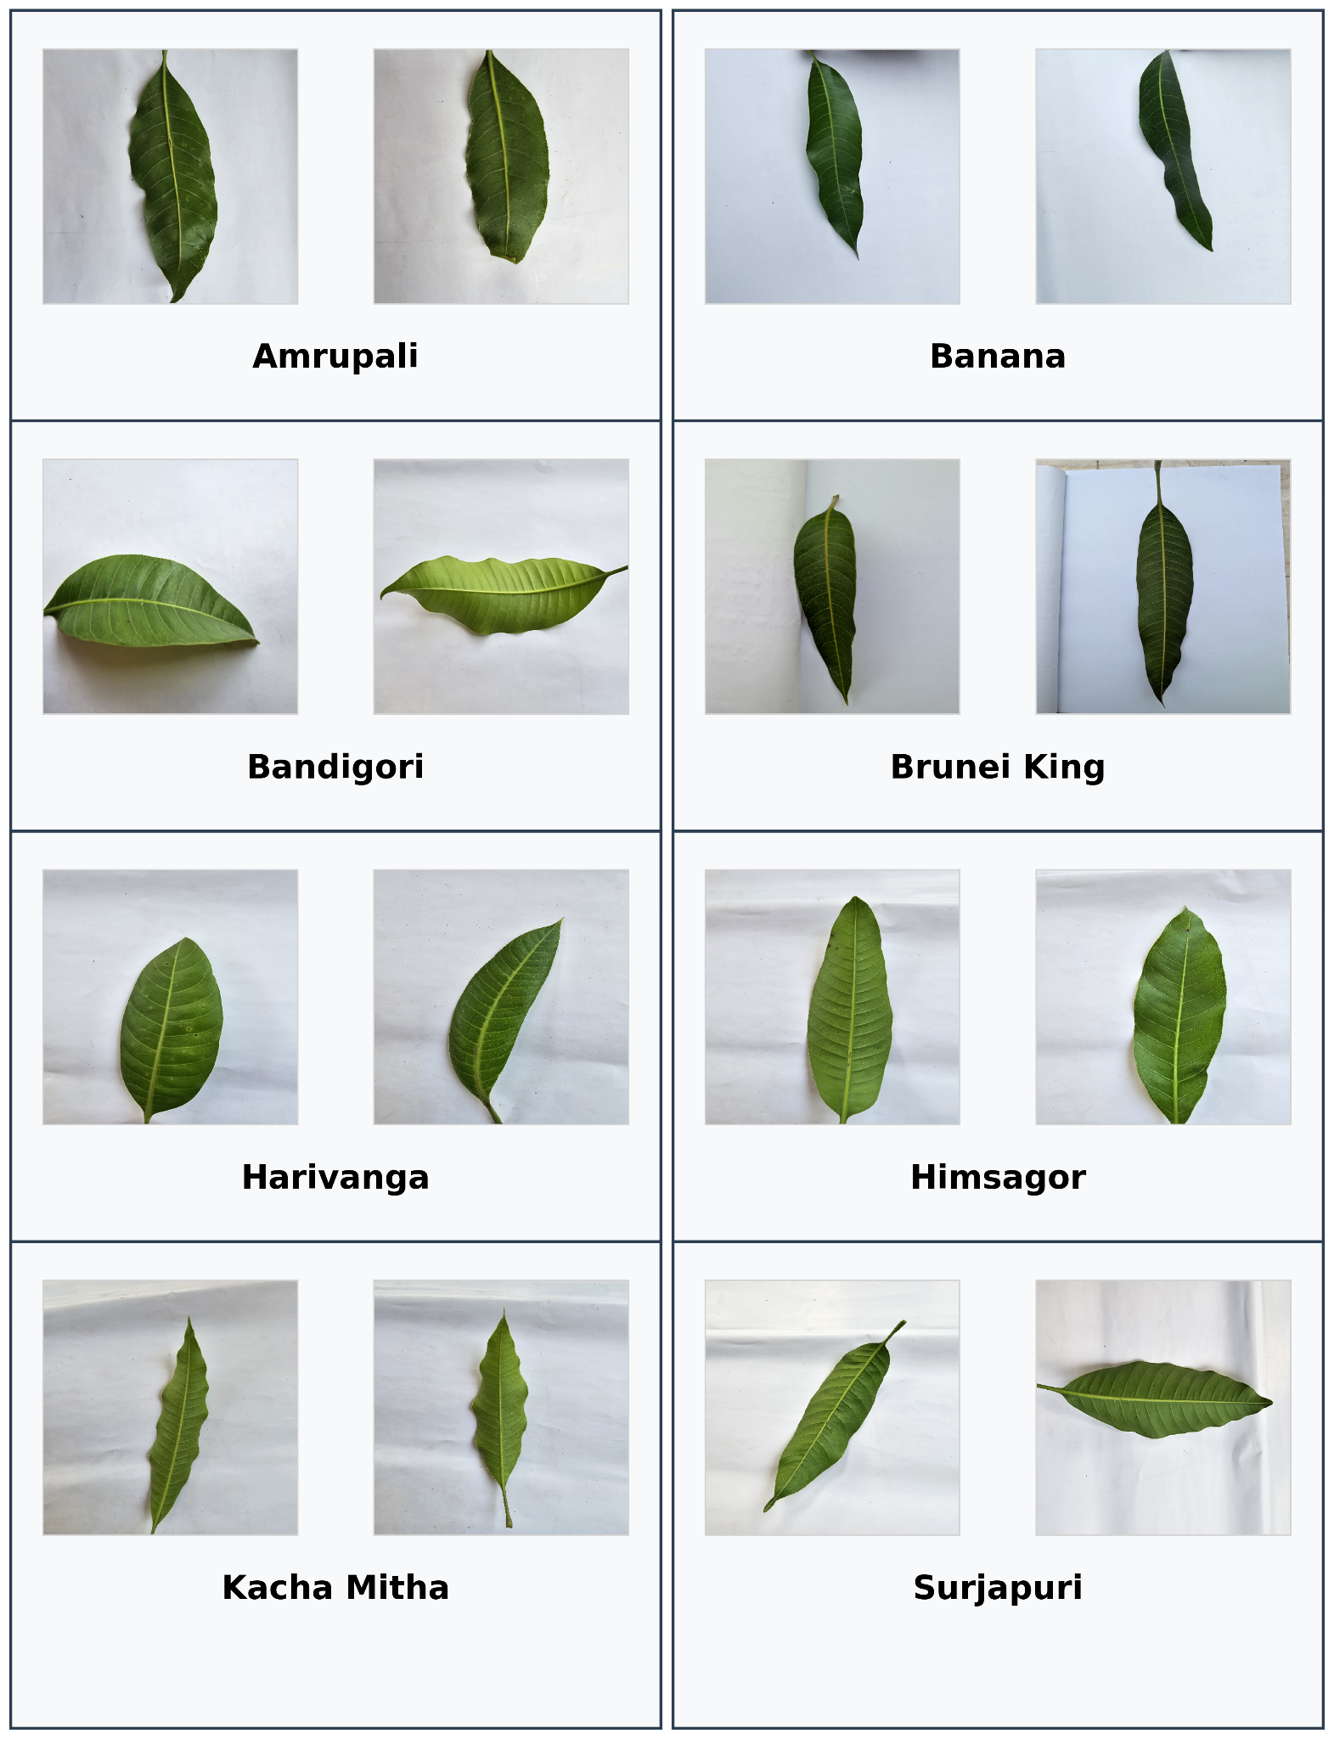

Fig. 1. Examples of eight distinct types of original mango leaf images included in the dataset.

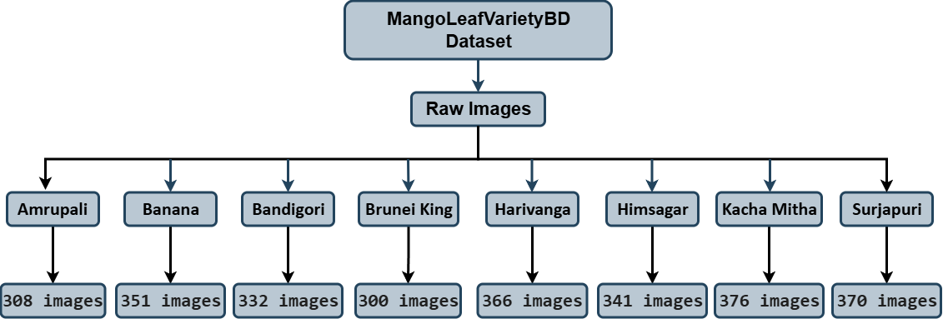

Fig. 2. Structure of the directory of the dataset.

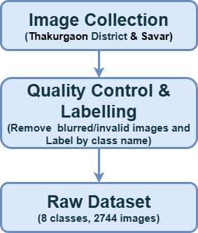

Fig. 3. Flowchart showing the data preparation steps.
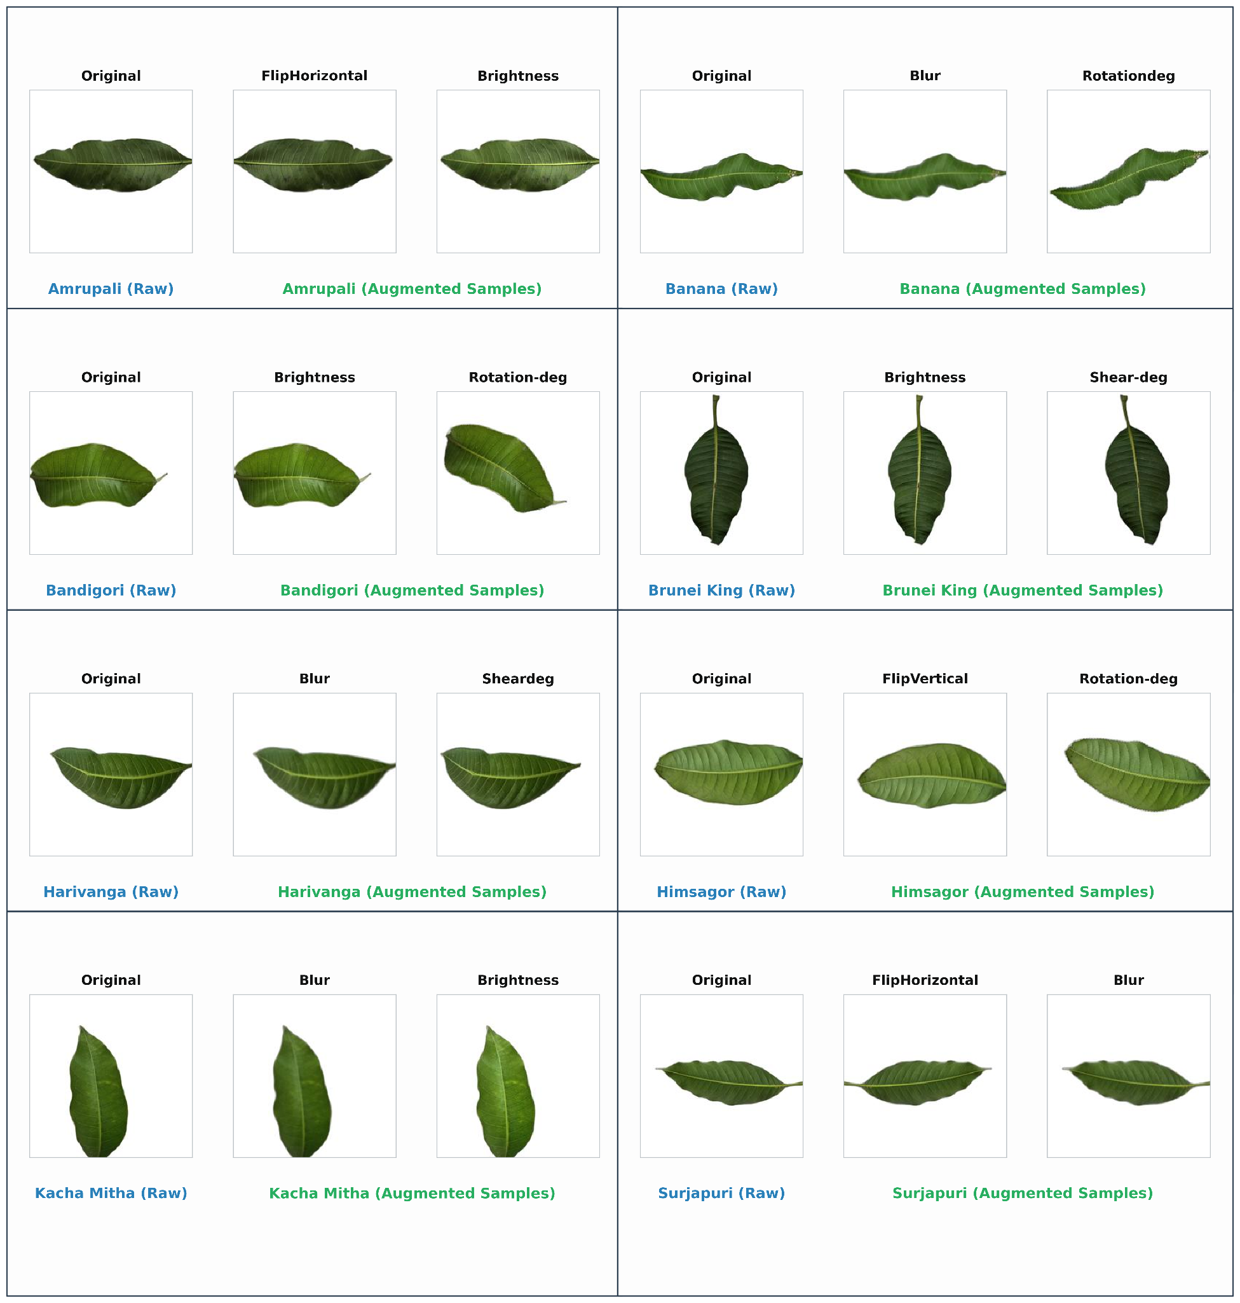

Fig. 4. Sample of augmented images of MangoLeafVarietyBD Dataset (for Experimental Model Training).
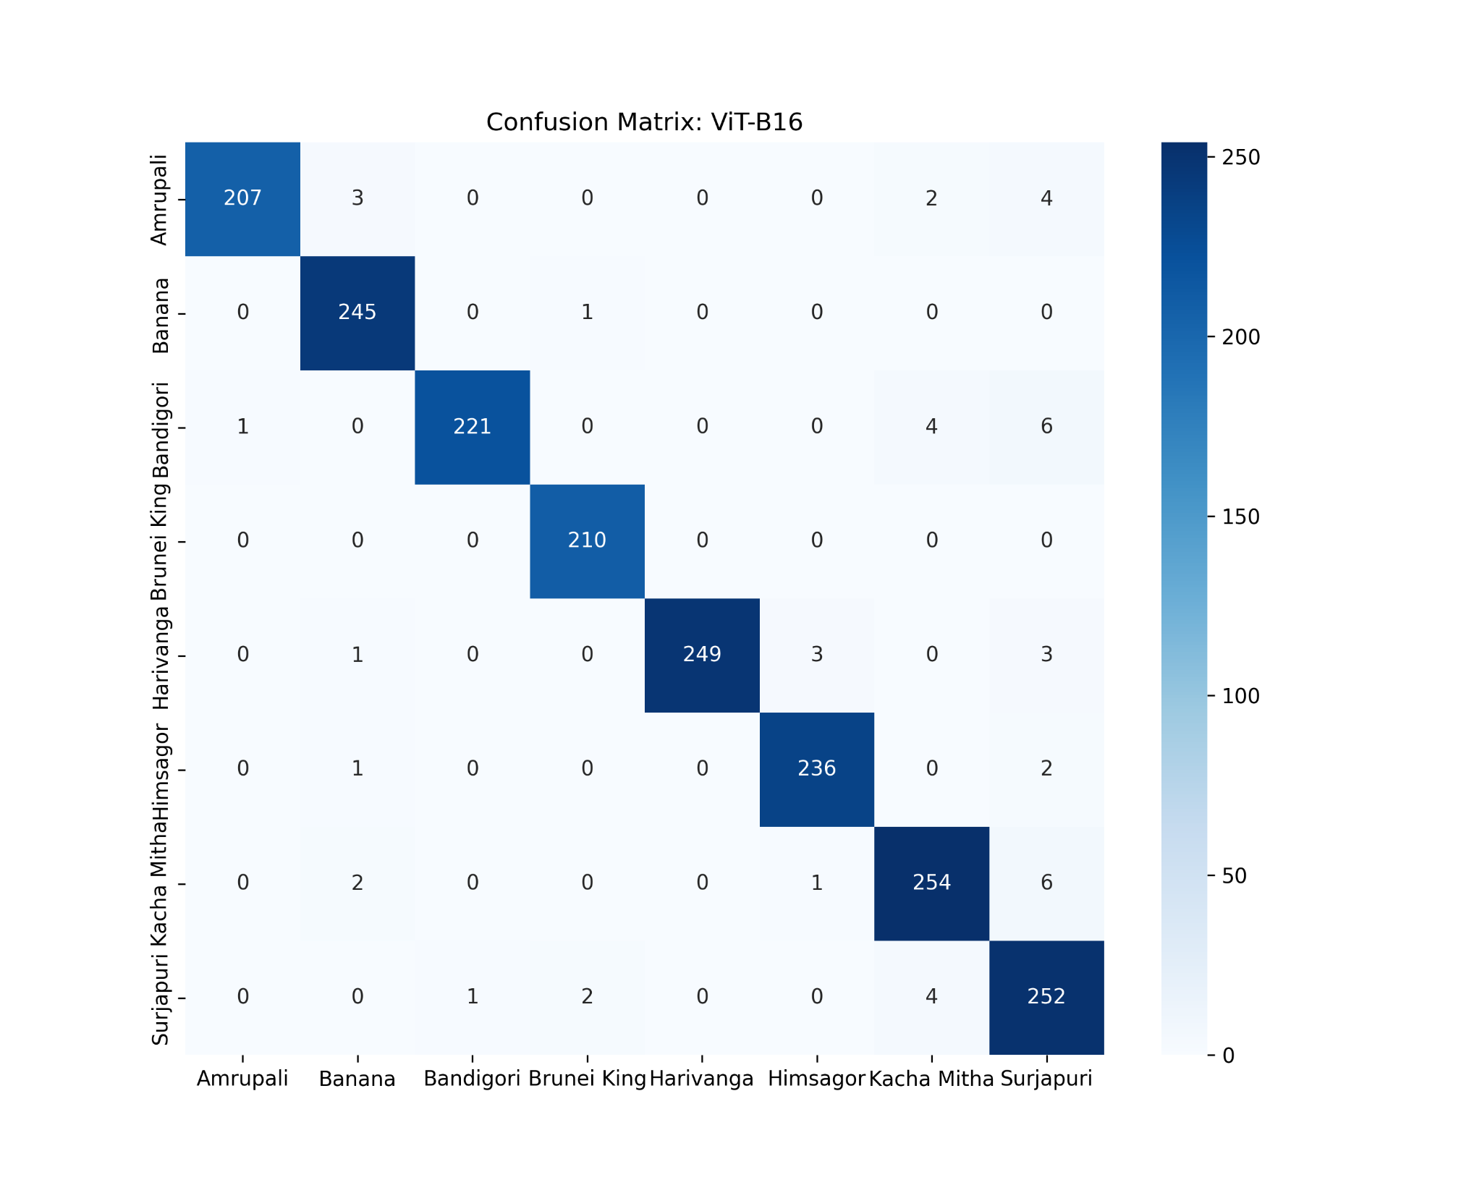
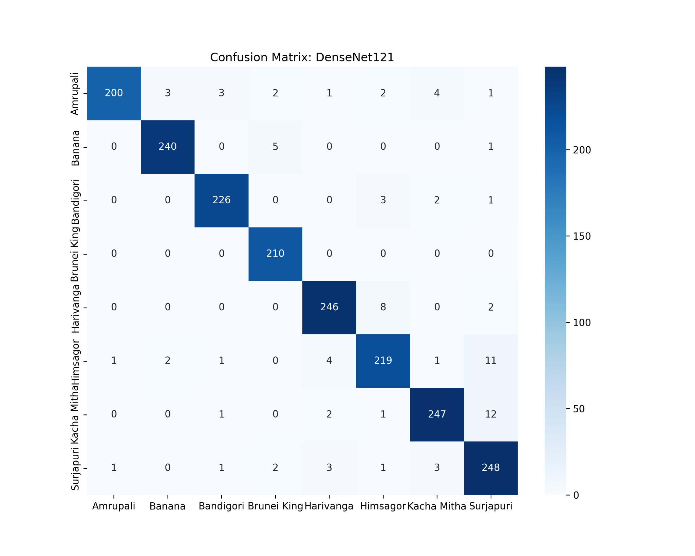

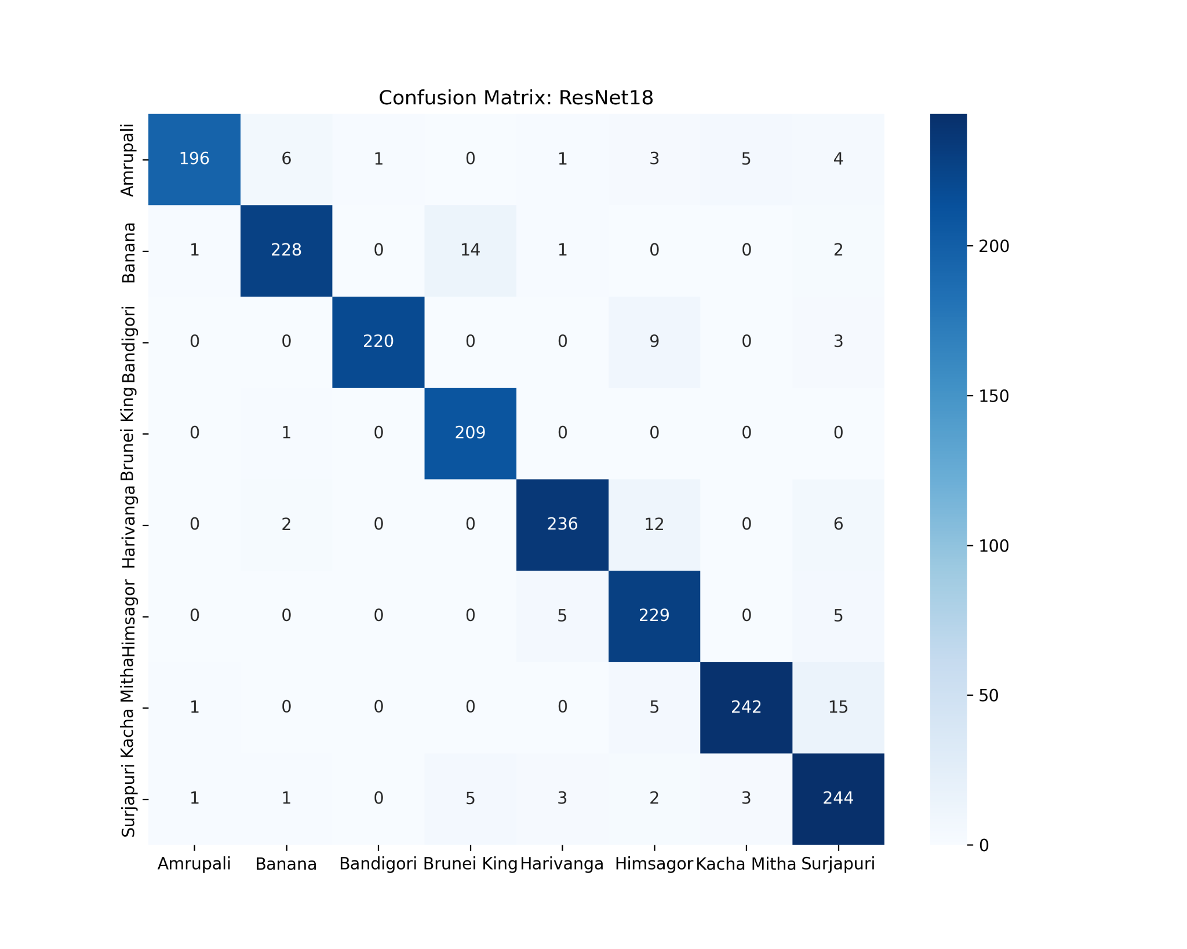
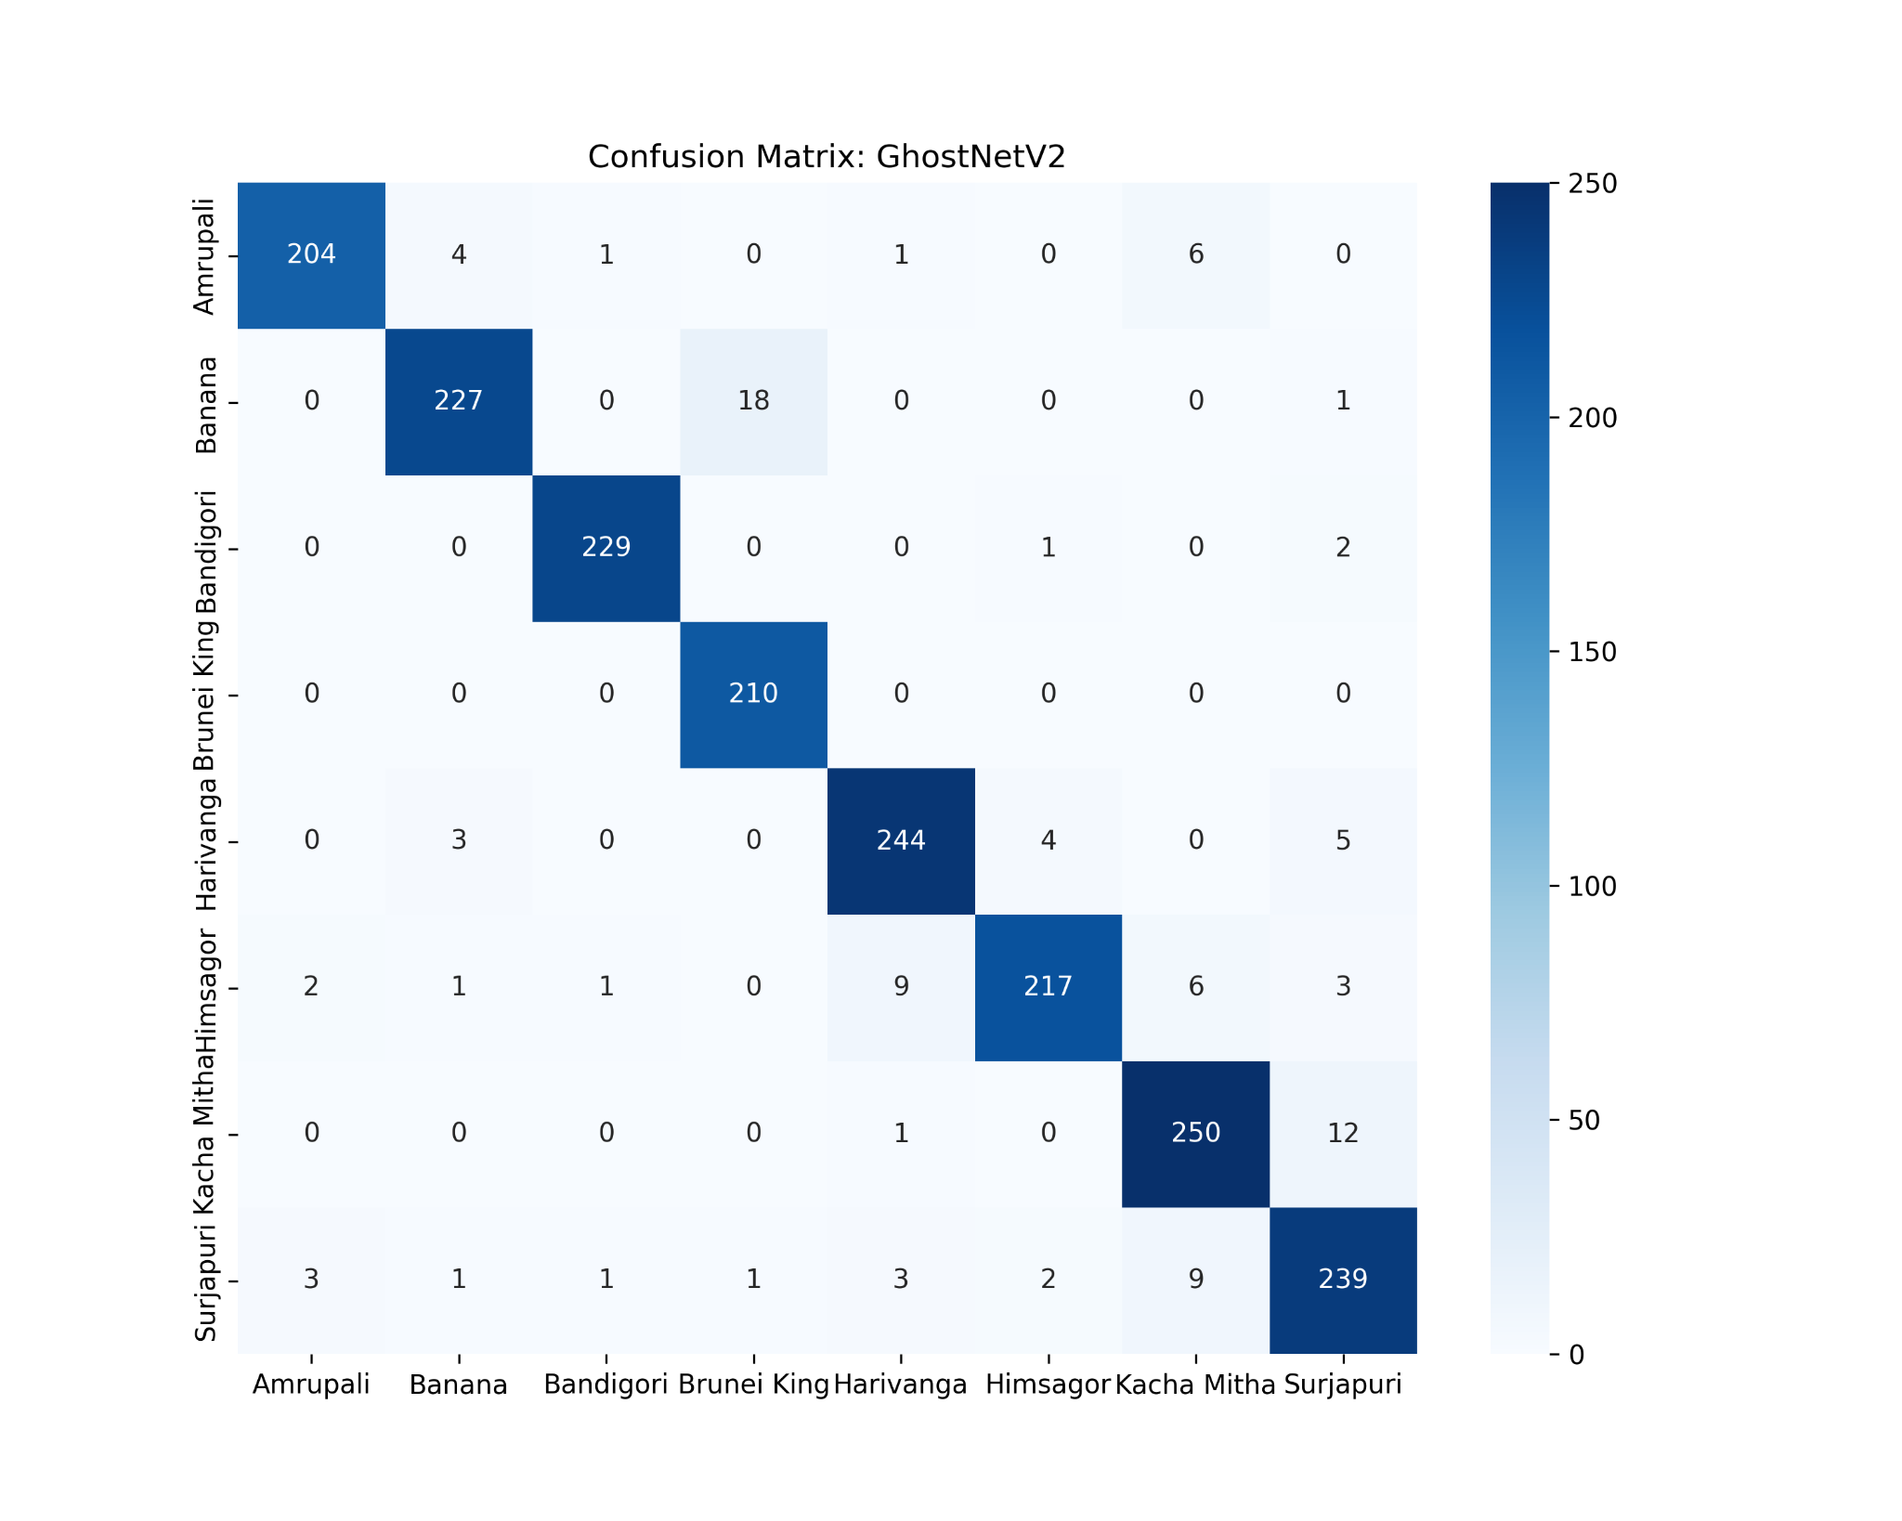
(a) (b)

(c) (d)
Fig. 5. Confusion Matrices of Four Deep Learning Models on MangoLeafVarietyBD Test Set (N=1,921). (a) ViT-B16, (b) DenseNet121, (c) GhostNetV2, (d) ResNet18

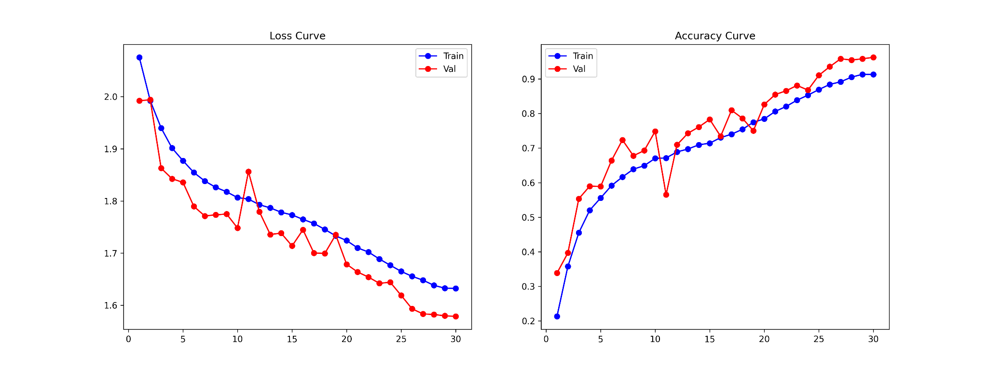
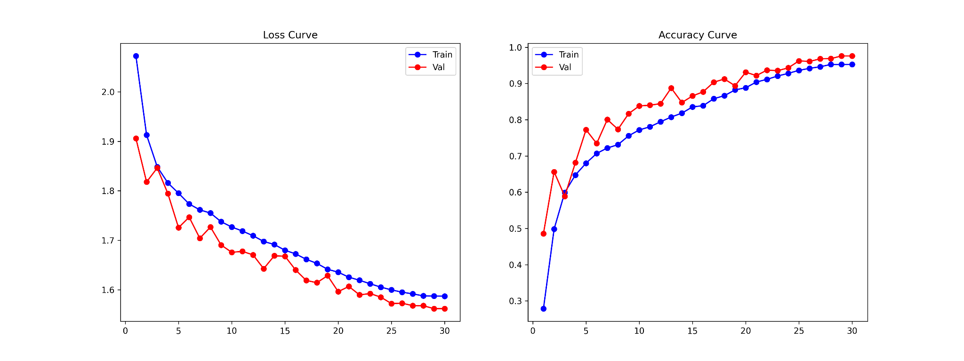

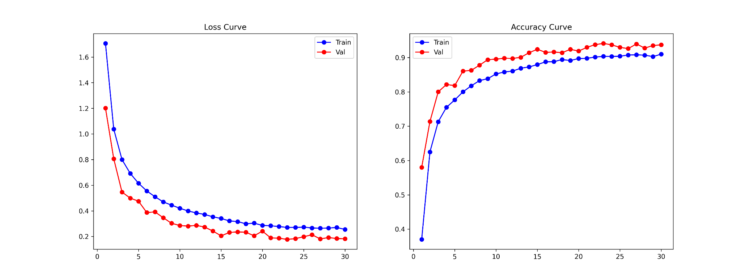
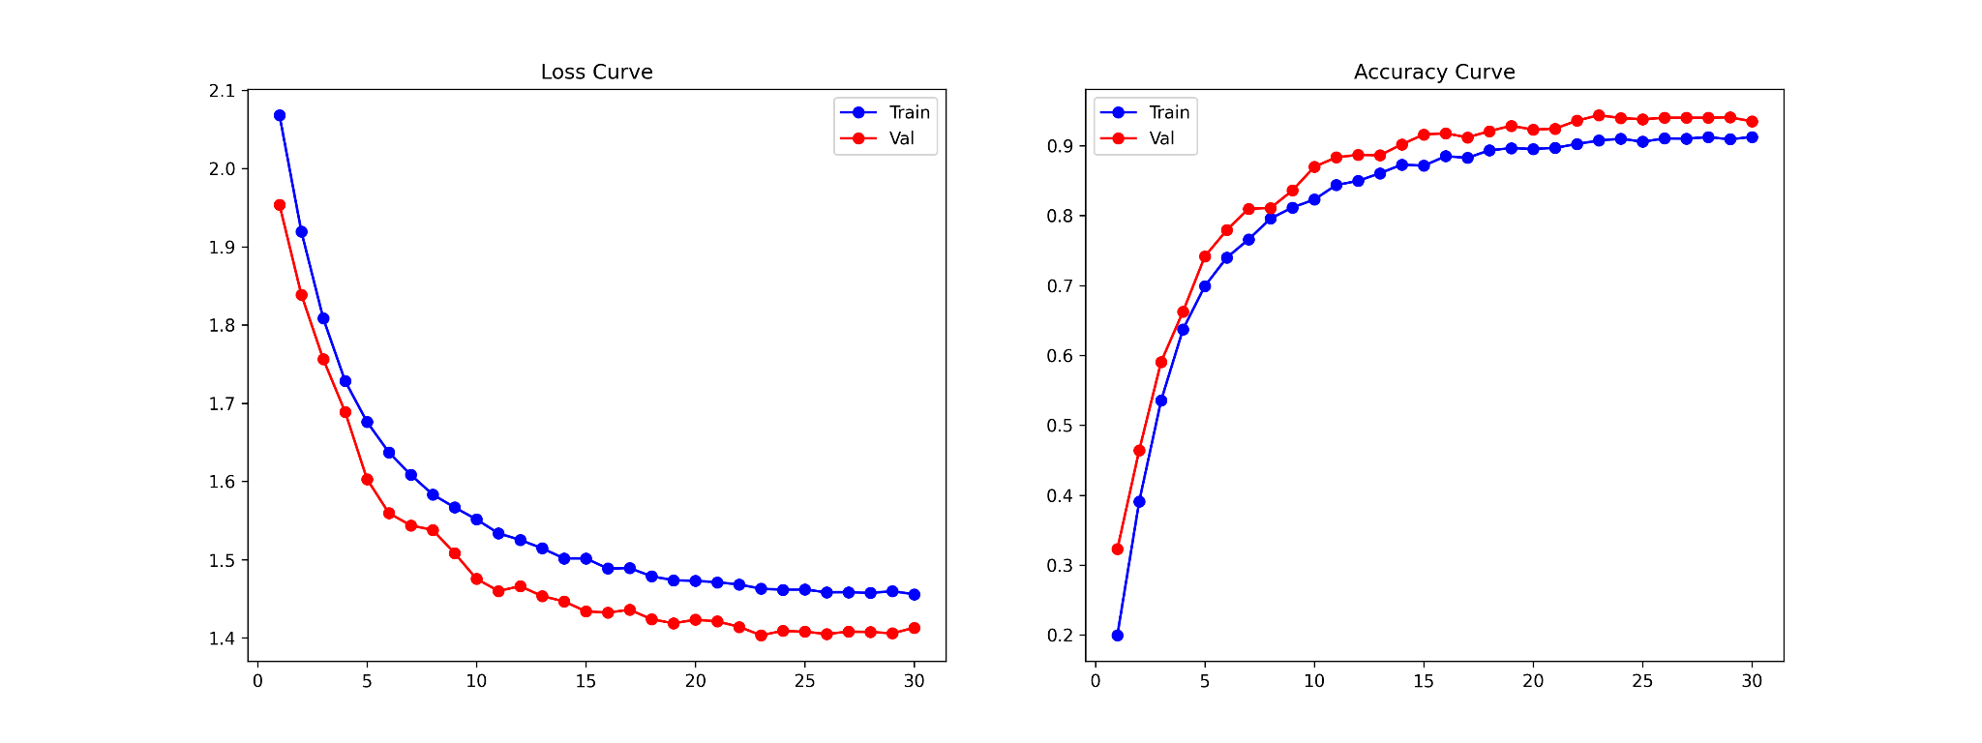
(a) (b)

(c) (d)
Fig. 6. Training Dynamics (Loss and Accuracy Curves) of Four Deep Learning Models on MangoLeafVarietyBD. (a) ViT-B16, (b) DenseNet121, (c) GhostNetV2, (d) ResNet18

