National Textile University, Faisalabad

Department of Computer Science
^{Group Members} | - ^{Gulam Habib (1154)}  - ^{Abdul Samad (1123)}  - ^{Hamna Hameed (1158)}
^{Project Title} | Student Management System
^{Class} | ^{BSSE}
^{Section} | ^{3rd-A}
Course Name | ^{Data Structures}
Submitted to | Sir Basit & Sir Hamid
Submission Date

Table of Contents
1. Introduction 4
Purpose of the System 4
Scope 4
Objectives 4
2. System Overview 5
High-Level Description 5
Users of the System 5
3. Functional Requirements 5
Student Management 5
Course Management 5
Attendance Management 5
Fee Management 6
Result Management 6
Admin Management 6
4. Non-Functional Requirements 6
5. System Architecture 7
Architectural Style 7
Component Interaction 7
6. Core Data Structures 7
Binary Search Tree (BST) 7
7. Queue-Based Operation Management 8
Rationale 8
Types of Queues 8
Insert Queues 8
Update Queue 8
Delete Queue 8
Benefits 8
8. Database Layer 9
DB Class Responsibilities 9
SQL Server Integration 9
Example Table: Student 9
9. Singleton Pattern Usage 9
Purpose 9
Implementation 9
Benefits 9
10. Search Engine 10
Search Methods 10
Efficiency 10
11. Print Engine 10
Responsibilities 10
Supported Outputs 10
12. Activity Flow 11
System Startup 11
Runtime Operations 11
System Shutdown 11
13. Use Case Analysis 12
Student Use Case 12
Admin Use Case 12
14.System Flowchart 13
15. Error Handling 14
Database Errors 14
Validation Errors 14
16. Memory Management 14
17. Conclusion 14

1. Introduction

Purpose of the System
The Student Management System (SMS) is a comprehensive desktop-based educational administration platform developed using C++ with Microsoft SQL Server as the backend database. The primary purpose of this system is to centralize, automate, and optimize academic and administrative operations within educational institutions.
The system is designed to replace fragmented and manual workflows with a structured, data-driven solution. SMS efficiently manages student enrollment, course registration, attendance tracking, fee management, result processing, administrative control, and reporting. It ensures data consistency by maintaining synchronization between in-memory data structures and persistent database storage.

Scope
The Student Management System is intended for small to medium-sized educational institutions, including colleges, academies, and training centers. It operates as a single-node desktop application, utilizing advanced in-memory data structures that are periodically synchronized with a relational database for long-term storage and reliability.

Objectives
The key objectives of the system are:
- Efficient management of student and academic records
- High-performance searching and retrieval using Binary Search Trees (BSTs)
- Reduced database overhead through batch processing techniques
- Data integrity ensured via controlled update and delete queues
- A modular and extensible software architecture

2. System Overview

High-Level Description
The Student Management System follows a hybrid architecture consisting of:
- In-Memory Layer: Binary Search Trees (BSTs) and Queues
- Persistent Storage Layer: SQL Server Database
All records are loaded into memory at system startup. User operations modify the in-memory structures, and changes are later synchronized with the database in a controlled manner to optimize performance.

Users of the System
The system supports multiple user roles:
- Students: View personal information, academic records, attendance, and fee status
- Teachers: Manage courses, attendance, and academic results
- Administrators: Full system access, configuration, and report generation

3. Functional Requirements

Student Management
- Add, update, and delete student records
- Assign students to specific fields of study
- Register students in courses

Course Management
- Add, update, and remove courses
- Assign courses to academic fields
- Manage student–course relationships

Attendance Management
- Record attendance for each course
- Retrieve and analyze attendance history

Fee Management
- Add and update fee records
- Track payment status
- Generate financial reports

Result Management
- Enter student marks
- Calculate academic results
- Generate transcripts

Admin Management
- Manage administrator accounts
- Control overall system operations

4. Non-Functional Requirements
- Performance: Average-case search complexity of O(log n)
- Reliability: Transaction-based database operations
- Scalability: Modular, entity-based system design
- Security: Prepared SQL statements and input validation
- Maintainability: Clear separation of system layers and responsibilities

5. System Architecture

Architectural Style
The system follows a Layered Architecture:
- Presentation Layer (Console-based UI)
- Business Logic Layer (SMSsystem)
- Data Structure Layer (BSTs and Queues)
- Persistence Layer (SQL Server via ODBC)

Component Interaction
User actions are processed by the business logic layer, which modifies the in-memory data structures. Database synchronization is deferred using queues to minimize frequent database access and improve system efficiency.

6. Core Data Structures

Binary Search Tree (BST)
Binary Search Trees serve as the primary in-memory storage mechanism.
Reasons for using BSTs:
- Faster search compared to linear data structures
- Ordered data traversal
- Efficient insertion and deletion operations
BST Variants Used:
- studentBST
- courseBST
- fieldBST
- attendanceBST
- stdCourseBST
- stdFeeBST
- stdResultBST
- adminBST
Each BST node (StdNode<T>) contains:
- Data object
- Left and right child pointers
- Height attribute (for future balancing extensions)

7. Queue-Based Operation Management

Rationale
Performing database operations for every user action is computationally expensive. To address this issue, SMS uses queues to batch operations and synchronize them with the database efficiently.

Types of Queues

Insert Queues
Used to temporarily store newly created records.

Update Queue
Stores pending updates until batch execution.

Delete Queue
Ensures safe and deferred deletion of records.

Benefits
- Reduced database calls
- Improved overall performance
- Grouped transaction processing

8. Database Layer

DB Class Responsibilities
- Establish ODBC database connections
- Execute prepared SQL statements
- Handle errors and transactions

SQL Server Integration
- Uses Windows ODBC drivers
- Strong type mapping between C++ and SQL

Example Table: Student
CREATE TABLE student (
stdId INT PRIMARY KEY,
stdName VARCHAR(40),
stdUserName VARCHAR(40),
stdAge INT,
fieldId INT,
stdFatherName VARCHAR(40)
);

9. Singleton Pattern Usage

Purpose
Ensures that only one instance of the SMSsystem exists throughout execution.

Implementation
static SMSSystem& getInstance() {
static SMSSystem instance;
return instance;
}

Benefits
- Centralized system control
- Prevents inconsistent system states

10. Search Engine

Search Methods
- ID-based search
- Name-based partial search
- Range-based search
- Multi-criteria search

Efficiency
Search operations utilize BST traversal, providing an average complexity of O(log n).

11. Print Engine

Responsibilities
- Display formatted data
- Generate system reports
- Traverse BSTs using iterators

Supported Outputs
- Student lists
- Course rosters
- Fee summaries
- Academic results

12. Activity Flow

System Startup
- Establish database connection
- Load records into BSTs
- Display main menu

Runtime Operations
- User selects an operation
- In-memory data is modified
- Operations are queued

System Shutdown
- Execute all queued operations
- Synchronize with database
- Release allocated resources

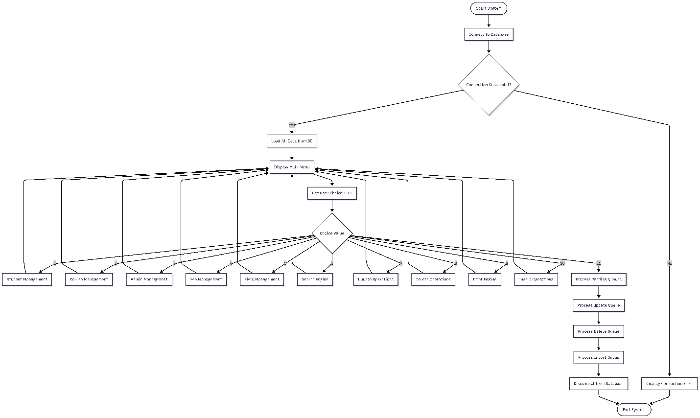

13. Use Case Analysis

Student Use Case
- View profile
- Check attendance
- View results
- Review fee status

Admin Use Case
- Manage users
- Generate reports
- Configure system settings

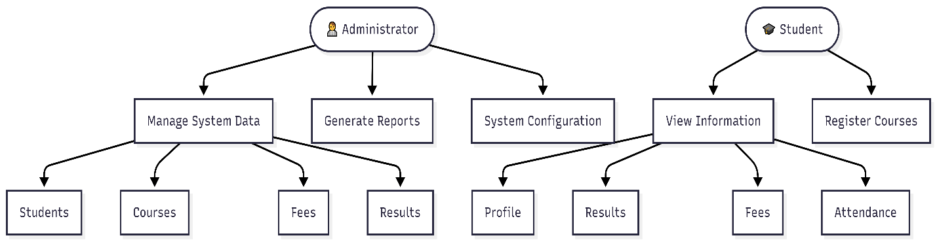

14.System Flowchart

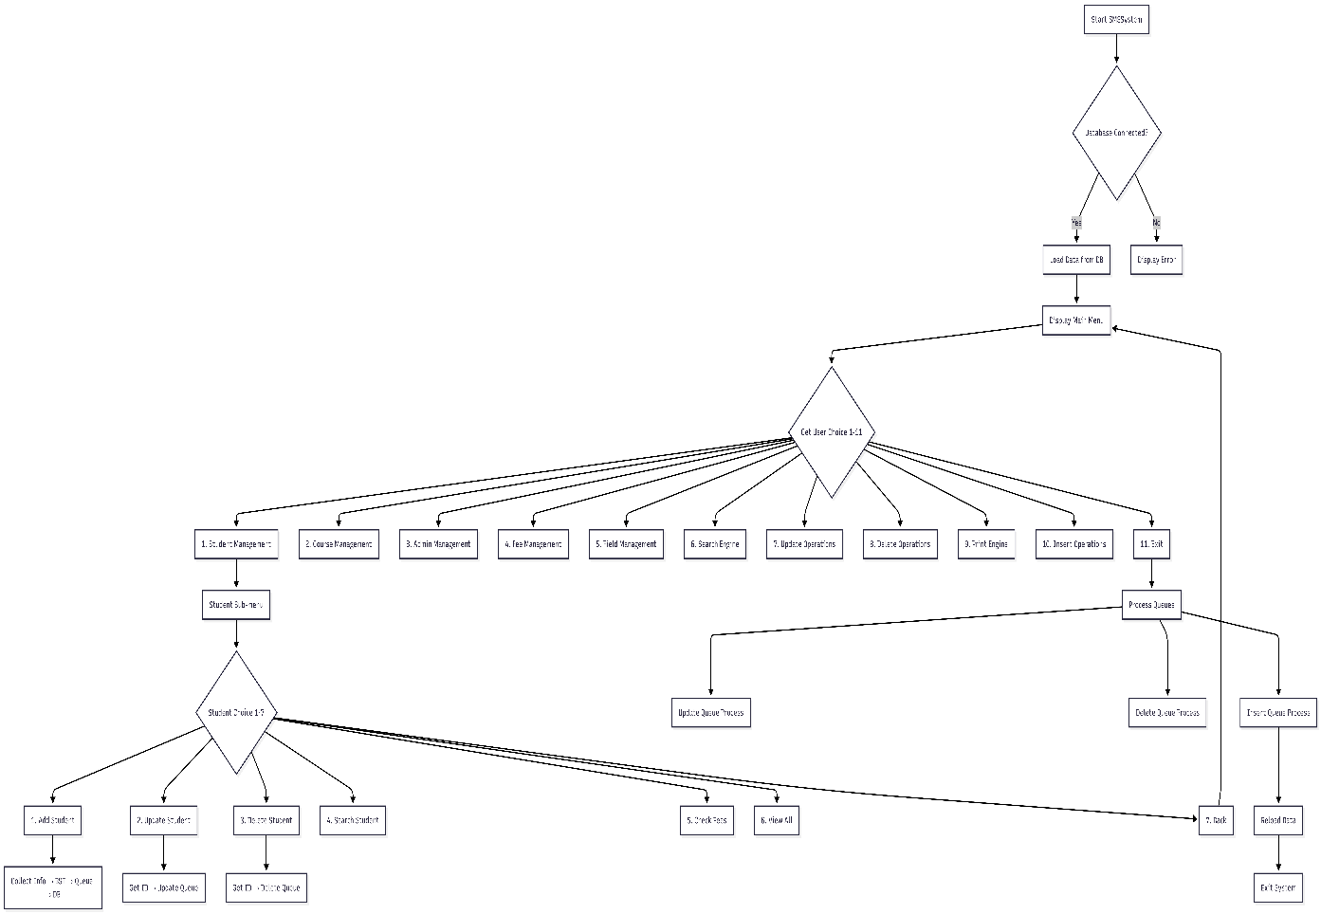

15. Error Handling

Database Errors
- Connection failure handling
- SQL execution error reporting

Validation Errors
- Invalid IDs
- Duplicate records

16. Memory Management
- Dynamic memory allocation via BST nodes
- Automatic cleanup during system restart
- Controlled deletion using queues

17. Conclusion
The Student Management System is a high-performance, modular, and reliable application that demonstrates effective use of data structures, design patterns, and database integration. It provides a scalable foundation for academic administration systems.

