Discord

Introduction to Discord

Author: Habil KOÇOĞLU

## Discord

### Week-1 (Introduction to Discord)

#### Autumn Semester, 2022-2023

Download [DOC](https://github.com/habilkocoglu/course-note-template/blob/main/docs/week-1/week-1.en.md_word.docx?raw=true), [PPTX](week-1.en.md_slide.pptx)

### Outline

* Understanding Basic Concepts
* Getting Familiar with Glossary

## Discord

### Discord

* **What is Discord?** Discord is a voice, video, and text chat app that's used by tens of millions of people ages 13+ to talk and hang out with their communities and friends.
* People use Discord daily to talk about many things, ranging from art projects and family trips to homework and mental health support. It's a home for communities of any size, but it's most widely used by small and active groups of people who talk regularly.
* The vast majority of servers are private, invite-only spaces for groups of friends and communities to stay in touch and spend time together. There are also larger, more open communities, generally centered around specific topics such as popular games like Minecraft and Fortnite. Users have control over whom they interact with and what their experience on Discord is.
* People love Discord because it’s a home for all their communities and groups of friends. It's a place where they can be themselves and spend time with other people who share their interests and hobbies. Conversations on Discord are driven by the people you choose and the topics you choose to talk about.

### Discord Glossary

* **Discord has its own vocabulary. You might hear your teen or students using these words when talking about Discord.**

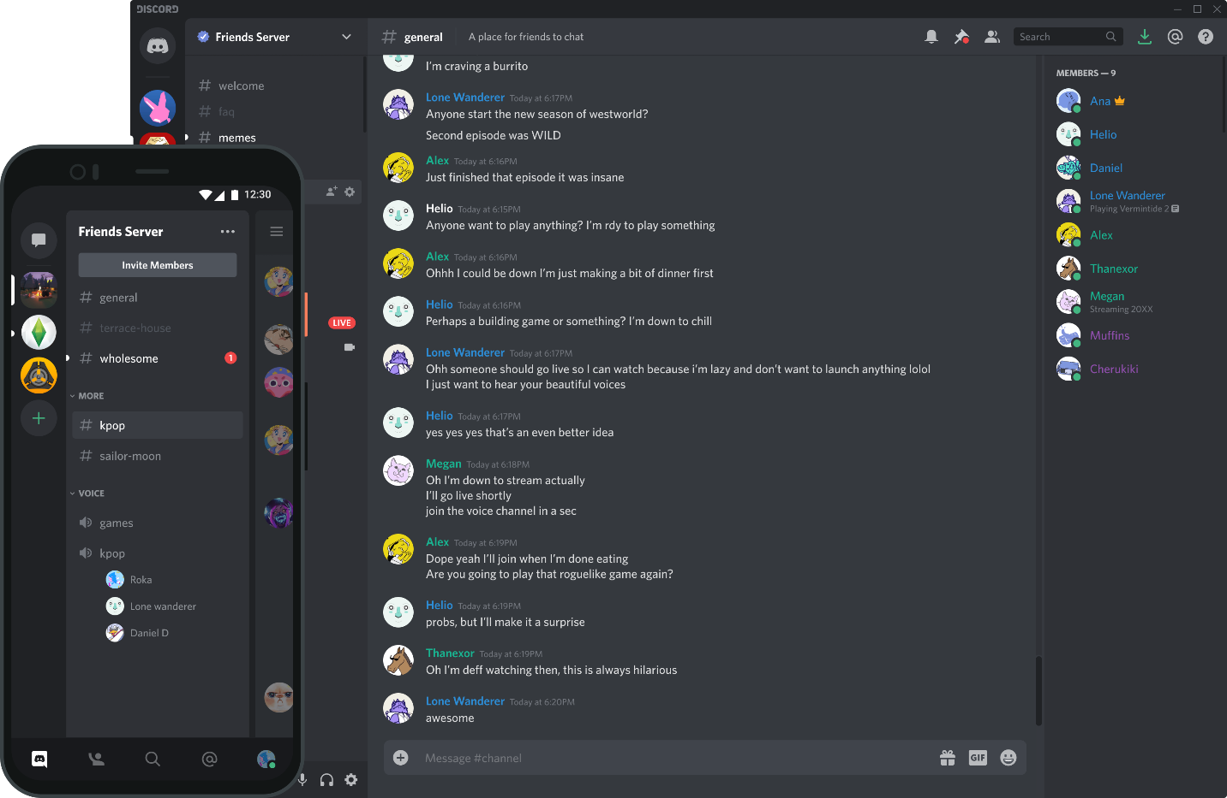

center h:400px

### Server

* **Servers are the spaces on Discord. They are made by specific communities and friend groups. The vast majority of servers are small and invitation-only. Some larger servers are public. Any user can start a new server for free and invite their friends to it.**

### Channel

* **Discord servers are organized into text and voice channels, which are usually dedicated to specific topics and can have different rules.**
* **In text channels, users can post messages, upload files, and share images for others to see at any time.**
* **In voice channels, users can connect through a voice or video call in real time, and can share their screen with their friends - we call this Go Live.**

### DMs and GDMs

* **Users can send private messages to other users as a direct message (DM), as well as start a voice or video call. Most DMs are one-on-one conversations, but users have the option to invite up to nine others to the conversation to create a private group DM (GDM), with a maximum size of ten people. Group DMs are not public and require an invite from someone in the group to join.**

### Go Live

* **Users can share their screen with other people who are in a server or a DM with them.**

### Nitro

* **Nitro is Discord’s premium subscription service. Nitro offers special perks for subscribers, such as the option to customize your Discord Tag, the ability to use custom emotes in every server, a higher file upload cap, and discounted Server Boosts.**

### Server Boosts

If your teen is a big fan of a community, they might want to boost the community’s server (or their own). Like Nitro, Server Boosts give servers special perks like more custom emotes, better video and voice quality, and the ability to set a custom invite link. Server Boosts can be bought with Nitro or purchased separately.

### Student Hubs

Discord Hubs for Students allow students to verify their Discord account with their official student email, and unlock access to an exclusive hub for students at their school. Within the hub, they can connect with other verified students, discover servers for study groups or classes, and share their own servers for fellow students to join. Hubs are not affiliated with or managed by a school or school staff. Servers in a Hub are student-run but may include non-students.

### Why people love Discord

Below, you can see just a few of our favorite stories about what people are doing on Discord and why they love it.

Cyndie, a parent of two from North Carolina, reflects on how her family uses Discord:

“There are four of us and we all have Discord installed on both our computers and phones. My oldest son is in an apartment, and the younger one is on campus, so we use Discord to make family plans. Everything gets dropped into that server. From dinner’s ready to internships and job offers. Usually it’s the silly, stupid stuff we just drop in that makes us all laugh, like when there’s a Weird Al question on Jeopardy. I can’t imagine life without it.”

Genavieve, a high-school student from California, talks about how her classes use Discord:

"I've been using Discord for the last two years as my main communication with my friends. We had too many people in our group chat and wanted a platform where we could all communicate with each other. Discord is a great way for a friend group of thirty people to stay in touch! Also, with distance learning in place, I’ve started using it with my AP Physics class too. It's been so important to feel connected to our teachers and each other when we are so isolated and in such a difficult class. Using Discord brought us closer together as a class — we are already a small class of 22 students, so being able to joke around and send memes helps us not feel so alone during the distance learning. The different channels and @mentions make it much easier to keep information straight. Screenshare makes it even easier, so we can show each other documents or problems we are working on to get feedback or troubleshooting advice.”

David, a physics and math tutor from New Jersey, talks about how he teaches students and connects with other teachers over Discord:

"I use Discord to tutor one of my students and to stay up to date with conversations and announcements in a group of physics teachers interested in physics education research. It's nice to see a side-by-side camera view of my desk with the student's work. I also really like that the audio through the OPUS codec which sounds very clean."

## References

* <https://discord.com/safety/360044149331-What-is-Discord>