**Course Name** 🡺 PL-300 Microsoft Power BI Data Analyst

**Trainer** 🡺 Anusha P

**Session Dates**🡺 **11/03/24 - 13/03/24**

**Reference Document**

**Power Platform 🡺**

No code Low Code platform

1. Power Apps
   1. Mobile/ Web App
2. Power Automate
   1. Flows > Automating a business process
3. Power BI: Business Intelligence
   1. Reports/ Dashboards
   2. Flexible Pricing Model
4. Power VA: Virtual Agent
   1. Chatbot

**Data Analysis 🡺**

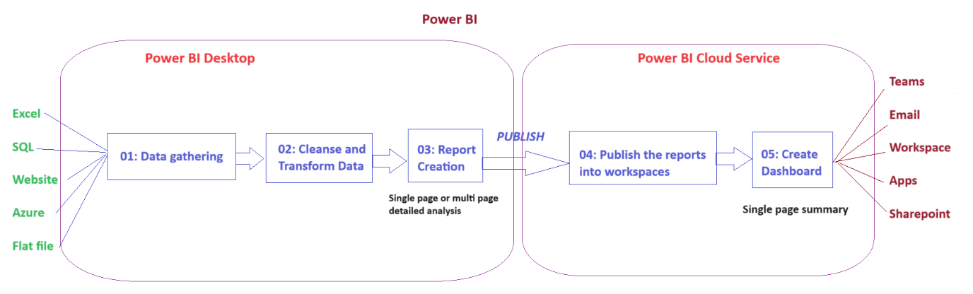

**Types of data analysis 🡺**

Data Analysis refers to the process of inspecting, cleaning, transforming and interpreting data to discover valuable insights, draw conclusions, decision making

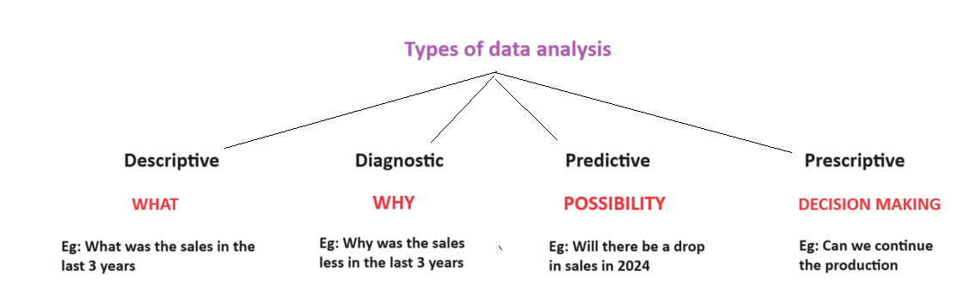

**Tasks of data Analyst 🡺**

1. Prepare
2. Model
3. Visualize
4. Analyse
5. Manage

**Building Blocks of Power BI 🡺**

1. Visualization
2. Dataset
3. Report
4. Dashboard
5. Tiles

**Install Power BI 🡺**

<https://www.microsoft.com/en-us/download/details.aspx?id=58494>

**Data Gathering 🡺**

* Excel
* Text/csv
* Json
* XML
* Folder
* SQL Server

**Data Connectivity Mode 🡺**

|  |  |
| --- | --- |
| **Import** | **DirectQuery** |
| Data will physically reside in power BI | Data will not physically reside in Power BI |
| When the data is less than 1 TB | When the data is more than 1 TB |
| When the data is not refreshed very often | When the data is refreshed very often |
| DAX is fully compatible | DAX is not fully compatible |
| Fast performance | Slow performance |

**Relationships in Power BI 🡺**

1. Power BI by default imports the relationships from the data source
2. Power BI creates new relationships based on the column names

**Data Profiling 🡺**

Features that allow us to understand the data structure, data flaws, data anomalies

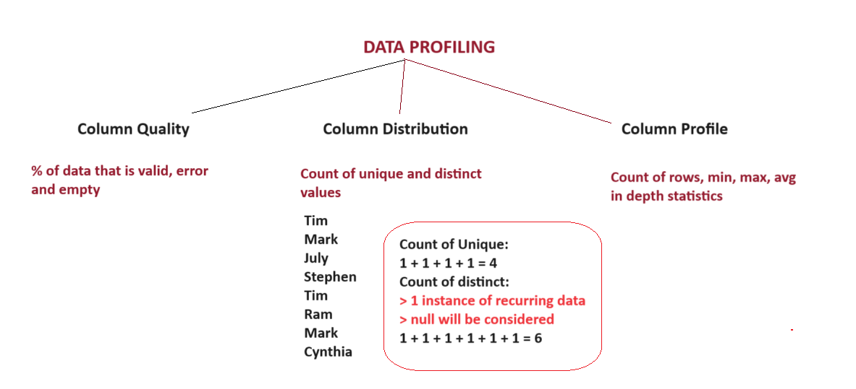

**Power Query Editor 🡺**

Kitchenhouse of Power BI

1. Manage the Queries Panel
2. Manage Query
   1. Rename the query with user friendly name
   2. Add description : Query settings > Advanced
3. Manage Columns
   1. Go to Column
   2. Choose Columns
   3. Remove Columns
   4. Remove Other Columns
4. Remove Rows
5. Filtered the query
   1. Column header drop down
   2. Filter Text
6. Rename the column header
7. Change the data type
8. Expand the table and value links

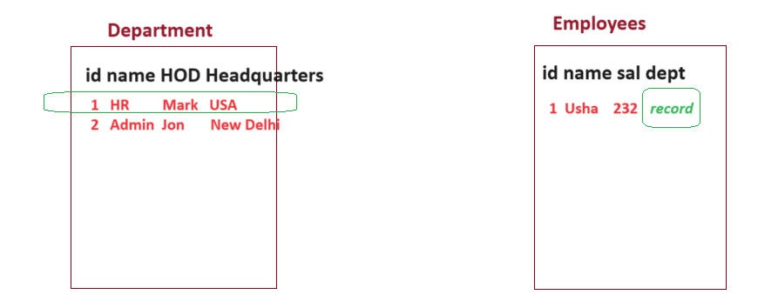

1. Add Column
   1. Custom Column > Based on custom formula
   2. Column from Example > Based on pattern
   3. Conditional Column > Based on some condition
   4. From Number > Mathematical calculations
   5. From Date / Time
2. M Language > Query Folding
3. Merged Columns
4. Merge Queries

**Data Modeling 🡺**

**Data Schema 🡺**

Logical arrangement of the data tables

**Star Schema 🡺**

**Fact vs Dimension tables 🡺**

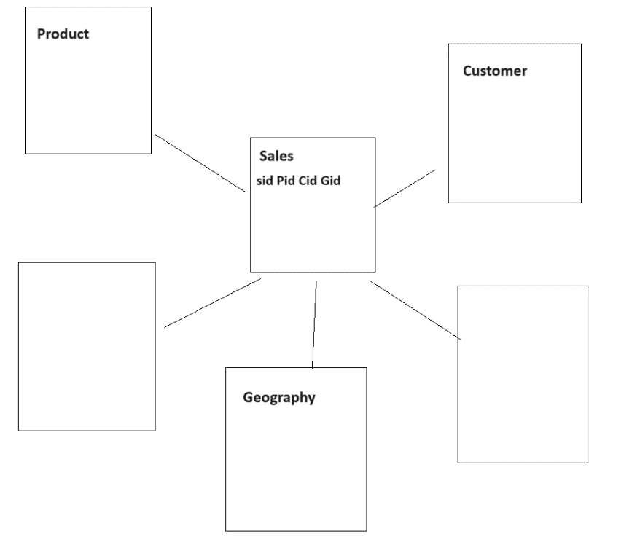

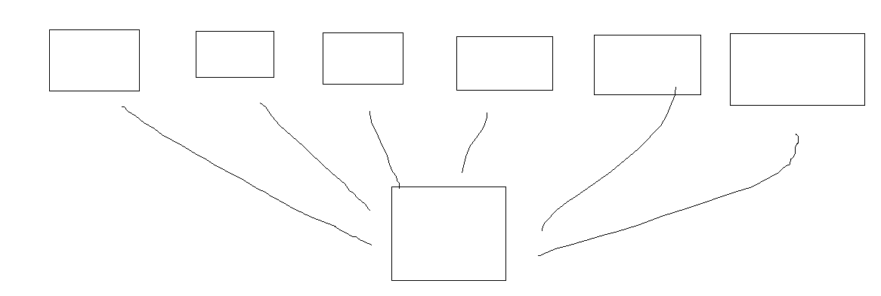

**2 ways to create relationships 🡺**

1. Manage relationships
2. Drag and drop approach

**Cardinality 🡺**

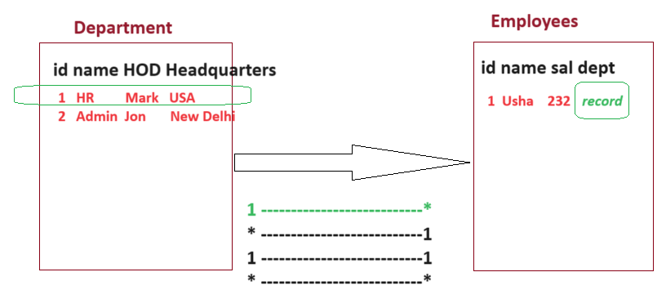

**Cross Filter Direction 🡺**

1. Single
2. Both

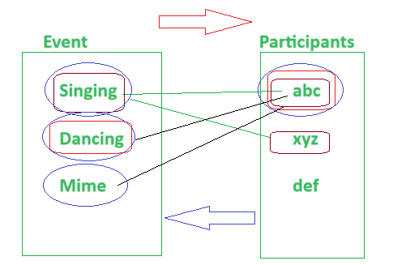

Table/ Column property 🡺

Display Folder 🡺

Hierarchy 🡺

**Dax 🡺**

**Data Analytics Expressions**

Library that contains a Collection of functions and operators

Build Formulae and expressions

Used for:

* Calculated Tables
* Calculated Column
* Measure

Calculated Column vs Measure 🡺

Calculated Column is physically saved in Power BI BUT Measure is only calculated on the fly (NOT physically saved)

**Calculate 🡺**

**Apply a static Filter**

**Syntax:**

CALCULATE(Expression, Filter)

<https://dax.guide/>

**Reports Creation 🡺 DONE**

**Best practices 🡺**

1. Maintain consistency by template
2. Copy the visual

**Lab1 DONE**

**Lab2 DONE**

**Lab3 DONE**

**Publish and create dashboard 🡺 DONE**

Workspace **🡺**

[Roles in workspaces in Power BI - Power BI | Microsoft Learn](https://learn.microsoft.com/en-us/power-bi/collaborate-share/service-roles-new-workspaces)

**Lab4**

**Row Level Security 🡺 DONE**

**Lab5**

**PL300 Certification 🡺 DONE**

[**https://learn.microsoft.com/en-us/credentials/certifications/exams/pl-300/**](https://learn.microsoft.com/en-us/credentials/certifications/exams/pl-300/)

**PL series roadmap 🡺 DONE**

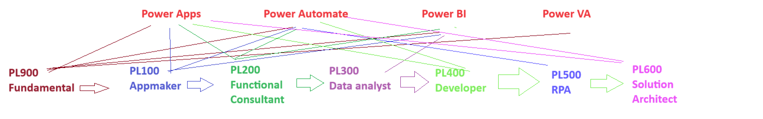

**LET features 🡺** lifetime accessible **DONE**

Log on: https://www.koenig-solutions.com/account/login

Login Credentials:

User ID: (Registered email id)

Password: 183478

**Share Notes 🡺 DONE**

**Quiz 🡺 DONE**

**Post requisite 🡺 DONE**