**Week 2 Lab Work**

1. Create a Student_Register Form as StudentRegister.html. The form should contain the first name, last name, date of birth, gender, email, phone number and subject information as shown in the figure.

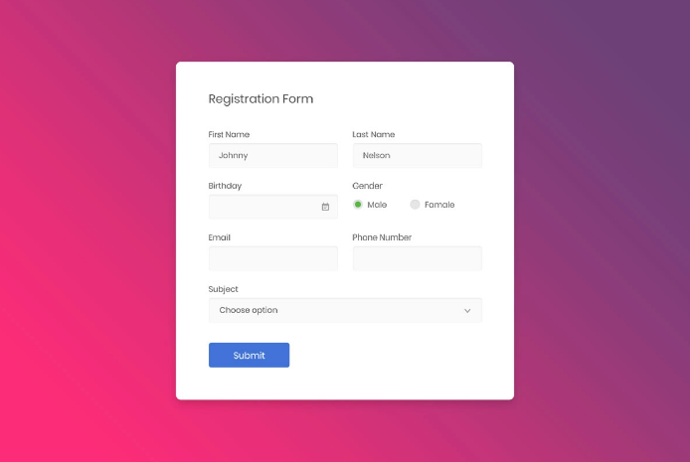

1. Create a Student_Register.java as Servlet which get all the information from the Student_register form and the form information should be stored in Database.

(Use research skills and weekly content help to complete the No. 3 task)

1. Then it should redirect to index.html page where all the information of database should be displayed accordingly in table form.