Every project, regardless of its size or budget, has some core tasks that are crucial to its completion. A task is defined as critical if delaying it will slow down the completion of the entire project.

If you had to create a short recipe for making an omelet, it would look something like this:

1. Beat 2 eggs
2. Heat a pan, add butter/oil when hot
3. Pour in the beaten eggs and cook for 5 minutes

There are several other tasks you need to perform to make a good omelet. You have to season the eggs with salt and pepper. Maybe add some vegetables and some cheese. Perhaps you could flip it on the other side so the eggs are fully cooked through.

However, these activities are in addition to the three core steps in the recipe. Even if you don’t perform them, you’ll still have an omelet. Not a very good one, but an omelet nonetheless.

On the other hand, if you forget to beat the eggs, or heat the pan, or cook the eggs, you won’t have anything but a cold pan and two eggs.

Which is to say, the three steps in the recipe describe the critical tasks necessary to make the omelet-making project a success.

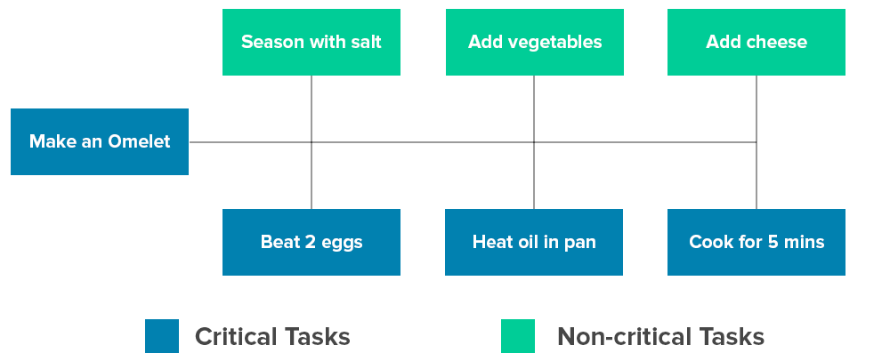

And the sequence of these steps describes the critical path a new cook must take if he wants to make an omelet.

This is the Critical Path Method in a nutshell.

“The Critical Path Method is the sequence of scheduled activities that determines the duration of the project.”

These scheduled activities must be performed if the project is to be considered a success. Moreover, they must be completed in a specific order