select \* from guests;

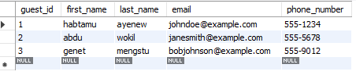

select \* from employees;

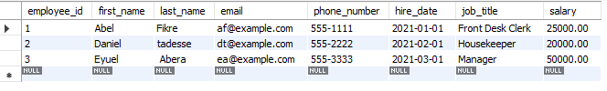

select \* from reservations;

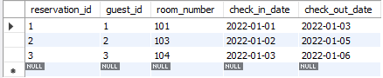

select \* from rooms;

