Now answer the questions
1. According to the text, what do banks enable people to do?
A. buy products
B. get money now that they have to pay back later
C. save money for the future
D. all of the above
2. What is the purpose of the head office of a bank?
A. Support the local branches to work properly
B. Offer services to local customers
C. Work with other banks
D. Look impressive.
3. What do bank tellers do?
A. they protect the money
B. they help the customers
C. they arrange loans for customers
D. they are in charge of the bank branch
4. What happens when bank customers spend more money than they have in their account?
A. They will need to see the security guard.
B. They will have to go to the police station.
C. They will have to have a meeting with the bank manager.
D. They will have to borrow money from the bank.
5. Which of the following methods is more convenient when paying for something than using a cheque?
A. using plastic card
B. using cash
C. there is not a more convenient method
D. using an exchange of products
Section Two: Vocabulary
Directions: Choose the best word that can complete the blank space and write the letter of your choice on the space provided in the answer sheet.
6. A document which shows all your withdrawals and deposits (usually for one month) is called a” bank
A. stapler
7. If your “cheque
B. bill
C. card
D. statement
7. If Your cheque …………… , there were probably not enough money in your account to cover it.
A. reworks
B. binds
C. bounces
D. burns
15. Many got you how sisters have?
A. How many got sisters you have?
B. How many sisters have you got?
C. How many have you got sisters?
D. How many you have sisters got?
16. Register at we college the now must?
A. Must register we at the college now?
B. Must we register at the college now?
C. Must we at the college register now?
D Must we now at the college register?.
17. To please what do tell you they.
A. Please, they tell you to do what.
C. Please, do what they tell you to.
B. Please, you tell they what to do.
D. Please, you do tell to they what.
Section Four: Sentence Comprehension
Directions: Four statements are made about each of the following sentences. Decide which one of the four choices is the correct statement.
18. We are now open on Saturdays in the morning as well as in the afternoon.
A. We are now open all weekend.
B. On Saturdays we now close for lunch.
C. On Saturdays we are now open in the afternoon instead of the morning.
D. On Saturdays we now stay longer than before.
19. You must show your discount card in order to get a discount on goods.
A. We must see your discount card before we reduce the price of goods.
B. We can only give a discount on certain goods.
C. We are selling cards at reduced prices.
D. We can sell you a discount card here.
20. We are closed for staff training until 9:30.
A. We can train you to work here.
B. We are not open today because of staff training
C. The shop is run by trained staff.
D. The shop will open at 9:30.
21. Latecomers: Use back entrance upstairs, please.
A. Latecomers must sit at the back
B. Latecomers must wait on the stairs.
C. If you’re late, use a different entrance.
D. If you’re late, you must go back to the entrance.
22. Add your name to the list if you want to go on the trip.
A. This list should be signed by people wanting to go on the trip.
B. Check this list for information if you are going on the trip.
C. If you find your name on the list, you can go on the trip.
D. This list shows who has been chosen to go on the trip.
23. She thinks it is theirs, but actually they gave it to me.
A. It’s mine
B. She thinks they actually gave it to me.
C. They’re hers
D. None of the above
24. She doesn’t have to practice for eight hours without break.
A. She shouldn’t practice for eight hours without break
B. She needn’t practice for eight hours without break.
C. She can’t practice for eight hours without a break.
D. She mustn’t practice for eight hours without practice.
Section Five: Grammar and usage
A. Directions: Which of the four possible answers below is grammatically correct? Write the letter of your choice on the space provided in the answer sheet.
25. Esayas travelled to Europe.
A. Esayas went a journey to Europe.
C. Esayas has been a journey to Europe.
B. Esayas went on a journey to Europe.
D. None of the above.
26. The firemen had to break the door down.
A. It was necessary the firemen to break the door down.
B. It was necessary for the fire men to break the door down.
C. It was necessary with the firemen to break the door down.
D. It was necessary on the firemen had to break the door down.
27. I couldn’t understand what was reading.
A. I couldn’t make sense what was reading.
B. I couldn’t see sense of what I was reading.
C. I couldn’t find any sense of what was reading.
D. I couldn’t make sense of what was reading.
28. The books were so dear that I couldn’t afford them.
A. The books were too expensive to me to buy.
B. The books were expensive too much for me to buy.
C. The books were too much expensive for me to buy.
D. The books were too expensive for me to buy.
B.Directions: Choose the answer that best completes the blank space and writ the letter of your choice on the space provided in the answer sheet.
29. The process ………………… selecting candidates is a difficult one.
A. about
B. in
C. of
D. on
30. I……………… talked about this later.
A. rather
B. would
C. would rather
D would rather we
31.I knew ……………… the beginning that this wouldn’t work.
A. of
B. in
C. by
D. from
32. We don’t examine patients ……………… we have verified their insurance coverage.
A. when
B. although
C. until
D. because
33. Which company do you work……………?
A. no preposition
B. in
C. for
D. from
34. He ……………… a manager when he was twenty.
A. has become
B. becomes
C. was becoming
D. became
35. The bank now employs more people ………………… organization in the country.
A. that any other
B. than any other
C. than some other,
D. that some other
36. My friend and ………………… were asked to work on Saturdays.
A.I B. me C. mine D. myself
37. He is an engineer in ……………………
A. the cotton industry B. cotton industry C. cotton industries D. cotton industrial
38. A good manager knows how to get ……………………… out of the staff.
A. better
B. more
C. most
D. the most
39. ……………… was Almaz late last week? “Three times.”
A. How much
B. How many
C. How often
D. How long
.
40. The people …………… In the Vatican
A. live
B. are living
C. lives
D. is living
41. Did you ………………… out yesterday?
A. went
B. going
C. go
D. goes
42. My sister ……………… three languages.
A. speak B. is speaking
C. speaking D. speaks
43. They ………… see the film last night.
A. weren’t B. don’t C. didn’t D. won’t
44. They ………… at 11.00 pm tomorrow.
A. will arrive B. will arriving
C. will have arrived D. arrived
45. Vicky……………… meeting new people.
A. is enjoying B. enjoys
C. will enjoy D. has enjoyed
Section Six: Dialogue
Directions: Choose the best answer and write the letter of your choice on the space provided in the answer sheet.
46. Have you transferred the funds to kemal’s account yet?
A. This looks more complicated
C. Which accounts do you want to use?
B. Am I authorized to make these changes?
D. No, I haven’t done that yet.
47. Where is your Sofa?
A. Between the two armchairs
B. Yes, there are a few near the windows.
C. Oh, yes. I keep a lap top on it.
D.I have got a table near the sofa.
48. I’ve got a new office now.
A. I think there are four cabinets in my office.
B. That’s great! Congratulations.
C. Are there any tables in your office?
D. You seem happy
49. How are you doing today?
A.I need a checking account B. Great! Thanks.
C. Have a good day. D. That’s fine.
50. Is there anything else I can do for you?
A.I need your help. B. All done
C. No thank you. That’s all.
D. Great! Thank you.
PART II: QUANTITATIVE APTITUDE TEST
Instruction: Choose the best answer and write the letter of your choice on the space provided in the answer sheet.
1. Here is a list of months and a code for each one:
January: 71
February: 82
March: 53
April: 54
May: 35
June: 46
July: 47
What is the code for the month of August?
A.48
B. 44
C. 40
D. 68
E. None of these choices
2. Pick out the one which is different from others
1050, 510, 240, 105, 37.5
A. 510 B. 240 C. 1050 D. 105 E. 37.5
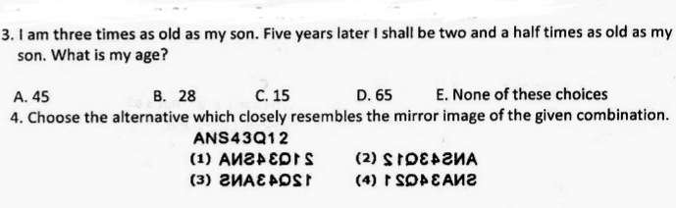

3. A. 45 years
4. Choice (2)
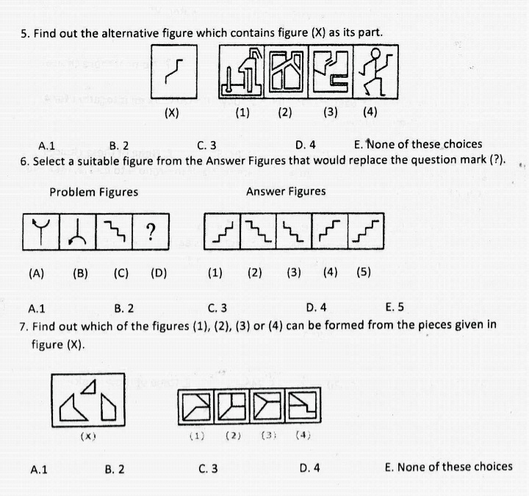
5. 4
6. 1
7. 1

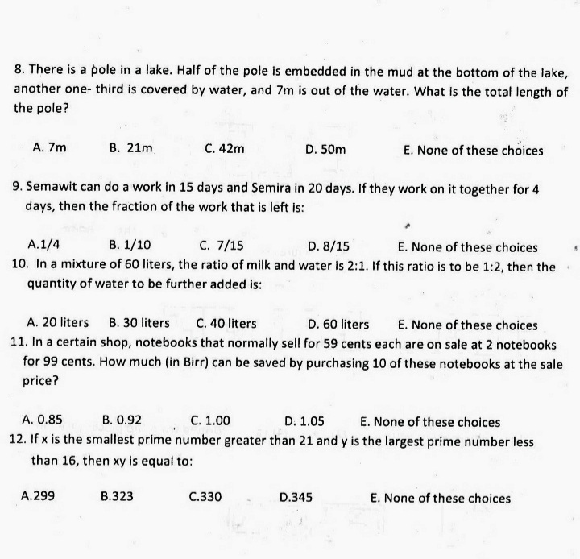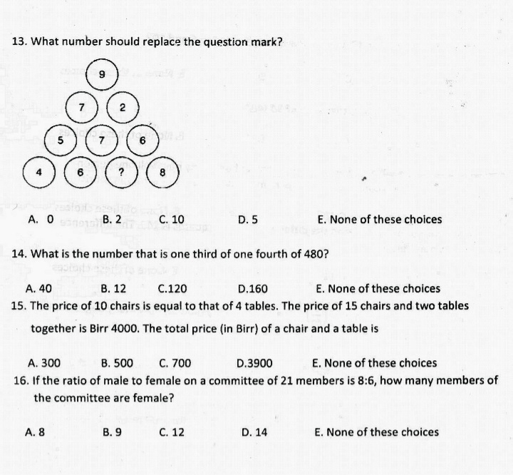
8. C. 42
9. D. 8/15
10. D. 60
11. E NONE ANSWER IS 0.95
12. 299

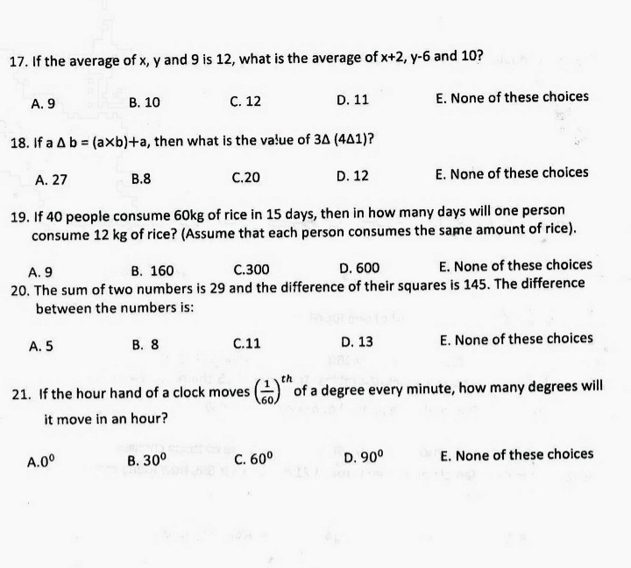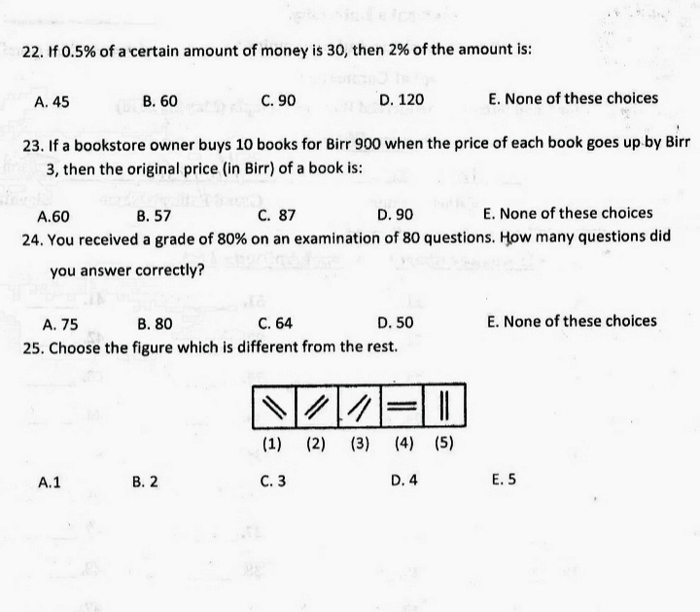
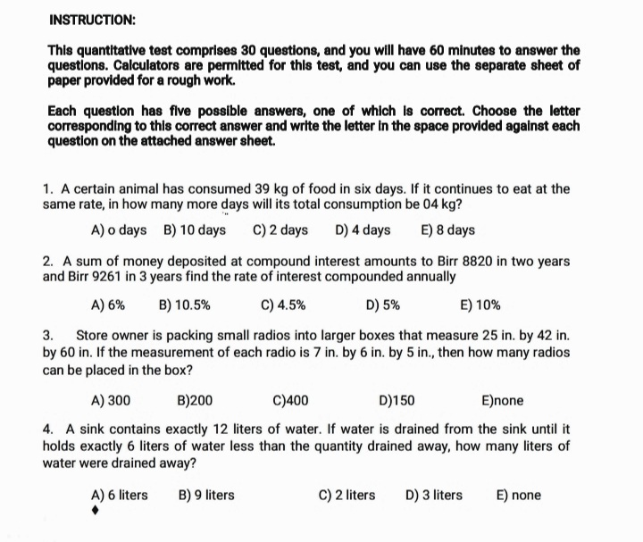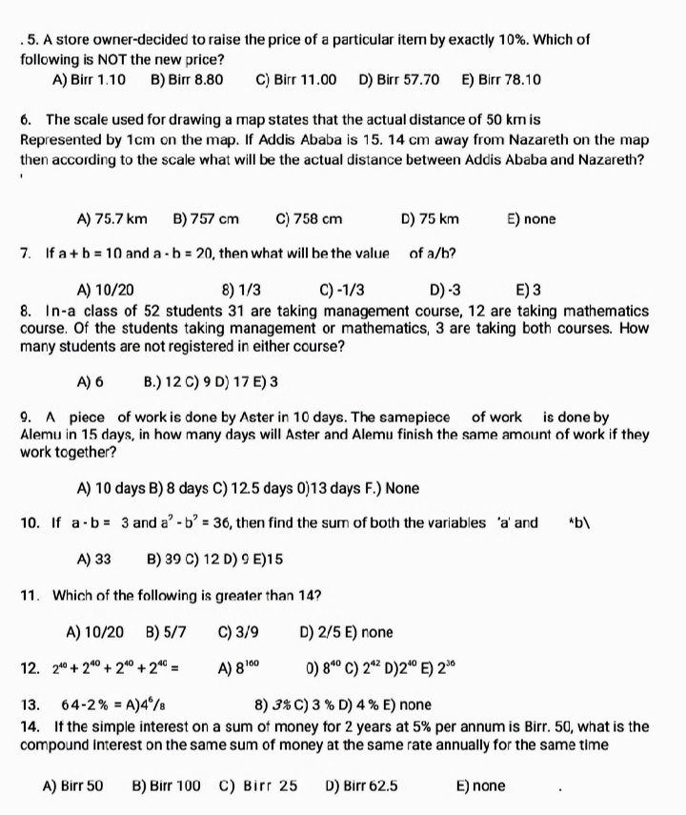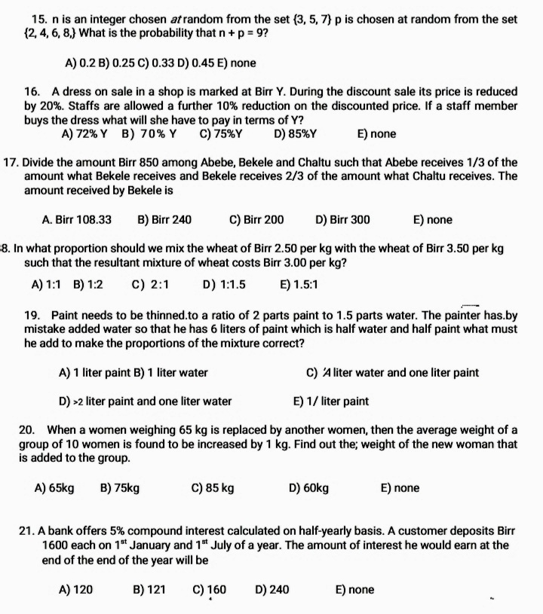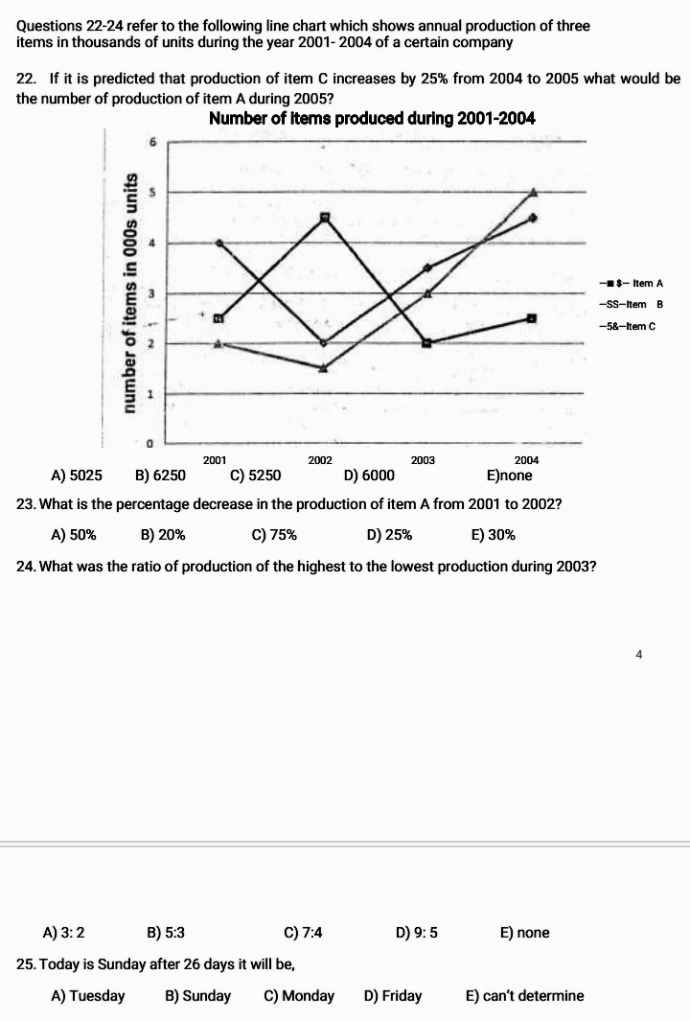
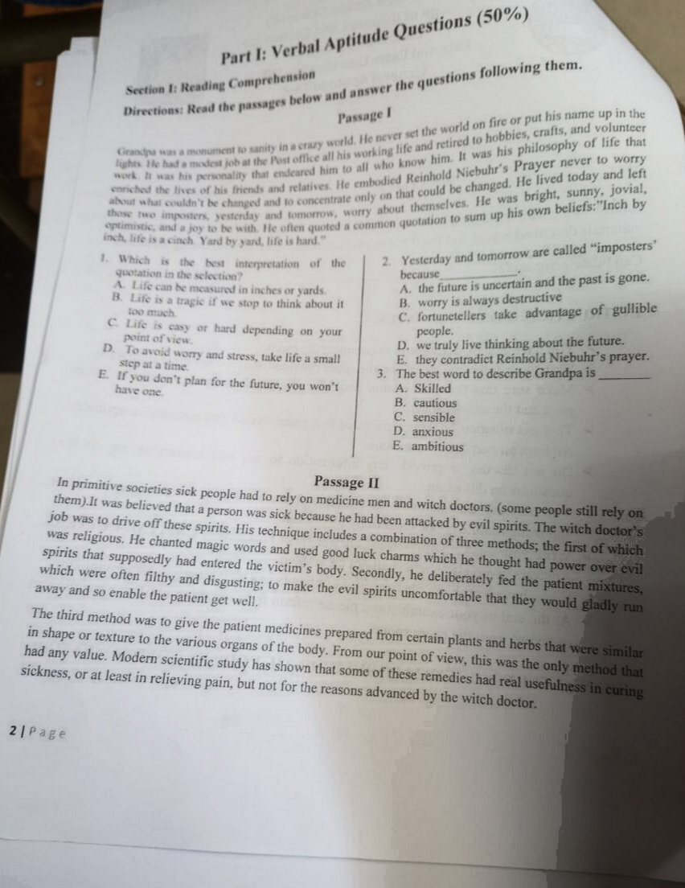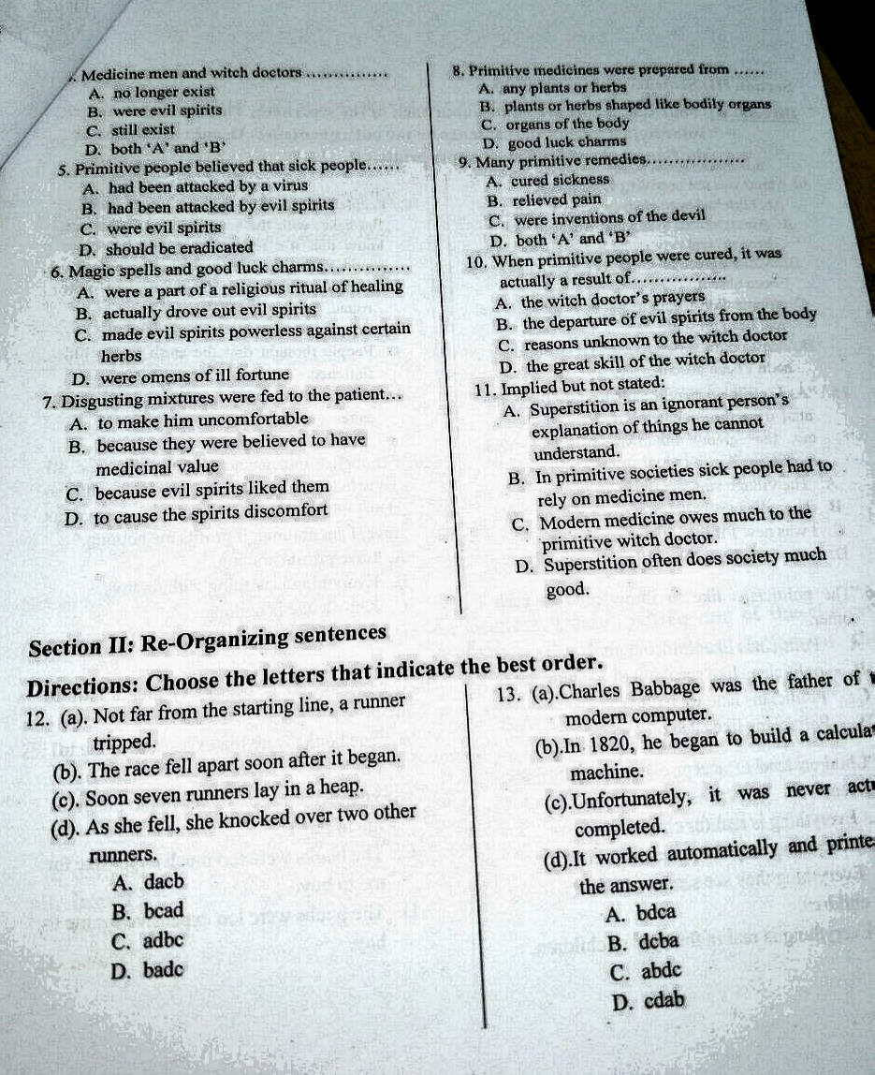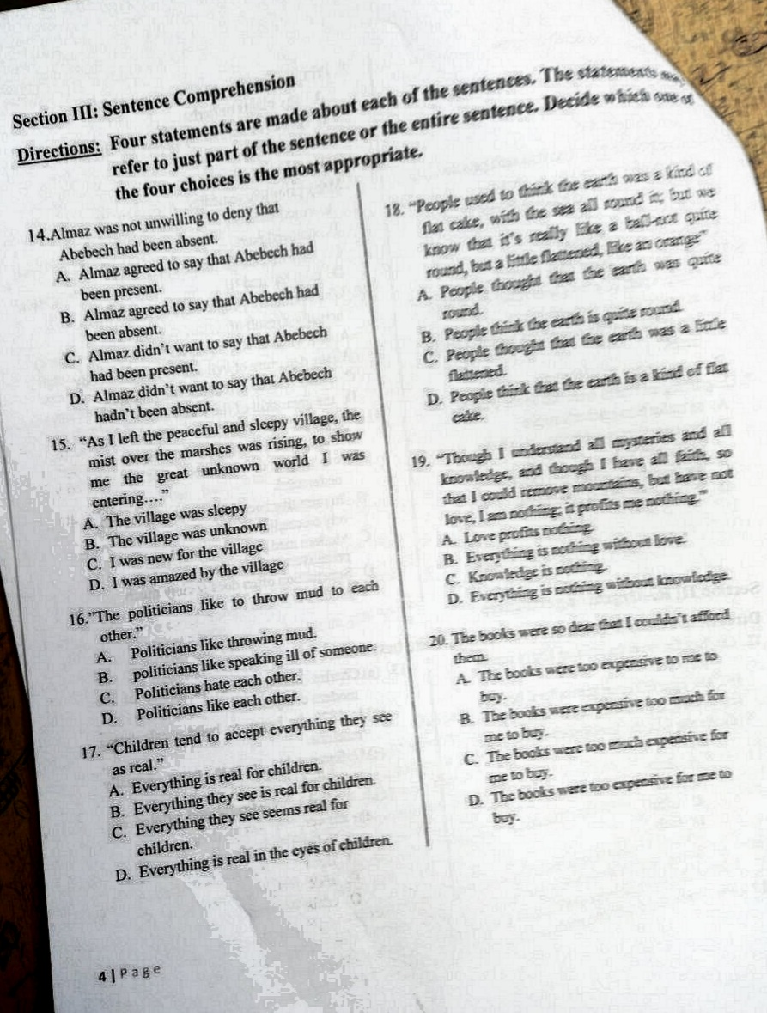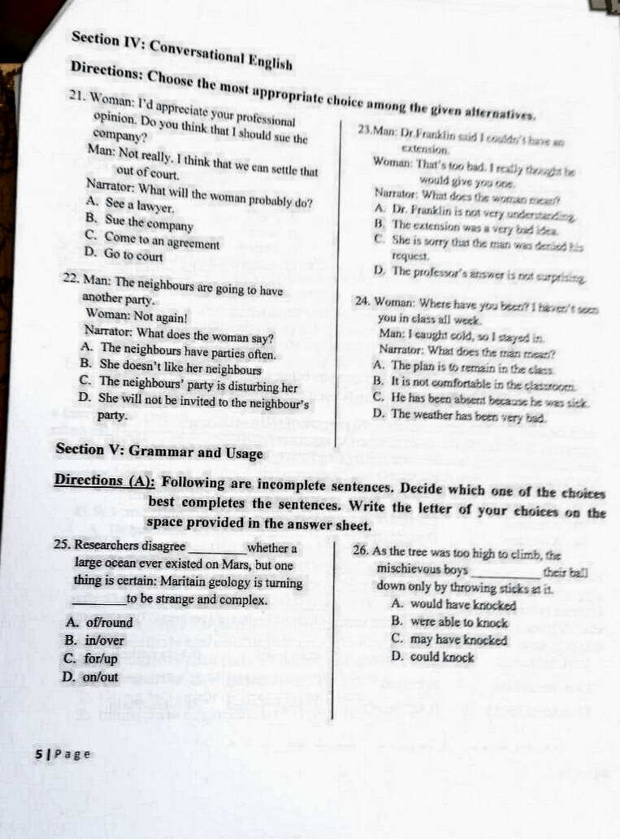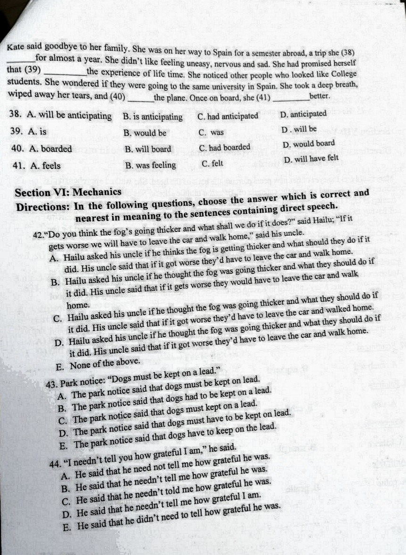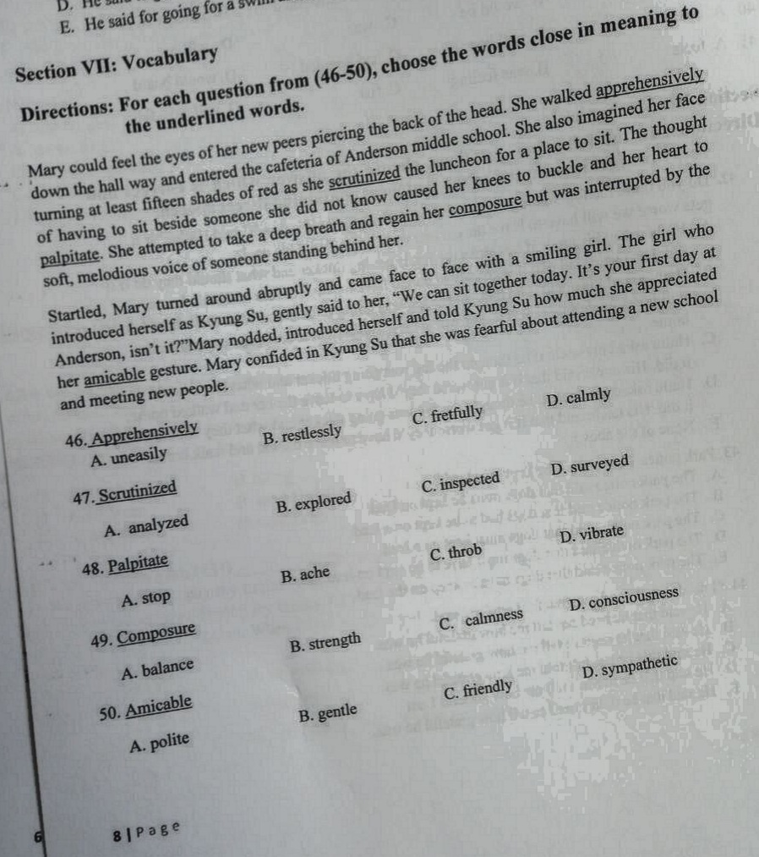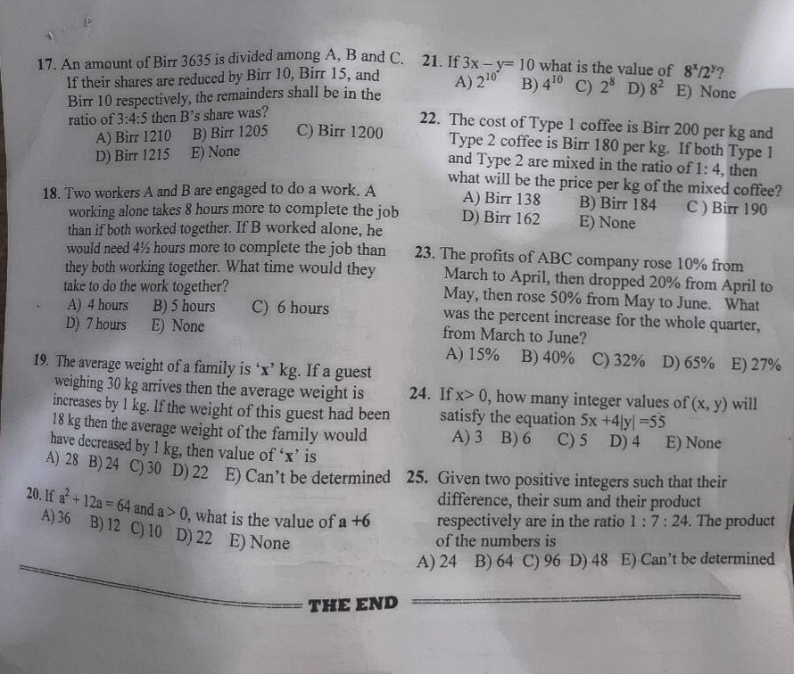
Copyright © 2022 All jobs in one

