**JEST**

Installation

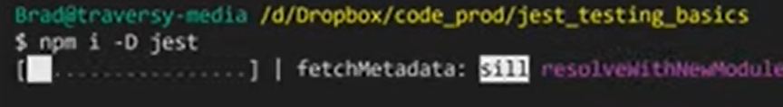

In package.json ensure Test:”jest” else change it accordingly

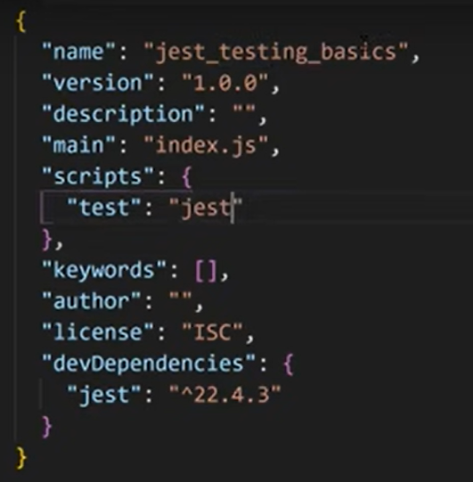

For test creation of file put samefilename.test.js as the name for the test script

In the test file first import the main file

Then under test function:

Test(“Comment”,()=>{

Expect(importedfile.function(inputs) .matcher(output)

}

Wherein a matcher is afunction used to check the output. Example toBe(x) ensures output == x. NOTE: toBe is strict in terms of type etc. toEqual is slightly leneietn version of the same (use for object and array).

Example code

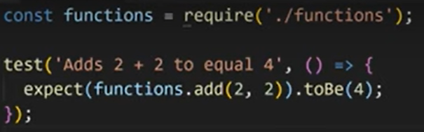

To just put npm test{ensure scripts.test=”jest”} in package.json

To use “not” use expect().not.matcher()

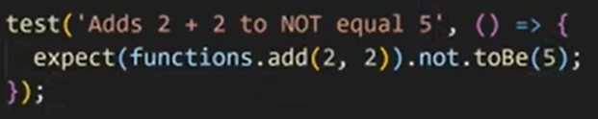

Some useful matchers

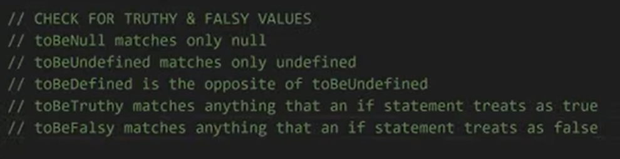

Regex : toMatch(regexp)

Check array values: toContain

Working with async calls

Assertion : <https://en.wikipedia.org/wiki/Assertion_%28software_development%29>

<https://stackoverflow.com/questions/54706481/expect-assertions-in-async-await-function>

https://stackoverflow.com/questions/66823017/what-are-assertions-in-jest

Using Promise

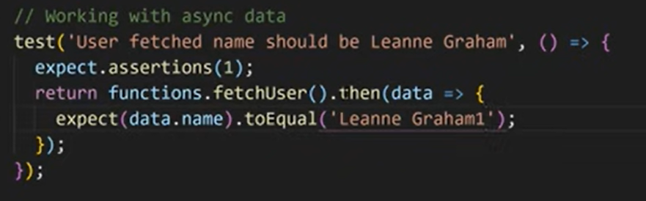

Using await and async

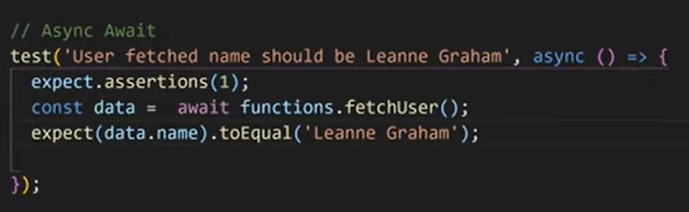

A custom sample

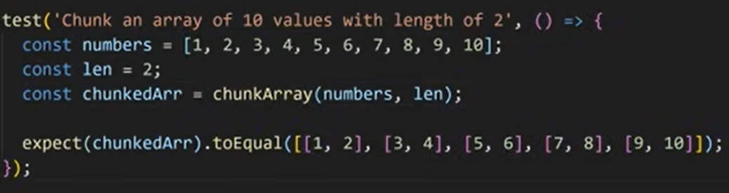

Beforeeach and aftereach

To run something before and after each test

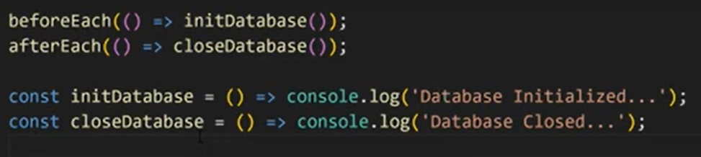

To run something before and after all tests

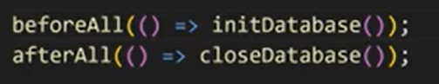

Describe

Used to target before each and after each for only few tests

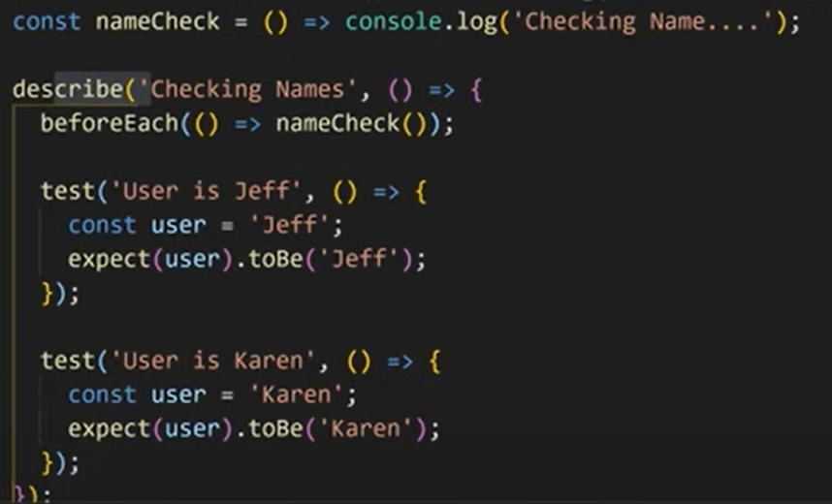

Testwatch

Used to run tests as the codes are typed and compiled. Set by including testwatch :”jest –watchAll”. Now each time you save a file with tests file associated it with it.the changed file will be automatically run against all the tests

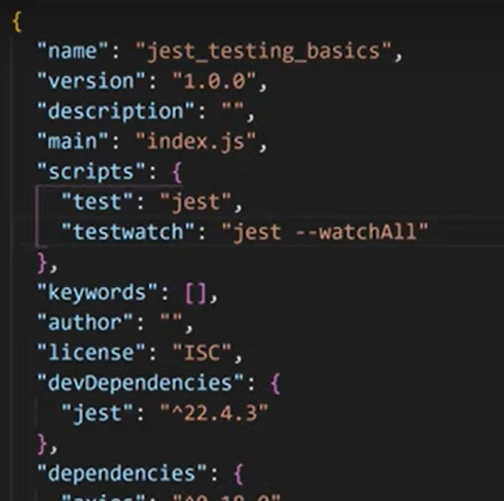

**REACT JEST**



Creaete Component with data-testid

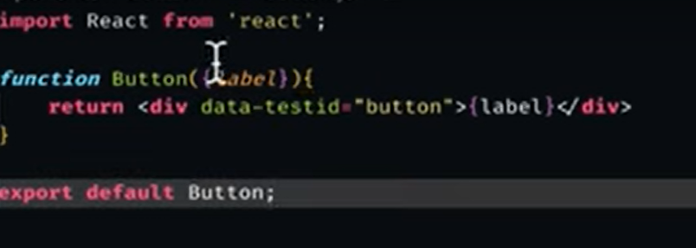

Create a __test__folder with components.test.js

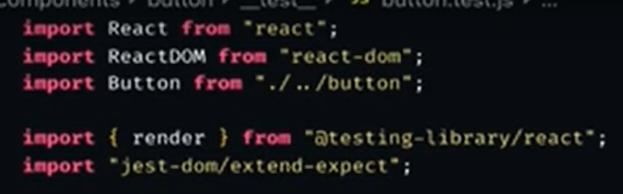

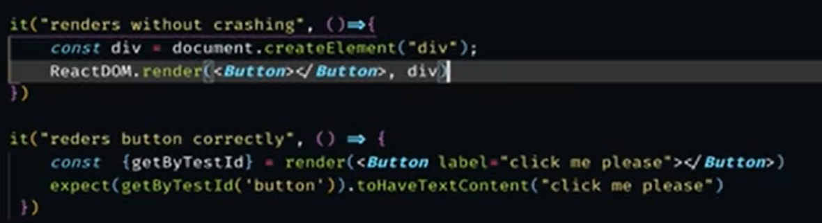

For running multiple tests on same component while ensuring that they are not rendered simultenously we use “cleanup” which is imporetest from @testing-library/react and it is called with aftereach(cleanup)

Snapshots are used to make the testing more easy to humans as shown below. In snap shot a folder with snapshots are created which hold the current value.

