# **Exploring Coffee Shops in Manchester, UK**

**1. Introduction**

**1.1 Background**

Manchester is one of the largest metropolises in the UK with a population of 547,627 as of 2018 (making it the fifth most populous English district). It lies within the United Kingdom's second-most populous urban area, with a population of 2.5 million and third most populous metropolitan area, with a population of 3.3 million. Manchester is the third most visited city in the UK, after London and Edinburgh. As a resident of this city, I decided to use Manchester in my Data Science Capstone Project.

**1.2 Problem**

Though tea is still the most popular hot drink within the UK, coffee drinking is certainly on the rise in UK while tea consumption is falling. For this reason, in this project, my aim is to find best coffee shops in Manchester.

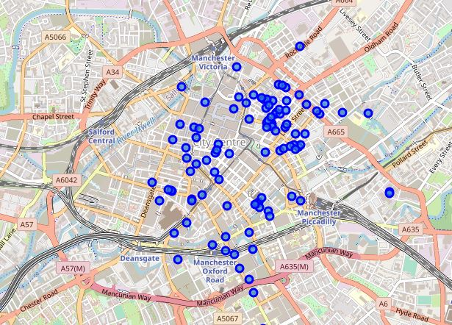

**1.3 Interested audience**

The aim of such a project is twofold. Firstly, any person who is visiting Manchester, UK can use the plots and maps from this project to quickly select coffee places that suit their budget and rating preferences. Similarly, resident of the Manchester can also use these plots and map to discover hidden coffee shops. Secondly, if someone or a company can use this information to open a coffee shop for selecting suitable part of the city.

# **2. Data acquisition and cleaning**

**2.1 Data sources**

To get location and other information about venues in Manchester, I used various data which is obtained from various sources on the internet: "[https://en.wikipedia.org/wiki/M_postcode_area"](https://en.wikipedia.org/wiki/M_postcode_area%22) and ''postcode-outcodes.csv''.

### **2.2 Data cleaning**

I used data cleaning to combine these datasets properly so that I got only one dataset which includes "Postcode, Post town, Coverage, Local authority area, latitude, longitude" values of each coverage (neighborhood).

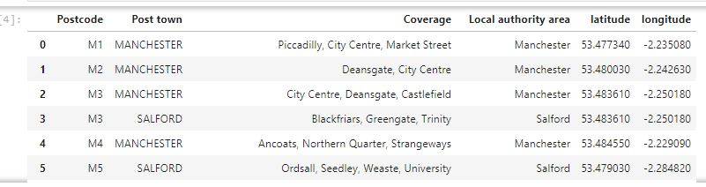

I also restricted my dataset to city centre of Manchester. By using the Foursquare’s explore API, I fetched venues up to a range of 1 kilometers from the center of Manchester and collected their names, categories and locations (latitude and longitude). Then, I choose 'Venue Category' as 'Coffee Shop' or 'Café'.

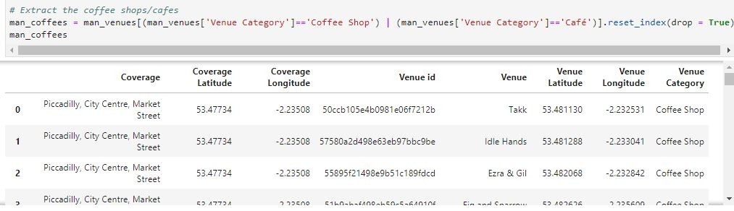

## **3. Methodology and Exploratory Data Analysis**

This project aims at identifying the coffee shops in Manchester based on their rating and average costs. This would enable any visitor to identify the venues he/she wants to visit based on their rating and cost preference.

As a first step, we retrieved the data from two APIs (Foursquare and Zomato). We extract venue information from the center of Manchester, up to a distance of 1 Km. The latitude and longitude values are then used to fetch venue rating and price from Zomato.

Secondly, we then explored the data retrieved from the two APIs and we carefully combined these two-dataset based on the name, latitude and longitude values from the two sources. The final dataset would include the rating and price values for each coffee shops.

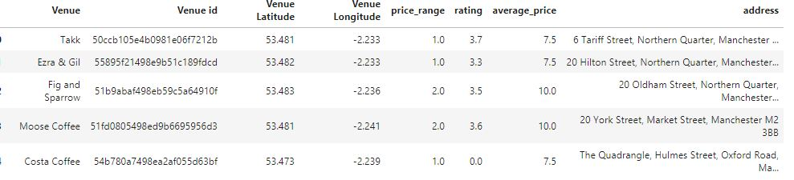

Next, we'll analyse the data that we created based on the ratings and price of each coffee shop. We'll identify places where many coffee shops are located so that any visitor can go to one place and enjoy the option to choose amongst many coffee shop options. We'll also explore areas that are high rated and those that are low rated while also plotting the map of high- and low-priced venues. Lastly, we'll cluster the coffee shop based on the available information of each venue. This will allow us to clearly identify which venues can be recommended and with what characteristics.

Finally, we'll discuss and conclude which coffee shop to be explored based on visitor requirement of rating and cost.

### 

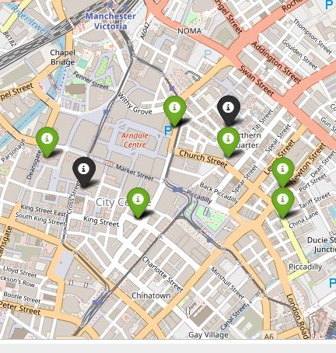

**3.1 Categories**

We have various types of coffee shops in the final dataset. We will take a look at the coffee shops and check which are the majority venue categories in the list.

As we can see the majority of the coffee shops are Starbucks, Federal and Moose Coffee . So, as a tourist, if you're looking for Sturbucks, you're in luck; there is 11 Sturbucks in the city centre.

**3.2 Rating**

Rating Rating of a coffee shop is an important factor on which a visitor decides whether it is worth it to visit the place. So we will first see what is the average rating for all the venues in the city. Next, we will plot the venues on the map and color code them.

We'll first identify the various rating values and plot them as a bar plot with their counts to see the most common rating.

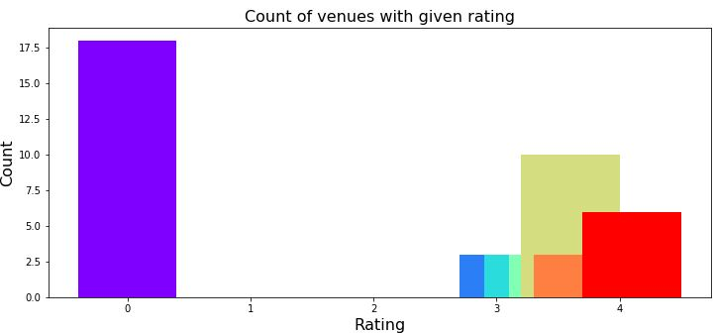

From the plot above, majority of coffee shops have their rating close to 4. We can also say that there are many coffee shops which have not been rated yet. So their ratings are equal to zero.

**3.3 Price**

We will now look the coffee shops based on the price values. We have two price features for our venues, one is average price which defines the average cost for one person and the other is price range which determines the price range as defined by Zomato.

We will first explore the average price using a scatter plot between the price and the count of venues with that average price. We'll size the points based on the price to highlight their price.

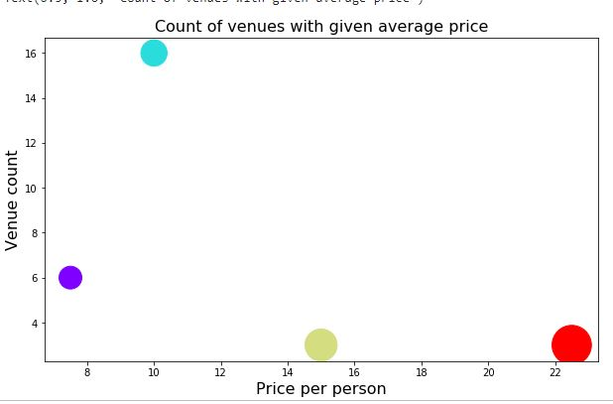

**3.4 Clustering**

We will now cluster all these coffee shops based on their price range, location and more to identify similar coffee shops and the relationship amongst them. We'll cluster the coffee shops into two separate groups.

For example, for cluster 0 we have:

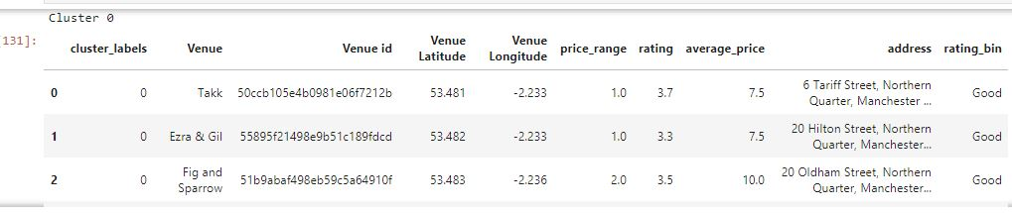

These venues for cluster 0 have mean price range of 1.73 and rating spread around 3.49.

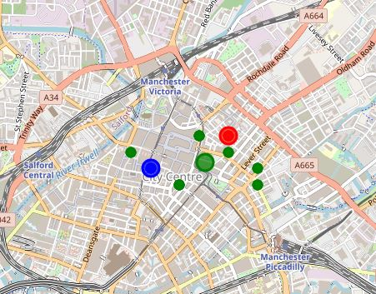

**4. Results and Discussion**

Based on our analysis above, we can draw a number of conclusions that will be useful to aid any visitor visiting the city of Manchester, UK.

After collecting data from the Foursquare and Zomato APIs, we got a list of 68 different coffee shops. However, not all coffee shops from the two APIs were identical. Hence, we had to inspect their latitude and longitude values as well as names to combine them and remove all the outliers. This resulted in a total venue count of 49.

The majority of coffee shops have ratings close to 4. This means that most coffee shops provide good quality food which is liked by the people of the city, thus indicating the high rating.

When we take a look at the price values of coffee shops, we explore that many coffee shops have prices which are in the range of £7.5 to £ 22.5 for one person. Although, the variation in prices is very large, most of the places have average price of £10.

Finally, through clusters we identified that there are many coffee shops which are relatively average priced of £10. On the other hand, there are few venues which are high priced with high rating.

If you're looking for average priced places with relatively average rating, you should check cluster 0.

**5. Discussion**

The purpose of this project was to explore the places that a person visiting Manchester could visit. The coffee shops have been identified using Foursquare and Zomato API and have been plotted on the map. The map reveals that there are many coffee shops with average priced and good rating in Manchester a person can visit.