Processing image with 'people' in filename: people1.jpg
Face detection results for people1.jpg:
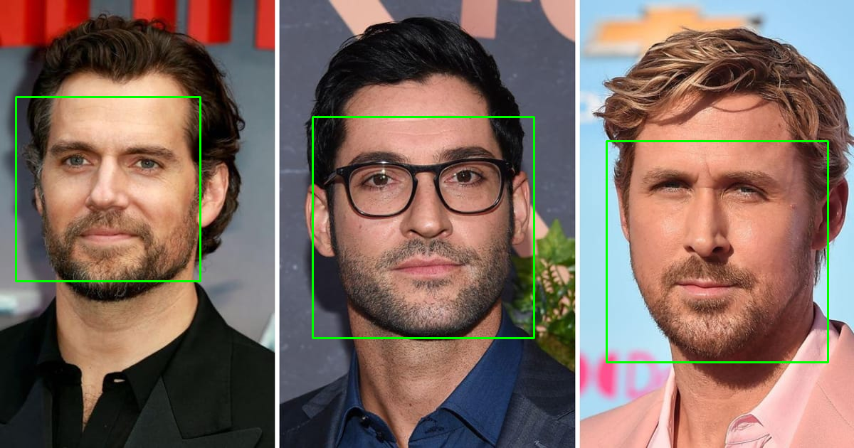
Processing image with 'people' in filename: people2 (1).jpg
Face detection results for people2 (1).jpg:
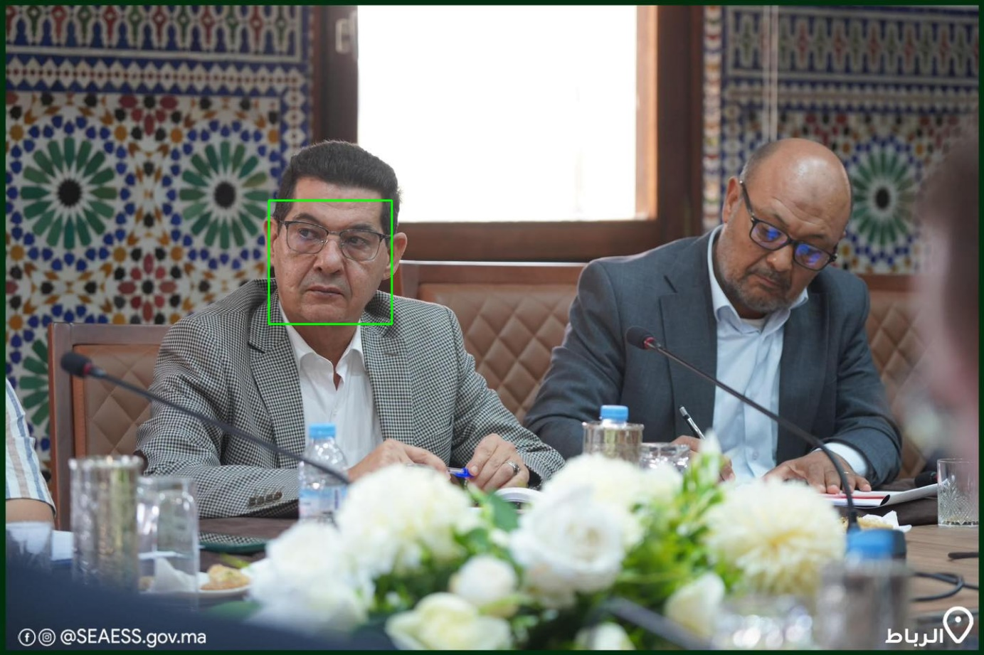
Processing image with 'people' in filename: people (1).jpg
Face detection results for people (1).jpg:
