GitHub Repository: github.com/username/repo

Sprint #0 Report

Instructions

Objectives
- Make decisions on the Solitaire software development project.
- Learn unit testing and GUI programming in the language of your choice.

Deliverables and Grading Policy
Read the “CS 449 Homework Overview” document carefully and make the key decisions for the software development. Use the following template to complete your report.

- Key Decisions of the Solitaire Project (2 points)

Topic | Decision
Object-oriented programming language (if not using OOP, then justify the use of the language) | Python, using classes for cards, decks, and game logic.
GUI library (strongly encouraged) | Tkinter
IDE (Integrated Development Environment) | Visual Studio Code with the Python extension
xUnit framework (e.g., JUnit for Java) | Python’s built-in “unittest framework”
Programming style guide (must read it carefully) | Google Python Style Guide
Project hosting site | Github.com
Other decisions if applicable | Keep game logic separate from GUI code so it can be tested independently.

Sample programming style guides:
- Google Java Style Guide: https://google.github.io/styleguide/javaguide.html
- Google C++ Style Guide: https://google.github.io/styleguide/cppguide.html
- Google Python Style Guide: https://google.github.io/styleguide/pyguide.html

- Unit testing (4 points)

Find a tutorial on the unit test framework you have chosen and write at least two xUnit tests of a program you have written or found elsewhere. Attach here (1) the screenshot of your program execution and (2) the source code of your program.

For example, Junit5 user guide: https://docs.junit.org/5.10.3/user-guide/index.html

- GUI programming (4 points)

Write a GUI program in the language you have chosen for your Solitaire project. The GUI of your program must include text, lines, a check box, and radio buttons. In this assignment, any GUI program of your own work is acceptable.

Attach here (1) the screenshot of your program execution and (2) the source code of your program.

Unit Testing:
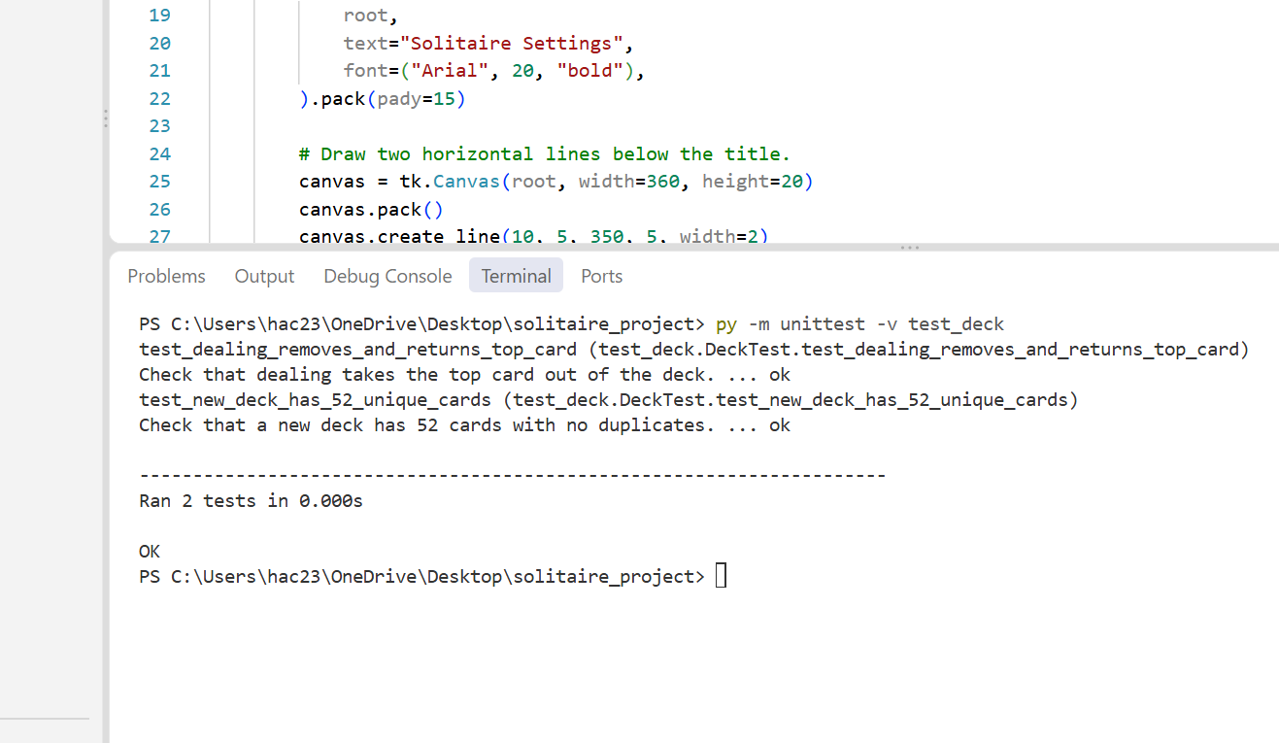

Program Execution:
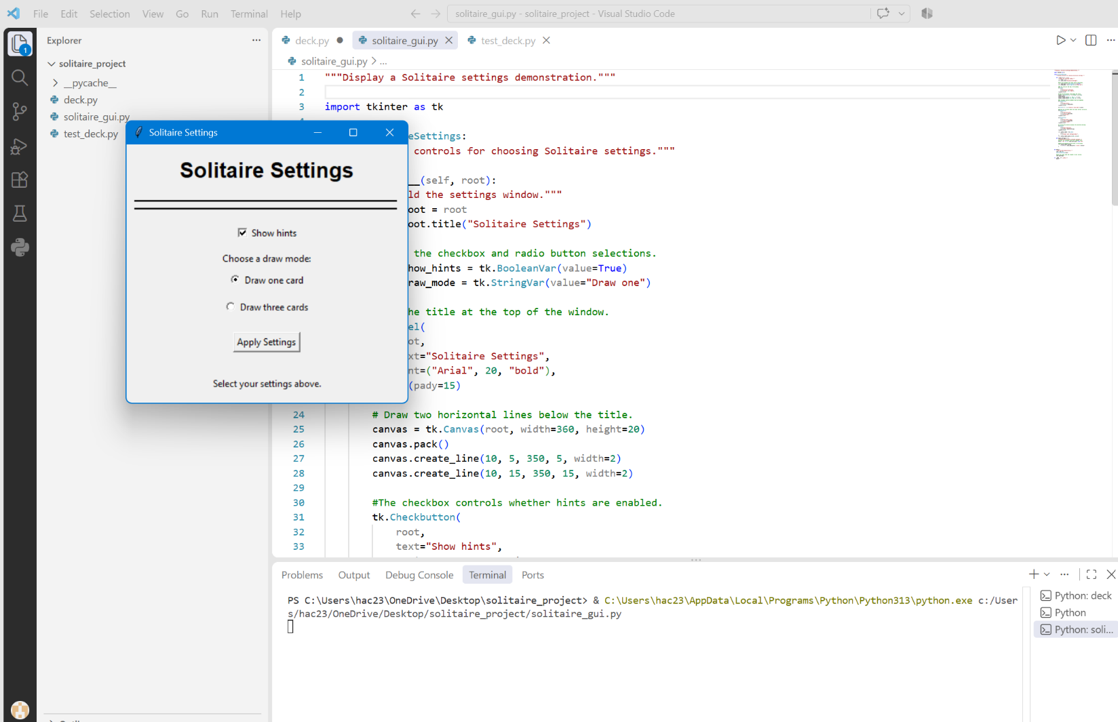
Source Code
Deck
"""Create a deck of cards and allow cards to be dealt."""

class Deck:
"""Represent a standard deck of 52 cards."""

def __init__(self):
"""Build the deck when a Deck object is created."""
self.cards = []
suits = ["Hearts", "Diamonds", "Clubs", "Spades"]
#Each suit has 13 cards.
#1 is Ace, 11 is Jack, 12 is Queen, and 13 is King.
for suit in suits:
for rank in range(1, 14):
card = (rank, suit)
self.cards.append(card)
def deal_card(self):
"""Remove and return one card from the deck.

Raises:
ValueError: If no cards are left.
"""
#Check that there is a card available before dealing.
if len(self.cards) == 0:
raise ValueError("Cannot deal from an empty deck.")

#Treat the last card in the list as the top of the deck.
card = self.cards.pop()
return card

GUI

"""Display a Solitaire settings demonstration."""

import tkinter as tk

class SolitaireSettings:
"""Display controls for choosing Solitaire settings."""

def __init__(self, root):
"""Build the settings window."""
self.root = root
self.root.title("Solitaire Settings")

#Store the checkbox and radio button selections.
self.show_hints = tk.BooleanVar(value=True)
self.draw_mode = tk.StringVar(value="Draw one")

#Add the title at the top of the window.
tk.Label(
root,
text="Solitaire Settings",
font=("Arial", 20, "bold"),
).pack(pady=15)

# Draw two horizontal lines below the title.
canvas = tk.Canvas(root, width=360, height=20)
canvas.pack()
canvas.create_line(10, 5, 350, 5, width=2)
canvas.create_line(10, 15, 350, 15, width=2)

#The checkbox controls whether hints are enabled.
tk.Checkbutton(
root,
text="Show hints",
variable=self.show_hints,
).pack(pady=10)

tk.Label(root, text="Choose a draw mode:").pack()

#Sharing one variable makes the radio buttons exclusive.
tk.Radiobutton(
root,
text="Draw one card",
variable=self.draw_mode,
value="Draw one",
).pack(pady=5)

tk.Radiobutton(
root,
text="Draw three cards",
variable=self.draw_mode,
value="Draw three",
).pack(pady=5)

# Clicking this button displays the selected settings.
tk.Button(
root,
text="Apply Settings",
command=self.apply_settings,
).pack(pady=15)

self.status_label = tk.Label(
root,
text="Select your settings above.",
)
self.status_label.pack(padx=20, pady=15)

def apply_settings(self):
"""Display the currently selected settings."""
#Convert the checkbox value into readable text.
hints = "On" if self.show_hints.get() else "Off"

#Update the message at the bottom of the window.
self.status_label.config(
text=f"{self.draw_mode.get()} | Hints: {hints}"
)

def main():
"""Run the GUI demonstration."""
root = tk.Tk()
SolitaireSettings(root)

#Keep the window open and respond to user actions.
root.mainloop()

if __name__ == "__main__":
main()

Test Deck:
"""Check that the deck is created and deals cards correctly."""

import unittest
import deck

class DeckTest(unittest.TestCase):
"""Contain the unit tests for the Deck class."""

def test_new_deck_has_52_unique_cards(self):
"""Check that a new deck has 52 cards with no duplicates."""
card_deck = deck.Deck()

#standard deck should contain exactly 52 cards.
self.assertEqual(len(card_deck.cards), 52)

#set removes duplicates, so it should still have 52 cards.
unique_cards = set(card_deck.cards)
self.assertEqual(len(unique_cards), 52)

def test_dealing_removes_and_returns_top_card(self):
"""Check that dealing takes the top card out of the deck."""
card_deck = deck.Deck()

#Remember the top card before it is removed.
top_card = card_deck.cards[-1]
dealt_card = card_deck.deal_card()

#The returned card should be the one that was on top.
self.assertEqual(dealt_card, top_card)

#There should be 51 cards left, without the dealt card.
self.assertEqual(len(card_deck.cards), 51)
self.assertNotIn(dealt_card, card_deck.cards)

if __name__ == "__main__":
unittest.main()

