Project Sprint #1

The Solitaire game is described in CS449HomeworkOverview. You should read the description very carefully.

In this assignment, you aim to specify the requirements (i.e., user stories and acceptance criteria) of the target software that allows a human player to play a Solitaire game. These requirements will be fully implemented by the end of sprint 3. The minimum features include choosing the board size and type, starting a new game, making a move, determining if a game is over. The following is a sample GUI layout.

Board size
7
Board Type  - English  - Hexagon  - Diamond | 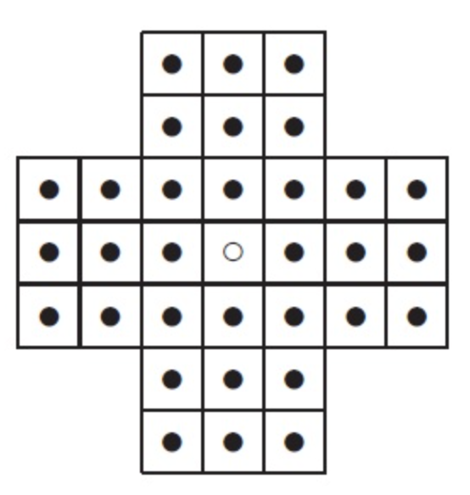 | New Game
Figure 1. Sample GUI layout of the first working program by the end of Sprint 3

Use the following tables to document your user stories and acceptance criteria.

You are required to use the free ChatGPT or another LLM to complete two user stories and two of their respective acceptance criteria. You must ensure that the generated user stories are correct and fix them if not. At the end of the submission, provide screenshots of your LLM prompts and answers, along with the description of errors the LLM made that you had to correct. Points will be deducted if no screenshots/description are provided.

For the other user stories and acceptance criteria, you are not required to use LLM.

- User Stories (3 points)

- User Story Template: As a <role>, I want <goal> [so that <benefit>]

ID | User Story Name | User Story Description | Priority | Estimated effort (hours)
1 | Choose a board size | As a player, I want to choose the board size so that I can play on a board that matches the difficulty and length of game I prefer. | High | 3
2 | Choose the board type | As a player, I want to choose the board type (English, Hexagon, or Diamond) so that I can play the board layout I find most interesting or challenging. | High | 3
3 | Start a new game of the chosen board size and type | As a player, I want to start a new game with the board size and type I selected so that I can begin playing from a fresh, correctly set-up board at any time. | High | 6
4 | Make a move in a game | As a player, I want to make a move by jumping a peg over an adjacent peg into an empty hole so that I can progress through the game and try to clear the board. | High | 10
5 | A game is over | As a player, I want the game to tell me when it is over so that I know when I have won or when no more moves are possible. | High | 6

- Acceptance Criteria (AC) (12 points): Add/delete rows as needed.

User Story ID and Name | AC  ID | Description of Acceptance Criterion | Status (completed, toDo, inPprogress)
1. Choose a board size | 1.1 | AC 1.1 <Choosing a valid board size>  Given the setup screen is displayed  When the player enters or selects a valid board size (an odd integer of at least 5, e.g., 7)  Then the Board size field shows the selected value and it is used the next time a new game is started | toDo
1. Choose a board size | 1.2 | AC 1.2 <Rejecting an invalid board size>  Given the setup screen is displayed  When the player enters an invalid board size (e.g., an even number, a number below 5, or non-numeric text)  Then the entry is rejected, an error message is shown, and the previously selected board size is kept | toDo
1. Choose a board size | 1.3 | AC 1.3 <Default board size>  Given the application has just been launched  When the setup screen appears  Then the board size is pre-set to the default value of 7 | toDo
2. Choose the board type | 2.1 | AC 2.1 <Selecting a board type>  Given the setup screen shows the options English, Hexagon, and Diamond  When the player selects one of them  Then only that option is shown as selected and it is used the next time a new game is started | toDo
2. Choose the board type | 2.2 | AC 2.2 <Default board type>  Given the application has just been launched  When the setup screen appears  Then the English board type is selected by default | toDo
2. Choose the board type | 2.3 | AC 2.3 <Changing type during a game>  Given a game is in progress  When the player selects a different board type without clicking New Game  Then the current board is left unchanged and the new type is applied only when a new game starts | toDo
3. Start a new game of the chosen board size and type | 3.1 | AC 3.1 <Starting a new game>  Given the player has selected a valid board size and board type  When the player clicks the New Game button  Then a board of the chosen size and type is displayed, with a peg in every valid hole except the center hole, which is empty | toDo
3. Start a new game of the chosen board size and type | 3.2 | AC 3.2 <Restarting during a game>  Given a game is already in progress (some moves have been made)  When the player clicks the New Game button  Then the current game is discarded and a fresh board with the currently selected size and type replaces it | toDo
3. Start a new game of the chosen board size and type | 3.3 | AC 3.3 <Board layout matches type>  Given the player has selected a board type  When a new game is started  Then the holes are arranged in the shape of the selected type (English cross, Hexagon, or Diamond) | toDo
4. Make a move in a game | 4.1 | AC 4.1 <Valid move>  Given a game is in progress and a peg has an adjacent peg horizontally or vertically with an empty hole directly beyond it  When the player moves the peg over the adjacent peg into the empty hole  Then the moving peg lands in the empty hole, the jumped peg is removed, the starting hole becomes empty, and the remaining peg count decreases by one | toDo
4. Make a move in a game | 4.2 | AC 4.2 <Invalid move>  Given a game is in progress  When the player tries to move a peg to a hole that is not empty, is not exactly two holes away in a straight line, has no peg to jump over, or is off the board  Then the move is rejected, the board stays unchanged, and an invalid-move message is shown | toDo
4. Make a move in a game | 4.3 | AC 4.3 <Moves blocked after game over>  Given the game is over  When the player tries to move a peg  Then no move is made until a new game is started | toDo
5. A game is over | 5.1 | AC 5.1 <Game over with no moves left>  Given a game is in progress and more than one peg remains  When the player makes a move after which no peg has a legal jump  Then the game is declared over, the number of remaining pegs is shown, and no further moves are allowed | toDo
5. A game is over | 5.2 | AC 5.2 <Game won>  Given a game is in progress  When the player makes a move that leaves exactly one peg on the board  Then the game is declared over with a win message | toDo
5. A game is over | 5.3 | AC 5.3 <Game continues while moves exist>  Given a game is in progress  When the player makes a move after which at least one legal jump still exists  Then the game is not declared over and the player can keep playing | toDo

