**Report: Art Monuments, Criticism, and Reading Visual Arts**

**1. Art Monuments and Criticism**

**Description**  
Art monuments constitute the physical manifestations of cultural memory. They can serve as points of veneration, dispute, or even political activity. Such structures can be critiqued on historical, ethical, and contemporary grounds. For instance, some debates about the appropiateness of Confederate monuments in the United States bring to the surface the conflicts between heritage and systematic oppression (Miles, 2021).

**Key Theories**:

* **Danto’s “Transfiguration”**: Monuments are ideological tools that reflect the values of their creators rather than objective history (Danto, 1981).
* **Decolonizing Art Spaces**: Miles (2021) argues that monument removal or recontextualization can challenge colonial narratives.

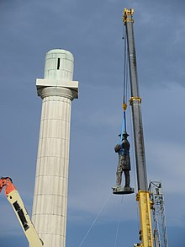 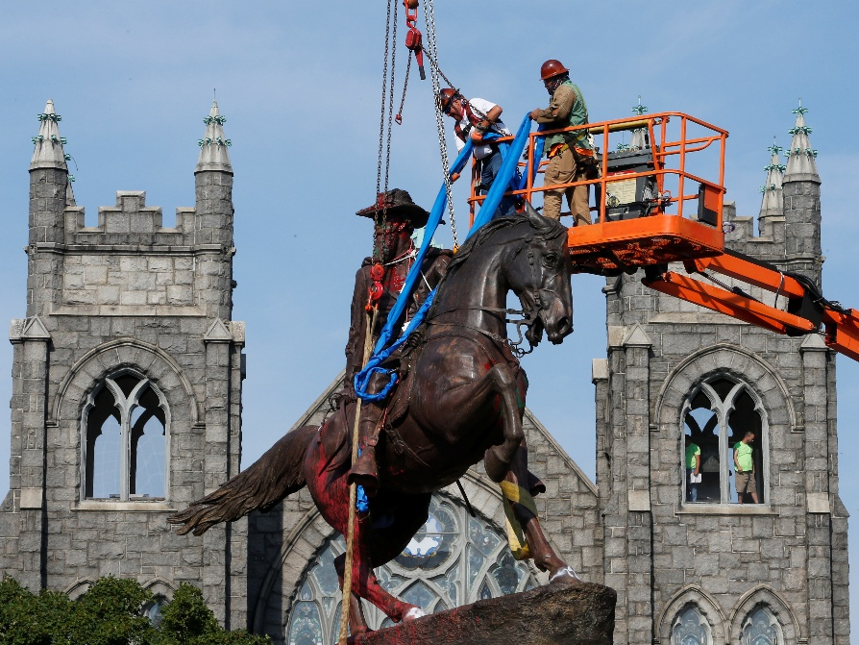

* **Figure 1**: *Removal of a Confederate Statue*
  + *Description*: A photograph of workers dismantling a Confederate general’s statue, surrounded by protesters and supporters. This image encapsulates the societal friction over monuments, illustrating Danto’s argument about their role in shaping present-day ideologies.

**2. Analysis of Reading Visual Arts – Authors’ Perspective**

**Description**  
By means of careful choice of composition, symbols, and the medium, artists intentionally embed political, personal, or philosophical messages. Picasso’s Guernica (1937), for example, uses broken shapes and stark colors to condemn the brutality of war. This can be situated in Panofsky’s iconography that separates the shallow subject of the artwork from its deeper structure Panofsky (1955) .

**Key Theories**:

* **Intentionality**: Berger (1972) emphasizes that artists “see” differently, embedding layered meanings accessible through critical analysis.
* **Iconography**: Panofsky’s three-tiered model (1955) decodes artworks by analyzing form, context, and cultural symbolism.

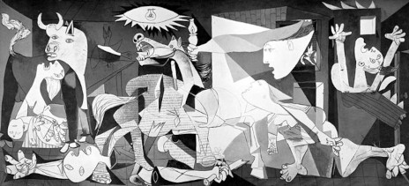

**Figure 2**: *Guernica by Pablo Picasso (1937)*

* + *Description*: A black-and-white close-up of *Guernica*’s central figures, annotated to highlight symbols like the bull (representing fascism) and the weeping mother (universal grief). This visual breakdown aligns with Panofsky’s method of interpreting artistic intent.

**3. Analysis of Reading Visual Arts – Audience’s Perspective**

**Description**  
Art is received and understood through subjectively formed lenses that are a product of one’s culture, education background, and personal experiences. Reception theory (Gadamer, 1975) argues that the viewer participates on co-creating meaning, whereas Bourdieu (1984) states that “cultural capital” is a determinant in aesthetic judgments. For instance, Jackson Pollock’s spontaneity elicits ratifying admiration responses, while his lack of skill gets him eschewed and criticized in equal measure.

**Key Theories**:

* **Reception Theory**: Gadamer’s “fusion of horizons” (1975) suggests interpretation merges the viewer’s context with the artist’s intent.
* **Cultural Capital**: Bourdieu (1984) links art preferences to social class and education.

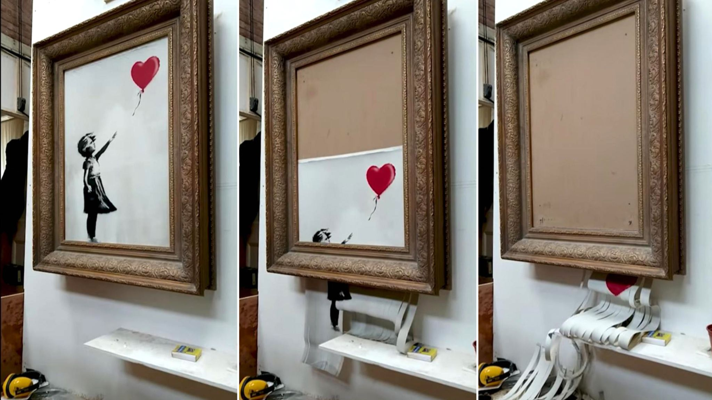**Figure 3**: *Banksy’s “Girl with a Balloon” (Shredded Version, 2018)*

* + *Description*: The half-shredded artwork moments after its auction sale, symbolizing the unpredictability of audience reception. The act of destruction transformed its meaning from a sentimental piece to a critique of art commodification, exemplifying Gadamer’s idea of dynamic interpretation.

**4. Comparative Analysis**

**Authors vs. Audience**

* **Authors**: Focus on intentionality and encoded symbolism (e.g., Frida Kahlo’s self-portraits reflecting her physical and political struggles).
* **Audience**: Prioritizes subjective meaning (e.g., *Mona Lisa*’s smile interpreted as mysterious, maternal, or melancholic depending on the viewer).

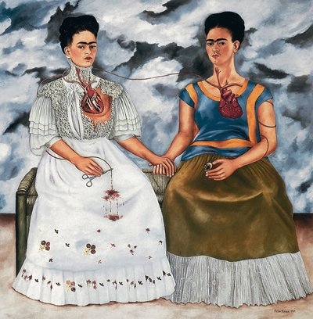

**Figure 4**: *Side-by-Side Comparison of Kahlo’s “The Two Fridas” (1939) and Audience Reactions*

* + *Description*: Left panel: Kahlo’s double self-portrait symbolizing her mixed heritage. Right panel: Quotes from viewers interpreting the work as a commentary on identity, divorce, or surrealism. This juxtaposition highlights the gap between intent and reception.

**5. Conclusion**

There is a constant interaction between the creation and interpretation of art monuments and visual artworks. While intention is crafted by the artist, the audience recontextualizes meaning using their own personal and cultural frameworks. Critical analysis, in the manner scholars like Danto, Panofsky, Bourdieu, and others have made, connects these perspectives, stimulating debate regarding the place of art in society.

**References**

1. Berger, J. (1972). *Ways of Seeing*. Penguin Books.
2. Bourdieu, P. (1984). *Distinction: A Social Critique of the Judgement of Taste*. Harvard University Press.
3. Danto, A. (1981). *The Transfiguration of the Commonplace*. Harvard University Press.
4. Gadamer, H. G. (1975). *Truth and Method*. Continuum.
5. Miles, M. (2021). *Art as Public Memory*. Routledge.
6. Panofsky, E. (1955). *Meaning in the Visual Arts*. University of Chicago Press.