CNSC 33rd  Foundation Anniversary Narrative

The CNSC Foundation Day began promptly at 8:20 AM with the stirring notes of the national anthem, bringing everyone together in a moment of pride and unity. Following the anthem, the opening remarks set the tone for the event, welcoming all participants and attendees to the celebration. This was followed by a heartfelt message from the organizers, paying tribute to the importance of the day and the institution. A solemn wreath-laying ceremony took place next, honoring the late Senator Renato Unico at his monument. After this, a brief historical perspective was shared, reflecting on the university's journey, challenges, and milestones over the years. By 10 AM, the first part of the event concluded with closing remarks from Ma'am Rhodavib Avila, wrapping up a thoughtful and reflective session.

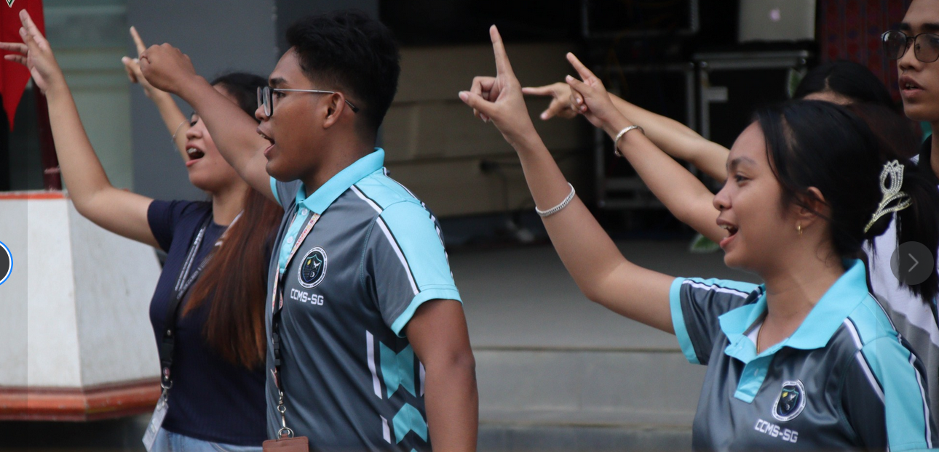

CCMS Student Government Participating in the Community Dance

The second part of the event began at around 10:25 AM with an energetic community dance, bringing together students, faculty, and staff in a vibrant display of spirit and unity. Following the dance, the *Laro ng Lahi* commenced, a series of traditional Filipino games that brought excitement and competition to the festivities.

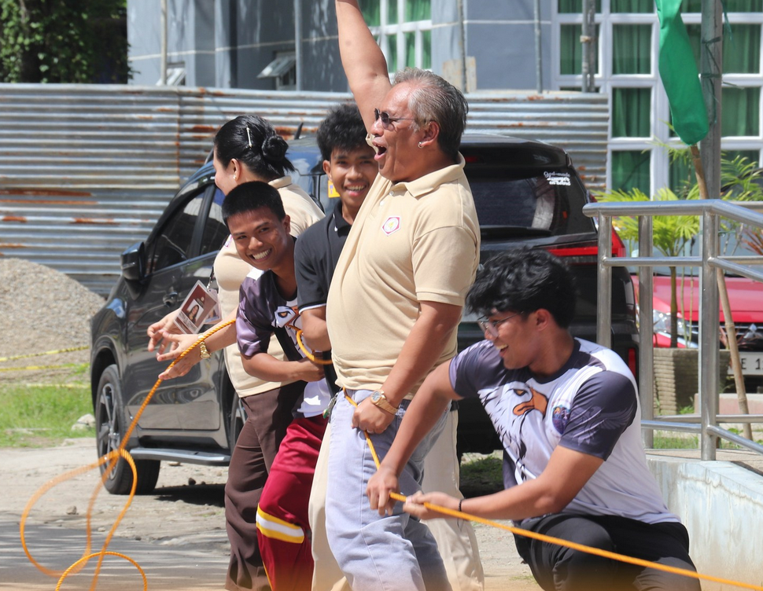

Sir Maligat along with participating CCMS students cheering during the tug of war game.

Although I was not able to witness the entirety of the *Laro ng Lahi*, I did catch a few of the games. In the egg toss event, CCMS gave a solid performance, securing a respectable fourth place. However, in the classic game of Jack and Poy, things didn’t go as planned, and unfortunately, CCMS finished in last place. Despite these results, the competition was spirited, and everyone had a great time.

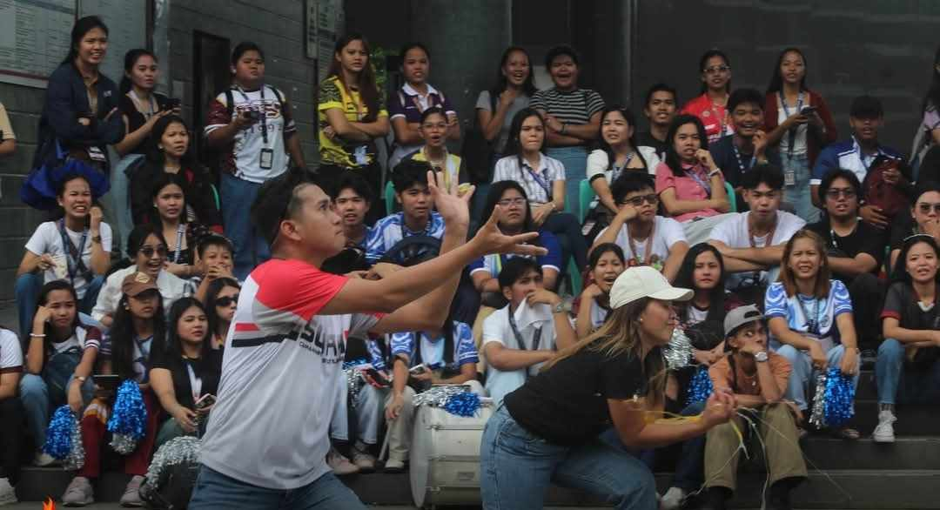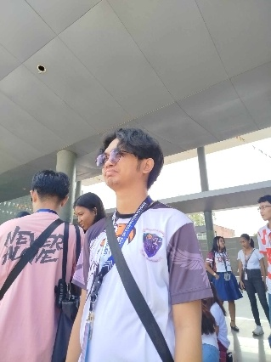

Left: Participants of the catch the egg event eagerly catching eggs, Right: spectator EGGearly watching

As the afternoon wore on, the heat became intense, and I had to step away before the boodle fight and the awarding ceremony took place. Still, the day's events were filled with enthusiasm, camaraderie, and a strong sense of pride in both CNSC and the CCMS participants. It was a memorable experience, full of energy and community spirit, showcasing the best of the university and its people.