Hachy

Enable easy and efficient smart egg candling for farmers and consumers

# The Team

We are a team from the University of Waterloo, we originally started with 2 people, then a friend of mine who are an agriculture student in China reached out to me via social media that he is interested in this project and offered me information on types of egg and their characteristics. Later, my friend had to exit due to external circumstance. Although we were still on the planning ideation phase at his exit, I in fact, gave up for, however in the following days, the thoughts of what could it have become keeps waking me up at night.

**The vision of our team is building an autonomous egg incubating tool that allows no human involvement in the incubating, candling and hatching of eggs. Hachy is considered as the first stage that enables autonomous egg development identification and tracking.**

**Eugene(Yujing) Wang,** University of Waterloo, 2nd year Mathematics students, graduate in 2020

Eugene has a great interest in data science, mobile, web and cloud development. Asides from studying data science in Mathematics faculty at University of Waterloo, he had done 2 internships: one as a cloud developer at RBC where he built pipelines that allowed the simultanous flow and filter of 50,000+ queries, the other as a app developer at blackberry, where he helped contributing to blend an app that syncs blackberry device data with users’ desktop via a local network.

**Mentors:**

* Prof. Wang, Jun (South China Agricultural University) – Assisted on the Development of Egg and Embryology and possible bacterial and viral infection of the egg

# The Concept

Ever since I was little, my family would purchase organic eggs from farmers market. Before purchasing these eggs, we need to candle them to see if they are fresh and fertile. Egg Candling, however is rather a skillful and long process to grasp for ordinary consumer. In fact, it cost approximately 673 hours for a homestead farmer to care for the development of egg with egg candling taking up most of the time. However, despite of the emergence of similar tool such as banana Freshness

**Therefore, Hach aims to:**

* reduce the skills requirement for consumers to shop egg by providing a easy way to identify the development status of the egg.
* Reduce the time for homestead farmers who raise egg themselves.

**By:**

* Use Image Recognition Service provided by Azure to determine the development of an egg
* Use Web & Mobile service to store data on the cloud such that the egg stats is readily avaliable whenever the user need them.

## Target Audience or Market:

The targeted audience are Homestead farmers and consumers of egg in a farmers’ market. On a survey conducted on 1487 egg farmers, 71% are homestead farmers who owns less than 10 hens1. However, these farmers would at least candle twice or at most daily for 18 days2. During a manual candling, a significant amount of time: usually around 30s seconds is spent on each egg according experience3. In addition there is always the risk of containmination or mishap during the process. Hachy effectively reduce candling time down to 10 seconds as the video demonstrated and decrease the amount of grasp and touch the egg will sustain.

Sources:

1. Backyard chickens in the United States: A survey of flock owners C. Elkhoraibi R. A. Blatchford M. E. Pitesky J. A. Mench https://academic.oup.com/ps/article/93/11/2920/2730497
2. Back Yard Chickens, “How early and how often do you candle your eggs?”, <https://www.backyardchickens.com/threads/how-early-and-how-often-do-you-candle-your-eggs.632425/>
3. The Heritage Homestead , “3 Reasons Why Candling Eggs Is Important” https://blog.mypetchicken.com/2013/03/31/5-reasons-why-egg-candling/

### Personas

[**Cath (Youtube)**](https://www.youtube.com/channel/UCCGhip1gdKPcq0g1rTKBlwQ)  
lives in Rural Italy and has raised 23 hens when she started with the raise hens, she had to go through a long journey to understand the egg development. In fact, she created a YouTube channel to teach the egg candling. Hachy Will help people like Cath to save time on candling egg track egg development so that they would not need to manually take an egg out from the nest, adjust angles and go through all the trouble to identify very subtle details on the egg.

[**Wancai (Youtube Video)**](https://www.youtube.com/watch?v=-wZeUUgJdUM)   
Wancai lives in PingTung, Taiwan. He is a organic egg shoper at PingTung’s local farmers market. He has been selecting his eggs for the best quality for

## Feedback

Here are some of the feedback I’ve received:

* enable detection for blood spots to check the fertility of the egg
* Allowing the tracking of individualized egg at different staged: basically, it shows the history of development
* Cope with concurrent agriculture and civilian system such that data could be shared
* In China, there is the demand to sync it with social media platform as the specialized farming technology system has not been as developed as the West, but the mobile network is more developed
* Expand on the feature of the app such that it explains the implication of the stages of egg development
* Make the packed card box so that it could be provided in a package rather than having to make one
* Use better fitting for egg seat so that the egg would sit tightly at right angle with least adjustments
* enable separate loading and unloading so that new egg will be inserted from one side while the old one will be repelled on the other-side to enable streamlined loading.

and so on ...

I am working on tacking these feedbacks one by one

# How it works:

To see a more detailed and up-to-date project architecture and usage guide, click here: <https://github.com/hachyEgg/hachy-android>

Design diagram:

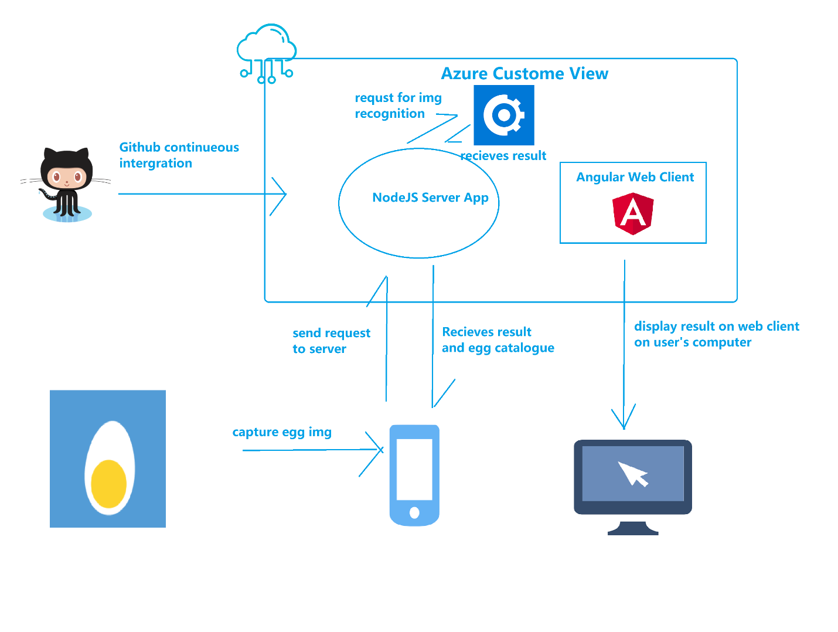

**Card box Setup:**

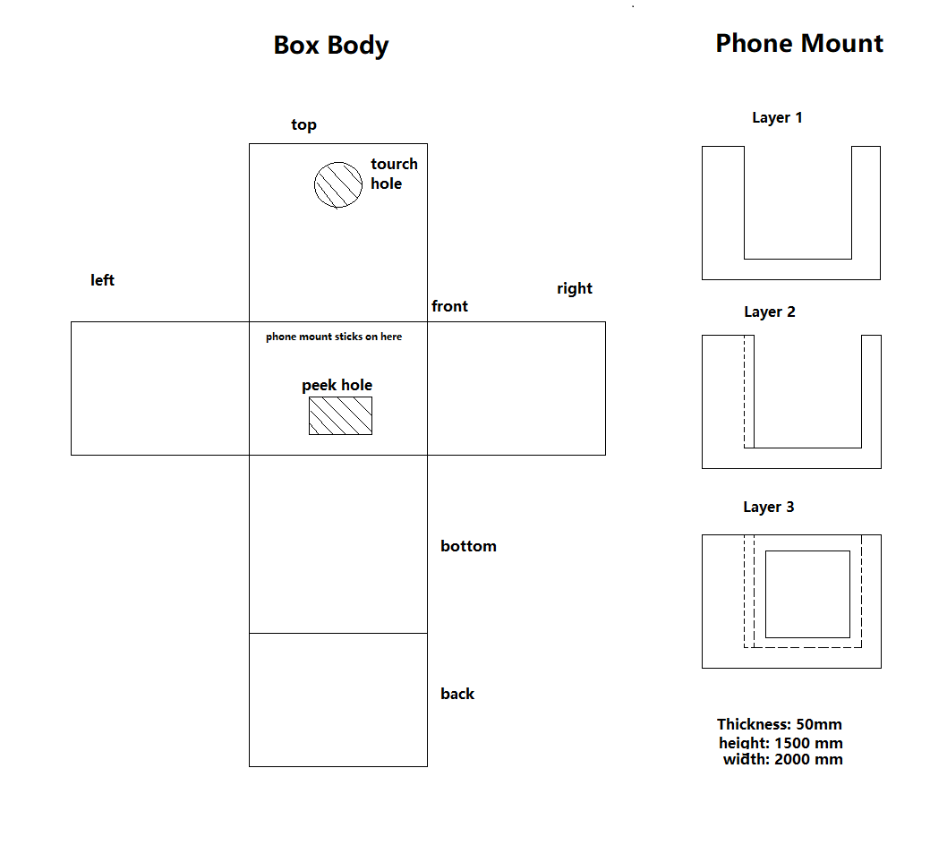

Use:

1. Purchase or make a cardbox of the following specs:
2. insert the device into the cardbox, A completed set up would look like this: (insert image)
3. insert egg, close egg and turn on the light source, observe that the phone screen will show a the egg: (insert image)
4. open app, login, and choose either to take picture or import existing egg picture:

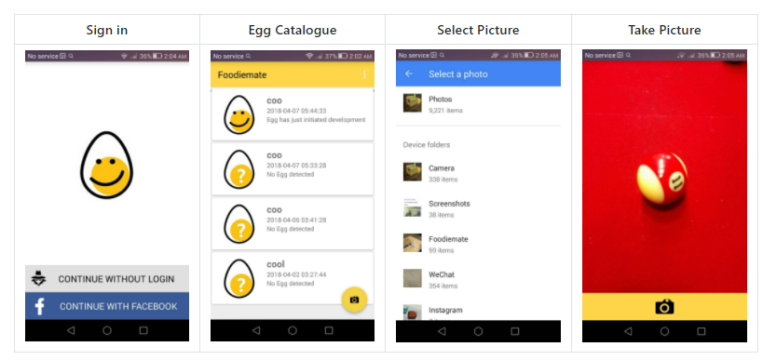

1. Press the button to capture the egg, the image will be persisted on the cloud and sent to Azure for analysis, Upon result complete, the status of the egg will change from "egg not found" to the deteremiend result

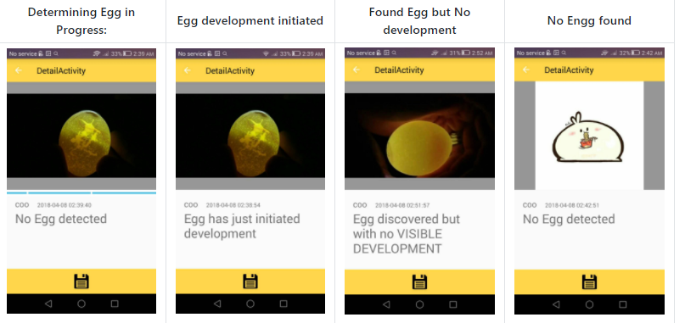

1. Navigate back to observe a catalogue of egg status

## Web-Client

As the phone is being mounted on the cardboard, it is a little hard to track egg status, the [Hachy Web Client](https://github.com/hachyEgg/hachy-web-dist) lets you see analysis data in realtime sync with the device remotely. As the phone maybe a little hard to check as it is been mounted.

[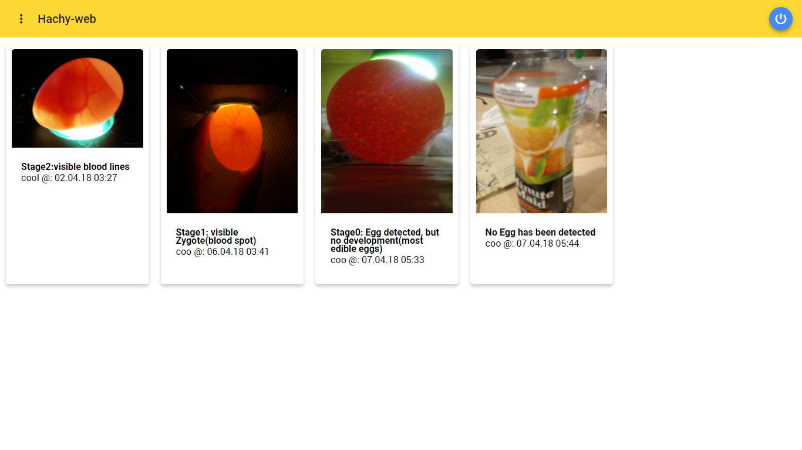](https://user-images.githubusercontent.com/7799433/38462289-84e70c60-3ab2-11e8-9587-d5706807c0a2.png)

## Datasets:

The datasets of which this modal is trained labeled in 4 different tags:

* egg_0 for egg with no development (no development)
* egg_1 for egg with a visible zygote (developing)
* egg_2 for egg with visible blood lines and other organs (mature)

## Core Technologies

The technology used here are Azure Web/Mobile Service and Custom Vision. Web/mobile service is used to host an angular/node app which host the web client that display egg catalogue, and handle request being sent from the mobile. The custom view service is used to train image recognition logistics with given datasets on egg development on 3 stages: early, middle, mature.

# The Business Plan:

You don’t need to have a fully fleshed out business plan, we just want to know that you’ve put time into thinking about it.

## Competition:

Currently, there are a variety of egg candling lamp in the market ranging from 10 dollars to 50 for a cheap one such as [Magicfly Bright Cool LED Light Egg Candler Tester - Incubator Warehouse Exclusive](https://www.amazon.com/Magicfly-Bright-Light-Candler-Tester/dp/B00KCKNYCY/ref=sr_1_1?ie=UTF8&qid=1523249839&sr=8-1&keywords=egg+candling) which cost 18$ or even more fancy ones such as [Egg Or-Candle](http://www.eggtester.com/products/egg-or-candler) which would cost much more.

However, this project is fundamentally different from those in that it uses machine learning to generate the egg candled result rather than still requiring a human to identify the result. It eliminate the last human factor in the chain. In addition, since Hachy stores egg information on the cloud, the egg development stats can be integrated with existing farmers’ digital system to enable autonomous egg caring farm.

## Business Model

The eventual business modal will be a consumer oriented subscription program:, it will require the user to pay a small amount of fee: predetermined to be 50$ annually or 10$ monthly the first 2 weeks will be offered as free trial.

However, a more imminent approach would be modeling it as a research tool and provide it to universities: in fact, I have a few students from Xinjiang Agricultural university working with me on this project and received the guidance from South China Agricultural university. So, a second option is providing it as a research tool to universities, as of writing this project proposal I am seeking cooperation from faculty members and students at the University of Toronto.

# Additional Information:

Add any links or information here. Any information you want to share is welcomed!