Detailed System Requirements:
- jdk and jre are requested from operating system to execute this java program.
-User must run makefile folder
Class Diagram:
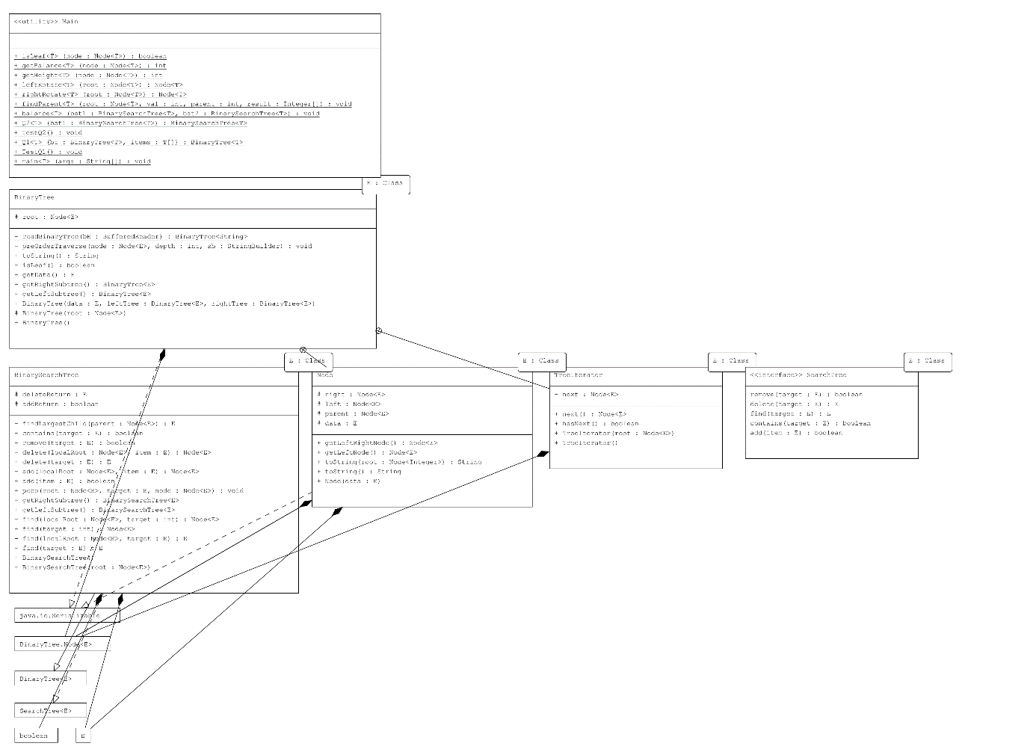

Q1)
Solution Approach:
In my method, first I sort the given array After that I traverse the Given BinaryTree in inorder way and put sorted arrays elements one by one to the binarytree. When function completed the given BinaryTree will be BinarySearchTree and return it.
- Sort given items array: I used Quick Sort
- Traverse Given Binary Tree in inorder way
- Put Sorted Arrays elements one by one to the binary Tree
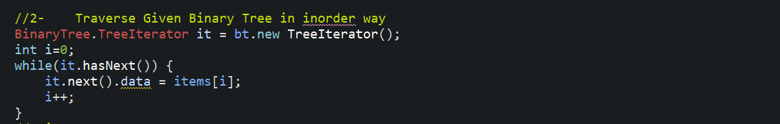
Note: TreeITerator is an iterator that helps to traverse the tree inorder way.

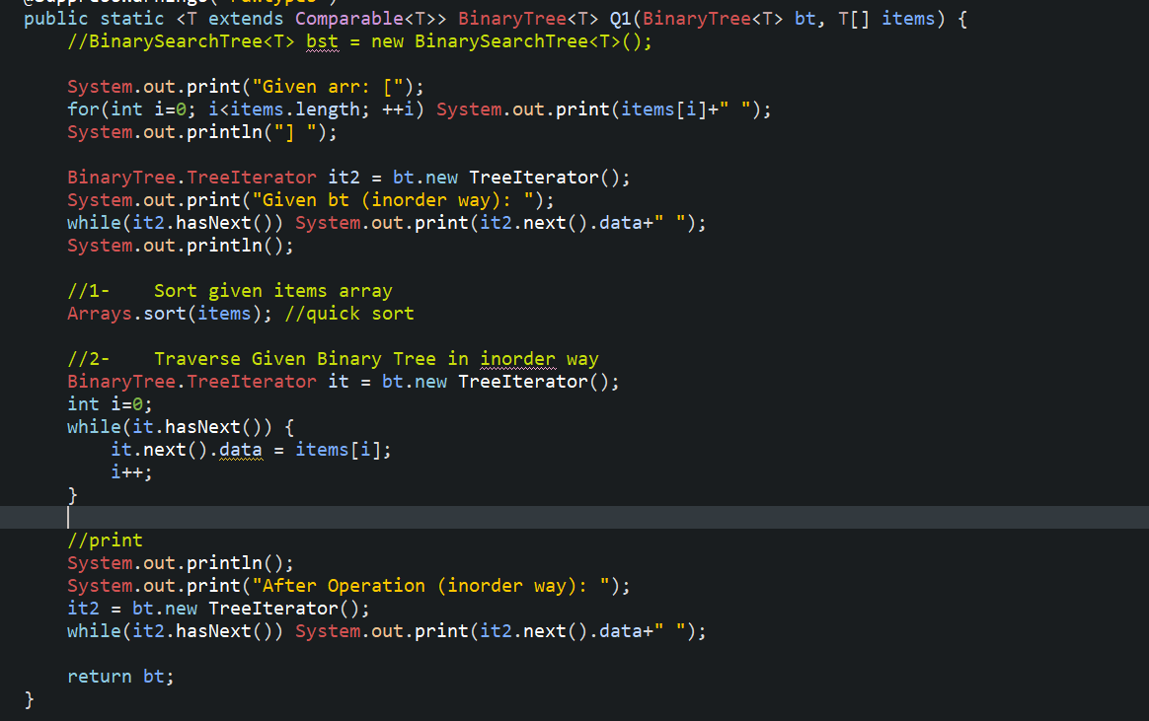

First we give this tree to Q1 function
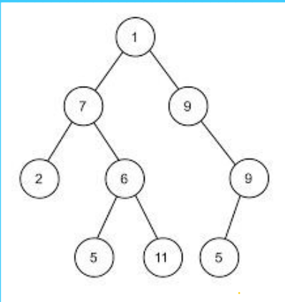
And we change above tree to this tree:
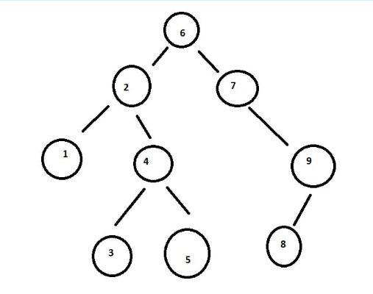

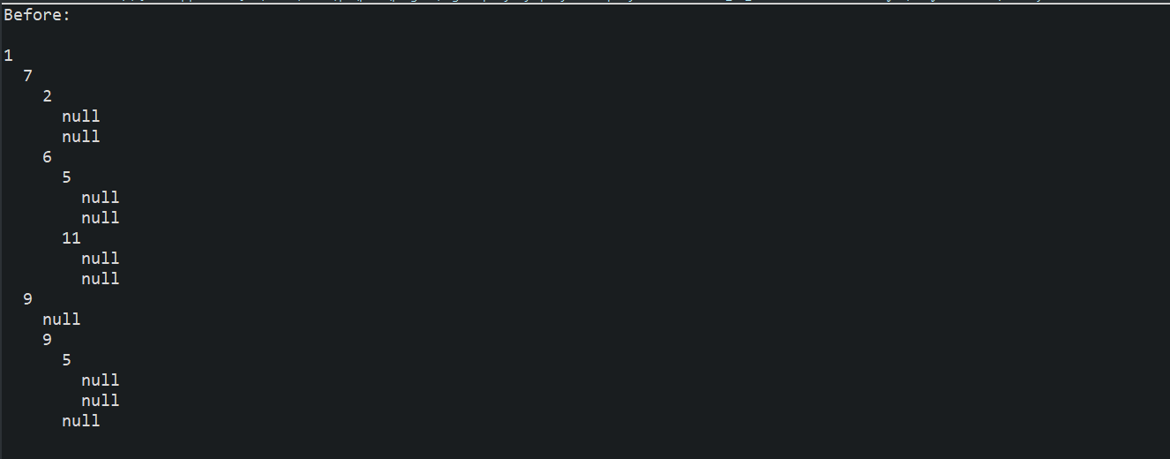
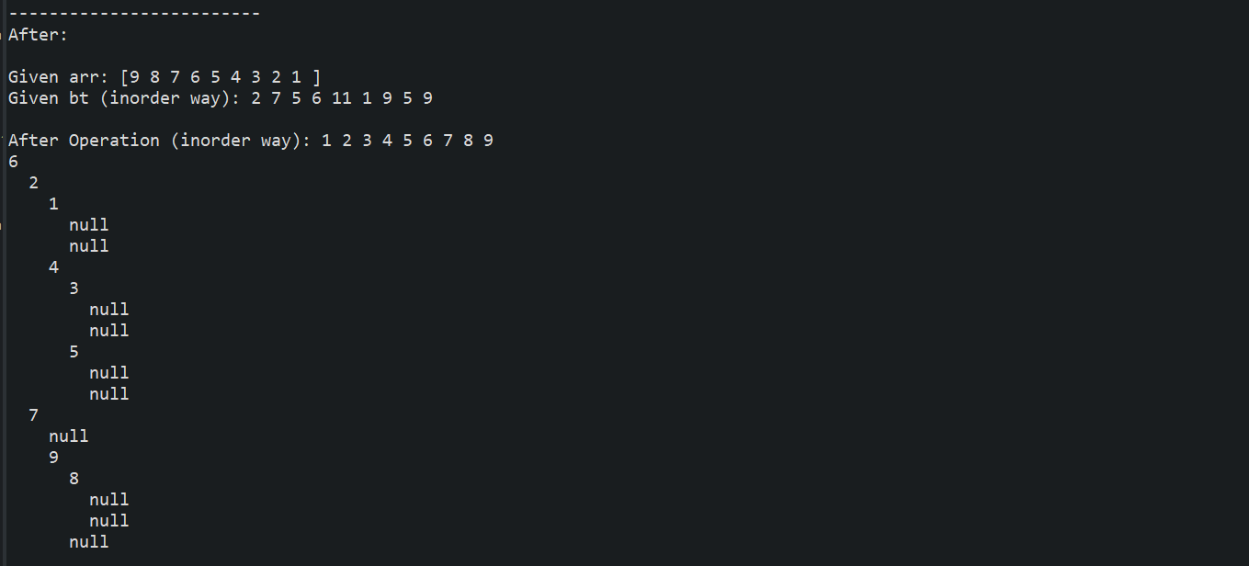
Works Perfectly.
Time Complexity: O(n^2)

Solution Approach:
The main function is balance function in here. Balance function is a recursive function. We look left and rightsub trees first. After we arrive the leaf nodes we look the balance value of current node and determine which rotation process is required. When determined which rotation type must be done, that rotation will be carried out.
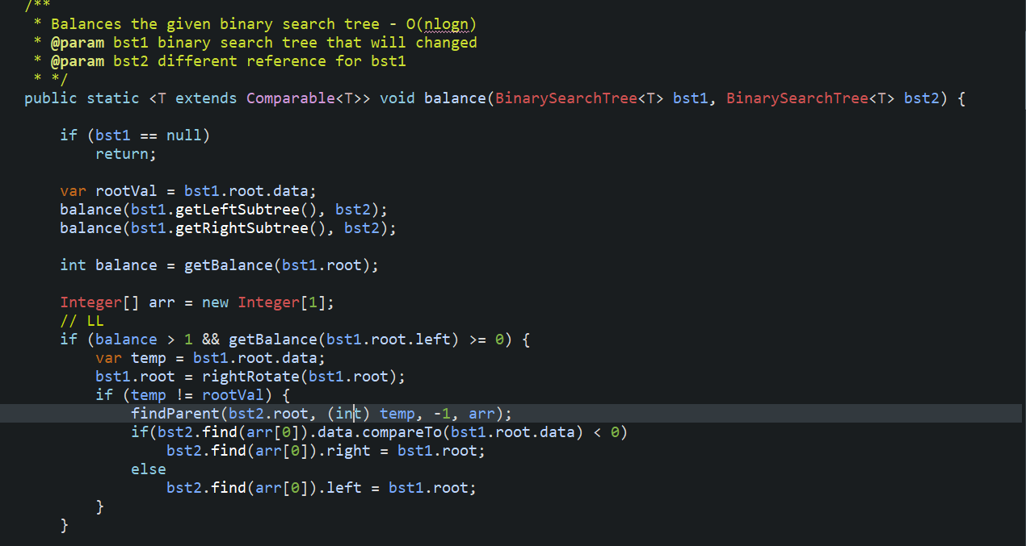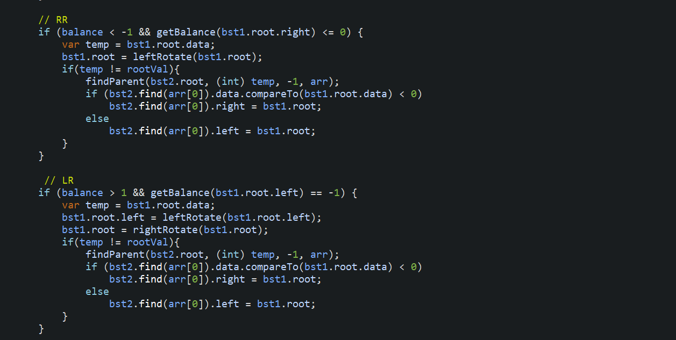
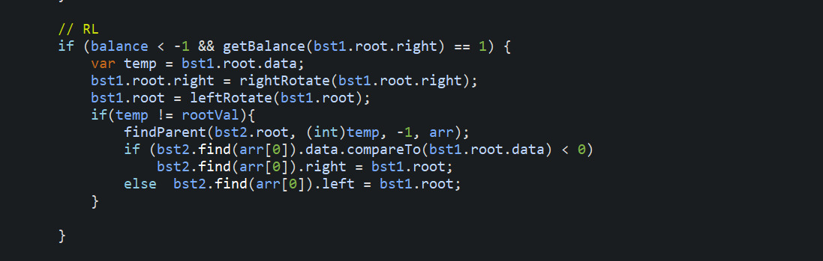

Time Complexity:
O(nlog(n))

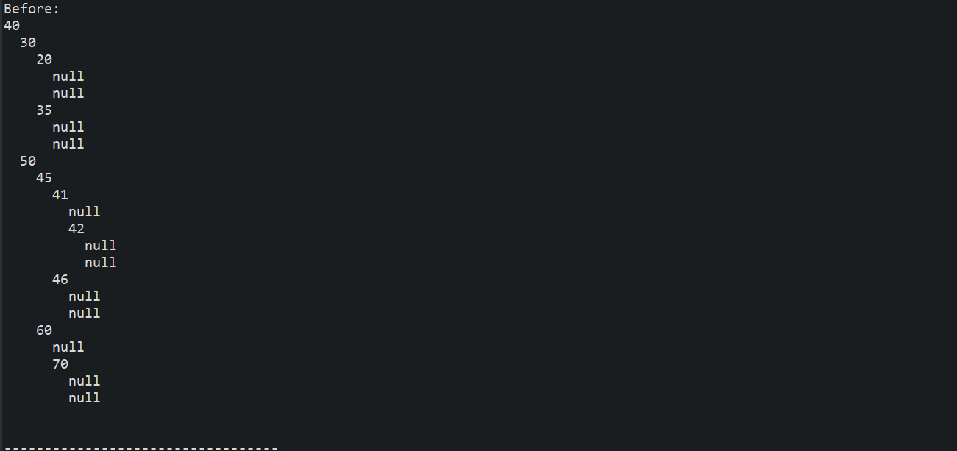
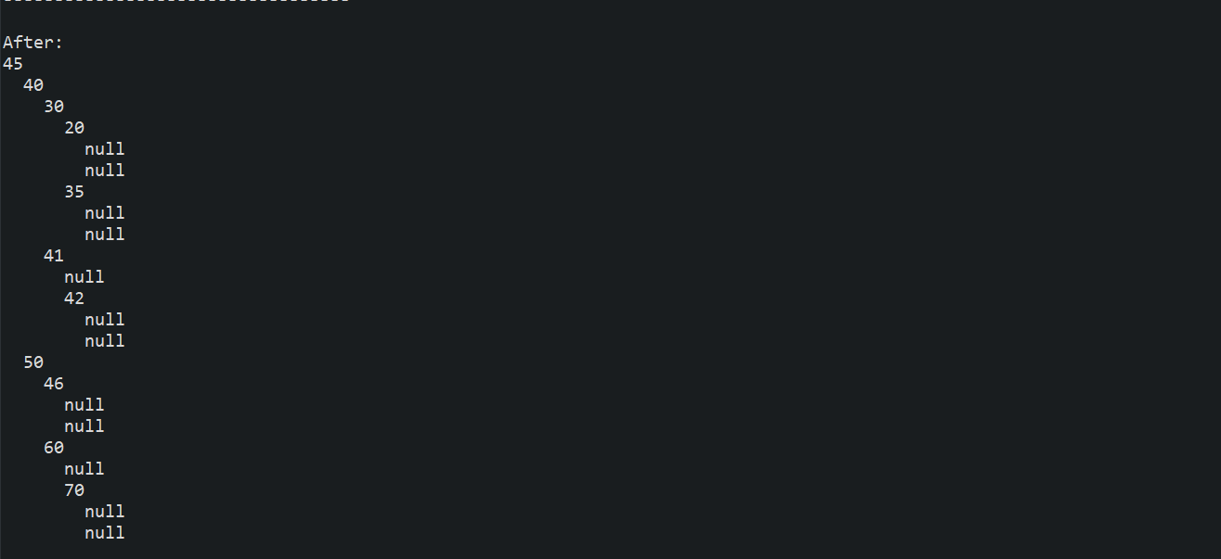
Works perfectly.

