Library Management System web based project

Author by Srinivas_chinthapalli

Step1: first install require tables
DataBase name:e_lib
Table list
1. Users
2.lib
3.issuebooks
4.std_registration
Those all done by open tables.php file in our browser

Its look like bellow

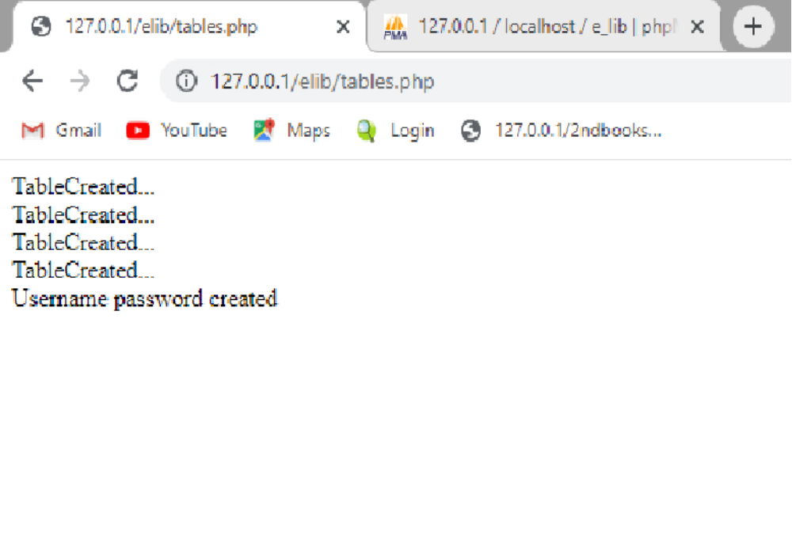
Step 2:

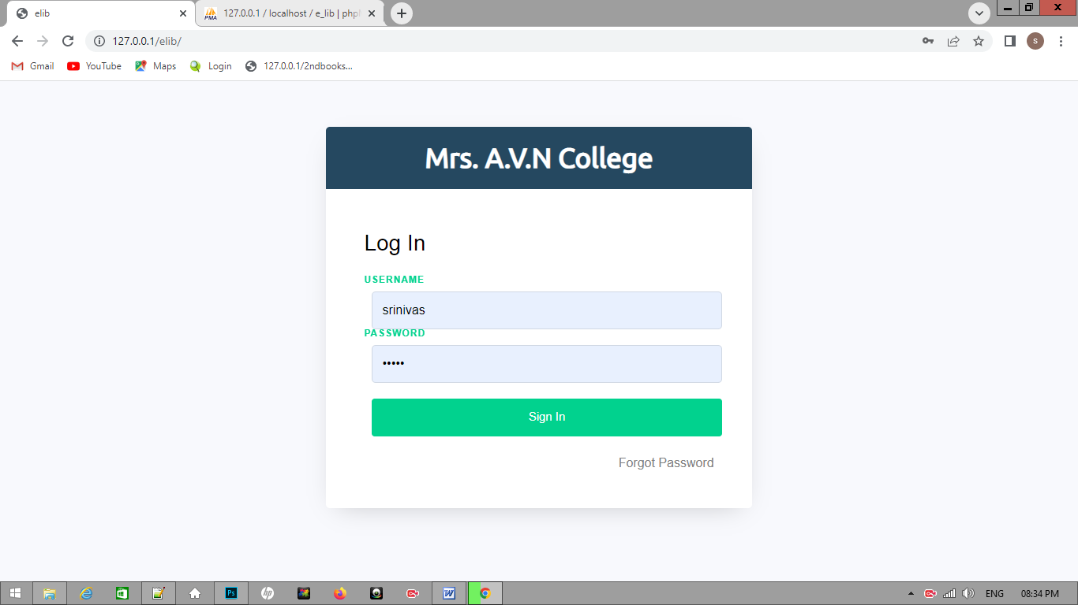

By default username is srinivas password is 12345

If you want chage college name go to php folder and open db.php file then edit collage name value

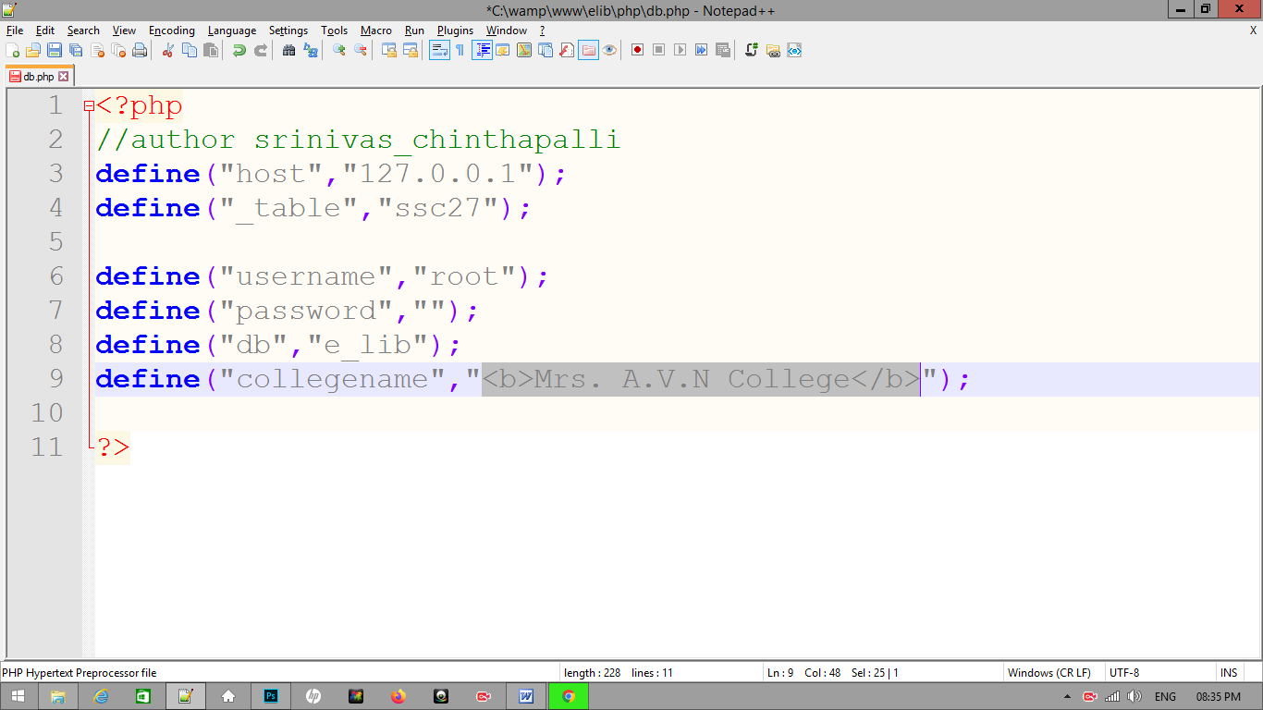

This is over main page
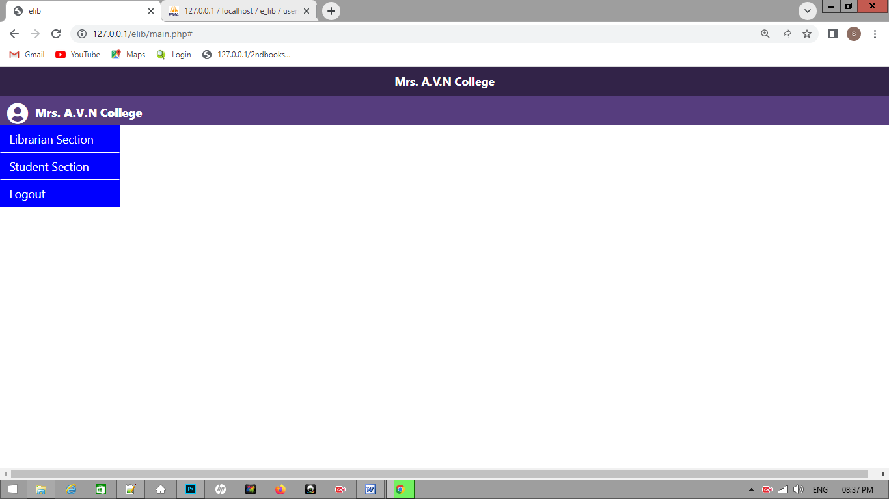

Add book

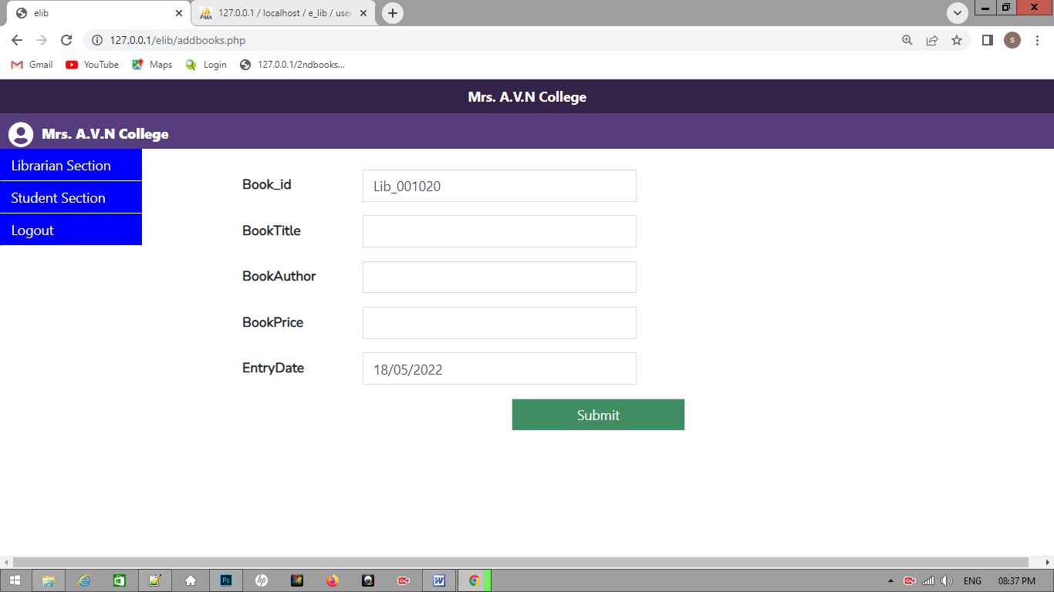

View book
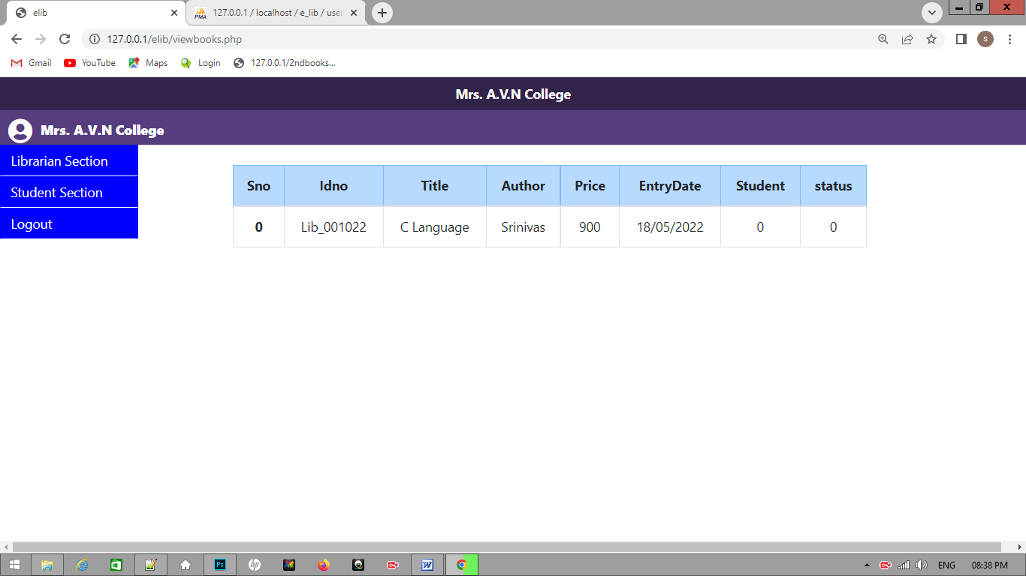

Issuebook

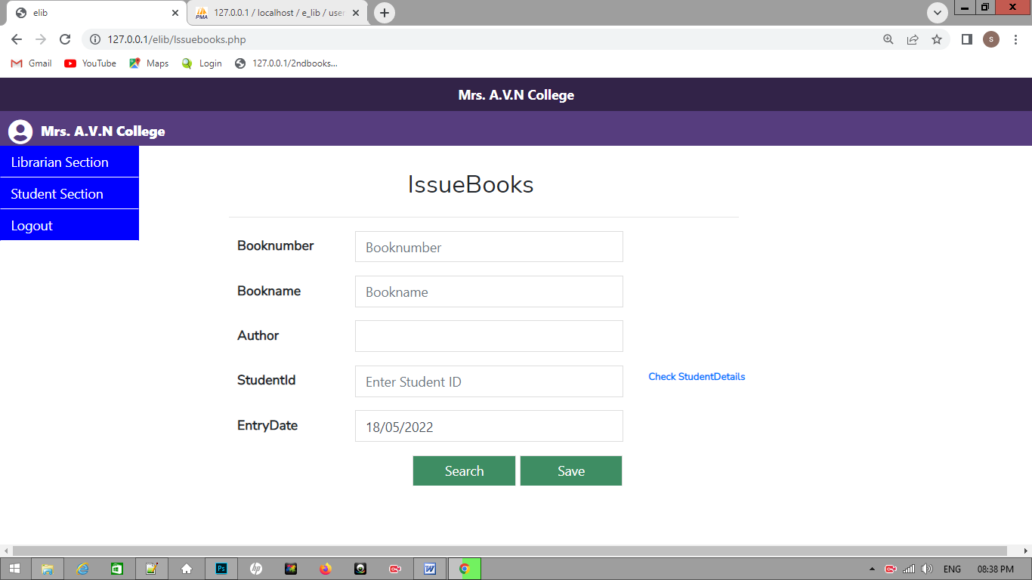

Student Registration

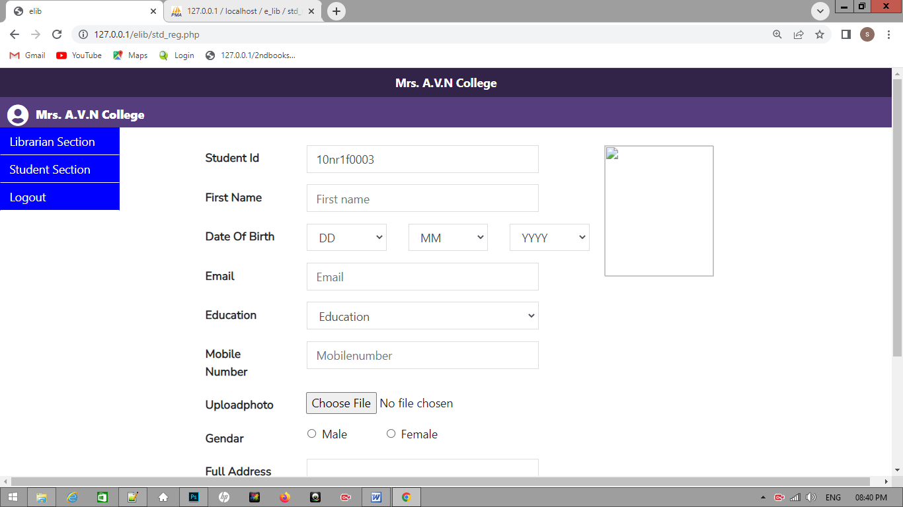

If any doubt plz inform me

Mymail id :chinthapalli.srinivas@yahoo.com

