Capstone Project-I Report

INFOGREPPER

Prepared By : Parth Sharma , Faizal Kadiwal

and Krish Patel.

Branch : Computer Engineering

SEMESTER : V

Guided By
Prof. Paresh Solanki



Department of Computer Engineering
U. V. Patel College of Engineering

INTRODUCTION & OVERVIEW

On 1st day here in college, we all are asked to tell us about our hobbies. The moment I uttered the word Hacking, I had seen a spark of excitement to learn about it in some of my colleagues. Actually thanks to Internet, the way hacking is portrayed into movies in general is itself cool and worth eye-catching for any individual to dirty down his/her hands on it. Hacking according to me is to exploit a system for personal advantages. Now the trick part comes, the advantage may vary from hacker to hacker, the downside resembles that it is always not beneficial to the targeted person. Not many individuals who wish to learn about hacking proceeds, because of having a constant fear of getting hacked while doing so. Hacking if done ethically is a strongest digital weapon available on the internet. The recent example of Uber showed us how hacking can be that derogatory if misused. Several OS has several toolkits for users to exploit for their advantages, some OS itself are the toolkits designed specifically for hacking. We here as a team and proud flagbearer of performing hacking with complete ethics present you a toolkit containing 8 carefully curated tools to be used by users to get information in a complete safe way.

PURPOSE

We as a team believe that alongside Data Science, Hacking is also the next big thing of 21st century. We pretty much had a good idea about how an individual shows curiosity when heard the term hacking or anything revolving around hacking, take it as phishing, scamming, reverse engineering or any fancy word which may sound fancy but deep down takes a lot to achieve it. Our noble purpose is to give users a toolkit which will act like a gateway for them to enter this hacking world hassle free irrespective of any fear regarding their internet freedom, tools which are completely ethical to use and to acknowledge users that hacking when used appropriately can make their digital lives better and even add some positive value in their lives. I personally had been into the digital world of Hacking for around 3 years now, so I pretty much know the basics and how any end user having little or no knowledge regarding it should be introduced to it in an interactive and simple way so that user may not get a sense of fear afterwards whenever they read about hacking portrayed in a negative light. The sole purpose of this application is to give users a toolkit to interact in their day-to-day life with complete security and ethics followed.

SCOPE & INTENDED USERS

Scope here plays a vital role to distinguish users. We carefully curated the users, take thorough feedback with them regarding their knowledge regarding hacking and we pretty much get a rough idea and then divided into 3 categories. First category includes OSINT researchers which is an acronym for Open-Source Intelligence researchers. They’re naive users who do not have that much exposure regarding tools and technologies related to hacking. They’re like abstraction concept of OOPS, they do not want to know the HOW part of a system and only interested in WHAT part of the system i.e. the output of their input. Second category includes penetration testers, they’re the people who had mid to high knowledge regarding technologies. Their intentions are morally correct most of the time, but can alter based on their personal intuitions. The last category includes SOC Analysts, the bigheads in term of maturity handling the hacking regularly, these users are strongly ethical and moral mindset when getting things done. Our tools are carefully crafted to cater the necessities for all these categories of users. We as a team believe that these tools will add some value for all users in their day-to-day lives.

PRODUCT DESCRIPTION & FUNCTIONALITIES

We had titled our project/product as INFOGREPPER which literally translates to Information Grepper, with last word paying a homage to my favorite terminal command utility grep. Our toolkit has 8 different tools to cater all kinds of cybersecurity audiences. We will now try to elaborate each tool one by one for better understanding.

I. ROBOTSTESTER

Description: - A text file having a default name robots.txt is created to tell search engine web crawlers to list down which URL websites can easily access your site. This is used mainly to avoid request overloading your site. With this Python script, users can easily filter out all URLs present in robots.txt file, and can know whether they can access them or not.

II. MASSCAN TO NMAP

Description: - A tool consisting of three process cycle -
I. Run MASSCAN to find the TCP & UDP ports that were open on a target.
II. Copy and paste those open ports, and ask NMAP to run those ports.
III. Find the service versions of those ports and run the enumeration scripts. An efficient Python script was designed to perform all this processes into one shot with just giving a single IP Address as a parameter. This script let users prints out the NMAP results and also saves a copy in your local directory as well.

III. SHODAN RECON

Description: - This tool takes a set of IP addresses and performs recon operation to fetch domain names associated with that particular IP Address. It is designed specifically when there is no Reverse DNS record set. This tool will become handy whenever the IP address will not directly resolve to the web app and may require a domain name.

IV. DORKSCAN

Description: - Dork is a keyword which can enable users to gain access to information that corporations did not intend to make publicly available. Dorkscan will take a single dork or a list of dorks as its arguments, after that the script will find the results we want according to our applied dorks and save them to a text file for further processing. We had designed Selenium powered Python script to automate searching web for vulnerable applications.

V. PYCAT
Description: - An efficient NETCAT replacement tool purely written in Python that automatically scans for hosts that are up on the local network. Simply run the script without any arguments to automatically start scanning the network hosts.

VI. TORRENT METASEARCHER
Description: - This script searches on multiple Torrent sites like torlock.com and thepiratebay10.org for supplied keywords and returns the results grouped by categories in JSON Format file.

VII. IPGEO
Description: - A Python Script for fast, accurate and reliable IPGeolocation search. This script is designed in such a way that the geolocation can be searched on the basis of provided IPV4 or IPV6 Address and Domain Name/s.

VIII. WEBURL SCRAPER
Description: - As the name implies this script access the website and returns all the links present in that website.
The main focus of this script is to retrieving all the webpage links from an given URL of any website.

PRODUCT REQUIREMENTS

Each tool is bounded with certain open source python libraries to get work done hassle free. I will mention the libraries corresponding to tools for better clarification.

I. For ROBOTSTESTER we will require these 2 libraries -
A. requests for manipulating requests
B. urllib3 for manipulating urls

II. For MASSCANTONMAP we will use these 2 libraries -
A. argparse for passing the arguments like ports and ip
B. subprocess for multithreading for masscan and nmap

III. For SHODAN RECON we will consider these 2 libraries -
A. shodan module for shodan related queries
B. iptools for converting ip requests to dns requests

IV. For DORKSCAN we will put in use of these 2 libraries -
A. GeckoDriver for proxifying WebDriver and Firefox
B. Selenium for automated testing

V. For PYCAT we will need these 3 libraries -
A. socket for socket programming
B. threading for multithreading
C. subprocess for handling processes parallelly
VI. For TORRENT METASEARCHER we want these 2 libraries
A. BeautifulSoap for web scraping purposes
B. aiohttp for asynchronous network operations

VII. For IPGEO we will necessitate the following library -
requests for manipulating IP Requests

VIII. For WEBURL_SCRAPPER we will take these 3 libraries -
A. urllib for url functions
B. BeautifulSoup for web scraping purposes
C. SSL to avoid certificate verifications

TECH STACK

A. DJANGO FRAMEWORK – A high level python web framework that will enables us to create rapid development of secure, maintainable and scalable progressive web application.

B. PYTHON LANGUAGE - A advantageous programming language for cybersecurity due to it’s great and reliable performance in many cybersecurity functions, including malware analysis, scanning, and reconnaissance. It is also very user-friendly in nature and has elegant simplicity, making it the perfect language choice for our web application.

C. BASH LANGUAGE - The default shell language in most server computing environments in linux in addition to having abilities for system administration and automation of tasks, including security.
It also holds great advantage over integration with python making a perfect choice for our software.

SOFTWARE REQUIREMENTS

Software requirements are the required specifications a device must have in order to use certain software.

A. Browser – Brave, DuckDuckGo, Chrome and Microsoft Edge
B. Minimum CPU or processor speed - Intel or AMD processor with 64-bit support; Recommended - 2 GHz or faster processor.
C. Minimum free storage space – 512MB of free disk space
D. Wireless connectivity - Internet connection required for software activation
E. Operating system – Windows or Linux

UML DIAGRAMS

I. USE CASE DIAGRAM:

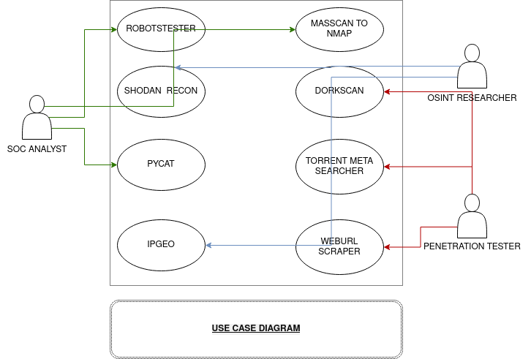

II. STATE DIAGRAM:
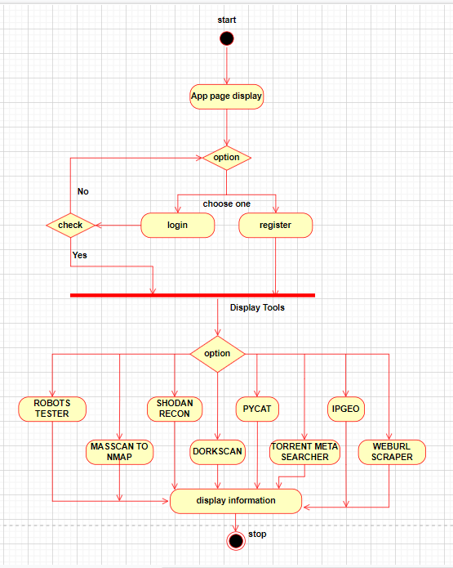

III. ACTIVITY DIAGRAM:

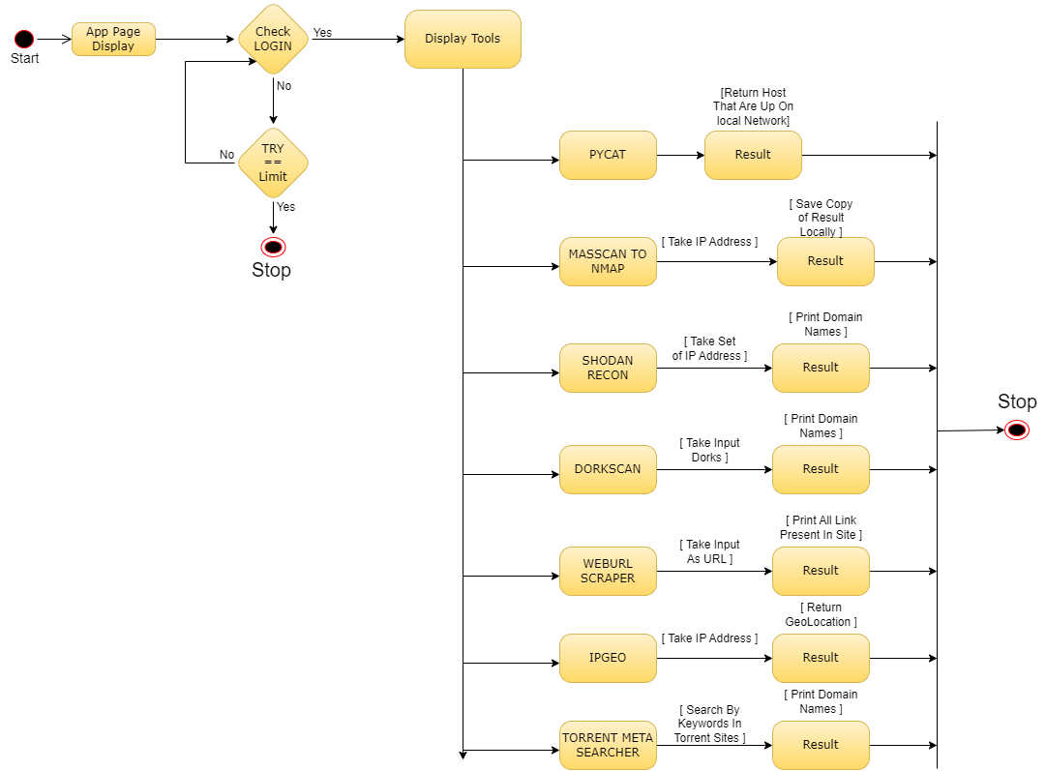

IV. CLASS DIAGRAM:

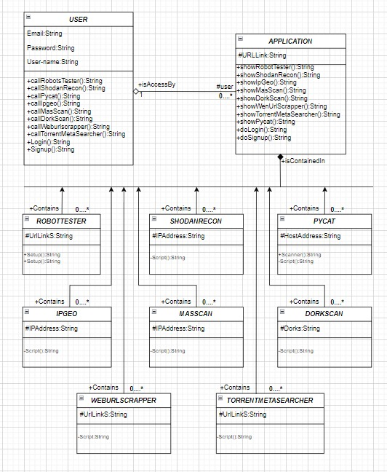

IV. SEQUENCE DIAGRAM:

