**(CN) Intro-Q&A**

**Q. Why Computer Network?**

Ans.

**We need Computer Networks for the following points:**

* **Information Exchange**

To exchange data and information between different individual users, it is necessary to interconnect the individual users’ computers.

* **Resource sharing**

The cost of a computer has come down. However, the cost of a laser printer, bulk storage, and large enterprise software remains high. When computers are interconnected, there is a possibility that users connected to the network may share the above-mentioned resources.

**Q. What is Computer Network?**

Ans.

* Computer Network is a group of computers connected through wires, optical fiber, or optical links so that various devices can interact with each other through a network.
* The aim of the computer network is the sharing of resources among various devices.

**Q. Features of Computer Networks.**

Ans.

* **Communication Speed:**

The network provides us to communicate over the network in a fast and efficient manner. For example, we can do video conferencing, email messaging, etc. over the internet. Therefore, the computer network is a great way to share our knowledge and ideas.

* **File Sharing:**

File sharing is one of the major advantages of the computer network. Computer network provides us to share files.

* **Back Up and Roll Back is easy:**

Since the files are stored in the main server which is centrally located. Therefore, taking the backup from the main server is easy.

* **Software and Hardware Sharing:**

We can install the applications on the main server; therefore, the user can access the applications centrally. So, we do not need to install the software on every machine. Similarly, hardware can also be shared.

* **Security:**

The network allows security by ensuring that the user has the right to access certain files and applications.

* **Scalability:**

Scalability means that we can add new components to the network. A network must be scalable so that we can extend the network by adding new devices. But it decreases the speed of the connection, and data of the transmission speed also decreases, this increases the chances of an error occurring. This problem can be overcome by using the routing or switching devices.

* **Reliability:**

A computer network can use an alternative source for data communication in case of any hardware failure.

**Q. What is Computer Network Architecture?**

Ans.

There are two types of Computer Architecture:

* **Peer-To-Peer Network:**

A Peer-To-Peer network is a network in which all the computers are linked together with equal privilege and responsibilities for processing the data.

* **Client/Server Network:**

A Client/Server network is a network model designed for the end users called clients, to access the resources such as songs, videos, etc. from a central computer known as Server.

**Q. What are the advantages and disadvantages of the Peer-To-Peer(P2P) Network?**

Ans.

**Advantages**

* It does not require any network operating systems.
* All workstations are capable to access any type of file so do not require any costly server.
* Peer-to-peer network does not need any full-time system administrator for managing the entire network.
* Without any high-level knowledge of this network, you can easily configure this P2P network.
* P2P network is more protective.

**Disadvantages**

* It does not contain any central medium used for data storage or file archiving.
* All computer systems can be used anytime duration.
* It is too much slow performance because every computer is accessed by other users.
* P2P network users do not get any preview of the file content before downloading.
* Few peer-to-peer networks can transfer illegal data on your computer system without your permission.

**Q. What are the advantages and disadvantages of the Client/Server Network?**

Ans.

**Advantages**

* All files are stored in a central location.
* Backup and network security are controlled centrally.
* It allows all users to decrease the data replication for their applications.
* It is capable to bear massive usage.
* User can access data that is centrally controlled.

**Disadvantages**

* The server is expensive to purchase.
* A specialist network operating system is needed.
* Specialist staff such as a network manager is needed.
* If any part of the network server fails a lot of disruption can occur.
* Its cost is not affordable for normal users.

**Q. What are the different types of Computer Networks?**

Ans.

A computer network can be categorized by its size. A **computer network** is mainly of **four types**:

* **LAN (Local Area Network)**
  1. Local Area Network is a group of computers connected to each other in a small area such as a building, or office.
  2. LAN is used for connecting two or more personal computers through a communication medium such as a twisted pair, coaxial cable, etc.
  3. It is less costly as it is built with inexpensive hardware such as hubs, network adapters, and ethernet cables.
  4. The data is transferred at an extremely faster rate in the Local Area Network.
  5. Local Area Network provides higher security.
* **PAN (Personal Area Network)**
  1. Personal Area Network is a network arranged within an individual person, typically within a range of 10 meters.
  2. Personal Area Network is used for connecting the computer devices of personal use is known as Personal Area Network.
  3. **Thomas Zimmerman** was the first research scientist to bring the idea of the Personal Area Network.
  4. Personal Area Network covers an area of **30 feet**.
  5. Personal computer devices that are used to develop the personal area network are laptop, mobile phones, media players, and play stations.
* **MAN (Metropolitan Area Network)**
  1. A metropolitan area network is a network that covers a larger geographic area by interconnecting a different LAN to form a larger network.
  2. Government agencies use MAN to connect to the citizens and private industries.
  3. In MAN, various LANs are connected to each other through a telephone exchange line.
  4. It has a higher range than the Local Area Network (LAN).
  5. It can be used in Airline reservations, communication between banks in the city, military and college, etc.
* **WAN (Wide Area Network)**
  1. A Wide Area Network is a network that extends over a large geographical area such as states or countries.
  2. A Wide Area Network is quite a bigger network than a LAN.
  3. A Wide Area Network is not limited to a single location, but it spans over a large geographical area through a telephone line, fiber optic cable, or satellite links.
  4. The internet is one of the biggest WANs in the world.
  5. A Wide Area Network is widely used in the field of Business, government, and education.

**Q. What is Network Topology? Types of Network Topology.**

Ans.

Topology defines the structure of the network of how all the components are interconnected to each other.

There are 6 types of topologies:

* **Bus Topology**

The bus topology is designed in such a way that all the stations are connected through a single cable known as a backbone cable.

**Advantages**

* 1. Low-cost cable
  2. Moderate data speeds
  3. Familiar technology
  4. Limited failure

**Disadvantages**

* 1. Extensive cabling
  2. Difficult troubleshooting
  3. Signal interference
  4. Reconfiguration difficult
  5. Attenuation

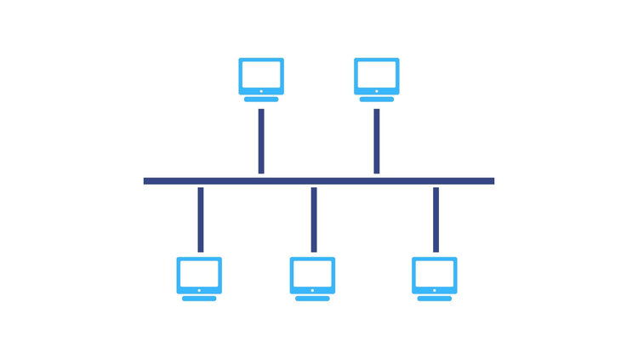

* **RING TOPOLOGY**

Ring topology is like a bus topology, but with connected ends.

The node that receives the message from the previous computer will retransmit to the next node.

**Advantages**

* 1. Network Management
  2. Cost
  3. Reliable

**Disadvantages**

* 1. Difficult troubleshooting Failure
  2. Reconfiguration difficult
  3. Delay

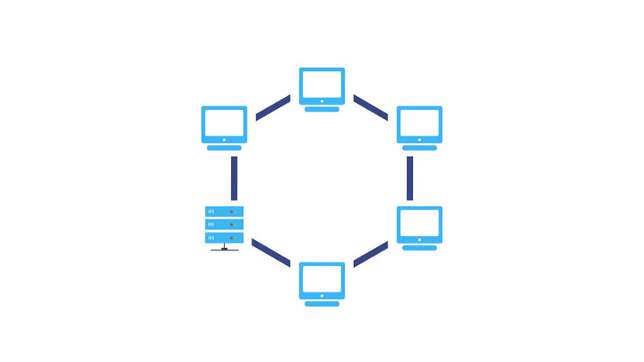

* **STAR TOPOLOGY**

Star topology is an arrangement of the network in which every node is connected to the central hub, switch, or central computer.

**Advantages**

* 1. Efficient troubleshooting
  2. Network control
  3. Limited failure
  4. Easily expandable
  5. Cost effective
  6. High data speeds

**Disadvantages**

* 1. A central point of failure
  2. Cable

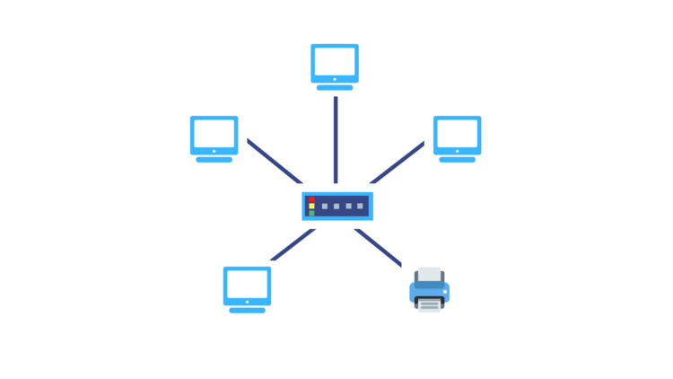

* **MESH TOPOLOGY**

Mesh technology is an arrangement of the network in which computers are interconnected with each other through various redundant connections.

Mesh topology can be formed by using the formula: **Number of cables = (n*(n-1))/2**.

**Advantages**

1. Reliable
2. Fast Communication
3. Easier Reconfiguration

**Disadvantages**

1. Cost
2. Management
3. Efficiency

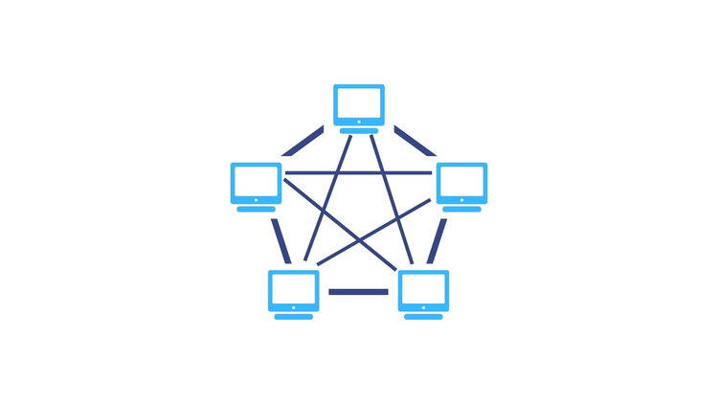

* **TREE TOPOLOGY**

A tree topology is a hybrid network resulting from the combination of bus topology and star topology. The bus resembles the trunk of the tree while the peripheral nodes resemble leaves, hence the name tree topology. The tree topology can be viewed as a hierarchical arrangement of star networks as it has a parent-child hierarchy to how the nodes are connected.

**Advantages**

1. Network expansion and the addition of new nodes are easy
2. As each network branch can be individually assessed, troubleshooting is easier

**Disadvantages**

1. The entire network depends on the central bus, which presents a single point of failure.
2. Tree topology can be expensive due to the amount of cabling required.
3. Due to the hierarchical structure, it can be difficult to configure.

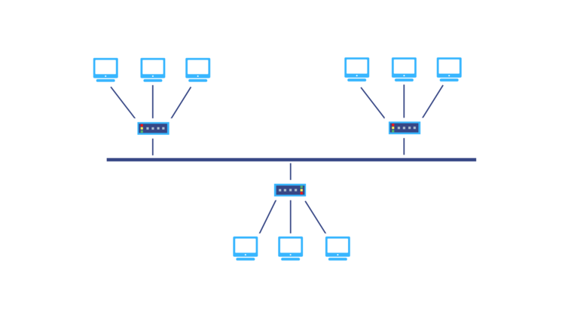

* **HYBRID TOPOLOGY**

A hybrid topology is one in which two or more distinct topologies are combined to build a network in such a way that it doesn’t exhibit any of the standard topologies. Hybrid topologies are commonly found in larger organizations where individual departments can have personalized network topologies based on their needs and network requirements.

**Advantages**

The most notable advantage of hybrid topology is the flexibility and degree of freedom it provides. With a hybrid network structure, there are very few limitations on how you can set up your network

**Disadvantages**

Each standard topology that is incorporated in a hybrid topology will bring along its own drawbacks so your hybrid topology won’t be free of problems. In addition, as your hybrid network grows the complexities in managing the network will also grow.

The most common example of a hybrid topology is the tree topology.

