Bug Report

# BUG 001: There is no validation of input Times

Due to the lack of validation in input times the app has an incorrect behavior when tries to calculate the cost using invalid parameters.

## Severety: High

**High**. There is a direct impact in the functionality of the app and may lead to the user to a jarring experience.

## Repro steps:

Given that I navigate to <http://adam.goucher.ca/parkcalc/index.php>

And I select the **Any-Parking** option from *Choose a Lot* dropdown

And I enter **an invalid time (e.g.: blank space, negative values)** and **2/1/2016** in the *Choose Entry Date and Time* section

And I enter **12:00 AM** and **3/1/2016** in the *Choose Leaving Date and Time* section

When I click ***Calculate*** is not showing the correct COST and DURATION

### Actual result

The COST and DURATION are incorrect.

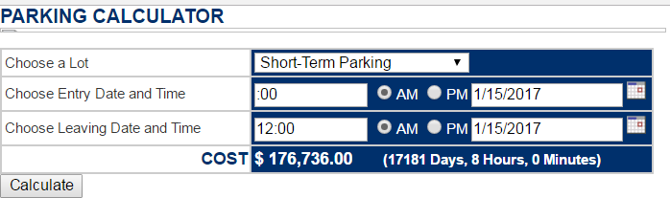

### expected result

There should be an error message or warning for the user allowing him/her to know that the time provided is incorrect.

It would be better to use a dropdown showing only the allowed values. Also, having an input field without any validation may have security issues.

# Bug 002: There is no validation of input dates

Due to the lack of validation in input dates the app has an incorrect behavior when tries to calculate the cost using invalid parameters.

## Severity: High

**High**. There is a direct impact in the functionality of the app and may lead to the user to a jarring experience

## Repro steps:

Given that I navigate to <http://adam.goucher.ca/parkcalc/index.php>

And I select the **Any-Parking** option from *Choose a Lot* dropdown

And I enter **12:00 AM** and **an invalid time (e.g.: blank space, negative values)** in the *Choose Entry Date and Time* section

And I enter **12:00 AM** and **3/1/2016** in the *Choose Leaving Date and Time* section

When I click ***Calculate*** is not showing the correct COST and DURATION

### Actual result

The COST and DURATION are incorrect

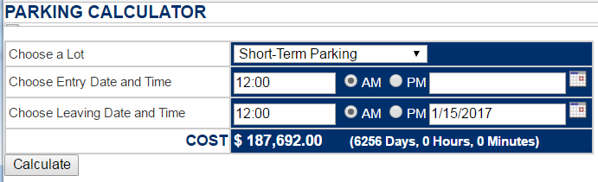

### Expected Scenario

There should be an error message or warning for the user allowing him/her to know that entry/exit date value is invalid.

# Bug 003: AMPM option is not working as expected

This bug seems to be related with BUG 002. The issue here is the time is being changed from 12-hour format (hh:mm:ss) to 24-hour format (HH:mm:ss) and after get the first calculation, following calculations may lead to some weird results in the time field.

## Severity: High

**High**. There is a direct impact in the functionality of the app and may lead to the user to a incorrect calculations.

## Repro Steps:

Given that I navigate to <http://adam.goucher.ca/parkcalc/index.php>

And I select the **Short-Term Parking** option from *Choose a Lot* dropdown

And I enter **10:00 PM** and **1/16/2017** in the *Choose Entry Date and Time* section

And I enter **11:00 PM** and **1/16/2017** in the *Choose Leaving Date and Time* section

When I click ***Calculate***

Then the **COST** is equal to **$ 2.00**

And the **DURATION** is **(0 Days, 1 Hours, 0 Minutes)**

### Actual result

If you observe below image, once we get the cost and duration, the value for the AM/PM has been reset to its default value (AM).

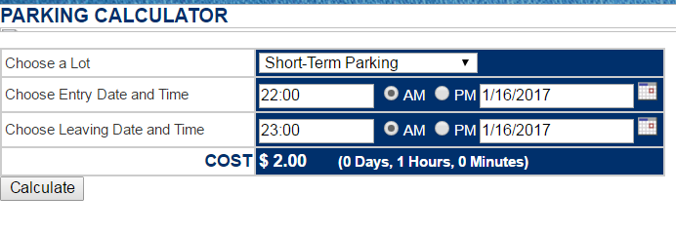

Also observe that the time has changed to 24 format which may lead to an error doing the following:

Select **PM** for both times as it was originally and then click on ***Calculate*** again.

Even when the result for COST and DURATION are correct, the entry and exit time displayed is incorrect and may confuse the user (12 hours were added)

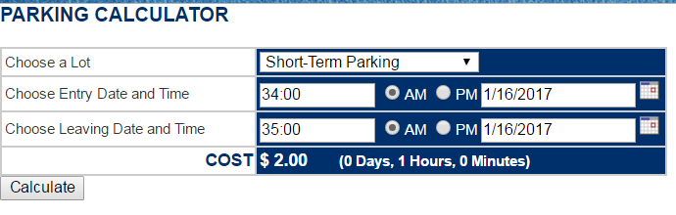

### expected result

The time shouldn’t be changed from one format to another based in the user interface. It should keep original values at interface level. If it is required for cost and duration calculation it should be done internally in the code to avoid this type of errors.

Another approach would be accepting only 24-hour format for entry/exit time to avoid internal conversions.

# BUG 004: HTML Control lost state after clicking on Calculate

The issue is once you make a parking estimation, the parking lot drop down and AMPM control loses its state (the value originally selected).

## severety: MEDIUM

**Medium**. Even when the first calculation is correct, following calculations may show another calculation and may confuse the user.

## Repro Steps

Given that I navigate to <http://adam.goucher.ca/parkcalc/index.php>

And I select the **Valet-Parking** option from *Choose a Lot* dropdown

And I enter **12:00 PM** and **1/16/2017** in the *Choose Entry Date and Time* section

And I enter **1:00 PM** and **1/16/2017** in the *Choose Leaving Date and Time* section

When I click ***Calculate***

Then the **COST** is equal to **$ 12.00**

And the **DURATION** is **(0 Days, 1 Hours, 0 Minutes)**

And HTML Controls should keep their values

### Actual result

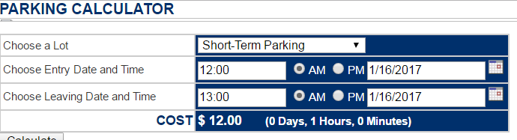

If you see, the value for lot dropdown and AMPM values lost their value and return to its default value.

### expected result

The values selected should be preserved as follows:

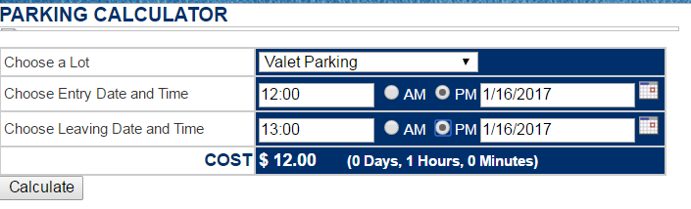

# BUG 005: There is no validation for time ranges

There is no validation for the scenario when the leaving time is less than the entry time.

## Severety: High

**High**. There is a direct impact in the functionality of the app and may lead to the user to a jarring experience.

## Repro steps

Given that I navigate to <http://adam.goucher.ca/parkcalc/index.php>

And I select the **Short-Term Parking** option from *Choose a Lot* dropdown

And I enter **12:00 AM** and **1/16/2017** in the *Choose Entry Date and Time* section

And I enter **11:00 AM** and **1/16/2017** in the *Choose Leaving Date and Time* section

When I click ***Calculate*** is not showing the correct **COST** and **DURATION**

### Actual scenario

The COST and DURATION are incorrect.

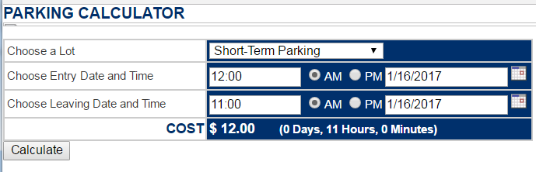

### Expected Scenario

There should be an error message or warning for the user allowing him/her to know that time range is invalid.

# BUG 006: DateTime conversion is not working properly

This issue seems to be related to Bug003 and Bug005. Again, the lack of validation in time and date input and missing validation between the boundaries between AM time and PM time the cost calculation is showing incorrect costs and duration.

## severity: HIGH

**High**. There is a direct impact in the functionality of the app and may lead to the user to a jarring experience.

## Repro Steps

Given that I navigate to <http://adam.goucher.ca/parkcalc/index.php>

And I select the **Short-Term Parking** option from *Choose a Lot* dropdown

And I enter **11:30 AM** and **1/16/2017** in the *Choose Entry Date and Time* section

And I enter **12:30 AM** and **1/16/2017** in the *Choose Leaving Date and Time* section

When I click ***Calculate*** is not showing the correct **COST** and **DURATION**

#### Actual result

The COST and DURATION are incorrect.

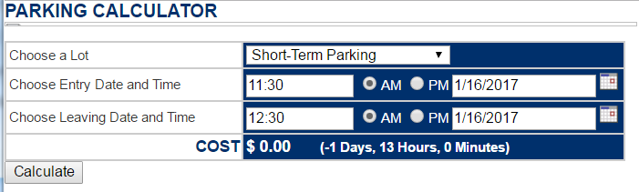

### Expected result

There should be an error message or warning for the user allowing him/her to know that time range is invalid.

**Observation:** There are a couple of errors using similar time combinations.