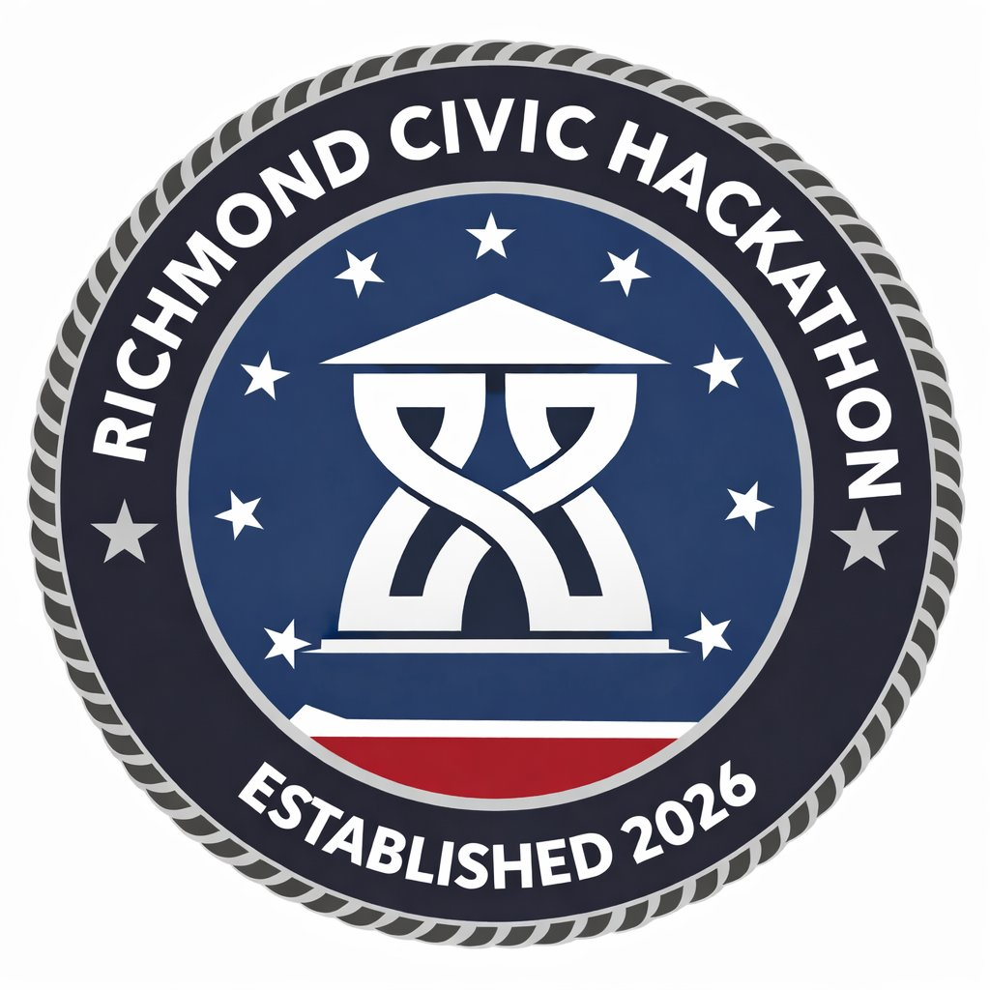
HACK FOR RVA · RICHMOND CIVIC HACKATHON · MARCH 27–29, 2026 · SCIENCE MUSEUM OF VIRGINIA

A CITY THAT TELLS ITS STORIES
Challenge Track 7 · Historical Truth-Telling, Cultural Preservation & Civic Narrative
WHAT THIS PILLAR IS ABOUT
Make Richmond a national model for telling the truth about its own history — including slavery, racism, and struggles for Black empowerment since the City's founding. Use the arts as a vehicle for telling these stories and for strengthening connections across the different cultures found in our city. The issues and inequalities addressed by every other pillar stem from our history.
“Data without a human story — they're just numbers. Resident stories provide civic insight that leads to policy.” — Haya Braxton, Public Information Officer, City of Richmond
WHO LED THIS WORKSHOP
Haya Braxton (Public Information Officer, City of Richmond, supporting human services and marginalized communities) and Sylvia Lynch (Secretary, City of Richmond History and Culture Commission). The Valentine Museum — Richmond's history museum, located downtown near City Hall — was also represented. This pillar is explicitly cross-departmental: it's meant to be woven through the fabric of all of City government.
HOW THIS PILLAR IS DIFFERENT
Unlike other pillars, this one doesn't have a single department 'owner.' It represents an ongoing set of conversations across the Mayor's Office, Strategic Communications, Planning and Development, and cultural institutions. The problems here are about how Richmond tells its own story — and how the City learns from the stories residents carry.
“This pillar represents a series of ongoing conversations between the mayor's office and strategic communications. It's an ongoing process where hopefully it's cross-departmental — a great analogy for how we bring residents closer to the inner workings of local government.” — Sylvia Lynch, History and Culture Commission
TARGETED PROBLEM 1: DISCOVERING RICHMOND'S ARTS & CULTURAL EVENTS
The Problem in Plain Language
Richmond has a vibrant arts and cultural scene spread across galleries, nonprofits, festivals, and community events. But information about these events is siloed across social media accounts, individual organization websites, and informal networks — meaning discovery is entirely dependent on who you already know and follow. There's no good answer to 'what's happening this weekend in Richmond?'
What City and Cultural Leaders Actually Said
“Everyone kind of has their favorite place they go to look for events, but it's not necessarily the same place someone else is looking. There's no central understanding of: I'm into the opera, where do I go? I'm into local music — what's happening? People would like to come to the City for some of that guidance, and there's a lack of it.” — City Strategic Communications
“From the perspective of an organization that has events to promote: we have to manually enter tour information into about 10 different calendars — all the local news stations, Richmond Region Tourism — it is a significant amount of time. If you multiply that across all the organizations in town, and it's hard to get information out... you have to post on socials, community calendars. Especially if you want to attract different generations who consume news differently.” — Sylvia Lynch, Valentine Museum
“We use social media and ask 'what's happening this weekend?' — but we don't do a ton of curating. We do recaps of things we've shown up to. We also have a heritage calendar trying to be intentional about honoring different cultural traditions.” — Haya Braxton, City PIO
“We have a general awareness problem about the Valentine Museum — where it is, what it does. We're located downtown, not on the Boulevard where the big museums are. People have to be more deliberate in coming to us. That's part of why we need better discovery tools.” — Sylvia Lynch, Valentine Museum
“There's a network of storytelling already happening in Richmond that is not necessarily coordinated together. The Richmond Public Library has a Memory Lab — a podcast studio and recording equipment you can check out. It's a new city effort to collect stories. But there's no coordination across the institutions.” — Sylvia Lynch, Valentine Museum
Constraints
• Focus on aggregating or syncing existing event information — not recreating content the City doesn't have capacity to maintain
• Work within City technology policies and approval processes
• Avoid solutions that depend on heavy manual curation or ongoing staff management
• Be cost-effective and sustainable over time
• Respect the preferences of partner organizations whose event information may be surfaced
💡 The constraint here is real: the City cannot staff a full-time event calendar editor. The solution must be automated or lightweight. The model is RSS aggregation and API syndication, not manual entry.
What Success Looks Like
• Residents can easily discover arts and cultural events happening across Richmond
• Local artists and venues gain greater visibility without additional administrative work on their part
• Event information stays reasonably up to date through automated or lightweight updates
• City staff are not required to manage a large content operation
• Participation in Richmond's arts districts and cultural events increases
TARGETED PROBLEM 2: RESIDENT STORIES AS CIVIC INSIGHT
The Problem in Plain Language
Richmond has rich lived histories — especially among long-time residents, neighborhood leaders, and activists whose perspectives shaped the city's past and could inform its future. These narratives are not being captured systematically, not connected to City decision-making, and are at risk of being lost as the city changes rapidly. Meanwhile, the City makes decisions based on data that lacks human context.
What City Leadership Actually Said
“Back in 2021, there was a surge of gun violence in public housing communities. Instead of increasing policing, we did focus groups to gather qualitative insight. We discovered residents were really sad about what happened — and also sad because they didn't have the financial means to move out. So instead of policing, we brought counselors in and established the Office of Gun Violence Prevention. That resident story provided civic insight that led to policy. That's the type of connection we're interested in.” — Haya Braxton, City PIO
“Richmond is experiencing rapid neighborhood change. People who have been here all that time intergenerationally see this change and they're not experiencing it as opportunity and excitement — they're experiencing it as 'my city is being taken away.' Housing prices have doubled. I'm not wanted here anymore. How do we ensure that if economic growth is happening in Richmond, those people are people who benefit from it?” — Brian Bills, OCWB (cross-pillar connection)
“There's a whole strong network of existing arts and cultural organizations and history organizations in town. It's not about replacing what they do — it's about helping strengthen and augment it. Maybe helping coordinate it a little. Raise the profile. The content is happening — but a lot of it isn't making it to the people who need it.” — Sylvia Lynch, Valentine Museum
“Think outside the traditional museum. You can learn the history of a city not in a standalone museum building. We have a really popular walking and bus tour program. People like to marry being active with learning about history or seeing public art — marrying those two things together can be really effective.” — Sylvia Lynch, Valentine Museum
“If you're optimized for residents, you're already optimized for visitors. The tools set for residents — when folks come to town, they can prepare before they even arrive. So certainly that's part of this too.” — Workshop participant
The Existing Storytelling Infrastructure
⚙ The Valentine Museum: Richmond's history museum, downtown near City Hall. Focused on the Richmond region specifically. Has online exhibits, an interactive timeline of Richmond history, and 'featured stories' about different aspects of Richmond's past. Website: thevalentine.org
⚙ Richmond Public Library Memory Lab: A new City-backed initiative at the main downtown branch — has a podcast studio and recording equipment available for community use. A direct City touchpoint for story collection.
⚙ Virginia Museum of History and Culture / Library of Virginia: State-level institutions covering Virginia history broadly. Larger budgets, broader scope. These exist and shouldn't be replicated — they should be connected.
⚙ Virginia Holocaust Museum, Virginia War Memorial: Subject-matter specialized institutions. Part of the broader storytelling ecosystem in Richmond.
Constraints
• Respect privacy, consent, and appropriate handling of sensitive stories — especially from communities with reason to distrust government
• Build trust with residents about how their stories will be used and what follow-through looks like
• Avoid heavy manual transcription, editing, or data processing — staff capacity is limited
• Complement — not duplicate — oral history efforts led by museums and cultural organizations
• Show how insights from residents can translate into decision-making: briefs, dashboards, or policy discussions
What Success Looks Like
• Residents have a clear, trusted way to share their lived experiences with the City
• Stories from underrepresented communities are captured before they are lost
• City staff and leaders can identify themes and insights across many narratives — not just read individual stories
• Community stories help inform policy, programming, and commemorative efforts
• Richmond's civic storytelling becomes inclusive, visible, and connected to decision-making
Example Ideas
→ Voice-to-Story Portal
A mobile-friendly platform where residents record short audio stories that are automatically transcribed and categorized using AI — lowering the barrier for residents who don't write but who have stories worth capturing.
→ "Tell Us Your Story" Event Kiosk
Portable tablets or phone-based tools used at community events to capture 3–5 minute spoken stories on the spot — staffed by a community ambassador who creates a low-pressure, conversational environment.
→ Neighborhood Story Map
A place-based digital layer connecting stories to locations across Richmond — QR codes on neighborhood signs, murals, and historic sites that link to audio, video, or text stories about what happened there. Marries active exploration with history.
BLUE SKY CHALLENGES
• Exploring Richmond Through Its Stories — How might technology help residents and visitors explore Richmond through the voices, memories, and experiences of the people who shaped its neighborhoods so that the city's history becomes more vivid, inclusive, and connected to place?
• Expanding Richmond's Narrative — How might technology help Richmond surface and share stories from communities whose experiences have historically been overlooked so that the city's evolving story reflects the full diversity of its people?

