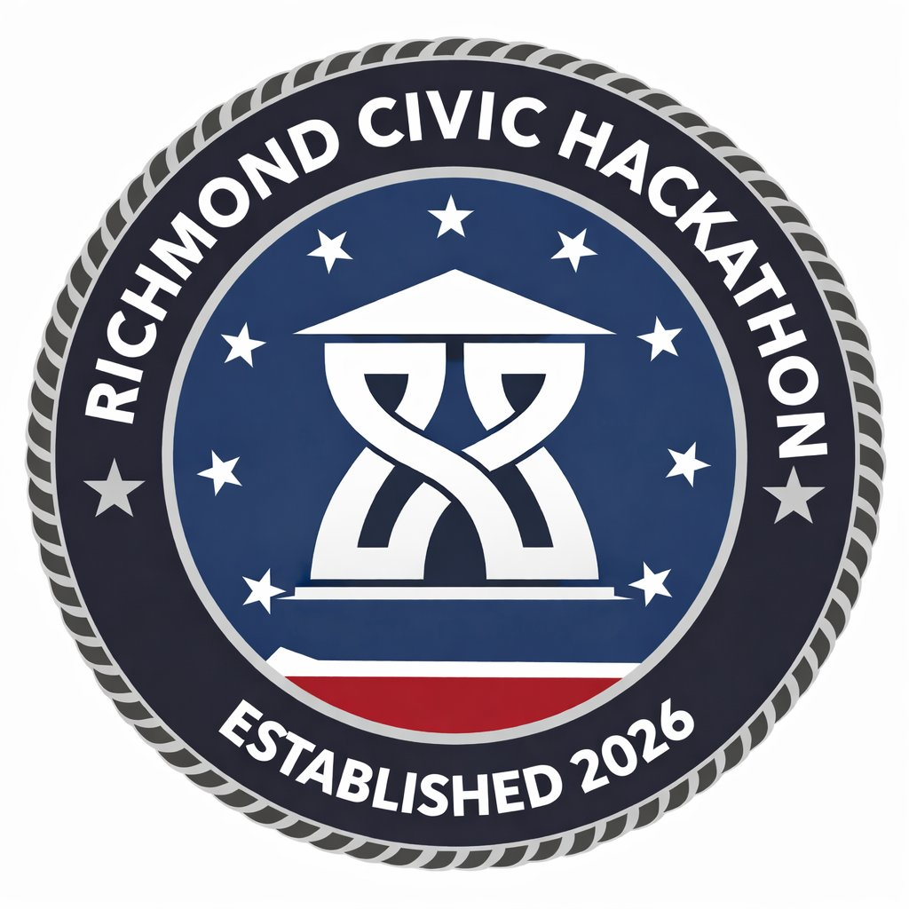
HACK FOR RVA · RICHMOND CIVIC HACKATHON · MARCH 27–29, 2026 · SCIENCE MUSEUM OF VIRGINIA

THRIVING BUILT ENVIRONMENT
Challenge Track 6 · Transportation, Infrastructure & Sustainability
WHAT THIS PILLAR IS ABOUT
Support continued progress on the RVAgreen 2050 comprehensive plan. Shift toward a net zero greenhouse emission local economy through improved public and multimodal transportation, strong stewardship of natural resources, greening neglected neighborhoods, and a strong commitment to sustainability across all departments.
“If you're just a lay person who wants to bike more — God help you if you'd like to know what's happening. Technically it's all public data. But ArcGIS Online? You only understand it if you're in the industry.” — Workshop participant
WHO LED THIS WORKSHOP
Bobby Vincent Jr. (DPW Operations / Torrance — fleet and service delivery) and Daniel Klein (Office of Sustainability, rvagreen2050.com) co-led this session, along with Ashley (data liaison). Bobby manages daily operations including snow removal, street cleaning, trash collection, and fleet logistics. Daniel tracks sustainability implementation across 136 climate actions.
TARGETED PROBLEM 1: TRANSPORTATION PROJECT VISIBILITY
The Problem in Plain Language
The City is spending money on bike lanes, bump outs, sidewalk repairs, and capital improvement projects across Richmond. Residents can't find this information without knowing where to look. The result: public distrust, reactive complaints, missed opportunities for community input — and staff fielding the same questions thousands of times.
What City Leadership Actually Said
“Having greater visibility around the projects will help residents realize how much the city is doing to address street safety. But also — and for lack of a better term — a mayor who can't fill potholes doesn't get reelected. People have to get around. So being able to know what those projects are and understand why they're happening isn't just about transparency. It's about accountability — and it's about building trust.” — Daniel Klein, Office of Sustainability
“I could see a civic association pulling up this map and saying: hey, everyone be aware — in the next few months, this street's going to get closed, this sidewalk's going to get put in, these tree wells are going to get enlarged. So if you're thinking about those end users, it's the common resident — but it could also be nonprofits who do advocacy work, or civic groups who say 'now we can see all the work that's actually happening.'” — Daniel Klein
“We now have a Division of Transportation, which we didn't have a few months ago. They're going to have a communications person soon. Their role would be to communicate something like this out. So whatever you develop, we will find an owner or somebody to manage it within the city.” — City representative
“This is not a city of Richmond problem specifically — every city has this. There's a huge UI/UX opportunity on the transportation side. Technically it's all public. But if you're just a lay person who wants to bike more, you know?” — Workshop participant
How the Data Actually Lives (From the Workshop)
⚙ Tracy (TRACE Dashboard): Daniel built a Power BI dashboard tracking implementation of Richmond's 136 climate equity actions — called 'Tracy' (Tracking Real-time Action for Climate Equity). It lives at rvagreen2050.com under 'Implementation.' It updates every morning at 1am from a shared spreadsheet. This is a model for what transportation project visibility could look like.
⚙ CIP Dashboard: Capital Improvement Project data is available and can be provided as a CSV. There's an existing ArcGIS map that goes down to the street level — showing individual projects like the bump outs near the Science Museum.
⚙ 311 Data: 311 tickets are categorized by type and timestamped — Daniel pulls standing water tickets quarterly to track flooding. This dataset can be accessed and cross-referenced with project data to show residents how their 311 reports connect to upcoming projects.
⚙ DPW Service Finder: A basic tool already exists at rva.gov where residents enter their address and get trash/recycling pickup schedules. This is the prototype for what a fuller 'Living City Map' could be.
What Success Looks Like
• Residents can search by address or neighborhood and see all nearby infrastructure projects
• Project status is clearly visible — planned, in design, in construction, complete
• Technical descriptions translated into plain language ('We're adding a curb extension here to slow traffic and create a safer crossing')
• Staff receive fewer repetitive information requests
• Works for residents without smartphones — SMS text lookup is specifically requested by DPW leadership
Example Ideas
→ City Infrastructure Explorer Map
A public map aggregating CIP data, transportation project records, and ArcGIS data into one interface — with plain-language project descriptions, status indicators, timelines, and 'why this location?' explanations.
→ "What's Happening Here?" Mobile Tool
Residents enter an address, take a photo of a construction sign, or text a project code — and receive project details: purpose, timeline, department, and current status. No ArcGIS expertise required.
→ SMS Project Lookup
Residents text an address or intersection to a City number and receive an automated response with project info and a link. Signs on active project sites include a text code. Works without a smartphone or data plan.
TARGETED PROBLEM 2: FLEET OPERATIONS VISIBILITY
The Problem in Plain Language
During the recent ice storm, residents needed to know: has my street been plowed? DPW didn't have a reliable way to answer that either. Route tracking is largely manual. Supervisors don't have real-time visibility. Public updates require staff to manually compile status at a desk. GPS is being rolled out — the infrastructure for a better system is being built right now.
What City Leadership Actually Said
“We don't have GPS on every city vehicle, but every city employee has a port phone. If there's an app or solution where this can help them track where they are, or act as a transponder in some way — that kind of information would be great for the city in terms of route planning, fuel usage, and route efficiency. And having that pushed to a platform where citizens can check and see where the vehicles are in relationship to their services.” — Bobby Vincent Jr., DPW
“On the service delivery side: there's stuff going on in the street every day and it's very hard to keep up with. I'd start with the first statement — because so much activity happens on a daily basis and making citizens better informed would help eliminate a lot of the calls we get.” — Bobby Vincent Jr., DPW
“We had residents during the ice storm who were in need of heating oil. There's no way from my seat I would know that a person needs oil. Is there a communication or medium that can help us better understand that — not that we're going to deliver it, but we may know there are vulnerable residents in a certain neighborhood, and when the opportunity allows, we can shift resources that direction.” — Bobby Vincent Jr., DPW
“A pole on a light was hit in an alley a couple months ago and it pulled down power lines. We collect trash in that alley. We drove there in the morning not knowing it was hit. Maybe we have to relay information to that block: 'Your trash may not get collected today. We'll come back Saturday.' It is two-way — it can help with efficiency and reporting and accountability.” — Bobby Vincent Jr., DPW
How DPW Operations Actually Work (From the Workshop)
⚙ Trash Truck Crews: Trash collection crews: 1 driver + 2 to 4 collectors per vehicle. They cover about 8 miles of routes per day. Radio communication only — cell phones are not permitted while driving. Currently no in-vehicle GPS tracking.
⚙ City Works Integration: Work orders flow from 311 through City Works (work order management system). This is the existing ticketing and dispatch backbone — any solution should consider how it connects here.
⚙ Scheduled vs. Request-Based Services: Snow removal and street cleaning run on schedules, not 311 requests. Pothole repair starts from 311 tickets. Solutions for these two service types need different approaches.
⚙ Internal App Store: The City has an internal app store — apps must be approved through IT before city employees can install them. Any solution requiring a mobile app for workers needs to account for this approval process.
Example Ideas
→ Street Service Status Map
A public map showing whether streets are scheduled, in progress, or completed for snow removal or street cleaning — using route boundaries, not live vehicle tracking. Updates as routes complete.
→ Fleet Route Progress Dashboard
An internal tool for DPW supervisors showing which routes are complete, in progress, or delayed — fed by GPS signals or simple worker status updates. Feeds the public-facing status map.
→ Two-Way Service Communication Tool
A system allowing DPW workers in the field to flag route disruptions (blocked alley, downed pole) via their city phone — triggering automatic notification to affected residents and updating the public status map.
BLUE SKY CHALLENGES
• The Living City Map — How might we use technology to help residents see and understand everything happening in the physical city around them — infrastructure projects, environmental improvements, service schedules — so that Richmond feels more transparent and connected to the people who live there?
• Reimagining Safer Streets — How might technology help residents and city leaders better understand and redesign unsafe intersections and streets so that Richmond becomes safer and more walkable for everyone? (Vision Zero goals are active — this connects directly to policy.)

