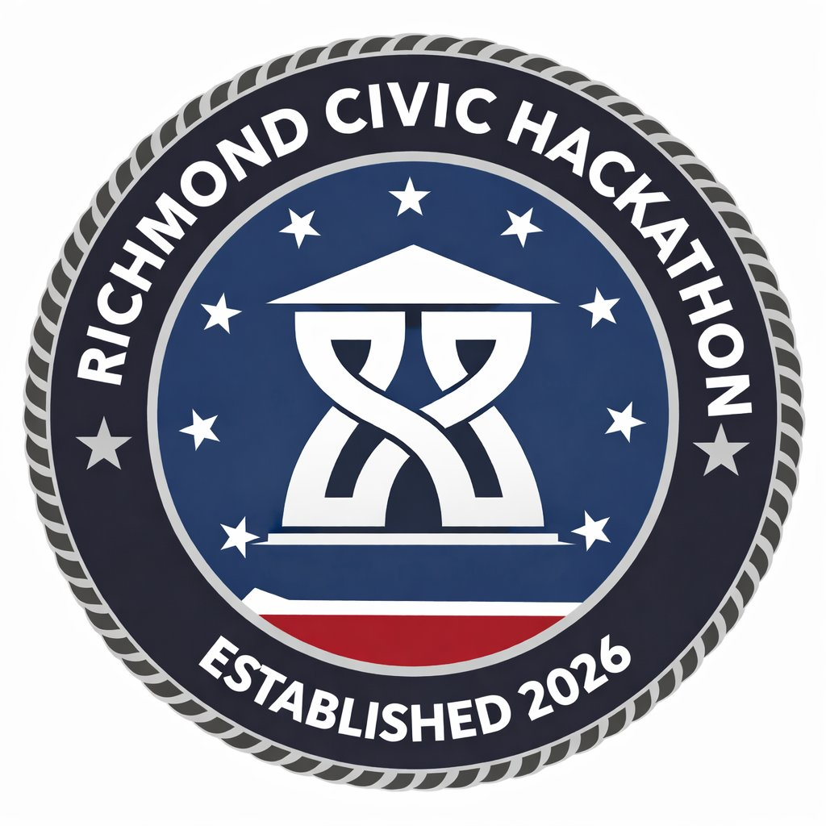
HACK FOR RVA · RICHMOND CIVIC HACKATHON · MARCH 27–29, 2026 · SCIENCE MUSEUM OF VIRGINIA

A THRIVING ECONOMY
Challenge Track 4 · Workforce Development, Small Business & Economic Mobility
WHAT THIS PILLAR IS ABOUT
Support small and minority-owned businesses and employers providing quality, living-wage job opportunities. Create pathways for disadvantaged residents to move from poverty to stability to wealth building, and direct investments to historically neglected neighborhoods.
“When the city spends our money, we want it to create a circular economy here — making our own citizens wealthier, building our city's tax base, versus shipping it to a company headquartered in Omaha. No offense to Omaha.” — Brian Bills, Office of Community Wealth Building
WHO LED THIS WORKSHOP
Brian Bills (Office of Community Wealth Building) and Pat Foster (Director, Office of Minority Business Development), joined by Martha, a community partner who helped frame the problem statements. OCWB is trying to end poverty in Richmond and ensure people can live thriving lives; OMBD focuses on the specific challenges facing minority-owned businesses in the city.
TARGETED PROBLEM 1: MINORITY-OWNED BUSINESSES & CITY CONTRACTING
The Problem in Plain Language
The City of Richmond — with 4,000 employees and $43M+ in annual spending — is one of the biggest businesses in the city. But the vendor portal is designed for people who already know how to navigate government procurement. Large firms from outside Richmond dominate bids. Local minority-owned businesses that could do the work can't find or decode the opportunities.
What City Leadership Actually Said
“The procurement database is not the most user-friendly, easy-to-navigate thing. Our experience is that really large businesses — many not necessarily rooted in Richmond — are the people most comfortable navigating these procurement requests.” — Brian Bills, OCWB
“Some minority business owners feel like it's still part of the good old boys network, so it doesn't make sense for them to try. A lot of it is they don't know how — they don't know how, right?” — Pat Foster, OMBD
“I think there's a reputation — which I believe is false — that you kind of have to know someone or know the system to navigate the system. And it's become a self-fulfilling prophecy: people opting themselves out.” — Brian Bills, OCWB
“We also do classes on using AI to help write bids. We had a particular company succeed doing that. The other side of that, though, is you've got to be able to interview and support what you said in your bid. So there are limits.” — Pat Foster, OMBD
“If the city's going to spend all this money, how do we make sure small local businesses have a good chance to bid for it? First thing: how do they even know what we're spending money on? How does it align with their capabilities? When a contract comes up that's interesting to them — how do they get notified?” — Brian Bills, OCWB
How the Procurement System Actually Works
⚙ Solicitations vs. Contracts: There are two relevant systems: one for active solicitations (requests for proposals, bids) and one for executed contracts. The focus for this problem is the solicitations — that's where the opportunity to bid still exists. Contracts are public record and can inform how to bid on renewals.
⚙ Portal URL: procurement.richmondgov.com / mvendor.cgieva.com — this is the official source; any solution must work with this portal as the authoritative data source
⚙ MBE Definition: Minority-owned businesses are defined using the federal government definition: African American, Asian, Hispanic, and Native American-owned businesses. There are partial ownership rules (percentage thresholds) and it can include corporations and franchises.
What Success Looks Like
• Businesses can more quickly determine whether an opportunity matches their services
• Procurement listings are easier for first-time vendors to interpret
• More minority-owned businesses feel confident exploring City contracting opportunities
• Businesses are better prepared before contacting City procurement staff
Example Ideas
→ Opportunity Match Tool
Businesses enter their services, certifications, or capabilities and receive a curated list of relevant opportunities pulled from the City procurement portal — filtered by category, size, and likelihood of fit.
→ Plain-Language Opportunity Explorer
A searchable interface that summarizes procurement listings in simple language: what's the work, what types of contractors typically do it, what are the key next steps to bid.
→ MBE Opportunity Alerts
A notification system that allows businesses to subscribe to alerts when new opportunities related to their services appear — or when existing contracts in their space are coming up for rebid.
TARGETED PROBLEM 2: SMALL BUSINESS NAVIGATION & SETUP
The Problem in Plain Language
Starting a business in Richmond requires navigating multiple City departments that don't talk to each other, with processes designed for the department's needs — not the entrepreneur's. Many businesses register with the state (SCC) and think they're done. They're not. And the consequences of not knowing can cost tens of thousands of dollars.
What City Leadership Actually Said
“If I turned to any of you and said you are setting up a business tomorrow — would you know what you have to do to legally make that happen? I'm seeing some soft shaking of heads.” — Brian Bills, OCWB
“We have a special business tax classification for 'Palm Street businesses' — which I believe is like people who read your palm. There's a lot of arcane, slightly older things in the city code around different classifications of business tax. Navigating that can feel daunting.” — Brian Bills, OCWB
“There are actually three different teams within the city you might go to for different parts of this process: OMBD holds your hand; Department of Economic Development runs the business taxing system; Planning and Development Review enforces zoning. And there's slippage between those pieces.” — Brian Bills, OCWB
“A small minority-owned business bought their building in Shockoe Bottom and renovated it. They thought they were getting the property tax abatement — but they hadn't done the first step of having someone from the city inspect it before the renovations. They finished, they were ready for the abatement, and the city said: 'What do you mean? No one came and inspected this property.' That's tens of thousands of dollars.” — Brian Bills, OCWB
“Not everyone who's supposed to register with the city does — and it's not like a huge financial burden, it's about $50 for your first two years. I think people are either not aware, or kind of intimidated by the process.” — Brian Bills, OCWB
“There's a lot of information that lives in people's heads and gets passed through informal networks. If we want to grow the economy for people who haven't traditionally been part of that opportunity, the path needs to be made clearer. That's inherently part of the equity issue.” — Martha, Community Partner
How City Departments Are Currently Connected (Or Not)
⚙ OMBD Does One-on-One Coaching: Pat Foster's team functions as a one-stop shop — but only if you know to call them. They personally set a path for each business. This doesn't scale. The goal: give every entrepreneur the equivalent of that one-on-one session through a tool.
⚙ SCC Does Not Notify the City: When a business registers with the Virginia State Corporation Commission, the City of Richmond receives no notification. The SCC is publicly searchable — and businesses with Richmond addresses could theoretically be cross-referenced — but no system currently does this.
⚙ The 'Carrots' Are Real But Invisible: Enterprise zones (state tax benefits), Opportunity Zones (federal tax benefits), the facade improvement program, and property tax abatement all exist — but businesses that don't register can't access any of them. The incentives are designed for people who don't know they exist.
What Success Looks Like
• Entrepreneurs can quickly understand what applies to them — based on business type, location, ownership
• Required steps are completed in the correct sequence (SCC → City license → zoning check → relevant permits)
• Fewer businesses unintentionally operate out of compliance
• Staff spend less time redirecting inquiries
💡 The two problems are upstream/downstream of each other: if businesses don't register with the city, the city can't connect them to contract opportunities. Build one well and you strengthen the other.
Example Ideas
→ Start Here Business Wizard
A guided intake flow that asks plain-language questions ('Home-based? Hiring employees? Selling food? Restaurant with a kitchen?') and generates a personalized, ordered checklist of licenses, permits, offices, and incentive programs the business may be eligible for.
→ Business Setup Copilot
A City-specific AI assistant trained on Richmond's actual business requirements — knows the difference between BPOL, zoning compliance, and a meals tax account — and links directly to forms, contacts, and the right sequence.
→ Small Business Pathway Dashboard
A tool showing a business owner exactly where they are in the setup process, what's done, what's next, and what City support programs they may be eligible for — turning a confusing maze into a progress tracker.
BLUE SKY CHALLENGES
• Turning City Data Into Opportunity — How might we use generative technology to analyze Richmond's business, workforce, and contracting data so that opportunities are surfaced proactively to the people who need them — rather than requiring them to find it?
• Rebuilding the Pathway Into the Trades — How might technology help more Richmond residents — especially from underrepresented communities — discover, prepare for, and persist in high-opportunity trades? (Richmond is currently importing construction workers from Florida because there aren't enough locally trained workers to fill the jobs here.)
• A Smarter Front Door for Starting a Business — How might we create a smarter, more supportive front door for starting a business in Richmond so that entrepreneurs can move from idea to legal operation with greater clarity and confidence?

