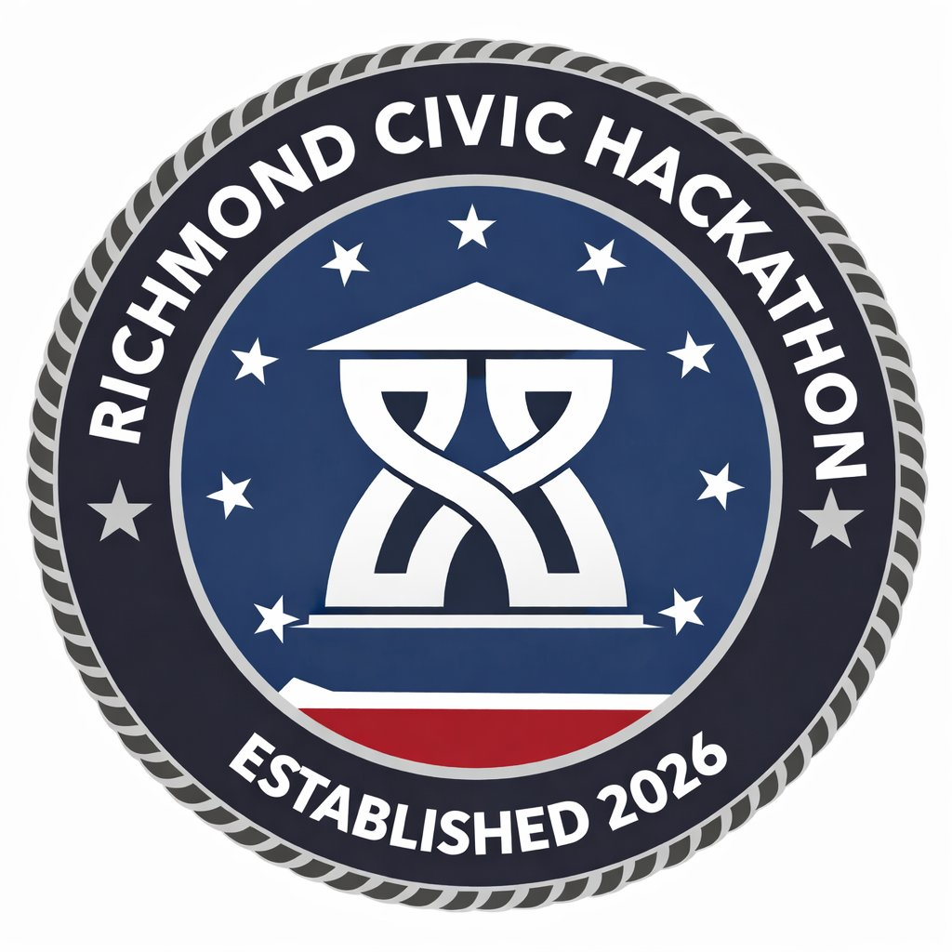
HACK FOR RVA · RICHMOND CIVIC HACKATHON · MARCH 27–29, 2026 · SCIENCE MUSEUM OF VIRGINIA

THRIVING FAMILIES
Challenge Track 3 · Youth Employment, Children's Services & Community Data
WHAT THIS PILLAR IS ABOUT
Support the education, health, and development of children and families — in and out of the classroom — so that students graduate from Richmond Public Schools well-prepared for success and connected to opportunities for further learning and career development.
“We are the Office of Children and Families. We are not a department of social services. We're not about what our mandated work is — we're about the solve for the humans who are experiencing all of that.” — Eva Colen, Senior Policy Advisor, City of Richmond
WHO LED THIS WORKSHOP
Eva Colen (Senior Policy Advisor, Office of Children and Families) and Jackie Hale (Early Childhood and Maternal Health Strategist). Jackie spent 20 years as a nonprofit community partner in healthcare, education, and early childhood before joining the City two years ago. Their shared focus: reducing friction for the residents who need the most and have access to the least.
TARGETED PROBLEM 1: YOUTH EMPLOYMENT PATHWAYS
The Problem in Plain Language
Richmond has real youth employment programs — but there is no single place a young person can go, independently, to find a job. No single place where employers can signal they're open to youth workers. And the current gap means who gets a job depends on who you know, not what you're capable of.
What City Leadership Actually Said
“We have some really great youth employment programs. But what we don't have is a single place where a young person can go to find a job that doesn't rely on them talking to another adult. Likewise, we don't have a one-stop shop for employers to say 'I've got these jobs that may be eligible for a young person.'” — Eva Colen
“Not everything has to be a registered youth apprenticeship. I babysat for a long time, realized I liked working with kids, went into teaching. My first employer hired me because they saw a waitressing job on my resume, not because I had an education degree. If we lock kids' work experiences up in the category of 'registered youth apprenticeship,' we may be denying them a lot of opportunities along the way.” — Eva Colen
“You could have the most prepared 16-year-old in the room — and you're still going to have a 16-year-old brain in that room. We always say our job is to cover from prenatal to prefrontal cortex.” — Eva Colen
“Jobs in Richmond — who gets them — it's like who you know, and it happens at every level of socioeconomics. How do we break that down so we have more equitable access?” — Eva Colen
“When you have a really good employer as a young person, that is transformative. And we also know that positive relationships with caring adults outside your family are transformative in many different domains — including as a prevention tactic for violence.” — Eva Colen
“Imagine: a kid goes to a website and it asks 'Do you like animals?' and it says, 'Here are types of things you can do. Maybe you just volunteer at the SPCA — you can read to puppies on Sundays.' That's technically work experience. And that kid who thinks they want to be a vet and discovers they really don't like yippy puppies — that's an important learning experience.” — Eva Colen
The Employer Side of the Gap
“There's a big gap between a youth labor law summary and a small business employer. I'm not tracking any of that as an employer. So there's an opportunity in translating those requirements into plain language for employers — including flagging when laws change in July before summer employment season.” — Greg Hauer, Volunteer (SBDC)
“We have seen young people have really terrible experiences with employers who have unreasonable expectations and don't know how to deliver feedback in a way that's supportive or coaching. On the flip: some businesses led by residents of color in Richmond might have more patience and time and capacity to actually mentor young people.” — Eva Colen
What Success Looks Like
• Youth have one clear place to explore employment opportunities and career experiences — no adult intermediary required
• Teens receive guidance on preparing for a first job
• Required documents can be organized digitally and securely
• Employers feel confident about youth labor law requirements
• More Richmond youth access early employment — especially those without strong adult networks
💡 The existing youth employment programs are reasonably good. The missing piece is the bridge — between the programs that prepare youth and the jobs that exist. Build the bridge, not another program.
Technical Constraints
• Must respect state youth labor laws and parental consent requirements (see labor law summary in data packet)
• Must prioritize privacy protections for minors
• Must recognize transportation limitations — a great job opportunity 45 minutes away by bus isn't actually accessible
• The City of Richmond has a city-built jobs database through Optimal Planning — but it's incomplete and not publicly searchable
TARGETED PROBLEM 2: PEOPLE DATA ON THE OPEN DATA PORTAL
The Problem in Plain Language
The City's Open Data Portal has buttons and maps but almost no demographic, health, or human services data. Every organization — City agencies, nonprofits, researchers — independently downloads the same public state datasets and builds the same spreadsheets, getting different numbers and making incompatible decisions. Budget arguments happen over whose count is right rather than what to do.
What City Leadership Actually Said
“My focus is early childhood. I know there are roughly 13,000 children zero to five in the city of Richmond. I don't want another partner pulling something off census.gov and coming up with 15,000. We need to be singing from the same songbook.” — Jackie Hale
“A council member wanted to know how many older adults were in her district versus how many children under five. That took a long time to answer — and it should just be immediately accessible. If that's the debate we're having — because we don't know where the data is — we're not actually having the conversation about where to direct investments.” — Eva Colen
“Despite the developments over the last 10 years downtown, there are still zero children under five in that footprint. That's a bunch of young professionals, which is great — but that doesn't mean we need to build a new school near there. We're leaving a lot of opportunities on the table because we don't have clear line of sight into what our actual human beings need.” — Eva Colen
“Not only having the numbers, but can we make it usable? Can I look at the number of older adults in this area? Identify neighborhoods where young families are growing — so if you have a baby and you're working, we can say: here's where you need childcare supply?” — Jackie Hale
The Data That Already Exists — Just Scattered
• Census and ACS population data (census.gov)
• Virginia Department of Health — birth rates, maternal health outcomes
• Virginia Department of Education — enrollment, graduation, attendance
• Kids Count data (vakids.org)
• Virginia Department of Medical Assistance Services (DMAS) — Medicaid data
• Virginia Department of Social Services (DSS) — human services data
⚙ Format Problem: Some data is in Tableau databases. Some is in PDFs. Some is exportable. Some is not. Some lives in someone's brain from three years ago.
What Success Looks Like
• A single repository for demographic and human services data on the City's Open Data Portal
• Data disaggregatable by age group, race/ethnicity, insurance coverage, council district
• Consistent update mechanism — so when VDH or DSS releases new data, it flows through
• Organizations no longer recreate the same datasets independently
• Grant applications and budget arguments use shared, standardized numbers
BLUE SKY CHALLENGES
• Preparing Every Young Person for Their First Job — How might technology help every Richmond youth gain the skills, guidance, and opportunities needed to successfully enter the workforce?
• Connecting Youth and Employers Across the City — How might we strengthen connections between Richmond youth and local employers so that businesses feel confident hiring young people?
• A Shared Understanding of Maternal Health — How might technology create a shared understanding of maternal health outcomes across Richmond? (Richmond lost over $1M in perinatal health funding at the peak of national maternal health attention — and outcomes here are worse than most comparable cities, but no one agrees on the baseline numbers.)

