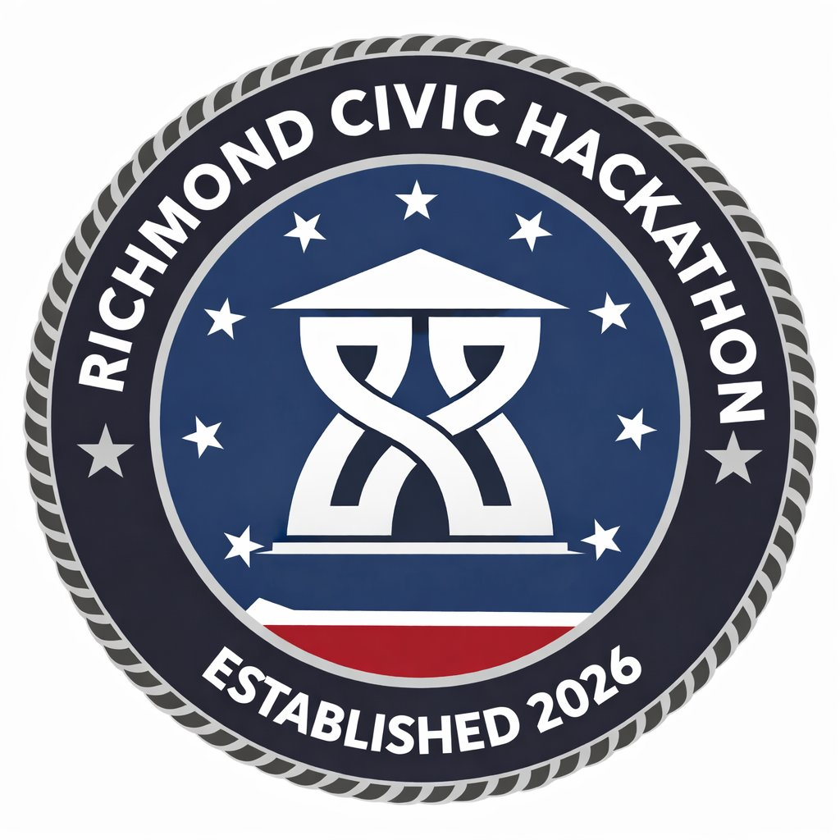
HACK FOR RVA · RICHMOND CIVIC HACKATHON · MARCH 27–29, 2026 · SCIENCE MUSEUM OF VIRGINIA

THRIVING & INCLUSIVE COMMUNITIES
Challenge Track 5 · Immigrant Services, Service Navigation & Health Equity
WHAT THIS PILLAR IS ABOUT
Protect everyone's rights — specifically the rights of immigrants and refugees, LGBTQ+ residents, other politically targeted groups, and the reproductive rights of women. Work to redress long-standing racial inequities in health and well-being. Richmond has a growing network of support services for vulnerable residents, but trust, navigation barriers, and fragmented systems prevent many people from accessing the help they deserve.
“Trust is tied to how technology is used, not just what it does.” — Workshop participant
KEY THEMES FROM COMMUNITY WORKSHOP
This pillar's workshop surfaced six critical themes that any solution must grapple with:
1. Trust and Safety Are the Core Barriers
Many immigrant and refugee residents worry that sharing personal information could expose them or their families to risk — and therefore avoid seeking help even when services exist. This is not a technical problem — it's a relational and political one that technology must not make worse.
“Residents may not know which services exist, how to access them, or whether engaging with them could expose personal information. At the same time, organizations providing support are often working in parallel without shared tools to coordinate.” — Workshop synthesis
2. Services Exist — But Can't Be Found
Many support services already exist across Richmond. The problem is not supply — it's discovery. Information is scattered across agencies, nonprofits, and websites. Residents often contact multiple organizations, navigate confusing eligibility rules, and repeat their story across systems.
3. Help1RVA Exists But Has Real Limitations
Richmond's Help1RVA platform (built on FindHelp/UniteUs) already connects residents to services — but requires manual data entry, uses different intake processes across organizations, and the underlying systems are not interoperable. The opportunity here is to improve and extend, not replace.
⚙ Help1RVA: Visit help1rva.org to understand the current tool. Any solution should treat this as the existing infrastructure to build on or complement — not compete with.
4. Language, Literacy & Digital Access Barriers Are Significant
Limited English proficiency, varying literacy levels, lack of smartphone access, and cultural nuances in translation all shape how residents can engage with services. How information is communicated matters as much as the information itself.
5. Technology Should Support — Not Replace — Human Relationships
The most trusted pathways to services often run through a specific person: a community leader, a pastor, a case manager. Effective technology strengthens these relationships rather than bypassing them. A 'care team' model — where residents can see who is helping them and what their next steps are — resonated strongly in the workshop.
6. Communication and Awareness Are Major Gaps
Many residents and organizations are unaware of existing support systems — including Help1RVA itself. Any solution must include an outreach and communication strategy, using trusted channels residents already rely on.
TARGETED PROBLEM 1: HELPING RESIDENTS SAFELY DISCOVER TRUSTED SERVICES
The Problem Statement
While Richmond has a growing network of City programs, nonprofits, and community-based organizations supporting immigrant and refugee residents, many residents struggle to safely discover and connect to these services. Concerns about privacy, language barriers, and uncertainty about which organizations can be trusted often prevent residents from seeking help. Without clearer, safer ways to find and access support, residents may delay or avoid assistance altogether.
Constraints
• Solutions must prioritize strong privacy protections and anonymity — design for the resident who cannot risk being identified
• Must work with existing nonprofit and community-based support networks, not require new infrastructure they can't staff
• Cannot require a full replacement of current systems — Help1RVA has real adoption and should be extended, not abandoned
• Should avoid collecting unnecessary personal data — data minimization is a feature, not a limitation
• Must operate within limited staffing capacity and budgets
• Service information should be easily updated by trusted organizations — it goes stale fast
What Success Looks Like
• Residents can safely discover and connect to trusted support services without fear
• Immigrant and refugee communities feel more comfortable seeking help
• Service information is accurate, multilingual, and easy to access — including via voice and SMS
• Community organizations coordinate more effectively around service availability
• Fewer residents fall through gaps between support programs
Example Ideas
→ Next-Generation Help1RVA Interface
A redesigned, multilingual interface for Help1RVA using voice navigation, audio explanations, and culturally informed translations. Addresses literacy and language barriers without requiring a smartphone or written input.
→ Trusted Community Messenger Tool
A system distributing verified service information through trusted channels — WhatsApp, SMS, community leaders, or faith organizations. Residents get information through sources they already trust rather than City websites they may distrust.
→ Privacy-First Help Connector
A tool allowing residents to describe their needs anonymously and receive a curated list of relevant services without entering any personal information — building trust before residents engage directly with organizations.
TARGETED PROBLEM 2: NAVIGATING SERVICES WITHOUT REPEATING YOUR STORY
The Problem Statement
Residents seeking housing stability, workforce support, or reentry services often need assistance from multiple City departments and partner organizations. Because these programs operate independently with different systems, residents must determine eligibility on their own and repeat their story each time — creating delays, confusion, and high drop-off rates.
Constraints
• Must respect privacy protections including HIPAA and PII rules — this limits what can be shared across systems
• Must work across departments operating on fundamentally different platforms
• Cannot require a full technology overhaul of existing systems — the solve must be additive
• Should support — not replace — human case managers and volunteers
• Must function within existing staffing capacity
What Success Looks Like
• Residents can quickly identify relevant services and eligibility requirements without staff intervention
• Residents do not have to repeat their story across agencies — even if the systems can't share data, the resident's experience should feel continuous
• More residents successfully connect to housing, workforce, or reentry support
• Staff spend less time redirecting residents between programs
• Organizations coordinate more effectively across service pathways
BLUE SKY CHALLENGES
• A City Where Everyone Knows Where to Turn for Help — Any Richmond resident, regardless of language, background, or familiarity with City services, can find the right help through a single trusted entry point.
• A Community Support Network That Works Like a Care Team — A coordinated ecosystem where residents, nonprofits, volunteers, and City agencies work together seamlessly — and the resident can see who is helping them and what their next steps are.
• A City That Makes Every Resident Feel Seen and Supported — Technology that makes support resources visible, accessible, and culturally responsive — so residents feel less alone in their struggles.
• Universal Access to City Services — Every resident, regardless of language, literacy, or digital access, can discover, understand, and use the services available to them.
• A Trusted Civic Infrastructure for Community Support — A digital infrastructure that connects residents, nonprofits, volunteers, and City services so communities can coordinate support more effectively — without requiring residents to navigate the City's internal complexity.

