**Creating 3D circle/sphere**

1. Draw a circle using the circle tool. Any color is fine.

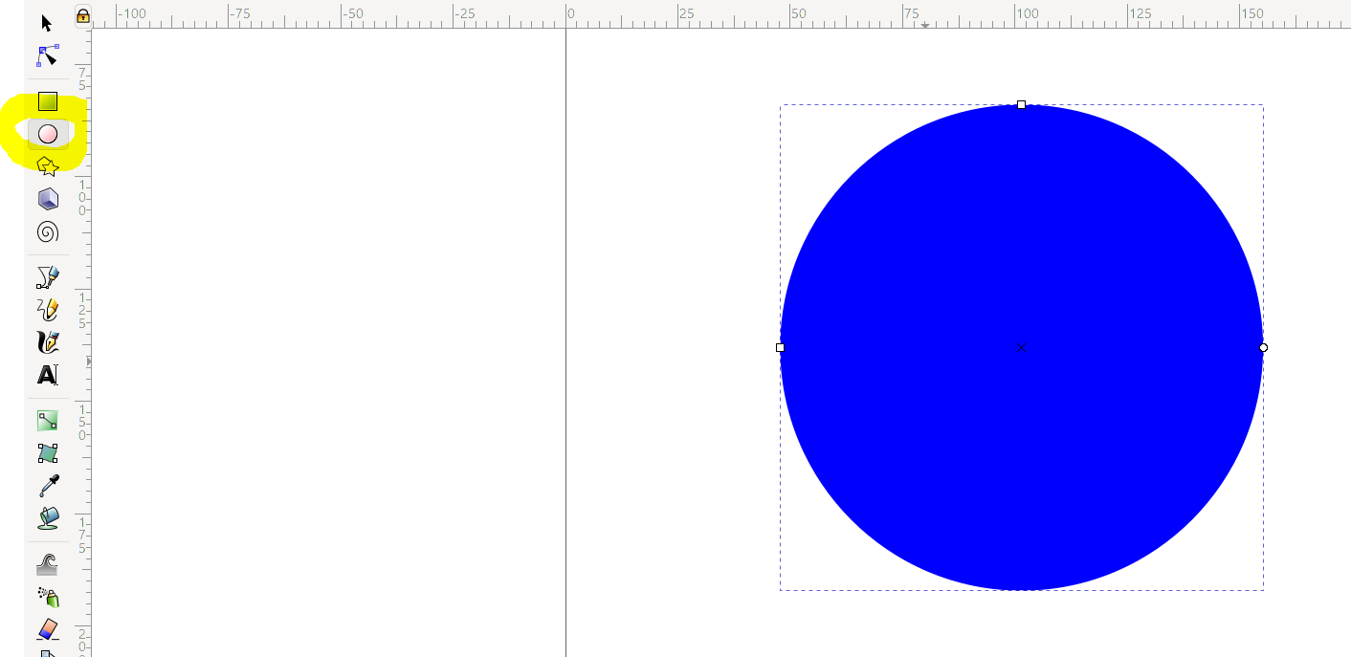

1. Click the gradient tool (highlighted). Make sure you select the radial gradient setting and “gradient in the fill” setting.

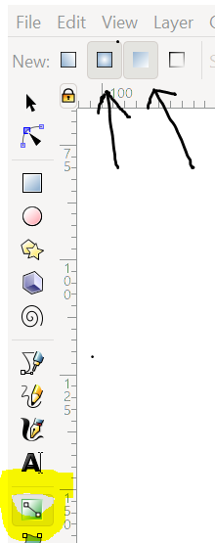

1. Click on the circle wherever you want the highlight/lightest part to be, and drag towards the outside of the circle so it looks like this. 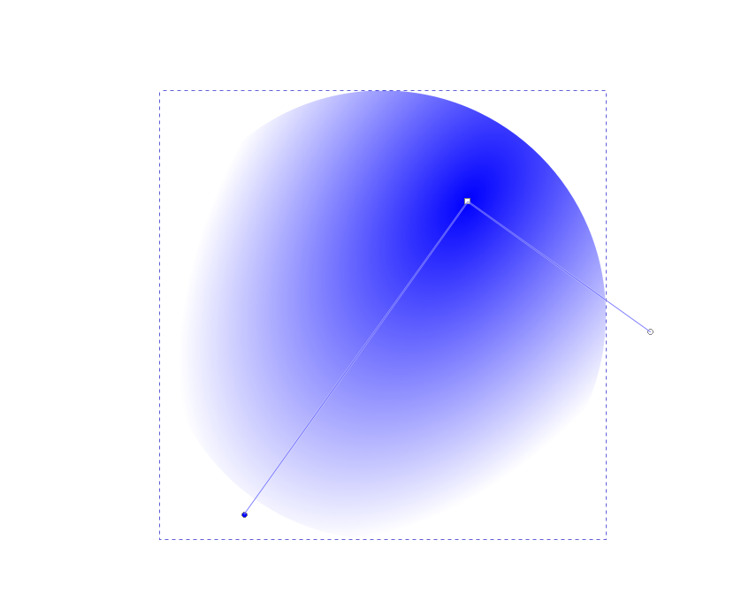
2. As you can see above, the lower left stop (dot) is blue, meaning it is selected and controls the outer edge color. Select a darker one for the shadow effect.

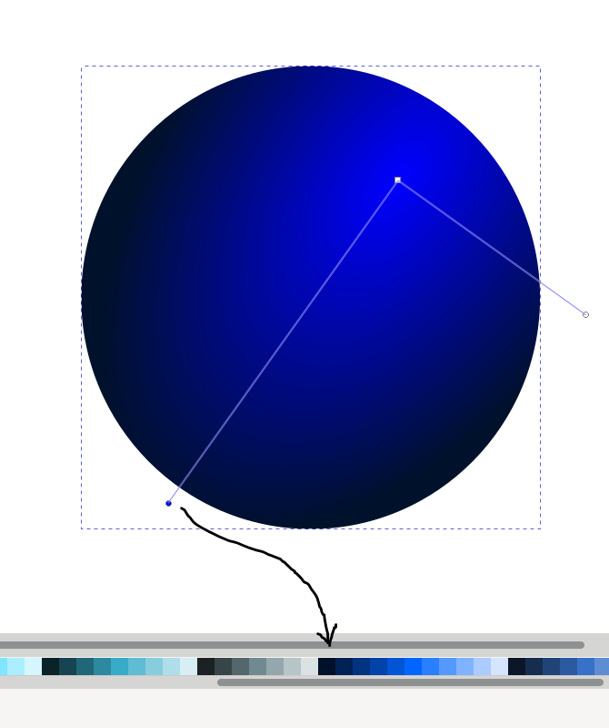

1. Click the center stop to select it, and choose a light color for the highlight.

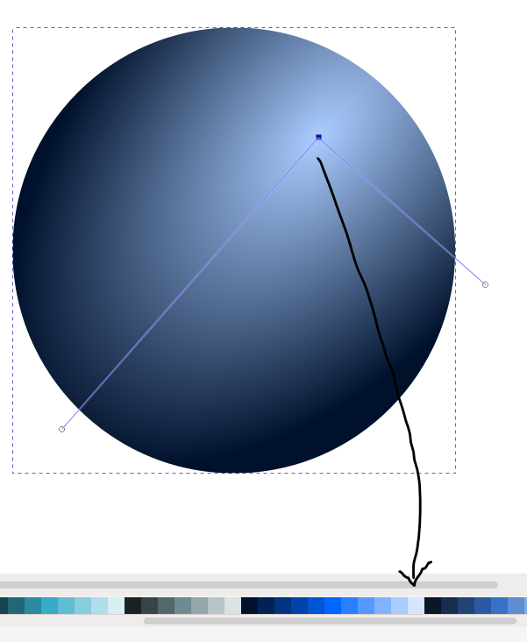

1. You can add stops by double clicking on the two lines. This will give you more color options for the gradient. You can also move the position of the gradient lines by dragging the stops to change the shape of the radial gradient. Final product below.

