# Team : Bifröst

**Challenge: Name pronunciation**

**Url Link :** <https://name-pronunciation-app.azurewebsites.net/>

**User login details ( user name and password is case sensetive )**

|  |  |  |
| --- | --- | --- |
| **User Name** | **Password** | **Non-Standard Audio captured** |
| parameswara | password123# | YES |
| debajit | password123# | YES |
| syed | password123# | YES |
| john | password123# | NO |

**Tech Stack used :**

1. Java 11 with Spring boot

2. React + Meterial UI

3. Aure speech api

4. Yugabyte

**Cloud Environment:**

Azure

**Use cases covered :**

1. Log in screen for user.

2. Above user has non-standard audio captured already, which can be reviewed form user profile screen.

3. In Dashboard page user can provide details for another user. Speak it will use those input and pronounce the name.

4. User preferred name is having higher precidence over first and last name.

Not in scope:

1. Limited country and language support in ui.

2. Non-standard audio capture record option is not yet available.

3. Admin user roles are not included.

**Screens:**

**Login Screen**

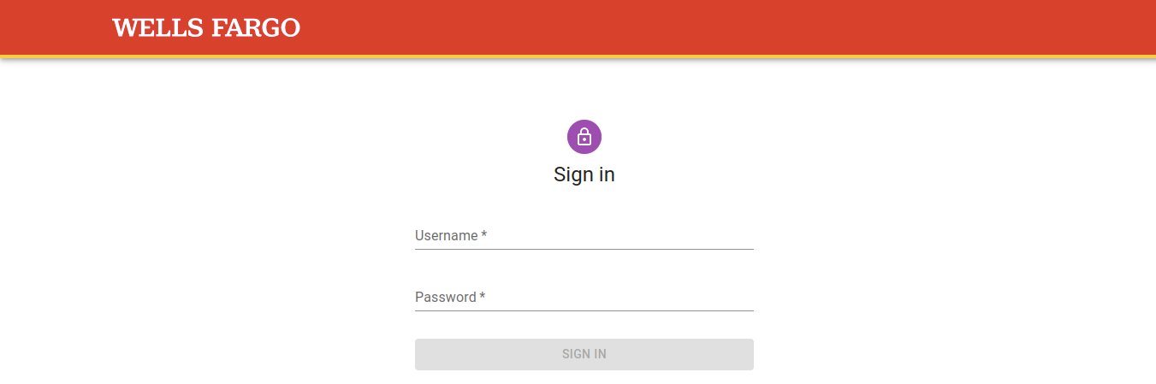

**Landing Screen**

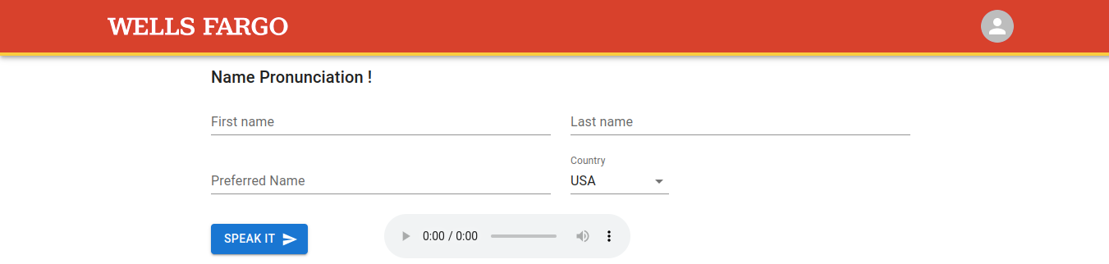

**User profile Screen**

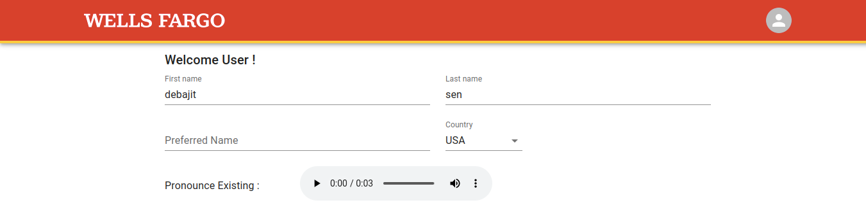

**Logout Action on drop down.**

