**Introduction**

Exploratory Data Analysis (EDA) is a foundational step in the data analysis process, allowing analysts and data scientists to understand the underlying patterns, detect anomalies, and test hypotheses with statistical models. The EDA process is critical for ensuring data quality, selecting appropriate models, and generating insights that inform decision-making. This documentation outlines a comprehensive plan for conducting an EDA project, divided into three distinct phases. Each phase is designed to build upon the previous one, progressively deepening the analysis and preparing the data for advanced statistical modeling or machine learning algorithms.

**Objective**

The primary objective of this EDA project is to thoroughly examine and prepare a dataset through a series of structured steps, including basic statistical analysis, data visualization, and data standardization. By the end of the project, we aim to have a clean, well-understood dataset that is ready for predictive modeling or any other analytical purpose. The project will ensure that all relevant aspects of the data including time-series metrics are explored, including the distribution of variables, relationships between them, and any potential issues that could impact further analysis.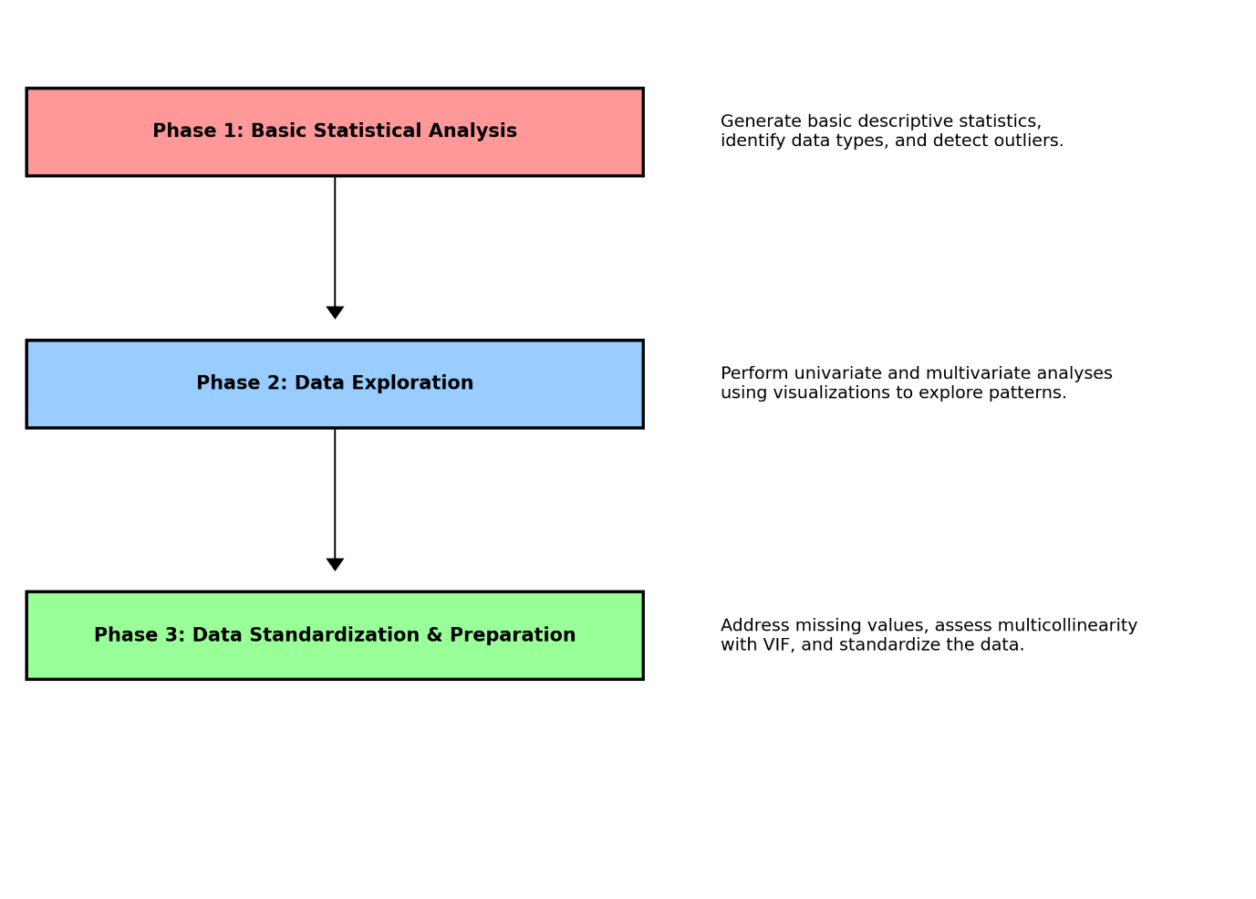

**Phase 1: Basic Statistical Analysis**

The first phase focuses on acquiring a fundamental understanding of the dataset's structure and attributes. This involves generating a report that includes the attribute names, their data types, and basic descriptive statistics. The statistics include the count of non-null values to assess data completeness, fill rates to understand data availability, and measures of central tendency (mean, median/mode) to grasp the distribution of the data. Additionally, this phase involves identifying outliers, which can significantly affect subsequent analyses. This foundational analysis provides a snapshot of the dataset's health and guides the data-cleaning process. In addition to this, a column to add information about the attribute is included.

**Phase 2: Data Exploration with Univariate and Multivariate Analysis**

With a basic understanding of the dataset established, the second phase dives deeper into data exploration, employing both univariate and multivariate analysis. This phase leverages visual tools to uncover patterns, trends, and relationships within the data. Univariate analysis focuses on individual attributes, using histograms and bar charts to visualize distributions. Multivariate analysis explores relationships between variables, utilizing scatter plots, pair plots, and heatmaps to reveal correlations and interactions. An essential tool in this phase is the automated generation of reports through libraries such as pandas-profiling or Dataprep, which streamline the creation of comprehensive exploratory visuals and statistics.

**Phase 3: Data Standardization and Preparation for Modeling**

The final phase prepares the data for modeling by addressing critical issues identified in the earlier phases, such as missing values and multicollinearity. Strategies for handling missing data are carefully considered, including imputation and deletion, based on the context and impact on analysis. The Variance Inflation Factor (VIF) is employed to assess multicollinearity among variables, guiding the selection of variables to retain for modeling. Finally, data standardization techniques are applied to ensure that numerical attributes are on a comparable scale, facilitating more effective modeling and analysis. This phase solidifies the dataset as a robust foundation for predictive modeling or in-depth statistical analysis.

**Conclusion**

Through the structured execution of these three phases, the EDA project systematically transforms raw data into an insightful, clean dataset ready for advanced analytics. This process not only enhances the understanding of the dataset's characteristics and underlying structure but also ensures that the data is optimally prepared for achieving accurate and meaningful analytical outcomes.