PlayBook - UI/Project

Contents

Software required 2

Running the project 2

Search using the UI 2

Using Chabot 2

Using the search bar 2

# Software required

1. Visual Studio
2. Postman (for API testing)

# Running the project

1. Clone the repo from GitHub
2. Open the **Hackathon_Search.sln** using Visual studio.
3. Run the project OR click F5 to start the project.

# Search using the UI

## Using Chabot

1. Once the project is opened in browser, you will see chat icon on right side bottom.



1. On clicking on the chat icon you can see a Chabot opened, which can be used to get the answers for the survey posting each question along with the reference document details.

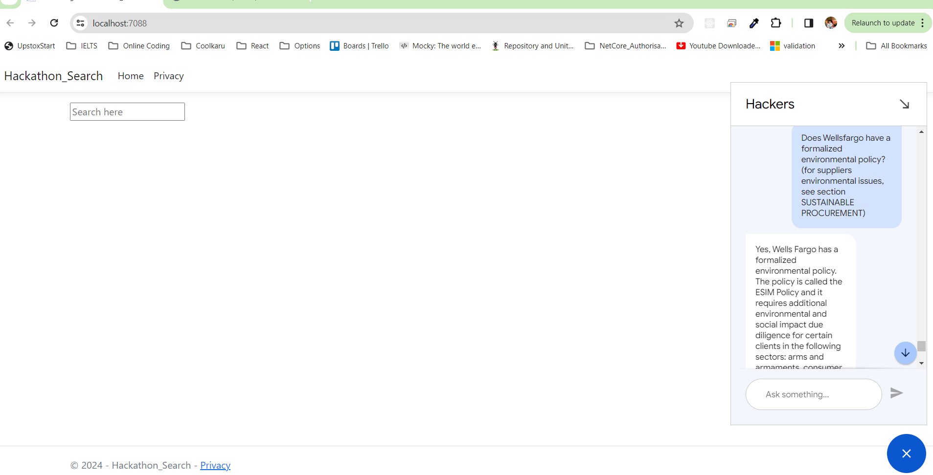

## Using the search bar

1. You can see a search bar on the application.
2. Click on the search bar and we can post a question and it will give the answers along with the reference documents where the information is captured.

