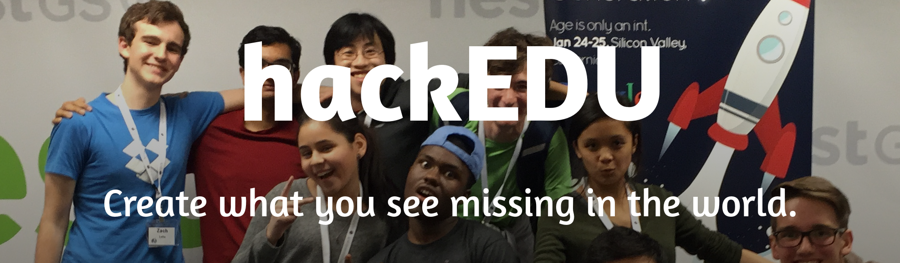
hackEDU (https://hackedu.us) is a non-profit initiative that works with high school students to start and lead student-run programming clubs at their schools.

Metrics
We’re currently running a pilot in 38 schools across 11 states reaching 1300 students.
- 32% of our constituency are women (nearly 2x the national average)
- 37% of our constituency represents ethnic minorities in tech (7x the national average)
- 1/3 of our schools serve communities where most students are on free or reduced lunch
At the two largest, most competitive collegiate hackathons, PennApps X and MHacks V where competitors were flown in from schools including MIT, Stanford, and Harvard, three of the six winning teams were led by high school students. All of these winning high school teams are part of hackEDU.
In February, one of our club leaders won Thiel Rookie of the Year for making an Android app that can access the internet without an internet connection. Chaoyi Zha, one of our club leaders from Philadelphia, is a contributor to the Fedora Project, one of the largest Linux operating systems with over 50 million users. Another leader, Raphael Kats, transmitted internet through FM radio over 10 miles (compare that to your Wi-Fi at home) and ran a program to teach local middle school students how to code.
This summer, another club leader, Amy Sorto, decided to put together a summer camp to teach 24 girls in middle school how to code. She's already secured a blank check from Panasonic, laptop donations from Codestarter, a donated venue in Newark.

Why It Matters
Currently only 1 out 10 high schools in the US offers any CS classes, and by 2020, one million technology jobs will go unfilled. Companies must find ways to expand the tech talent pipeline at the point where young people are deciding on their career paths. Since 4 out of 5 STEM (Science Technology, Engineering, and Mathematics) professionals choose their career in high school or earlier, high school is the pivotal point where getting involved in STEM matters.

Our Vision
Our vision is to create a world where all its citizens are empowered to create what they see missing. We believe that nobody should be afraid to tackle the world's most ambitious problems or break the rules doing so. This mindset is what we at hackEDU call the “hacker ethos”. In short, a "hacker" is a changemaker who challenges the status quo.
Note on the definition of “hacker”: The media commonly refers to “hacking” as the “use [of] a computer to gain unauthorized access to data in a system” and a “hacker” as someone who performs such activities. When we refer to the term “hacker”, we are referring to the commonly used term in tech culture. Here is an excerpt from the Wikipedia article on hacker: http://wki.pe/Hacker_(term).

“The act of engaging in activities (such as programming or other media) in a spirit of playfulness and exploration is termed hacking. Hacking entails some form of excellence, for example exploring the limits of what is possible, thereby doing something exciting and meaningful.”

Our Mission
By engaging high school students in our community of student-run coding clubs, we create and empower the next generation of changemakers. By providing a stellar club culture, we inspire the hacker ethos, and foster qualities including self-confidence, social responsibility, inclusivity, collaboration, and agency.
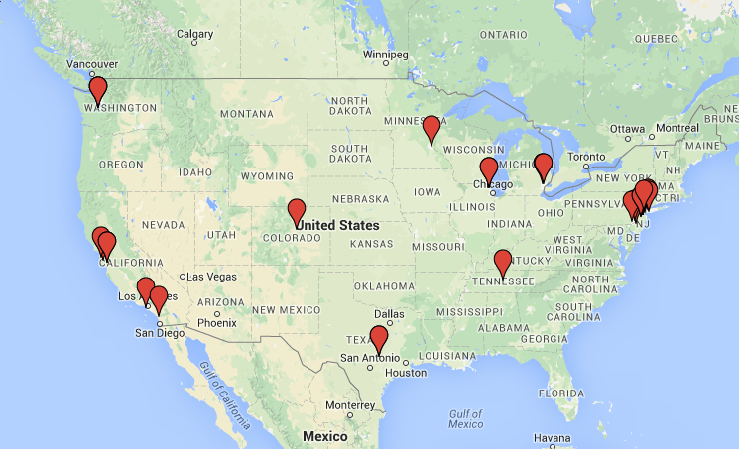
Our current clubs in the United States.

http://media.collegeboard.com/digitalServices/pdf/research/2014/Program-Summary-Report-2014.xls
http://www.usatoday.com/story/tech/2014/12/29/20868353/
Code.org
Harris Interactive,STEM Perceptions: Student & Parent Study, Sept 2011

