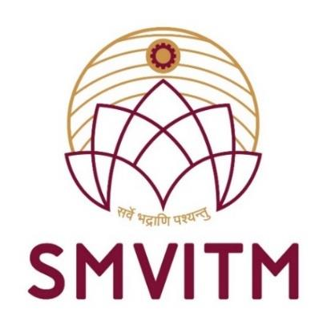

SHRI MADHWA VADIRAJA
INSTITUTE OF TECHNOLOGY & MANAGEMENT
(A unit of Shri Sode Vadiraja Mutt Education Trust ®)
(Affiliated to Visvesvaraya Technological University, Belagavi)
Vishwothama Nagar, Bantakal – 574115, Udupi District, Karnataka
A Report on
SOCIAL CONNECT RESPONSIBILITY (BSCK307)
Submitted by

NAME : Shreyas
USN : 4MW22AI042

DEPARTMENT OF
ARTIFICIAL INTELLIGENCE AND MACHINE
LEARNNG ENGINEERING
2023-2024

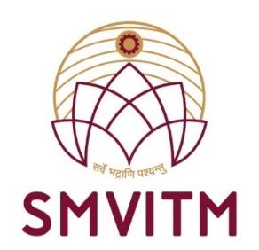
SHRI MADHWA VADIRAJA
INSTITUTE OF TECHNOLOGY & MANAGEMENT
Vishwothama Nagar, Bantakal – 574115, Udupi District,
Karnataka

Department of Artificial Intelligence & Machine
Learning Engineering

CERTIFICATE

This is to certify that Mr./Ms. Shreyas, bearing University
Seat Number 4MW22AI042, a student of III semester B.E.,
Artificial Intelligence and Machine Learning Engineering, has
successfully
presented
the
seminar
on
Social
Connect
Responsibility (BSCK307).

Mr. Vighnesh
Shenoy
Coordinator
(Signature with
date)

Prof.Dr.Thirumaleshwara
Bhat
Principal
(Signature with date and
seal)

Mr. Nagaraja Rao
In charge
Head
(Signature with date
and seal)

External Viva
Name of the Examiners:

Signature
with Date
1.
2.

