**SHRI MADHWA VADIRAJA**

**INSTITUTE OF TECHNOLOGY & MANAGEMENT**

(A unit of Shri Sode Vadiraja Mutt Education Trust ®)

(Affiliated to Visvesvaraya Technological University, Belagavi)

Vishwothama Nagar, Bantakal – 574115, Udupi District, Karnataka

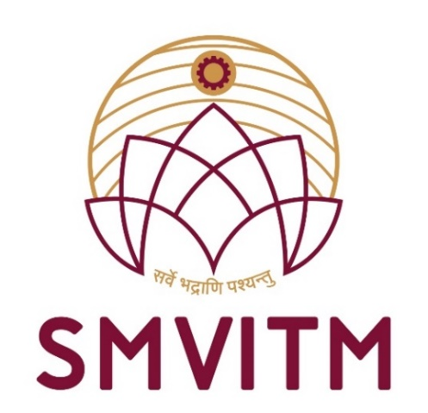

**A Report on**

**SOCIAL CONNECT & RESPONSIBILITY (BSCK307)**

**Submitted by**

**NAME : Shreyas**

**USN : 4MW22AI042**

**DEPARTMENT OF**

**ARTIFICIAL INTELLIGENCE AND MACHINE LEARNING ENGINEERING**

**2023-2024**

**SHRI MADHWA VADIRAJA**

**INSTITUTE OF TECHNOLOGY & MANAGEMENT**

**Vishwothama Nagar, Bantakal – 574 115, Udupi District, Karnataka**

**Department of Artificial Intelligence & Machine Learning Engineering**

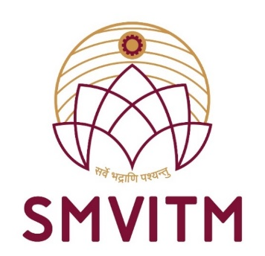

**CERTIFICATE**

This is to certify that Mr. **Shreyas**, bearing University Seat Number **4MW22AI042**, a student of III semester B.E., Artificial Intelligence and Machine Learning Engineering, has successfully presented the seminar on **Social Connect Responsibility (BSCK307).**

|  |  |  |
| --- | --- | --- |
| **Mr. Balachandra Jogi**  **Coordinator**  (Signature with date) | **Prof.Dr.Thirumaleshwara Bhat**  **Principal**  (Signature with date and seal) | **Mr. Nagaraja Rao**  **In charge Head**  (Signature with date and seal) |

**External Viva**

**Name of the Examiners: Signature with Date**

**1.**

**2.**