**Client-Side Scripting Assignment 2**

Band/Artist Page

Your goal is to create a fan page of your favourite music artist or band.

You need to find three images of the band members or artist to represent on your page.

Save all files into a folder inside your web folder called FirstNameLastIntitial_Assignment2 (Ex. DylanH_Assignment2)

ZIP the folder contents and then submit the zipped folder to D2L when completed.

All images and text must be school appropriate.

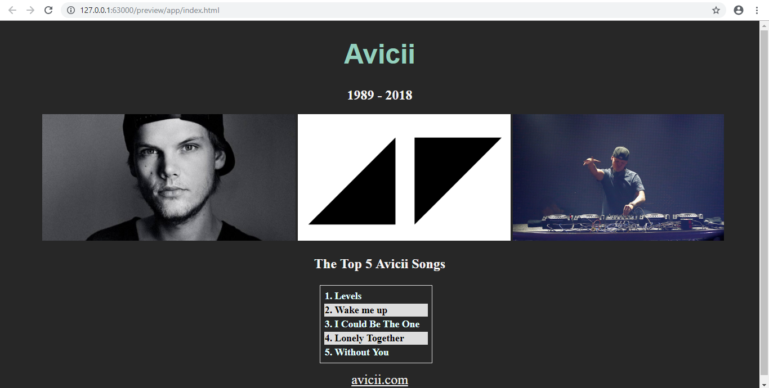

**Assessment**

Include the following to receive exemplary. Any missing parts will take you down the assessment continuum

* Title: centred, different colour, different font, and size
* Subtitle: Centered
* Three images **all with the same height**, centered, and on one line
* Table showing top songs of Artist: alternate table colours, border around table with padding, centered
* Working link to artist’s real homepage. Link changes colour when hovered over.
* Background colour change
* CSS as external file

**Visual Composition:**

* Focus on Contrast between images/text and background
* Choose colours that are analogous and not too similar
* Make use of the space