**Scripting Assignment 3**

Band/Artist Touring Page

Your goal is to create a tour page of your favourite music artist, band, or sports player

Save all files into a folder inside your web folder called FirstNameLastIntitial_Assignment3 (Ex. DylanH_Assignment3)

ZIP the folder contents and then submit the zipped folder to D2L when completed.

All images and text must be school appropriate.

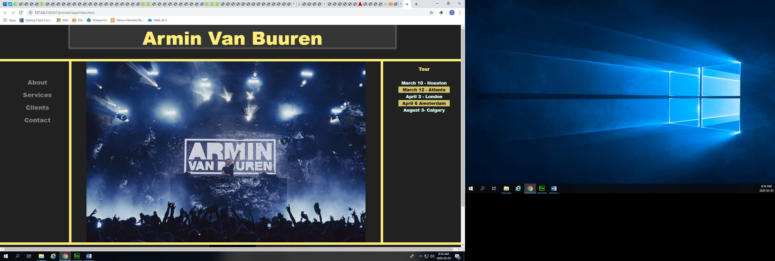

**Assessment**

Include the following to receive exemplary. Any missing parts will take you down the assessment continuum

* Grid layout: with size that change when window is resized.
* Subtitle: Centered
* Title: centred, different colour, different font
* Block around title with gradient Boarder-shadow around title block with blur
* Table showing tour dates: alternate table colours (no border)
* Working link to artist’s real homepage using a symbol or picture
* Links on side that change colour when hovered over (do not have to work)
* Image in one grid that changes when window is resized and does not go over the grid.
* Background colour change
* CSS as external file
* Background colour change
* CSS as external file

**Visual Composition:**

* Focus on Contrast between images/text and background
* Choose colours that are analogous and not too similar
* Make use of the space
* Try to choose a different style from last time